Electronic supplementary materials
Fig. S1 (A) Fallout radionuclides in the Drevviken sediment core DRE_20d_P1 showing (a) total and supported ²¹⁰Pb, (b) unsupported ²¹⁰Pb, (c) ¹³⁷Cs and ²⁴¹Am concentrations versus depth. (B) Radiometric chronology of the Drevviken sediment core DRE_20d_P1. The ²¹⁰Pb dates were unequivocal and suggest a relatively uniform sedimentation rate. The broad ¹³⁷Cs peak between 20-29 cm appears to record fallout from the 1986 Chernobyl accident. The absence of any record of the early 1960s weapons test fallout maximum raises questions about the integrity of the early part of the record (below 30 cm), and those depths were therefore not considered for further analysis
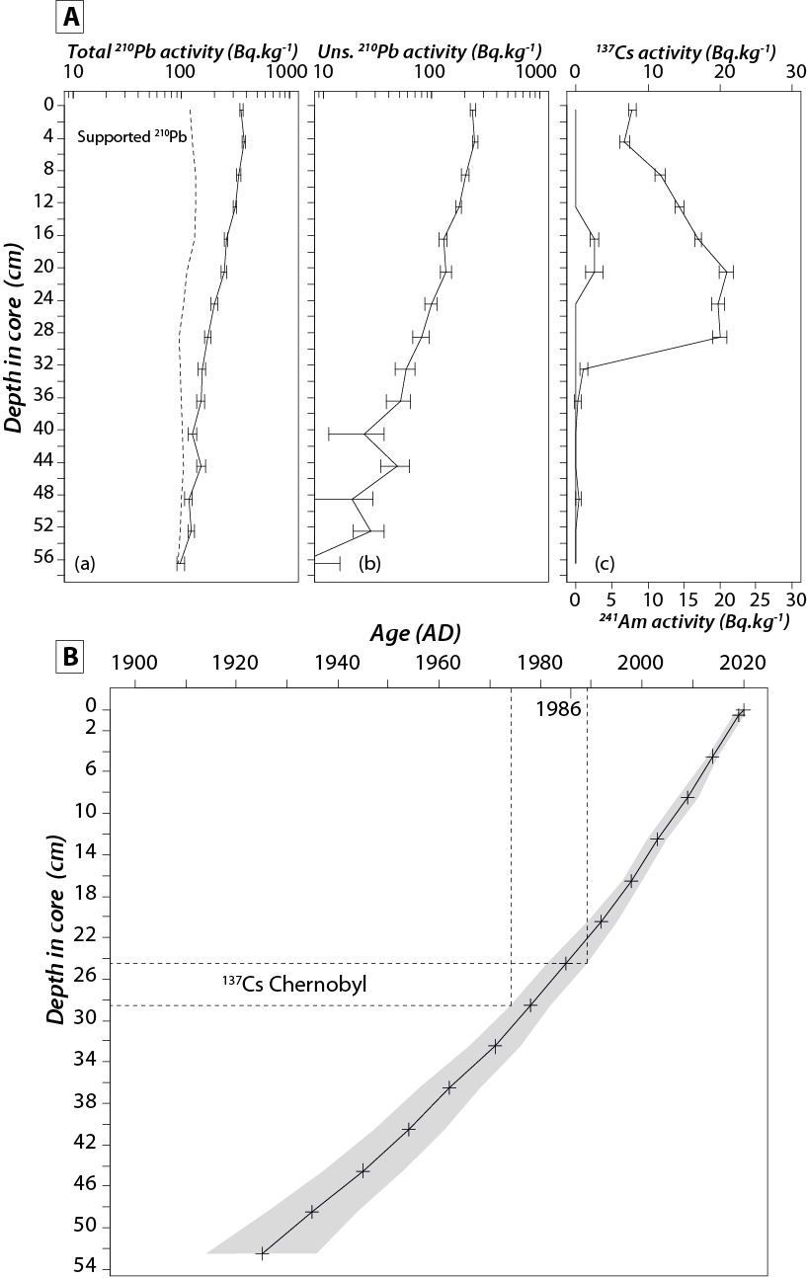
Fig. S2 (A) Fallout radionuclides in the Gyltigesjön sediment core GYL_20_P1 showing (a) total and supported ²¹⁰Pb, (b) unsupported ²¹⁰Pb, (c) ¹³⁷Cs and ²⁴¹Am concentrations versus depth. (B) Radiometric chronology of the Gyltigesjön sediment core GYL_20_P1. Radiometric chronology of the Gyltigesjön sediment core GYL_20, showing the ²¹⁰Pb dates and sedimentation rates calculated using the CRS model and the possible 1986 and 1963 depths, suggested by the ¹³⁷Cs/²⁴¹Am records
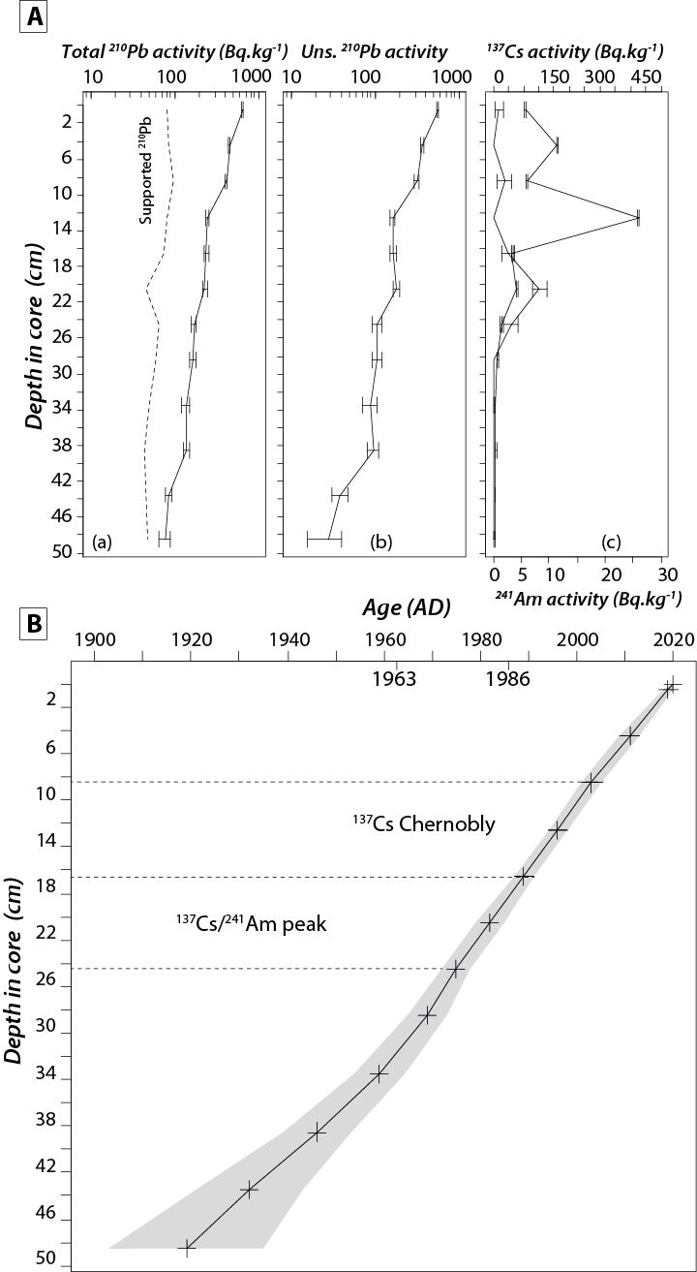
Total ²¹⁰Pb activity of Lake Drevikken reached near-equilibrium with the supporting ²²⁶Ra at a depth between 55 and 60 cm (Fig. S1). Unsupported ²¹⁰Pb concentrations declined to some extent exponentially with depth in core, suggesting a relatively uniform sedimentation rate throughout the period of time spanned by the core. ¹³⁷Cs concentrations had a broad double peak between 20 and 29 cm. Traces of ²⁴¹Am were recorded in sediments between 16 and 21 cm. ²¹⁰Pb dates for this core were relatively unequivocal. The CRS and CIC models (Appleby and Oldfield 1978) both indicated uniform sedimentation since at least the middle of the 20th century, and probably earlier. Mean sedimentation rate during that time was calculated to be of 0.12 ± 0.02 g cm⁻² y⁻¹ (0.55 cm y⁻¹). Results from the ¹³⁷Cs/²⁴¹Am method, shown in Fig. S1, placed 1986 at a depth between 23 and 25 cm, and suggests that the broad ¹³⁷Cs peak is mainly a record of fallout from Chernobyl, thus confirming the reliability of the age-depth models. However, the abrupt decline in ¹³⁷Cs activity below 29 cm, to values close to the limit of detection at the suggested 1963 depth, is very unusual and does raise questions about the integrity of the record in the lower part of the core. Although the ²¹⁰Pb dates appeared to be unambiguous, those below 30 cm must be regarded with some caution unless supported by other evidence, and were discarded from further analysis.
Although there was a significant decline in total ²¹⁰Pb activity over the length of the Lake Gyltigesjön core, values at the base of the core remain significantly above that of the supporting ²²⁶Ra, limiting the period of time spanned by the core to a little more than around four ²¹⁰Pb half-lives (~100 years). ¹³⁷Cs concentrations had a maximum value in the 12-13 cm sample and probably record fallout from the 1986 Chernobyl accident (Fig S2). However, ²¹⁰Pb dates calculated using the CRS model place 1986 within the 18-19-cm slice, significantly deeper than the depths suggested by the ¹³⁷Cs/²⁴¹Am records. The most likely cause of the discrepancy is the presence of one or more hot particles in the ¹³⁷Cs record (Persson et al. 1987; Appleby P. pers. comm.). For Lake Gyltigesjön, the mean sedimentation rate over the past 100 years was estimated to be 0.054 ± 0.009 g cm⁻² y⁻¹ (0.48 cm y⁻¹), so results from Lake Gyltigesjön sediment core were plotted against depth, with potential dates also given

