Appendix
Table 6
Regularized Partial Correlation Matrix (Edge Weights) for the Network Analysis
 | 1 | 2 | 3 | 4 | 5 | 6 | 7
1. Suicidal Communication (ComEx) | —
2. Indirect Exposure (IndEx) | .426 | —
3. Direct Exposure (DirEx) | .478 | .000 | —
4. Nonjudgemental Attitude (NonJd) | .000 | .000 | .000 | —
5. Pastoral Care (Care) | .000 | .145 | .000 | .304 | —
6. Confidence/Knowledge (Conf) | .000 | .000 | .000 | .000 | .431 | —
7. Ministerial Approaches (Postv) | .000 | .000 | .000 | .000 | .282 | .276 | —
Note. Values represent EBICglasso-regularized partial correlations; zeros indicate edges shrunk to zero. The Indirect Exposure–Pastoral Care edge (r = .145) is the primary cross-domain linkage.

Figure 5
Case-dropping bootstrap stability plot for expected influence

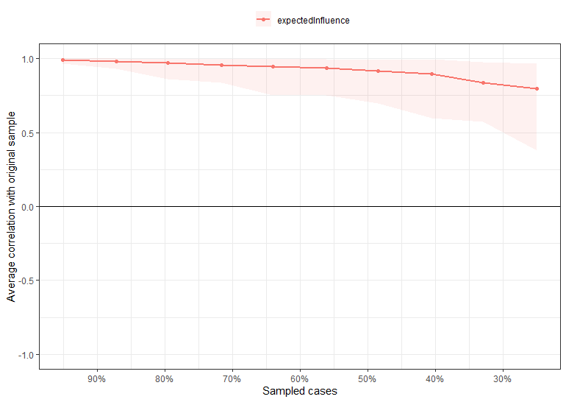

Figure 6
Non-parametric bootstrap confidence intervals for edge weights
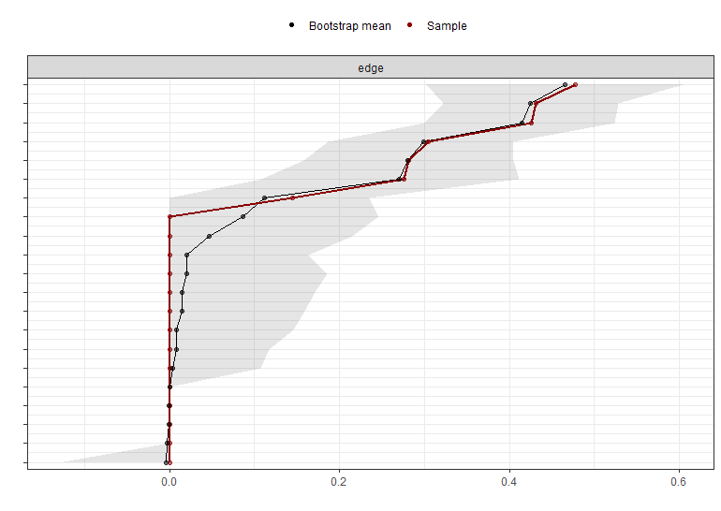

The Suicidal Behaviour Exposure Scale (SBX scale, Wolford-Clevenger et al., 2019, 2020)
Instructions: The following items measure the frequency that clergy are exposed to those with suicidal behaviours. The numbers stand for: Never (1), Once in a while (2), Fairly often (3), Very often (4). How often have you:
1 | heard/seen someone joke about death by suicide?
2 | heard/seen someone wish for death/suicide?
3 | someone talked to you about their suicidal thoughts?
4 | heard someone threaten to die by suicide?
5 | heard about someone’s suicide attempt
6 | heard specific details about suicide attempt
7 | heard about someone dying from suicide?
8 | been told specific details about someone’s dying by suicide
9 | found someone after their suicide attempt
10 | found someone’s body following suicide death
11 | witnessed someone’s suicide attempt
12 | witnessed someone’s death by suicide
13 | found someone’s poetry/diary about death/suicide
14 | found someone’s suicide note
15 | witnessed someone plan/prepare for suicide
16 | tried to stop someone’s attempt

Measure of Suicide Prevention Clergy Competencies (MSPCC, Mason et al., 2020).
Instructions: Please indicate the extent to which you practice this skill in your current faith community. If you have never talked to a suicidal person or a friend or family member after a suicide, choose N/A. Response scale: never/not like me (0), rarely (1), sometimes/somewhat like me (2), often (3), always/like me (4), not applicable (NA).
1 | When a suicidal person talks to me, I am nonjudgmental
2 | When a person who has attempted suicide talks to me, I am nonjudgmental
3 | When a survivor talks to me after his/her friend or family member’s suicide  death, I am nonjudgmental
4 | When a suicidal person talks to me, I take her or his culture into account (e.g., is the suicidal person experiencing discrimination?)
5 | I have reflected on my theology of suicide.
6 | When a suicidal person talks to me, I am clear about my role as a spiritual leader not a mental health professional.
7 | When a suicidal person talks to me, my first goal is to listen.
8 | When a suicidal person talks to me, I am confident about next steps.
9 | When a suicidal person talks to me, I know the right questions to ask.
10 | When a suicidal person talks to me, I know where to refer them for help
11 | When a suicidal person talks to me, I know how to reach out for support for myself if needed.
12 | In my faith community, the congregation watch over each other
13 | When a suicide death happens, I know how to care for the friend(s) and family member(s)/the survivor(s).
14 | When a suicide death happens, I know how to conduct a funeral that is helpful to survivor(s) and congregant(s).
15 | During a suicide funeral, I know how to strike a balance between talking about suicide without making it sound like a good solution to life’s problems.
16 | When a suicide death happens, I do not take on guilt.
17 | I can talk to my congregation (preach or teach) about suicide.

