Supplementary material

Figure A1. Intensity (EMS98) distribution map of the broader area of Athens for the 1999 earthquake. Thick lines are major faults, heavy line is the major tectonic contact, red star and blue circle the 2019 and 1999 events (modified from Lekkas 2001).
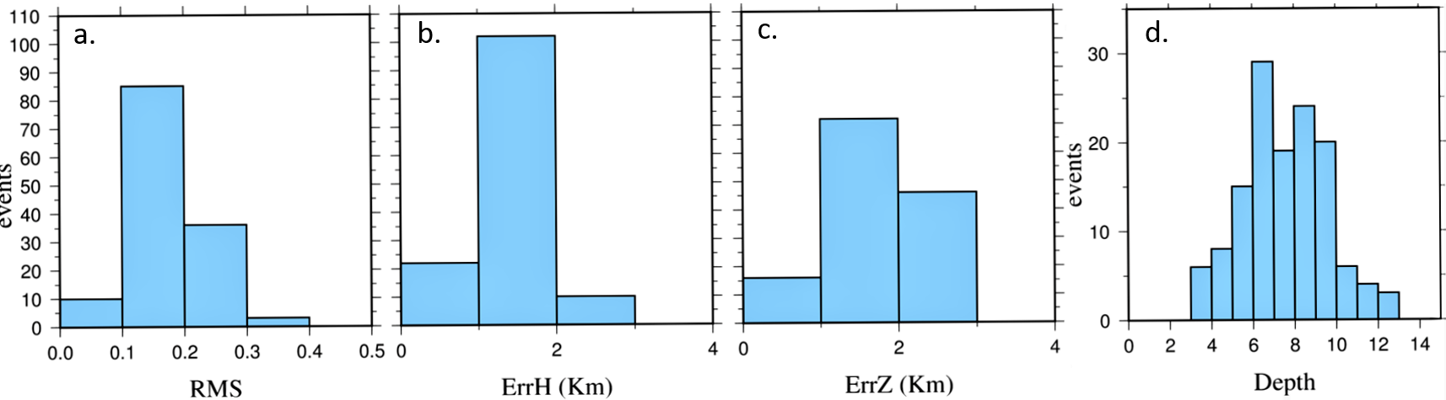
Figure A2. Frequency histograms of the hypocentral location errors a) RMS b) horizontal error ErrH c) vertical error ErrZ and d) focal depth distribution.

Table A1. Velocity model used in this study.
Depth (km) | Vp(km/s)
0 | 2.67
1 | 4.45
2 | 5.7
5 | 6.0
18 | 6.4
39 | 7.9

Table A2. Performance of various velocity models tested (RMS and spatial errors).
Velocity Models | Zahradnik, 2001 | Papadimitriou et al.2002 | Drakatos et al. 2005
Average RMS | 0.11 | 0.25 | 0.28
Average ErrH | 0.93 | 2.03 | 2.02
Average ErrZ | 1.08 | 1.5 | 1.69

Table A3. Municipalities damaged by the Athens 19 July 2019 earthquake: Total number of buildings per EMS98 vulnerability class (2011 census data) and number of damaged buildings per vulnerability class. Percentages of “yellow” and “green” vulnerability C buildings are given.

Table A4. Strong ground motion characteristics of the 19 July 2019 mainshock.
Table A5. Values of Significant Duration for both horizontal components (Athens 1999 earthquake).
Station | Component | Significant Duration (sec)
ATH29901 | L | 7.235
ATH29901 | T | 7.165
ATH39901 | L | 5.875
ATH39901 | T | 4.365
ATH49901 | L | 6.505
ATH49901 | T | 5.08
ATHA9901 | L | 8.715
ATHA9901 | T | 6.285
ATLA9901 | L | 11.435
ATLA9901 | T | 13.32
DMKA9901 | L | 13.315
DMKA9901 | T | 11.225
ISTA9905 | L | 13.37
ISTA9905 | T | 12.015
KOR19901 | L | 18.585
KOR19901 | T | 20.7
KORA9901 | L | 19.065
KORA9901 | T | 20.57
RFNA9901 | L | 7.895
RFNA9901 | T | 6.63
SGMA9901 | L | 7.07
SGMA9901 | T | 3.685
SPLB9901 | L | 5.56
SPLB9901 | T | 5.515
THV19902 | L | 15.06
THV19902 | T | 18.035
THVC9901 | L | 15.94
THVC9901 | T | 15.91

