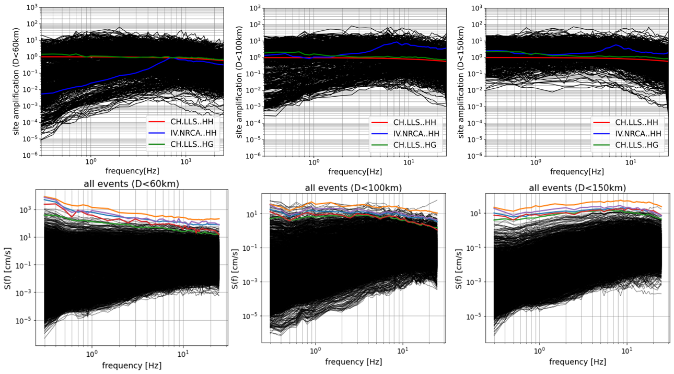
Figure S1. Resulting site amplifications and source spectra for cut-off distances of 60, 100, and 150 km. Colored curves show the selected events (the 2009 L’ Aquila, 2012 Emilia, and 2016 Amatrice, Norcia, Visso earthquakes).

