Supplementary Information
The present supplementary information is assigned to the article: “Earthquakes and Seismic Hazard for Norway and Svalbard” by C. Lindholm, H. Bungum, F. Ghione, A. Meslem, C. Huang and V. Oye, hereafter called the “main paper”.

The information herein highlights some aspects of the research that are intended to supplement and corroborate the main paper. The material is organized under (internally unrelated) section headings.

The catalogue
The catalogue developed by NORSAR and used in the present study is released for public use as an Excel file: Catalogue_for_Public.
We focus in the catalogue release on earthquakes with Mw≥3.0 within the geographical area defined in the main document and from 1657 through 2018. This reflects that we have in our work focused on larger earthquakes. Lower magnitude events can be obtained from NNSN (Norwegian National Seismic Network operated by the University of Bergen). Each event is characterized with time of occurrence, hypocentre reporting agency, latitude, longitude and depth (when available), moment magnitude and reference for the magnitude (only for original Mw values). In case of more than one magnitude in the original reports the one with the presumably best quality magnitude was used for the conversion. The agency abbreviations in the main paper indicate:

BAT (1) | AMB (2) | BER (3) | BKH (4)
FEN (5) | ISC (6) | KRK (7) | NOR (8)
PDE (9) | PEN (10) | PML (11) | SEL (12)

References to the table:
(1) Båth, M. (1956). An earthquake catalogue for Fennoscandia for the years 1891-1950. Sveriges Geol. Unders., Avhandlinger och Uppsatser, Ser. C, No. 545.
Båth, M. (1979). Earthquakes in Sweden 1951 - 1976. Sveriges Geol. Unders., Serie C. Nr. 750.
(2) Ambraseys, N.N. (1984): Magnitude assessment of northwestern European Earthquakes. Earthq. Eng. Struct. Dyn., 13, 307-320.
Ambraseys N.N. (1985). The seismicity of western Scandinavia. Earthq. Eng. Struct. Dyn., 13(3), 361–399, doi: 10.1002/eqe.4290130309.
(3) https://www.uib.no/en/rg/geophysics/136308/norwegian-national-seismic-network-nnsn
(4) B. Hokland; https://www.norsar.no/
(5) https://www.helsinki.fi/en/institute-seismology/research/seismic-bulletins
(6) Mainly from https://www.isc.ac.uk/iscbulletin/. More details can be found in:
Storchak, D.A. et al. (2013). Public Release of the ISC-GEM Global Instrumental Earthquake Catalogue (1900-2009). Seism. Res. Lett., 84, 5, 810-815, doi: 10.1785/0220130034.
Storchak, D.A. et al. (2017). Rebuild of the Bulletin of the International Seismological Centre (ISC), part 1: 1964–1979. Geosci. Lett. (2017) 4: 32. doi: 10.1186/s40562-017-0098-z.
(7) Karnik, V. (1969). Seismicity of the European area, Vol. I. D. Reidel Publ. Co., Dordrecht, 364 p.
Karnik, V. (1971). Seismicity of the European area, Vol. II. D. Reidel Publ. Co., Dordrecht, 218 p.
(8) https://www.norsar.no/
(9) https://www.usgs.gov/programs/earthquake-hazards/earthquakes
(10) Penttilä E. (1978). Earthquakes in Finland 1610-1976, Inst. Seism., Univ. Helsinki, Rep. S-1.
(11) Muir Wood, R. and G. Woo (1987). The historical seismicity of the Norwegian Continental Shelf. Earthquake Loading on the Norwegian Continental Shelf (ELOCS) Report No 2-1, Norw. Geotech. Inst., Oslo, Norway, 116 pp.
(12) Sellevoll, M.A. et al. (1980). A catalogue of earthquakes felt in Norway from 1953 to 1975, with some homogeneous tests. Institute report. Seism. Obs., Univ. of Bergen, Norway.

Seismotectonic setting
A brief overview of the regional seismotectonic setting is provided in the paper. Here, we add some information that may be relevant together with several references. The paper applies two area-zonations in the hazard estimation. These have of course significant similarities, but zonation 2 is reflecting more on the structures and the tectonic setting described below while zonation 1 is based with more weight on seismicity. The interested reader is advised to also confer with Fig. 1 in the main paper.

Structures
The structural history and development of the Fennoscandian region reflects several stages of deformation. The Scandinavian Caledonides, which stretch through most of Norway and include adjacent parts of Sweden, are made up of late Proterozoic to Silurian metasedimentary and metavolcanic rocks, deposited in the Iapetus Ocean (the predecessor of the present-day Atlantic Ocean) c. 700 to 400 Ma ago. Together with slices of older basement, these rocks were thrust several hundred kilometres eastwards over the edge of the Fennoscandian Shield in several large thrust sheets known as nappes, when North America and Greenland collided with Scandinavia during the Caledonian orogeny c. 400 Ma ago (Ramberg et al. 2008). It is important to bear in mind that some of these orogenic structures remain visible on the surface also today, and have bearing on present-day seismicity.
While the offshore structures have been mapped in detail due to hydrocarbon exploration, the onshore structures that are more important in the present study belong to the geological mapping that started in the early 19th century. For an overview of the geological development and the regional seismotectonics the interested reader is directed to Ramberg et al. (2008), Ksienzyk et al. (2014) and Gregersen et al. (2021), and to the references therein.
One of the first major seismotectonic studies for onshore and offshore Norway was by Bungum et al. (1991) who summarized available seismicity and focal mechanism data at that time, concluding that the ‘ridge push’ force is a major source of stress, consistent with a NW- SE compression and dominantly reverse faulting along the continental margin. This was followed up later with several papers, including Fejerskov and Lindholm (2000) and Hicks et al. (2000). Another important contribution here was also Byrkjeland et al. (2000), focusing on the seismotectonics of northern Norway and its offshore areas.
Important local and regional investigations in southern Norway were conducted and reported by Fossen and Hurich (2005) and Gabrielsen et al. (2002, 2019). Fossen and Hurich (2005) documented the old deep-seated Hardanger shear zone that seems to be important for the regional seismicity. Gabrielsen et al. (2019) mapped the Drangedal Fault Complex more recently, and demonstrated a deep suture in the continental crust that runs SW-NE. These two examples show that the very old, lower crust structures play a role also in present-day seismicity (Hicks and Ottemöller 2001). See Fig. 1 for the two structures.

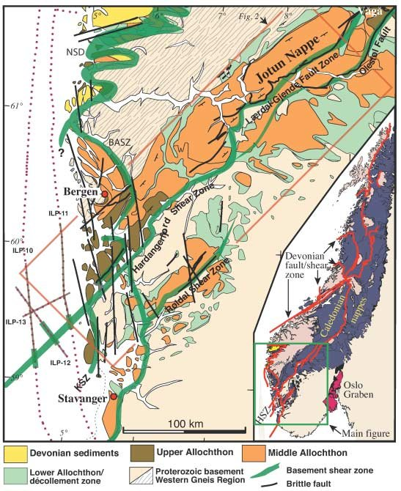 | 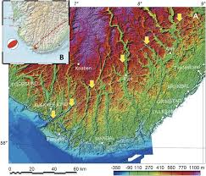
Fig. 1. Left: Geological map of SW Norway, showing the Hardangerfjord Shear Zone and other prominent shear zones in southwestern Norway; from Fossen and Hurich (2005). Right: the Listafjorden–Drangedal Fault Complex of the Agder–Telemark Lineament Zone, southern Norway as described by Gabrielsen et al. (2019).
Western Norway is separated from the Norwegian continental shelf by the major Øygarden fault zone that runs NS. The Øygarden Fracture zone is seismically active (Fossen and Rykkelid 1990; Wiest et al. 2020) and constitutes a main structural boundary to the Caledonide mountains rising east of the shelf (the Caledonian front is depicted in Fig. 2 in the main paper). The listric and complex Øygarden structure has also been of main concern for the petroleum industry with respect to pipeline crossings.
Southern Norway is also shaped between two aborted rift structures: The Viking Graben (offshore) and the Oslo Graben extending northwards from the Oslofjord. Failed rifts were identified by Johnson et al. (1994) as important source regions for earthquakes in Stable Continental Regions (SCR), supported also by observations from Norway. See also Bungum et al. (2009) and Ramberg et al. (2008) for the developments of these structures that until today reveal both seismic activity and thinned crust. Two major earthquakes (1904 and 1927) are associated with the Oslo Graben and the Viking Graben structures as listed in the main article. A more peculiar large earthquake took place in the Vøring Basin in 1988, in an area with almost no earlier seismicity (Byrkjeland et al. 2000), followed by an M 5.2 event in the north-eastern North Sea in 1989 (Hansen et al. 1989).
Northern Norway experienced in 1819 (see Table 1 in the main paper) the largest earthquake recorded with fair precision in location and magnitude. With basis in this historical record significant studies were undertaken in northern Norway through the NEONOR I and II projects (Olesen et al. 2013, 2018). In the far north (Nordland and Finmark), Olesen et al. (2013, 2018), Olsen et al. (2022) and Olsen and Olesen (2023) have made groundbreaking mapping of postglacial structures that are suggested to have been active as recent as 300-500 ybp. Fig. 2 shows the Holocene faults in northern Scandinavia, including also the Stuoragurra reverse fault, with its surface deformation. Stuoragurra (Fig. 2) is one of the many Holocene faults found where a large postglacial rupture has been documented, and present-day earthquakes have been recorded in a linear zone about 30 km wide parallel to the Stuoragurra fault (Bungum and Lindholm 1996).

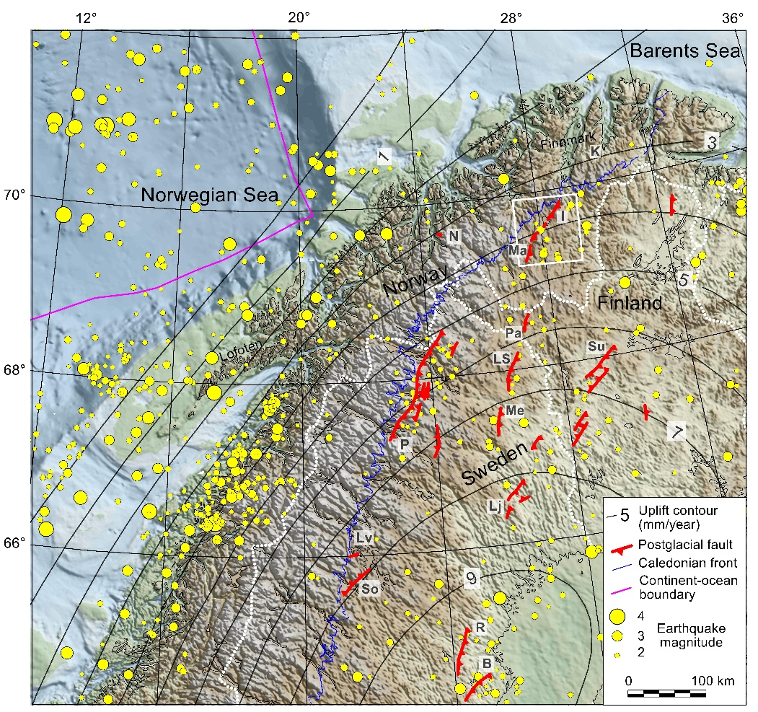
Fig. 2. Postglacial faults, topography, bathymetry, earthquakes during the period 1750–2011 and present-day uplift (mm/year) in northern and central Fennoscandia. P: Pärve fault complex; Ma and I: Stuoragurra fault complex (Olesen et al. 2022).

Sources and directions of crustal stress
The general (not Norway specific) quest for the source of stresses causing deformations in plate interiors was raised decades ago. Pioneering modelling work on the global distribution of crustal earthquake-driving stresses were published already from the mid 1970’s (Solomon et al. 1975; Richardson et al. 1979; Harper 1989), to be followed up for eastern North America by Adams (1989) and for Scandinavia by Stephansson et al. (1986), Slunga (1989, 1991), Bott (1991) and Bungum et al. (1991), among many others.
For Norway, the sources of plate stress were later elaborated on in several investigations (Fejerskov and Lindholm 2000; Muir Wood 2000; Fjeldskaar et al. 2000; Pascal and Cloetingh 2009; Olesen et al. 2013, 2018). The overall conclusion remains that plate-wide sources of stress (ridge push) will interact with regional and local sources, and weakness zones, including postglacial uplift, topography, sedimentation and crustal inhomogeneities, as summarized in Fig. 3. Even when more earthquake focal mechanisms have refined this first-order picture, the crustal stress directions summarized many years ago in Fig. 4 still remains representative.
Even if a significant stress generation in Fennoscandia clearly relates to the postglacial uplift centred in the Bothnian Bay, at a current rate of about 9 mm/year, it is also clear that most of this stress is released aseismically (Slunga 1991).
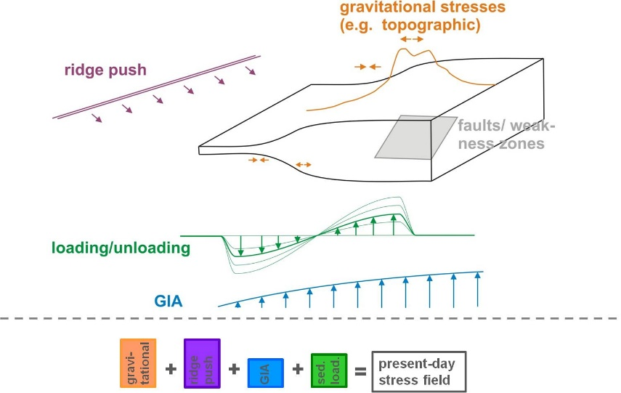
Fig. 3. Schematic presentation of the stress field components contributing to the present-day stress regime on the Nordland margin, applicable for most of mainland Norway (Gradmann et al. 2018).
While shear stress is a requirement for earthquake occurrence it is also clear that the deviatoric stresses in Norwegian regions are relatively small (Fejerskov and Lindholm, 2000; Pascal and Cloetingh, 2009), and a prerequisite for earthquake occurrence is therefore weakened/lubricated faults. That question, related to the presence and importance of crustal fluids for seismicity in Norway, has been addressed by many authors (Fjeldskaar et al. 2000), and indicators of the importance of lubricated faults are found also in the many earthquake swarms in Nordland, where the possible relation between intensity of snowmelt and seismicity is still unresolved (Bungum et al. 1979; Atakan et al. 1994; van Laaten et al. 2023; Ueda et al. 2024).
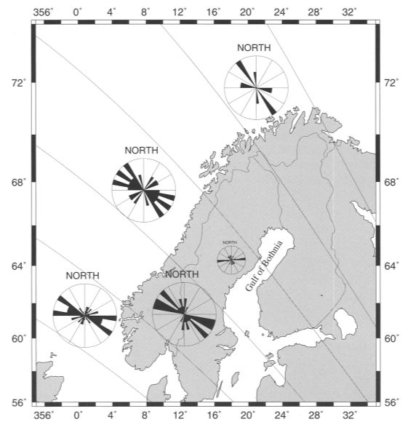
Fig. 4. Current stress trajectories based on earthquake focal mechanisms and borehole breakouts plotted with rose diagrams from regionally clustered earthquake focal mechanisms and in-situ measurements in offshore boreholes (Lindholm et al. 2000).
How closely related is the observed seismicity to the stress field? For the last two decades there has been a close cooperation around this question between NORSAR and the national geologic (NGU) and geodetic (SK) surveys, with results documented in Dehls et al. (2000), Kierulf et al. (2014), Keiding et al. (2015), Janutyte and Lindholm (2017), Janutyte et al. (2017) and Olesen et al. (2018).

Post-glacial earthquakes
The burst of large-magnitude paleoseismic events in Fennoscandia following the deglaciation in Holocene (see Fig. 2) represents an important background for the recurrence of large earthquakes in Fennoscandia also today, as recently summarized and discussed in detail by Eldholm and Bungum (2021) and Bungum and Eldholm (2022). What was found there was that a much larger region than previously assumed has been subjected to these spectacular events. Both the Stuoragurra and the Pärve fault in Sweden have been the sites of Holocene 7+ magnitude earthquakes, however, an important qualification was noted by Bungum et al. (2005), who found that earthquakes up to M7 could have occurred also in Norwegian offshore regions without breaking the surface.
Another important unresolved question is to which extent the present seismicity is still driven by postglacial rebound, where Bungum et al. (2010) concluded that such influence is likely to be small. Finally, Eldholm and Bungum (2021) found that a lot of uncertainty still prevails around the dating of the postglacial events in Fennoscandia, but also that some of the assumed dates could be much younger that previously assumed. A noteworthy case here is the Stuoragurra Fault Complex in Northern Norway where the latest trenching results from NGU (Olsen et al., 2022; Olsen and Olesen 2023) indicate increasingly younger dates, now as recent as 300-500 years ago and with M>6.5. If these results can be supported and corroborated through further studies, it may be necessary to revisit our present understanding of the seismicity of Fennoscandia.

The Svalbard archipelago
The earthquake record for the Svalbard archipelago is much shorter than for mainland Norway, and even today the number of seismic monitoring stations is sparse, in particular in the northern areas. Also the geological mapping was sparse until recently, and mainly focused on the coal mining on Spitsbergen. For the Svalbard archipelago the Storfjorden Fault zone and the Nordaustlandet in the north (Bungum et al. 1982; Mitchell et al. 1990; Pirli et al. 2010; Dallmann 2015) stands out through enhanced earthquake activity together with the Hopen activity. See Fig. 1 in the main document. The Knipovitch section of the mid-Atlantic spreading ridge is highly active, but largely confined west of the Svalbard shelf. The main structures of Svalbard are prominent, but with the Storfjorden exception, it is not easy to assign specific earthquakes or enhanced seismicity to these structures.
Two area zonations, as used for Norway, were established also for the Svalbard archipelago and included in the computational model. These are shown in Fig. 5.

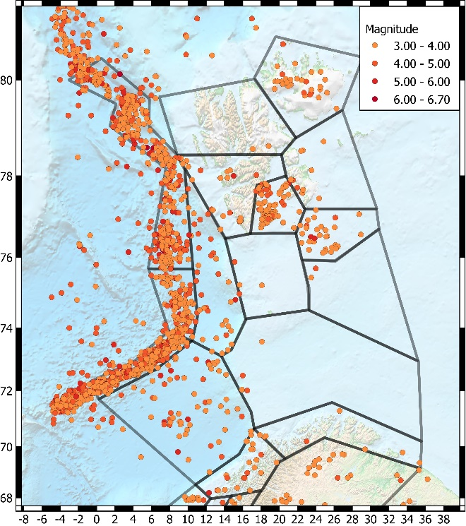 | 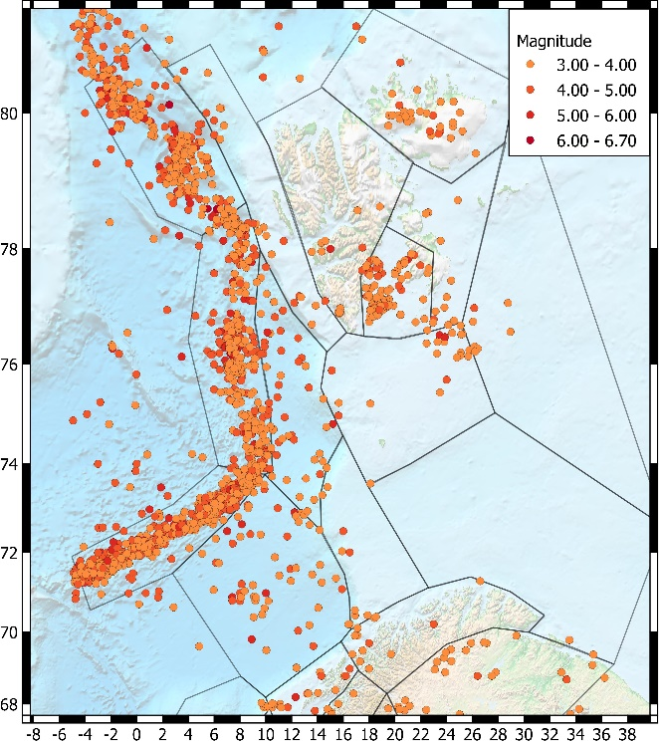
Figure 5. The two zonation models for the Svalbard archipelago and surroundings used in the computational model.

Vertical motion spectra
Given that the selected GMPEs do not provide solutions for vertical motions, those can be assessed, if needed, only through the application of specific V/H relations. There are regulatory guidelines for this, but none that are directly applicable to our target region. An empirical V/H relation is available for Norway (NORSAR and Risk Engineering 1991), however, based entirely on weak motions. Since an update of that study would be beyond the scope of this study we went instead for a review of published V/H relations, including GA11 (Gülerce and Abrahamson 2011), ASA14 (Akkar et al. 2014), and BAK11 (Bommer et al. 2011), as shown in Fig. 6, where also some empirical relations are shown, including the old one from Norway.
After a more detailed assessment of these relations, it was concluded that we would recommend using the average curve from Fig. 6 as a V/H model for our target region. It is, however, important to note that this relation is independent of both magnitude and distance, a potentially important refinement that would require better regional data and moreover is not called for in this study.

T | EMP | EMP |  | GA11 |  | ASA14 |  | AVE | STD
(sec) | Norway | US East | US West | M5-R15 | M6-R40 | M5-R15 | M6-R40
0.01 | 0.70 | 0.68 | 0.64 | 0.63 | 0.58 | 0.60 | 0.63 | 0.64 | 0.04
0.02 | 0.70 | 0.68 | 0.66 | 0.63 | 0.58 | 0.62 | 0.64 | 0.64 | 0.04
0.03 | 0.70 | 0.74 | 0.71 | 0.67 | 0.61 | 0.67 | 0.66 | 0.68 | 0.04
0.05 | 0.70 | 0.64 | 0.70 | 0.71 | 0.60 | 0.67 | 0.67 | 0.67 | 0.03
0.10 | 0.70 | 0.63 | 0.57 | 0.60 | 0.59 | 0.54 | 0.62 | 0.61 | 0.05
0.20 | 0.70 | 0.69 | 0.55 | 0.52 | 0.56 | 0.50 | 0.56 | 0.58 | 0.07
0.40 | 0.74 | 0.76 | 0.63 | 0.65 | 0.66 | 0.57 | 0.63 | 0.66 | 0.06
1.00 | 0.90 | 0.84 | 0.67 | 0.72 | 0.72 | 0.73 | 0.82 | 0.77 | 0.08
2.00 | 0.90 | 0.87 | 0.67 | 0.72 | 0.73 | 0.77 | 0.84 | 0.78 | 0.08
4.00 | 0.90 | 0.87 | 0.67 | 0.77 | 0.78 | 0.80 | 0.94 | 0.82 | 0.09

Fig. 6. V/H values as functions of period for the six models used in this assessment, with averages shown as a solid black line. Right: Tabulated data for the figure.

Relative weighting of the area zonation models and the zonation free model
The present analysis involves several levels of expert judgement and choices where the aim was to catch the epistemic uncertainty. One such choice is the logic tree weighting where our expert judgement concluded with a 0.4 – 0.4 – 0.2 weighting between the three models (two area zonations and one zonation free). For the sake of transparency, we have conducted a test with two alternative logic tree weighting schemes aimed at demonstrating the influence that other choices could have introduced. We have investigated the influence of the relative zonation weighting on PGA using various alternative weighting schemes (1/3 - 1/3 - 1/3 and 0.5 - 0.3 - 0.2). The difference when comparing the preferred weighting (0.4 - 0.4 - 0.2) with all-models-equal-weight shows for Norway variations from -9% to +15% and for Svalbard up to 15% difference. Fig. 7 demonstrates the effect of the expert opinion choices incorporating expert judgement, and also demonstrates that the zonation free method, in general, seems to generate a somewhat lower hazard (lower shaking intensities) with exceptions for areas with earthquake clustering. Since our expert opinion is that the larger earthquakes cannot fully be predicted by the microseismicity clustering we feel confident with the relative weighting choice made.
One specific reason to down weight the zonation free method relative to the area-based models is that the zonation free method is more directly reflecting the historical earthquake catalogue. This is an advantage when the catalogue covers a long-time window, while a short window may not reflect the full seismic potential. Woo (1996) recognized this and suggested: “where it is reckoned that the maximum magnitude earthquake is missing from the regional earthquake catalogue, the activity rate density field may be adjusted to accommodate such an extreme occurrence.” We could in the present paper not implement this and consequently the zonation free method was included with lower weights even when noting that Mmax has lower influence on the results when, as in our case, the return period was set as low as 475 years compared to when hazard is computed for longer return periods.
Figure 7 demonstrates the relative influence of the model weighting. Even when we have done our best to achieve models that are balanced and reflect the centre, this demonstrates without direct quantification the real uncertainty inherent in our results (and in nearly all seismic hazard results).

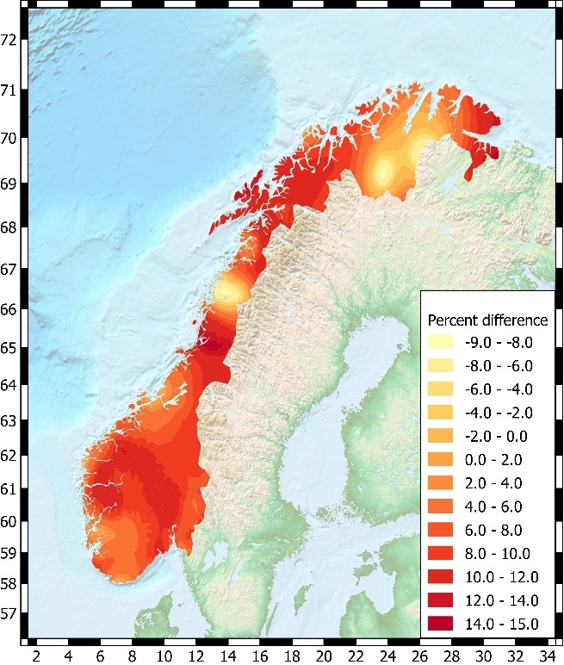 | 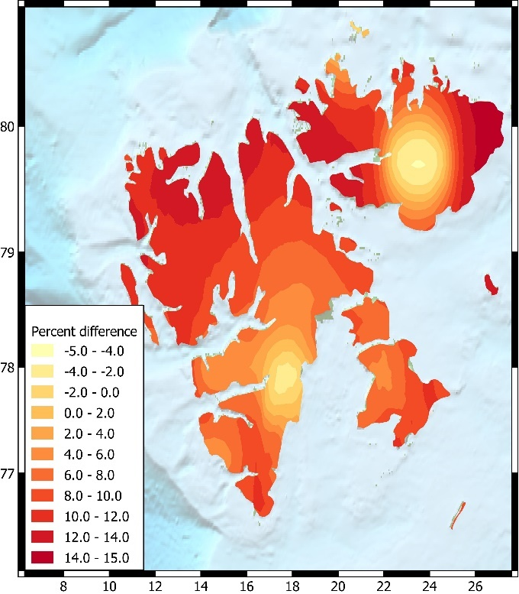
Fig. 7. Example of model weighting sensitivity: PGA difference in % between the preferred model and the equal weighted model (all three models with the same weight).

Two synthetic earthquake catalogues; Model differences; Uncertainty
The computational model was established with two area-zone models and one zonation-free model. The two area models were established from two different perspectives: observed seismicity and known deformation zones. The idea was therefore to generate zonation models fulfilling complementary perspectives. For the two area-zone models we generated synthetic earthquake catalogues showing 500 years of model predicted seismicity (randomized in space and magnitude within each subzone). The results are shown in Fig. 8. The purpose of showing this figure is to demonstrate the effect of the difference in the zonations and the associated recurrence predictions. The differences are significant. This test aims to visualize the inherent uncertainty in using a short catalogue spanning only some 100+ years for a 500-year prediction.
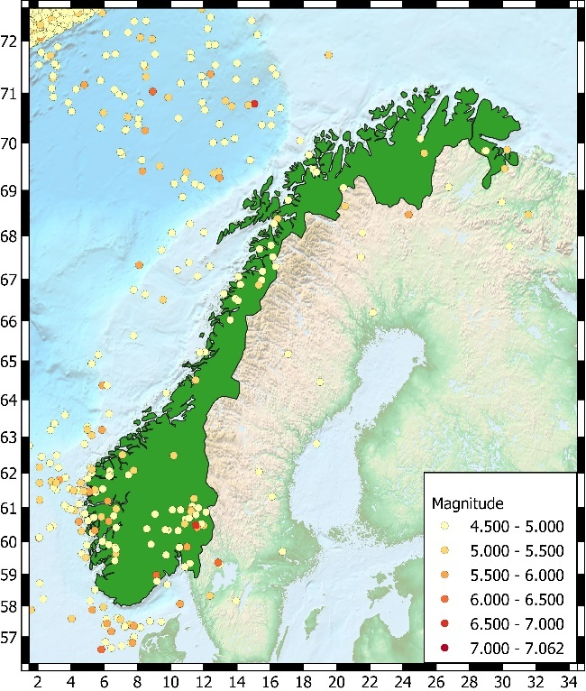 | 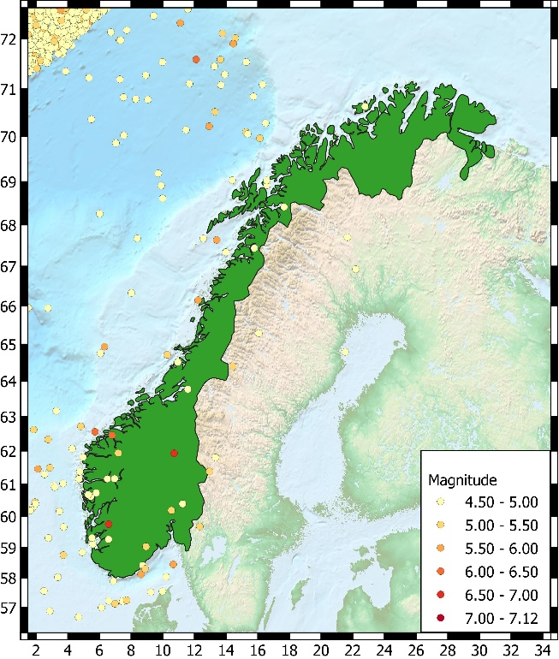
Fig. 8. Examples from two synthetic earthquake catalogues generated from the two area-zone-models predicting 500 years of earthquake occurrence for magnitudes greater or equal to M4.5.

Sensitivity of the results to Vs30 reference velocity
In order to understand better the significance of the variations in Vs30 levels a common approach is to establish so-called generic crustal profiles, which are smooth velocity profiles which characterize average and regionally stable crustal shear-wave velocities for the area under study. These profiles can be used for calculating site amplifications in a simple way, which in turn provides a means for assessing the relative ground-motion differences between regions with different Vs30 levels. The main factor influencing regional ground-motion differences, besides the shallow shear-wave velocities, is the near-surface attenuation, characterized through the diminution factor kappa. The kappa parameter is not well understood and not well constrained, even though it influences the spectrum significantly for high frequencies and for very hard rock site conditions. Generic crustal profiles are important for understanding the importance of Vs30, both for GMPE selection and for adjustments related to different Vs30 levels. To this end we show in Fig. 9 a set of profiles for Vs30 ranging from 800 to 2800 m/s, using an interpolation scheme between anchoring points as outlined by Cotton et al. (2006), in turn based on Western and Eastern US crustal profiles from Boore and Joyner (1997) and Boore (2016).

Figure 9. Generic profiles for Vs30 between 800 and 2800 m/s and depths down to 300 m.
An issue deliberately not discussed in the main paper is how to adjust the results for different reference velocities. Without an adjustment the hazard will be underestimated for softer sites and overestimated for harder sites, and the question of whether these errors should be resolved for a specific construction site depends on the safety requirements of the project. If safety requirements are high, there could be a need for a site-specific analysis.
We note that the site-specific adjustments that should be applied are principally of two types: (1) Adjustments for different reference velocities in cases when the Vs30 is significantly different from 1200 m/s; and (2) Soil response calculations in cases when the building site is on softer grounds and, in particular, when the top layers are significantly softer and/or deep. Adjustments are most often done using the square-root-impedance (SRI, often also called quarter-wavelength) method (Joyner et al. 1981; Boore and Joyner 1997).
As an illustration of these issues, we show in Fig. 10 the sensitivities to different Vs30 values and to the inclusion of an appropriate hard-rock diminution factor (kappa) model.

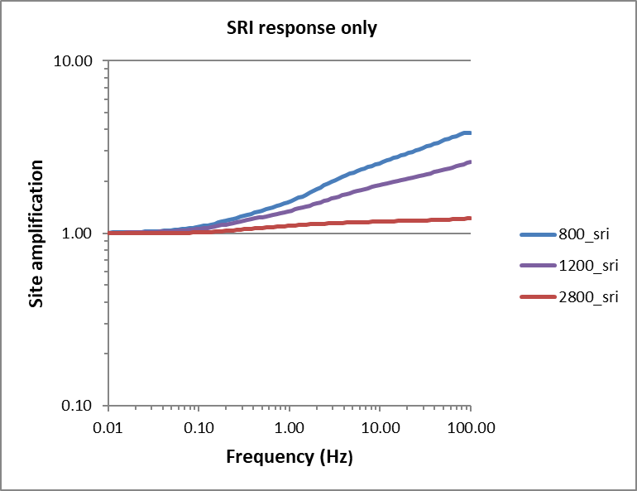 | 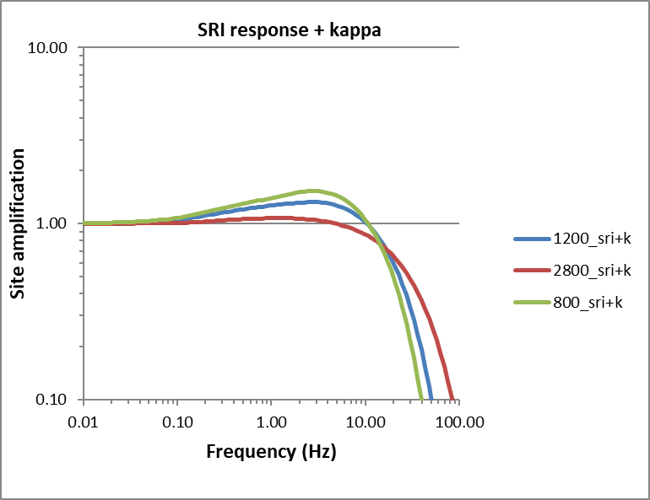
Fig. 10. Site amplifications for the generic profiles shown in Fig. 10, for Vs30 values of 800, 1200 and 2800 m/s, without (left) and with (right) kappa effects based on a tentative SCR kappa model. SRI is referring to the square-root-impedance (quarter wavelength) method.

Comparison of the results with ESHM20
The new model for Norway was compared to the 2020 European Seismic Hazard Model (ESHM20) (http://www.hazard.efehr.org/en/hazard-data-access/hazard-maps/), in terms of PGA and spectral accelerations at period T of 0.1s, 0.2s and 1.0s, as shown in Figure 11.

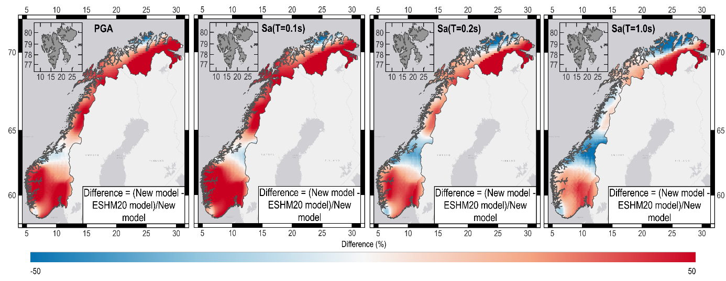
Fig. 11. Difference in % between the results of hazard map obtained in this study and the ESHM20 results for the return period of 475 years. From Left to Right, representing PGA, Sa(T=0.1s), Sa(T=0.2s), and Sa(T=1.0s), respectively.
The difference between the new model and the ESHM20 model was computed as follows:

$$Difference=\frac{Value from new model-Value from ESHM20}{Value from new model}×100\%$$

The first observation is that the present study covers a larger area (i.e., Norway mainland and Svalbard) than the ESHM20. In Northern Norway (e.g., 70.098N, 25.725E), at the border with Sweden, Finland, and Russia, the ESHM20 provided no values or values are too small (<5e-5g) to retrieve for the Norway mainland, particularly at a longer period. And ESHM20 did not cover Svalbard in their model. This coverage difference results in a large positive difference between the two models in North Norway.
Moreover, the present results demonstrate a systematic difference from ESHM20 across the four periods. The values for western, southern and eastern Norway from the new model were higher than the ESHM20 model, while values for Trøndelag (mid-Norway) from the new model are lower than ESHM20. The values for Northern Norway from the new models were generally higher than ESHM20 at short periods but are lower than ESHM20 at long periods. This is somewhat surprising since the present study uses 1200 m/s as reference velocity, which by itself should reduce the differences. Among various factors contributing to this difference the authors considered the ground-motion prediction equation (GMPE) as the dominant factor.
This study selected the GMPEs of Akkar et al. (2014), Bindi et al. (2017), Cauzzi et al. (2015) and Yenier and Atkinson (2015). This choice was based on the applicability of tectonic regions, geological conditions, magnitude and distance ranges. The ESHM20 adopted the adjustable backbone ground-motion model approach to account for the region-specific features. We believe that the different ground-motion characteristics, primarily the selection of GMPEs, contribute most to the observed differences, while not ignoring other significant model differences (e.g., earthquake catalogue, zonation, ground-motion prediction equation, site characteristics and reference velocity).
As expected, both models agreed that Norway's mainland was of low seismic hazard, compared to other high seismic hazard areas in Europe (e.g., Italy). Even when the difference in % seems dramatic, the max absolute difference in values for 475 years was generally small (e.g., absolute maximum value difference was 0.03g for PGA and 0.07g for Sa@0.2s).

References
Adams J (1989) Crustal stresses eastern Canada. In: Gregersen S and Basham PW (ed) Earthquakes at North Atlantic Passive Margins: Neotectonics and Postglacial Rebound, NATO ASI Series (266), Dordrecht, pp 289-297. https://doi.org/10.1007/978-94-009-2311-9_17
Akkar S, Sandikkaya MA, Ay BÖ (2014) Compatible ground-motion prediction equations for damping scaling factors and vertical-to-horizontal spectral amplitude ratios for the broader Europe region. Bulletin of Earthquake Engineering 12:517–547. https://doi.org/10.1007/s10518-013-9537-1
Atakan K, Lindholm C, Havskov J (1994) Earthquake swarm in Steigen, northern Norway: an unusual example of intraplate seismicity. Terra Nova 6:180-194. https://doi.org/10.1111/j.1365-3121.1994.tb00652.x
Bommer JJ, Akkar S, Kale O (2011) A model for vertical‐to‐horizontal response spectral ratios for Europe and the Middle East. Bulletin of the Seismological Society of America 101 (4):1783‐1806. https://doi.org/10.1785/0120100285
Boore DM (2016) Determining generic velocity and density models for crustal amplification calculations, with an update of the Boore and Joyner (1997) Generic Site Amplification for Graphic Site Amplification. Bulletin of the Seismological Society of America 106:316-320. http://doi.org/10.1785/0120150229
Boore DM, Joyner W.B. (1997) Site amplification for generic rock sites. Bulletin of the Seismological Society of America 87(2): 327-341. https://doi.org/10.1785/BSSA0870020327
Bott MHP (1991) Ridge push and associated plate interior stress in normal and hot spot regions. Tectonophysics 200:17-32. https://doi.org/10.1016/0040-1951(91)90003-B
Bungum H, Hokland BK, Husebye ES, Ringdal F (1979) An exceptional intraplate earthquake sequence in Meløy, Northern Norway. Nature 280:32-35. https://doi.org/10.1038/280032a0
Bungum H, Mitchell BJ, Kristoffersen Y (1982) Concentrated earthquake zones in Svalbard. Tectonophysics 82:175-188. https://doi.org/10.1016/0040-1951(82)90044-0
Bungum H, Alsaker A, Kvamme LB, Hansen RA (1991) Seismicity and seismotectonics of Norway and surrounding continental shelf areas. Journal of Geophysical Research 96:2249-2265. https://doi.org/10.1029/90JB02010
Bungum H, Pettenati F, Schweitzer J, Sirovich L, Faleide JI (2009) The MS 5.4 October 23, 1904, Oslofjord earthquake: Reanalysis based on macroseismic and instrumental data. Bulletin of the Seismological Society of America 99(5):2836-2854. http://doi.org/10.1785/0120080357
Bungum H, Lindholm C, Faleide JI (2005) Postglacial seismicity offshore mid-Norway with emphasis on spatio-temporal-magnitudal variations. Marine and Petroleum Geology 22:137-148. https://doi.org/10.1016/j.marpetgeo.2004.10.007
Bungum H, Eldholm O (2022) The conundrums of the postglacial tectonic response of the Fennoscandian and Canadian Shields. Earth-Science Reviews 232:895-902. https://doi.org/10.1016/j.earscirev.2022.104146
Bungum H, Pascal C, Olesen O, Lindholm C, Vestøl O, Gibbons S (2010) To what extent is the present seismicity of Norway driven by postglacial rebound?, Journal of the Geological Society 167:373-384. https://doi.org/10.1144/0016-76492009-009
Byrkjeland U, Bungum H, Eldholm O (2000) Seismotectonics of the Norwegian continental margin. Journal of Geophysical Research 105:6221-6236. https://doi.org/10.1029/1999JB900275
Cotton F, Scherbaum F, Bommer J, Bungum H (2006) Criteria for selecting and adju sting ground-motion models for specific target regions: Application to Central Europe and rock sites. Journal of Seismology 10:137-156. https://doi.org/10.1007/s10950-005-9006-7
Dallmann WK (2015) Geoscience Atlas of Svalbard. Norsk Polarinstitutt, Rapport 148. http://hdl.handle.net/11250/2580810
Dehls JF, Olesen O, Olsen L, Blikra LH (2000) Neotectonic faulting in northern Norway; the Stuoragurra and Normannvikdalen postglacial faults. Quaternary Science Reviews 19:1447-1460. https://doi.org/10.1016/S0277-3791(00)00073-1
Eldholm O., Bungum H. (2021) Potential secondary events caused by early Holocene paleoearthquakes in Fennoscandia – a climate-related review. Norwegian Journal of Geology 101:1-42. https://dx.doi.org/10.17850/njg101-2-3
Fejerskov M., Lindholm C. (2000) Crustal stress in and around Norway: an evaluation of stress-generating mechanisms. In: Nøttvedt A (ed) Dynamics of the Norwegian Margin. Geological Society, London, Special Publications 167: 451-467. https://doi.org/10.1144/gsl.sp.2000.167.01.19
Fjeldskaar W, Lindholm C, Dehls JF, Fjeldskaar I (2000) Postglacial uplift, neotectonics and seismicity in Fennoscandia. Quaternary Science Reviews 19:1413-1422. https://doi.org/10.1016/S0277-3791(00)00070-6
Fossen H., Hurich C.A. (2005) The Hardangerfjord Shear Zone in SW Norway and the North Sea: a large-scale low-angle shear zone in the Caledonian crust. Journal of the Geological Society 162:675-687. https://doi.org/10.1144/0016-764904-136
Fossen H, Rykkelid E (1990) Shear zone structures in the Øygarden area, West Norway. Tectonophysics 174:385-397. https://doi.org/10.1016/0040-1951(90)90333-4
Gabrielsen RH, Olesen O, Braathen A, Faleide JI, Baranwal VC, Lindholm C (2019) The Listafjord-Drangedal Fault Complex, southern Norway. A structural analysis based on remote sensing and potential field data. Geologiska Föreningen i Stockholm Förhandlingar 141(1):1-16. https://doi.org/10.1080/11035897.2019.1624978Gabrielsen RH, Braathen A, Dehls J, Roberts D (2002) Tectonic lineaments of Norway. Norwegian Journal Geology 82:153-17 4.
Gradmann S, Olesen O, Keiding M, Maystrenko Y (2018) The regional 3D stress field of Nordland, northern Norway – insights from numerical modelling. In: Olesen et al. (ed) Neotectonics in Nordland – Implications for petroleum exploration (NEONOR2), Report 2018.010, Norges Geologiske Undersøkelse, pp 215–240.
Gradmann S, Olesen O, Keiding M, Maystrenko Y (2024) The 3D stress field of Nordland, northern Norway - insights from numerical modelling. Geological Society, London, Special Publications 546:215-238. https://doi.org/10.1144/SP546-2023-163
Gregersen S, Lindholm C, Korja A, Lund B, Uski M, Oinonen K, Voss PH, Keiding M (2021) Seismicity and Sources of Stress in Fennoscandia. In: Steffen H, Olesen O, Sutinen R (ed) Glacially-Triggered Faulting, Cambridge University Press, pp 177-197. https://doi.org/10.1017/9781108779906
Gülerce Z, Abrahamson N (2011) Site‐specific design spectra for vertical ground motions. Earthquake Spectra 27 (4): 1023‐1047. https://doi.org/10.1193/1.3651317
Hansen R, Bungum H, Alsaker A (1989) Three recent larger earthquakes offshore Norway. Terra Nova 1:284-295. https://doi.org/10.1111/j.1365-3121.1989.tb00371.x
Harper J F (1989) Forces driving plate tectonics: The use of simple dynamic models, Reviews in Aquatic Science 1:319-336.
Hicks E, Bungum H, Lindholm C (2000) Stress inversions of earthquake focal mechanism solutions from onshore and offshore Norway. Norsk Geologisk Tidsskrift 80:235-250. https://doi.org/10.1080/00291960051030545
Hicks E, Ottemöller L (2001) The ML 4.5 Stord/Bømlo, southwestern Norway, earthquake of 12 August 2000. Norsk Geologisk Tidsskrift 81:293-304.
Janutyte I, Lindholm C (2017) Earthquake source mechanisms in onshore and offshore Nordland, northern Norway. Norwegian Journal of Geology 97:177–189. https://dx.doi.org/10.17850/njg97-3-03
Janutyte I, Lindholm C, Olesen O (2017) Relation between seismicity and tectonic structures offshore and onshore Nordland, northern Norway. Norwegian Journal of Geology 97:161–175, https://dx.doi.org/10.17850/njg97-3-02.
Johnston AC, Coppersmith KJ, Kanter LR, Cornell CA (1994) The earthquakes of stable continental regions. Electric Power Research Institute (EPRI). https://www.epri.com/research/products/TR-102261-V1. Accessed 18 July 2024
Joyner WB, Warrick RE, Fumal TE (1981) The effect of Quaternary alluvium on strong ground motion in the Coyote Lake, California, earthquake of 1979. Bulletin of the Seismological Society of America. 71(4):1333–1349. https://doi.org/10.1785/BSSA0710041333
Keiding M, Kreemer C, Lindholm C, Gradmann S, Olesen O, Kierulf HP (2015) A comparison of strain rates and seismicity for Fennoscandia: depth dependency of deformation from glacial isostatic adjustment. Geophysical Journal International 202:1021–1028. https://doi.org/10.1093/gji/ggv207
Kierulf HP, Steffen H, Simpson MJR, Lidberg M, Wu P, Wang H (2014) A GPS velocity field for Fennoscandia and a consistent comparison to glacial isostatic adjustment models. Journal of Geophysical Research 119(8):6613-6629. https://doi.org/10.1002/2013JB010889
Ksienzyk A, Dunkl I, Jacobs J, Fossen H, Kohlmann F (2014) From orogen to passive margin: constraints from fission track and (U–Th)/He analyses on Mesozoic uplift and fault reactivation in SW Norway. Geological Society, London, Special Publications 390:679-702. https://doi.org/10.1144/SP390.27
Mitchell BJ, Bungum H, Chan WW , Mitchell BP (1990) Seismicity and present-day tectonics of the Svalbard region. Geophysical Journal International 102:139-149. https://doi.org/10.1111/j.1365-246X.1990.tb00536.x
Muir-Wood R (2000) Deglaciation Seismotectonics: a principal influence on intraplate seismogenesis at high latitudes. Quaternary Science Reviews 19:1399-1411. https://doi.org/10.1016/S0277-3791(00)00069-X
NORSAR, Risk Engineering, Inc. (1991). Ground Motions from Earthquakes on the Norwegian Continental Shelf. Technical Report for Operatørkomite Nord (OKN), Stavanger.
Olesen O, Bungum H, Dehls J, Lindholm C, Pascal C, Roberts D (2013). Neotectonics, seismicity and contemporary stress field in Norway – mechanisms and implications. In Forfattere Olsen L , Fredin O, Olesen O (ed) Quaternary Geology of Norway, Geological Survey of Norway, Special Publication 13:145–173.
Olesen O, Janutyte I, Michálek J et al (2018) Neotectonics in Nordland - Implications for petroleum exploration (NEONOR2). NGU Report No. 2018.010. https://openarchive.ngu.no/ngu-xmlui/handle/11250/2664211. Assessed 18 July 2024.
Olesen O, Olsen L, Gibbons S, Ruud B, Høgaas F, Johansen TA, Kværna T (2022) Postglacial Faulting in Norway; Large Magnitude Earthquakes of the Late Holocene Age. In: Steffen H, Olesen O, Sutinen R (ed) Glacially-Triggered Faulting, Cambridge University Press, pp 198-217. https://doi.org/10.1017/9781108779906
Olsen L, Olesen O, Høgaas F et al (2022) Trenching and 14C dating of the Stuorgurra Fault Complex in Finnmark, Northern Norway – with some accompanying data included. NGU report No. 2022.010.
Olsen L, Olesen O (2023) Trenching and 14C dating of the postglacial Stuoragurra Fault Complex in Finnmark, Northern Norway, and geohazard implications. NGU report No. 2023.026. https://www.ngu.no/publikasjon/trenching-and-14c-dating-postglacial-stuoragurra-fault-complex-finnmark-northern-norway. Assessed 18 July 2024.
Pascal C, Cloetingh S (2009) Gravitational potential stresses and stress field of passive continental margins: Insights from the south-Norway shelf. Earth and Planetary Science Letters 277:464–473. https://doi.org/10.1016/j.epsl.2008.11.014
Pirli M, Schweitzer J, Ottemöller L et al (2010) Preliminary Analysis of the 21 February 2008 Svalbard (Norway) Seismic Sequence. Seismological Research Letters 81:63-75. https://doi.org/10.1785/gssrl.81.1.63
Ramberg IB, Bryhni I, Nøttvedt A, Rangnes K (2008) The Making of a Land - Geology of Norway. Norsk Geologisk Forening, ISBN978-82-92-39442-7.
Richardson RM, Solomon SC, Sleep NH (1979) Tectonic stress in the plates. Reviews of Geophysics 17:981-1019. https://doi.org/10.1029/RG017i005p00981
Slunga RS (1989) Focal mechanisms and crustal stresses in the Baltic Shield. In: Gregersen S and Basham PW (ed) Earthquakes at North Atlantic Passive Margins: Neotectonics and Postglacial Rebound, NATO ASI Series (266), Dordrecht, pp 289-297. https://doi.org/10.1007/978-94-009-2311-9_17
Slunga RS (1991) The Baltic Shield earthquakes. Tectonophysics 89:323-331. https://doi.org/10.1016/0040-1951(91)90505-M
Solomon SC, Sleep NH, Richardson RM (1975) On the forces driving plate tectonics: inferences from absolute plate velocities and intraplate stress. Geophysical Journal International 42(2):769-801. https://doi.org/10.1111/j.1365-246X.1975.tb05891.x
Stephansson O, Särkkä P, Myrvang A (1986) State of stress in Fennoscandia. In Stephansson O (ed) Proceedings of the International Symposium on Rock Stress and Rock Stress Measurements, Centek, Luleå, Sweden, pp 21-32
Ueda T, Kato A, Johnson CW, Terakawa T (2024) Seasonal modulation of crustal seismicity in northeastern Japan driven by snow load. Journal of Geophysical Research: Solid Earth 129:1-17. https://doi.org/10.1029/2023JB028217
van Laaten M, Wegeler U, Eulenfield T (2023) On the trail of fluids in the northernmost intracontinental earthquake swarm areas of the Leipzig-Regensburg fault zone, Germany. Journal of Seismology 27:573–597. https://doi.org/10.1007/s10950-023-10146-8
Wiest JD, Fossen H, Jacobs J (2020) Shear zone evolution during core complex exhumation – Implications for continental detachments. Journal of Structural Geology. https://doi.org/10.1016/j.jsg.2020.104139
Woo G (1996) Kernel Estimation Methods for Seismic Hazard Area Source Modeling. Bulletin of the Seismological Society of America 86(2):353–362. https://doi.org/10.1785/BSSA0860020353

