Time-Dependent Magnitude Homogenization and Its Impact on Seismic Completeness, b-Values, and Aftershock Productivity: Insights from the New Zealand Earthquake Catalogue

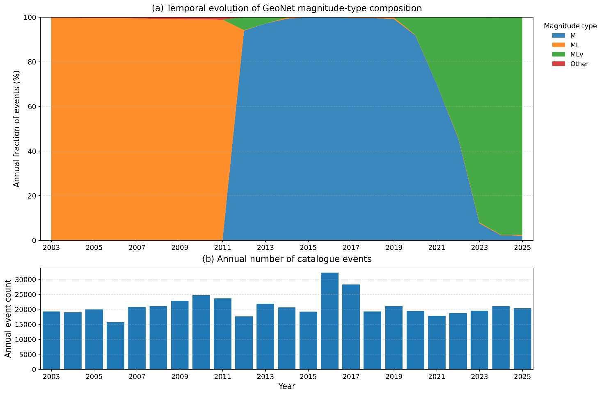
Figure S1. Temporal evolution of magnitude-type composition in the GeoNet earthquake catalogue (2003–2025). (a) Annual fraction of events associated with the dominant operational magnitude labels reported by GeoNet. The catalogue is overwhelmingly dominated by three magnitude types, M, M_{L}, and MLv, which together account for more than 99% of all processed events. Their relative contribution changes markedly through time, with M_{L} dominating the early part of the catalogue, M prevailing during most of the intermediate period, and M_{Lv} becoming increasingly prevalent in the most recent years. This temporal evolution demonstrates that the operational catalogue magnitude is not stationary in terms of magnitude-type composition throughout the study period. (b) Annual number of catalogue events. The combined effect of changing magnitude-type composition and variable annual event counts provides additional motivation for adopting a time-dependent calibration between the operational catalogue magnitude, $M_{cat}$, and moment magnitude derived from GeoNet moment tensor solutions, $M_{w}^{MT}$.

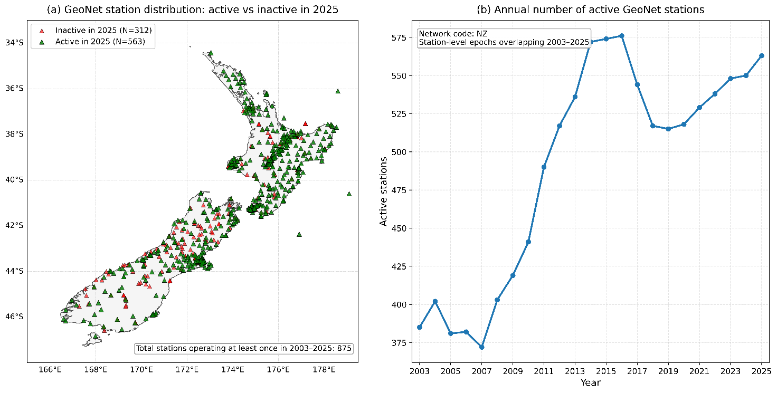
Figure S2. Evolution of the GeoNet seismic network during the study period (2003–2025). (a) Spatial distribution of GeoNet seismic stations operating during the study period. Stations that remained active in 2025 are shown in green, whereas stations that were active at some point between 2003 and 2025 but were no longer operating in 2025 are shown in red. The map illustrates both the current network configuration and the cumulative historical footprint of the network. (b) Annual number of active GeoNet stations derived from station metadata. The network expanded substantially during the study period, increasing from approximately 380 active stations in the early 2000s to more than 550 stations in recent years. This progressive increase in network coverage provides an observational basis for the expected temporal evolution of earthquake detectability, catalogue completeness, and magnitude-estimation performance.

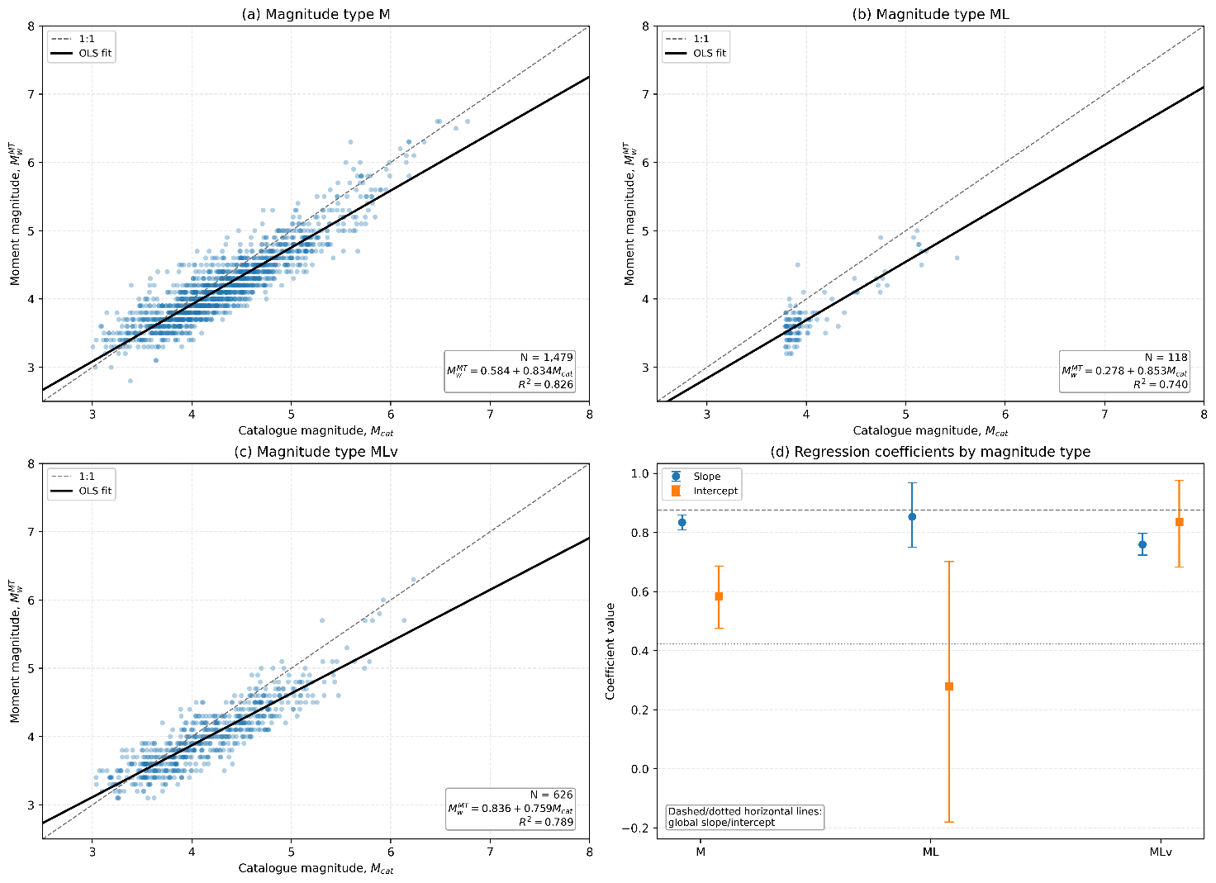
Figure S3. Magnitude-type-specific regression sensitivity of the catalogue-to-moment-magnitude calibration. (a–c) Ordinary least-squares relationships between operational catalogue magnitude, M_{cat}, and moment magnitude from GeoNet moment tensor solutions, $M_{w}^{MT}$, computed separately for the three dominant magnitude types: M, M_{L}, and M_{Lv}. Dashed lines indicate the 1:1 relation and solid lines the corresponding type-specific linear fits; the number of matched events, fitted regression equation, and coefficient of determination are reported in each panel. The resulting slopes are approximately 0.834 for M, 0.853 for ML, and 0.759 for M_{Lv}, showing broadly linear relationships but measurable differences among magnitude types. (d) Comparison of the fitted slopes and intercepts for the three magnitude types, with uncertainty bars; horizontal reference lines indicate the slope and intercept of the global catalogue-to- regression. The diagnostic confirms that magnitude-type-specific differences exist, particularly for MLv, while supporting the use of the unified calibration as an operational catalogue-level homogenization rather than as a physical conversion law for any individual magnitude scale.

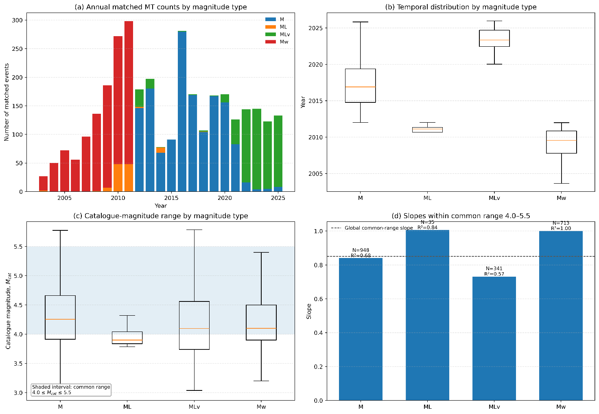
Figure S4. Temporal and magnitude-range diagnostics of magnitude-type-specific calibration. (a) Annual number of earthquakes with matched catalogue magnitudes and GeoNet moment tensor solutions, subdivided by operational magnitude type. The relative contribution of M, M_{L}, M_{Lv}, and M_{w} changes markedly through time, demonstrating strong temporal segregation among magnitude types within the calibration dataset. (b) Distribution of occurrence years for the matched events associated with each magnitude type, further illustrating their different temporal sampling. (c) Distribution of $M_{cat}$ for each magnitude type. The shaded interval, $4.0≤M_{cat}≤5.5$, defines the magnitude range common to the principal types and used for the controlled comparison in panel (d). (d) Type-specific regression slopes estimated using only events within this common magnitude interval. Sample size N and R² are reported above each estimate, and the dashed horizontal line indicates the global common-range slope. Restricting the analysis to a common magnitude range reduces differences associated with unequal magnitude support but does not remove the lower slope observed for M_{Lv}, whereas the M_{L} estimate is based on substantially fewer matched events. These diagnostics show that magnitude type, observation time, and sampled magnitude range are partially confounded and therefore motivate interpreting the type-specific regressions as sensitivity tests rather than independent magnitude-conversion laws.

