Supplementary Material

Wolfram W. Rudolph and Gert Irmer: Raman spectroscopic studies and DFT calculations of sodium formate solutions.

Journal of Solution Chemistry, 2022; #JOSL-D-21-00218

Table S1. Electronic energy and trend of the geometrical parameters for the cluster HCO₂⁻ ·nH₂O (n = 1-5) and HCO₂⁻ ·5H₂O·H₂O bond lengths a_{ij} (in Å), angles α_{ijk} and dihedral angle d₂₁₃₄ of the HCOO⁻ ion (see Figure S1) derived from DFT calculations (B3LYP/ 6-311++G(3df,2pfd)).

 | HCO₂⁻  in vacuo | HCO₂⁻·H₂O | HCO₂⁻·2H₂O | HCO₂⁻·4H₂O | HCO₂⁻ ·5H₂O | HCO₂⁻ ·5H₂O  ·H₂O
E_{electr} /  Hartree | -189. 284288 | -265.77727 | -342.26555 | -495.233617 | -571.715373 | -648.196940
a_{1,2} | 1.249 | 1.252 | 1.246 | 1.252 | 1.249 | 1.247
a_{1,3} | 1.249 | 1.252 | 1.256 | 1.254 | 1.259 | 1.262
a_{1,4} | 1.136 | 1.126 | 1.121 | 1.114 | 1.109 | 1.108
α_{2,1,3} | 130.44° | 129.46° | 129.52° | 128.01° | 127.08° | 127.00°
α_{2,1,3,4} | 180.00° | 180.00° | 179.90° | 179.76° | 179.89° | 179.86°
a_{2,6} |  | 2.021 | 1.848 | 1.765 | 1.833 | 1.701
α_{2,6,5} |  | 143.32° | 172.41° | 173.96° | 172.31° | 177.54°
a_{3,9} |  |  | 1.682 | 1.967 | 2.127 | 2.052
α_{3,9,8} |  |  | 176.34° | 163.42° | 155.46° | 159.25°
a_{3,12} |  |  |  | 1.937 | 1.944 | 1.955
α_{3,12,11} |  |  |  | 159.84° | 161.50° | 160.55°
a_{2,15} |  |  |  | 2.004 | 1.794 | 1.992
α_{2,15,14} |  |  |  | 151.81° | 174.09 | 165.03°
a_{3,18} |  |  |  |  | 1.798 | 1.798
α_{3,18,17} |  |  |  |  | 174.28° | 175.60°
a_{2,21} |  |  |  |  |  | 3.499
α_{2,21,20} |  |  |  |  |  | 123.08°

Table S2. Vibrational frequencies of DCO₂⁻ in a solid neon matrix (ref. [1]) and DFT calculations of harmonic and anharmonic frequencies.

modes | description of n.m. | DCO₂⁻ [1]  (Ne-matrix) | harmonic  frequencies | anharmonic  frequencies
ν₃ (a₁) | OCO scissor | 736.9 | 739.6 | 734.2
ν₄ (b₁) | C-D out-of-plane def. | - | 905.0 | 891.2
ν₂ (a₁) | C-O sym. stretch | 1309.1 | 1329.5 | 1307.1
ν₆ (b₂) | C-D in-plane def. | - | 1007.3 | 986.8
ν₅ (b₂) | C-O antisym. stretch | 1625.0 | 1656.4 | 1626.9
ν₁ (a₁) | C-D stretch | 1844.6 | 1877.2 | 1729.6

Table S3. Assignment of the vibrational modes including the combination modes of the formate ion in NaHCOO solution in water and heavy water band positions in cm⁻¹). The relative integrated intensity was given as % intensity with respect to the one for the strongest band, ν₂ which was set at 100.
modes | Normal vibrations | 9.245 molL⁻¹ (H₂O) | Relative  Intensity | Fwhm / cm⁻¹ | Depol. ratio | 9.020 molL⁻¹ (D₂O)
ν₃ | OCO scissor | 766 | 3.84 | 27.0 | 0.33 | 772
ν₆ | C-H out-of-plane def. | 1067 | 2.66 | 11.6 | 0.73 | 1063
ν₂ | C-O sym. stretch | 1352.2 | 100 | 18.1 | 0.125 | 1352
ν₅ | C-H in-plane def. | 1383 | 6.86 | 14.3 | 0.415 | 1381
ν₄ | C-O antisym. stretch | 1592 | 2.13 | 47 | ~0.62 | 1596
 | combination | 2128 | 0.369 | 26.9 | 0.31 | 2128
ν₁ | C-H stretch * | 2732  2818 | 27.90  67.32 | 42.3  42.0 | 0.26  0.21 | 2727  2817
 | combination | 2974 | 5.00 | 42.3 | 0.30 | 2971

*) The band doublet is a result of Fermi resonance of the first overtone of ν₆ (2ν₆) with ν₁ and the unperturbed mode ν₁ was calculated at 2785 cm⁻¹ for HCOO⁻(aq) and at 2782 cm⁻¹ for HCOO⁻(D₂O).
Table S4. Trend of the wavenumber band positions (ν_{max} in cm⁻¹) and depolarization values (ρ) from DFT calculations on HCOO⁻·nH₂O clusters (n = 0 - 5) and a cluster HCOO⁻·5H₂O·H₂O compared to the experimental Raman data such as wavenumbers (ν_{max} in cm⁻¹) and depolarization degrees (ρ) on HCOO⁻(aq).

Descr. of modes | Experimental Raman data |  | HCOO⁻ in vacuo |  | HCOO⁻·H₂O |  | HCOO⁻·2H₂O |  | HCOO⁻·4H₂O |  | HCOO⁻·5H₂O |  | HCOO⁻·5H₂O·H₂O
Descr. of modes | ν_{max} | ρ | ν_{max} | ν_{max} | ν_{max} | ν_{max} | ν_{max} | ρ | ν_{max} | ρ | ν_{max} | ρ | ν_{max} | ρ
ν₃ | 762 | 0.33 | 746.9 | 0.049 | 759.8 | 0.02 | 754.1 | 0.03 | 770.6 | 0.31 | 766.1 | 0.56 | 768.9 | 0.68
ν₆ | 1066 | 0.74 | 1045.7 | 0.75 | 1052.0 | 0.75 | 1058.0 | 0.75 | 1067.5 | 0.75 | 1072.5 | 0.75 | 1073.5 | 0.75
ν₂ | 1350 | 0.13 | 1342.5 | 0.61 | 1353.7 | 0.74 | 1365.1 | 0.73 | 1375.4 | 0.45 | 1378.3 | 0.29 | 1374.2 | 0.27
ν₅ | 1383 | 0.42 | 1374.1 | 0.75 | 1380.0 | 0.75 | 1391.6 | 0.74 | 1389.8 | 0.73 | 1403.4 | 0.62 | 1401.4 | 0.53
ν₄ | 1586 | 0.62 | 1660.4 | 0.75 | 1642.1 | 0.75 | 1647.9 | 0.73 | 1627.7 | 0.70 | 1633.3 | 0.72 | 1628.9 | 0.70
ν₁ | 2731  2818 | 0.26  0.21 | 2567.4 | 0.28 | 2679.7 | 0.30 | 2736.8 | 0.29 | 2816.8 | 0.31 | 2875.2 | 0.32 | 2886.0 | 0.31

Table S5.A Band parameters such as peak position, fwhm (in cm⁻¹) and integrated band intensity of the symmetric stretching mode ν₂ -COO⁻ as a function of NaHCOO concentration (in molL⁻¹). The molar ratio water to NaHCOO expressed as R_{w} is also given.

Concentration | R_{W} | peak position | fwhm | integrated band intensity
9.459 | 4.04 | 1352.25 | 18.22 | 129783.0
9.245 | 4.18 | 1352.20 | 18.15 | 129187.2
7.888 | 5.22 | 1351.91 | 17.95 | 122800.9
6.123 | 7.31 | 1351.42 | 17.16 | 114263.0
4.878 | 9.68 | 1351.02 | 16.15 | 99787.2
3.980 | 12.28 | 1350.72 | 15.01 | 82602.0
2.008 | 26.04 | 1350.16 | 13.74 | 39983.3
1.001 | 53.87 | 1350.04 | 13.44 | 20102.0
0.732 | 74.15 | 1350.03 | 13.38 | 15665.8
0.312 | 175.99 | 1350.01 | 13.31 | 6677.6
0.102 | 541.40 | 1349.98 | 13.28 | 2290.1
0.0645 | 857.04 | 1349.97 | 13.27 | 1448.1

Table S5.B Band parameters such as peak position, fwhm (in cm⁻¹) and integrated band intensity of the symmetric stretching mode ν₂ -COO⁻ as a function of NaDCOO concentration (in molL⁻¹). The molar ratio water to NaDCOO expressed as R_{w} is also given.

Concentration  molL⁻¹ | R_{W} | peak position | fwhm | integrated band intensity
3.950 | 12.33 | 1324.95 | 10.10 | 10965
1.972 | 26.49 | 1324.21 | 9.31 | 5655
0.861 | 62.74 | 1323.95 | 8.85 | 2861
0.287 | 191.32 | 1323.83 | 8.71 | 941.3
0.144 | 384.26 | 1323.80 | 8.68 | 450.1
0.0718 | 770.17 | 1323.78 | 8.66 | 208

Table S6. Electronic energy and geometrical parameters for the cluster Na⁺(H₂O)₄HCOO⁻ and Li⁺(H₂O)₄HCOO⁻ such as bond lengths a_{ij} (in Å), angles α_{ijk} and dihedral angle d₂₁₃₄ of the HCOO⁻ ion (see Figure 8) derived from DFT calculations (B3LYP/6-311++G(3df,2pfd)). Note that the average Na⁺-O bond distances at 2.308 Å and Li⁺-O: at 1.970 Å are close to the ones for [Na(OH₂)₅]⁺ respectively [Li(OH₂)₄]⁺.

 | HCOO⁻  in vacuo | HCOO⁻  + solvation sphere | HCOO⁻Na⁺(H₂O)₄ | HCOO⁻Li⁺(H₂O)₄
E_{electr /}  Hartree | -189.28428 | -189.39474 | -657.549403 | -502.789591
a_{1,2} | 1.249 | 1.252 | 1.249 | 1.253
a_{1,3} | 1.249 | 1.252 | 1.262 | 1.259
a_{1,4} | 1.136 | 1.118 | 1.105 | 1.105
α_{2,1,3} | 130.44° | 128.31° | 125.15° | 125.93°
α_{2,1,3,4} | 180.00° | 180.00° | 179.97° | 179.90°
a_{2,17} |  |  | 2.323 | 1.969
a_{17,14} |  |  | 2.322 | 1.997
a_{17,5} |  |  | 2.288 | 1.945
a_{17,8} |  |  | 2.297 | 1.970
a_{2,15} |  |  | 1.871 | 1.994
a_{3,9} |  |  | 1.731 | 1.745
a_{3,12} |  |  | 1.777 | 1.802
a_{3,6} |  |  | 3.499 | 3.369
a_{17,3} |  |  | 3.247 | 3.046
a_{17,11} |  |  | 3.702 | 3.513
α_{17,2,1,3} |  |  | 1.599° | 0.265°

The calculated bond distances may be compared with experimental results from neutron scattering on an aqueous 15 mol% DCOONa solution and X-ray diffraction on an aqueous 15 mol% HCOONa solution from ref.[2] Neutron scattering, intramolecular bond distances: r_{CD} = 1.07 ± 0.01 Å, r_{CO} = 1.272 ± 0.007 Å and r_{OO} = 2.18 ± 0.02 Å, cluster DCOO⁻Na⁺(D₂O)₅ : r_{CD} = 1.109 Å, r_{CO} = 1.256 Å and r_{OO} = 2.245 Å. X-ray diffraction: r_{Oformate}···r_{OH2}= 2.82 ± 0.01 Å, r_{Na}⁺···H₂O = 2.37 ± 0.01 Å. From our DFT calculations on cluster HCOO⁻(H₂O)₅ follows r_{Oformate}···r_{OH2}= 2.85 Å and for cluster Na⁺(H₂O)₅: r_{Na}⁺···H₂O = 2.39 Å.

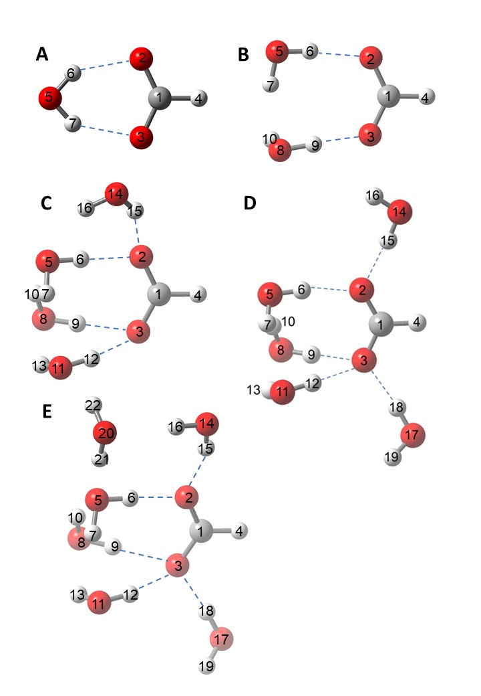

Figure S1. Five selected formate-water clusters with different numbers of water molecules; HCOO⁻∙nH₂O∙mH₂O (n = 1-5, m=1). See Table S1 for the geometrical parameters of the clusters HCOO⁻·nH₂O·mH₂O such as bond lengths a_{ij} (in Å), angles α_{ijk} and dihedral angle d₂₁₃₄ of the HCOO⁻.

Figure S2. Concentration profile of isotropic Raman spectra of four aqueous NaHCOO solutions at 9.245 mol L⁻¹ (first profile at bottom), at 3.980 mol L⁻¹ (second profile from bottom), at 2.008 mol L⁻¹ (third profile from bottom) and at 0.732 mol L⁻¹ (fourth profile from bottom) in the O-H stretching region of water. In comparison the O-H profile of neat water (profile on top) is shown. Note, the C-H stretching band of HCOO⁻(aq) at ca. 2800 cm⁻¹ appears as a Fermi doublet (see Table 3 and S3).

Figure S3. Raman scattering profiles (polarized and depolarized) and underneath depolarization degree over the O-H stretching band are given of H₂O in a saturated NaHCOO solution at 9.459 molL⁻¹ (left graph). Shown is the wavenumber range from 2600 – 3900 cm⁻¹. Note the strong C-H bands of HCOO⁻(aq) (see also Table 2 and S2). In the same wavenumber range the O-H stretching band, polarized and depolarized, for neat water are given as well as the depolarization degree over the O-H stretching region (graph at right).

Figure S4. Stack plot of four isotropic Raman scattering profiles of NaHCOO(aq) (R-format) in the low frequency region/terahertz region. Concentrations from top to bottom: at 9.245 molL⁻¹, 3.980 molL⁻¹, 2.008 molL^{-1,} and 0.732 molL⁻¹. The broad bands at 174 cm⁻¹ shows the O-H···O restricted translation mode H-bonds of water in different environments and shifts with concentration slightly to higher wavenumbers. In a NaHCOO(aq) solution at 0.732 molL⁻¹ the water molecules dominate and at a concentration at 9.245 molL⁻¹ water is mostly coordinated to Na⁺ as Na⁺-(OH₂) and OH···O_{Formate}.

Figure S5. Raman scattering profiles in R-format (Upper panel: polarized, depolarized and Lower panel: isotropic scattering) of the same saturated NaHCOO(aq) solution at 9.459 mol L⁻¹ in the low wavenumber region from 53 – 845 cm⁻¹. Note that the scattering profiles were scaled by a factor of 75 compared to the one in Figure 2. The broad band at 162 cm⁻¹ in the R_{VV} scattering shows the O-H···O restricted translation mode of water in different structural arrangements in such a concentrated solution such as O-H···O_{Formate}, Na⁺-HOH···O_{Formate} etc. In the isotropic scattering, as shown in the lower panel, the band appears as a broad band showing the Na⁺-(OH₂) stretching mode at 194 cm⁻¹ and the HCOO⁻···H-OH hydrogen bonds of carboxylate oxygen with water at 256.5 cm^{-1.}

Figure S6. Raman spectrum (polarized, depolarized und isotropic) of a 0.732 molL⁻¹ Na-formate solution plus 8.420 molL⁻¹ LiCl (mole ratio Li⁺ : HCOO⁻ = 11.06). The band, ν₂ HCOO⁻, the symmetric stretch of COO⁻, is in this LiCl(aq) solution shifted by 8 cm⁻¹ wavenumbers to higher peak positions compared to the solution of the same NaHCOO(aq) solution without LiCl. The band width is also broadened by a factor of 1.72 in the solution containing LiCl compared with the one without LiCl added. The ν₂ was fitted with free component bands at 1358 cm⁻¹, at 1364 cm⁻¹ and at 1387 cm⁻¹. The scissor mode ν₃ is also noticeably shifted to higher wavenumbers and appears as a broader band at 776 cm⁻¹ compared to 762 cm⁻¹ observed for the formate solution without LiCl added.

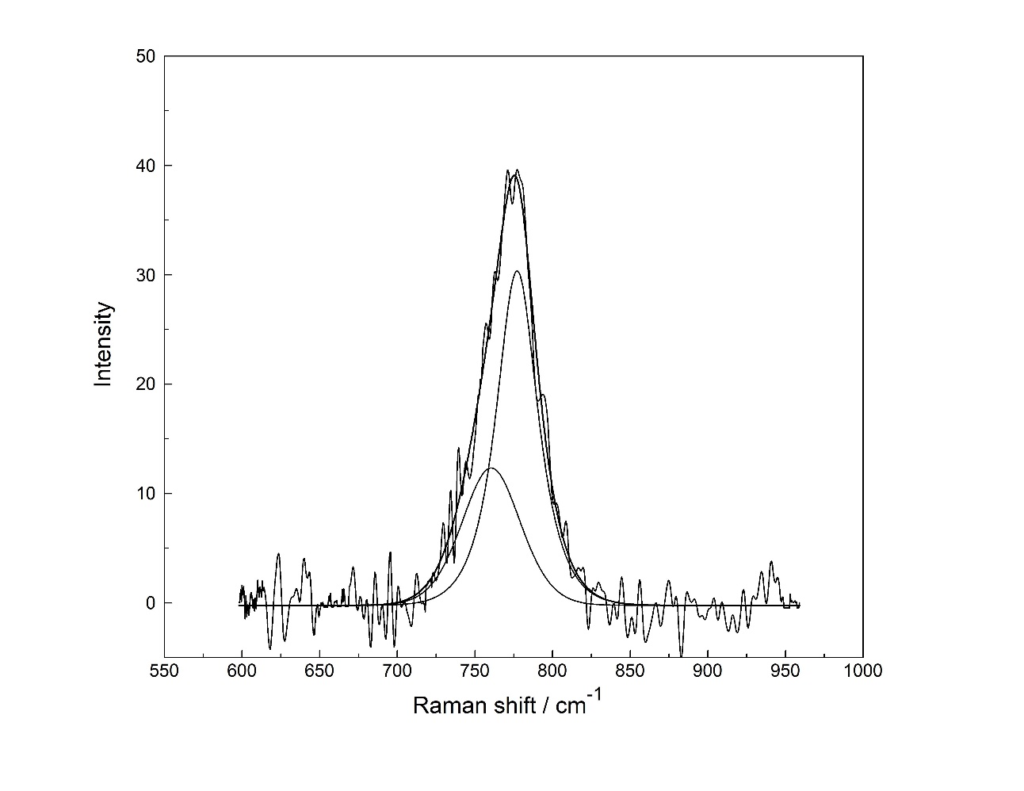

Figure S7. Isotropic Raman spectrum of a 0.732 molL⁻¹ sodium formate solution plus 8.420 molL⁻¹ LiCl. The band fit of the scissor mode, ν₃ is shown with the measured spectrum (baseline corrected), the sum curve and two component bands. The component bands of the scissor mode ν₃ were fitted with two Lorentz bands a much less intense band at 760.4 cm⁻¹ and a main band at
777.1 cm⁻¹.

1. Forney, D., Jacox, M.E., Thompson, W.E.: Infrared spectra of trans-HOCO, HCOOH+, and HCO2− trapped in solid neon. J. Chem. Phys. 119(20), 10814-10823 (2003). doi:10.1063/1.1621382
2. Kameda, Y., Takahiro, M., Takashi, N., Takeshi, U., Osamu, U.: Structure of Concentrated Aqueous Sodium Formate Solutions. Bulletin of the Chemical Society of Japan 69(6), 1495-1504 (1996). doi:10.1246/bcsj.69.1495

