Appendix A: TTO presence in ANZ universities
Global rankings |  | University | Country/ TTO status | TTO
World | Science | University | Country/ TTO status | TTO
31 | 133 | Australian National University | AU/Y | Innovation ANU
40 | 22 | University of Sydney | AU/Y | Commercialisation Development and Industry Partnerships Team
41 | 25 | University of Melbourne | AU/Y | UoM Commercialisation Ltd/Technology Licensing Services  within Research, Innovation & Commercialisation
44 | 66 | University of New South Wales | AU/Y | New South Innovations
46 | 38 | University of Queensland | AU/Y | UniQuest
55 | 35 | Monash University | AU/Y | Monash Innovation
81 | 94 | University of Auckland | NZ/Y | UniServices
92 | 100 | University of Western Australia | AU/Y | Research Development and Innovation Office
106 | 100 | University of Adelaide | AU/Y | Division of Research & Innovation
133 | N/A | University of Technology Sydney | AU/Y | Research and Innovation Office
184 | 100 | University of Otago | NZ/Y | Otago Innovation
196 | 401-450 | University of Wollongong | AU/Y | Innovation & Commercial Research
197 | 177 | University of Newcastle | AU/Y | Newcastle Innovation
214 | 290 | Macquarie University | AU/Y | Commercialisation and Innovation
217 | 233 | Queensland University of Technology | AU/Y
217 | 304 | Curtin University | AU/Y
223 | N/A | Victoria University of Wellington | NZ/Y | Wellington UniVentures
223 | N/A | RMIT University | AU/Y | Research, Innovation & Entrepreneurship team
270 | N/A | University of Canterbury | NZ/Y | IP Commercialisation
272 | 385 | Massey University | NZ/Y | Massey Ventures
275 | 230 | Deakin University | AU/Y | Business and research partnerships
295 | 307 | University of South Australia | AU/Y | UniSA Ventures
303 | 273 | Griffith University | AU/Y | Griffith Enterprise
308 | N/A | University of Tasmania | AU/Y | Innovation and Enterprise Office
372 | N/A | Swinburne University of Technology | AU/Y
375 | N/A | University of Waikato | NZ/Y | WaikatoLink
387 | N/A | Lincoln University | NZ/P | Research Management Office
398 | 294 | La Trobe University | AU/Y | Innovation & Commercialisation
414 | N/A | Bond University | AU/N
423 | 301 | Flinders University | AU/Y | Flinders Partners
437 | 451-500 | Auckland University of Technology | NZ/Y | AUTEL
456 | N/A | University of Canberra | AU/P | Engage UC
462 | 335 | James Cook University | AU/Y | JCU Connect
474 | 347 | Western Sydney University | AU/Y | Business Services
551-560 | N/A | Victoria University | AU/Y
571-580 | N/A | Murdoch University | AU/Y | Industry & partnerships
591-600 | N/A | Central Queensland University | AU/Y | Office of Engagement & Campuses
651-700 | N/A | Edith Cowan University | AU/P | Office of Research & Innovation
701-750 | N/A | Charles Darwin University | AU/P | Research Grants and Business Development Team
701-750 | N/A | University of Southern Queensland | AU/N
751-800 | N/A | Southern Cross University | AU/P | Engagement team
801-1000 | N/A | Australian Catholic University | AU/N
801-1000 | N/A | Charles Sturt University | AU/N
801-1000 | N/A | University of New England Australia | AU/N
N/A | N/A | University of the Sunshine Coast | AU/N
N/A | N/A | Torrens University Australia | AU/N
N/A | N/A | University of Divinity | AU/N
N/A | N/A | Carnegie Mellon University - Australia | AU/P | Centre for Technology Transfer and Enterprise Creation
N/A | N/A | Federation University Australia | AU/P | Research and Innovation team
N/A | N/A | University of Notre Dame Australia | AU/P | Research Office  Research Development and Grant Management
N/A | N/A | University College London | AU/Y | UCLB

Appendix B: Interview Guide (TTO Experts)
Part 1: TTO EXPERT PROFILE
Role with (TTO name) [probe for key responsibilities, reports, relationships with other departments/parts of the university/individual researchers/external relationship building, etc]
Part 2: TNCs
- When a research group approaches with opportunity, next steps? [probe]
- At what stage would you generally present an opportunity to a potential partner?
- To what extent have you been involved with TNCs? [Probe technology licensing, research collaboration, other]
- Opportunities presented to TNCs past 2-3 years:
  - Example of ‘good’ relationship [probe for what, why, how, when, where, who]
  - Extent of direct contact between the researcher and TNC?
  - Results / outcomes? [probe for how learnings/information is handled]
  - Example of ‘bad’ relationship [probe for what, why, how, when, where, who]
- Opportunities developed at the request of TNCs? Extent of project involvement?
- Extent to which TNCs approach TTO? [specific research projects, researchers, knowledge management]
- Barriers / challenges when working with TNCs
Part 3: RESEARCHERS/TECHNOLOGY DEVELOPERS
- How do researchers decide research direction? [probe]
- To what extent do researchers approach the TTO for advice? [probe stage and type of information sought]
- Day-to-day barriers / challenges when working with researchers?

Appendix C: Coding framework
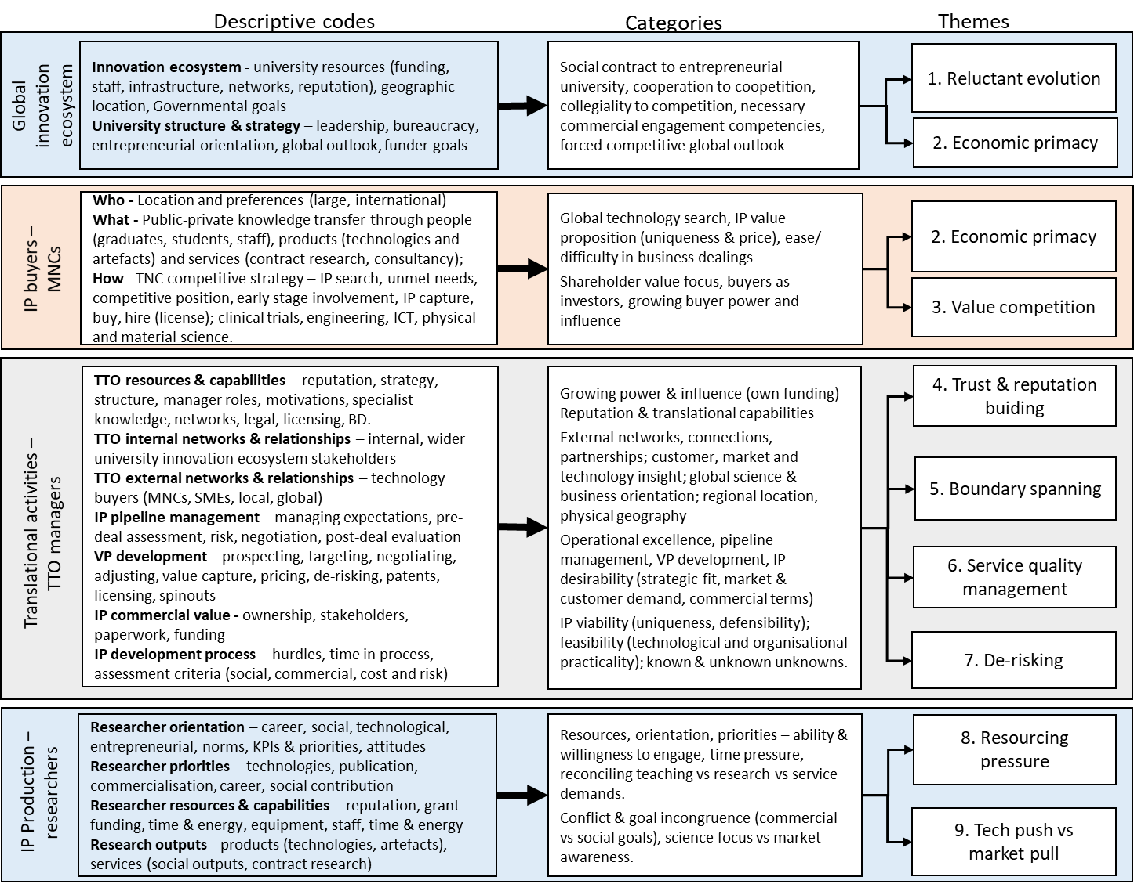

Y= TTO, N=no TTO, P=no formal TTO, however informal industry knowledge transfer activities
QS 2021 World Ranking
QS 2020 Life Sciences + Medicine Ranking

