Landscapes for Neolithic People in Mainland, Orkney
JANE BUNTING, MICHELLE FARRELL, ELAINE DUNBAR, PAULA REIMER, ALEX BAYLISS, PETER MARSHALL AND ALASDAIR WHITTLE (Corresponding author: Department of Archaeology and Conservation, Cardiff University, whittle@cardiff.ac.uk)
Supplementary Information S2: Multiple Scenario Approach to land cover reconstruction
This study forms part of The Times of Their Lives project, funded by the European Research Council (Advanced Investigator Grant 295412). This enabled new programmes of radiocarbon dating and chronological modelling to be undertaken on a series of Late Neolithic archaeological sites in Mainland, Orkney (Barnhouse (Richards et al., 2016); Ness of Brodgar (Card et al., 2018) and Skara Brae (Clarke & Shepherd, forthcoming)) and other islands (Pool, Sanday (MacSween et al., 2015); Links of Noltland, Westray (Clarke et al., 2017)) and palaeoenvironmental sequences in Mainland, Orkney (see Supplementary Information S1; Table 1).

All the land cover modelling discussed in the main publication has been undertaken using the Multiple Scenario Approach (MSA), outlined in Bunting & Middleton (2009). Two groups of assumptions need to be made to effectively apply the approach, firstly about the past ecosystem and secondly about the appropriate model of pollen dispersal and deposition. Here we outline the parameters and assumptions and summarise the analytical strategy used to produce the land cover reconstructions presented in the main publication.

Landscape scenarios were produced using LandPolFlow software (Middleton, unpublished) for a 50 m pixel grid of dimensions 32km x 30k m centred on the Heart of Neolithic Orkney UNESCO World Heritage Site (Figure 1).

Environmental constraints for creation of possible land cover grids
Within the MSA, a Geographic Information System (GIS) is used to combine knowledge of past environmental constraints, such as topography and geology, with simple ecological principles to generate possible land cover maps. This section first outlines the approaches used to derive a variety of environmental input grids used to constrain distribution of vegetation communities in the MSA modelling of our Orcadian study area then considers how those communities are defined and parameterised within the model.

Topography
We used a DEM of modern surface elevations derived from Ordnance Survey PANORAMA DTM NTF geospatial data supplied by EDINA Digimap at a scale of 1:50,000 as a starting point for land cover modelling. The NTF data were clipped to the spatial extent of the study area and converted to IDRISI format using the GridIn application (Middleton, unpublished).

Surficial geology
The bedrock geology of the study area is dominated by Old Red Sandstone of Devonian age (Mykura, 1976) and was not used to constrain placement of vegetation communities as we considered that the minimal variation in rock type across the study area would be unlikely to have a significant effect on vegetation distribution. However, the surficial geology of the islands which includes glacial deposits, post-glacial windblown sand and peat does affect the vegetation types present. A surficial geology input grid was created in ArcGIS 10.3.1 and converted to IDRISI format using the GridIn application (Middleton, unpublished). The surficial geology grid is based on British Geological Survey SHAPE geospatial data provided by EDINA Digimap at a scale of 1:625,000.

Palaeogeography
There is little data relating to the palaeogeography of Orcadian lochs, with the exception of Loch of Stenness. Here, a palaeoenvironmental investigation of several sequences recovered from the loch has demonstrated that the loch level has risen since the early Neolithic (Bates et al., 2016). We decided to use modern loch shoreline positions for every timeslice since Bates et al. (2016) present a single palaeogeography map rather than reconstructing a timeline of changes that could be used as a model constraint. A shapefile delineating the shores of all lochs with an area greater than one pixel (50m x 50m) was extracted from the British Geological Survey SHAPE surficial geology data provided by EDINA Digimap at a scale of 1:50,000. The shapefile was created in ArcGIS 10.3.1 and converted to IDRISI format using the GridIn application (Middleton, unpublished).

Rising sea-levels have significantly altered the position of the Orcadian coastline during the Holocene, and present sea-level was reached at approximately 2000 cal BC (Wickham-Jones et al., 2016; 2018). In this study we used the modern coastline position for all timeslices, since our current understanding of Holocene sea-level change in Orkney relies heavily on large-scale models produced for north-west Europe (e.g. Sturt et al., 2013). A programme of work that aims to produce local sea-level curves for Orkney is currently underway (Dawson & Wickham-Jones, 2007; Bates et al., 2013), though at present chronological resolution is not sufficient to estimate sea-level for 200-year timeslices as used in our land cover modelling.

Plant community composition
Simplified plant communities were defined on the basis of the typical communities formed by the main types of pollen-producing plants and by current archaeological and palaeoecological interpretation of the ecology of northern and western Scotland, and are described briefly in the main paper. Communities and their composition are summarised in Table S2a. Here we explain the choices made in more detail.

Communities contained a mixture of different taxa. The taxa present were identified based on ecological understanding of broad community types. The ratios of taxa within communities were determined using modern ecological data and, for the two woodland communities and the disturbed ground weed component, the available pollen data were also considered. For each timeslice considered in this study, all the available pollen counts for taxa in a given community were summed, converted to percentages, and then the RPP_{Poaceae} values in Table S2a were used to ‘correct’ the proportions to give a first estimate of the ratios of those types in the source vegetation. This is a very simplistic approach to vegetation reconstruction, essentially the approach of Davis (1963) applied to multiple summed sites. By summing values from multiple small sites, we average out local variations in land cover, using the same logic as the Landcover 6k reconstruction approach which applies REVEALS to the sum of multiple small sites, effectively treating them as sample points within a single large basin (e.g. Trondman et al., 2015). For woodland composition, we took the average proportions of the taxa across all timeslices. For disturbed ground weeds, we took the average proportions of the taxa in timeslices which post-dated the date of Neolithic settlement derived from the modelling of archaeological sites (Figure 2).

Local vegetation at each pollen site was defined from the general site characteristics inferred from the published record, and where details were unclear, multiple options were tested during the early scoping runs (see section on ‘MSA modelling strategy’ below) and the best solution selected for use in later analysis. Loch of Skaill was treated as open water throughout, and no separate local wetland community was modelled for Maes Howe North and Stones of Stenness due to the small size of the sediment units. Bay of Carness, Bay of Skaill, Scapa Bay, Quholm and Lesliedale Moss were all modelled as large mires (250m radius). The Hobbister peatland is known to have been expanding during the period, given the difference between the radiocarbon dates at the base of the HobbA and HobbB cores (Farrell, 2015). Therefore this site was modelled as a mire of 100m radius positioned with HobbA in the centre and HobbB close to the edge. Glims Moss was modelled as a topographically constrained mire filling the basin below 40m asl, with a distinctive vegetation community with fewer vascular plants more akin to a raised mire (named wet mire hereafter and in Table S2a) than the mire community used for the shallower, smaller peat bodies. Spretta Meadow was modelled as a mire of 150m radius. Since the site is topographically confined, the size is unlikely to have changed, and the local vegetation is initially set to wet mire then changed to mire at c. 3000 cal BC, where there was a change in the site stratigraphy implying an increase in vascular plant density.

Pollen dispersal and deposition model
Pollen dispersal and deposition modelling was carried out using the LandPolFlow software package (Middleton, unpublished; Bunting et al., 2018). Pollen loading originating from each pixel in the land cover map and deposited at a specified sample point location was simulated and summed to model the pollen assemblage formed at that sampling point. The underlying model is a simple linear model of the form:

$y_{ik}=α_{i}ψ_{ik}+ω_{i}$ (equation S2 – 1)

where y_{ik} = pollen influx from type i at site k, ψ_{ik} = the distance-weighted plant abundance of taxon i around site k, and α_{i} and ω_{i} are constants, the pollen productivity and background pollen component of taxon i in the studied region respectively (Sugita, 1993; 1994).

In this study, we use the Sutton-Prentice distance-weighting algorithm (Sutton, 1953; Prentice, 1985; 1988), which varies with plant taxon and involves making the following assumptions:
- Even wind distribution around the compass during pollen dispersal,
- Majority of pollen transport takes place above the vegetation canopy (C_{c} from the Tauber (1965; 1967) model dominates),
- The vegetation canopy is a single, flat layer,
- Pollen deposition occurs within a gap in said canopy (this is important to remove effects of the trunkspace and gravity components (C_{t} and C_{g} in Tauber, 1965; 1967).

We also assumed stable atmospheric conditions (but see Jackson & Lyford, 1999):

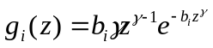 (equation S2 – 2)

Where z = distance to mid-point of ring, γ = 0.125 (Prentice, 1985), and b_{i} is defined as:

$b_{i}=75.2\frac{v_{si}}{u}$ (equation S2 –3)

Where v_{si} is the sedimentation velocity (fall speed) of taxon i and u is the wind speed (3m s⁻¹ was used in all modelling runs). Fall speeds and Relative Pollen Productivity (RPP) estimates are given in Table S2a. These parameters were those estimated for western Europe as a whole (see references in Table S2a), which may not apply fully to the hyperoceanic conditions of Orkney, especially for species close to their range limits (e.g. oak and pine).

Pollen data ‘targets’ for testing modelled land cover scenarios
For each pollen sequence (Figure 1), all samples falling within a particular timeslice (Table 2) were summed and averaged to provide a single pollen assemblage for that time period at each location. Only sites with pollen assemblages dating to the relevant timeslice were included in the modelling, so each timeslice used a slightly different set of pollen records (ranging from four to eight different locations: see Table 2, Table S2b), which will affect the potential sensitivity of the record to changes in land cover within the study area. Sites were reasonably well distributed throughout the study area in all timeslices, and therefore we did not consider this effect to be significant.

MSA modelling strategy
We carried out a minimum of two ‘scoping runs’ and one ‘focus run’ for each of the timeslices. Identification of potential past vegetation mosaics using the MSA relies on the statistical similarity of simulated and actual pollen assemblages, which is measured by a fit statistic. In this study we used the squared chord distance (scd), which is widely used in other palaeoecological reconstruction approaches such as the Modern Analog Technique (Overpeck et al., 1985), and yields values between 0 (assemblages identical) and 200 (assemblages have no taxa in common). Previous work suggests that values of 25 or below show a good match between pollen assemblages from similar vegetation communities (Wahl, 2004). Lower scd values indicate better fits, and therefore suggest that if the assumptions in the pollen dispersal and deposition model are valid then the land cover map producing the lowest fit score is the most likely reconstruction of the past land cover that produced the actual pollen assemblage. Since multiple pollen sites were available in each timeslice, individual site fits could be summed to give an overall fit score.

The first scoping run considered a very broad range of options from a 100% wooded landscape (birch-hazel woodland) to one which was 100% cleared, with a range of options for the presence of disturbed ground, oak-pine woodland and heathland communities. The results were then used to constrain further scoping runs with a smaller range of options (limited to the range of values which produced the best fits for each individual site, as well as for all sites when considered together), which enabled more repeats of each set of parameters to be explored allowing for the effects of chance (e.g. placement of a random stand of woodland close to or far from a particular pollen site), since pollen records from smaller sites in particular are known to be sensitive to variations in vegetation patterning within a few hundred metres, as well as overall land cover composition (Bunting et al., 2004). From these scoping runs, “focus” scripts were created which modelled only the relatively narrow range of conditions which produced the best overall fit score, ran a larger number of replicates, and saved images of those land cover maps with the best overall fit score for each timeslice.

MSA output: assessment of reconstruction fit
Figure S2a compares the fit scores for each timeslice based on overall best fit (standardised by the number of sites – black bars) and on the averages for individual sites (examined separately to explore possible variations within the landscape – grey bars). All values are below 35, and most are close to 25, suggesting fits are as good as those expected to occur between modern pollen samples collected within the same communities (see e.g. Lytle & Wahl, 2005). These results suggest that the reconstructions identified can be considered broadly reliable, assuming the validity of the pollen dispersal and deposition model assumptions.

Table S2b summarises the best fit scores for individual sites. Some sites’ pollen assemblages are clearly better modelled by the range of scenarios considered than others — for example, Loch of Skaill (LoS) has scores below 10 throughout, whilst SK134/94 never have a score below 25. This is in part likely to reflect the degree of uncertainty about the type and size of pollen trapping site present during the study period. Loch of Skaill, which is still present in the landscape as an intact lake, is clearly topographically confined, and there is no surface vegetation to try and model. The SK cores come from a coastal lagoon margin with a dynamic sedimentary environment shown through stratigraphy, pollen, mollusc and ostracod analyses (de la Vega Leinert et al., 2000). At many locations, fit scores vary quite widely – we interpret this as showing that local site characteristics were changing during the study period, and reconstructing past size and vegetation cover of sites is difficult both due to lack of data in published sources and to loss of data from the sites themselves, for example active peat extraction at Hobbister and coastal erosion at the Bay of Skaill.

MSA output: effects of long-distance pollen inputs
The modelling approach employed in this study assumes that all pollen is sourced from within the modelled area of Orkney; at least for pine, a long-distance component from Hoy and from northern Scotland will also have contributed to the actual pollen assemblages, and this may partly explain the apparent stability of the oak-pine community compared with the variability of the birch-hazel woodland. The relatively small number of sites in any one timeslice and the variations in which sites are included in each timeslice are likely to contribute to the variability seen, but the overall pattern provides some detail on likely location of wooded areas.

Comparison with Bunting et al. (2018) and future developments
Bunting et al. (2018) included some results from an earlier version of this modelling work. The main differences between that earlier version and the results of the enhanced analysis presented in this paper are considered here.

First, the original analysis assumed that the ‘disturbed’ community which signalled human occupation was created by cereal cultivation, and the pre-Neolithic grassland community was assumed not to be altered by human activities such as the introduction of new species of herbivore or the changing dynamics of existing species. However, archaeological evidence suggests that the economy of Neolithic Orkney was based on animal husbandry with only occasional cereal cultivation. The pollen signal of cereal cultivation is also problematic, especially in landscapes such as northern Scotland where the most common early cultivar was barley. Most cereal pollen grains are only distinguished from wild grasses on the basis of grain size, with some support from surface texture. The size range of barley pollen, especially of more primitive landraces, overlaps with some of the larger wild grasses such as Glyceria, commonly found in wet flushes in grassland or along streams, and Zostera (eelgrass), which may be present in coastal lagoon type habitats. Different studies either use slightly different criteria for distinguishing cereal pollen, or do not report whether differentiation was attempted at all. Cereal pollen is under-represented in the pollen record, so the accuracy of percentages of cereal pollen is lower than for better-represented taxa such as Plantago lanceolata or Betula, and absence of pollen does not mean absence of any cereal cultivation in the wider landscape. Relative Pollen Productivity (RPP) values for cereals are based on modern data, and domesticates like cereals have clearly been selectively bred and altered over the millennia since the first Neolithic farmers settled in Orkney, meaning that our estimated values may be less reliable than those for plants which have not undergone active, deliberate selection; available estimates come from landscapes which are mostly planted with modern monocrop industrial-agriculture strains. Therefore removing the cereal pollen count from the dataset, focusing on a more general disturbance signal, and assuming that the introduction of new species of herbivores in some numbers would have affected the wider grassland areas provides a more robust set of assumptions for the landscape reconstructions presented in this paper.

Secondly, the woodland community composition in the original analysis was based on observations of remaining fragments of ‘semi-natural’ woodland in northern Scotland. There is no reason to believe that surviving fragments are good indicators of the ‘wildwood’ due to biases of survival (woodland on poor soils, steep slopes, and other places unsuited for crop cultivation and difficult for grazing animals to access is most likely to survive into the modern landscape). The revised analysis presented here uses the pollen data taken as a whole to propose woodland composition. This is also not ideal as it has an element of ‘double-dipping’, since the pollen assemblages are both used to define the community composition and to test different abundances of that community against, but by averaging values across all sites and timeslices, the effect should be minimised. The MSA does not easily allow for a ‘leave one out’ strategy. A record from a very large site which effectively lacks a local pollen signal (Sugita, 1994; 2007) could be used for community specification if one were available.
Thirdly, in the original analysis different patch sizes of woodland as well as different overall coverage of woodland were included as scenario options, and Bunting et al. (2018) showed that equifinal solutions occurred – that is, that equally good fit landscape reconstructions could be obtained with different assumptions about woodland organisation in the landscape. In the revised analysis, patch size was not considered, only overall woodland coverage. We chose not to include patch size in the new simulations for two reasons. First, the focus of our research questions was on overall landscape cover rather than on the local landscapes around individual basins, and so details of the vegetation structure were deemed less important than overall composition. Secondly, patches smaller than the size of the sedimentary basin are not effectively detected by pollen signals (Sugita, 1994), and most of our basins are large compared with the sizes of woodland patch considered (Bunting et al., 2018).
Fourthly, results from the original analysis were expressed in terms of model parameters, and therefore the results could only be explored in terms of trends in land cover over time. For the revised analysis results were output differently allowing us to extract estimates of land cover in hectares of the reconstructed landscape. Whilst this decision increased model run time, in this format the results can be more directly related to the past landscapes inhabited by Neolithic Orcadians.

References
Bates, C.R., Bates, M.R., Dawson, S., Huws, D., Whittaker, J.E. & Wickham-Jones, C.R. (2016). The environmental context of the Neolithic monuments on the Brodgar Isthmus, Mainland, Orkney. Journal of Archaeological Science: Reports, 7, 394–407.

Bates, M.R., Nayling, N., Bates, R., Dawson, S., Huws, D. & Wickham-Jones, C. (2013). A multi-disciplinary approach to the archaeological investigation of a bedrock-dominated shallow marine landscape: an example from the Bay of Firth, Orkney, UK. International Journal of Nautical Archaeology, 42, 24–43.

Bunting, M.J., Gaillard, M.-J., Sugita, S., Middleton, R. & Broström, A. (2004). Vegetation structure and pollen source area. The Holocene, 14, 651–660.

Bunting, M.J. & Middleton, R. (2009). Equifinality and uncertainty in the interpretation of pollen data: the Multiple Scenario Approach to reconstruction of past vegetation mosaics. The Holocene, 19, 799–803.

Bunting, M.J., Farrell, M., Bayliss, A., Marshall, P. & Whittle, A. (2018). Maps from mud — using the Multiple Scenario Approach to reconstruct land cover dynamics from pollen records: a case study of two Neolithic landscapes. Frontiers in Ecology and Evolution, 6, article 36. doi: 10.3389/fevo.2018.00036

Card, N., Mainland, I., Timpany, S., Batt, C., Bronk Ramsey, C., Dunbar, E., Reimer, P.J., Bayliss, A., Marshall, P. & Whittle, A. (2018). Formal chronological modelling for the Late Neolithic site of Ness of Brodgar, Orkney. European Journal of Archaeology, 21, 217–263.

Clarke, D.V. & Shepherd. A. forthcoming. Skara Brae. A full compendium of the site. Historic Environment Scotland.

Clarke, D., Sheridan, A., Shepherd, A., Sharples, N., Amrour-Chelu, M., Hamlet, L., Bronk Ramsey, C., Dunbar, E., Reimer, P., Marshall, P. & Whittle, A. (2017). The end of the world, or just ‘goodbye to all that’? Contextualising the red deer heap from the Links of Noltland, Westray, within late-3rd-millennium cal BC Orkney. Proceedings of the Society of Antiquaries of Scotland, 146, 57–89.

Davis, M. (1963). On the theory of pollen analysis. American Journal of Science, 261, 897–912.

Dawson, S. & Wickham-Jones, C.R. (2007). Sea-level change and the prehistory of Orkney. Antiquity, 81, 312.

de la Vega Leinert, A.C., Keen, D.H., Jones, R.L., Wells, J.M. & Smith D.E. (2000). Mid-Holocene environmental changes in the Bay of Skaill, Mainland Orkney, Scotland: an integrated geomorphological, sedimentological and stratigraphical study. Journal of Quaternary Science, 15, 509–528.

Farrell, M. (2015). Later prehistoric vegetation dynamics and Bronze Age agriculture at Hobbister, Orkney, Scotland. Vegetation History and Archaeobotany, 24, 467–486.

Hellman, S.E.V., Gaillard, M.-J., Broström, A. & Sugita, S. (2008). Effects of the sampling design and selection of parameter values on pollen-based quantitative reconstructions of regional vegetation: a case study in southern Sweden using the REVEALS model. Vegetation History and Archaeobotany, 17, 445–459.

Jackson, S.T. & Lyford, M.E. (1999). Pollen dispersal models in Quaternary plant ecology: assumptions, parameters, and prescriptions. Botanical Review, 65, 39–75.

Lytle, D.E. & Wahl, E.R. (2005). Palaeoenvironmental reconstructions using the modern analogue technique: the effects of sample size and decision rules. The Holocene, 15, 554–566.

MacSween, A., Hunter, J., Sheridan, A., Bond, J., Bronk Ramsey, C., Reimer, P.J., Bayliss, A., Griffiths, S. & Whittle, A. (2015). Refining the chronology of the Neolithic settlement at Pool, Sanday, Orkney. Proceedings of the Prehistoric Society, 81, 283–310.

Mykura, W. (1976). British regional geology: Orkney and Shetland. HMSO.

Overpeck, J.T., Webb, T. & Prentice, I.C. (1985). Quantitative interpretation of fossil pollen spectra: dissimilarity coefficients and the method of modern analogs. Quaternary Research, 23, 87–108.

Poska, A., Meltsov, V., Sugita, S. & Vassiljev, J. (2011). Relative pollen productivity estimates of major anemophilous taxa and relevant source area of pollen in a cultural landscape of the hemi-boreal forest zone (Estonia). Review of Palaeobotany and Palynology, 167, 30–39.

Prentice, I.C. (1985). Pollen representation, source area and basin size: towards a unified theory of pollen analysis. Quaternary Research, 23, 76–86.

Prentice, I.C. (1988). Records of vegetation in time and space: the principles of pollen analysis. In B. Huntley & T. Webb (eds.) Vegetation history (pp. 17–42). Kluwer.

Räsänen, S., Suutari, H. & Nielsen, A.B. (2007). A step further towards quantitative reconstruction of past vegetation in Fennoscandian boreal forests: pollen productivity estimates for six dominant taxa. Review of Palaeobotany and Palynology, 146, 208–220.

Richards, C., Jones, A.M., Sheridan, A., Dunbar, E., Reimer, P.J., Bayliss, A., Griffiths, S. & Whittle, A. (2016). Settlement duration and materiality: formal chronological models for the development of Barnhouse, a Grooved Ware settlement in Orkney. Proceedings of the Prehistoric Society, 82, 193–225.

Sturt, F.D., Garrow, D. & Bardley, S. (2013). New models of North West European Holocene palaeogeography and inundation. Journal of Archaeological Science, 40, 3963–3976.

Sugita, S. (1993). A model of pollen source area for an entire lake surface. Quaternary Research, 39, 239–244.

Sugita, S. (1994). Pollen representation of vegetation in Quaternary sediments: theory and method in patchy vegetation. Journal of Ecology, 82, 881–897.

Sugita, S. (2007). Theory of quantitative reconstruction of vegetation I: pollen from large sites REVEALS regional vegetation composition. The Holocene, 17(2), 229–241.

Sutton, O.G. (1953). Micrometeorology. McGraw-Hill.

Tauber, H. (1965). Differential pollen dispersion and the interpretation of pollen diagrams. Danmarks Geologiske Undersøgelse Series II, 89, 1–69.

Tauber, H. (1967). Investigations of the mode of pollen transfer in forested areas. Review of Palaeobotany and Palynology, 3, 277–286.

Trondman, A.-K., Gaillard, M.J., Mazier, F., Sugita, S., Fyfe, R., Nielsen, A.B., Twiddle, C., Barratt, P., Birks, H.J.B., Bjune, A.E., Björkman, L., Broström, A., Caseldine, C., David, R., Dodson, J., Dörfler, W., Fischer, E., van Geel, B., Giesecke, T., Hultberg, T., Kalnina, L., Kangur, M., van der Knapp, P., Koff, T., Kuneš, P., Lagerås, P., Latałowa, M., Lechterbeck, J., Leroyer, C., Leydet, M., Lindbladh, M., Marquer, L., Mitchell, F.J.G., Odgaard, B.V., Peglar, S.M., Persson, T., Poska, A., Rösch, M., Seppä, H., Veski, S. & Wick, L. (2015). Pollen-based quantitative reconstructions of Holocene regional vegetation cover (plant-functional types and land-cover types) in Europe suitable for climate modelling. Global Change Biology, 21, 676–697.

von Steding, K.H., Fyfe, R.M. & Allard, A. (2008). Pollen productivity estimates from the forest-tundra ecotone in west-central Sweden: implications for vegetation reconstruction at the limits of the boreal forest. The Holocene, 18, 323–332.

Wahl, E.R. (2004). A general framework for determining cutoff values to select pollen analogs with dissimilarity metrics in the modern analog technique. Review of Palaeobotany and Palynology, 128, 263–280.

Wickham-Jones, C.R., Bates, M., Bates, C.R., Dawson, S. & Kavanagh, E. (2016). People and landscape at the heart of Neolithic Orkney. Archaeological Review from Cambridge, 31, 26–47.

Wickham-Jones, C.R., Bates, C.R., Dawson, S., Dawson, A.G. & Bates, M.R. (2018). The changing landscape of prehistoric Orkney. In P. Persson, B. Skar, H.M. Breivik, F. Reide & L. Jonsson (eds.), Early settlement in north-western Europe: climate, human ecology and subsistence (pp. 393–414). Equinox.

Table S2a: Pollen dispersal and deposition model parameters and community compositions used in the MSA
Pollen taxon | Fall speed | RPP_{Poaceae} | Notes | Grassland | Birch-hazel woodland | Oak-pine woodland | Disturbed ground | Dry heath | Mire | Wet mire
Artemisia spp. | 0.025 | 3.48 | Poska et al. (2011) |  |  |  | 1
Betula spp. | 0.024 | 8.90 | Hellman et al. (2008) |  | 20
Corylus avellana | 0.025 | 1.40 | Hellman et al. (2008) |  | 80
Cyperaceae | 0.035 | 1 | Hellman et al. (2008) | 5 |  |  |  |  | 20 | 20
Calluna vulgaris | 0.038 | 1.10 | Hellman et al. (2008) Denmark |  |  |  |  | 50 | 50 | 20
Empetrum nigrum | 0.038 | 0.11 | von Stedingk et al. (2008) |  |  |  |  | 10
Vaccinium-type | 0.029 | 0.01 | Räsänen et al. (2007) |  |  |  |  | 10
Pinus sylvestris | 0.031 | 5.71 | Hellman et al. (2008) |  |  | 75
Plantago lanceolata | 0.029 | 0.90 | Hellman et al. (2008) Denmark | 2 |  |  | 10
Poaceae | 0.035 | 1 | Hellman et al. (2008) | 90 |  |  | 50 | 20 | 10 | 10
Quercus spp. | 0.035 | 7.60 | Hellman et al. (2008) |  |  | 25
Rumex-type | 0.018 | 1.56 | Hellman et al. (2008) Denmark | 3 |  |  | 2

Table S2b: Individual site fit scores calculated between the pollen assemblages simulated for the best fit landscape scenario for that specific site and the pollen target for each timeslice where the site was included in the MSA reconstruction.

Site | Timeslice (cal BC)
 | 4200–4000 | 4000–3800 | 3800–3600 | 3600–3400 | 3400–3200 | 3200–3000 | 3000–2800 | 2800–2600 | 2600–2400 | 2400–2200
Carness | 25.83 | 14.94 | 20.34 | 22.53 | 22.54 | 29.77 | 22.92 | 18.44 | 26.58 | 27.82
Glims |  | 3.32 | 10.17 |  | 54.67 |  | 15.48 |  | 24.85 | 16.81
HobbA |  |  | 19.19 | 20.14 | 28.99 | 38.77 | 51.26 | 58.4 | 55.52 | 36.11
HobbB |  |  |  |  |  |  |  |  | 12.24 | 5.78
Lesliedale Moss |  |  |  |  |  |  |  |  |  | 38.55
LoS |  | 3.35 | 4.05 | 3.09 | 3.94 | 3.47 | 9.36 | 3.91 |  | 5.82
MHN |  |  |  |  |  |  |  | 24.85
Quholm |  | 26.56 |  |  |  |  |  | 70.7
Scapa | 38.66 | 20.29 | 44.75 | 36.92 | 29.63 | 14.82 | 42.57 | 26.31 | 12.7
SK94 |  |  | 56.62 | 43.52
SK134 | 29.69 | 45.76 | 46.82 | 44.78 | 61.7 | 42.11
Spretta | 25.8 | 49.6 | 28.9 | 17.59 | 18.71 | 15.92 | 30.31 | 25.11 | 25.91 | 29.59
Stenness |  |  |  |  |  |  | 13.09

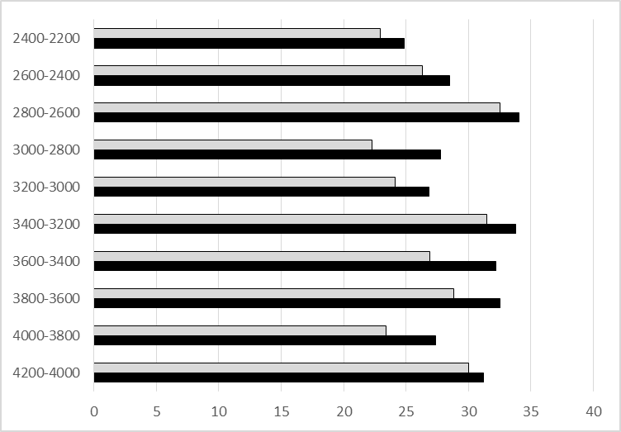
Figure S2a: comparison of fit scores between the pollen assemblages simulated for the overall best fit landscape scenario and the pollen targets for each timeslice based on overall best fit (standardised by the number of sites – black bars) and on the averages for individual sites (which reflect local variations in the landscape around each site – grey bars).

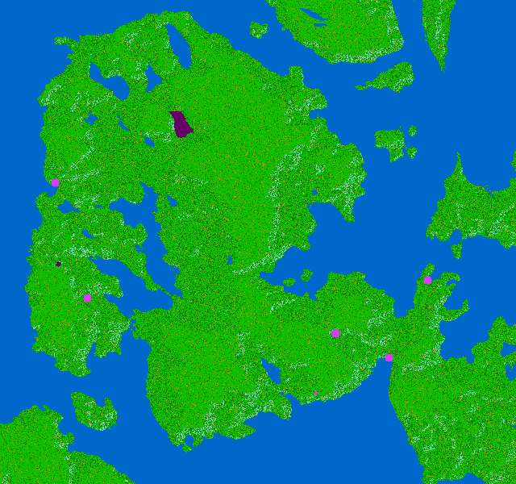
Figure S2b: Visualisations of the best overall fit land cover scenarios for the whole study area 4200–4000 cal BC timeslice (green = grassland; dark green = birch-hazel woodland; orange = disturbed ground; teal = oak-pine woodland; pink = pollen sites (mire); purple = pollen sites (wet mire)

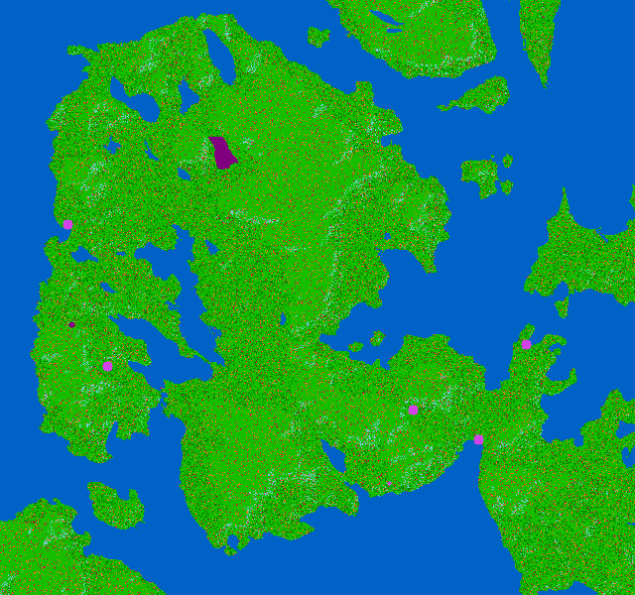
Figure S2c: Visualisations of the best overall fit land cover scenarios for the whole study area 4000–3800 cal BC timeslice (green = grassland; dark green = birch-hazel woodland; orange = disturbed ground; red = dry heath; teal = oak-pine woodland; pink = pollen sites (mire); purple = pollen sites (wet mire)

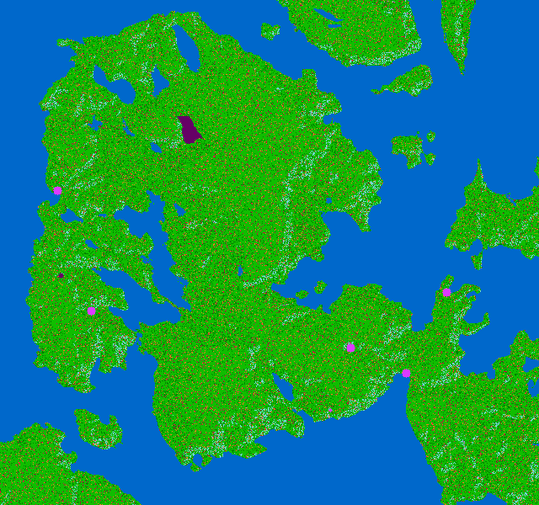
Figure S2d: Visualisations of the best overall fit land cover scenarios for the whole study area 3800–3600 cal BC timeslice (green = grassland; dark green = birch-hazel woodland; orange = disturbed ground; red = dry heath; teal = oak-pine woodland; pink = pollen sites (mire); purple = pollen sites (wet mire)

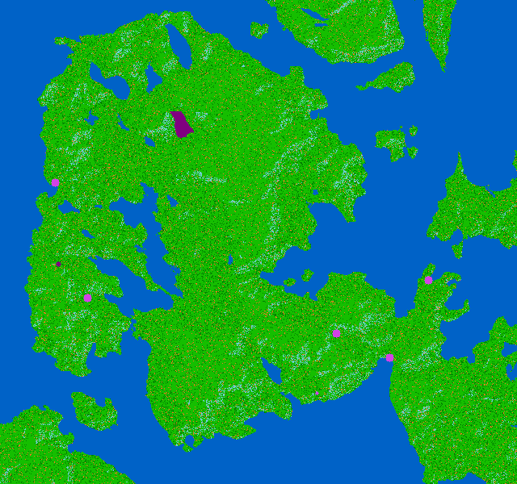
Figure S2e: Visualisations of the best overall fit land cover scenarios for the whole study area 3600–3400 cal BC timeslice (green = grassland; dark green = birch-hazel woodland; orange = disturbed ground; teal = oak-pine woodland; pink = pollen sites (mire); purple = pollen sites (wet mire)

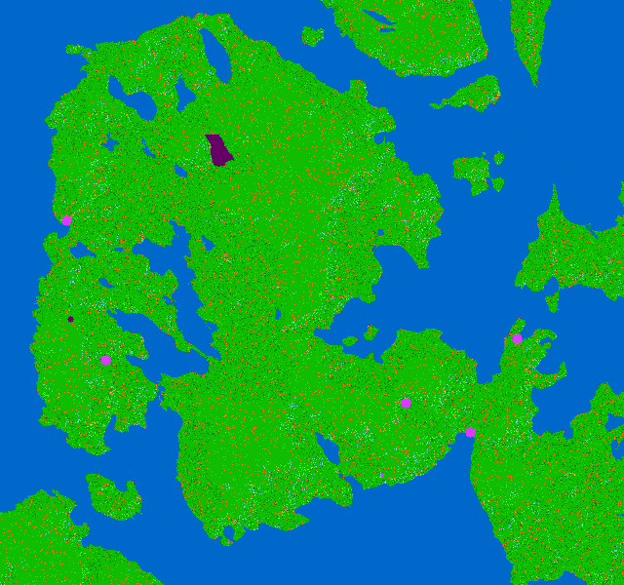
Figure S2f: Visualisations of the best overall fit land cover scenarios for the whole study area 3400–3200 cal BC timeslice (green = grassland; dark green = birch-hazel woodland; orange = disturbed ground; teal = oak-pine woodland; pink = pollen sites (mire); purple = pollen sites (wet mire)

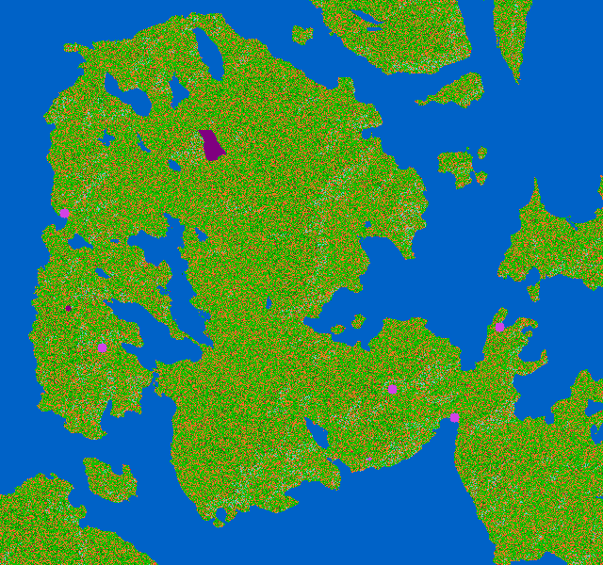
Figure S2g: Visualisations of the best overall fit land cover scenarios for the whole study area 3200–3000 cal BC timeslice (green = grassland; dark green = birch-hazel woodland; orange = disturbed ground; red = dry heath; teal = oak-pine woodland; pink = pollen sites (mire); purple = pollen sites (wet mire)

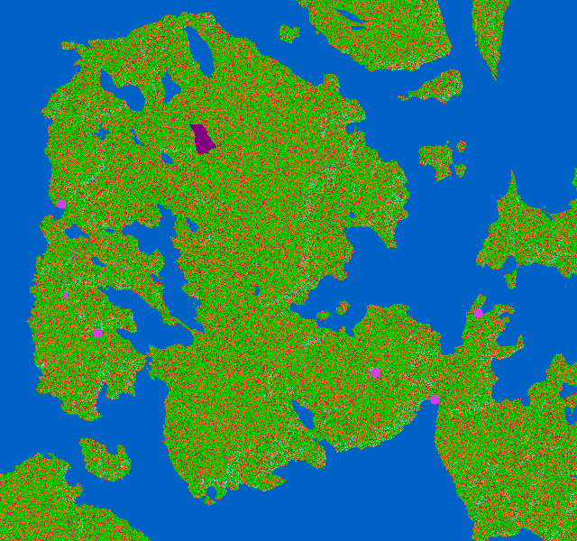
Figure S2h: Visualisations of the best overall fit land cover scenarios for the whole study area 3000–2800 cal BC timeslice (green = grassland; dark green = birch-hazel woodland; orange = disturbed ground; red = heath; teal = oak-pine woodland; pink = pollen sites (mire); purple = pollen sites (wet mire)

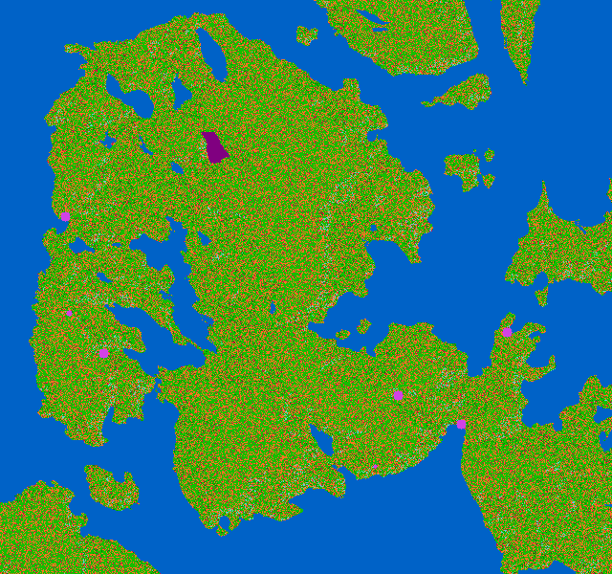
Figure S2i: Visualisations of the best overall fit land cover scenarios for the whole study area 2800–2600 cal BC timeslice (green = grassland; dark green = birch-hazel woodland; orange = disturbed ground; red = dry heath; teal = oak-pine woodland; pink = pollen sites (mire); purple = pollen sites (wet mire)

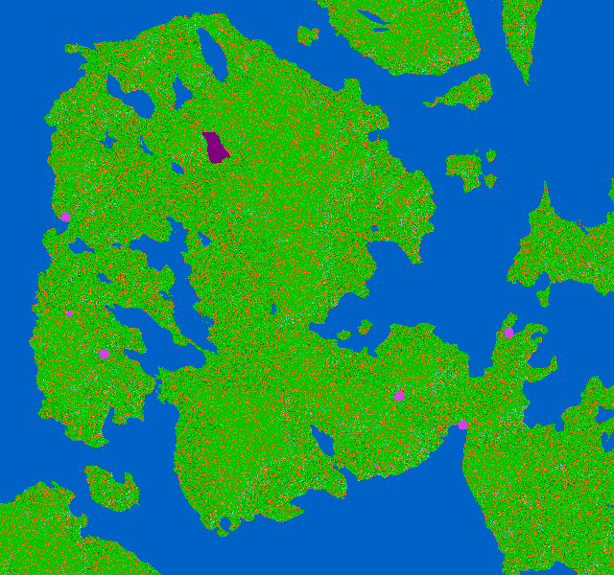
Figure S2j: Visualisations of the best overall fit land cover scenarios for the whole study area 2600–2400 cal BC timeslice (green = grassland; dark green = birch-hazel woodland; orange = disturbed ground; teal = oak-pine woodland; pink = pollen sites (mire); purple = pollen sites (wet mire)

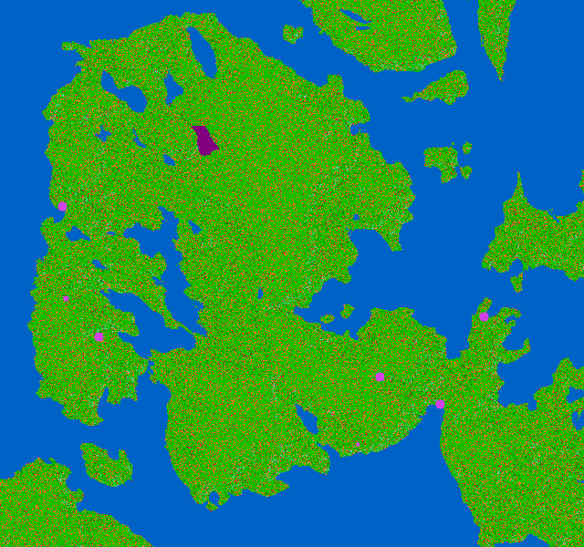
Figure S2k: Visualisations of the best overall fit land cover scenarios for the whole study area 2400–2200 cal BC timeslice (green = grassland; dark green = birch-hazel woodland; orange = disturbed ground; red = dry heath; teal = oak-pine woodland; pink = pollen sites (mire); purple = pollen sites (wet mire)

