Table S1
 | χ² | df | CFI | TLI | RMSEA | SRMR | BIC | ΔCFI | ΔTLI | ΔRMSEA
 | Wave 1
Configural | 161 | 36 | .973 | 0.956 | .085 | .025 | 16951
Metric | 212 | 51 | .965 | 0.959 | .082 | .064 | 16917 | .008 | -.003 | .003
Scalar | 262 | 66 | .958 | 0.962 | .079 | .060 | 16847 | .007 | -.003 | .003
 | Wave 2
Configural | 177 | 36 | .972 | .953 | .093 | .023 | 16060
Metric | 204 | 51 | .970 | .964 | .081 | .044 | 15981 | .002 | -.011 | .012
Scalar | 279 | 66 | .958 | .961 | .085 | .041 | 15946 | .012 | .003 | -.004
 | Wave 3
Configural | 131 | 36 | .976 | .960 | .078 | .023 | 15670
Metric | 188 | 51 | .966 | .960 | .078 | .060 | 15626 | .010 | .000 | .000
Scalar | 250 | 66 | .954 | .958 | .080 | .054 | 15579 | .012 | .002 | -.002
 | Wave 4
Configural | 168 | 36 | .970 | .951 | .093 | .026 | 15165
Metric | 200 | 51 | .966 | .960 | .083 | .041 | 15077 | .004 | -.009 | .010
Scalar | 268 | 66 | .955 | .959 | .085 | .044 | 15034 | .011 | .001 | .002
 | Wave 5
Configural | 250 | 36 | .951 | .918 | .121 | .030 | 14136
Metric | 326 | 51 | .937 | .926 | .115 | .070 | 14117 | .014 | -.008 | .006
Scalar | 397 | 66 | .924 | .931 | .111 | .065 | 14063 | .013 | -.005 | .004
 | Wave 6
Configural | 158 | 36 | .973 | .955 | .092 | .024 | 13758
Metric | 226 | 51 | .961 | .955 | .092 | .066 | 13725 | .012 | .000 | .000
Scalar | 285 | 66 | .952 | .956 | .091 | .062 | 13673 | .009 | -.001 | .001
 | Longitudinal Invariance (W1 – W6)
Configural | 3515 | 1956 | .963 | .953 | .040 | .035 | 70167
Metric | 3701 | 2056 | .961 | .953 | .040 | .042 | 69628 | .002 | .000 | .000
Scalar | 3992 | 2156 | .957 | .950 | .042 | .044 | 69194 | .004 | .003 | .002
Fit indices of measurement invariance analyses for the Negative Interactions scale, across adolescent-mother, adolescent-father, mother-adolescent, and father-adolescent reports for waves 1-6, as well as longitudinally across waves 1-6.
Note: CFI: Comparative Fit Index; TLI: Tucker-Lewis Index; RMSEA: Root-Mean Square Error of Approximation; SRMR: Standardized Root-Mean Residual; BIC: Bayesian Information Criterion. W1-W6: Wave 1 to Wave 6.

Table S2
Fit Indices for the Latent Growth Curve Models of Conflict Intensity and Discrepancies in Conflict Intensity with Linear, Quadratic, and Piecewise Specification.
 | χ² |  |  |  | p |  |  |  | CFI |  |  |  |  | RMSEA |  |  |  | SRMR
 | Linear | Piecewise* | Quad. |  | Linear | Piecewise | Quad. |  | Linear | Piecewise | Quad. |  |  | Linear | Piecewise | Quad. |  | Linear | Piecewise | Quad.
Conflict Intensity
AM | 84.1 | 38.1 | 35.2 |  | .000 | .001 | .001 |  | .946 | .981 | .983 |  |  | .069 | .042 | .037 |  | .102 | .073 | .067
AF** | 97.7 | 35.7 | 41.7 |  | .000 | .001 | .000 |  | .937 | .983 | .979 |  |  | .072 | .036 | .042 |  | .105 | .095 | .094
MA | 71.8 | 48.2 | 55.8 |  | .000 | .000 | .000 |  | .967 | .979 | .974 |  |  | .059 | .050 | .056 |  | .070 | .073 | .069
FA | 131.2 | 58.2 | 66.7 |  | .000 | .000 | .000 |  | .922 | .970 | .964 |  |  | .101 | .065 | .074 |  | .138 | .109 | .088
Discrepancies
A-M | 87.5 | 27.8 | 46.7 |  | .000 | .010 | .000 |  | .903 | .980 | .955 |  |  | .080 | .037 | .057 |  | .098 | .042 | .056
A-F | 36.7 | 15.5 | 19.5 |  | .004 | .344 | .145 |  | .977 | .998 | .994 |  |  | .035 | .000 | .009 |  | .057 | .043 | .046
Note: AM: Adolescent report for mother; AF: adolescent report for father; MA: Mother report for adolescent; FA: Father report for adolescent. CFI: Comparative Fit Index; RMSEA: Root-Mean Square Error of Approximation; SRMR: Standardized Root-Mean Residual. *For all the piecewise models, the knot was set to Wave 4 (adolescent age 16 years), except if otherwise specified. **For this piecewise model, the knot was set to Wave 3 (adolescent age 15 years).

Table S3
Parameter Estimates (means and variances) of the Latent Congruency Models for the Discrepancies, Across Waves.
 | Mother-Adolescent |  | Father-Adolescent
 | Mean | Variance | Mean | Variance
Wave 1 | 0.148*** | .313*** | 0.004 | .229***
Wave 2 | 0.159*** | .296*** | 0.075** | .281***
Wave 3 | 0.211*** | .279*** | 0.151*** | .257***
Wave 4 | 0.231*** | .344*** | 0.152*** | .291***
Wave 5 | 0.305*** | .379*** | 0.184*** | .285***
Wave 6 | 0.255*** | .275*** | 0.218*** | .374***
Note: *p < .05; **p < .01; ***p < .001.

Table S4
Means and 95% Confidence Intervals for Growth Parameters of the Adolescent Big Five, for Resilients, Overcontrollers, and Undercontrollers.
Adolescent Personality Types | Resilients (n = 183, 36.8%) | Overcontrollers (n = 156, 31.4%) | Undercontrollers (n = 158, 31.8%)
 | M (95% C.I.) | M (95% C.I.) | M (95% C.I.)
Intercepts
Ag | 5.83***ª (5.74, 5.91) | 5.51***^{b} (5.41, 5.60) | 5.02***^{c} (4.89, 5.15)
ES | 4.71***ª (4.57, 4.85) | 3.73***^{b} (3.56, 3.89) | 4.81***ª (4.68, 4.94)
Ext | 5.57***ª (5.43, 5.70) | 4.34***^{c} (4.20, 4.48) | 5.23***^{b} (5.11, 5.36)
Con | 4.19***ª (4.02, 4.36) | 4.20***ª (4.09, 4.42) | 3.54*** ^{b} (3.39, 3.68)
Op | 5.40***ª (5.29, 5.51) | 5.07***^{b} (4.95, 5.19) | 4.08***^{c} (3.96, 4.21)
Linear Slopes
Ag | -.069 (-.186, .047) | -.115 (-.264, .033) | -.264** (-.446, -.082)
ES | .157** (.054, .260) | -.110 (-.236, .015) | .171** (.055, .287)
Ext | .138** (.038, .238) | -.150** (-.256, -.044) | .143** (.042, .245)
Con | -.013 (-.114, .088) | .062 (-.037, .161) | -.102 (-.209, .004)
Op | .065 (-.009, .139) | -.016 (-.103, .071) | .022 (-.087, .131)
Quadratic Slopes
Ag | .054 (-.002, .109) | .071 (-.002, .144) | .164*** (.078, .250)
ES | -.026** (-.045, -.007) | .020 (-.003, .043) | -.035* (-.056, -.013)
Ext | -.020* (-.038, -.002) | .018 (-.001, .038) | -.033** (-.052, -.013)
Con | .004 (-.015, .022) | -.011 (-.029, .008) | .029** (.009, .048)
Op | -.012 (-.025, .002) | -.003 (-.018, .012) | .005 (-.015, .025)
Cubic Slopes
Ag | -.007* (-.014, -.000) | -.009 (-.019, .001) | -.021*** (-.032, -.010)
Note: Ag: Agreeableness; ES: Emotional Stability; Ext: Extraversion; Con: Conscientiousness; Op: Openness; C.I.: Confidence Intervals. Values with different letter indicators indicate statistically different means.
*p < .05; **p < .01; ***p < .001.

Table S5
Means and 95% Confidence Intervals for Growth Parameters of the Parental Big Five, for Resilients, Overcontrollers, and Undercontrollers.
Parental Personality Types | Resilients (n = 456, 47.8%) | Overcontrollers (n = 253, 26.5%) | Undercontrollers (n = 245, 25.7%)
 | M (95% C.I.) | M (95% C.I.) | M (95% C.I.)
Intercepts
Ag | 5.92***ª (5.88, 5.97) | 5.40***^{c} (5.33, 5.47) | 5.56***^{b} (5.48, 5.64)
ES | 5.08***ª (4.99, 5.16) | 4.16***^{c} (4.03, 4.28) | 4.60***^{b} (4.48, 4.72)
Ext | 5.50***ª (5.42, 5.78) | 3.73***^{c} (3.63, 3.82) | 4.93***^{b} (4.81, 5.05)
Con | 5.52***ª (5.45, 5.58) | 5.28***^{b} (5.18, 5.38) | 3.76*** ^{c} (3.67, 3.86)
Op | 5.04***ª (4.96, 5.13) | 4.12***^{c} (4.00, 4.24) | 4.83***^{b} (4.71, 4.96)
Linear Slopes
Ag | .022*** (.013, .031) | .008 (-.006, .022) | .008 (-.007, .022)
ES | .069***ª (.054, .083) | .027*^{b} (.005, .049) | .044***^{b} (.022, .066)
Ext | .038*** (.023, .053) | .014 (-.005, .032) | .018 (-.001, .037)
Con | .039*** (.026, .052) | .005 (-.012, .023) | .025** (.006, .044)
Op | .009 (-.004, .023) | -.007 (-.024, .010) | .001 (-.015, .016)
Note: Ag: Agreeableness; ES: Emotional Stability; Ext: Extraversion; Con: Conscientiousness; Op: Openness; C.I.: Confidence Intervals. Values with different letter indicators imply statistically different means.
*p < .05; **p < .01; ***p < .001.

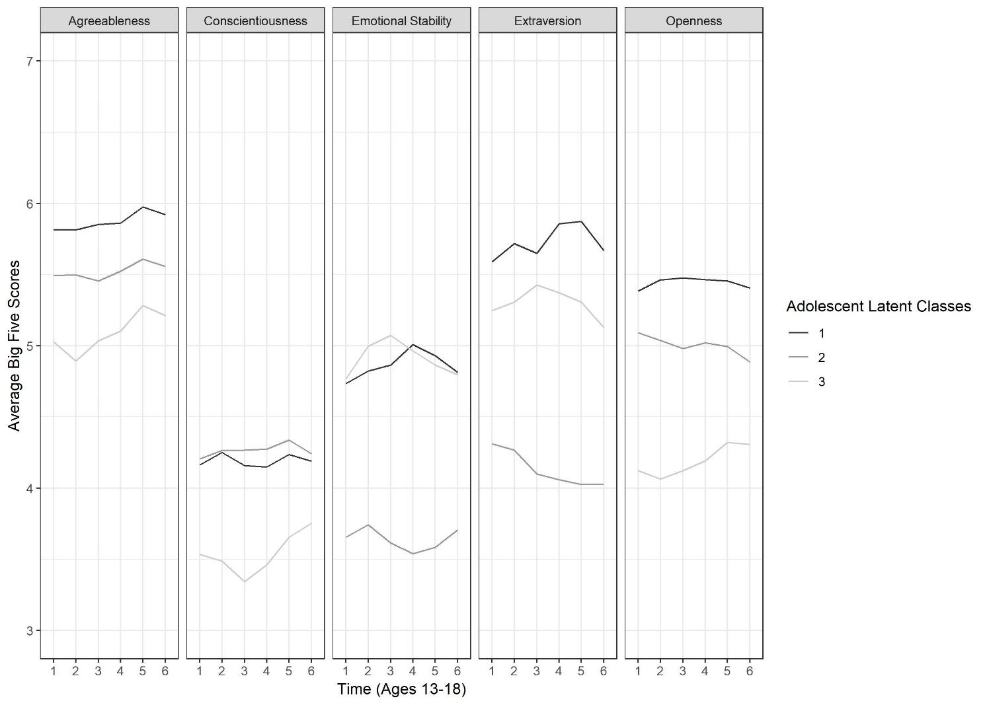Figure S1. Means on the Big Five in the 3-class solution from the adolescent Latent Class Growth Analysis.

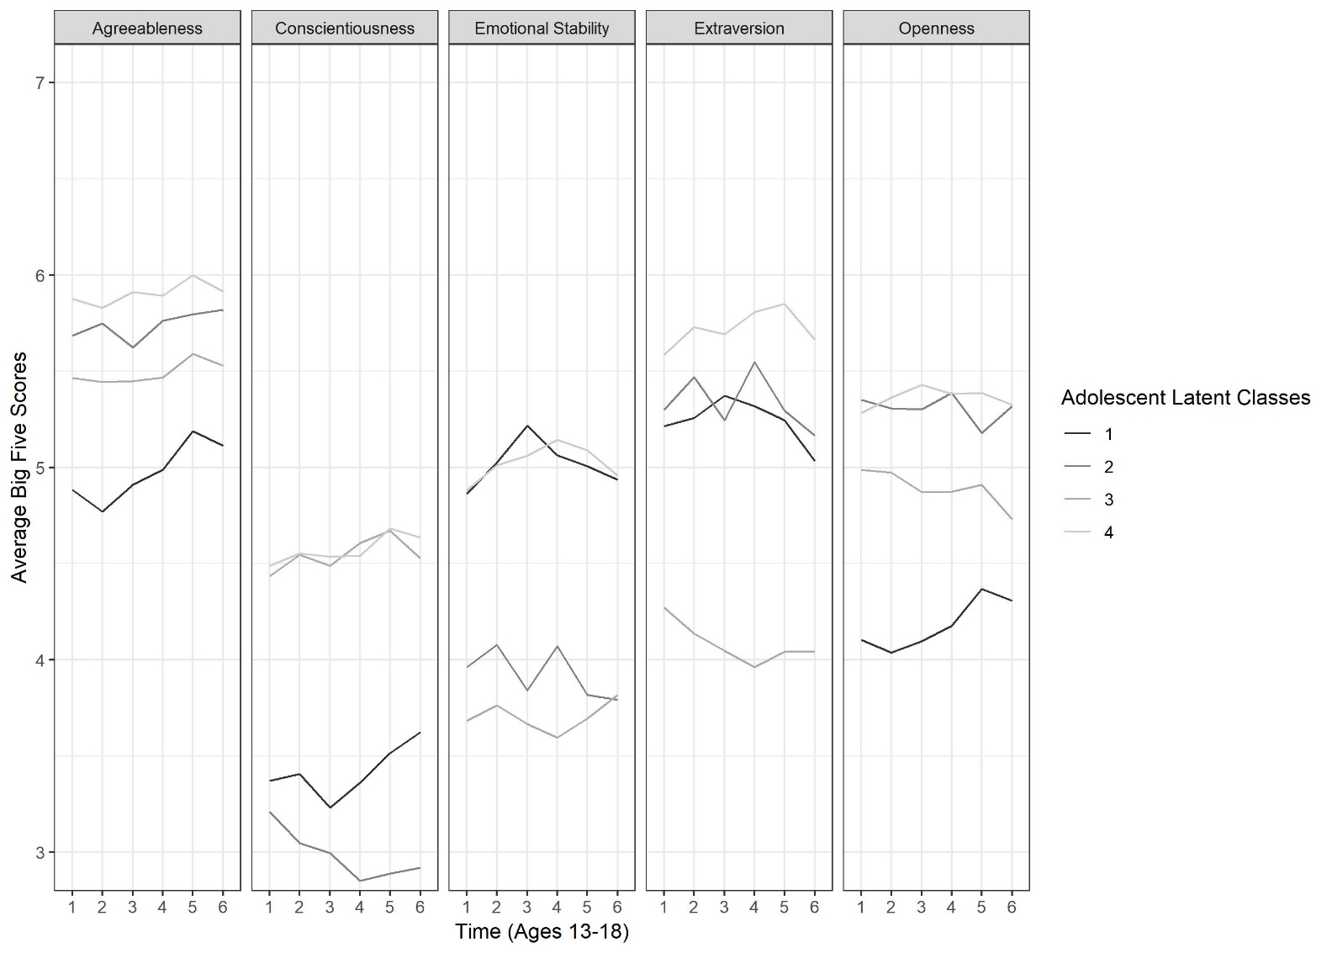
Figure S2. Means on the Big Five in the 4-class solution from the adolescent Latent Class Growth Analysis.

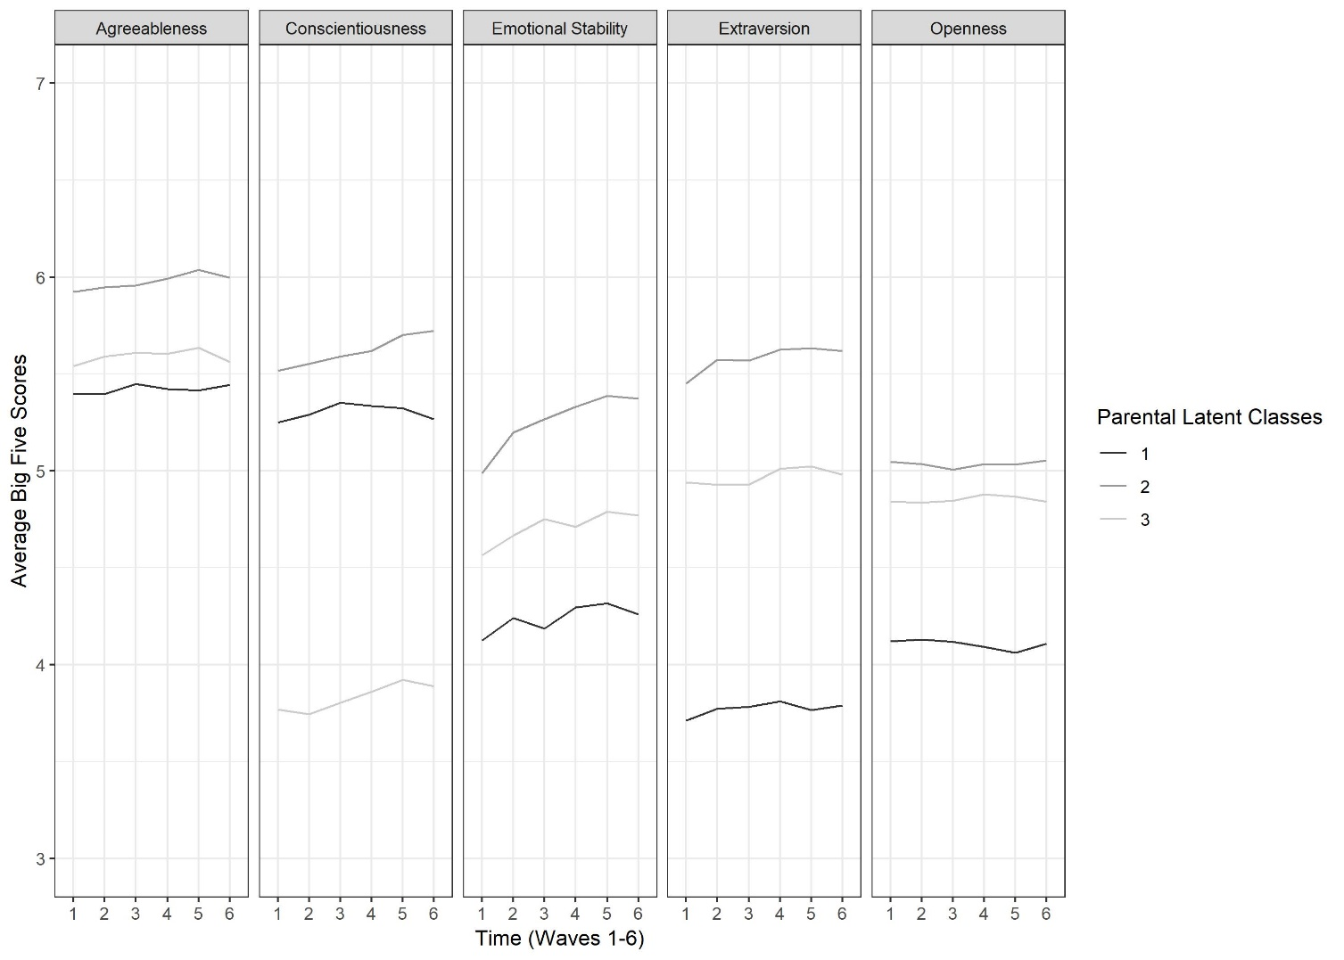
Figure S3. Means on the Big Five in the 3-class solution from the parental Latent Class Growth Analysis.

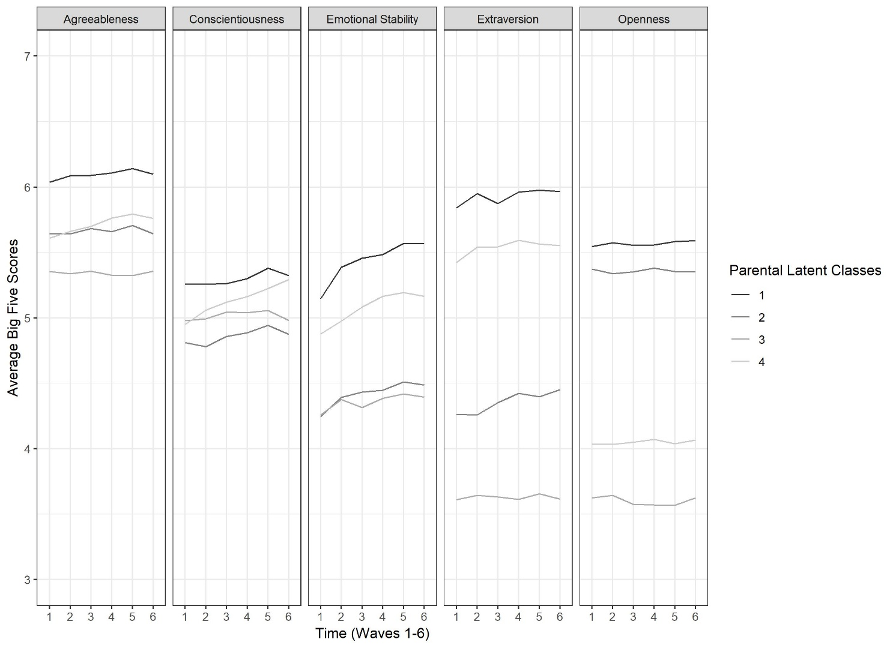
Figure S4. Means on the Big Five in the 4-class solution from the parental Latent Class Growth Analysis.

Table S6
Growth Parameter Estimates (Means and Variances) of the Latent Growth Curve Models for Adolescent-, Mother-, and Father-reported Conflict Intensity, and the Latent Growth Curve Models for Mother-Adolescent and Father-Adolescent Discrepancies in Conflict Controlling for Gender and Family SES.
 | Intercept |  | Slope 1 |  | Slope 2
 | Mean | Variance | Mean | Variance | Mean | Variance
Conflict Intensity
AM | 1.60*** | .190*** | .060** | .031** | -.001 | .015**
AF | 1.51*** | .210*** | .069*** | .034*** | .005 | .026***
MA | 1.44*** | .154*** | .027 | .010** | -.020* | .006**
FA | 1.50*** | .154*** | .015 | .013** | -.017 | .016***
Discrepancies
Mother-Adolescent | 0.167*** | 0.072*** | 0.024 | 0.018*** | 0.022* | 0.009**
Father-Adolescent | 0.004 | 0.084*** | 0.060*** | 0.011** | 0.018 | 0.010***
Note: AM: Adolescent report for mother; AF: adolescent report for father; MA: Mother report for adolescent; FA: Father report for adolescent.
*p < .05; **p < .01; ***p < .001.

Table S7
Regression Coefficients (Unstandardized Β, and Standardized β) and Confidence Intervals for the Prediction of the Intercepts of Conflict Intensity and Discrepancies in Conflict Intensity by Adolescent and Parental Personality Type, Controlling for SES and Gender.
 |  | Adolescent |  |  |  | Mother |  |  |  | Father
 |  | U vs. R | O vs. R | U vs. O |  | U vs. R | O vs. R | U vs. O |  | U vs. R | O vs. R | U vs. O
 |  | Parent-Adolescent Conflict Intensity
AM Intercept | B | .126 | .126 | .000 |  | .140 | .222 | -.081 |  | - | - | -
AM Intercept | C.I. | .01-.24 | .01-.25 | -.14-.14 |  | .01-.27 | .10-.35 | -.24-.07 |  | - | - | -
AM Intercept | β | .132* | .132* | -.001 |  | .132* | .220*** | -.077 |  | - | - | -
MA Intercept | B | .094 | .049 | .045 |  | .152 | .125 | .026 |  | - | - | -
MA Intercept | C.I. | -.01-.20 | -.06-.15 | -.07-.16 |  | .04-.26 | .02-.23 | -.10-.16 |  | - | - | -
MA Intercept | β | .108 | .057 | .051 |  | .158** | .138* | .028 |  | - | - | -
AF Intercept | B | .140 | .101 | .039 |  | - | - | - |  | -.009 | .048 | -.057
AF Intercept | C.I. | .02-.26 | -.02-.23 | -.09-.17 |  | - | - | - |  | -.13-.11 | -.08-.18 | -.20-.09
AF Intercept | β | .141* | .102 | .039 |  | - | - | - |  | -.009 | .046 | -.056
FA Intercept | B | .065 | -.029 | .094 |  | - | - | - |  | .124 | .150 | -.025
FA Intercept | C.I. | -.06-.18 | -.13-.07 | -.02-.21 |  | - | - | - |  | .02-.23 | .03-.27 | -.16-.11
FA Intercept | β | .076 | -.035 | .111 |  | - | - | - |  | .141* | .166* | -.029
 | Parent-Adolescent Discrepancies in Conflict Intensity
M-A Discrepancies Intercept | B | .035 | .070 | -.035 |  | .004 | .080 | -.076 |  | - | - | -
M-A Discrepancies Intercept | C.I. | -.06-.13 | -.03-.17 | -.14-.07 |  | -.09-.10 | -.02-.18 | -.19-.04 |  | - | - | -
M-A Discrepancies Intercept | β | .062 | .124 | -.063 |  | .007 | .134 | -.120 |  | - | - | -
F-A Discrepancies Intercept | B | .068 | .093 | -.026 |  | - | - | - |  | -.119 | -.080 | -.038
F-A Discrepancies Intercept | C.I. | -.02-.16 | .00-.18 | -.12-.07 |  | - | - | - |  | -.21- -032. | -.18-.014 | -.14-.062
F-A Discrepancies Intercept | β | .108 | .149* | -.041 |  | - | - | - |  | -.182** | -.121 | -.059
Note: U: Undercontroller; R: Resilient; O: Overcontroller; AM: Adolescent report for Mother; MA: Mother report for Adolescent; AF: Adolescent report for Father; FA: Father report for Adolescent; M-A: Discrepancies between the Adolescent for Mother, and Mother for Adolescent reports; F-A: Discrepancies between the Adolescent for Father, and Father for Adolescent reports. C.I.: Confidence Intervals.
*p < .05; **p < .01; ***p < .001.

