Online Supplemental Materials for:
Putting the Goal Back into Grit: Academic Goal Commitment, Grit and Academic Achievement

Contents
Table S1 Goodness-of-Fit Statistics of the Preliminary Measurement Models 2
Table S2 Results from the Latent Profile Analysis Models Estimated Separately at Each Time Point 3
Figure S1 Elbow Plot of the Value of the Information Criteria for Solutions Including Different Number of Latent Profiles (Grade 8) 4
Figure S2 Elbow Plot of the Value of the Information Criteria for Solutions Including Different Number of Latent Profiles (Grade 9) 4
Table S3 Goodness-of-Fit Statistics of the Preliminary Measurement Models for Original data 5
Table S4 Results from the Latent Profile Analysis Models Estimated Using Original Data 6
Figure S2a & S2b Elbow Plot of the Value of the Information Criteria for Solutions Including Different Number of Latent Profiles from Original Data 7
Figure S3a & 3b Profiles of Academic-goal and Grit in 8th grade and 9th grade from original data 8
Table S5 Goal commitment-grit profiles and academic achievements for 8th grade from original data 9
Table S6 Goal commitment-grit profiles and academic achievements for 9th grade from original data 10

Table S1 Goodness-of-Fit Statistics of the Preliminary Measurement Models
Description | χ² (df) | CFI | TLI | RMSEA | 90% CI | MD ∆χ² (df) | ∆CFI | ∆TLI | ∆RMSEA
Measurement Models
Grade 8 (N = 549) | 191.343(41) | .883 | .843 | .082 | [.07; .094] | - | - | - | -
Grade 9 (N = 549) | 153.743(41) | .921 | .894 | .071 | [.059; .083] | - | - | - | -
Longitudinal configural invariance (N = 549) | 452.189 (183) | .92 | .899 | .052 | [.046; .058] | - | - | - | -
Longitudinal weak invariance | 465.979 (191) | .918 | .901 | .051 | [.045; .057] | 14.106 (8) | -.002 | .002 | -.001
Longitudinal strong invariance | 516.722 (199) | .906 | .89 | .054 | [.048; .06] | 54.882 (8)* | -.012 | -.011 | .003
Longitudinal partial strong invariance (free intercept of grit1) | 503.129 (198) | .909 | .894 | .053 | [.047; .059] | 39.884 (7)* | -.009 | -.007 | .002
Note. * p < .01; χ²: chi-square test of exact fit; df: degrees of freedom; CFI: comparative fit index; TLI: Tucker-Lewis index; RMSEA: root mean square error of approximation; 90% CI: 90% confidence interval; MD ∆χ²: chi-square difference tests calculated with Mplus’ DIFFTEST function.

Table S2 Results from the Latent Profile Analysis Models Estimated Separately at Each Time Point
Model | LL | #fp | Scaling | AIC | CAIC | BIC | ABIC | Entropy | aLMR | BLRT
Time 1 (N = 549)
1 Profile | -2139.375 | 6 | 1.2746 | 4290.75 | 4322.599 | 4316.598 | 4297.552 | Na | Na | Na
2 Profiles | -1996.993 | 13 | 1.3326 | 4019.986 | 4088.991 | 4075.992 | 4034.724 | .607 | .0032 | < .001
3 Profiles | -1922.062 | 20 | 1.148 | 3884.123 | 3990.286 | 3970.285 | 3906.797 | .698 | .0019 | < .001
4 Profiles | -1859.832 | 27 | 1.1093 | 3773.664 | 3916.983 | 3889.982 | 3804.273 | .802 | .0117 | < .001
5 Profiles | -1813.083 | 34 | 1.1061 | 3694.166 | 3874.641 | 3840.641 | 3732.711 | .815 | .0354 | < .001
Time 2 (N = 549)
1 Profile | -2350.959 | 6 | 1.1905 | 4713.917 | 4745.767 | 4739.766 | 4720.719 | Na | Na | Na
2 Profiles | -2203.827 | 13 | 1.4531 | 4433.654 | 4502.659 | 4489.659 | 4448.392 | .654 | .0179 | < .001
3 Profiles | -2099.803 | 20 | 1.2524 | 4239.605 | 4345.768 | 4325.767 | 4262.279 | .77 | .0023 | < .001
4 Profiles | -1991.451 | 27 | 1.1665 | 4036.901 | 4180.221 | 4153.22 | 4067.511 | .825 | < .001 | < .001
5 Profiles | -1950.654 | 34 | 1.216 | 3969.308 | 4149.783 | 4115.783 | 4007.853 | .782 | .0882 | < .001
Note. LL: model loglikelihood; #fp: number of free parameters; scaling: scaling correction factor associated with robust maximum likelihood estimates; AIC: Akaïke information criteria; CAIC: constant AIC; BIC: Bayesian information criteria; ABIC: sample size adjusted BIC; aLMR: adjusted Lo-Mendel-Rubin likelihood ratio test; BLRT: bootstrap likelihood ratio test.

Figure S1 Elbow Plot of the Value of the Information Criteria for Solutions Including Different Number of Latent Profiles (Grade 8)

Figure S2 Elbow Plot of the Value of the Information Criteria for Solutions Including Different Number of Latent Profiles (Grade 9)

Table S3 Goodness-of-Fit Statistics of the Preliminary Measurement Models for Original data
Description | χ² (df) | CFI | TLI | RMSEA | 90% CI | MD ∆χ² (df) | ∆CFI | ∆TLI | ∆RMSEA
Measurement Models
Grade 8 (N = 1171) | 262.358(41) | .926 | .900 | .068 | [.06; .076] | - | - | - | -
Grade 9 (N = 765) | 168.528(41) | .933 | .910 | .064 | [.054; .074] | - | - | - | -
Longitudinal configural invariance | 541.451(183) | .937 | .921 | .038 | [.034; .041] | - | - | - | -
Longitudinal weak invariance | 562.212(191) | .935 | .921 | .037 | [.034; .041] | 21.035(8)* | -0.002 | 0 | -0.001
Longitudinal strong invariance | 660.838(199) | .919 | .906 | .041 | [.037; .044] | 109.379(8)* | -0.016 | -0.015 | 0.004
Longitudinal partial strong invariance (free intercept of grit1) | 624.233(198) | .925 | .913 | .039 | [.036; .043] | 67.933(7)* | -0.01 | -0.008 | 0.002
Note. * p < .01; χ²: chi-square test of exact fit; df: degrees of freedom; CFI: comparative fit index; TLI: Tucker-Lewis index; RMSEA: root mean square error of approximation; 90% CI: 90% confidence interval; MD ∆χ²: chi-square difference tests

Table S4 Results from the Latent Profile Analysis Models Estimated Using Original Data
Model | LL | #fp | Scaling | AIC | CAIC | BIC | ABIC | Entropy | aLMR | BLRT
Time 1 (N = 1171)
1 Profile | -4423.27 | 6 | 1.1868 | 8858.539 | 8894.934 | 8888.933 | 8869.875 | #N/A | #N/A | #N/A
2 Profiles | -4105.443 | 13 | 1.265 | 8236.885 | 8315.739 | 8302.738 | 8261.446 | 0.958 | 0 | 0
3 Profiles | -3812.892 | 20 | 1.2796 | 7665.783 | 7787.096 | 7767.096 | 7703.569 | 0.769 | 0.0021 | 0
4 Profiles | -3664.356 | 27 | 1.1171 | 7382.711 | 7546.484 | 7519.483 | 7433.721 | 0.837 | 0 | 0
5 Profiles | -3557.288 | 34 | 1.0423 | 7182.575 | 7388.807 | 7354.806 | 7246.81 | 0.806 | 0 | 0
6 Profiles | -3464.871 | 41 | 1.0514 | 7011.743 | 7260.432 | 7219.433 | 7089.203 | 0.803 | 0.0005 | 0
7 Profiles | -3427.584 | 48 | 1.0387 | 6951.168 | 7242.317 | 7194.318 | 7041.853 | 0.786 | 0.0007 | 0
Time 2 (N = 765)
1 Profile | -3012.104 | 6 | 1.1798 | 6036.207 | 6070.047 | 6064.047 | 6044.994 | #N/A | #N/A | #N/A
2 Profiles | -2816.579 | 13 | 1.3942 | 5659.157 | 5732.476 | 5719.476 | 5678.195 | 0.6 | 0.0037 | 0
3 Profiles | -2673.527 | 20 | 1.451 | 5387.053 | 5499.851 | 5479.851 | 5416.342 | 0.741 | 0.0683 | 0
4 Profiles | -2525.704 | 27 | 1.4765 | 5105.409 | 5257.685 | 5230.685 | 5144.948 | 0.822 | 0.0288 | 0
5 Profiles | -2457.324 | 34 | 1.2062 | 4982.648 | 5174.404 | 5140.404 | 5032.439 | 0.795 | 0.0461 | 0
6 Profiles | -2406.666 | 41 | 1.2578 | 4895.332 | 5126.567 | 5085.567 | 4955.374 | 0.812 | 0.0438 | 0
7 Profiles | -2353.57 | 48 | 1.3304 | 4803.14 | 5073.854 | 5025.854 | 4873.433 | 0.807 | 0.3634 | 0
Note. LL: model loglikelihood; #fp: number of free parameters; scaling: scaling correction factor associated with robust maximum likelihood estimates; AIC: Akaïke information criteria; CAIC: constant AIC; BIC: Bayesian information criteria; ABIC: sample size adjusted BIC; aLMR: adjusted Lo-Mendel-Rubin likelihood ratio test; BLRT: bootstrap likelihood ratio test.

Figure S2a & S2b Elbow Plot of the Value of the Information Criteria for Solutions Including Different Number of Latent Profiles from Original Data

3a) 3b)
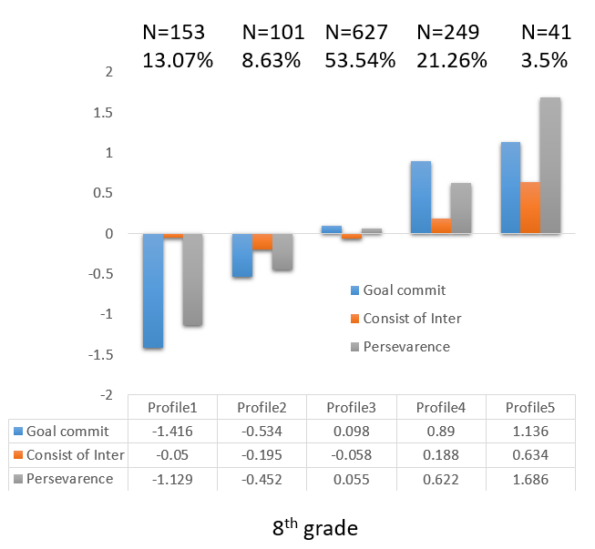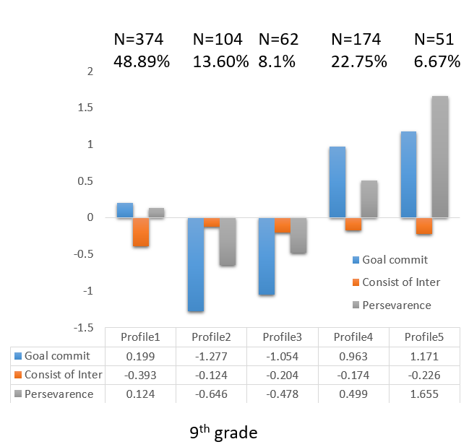

Figure S3a & 3b Profiles of Academic-goal commitment and Grit in 8th grade and 9th grade from original data

Table S5 Goal commitment-grit profiles and academic achievements for 8th grade from original data
 | Profile 1  M [CI] | Profile 2  M [CI] | Profile 3  M [CI] | Profile 4  M [CI] | Profile 5  M [CI] | Significant test
Without covariates
GPA | 7.525  [7.312; 7.737] | 7.877  [7.695; 8.058] | 8.314  [8.225; 8.402] | 8.518  [8.391; 8.646] | 8.811  [8.562; 9.06] | P5>P4>P3>P2>P1  Cohen’s d_{p1-p2} = .356  Cohen’s d_{p1-p3} = .816  Cohen’s d_{p1-p4} = 1.137  Cohen’s d_{p1-p5} = 1.436  Cohen’s d_{p2-p3} = .423  Cohen’s d_{p2-p4} = .826  Cohen’s d_{p2-p5} = 1.147  Cohen’s d_{p3-p4} = .309  Cohen’s d_{p3-p5} = .629  Cohen’s d_{p4-p5} = .336
With covariatesª
GPA | 7.484  [7.124; 7.843] | 7.899  [7.549; 8.249] | 8.096  [7.788; 8.403] | 8.177  [7.829; 8.525] | 8.398  [7.934; 8.861] | P5=P4; P5>P3=P2>P1; P4=P3;  Cohen’s d_{p1-p2} = .502  Cohen’s d_{p1-p3} = .749  Cohen’s d_{p1-p4} = .852  Cohen’s d_{p1-p5} = 1.082  Cohen’s d_{p2-p3} = .27  Cohen’s d_{p2-p4} = .38  Cohen’s d_{p2-p5} = .643  Cohen’s d_{p3-p4} = .108  Cohen’s d_{p3-p5} = .38  Cohen’s d_{p4-p5} = .278
Note. M: Mean; CI: 95% Conﬁdence Interval. Proﬁle 1: Extremely-low Committed; Proﬁle 2: Low Committed; Proﬁle 3: Moderate; Proﬁle 4: High Committed; Proﬁle 5: Extremely-high Committed-Persistent. ªCovariates are Gender, SES, Conscientiousness, and Academic Persistence

Table S6 Goal commitment-grit profiles and academic achievements for 9th grade from original data
 | Profile 1  M [CI] | Profile 2  M [CI] | Profile 3  M [CI] | Profile 4  M [CI] | Profile 5  M [CI] | Significant test
Without covariates
GPA | 8.551  [8.428; 8.674] | 8.002  [7.74; 8.264] | 7.912  [7.652; 8.172] | 8.615  [8.462; 8.767] | 8.705  [8.457; 8.953] | P5=P4=P1>P3=P2  Cohen’s d_{p1-p2} = .642  Cohen’s d_{p1-p3} = .753  Cohen’s d_{p1-p4} = .07  Cohen’s d_{p1-p5} = .171  Cohen’s d_{p2-p3} = .044  Cohen’s d_{p2-p4} = .717  Cohen’s d_{p2-p5} = .804  Cohen’s d_{p3-p4} = .841  Cohen’s d_{p3-p5} = .935  Cohen’s d_{p4-p5} = .105
With covariatesª
GPA | 8.099  [7.7; 8.498] | 7.612  [7.122; 8.102] | 7.459  [6.972; 7.946] | 8.056  [7.642; 8.469] | 8.045  [7.558; 8.531] | P5=P4=P1>P3=P2  Cohen’s d_{p1-p2} = .658  Cohen’s d_{p1-p3} = .789  Cohen’s d_{p1-p4} = .112  Cohen’s d_{p1-p5} = .11  Cohen’s d_{p2-p3} = .06  Cohen’s d_{p2-p4} = .563  Cohen’s d_{p2-p5} = .573  Cohen’s d_{p3-p4} = .684  Cohen’s d_{p3-p5} = .698  Cohen’s d_{p4-p5} = .004
Note. M: Mean; CI: 95% Conﬁdence Interval. Proﬁle 1: Moderate; Proﬁle 2: Extremely-low Committed; Proﬁle 3: Low Committed; Proﬁle 4: High Committed; Proﬁle 5: Extremely-high Committed-Persistent. ªCovariates are Gender, SES, Conscientiousness, and Academic Persistence

