Supplementary material
Supplementary figure 1. Flowchart of the population for analysis.
Supplementary table 1. Baseline characteristics compared between participants included in current study population; cohort 1
Supplementary table 2. Baseline characteristics compared between participants included in current study population; cohort 2
Supplementary table 3. Fit indices for class model solutions positive affect trajectories
Supplementary table 4. Baseline characteristics stratified by identified latent classes on positive affect
Supplementary table 5. Fit indices for class model solutions negative affect trajectories
Supplementary table 6. Baseline characteristics stratified by identified latent classes on negative affect

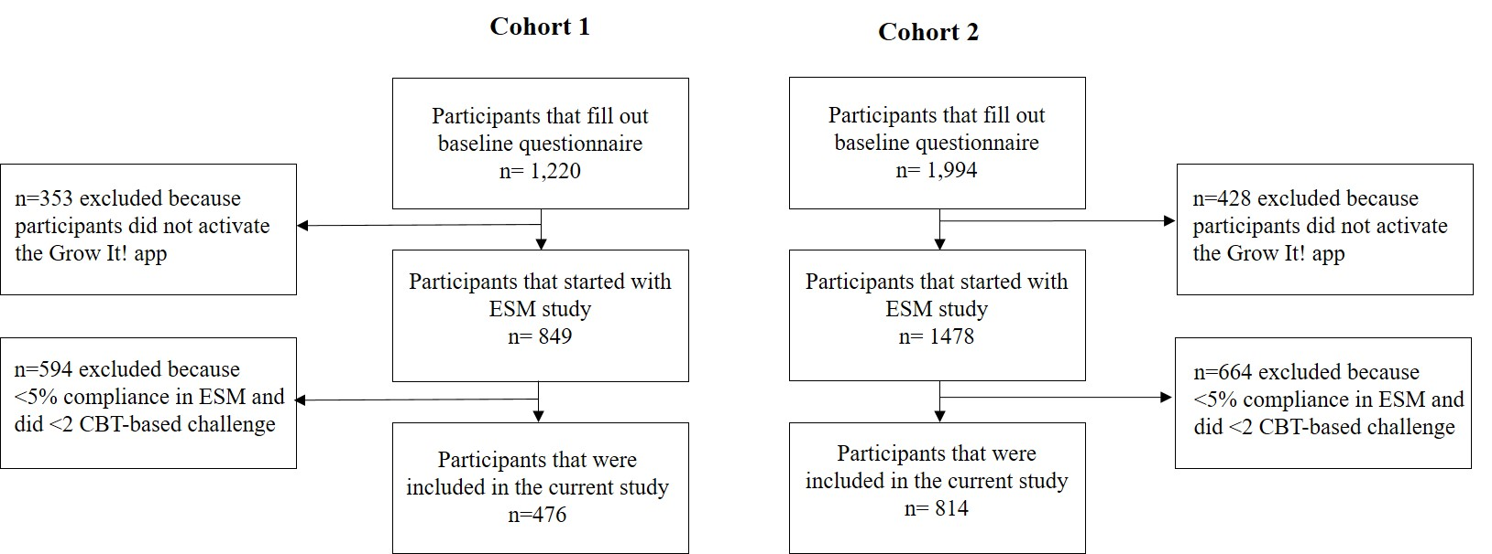
Supplementary figure 1. Flowchart of the population for analysis.

Supplementary table 1. Baseline characteristics compared between participants included in current study population; cohort 1
Cohort 1 | Participants included in study  (n=476) | Study population (n=849) |  | P value of group difference
Age (years), mean (SD) | 16.24 (3.01) | 16.52 (3.30) |  | 0.12
Female, n(%) | 362 (76.1%) | 596 (70.2%) |  | 0.014
Depression (score), mean (SD) | 5.41 (3.98) | 5.56 (4.09) |  | 0.52
Anxiety (score), mean (SD) | 16.24 (4.67) | 16.30 (4.85) |  | 0.81
Wellbeing (score), mean (SD) | 4.92 (1.28) | 4.89 (1.40) |  | 0.69
Adaptive coping (score), mean (SD)  Psychological care  Yes  Waiting list | 4.23 (1.33)  65 (13.7%)  10 (2.1%) | 4.24 (1.26)  127 (15.0%)  22 (2.6%) |  | 0.94  0.72
Variables are expressed as mean (SD), or percentage (%). Difference between two cohorts based on Student t test.

Supplementary table 2. Baseline characteristics compared between participants included in current study population; cohort 2
Cohort 2 | Participants included in study  (n=814) | Study population (n=1478) |  | P value of group difference
Age (years), mean (SD) | 18.45 (3.44) | 18.65 (3.65) |  | 0.22
Female, n(%) | 671 (82.8%) | 1178 (79.7%) |  | 0.15
Depression (score), mean (SD) | 7.56 (4.47) | 7.36 (4.22) |  | 0.24
Anxiety (score), mean (SD) | 18.91 (4.43) | 18.71 (4.48) |  | 0.27
Wellbeing (score), mean (SD) | 4.26 (1.40) | 4.27 (1.41) |  | 0.77
Adaptive coping (score), mean (SD)  Psychological care  Yes  Waiting list | 4.04 (1.26)  172 (21.1%)  40 (4.9%) | 4.01 (0.99)  306 (20.7%)  67 (4.5%) |  | 0.94  0.98
Variables are expressed as mean (SD), or percentage (%). Difference between two cohorts based on Student t test.

 |  | G | loglik | AIC | BIC | SABIC | entropy | ICL | %class1  (mean posterior probability) | %class2  (mean posterior probability)
Cohort 1 |  | 1 | -33738.13 | 67488.25 | 67513.24 | 70113.65 | 1 | 70132.70 | 100
 |  | 2 | -34676.88 | 69373.75 | 69417.62 | 69385.87 | 0.41 | 68484.54 | 69.19 (0.79) | 30.81 (0.77)
Cohort 2 |  | 1 | -43200.18 | 86412.37 | 86440.58 | 86421.53 | 1 | 86440.58 | 100
 |  | 2 | -42766.51 | 85553.02 | 85600.04 | 85568.29 | 0.54 | 84226.71 | 71.99 (0.85) | 28.01 (0.83)
Supplementary table 3. Fit indices for class model solutions positive affect trajectories.
Akaike Information Criteria (AIC), Bayesian Information Criteria (BIC), and sample size adjusted Bayesian Information Criteria (ssaBIC), integrated complete-data likelihood criterion (ICL)

Supplementary table 4. Baseline characteristics stratified by identified latent classes on positive affect
 | Cohort 1 |  |  | Cohort 2
 | Increase positive affect (N=308, 64.7%) | Decrease positive affect (N=168, 35.3%) | P value of group difference | Increase positive affect (N=586, 72.0%) | Decrease positive affect (N=228, 28.0%) | P value of group difference
Intercept | 4.90 | 4.45 | <0.0001 | 4.37 | 4.06 | <0.0001
Slope | 0.06 | -0.27 | <0.0001 | 0.10 | -0.52 | <0.0001
Age (years) | 16.17 | 16.37 | 0.49 | 18.44 | 18.67 | 0.28
Female  Ethnicity  Dutch  Non-Dutch  Mixed  Education  primary school  secondary school  low  middle  high  university/college  low  middle  high  other  COVID positive/symptoms  Family member affected | 234 (76.0%)  272 (88.3%)  2 (0.6%)  25 (8.1%)  19 (6.2%)  19 (6.2%)  45 (14.6%)  159 (51.6%)  21 (6.8%)  16 (5.2%)  23 (7.5%)  1 (0.3%)  24 (7.8%)  34 (11.0%) | 128 (76.2%)  150 (89.3%)  0 (0%)  10 (6.0%)  8 (4.8%)  11 (6.5%)  25 (14.9%)  82 (48.8%)  10 (5.9%)  16 (9.5%)  12 (7.1%)  1 (0.6%)  18 (10.7%)  20 (11.9%) | 0.96  0.17  0.79  0.55 | 473 (80.1%)  571 (97.4%)  1 (0.2%)  11 (1.9%)  7 (1.2%)  33 (5.6%)  82 (14.0%)  124 (21.2%)  64 (10.9%)  99 (16.9%)  126 (21.5%)  32 (5.5%)  75 (12.8%)  108 (18.4%) | 198(87.2%)  220 (96.5%)  1 (0.4%)  5 (2.2%)  0 (0%)  15 (6.6%)  28 (12.3%)  49 (21.5%)  25 (11.0%)  47 (20.6%)  42 (18.4%)  18 (7.9%)  32 (14.0%)  45 (19.7%) | 0.021  0.64  0.78  0.65
Depression | 5.38 | 5.47 | 0.82 | 7.63 | 7.49 | 0.69
Anxiety | 16.26 | 16.19 | 0.87 | 18.85 | 19.13 | 0.42
Well-being | 4.97 | 4.82 | 0.24 | 4.27 | 4.23 | 0.69
Adaptive coping  Psychological care  Yes  Waiting list | 4.30  48 (15.6%)  6 (1.9%) | 4.10  17 (10.1%)  4 (2.4%) | 0.12  0.11 | 4.03  121 (20.6%)  27 (4.6%) | 4.05  51 (22.4%)  13 (5.7%) | 0.84  0.38
ESM | 55.32 | 41.00 | 0.00047 | 35.98 | 37.32 | 0.50
Challenge | 17.91 | 15.65 | 0.037 | 11.18 | 12.04 | 0.05

Supplementary table 5. Fit indices for class model solutions negative affect trajectories.
 | G | loglik | AIC | BIC | SABIC | entropy | ICL | %class1  (mean posterior probability) | %class2  (mean posterior probability)
Cohort 1 | 1 | -29619.35 | 59250.70 | 59277.02 | 59257.97 | 1 | 59277.02 | 100
 | 2 | -29212.59 | 58445.18 | 58489.05 | 58457.30 | 0.72 | 57391.50 | 17.4 (0.87) | 82.83 (0.95)
Cohort 2 | 1 | -37590.48 | 75192.95 | 75221.16 | 75202.11 | 1 | 75221.16 | 100
 | 2 | -37085.30 | 74190.60 | 74237.62 | 74205.87 | 0.70 | 72745.14 | 18.43 (0.87) | 81.57 (0.93)

Akaike Information Criteria (AIC), Bayesian Information Criteria (BIC), and sample size adjusted Bayesian Information Criteria (ssaBIC), integrated complete-data likelihood criterion (ICL)

Supplementary table 6. Baseline characteristics stratified by identified latent classes on negative affect
 | Cohort 1 |  |  | Cohort 2
 | Increase negative affect  (N=83, 17.4%) | Decrease negative affect  (N=393, 82.6%) | P value | Increase negative affect  (N=150, 18.4%) | Decrease negative affect  (N=664, 81.6%) |  | P value
Intercept | 2.69 | 1.68 | <0.0001 | 2.71 | 1.89 | <0.0001
Slope | 0.32 | -0.03 | <0.0001 | 0.47 | -0.10 | <0.0001
AGE | 16.51 | 16.18 | 0.38 | 18.43 | 18.47 | 0.90
Female  Ethnicity  Dutch  Non-Dutch  Mixed  Education  primary school  secondary school  low  middle  high  university/college  low  middle  high  other  COVID positive/symptoms  Family member affected | 66 (79.5%)  75 (90.4%)  0 (0%)  6 (7.2%)  3 (3.6%)  3 (3.6%)  13 (15.7%)  40 (48.2%)  5 (6.0%)  8 (9.6%)  2 (2.4%)  1 (1.2%)  12 (14.5%)  11 (13.3%) | 296 (75.3%)  347 (95.2%)  2 (0.5%)  29 (7.4%)  6 (1.5%)  27 (6.9%)  57 (14.5% )  201(51.1%)  26 (6.6%)  24 (6.1%)  33 (8.4%)  1 (0.3%)  30 (7.6%)  43 (10.9%) | 0.42  0.87  0.14  0.49 | 133 (88.7%)  145 (96.7%)  0 (0%)  5 (3.3%)  0 (0%)  12 (8.0%)  24 (16.0%)  33 (22.0%)  9 (6.0%)  27 (18.0%)  17 (11.3%)  15 (10.0%)  28 (18.7%)  32 (21.3%) | 538 (81.0%)  646 (97.3%)  2 (0.3%)  11 (1.7%)  7 (1.1%)  36 (5.4%)  86 (13.0%)  140 (18.1%)  69 (10.4%)  119 (17.9%)  151 (22.7%)  35 (5.3%)  79 (11.9%)  121 (18.2%) | 0.0066  0.58  <0.0001  0.37
Depressive symptoms | 7.67 | 4.93 | <0.0001 | 9.73 | 7.10 | <0.0001
Anxiety symptoms | 18.34 | 15.79 | <0.0001 | 20.83 | 18.49 | <0.0001
Wellbeing | 4.28 | 5.06 | <0.0001 | 3.80 | 4.36 | <0.0001
Adaptive coping  Psychological care  Yes  Waiting list | 3.85  18 (21.7%)  2 (2.4%) | 4.31  47 (12.0%)  8 (2.04%) | 0.0042  0.084 | 3.79  57 (38.0%)  11 (7.3%) | 4.09  115 (17.3%)  29 (4.4%) | 0.0079  0.00083
ESM | 39.64 | 51.51 | 0.0059 | 37.47 | 36.10 | 0.57
Challenge | 15.32 | 17.49 | 0.059 | 12.04 | 11.18 | 0.05

