Supplementary 2

Figure 3. Associations between ACEs and bullying victimization regarding internalizing problems with 95% confidence intervals.
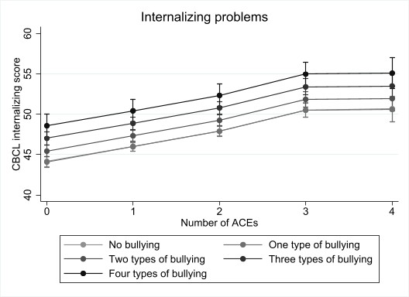
Figure 4. Associations between ACEs and bullying victimization regarding externalizing problems with 95% confidence intervals.

