Do patterns of adolescent participation in arts, culture and entertainment activities predict later wellbeing? A latent class analysis: Supplementary Materials

Table of Contents
Section 1: Comparing analytical sample with Greater Manchester and National Populations 2
Section 2: Split Halves Analyses 3
Section 3: Relationship between PACE class membership and T2 Wellbeing (unadjusted) 5
Section 4: Missing Data and complete case analyses for relation between PACE class membership and T2 Wellbeing 6
Section 5: Class separation and item homogeneity 9

Section 1: Comparing analytical sample with Greater Manchester and National Populations

Table S1: Comparison of analytic sample with Greater Manchester (GM) and National Population Statistics

 | %
 | Sex | FSM | EAL | SEND | Ethnicity
Analytical sample | F = 50.54  M=49.38  NA = 0.08 | N = 72.21  Y = 25.49  NA = 2.30 | N = 78.07  Y = 20.62  NA = 1.32 | N = 83.59  Y = 14.90  NA = 1.51 | AOEG = 2.23  Asian = 17.15  Black = 4.87  Chinese = 0.95  Mixed = 5.75  Unclassified = 2.07  White = 65.10  NA = 1.88
GM populationª | F = 48.60  M = 51.40 | Data not available^{c} | N = 78.46  Y = 21.10 | N = 85.81  Y = 14.19 | AOEG = 2.77  Asian = 17.1  Black = 6.55  Chinese = 0.65  Mixed = 6.32  Unclassified = 1.28  White = 65.4
National statistics^{b} | F = 50  M = 50 | Data not available^{c} | N = 80.1  Y = 19.5 | N = 83.4  Y = 16.6 | AOEG: 2.2  Asian = 11.7  Black = 5.8  Chinese = 0.6  Mixed = 6.6  Unclassified = 1.6  White = 71.4
ª Greater Manchester (GM) population statistics: see Table S1 here
^{b} National statistics: see here
^{c} GM and national statistics only available for current FSM eligibility as opposed to EverFSM6 metric used in the current study

Section 2: Split Halves Analyses
Table S2: Item response probabilities in the split half analysis: Split 1

Item | Dynamic Doers | Game and Gain Squad | Mind and Body Crew | Activity Free Adolescents
Cinema | 0.691 | 0.251 | 0.158 | 0.135
Watching sport | 0.583 | 0.387 | 0.085 | 0.057
Music | 0.299 | 0.029 | 0.103 | 0.03
Reading | 0.794 | 0.268 | 0.671 | 0.204
Clubs | 0.667 | 0.345 | 0.297 | 0.059
Culture | 0.568 | 0.032 | 0.092 | 0.028
Religion | 0.522 | 0.188 | 0.277 | 0.146
Crafts | 0.795 | 0.157 | 0.816 | 0.224
Gaming | 0.905 | 0.924 | 0.812 | 0.597
Playing sports | 0.974 | 0.999 | 0.869 | 0.314
Other | 0.931 | 0.539 | 0.906 | 0.22

Table S3: Item response probabilities in the split half analysis: Split 2

Item | Dynamic Doers | Game and Gain Squad | Mind and Body Crew | Activity Free Adolescents
Cinema | 0.588 | 0.269 | 0.157 | 0.123
Watching sport | 0.498 | 0.43 | 0.082 | 0.049
Music | 0.28 | 0.036 | 0.111 | 0.031
Reading | 0.818 | 0.279 | 0.67 | 0.218
Clubs | 0.637 | 0.327 | 0.297 | 0.082
Culture | 0.524 | 0.046 | 0.093 | 0.019
Religion | 0.495 | 0.184 | 0.281 | 0.164
Crafts | 0.804 | 0.166 | 0.815 | 0.224
Gaming | 0.885 | 0.922 | 0.818 | 0.621
Playing sports | 0.962 | 0.994 | 0.866 | 0.372
Other | 0.913 | 0.575 | 0.925 | 0.243

Table S4: Differences in item endorsement probabilities between Split 1 and Split 2

Item | Dynamic Doers | Game and Gain Squad | Mind and Body Crew | Activity Free Adolescents
Cinema | 0.103 | 0.018 | 0.001 | 0.012
Watching sport | 0.085 | 0.043 | 0.003 | 0.008
Music | 0.019 | 0.007 | 0.008 | 0.001
Reading | 0.024 | 0.011 | 0.001 | 0.014
Clubs | 0.03 | 0.018 | 0 | 0.023
Culture | 0.044 | 0.014 | 0.001 | 0.009
Religion | 0.027 | 0.004 | 0.004 | 0.018
Crafts | 0.009 | 0.009 | 0.001 | 0
Gaming | 0.02 | 0.002 | 0.006 | 0.024
Playing sports | 0.012 | 0.005 | 0.003 | 0.058
Other | 0.018 | 0.036 | 0.019 | 0.023
Average absolute difference | 0.103 | 0.043 | 0.019 | 0.058

Section 3: Relationship between PACE class membership and T2 Wellbeing (unadjusted)

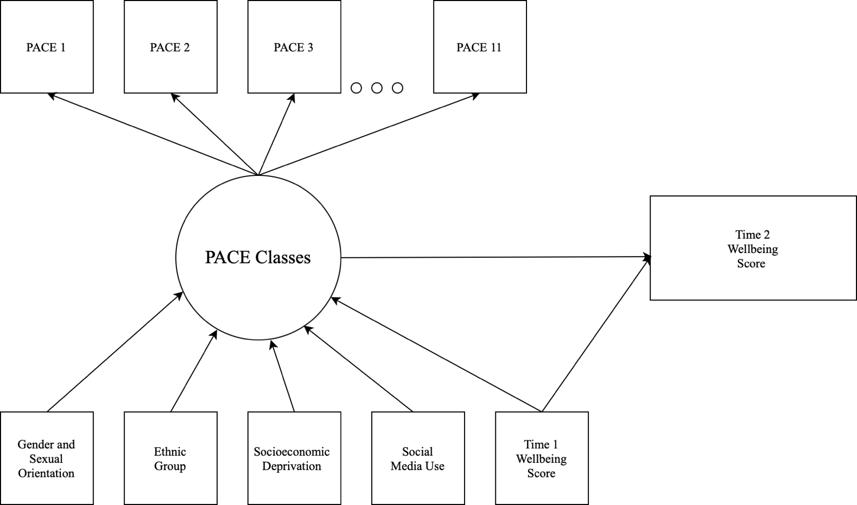
Figure S1: Conceptual diagram showing the unadjusted latent class model

Table S5: PACE Classification and Later Mental Wellbeing: Adjusted Model compared to Unadjusted model

 | Effect Size (d), p value
 | Adjusted | Unadjusted
Dynamic Doers Class vs Game and Gain Squad | .12, p =.124 | .09, p =.262
Dynamic Doers Class vs Mind and Body Crew | .24, p = .002 | .37, p <.001
Dynamic Doers Class vs Activity Free Adolescents | .26, p <.001 | .43, p<.001
Game and Gain Squad vs Mind and Body Crew | .12, p = .016 | .28, p<.001
Game and Gain Squad vs Activity Free Adolescents | .14, p = .009 | .33, p<.001
Mind and Body Crew vs Activity Free Adolescents | .02, p = .555 | .05, p = .136

Section 4: Missing Data and complete case analyses for relation between PACE class membership and T2 Wellbeing

Figure S2: Proportion of missing data in analytical sample
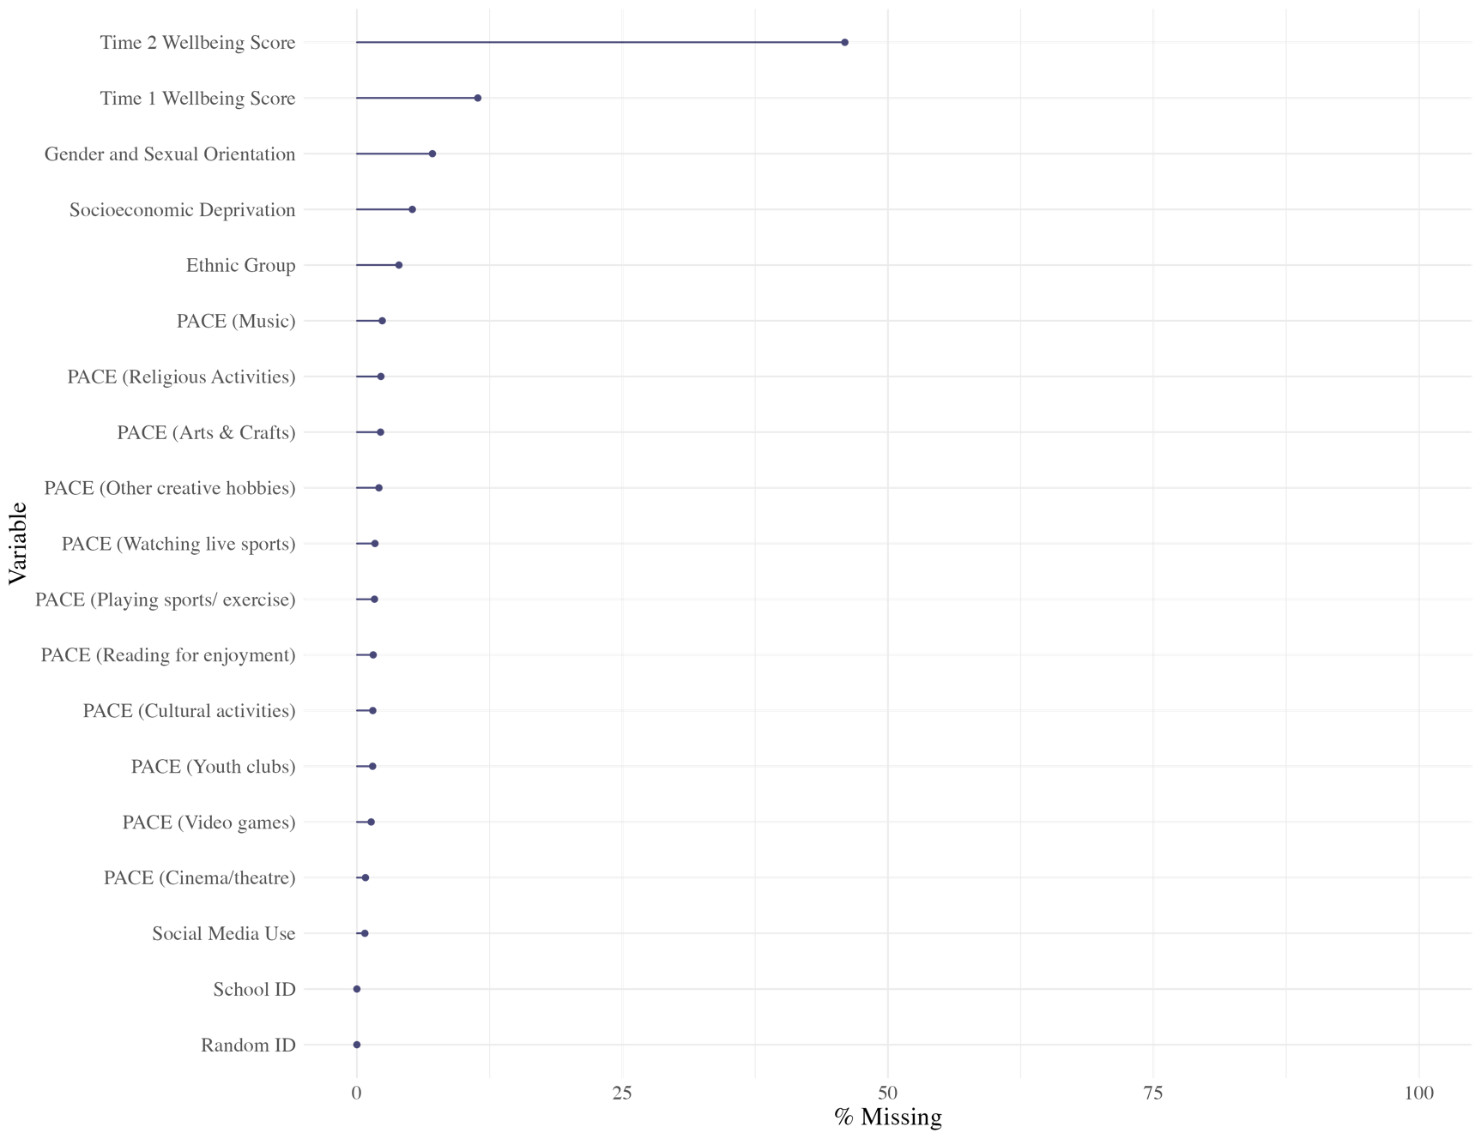

Table S6: Odds Ratios and 95% Confidence Intervals Showing the Relationship Between Class and Predictor Variables: Complete Case Analyses

Covariate | Dynamic Doers Class | Game and Gain Squad | Mind and Body Crew | Activity Free Adolescents
Activity Free Adolescents as reference class
Cisgender heterosexual girls | 0.44 [0.33; 0.58]* | 0.11 [0.09; 0.14]* | 1.11 [0.88; 1.41] | -
LGBTQ+ | 0.67 [0.51; 0.88]* | 0.12 [0.1; 0.16]* | 1.51 [1.2; 1.9]* | -
Asian | 1.14 [0.86; 1.51] | 0.47 [0.36; 0.63]* | 1 [0.82; 1.22] | -
Black | 1.73 [1.19; 2.51]* | 0.47 [0.33; 0.66]* | 0.76 [0.56; 1.04] | -
Mixed | 1.17 [0.76; 1.81] | 0.75 [0.55; 1.01] ª | 1.17 [0.89; 1.53] | -
Other (incl. Chinese) | 1.07 [0.7; 1.65] | 0.27 [0.16; 0.45]* | 1.37 [0.91; 2.05] | -
Disadvantaged | 0.86 [0.65; 1.14] | 0.57 [0.45; 0.73]* | 0.71 [0.59; 0.86]* | -
Social media use | 0.83 [0.79; 0.87]* | 0.98 [0.94; 1.03] | 0.81 [0.78; 0.84]* | -
Wellbeing (Time 1) | 1.19 [1.16; 1.22]* | 1.1 [1.08; 1.13]* | 1.08 [1.07; 1.1]* | -
Dynamic Doers Class as reference class
Cisgender heterosexual girls | - | 0.26 [0.21; 0.33]* | 2.55 [1.97; 3.31]* | -
LGBTQ+ | - | 0.19 [0.14; 0.24]* | 2.25 [1.75; 2.89]* | -
Asian | - | 0.42 [0.31; 0.56]* | 0.88 [0.7; 1.12] | -
Black | - | 0.27 [0.19; 0.37]* | 0.44 [0.32; 0.6]* | -
Mixed | - | 0.64 [0.41; 0.99]* | 1 [0.65; 1.54] | -
Other (incl. Chinese) | - | 0.25 [0.15; 0.42]* | 1.28 [0.82; 1.99] | -
Disadvantaged | - | 0.66 [0.49; 0.9]* | 0.82 [0.61; 1.11] ª | -
Social media use | - | 1.19 [1.14; 1.24]* | 0.98 [0.94; 1.01] | -
Wellbeing (Time 1) | - | 0.93 [0.91; 0.95]* | 0.91 [0.89; 0.93]* | -
Game and Gain Squad as reference class
Cisgender heterosexual girls | - | - | 9.76 [7.93; 12.01]* | -
LGBTQ+ | - | - | 12.17 [9.55; 15.51]* | -
Asian | - | - | 2.11 [1.62; 2.76]* | -
Black | - | - | 1.63 [1.16; 2.31]* | -
Mixed | - | - | 1.56 [1.12; 2.17]* | -
Other (incl. Chinese) | - | - | 5.15 [3.2; 8.27]* | -
Disadvantaged | - | - | 1.25 [0.96; 1.62] | -
Social media use | - | - | 0.82 [0.79; 0.85]* | -
Wellbeing (Time 1) | - | - | 0.98 [0.97; 1] | -
* indicates significant ORs (95% CIs do not cross 1)
ª Cases where discrepancies in statistical significance were observed between FIML and complete case analyses

Adolescents in the Dynamic Doers Class had the highest wellbeing scores at T2, and adolescents in the Activity Free Adolescents had the lowest wellbeing scores at T2. Time 2 wellbeing was not significantly different between adolescents in the Dynamic Doers Class and the Game and Gain Squad (d = .04, p=.647), between adolescents in the Dynamic Doers Class and the Mind and Body Crew (d = .16, p = .053), or between adolescents in the Mind and Body Crew and Activity Free Adolescents (d =.04, p = .300). However, adolescents in the Dynamic Doers Class had significantly higher T2 wellbeing scores (mean = 23.31) than adolescents in the Activity Free Adolescents (mean = 19.98; d = .2, p = .010). Adolescents in the Game and Gain Squad had higher T2 wellbeing scores (mean = 22.56) than adolescents in the Mind and Body Crew (mean = 21.17; d = .12, p=.025) and those in the Activity Free Adolescents (d = .16, p=.007).

Section 5: Class separation and item homogeneity

Table S7: Odds ratios showing separation between classes

PACE item | Class 1 vs Class 2 | Class 1 vs Class 3 | Class 1 vs Class 4 | Class 2 vs Class 3 | Class 2 vs Class 4 | Class 3 vs Class 4
Cinema | 2.39 | 1.88 | 0.19 | 0.79 | 0.08 | 0.10
Wating Sport | 12.43 | 7.51 | 0.58 | 0.6 | 0.05 | 0.08
Music (e.g., orchestra) | 1.06 | 0.28 | 0.08 | 0.27 | 0.08 | 0.29
Reading for Fun | 1.41 | 0.18 | 0.09 | 0.13 | 0.06 | 0.49
Youth Clubs | 6.59 | 1.2 | 0.271 | 0.18 | 0.04 | 0.23
Cultural activities (e.g., museums) | 1.67 | 0.4 | 0.03 | 0.24 | 0.02 | 0.08
Religious activities | 1.25 | 0.59 | 0.22 | 0.47 | 0.18 | 0.37
Arts and Crafts | 0.67 | 0.04 | 0.05 | 0.07 | 0.07 | 1.1
Video games | 7.72 | 2.75 | 1.42 | 0.36 | 0.18 | 0.52
Playing sports/exercise | 592.90 | 47.76 | 10.54 | 0.08 | 0.02 | 0.22
Other creative hobbies | 4.15 | 0.12 | 0.11 | 0.03 | 0.03 | 0.90
Odds ratios >5 or <0.2 are bolded to indicate a high degree of class separation
Class 1 = Game and Gain Squad; Class 2 = Activity Free Adolescents; Class 3 = Mind and Body Crew; Class 4 = Dynamic Doers.

Table S8: Item endorsement probabilities in each class (4-class model)
 | Probability of High Endorsement of Category
PACE item | Dynamic Doers | Game and Gain Squad | Mind and Body Crew | Activity Free Adolescents
Cinema | 0.645 | 0.261 | 0.158 | 0.129
Wating Sport | 0.544 | 0.41 | 0.085 | 0.053
Music (e.g., orchestra) | 0.291 | 0.033 | 0.107 | 0.031
Reading for Fun | 0.807 | 0.274 | 0.672 | 0.211
Youth Clubs | 0.653 | 0.338 | 0.298 | 0.072
Cultural activities (e.g., museums) | 0.553 | 0.039 | 0.093 | 0.024
Religious activities | 0.511 | 0.186 | 0.280 | 0.155
Arts and Crafts | 0.801 | 0.162 | 0.816 | 0.225
Video games | 0.895 | 0.924 | 0.815 | 0.611
Playing sports/exercise | 0.968 | 0.997 | 0.869 | 0.348
Other creative hobbies | 0.923 | 0.559 | 0.915 | 0.234
Item probabilities >0.7 or <0.3 are bolded to indicate a high degree of class homogeneity.

