Title:- Does Employment Status Matter for Emerging Adult Identity Development and Life Satisfaction? A Two-wave Longitudinal Study
Journal name:- Journal of Youth and Adolescence

Figure S1
Measurement Models for Identity and Life Satisfaction
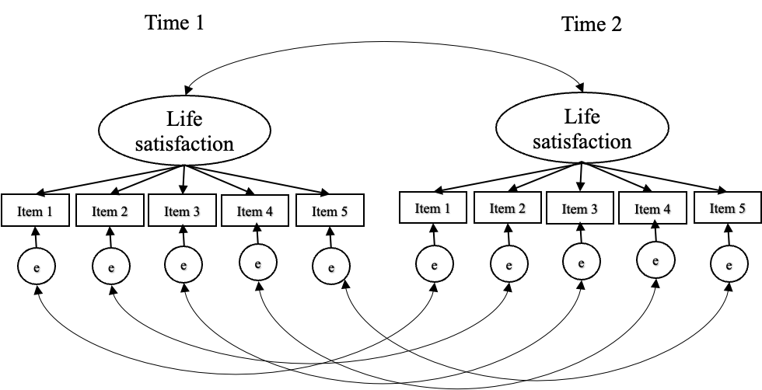

Table S1
Participants' Region, Household Income, and Educational Background
 | %
Region
Urban
Kanto | 33.5
Chubu | 19.9
Kansai | 16.9
Less urban
Hokkaido | 4.9
Tohoku | 6.4
Chugoku | 5.5
Shikoku | 2.1
Kyusyuu | 10.9
Household income
Low (<2 million yen) | 9.0
Middle (2 to 8 million yen) | 45.5
High (>8 million yen) | 10.1
Unknown | 18.4
Educational background
Master's | 8.2
Bachelor's | 55
Associate degree | 6.1
Diploma | 10.7
High school | 17.6
Junior high school | 2.3
Other | 0.1

Table S2

Fit Indices of the EPSI and Life Satisfaction Measurement Model
 | S-Bχ^{２} | CFI | RMSEA [90% CI] | Compared to configural model
 | S-Bχ^{２} | CFI | RMSEA [90% CI] | ΔS-Bχ^{２} | Δdf | p | |ΔCFI| | |ΔRMSEA|
EPSI
Configural invariance | 250.486 | .951 | .045 [.039-.052]
Metric invariance | 258.138 | .950 | .044 [.038-.051] | 6.678 | 6 | .352 | .001 | .001
Full scalar invariance | 270.865 | .949 | .043 [.036-.049] | 16.484 | 15 | .351 | .002 | .002
Life satisfaction
Configural invariance | 70.417 | .988 | .040 [.028-.053]
Metric invariance | 77.286 | .987 | .039 [.028-.051] | 5.350 | 4 | .253 | .001 | .001
Full scalar invariance | 94.065 | .984 | .041 [.031-.052] | 24.480 | 9 | .004 | .004 | .001

Note: S-Bχ^{２} = Satorra–Bentler adjusted χ^{２}test statistic; ΔS-Bχ^{２} = change in S-Bχ^{２}; p = p value across model comparisons, based on S-Bχ^{２} difference; testing (ΔS-Bχ^{２}); CFI = comparative fit index; RMSEA = root mean-square error of approximation; 90% CI = 90% confidence interval; Δ= change in parameter; EPSI = the Erikson Psychosocial Stage Inventory

