Supporting Information

Manuscript Title: Peer-Friendship Networks and Self-harm Among Adolescents from Inner-City Schools: A Social Network Study
Authors: Holly Crudgington, Rachel Blakey, Molly Copeland, Charlotte Gayer-Anderson, Samantha Davis, Katie Lowis, Esther Putzgruber, Thai-sha Richards, Jonas Kitisu, Adna Hashi, Karima Shyan Clement-Gbede, Niiokani Tettey, Daniel Stanyon, Alice Turner, Lynsey Dorn, Seeromanie Harding, Kamaldeep Bhui, Vanessa Pinfold, Gemma Knowles, Craig Morgan.

S1. Correlations between network variables
S2. Network descriptives table
S3. Further information about sociometric variables
S4. Sociograms of all networks
S5. Missing data information
S6. Network characteristics by cohort and ethnic group
S7. Gender*network metric interaction results for lifetime self-harm
S8. Sensitivity analyses
S9. Full models with all covariate results for network metrics and self-harm
S10. Young Person Community Champion (YPCC) views
S1. Correlations between network variables

 | 1 | 2 | 3 | 4 | 5
Betweenness centrality (1) | 1
In-degree (2) | 0.39* | 1
Out-degree (3) | 0.28* | 0.22* | 1
Total degree (4) | 0.41* | 0.75* | 0.67* | 1
Ego-network density (5) | -0.21* | 0.04 | -0.07* | -0.27* | 1
n, 2203, *p <.001

S2. T1 Network descriptives table
School | Year group friendship network | # of nodes at T1 | Overall density | % of people missing on the friendship network questions *a
4 | Network 1 (Cohort 1) | 141 | 0.03 | 29.8
4 | Network 2 (Cohort 2) | 133 | 0.03 | 21.1
4 | Network 3 (Cohort 3) | 142 | 0.03 | 21.1
5 | Network 4 (Cohort 1) | 126 | 0.04 | 38.1
5 | Network 5 (Cohort 2) | 125 | 0.04 | 39.2
5 | Network 6 (Cohort 3) | 123 | 0.04 | 29.0
6 | Network 7 (Cohort 1) | 141 | 0.02 | 46.8
6 | Network 8 (Cohort 2) | 146 | 0.03 | 43.8
6 | Network 9 (Cohort 3) | 149 | 0.04 | 38.3
7 | Network 10 (Cohort 1) | 170 | 0.03 | 16.5
7 | Network 11 (Cohort 2) | 155 | 0.03 | 22.6
7 | Network 12 (Cohort 3) | 138 | 0.03 | 24.6
8 | Network 13 (Cohort 1) | 130 | 0.04 | 28.5
8 | Network 14 (Cohort 2) | 123 | 0.04 | 24.4
8 | Network 15 (Cohort 3) | 119 | 0.04 | 44.5
9 | Network 16 (Cohort 1) | 121 | 0.04 | 24.8
10 | Network 17 (Cohort 1) | 85 | 0.06 | 52.9
10 | Network 18 (Cohort 2) | 86 | 0.06 | 20.9
10 | Network 19 (Cohort 3) | 69 | 0.07 | 49.3
11 | Network 20 (Cohort 1) | 142 | 0.03 | 24.7
11 | Network 21 (Cohort 2) | 135 | 0.04 | 16.3
11 | Network 22 (Cohort 3) | 136 | 0.04 | 34.6
12 | Network 23 (Cohort 1) | 182 | 0.03 | 36.6
12 | Network 24 (Cohort 2) | 181 | 0.03 | 48.6
12 | Network 25 (Cohort 3) | 180 | 0.03 | 23.3
Cohort 1 = baseline year 7, Cohort 2 = baseline year 8, Cohort 3 = baseline year 9. T1 = time 1. *a = this is the percentage of missing friendship nomination data [of the nodes listed in the number of nodes per time point column], irrespective of participation status i.e., includes item non-response as well as pupil absence and non-participation.
S3. Further information about sociometric variables
To accurately reflect out-degree 0 (i.e., adolescents who did not nominate friends but were present on the day of data collection), we conducted additional data cleaning. This involved manually inspecting responses to determine if adolescents with an out-degree of 0 (n, 1076) had completed the questions immediately following the friendship network section. There were 301 students who had an out-degree 0 who answered subsequent questions after the friendship nomination section. Their out-degree value was coded as 0, while the other participants were treated as missing (n,775).
Betweenness centrality
The formula for betweenness centrality is given by shortest path betweenness of a vertex [v]:
$$C_{B}(v)=\sum_{i,j:i≠j,i≠v,j≠v}{ }\frac{g_{ivj}}{g_{ij}}$$
Where $g_{ivj}$ is the number of geodesics from i to j through v. Betweenness centrality values can be very large dependent on network size, because nodes have more opportunity to lie on the shortest path between others in a large network (i.e., in this dataset betweenness values range from 0 – 5880 and the variable is positively skewed). To aid interpretation in analyses, each adolescent’s betweenness score was divided by 100.
Friendship group density (Ego-network density)
Ego-network density is the ratio of actual friendship ties among an adolescent’s send and receive network to all possible ties in their send and receive network, producing a statistic that ranges from 0 (no connections) to 1 (completely connected ego-network). The measure of ego-network density computed in igraph includes ego in the calculation. Whether a density value should be considered high, medium, or low depends on context. For example, an adolescent who belongs in an ego-network with 5 friends but with a density of 0-0.3 could be considered very low – as we tend to see higher density ties for positive ties and for ego-networks in general. However, there is no consensus in the field of Social Network Analysis (SNA) as to exactly what cut points should be used to reflect Low, Medium, and High. We defined low density as scoring 0-0.3, medium density as 0.31 – 0.59, and high density as 0.6-1. We explore different cut-points for density in sensitivity analyses (S8).

S4. Sociograms of all networks
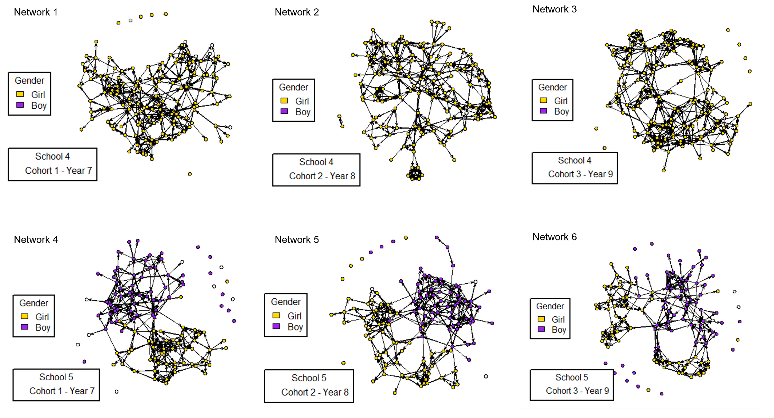
Sociograms of Schools 4 - 5, Networks #1 - 6

Sociograms of Schools 6 – 7, networks #7 to 12
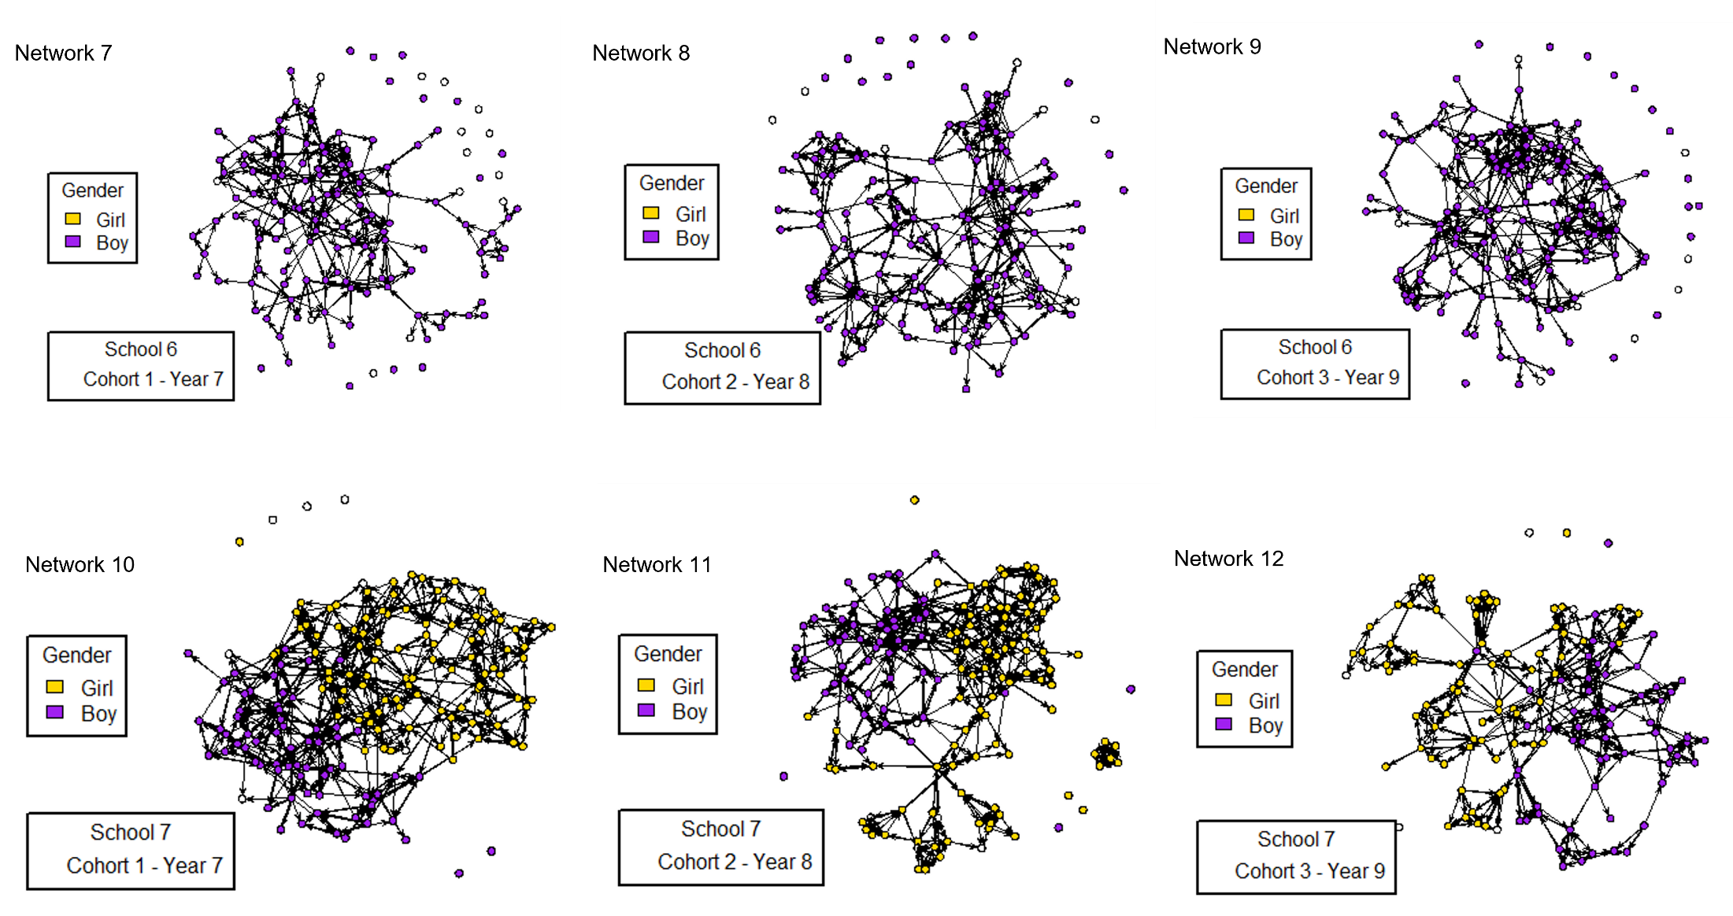

Sociograms of Schools 8-9, Networks #13 - 16
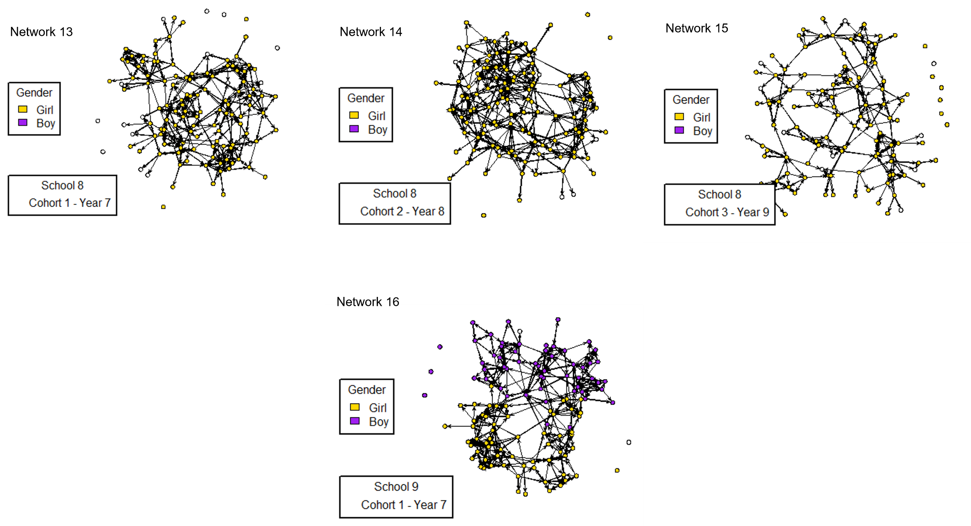

Sociograms of Schools 10 – 11, Networks #17 – 22
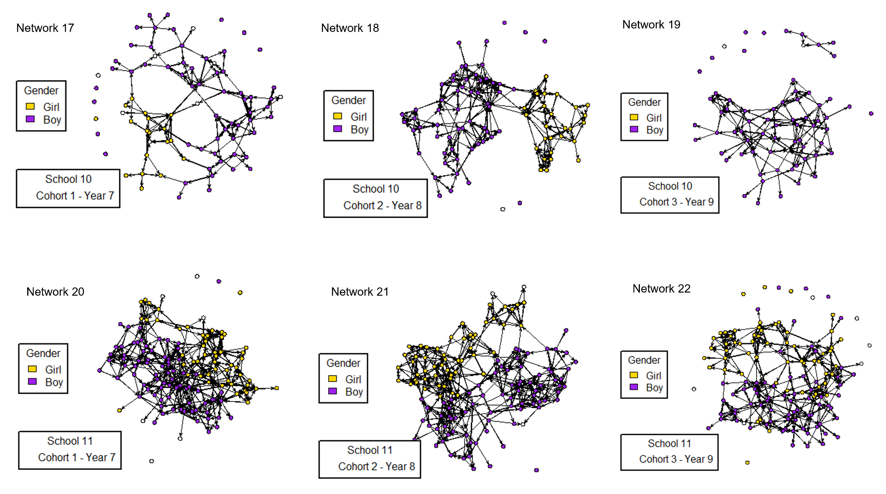

Sociograms of School 12, networks #23 - 25
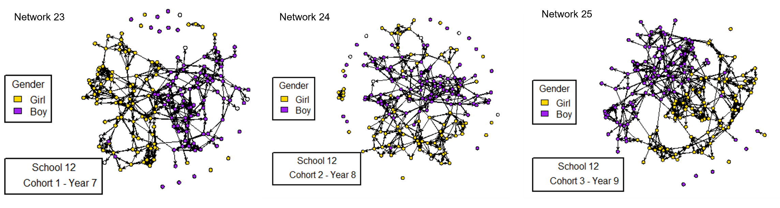

Network visualisations reflect everyone that was eligible to be part of a network at baseline irrespective of participation status.

S5. Missing data information
S5.1. Comparison of analysis sample with the REACH baseline sample and those eligible to be in the networks at T1
 | Analysis sample  (complete cases)  n (2, 2203) |  | Total ____ baseline sample - eligible to be in a network at T1  (9 schools, 25 networks) *a  n (3, 378) |  | Total ____ baseline sample - participated  (12 schools) *b  n (4, 353)
Socio-demographics | n | % | n | % | n | %
Gender | n (2, 203) |  | n (3, 193) |  | n (4,353)
Boys | 1,026 | 46.6 | 1,513 | 47.4 | 2,140 | 49.2
Girls | 1,177 | 53.4 | 1,680 | 52.6 | 2,213 | 50.8
Year Group | N (2, 203) |  | n (3, 378) |  | n (4,353)
Year 7 (@ baseline) | 733 | 33.3 | 733 | 33.3 | 1,593 | 36.6
Year 8 (@ baseline) | 720 | 32.7 | 720 | 32.7 | 1,423 | 32.7
Year 9 (@ baseline) | 750 | 34.0 | 750 | 34.0 | 1,337 | 30.7
Ethnic group | n (2, 203) |  | n (3, 187) |  | n (4,353)
White British | 372 | 16.9 | 520 | 16.3 | 639 | 14.7
Indian, Pakistani, Bangladeshi | 112 | 5.1 | 146 | 4.6 | 180 | 4.1
Black Caribbean | 291 | 13.2 | 435 | 13.7 | 71 | 16.4
Other Black | 68 | 3.1 | 100 | 3.1 | 130 | 3.0
Mixed/multiple | 129 | 5.9 | 186 | 5.8 | 243 | 5.6
Any Other | 145 | 6.6 | 203 | 6.4 | 299 | 6.9
Black African | 639 | 29.0 | 915 | 28.7 | 1,112 | 25.6
Non-British White | 174 | 7.9 | 256 | 8.0 | 430 | 9.9
Mixed White and Black | 188 | 8.5 | 288 | 9.0 | 386 | 8.9
Latin American | 85 | 3.9 | 138 | 4.3 | 220 | 5.1
Free School Meals | n (2, 203) |  | n (2, 803) *c |  | n (4, 113)
No | 1,775 | 80.6 | 2,244 | 80.0 | 3,136 | 76.3
Yes | 428 | 19.4 | 559 | 20.0 | 977 | 23.8
Lifetime self-harm | n (2, 203) |  | n (2, 562) *d |  | n (3, 061)
No | 1,902 | 86.3 | 2,209 | 86.2 | 2,620 | 85.6
Yes, ever | 301 | 13.7 | 353 | 13.8 | 441 | 14.4

*a = The eligible REACH sample at baseline was 4,945. Three schools were excluded from these analyses culminating in 25 separate year groups (networks) across 9 schools, with 3378 participants that were eligible to be in one of those networks.
*b = There were 4945 adolescents who were eligible to be part of the REACH baseline sample from all 12 schools (i.e., including the pilot schools). Of the 4945 eligible, 4,353 participated in the REACH study. The reason for non-participation from pupils included school absenteeism (n= 353, 7%), parental opt-out (n, 167, 3%), non-assent (n = 57, 1%), technical issues (n = 15, 0.3%).
*c = reasons for missing data on free-school meals - 409 did not participate (reasons [opt out n= 125], [non-assent n=33], [absent n = 241], [leaver/move [n =2], [technical issues n = 8], of those that did participate (2, 969) reasons for missing data were skipped/didn't reach that part of the questionnaire (n = 6) don't know (n = 145), refused (n = 15).
*d = reasons for missing data on self-harm - 409 did not participate (reasons [opt out n= 125], [non-assent n=33], [absent n = 241], [leaver/move [n =2], [technical issues n = 8. Of those that did participate (2969) - reasons for missing data included skipped/didn't reach that part of the questionnaire (n = 93), refused (n= 314).
S5.2. Analysis sample compared with those who were not in the analysis sample but were eligible to be part of the baseline networks (categorical variables)
Total eligible  (9 schools - 25 networks)  n = 3378*a | Analysis sample  (n = 2203) | Not included in  analysis sample  (n = 1175) *b | Chi square
 | n (%) | n (%) | χ2(df)p
Gender (n, 3193) |  |  | 1.87 (1) .170
Boys | 1026 (46.57) | 487 (49.19)
Girls | 1177 (53.43) | 503 (50.81)
Year Group (n, 3378) |  |  | 36.95 (2) <.001
Year 7 (@ baseline) | 505 (42.98) | 505 (42.98)
Year 8 (@ baseline) | 367 (31.23) | 367 (31.23)
Year 9 (@ baseline) | 303 (25.79) | 303 (25.79)
Ethnic group (n, 3187) |  |  | 12.97 (9) .164
White British | 372 (16.89) | 148 (15.04)
Indian, Pakistani, Bangladeshi | 112 (5.08) | 34 (3.46)
Black Caribbean | 291 (13.21) | 144 (14.63)
Other Black | 68 (3.09) | 32 (3.25)
Mixed/multiple | 129 (5.86) | 57 (5.79)
Any Other | 145 (6.58) | 58 (5.89)
Black African | 639 (29.01) | 276 (28.05)
Non-British White | 174 (7.90) | 82 (8.33)
Mixed White and Black | 188 (8.53) | 100 (10.16)
Latin American | 85 (3.86) | 53 (5.39)
Free School Meals (n, 2803) |  |  | 1.70 (1) .191
No | 1775 (80.57) | 469 (78.17)
Yes | 428 (19.43) | 131 (21.83)
*a = Eligible adolescents from 25 networks (year groups) across 9 schools at T1.
*b = 1175 people were not included in our analysis sample. Of those, 766 (65.19%) participated in REACH but were missing data on a variable used in this analysis. 409 (34.81%) did not participate due to the following reasons: parental opt-out (n = 125, 10.64%), non-assent (n = 33, 2.81%), leaver/mover (n = 2, 0.17%), absence (n = 241, 20.51%), technical issues (n =8, 0.68%).
S6. Network characteristics by cohort and ethnic group
The focus of the main manuscript is on self-harm, social networks and gender, but these descriptives are provided for information and completeness. In the absence of a priori hypotheses regarding age and ethnic group (and small cell sizes), we do not make any inferences based solely on the descriptive data here.
Table S6.1. Network characteristics by cohort (year group)
Network Metrics | Total  (n = 2203) | Cohort 1  Year 7  (n = 733) | Cohort 2  Year 8  (n = 720) | Cohort 3  Year 9  (n = 750)
Friends’ self-harm, n(%)
0 friends report self-harm | 1215 (55.2) | 450 (61.4) | 356 (49.4) | 409 (54.5)
1 friend reports self-harm | 674 (30.6) | 193 (26.3) | 244 (33.9) | 237 (3.6)
2 friends report self-harm | 230 (10.4) | 72 (9.8) | 85 (11.8) | 73 (9.7)
≥3 friends report self-harm | 84 (3.8) | 18 (2.5) | 35 (4.9) | 31 (4.1)
Isolated, n(%)
No | 2097 (95.2) | 713 (97.3) | 686 (95.3) | 698 (93.1)
Yes | 106 (4.8) | 20 (2.7) | 34 (4.7) | 52 (6.9)
Popularity (M±S.D) | 3.4 (2.2) | 3.5 (2.3) | 3.3 (2.2) | 3.3 (2.1)
Sociality (M±S.D) | 4.0 (1.7) | 4.2 (1.5) | 4.1 (1.6) | 3.8 (1.9)
Betweenness centrality/100, (M±S.D)* | 4.2 (6.2) | 4.56 (5.6) | 4.11 (6.2) | 3.95 (6.7)
Friendship group density n(%)
Low density (0 - 0.3) | 798 (36.2) | 294 (40.1) | 263 (36.5) | 241 (32.1)
Medium density (0.31 - 0.59) | 1189 (54.0) | 396 (54.0) | 375 (52.1) | 418 (55.7)
High density (0.6 - 1) | 216 (9.8) | 43 (5.9) | 82 (11.4) | 91 (12.1)
Friendship group size (M+SD) | 5.6 (2.1) | 5.8 (2.1) | 5.58 (2.1) | 5.3 (2.2)

M = mean, S.D standard deviation, n = number. Where necessary, small cell sizes have been omitted for data protection.
Table S6.2. Network characteristics by ethnic group
Network Metrics | Any other  (n, 145) | Black African  (n, 639) | Black Carib.  (n, 291) | Indian, Pakistani, Bangladeshi  (n, 112) | Latin A.  (n, 85) | Mixed White & Bl  (n, 188) | Mixed/Mult.  (n, 129) | Non-British White  (n, 174) | Other Black  (n, 68) | White British  (n, 372)
Friends’ self-harm n(%)
0 friends report self-harm | 75 (51.7) | 375 (58.7) | 133 (45.7) | 80 (71.4) | 37 (43.5) | 97 (51.6) | 77 (59.7) | 95 (54.6) | 40 (58.8) | 206 (55.4)
At least 1 friend reports self-harm | 70 (48.3) | 264 (41.3) | 158 (54.3) | 32 (28.6) | 48 (56.5) | 91 (48.4) | 52 (40.3) | 79 (45.4) | 28 (41.2) | 166 (44.6)
Popularity (M±S.D) | 3.04 (2.0) | 3.37 (2.2) | 3.31 (2.1) | 2.85 (2.3) | 3.07 (2.2) | 3.51 (2.4) | 3.31 (2.1) | 3.25 (2.0) | 3.05 (2.0) | 3.71 (2.3)
Sociality (M±S.D) | 3.99 (1.7) | 3.86 (1.9) | 4.07 (1.7) | 3.88 (1.7) | 4.07 (1.5) | 4.23 (1.5) | 4.11 (1.5) | 4.08 (1.6) | 3.91 (1.9) | 4.29 (1.4)
Bridging, (M±S.D)* | 2.98 (4.6) | 3.16 (4.7) | 4.86 (6.6) | 3.41 (5.4) | 4.50 (6.3) | 5.37 (7.0) | 4.78 (7.2) | 3.97 (6.0) | 3.31 (4.7) | 5.58 (7.7)
Friendship group size (M+SD) | 5.28 (2.0) | 5.55 (2.3) | 5.93 (2.2) | 4.78 (1.6) | 5.4 (2.1) | 5.80 (2.2) | 5.47 (2.1) | 5.44 (1.7) | 5.22 (2.2) | 5.74 (2.0)
M = mean, S.D standard deviation, n = number, I P D = Indian, Pakistani, Bangladeshi. Where necessary, network metrics that had small groups (cell sizes) have been omitted for data protection
S7. Gender × network metric interaction results for lifetime self-harm
 | Overall^{*a} | Boys^{*b} | Girls^{*b} | p value for  gender * network metric interaction
 | aOR (95%CI) p | aOR (95%CI) p | aOR (95%CI) p
Friends' self-harm
0 friends report self-harm | Ref | Ref | Ref
At least one friend reports self-harm | 1.63 (1.25, 2.13), <.001 | 1.32 (0.87, 2.00), 0.176 | 1.86 (1.33, 2.61), <.001 | 0.194
Friends' self-harm
0 friends report self-harm | Ref | Ref | Ref | 0.666
1 friend reports self-harm | 1.32 (0.98, 1.78), 0.064 | 1.06 (0.66, 1.70), 0.804 | 1.52 (1.04, 2.20), 0.028
2 friends report self-harm | 2.35 (1.60, 3.46), <.001 | 1.96 (1.03, 3.70), 0.039 | 2.62 (1.63, 4.22), <.001
>3 friends report self-harm | 3.72 (2.20, 6.28), <.001 | 3.51 (1.45, 8.48), 0.005 | 3.92 (2.07, 7.39), <.001
Friendship group density
Medium Density | Ref | Ref | Ref | 0.841
Low Density | 0.93 (0.70, 1.23), 0.639 | 0.89 (0.59, 1.35), 0.608 | 0.97 (0.67, 1.40), 0.878
High Density | 0.51 (0.31, 0.85), 0.010 | 0.64 (0.22, 1.89), 0.428 | 0.49 (0.27, 0.86), 0.014
Bridging | 1.02 (1.00, 1.05), 0.014 | 1.03 (1.00, 1.06), 0.011 | 1.01 (0.99, 1.04), 0.180
Popularity | 1.05 (0.99, 1.12), 0.051 | 1.03 (0.94, 1.12), 0.528 | 1.08 (1.00, 1.17), 0.038
Sociality | 0.95 (0.88, 1.02), 0.192 | 0.94 (0.84, 1.05), 0.266 | 0.96 (0.87, 1.06), 0.438
Isolated
No | Ref | Ref | Ref
Yes | 1.73 (1.05, 2.83) 0.029 | 2.55 (1.37, 4.77), 0.003 | 1.14 (0.48, 2.68) 0.767 | 0.134
n, 2203
*a Overall model estimates are the same as the final column of the main results table in the main manuscript (i.e., adjusted for gender, age, free-school meals, ethnic group, and a network control [where applicable]). *b Linear combination of estimates was used to extract gender-specific ORs directly from the interaction model that contained all control variables. Unadjusted interaction models showed similar patterns with no significant gender moderation (i.e., all interaction p values >.05)
S8. Sensitivity analyses
S8.1 Estimated odds ratios for the effects of friendship group density (different cut points of the friendship group density variable) and lifetime self-harm among adolescents overall
 | Model 1 |  | Model 2 |  | Model 3
 | uOR (95%CI) | p | aOR (95%CI) | p | aOR (95%CI) | p
Friendship group density^{*a}
Medium density (0.30 - 0.49) | Ref |  | Ref |  | Ref
Low density (0 - 0.29) | 0.90 (0.68, 1.20) | 0.492 | 0.99 (0.74, 1.33) | 0.982 | 0.97 (0.72, 1.31) | 0.876
High density (0.5 - 1) | 0.77 (0.54, 1.11) | 0.169 | 0.68 (0.47, 0.99) | 0.045 | 0.70 (0.48, 1.01) | 0.058
Ego-network density^{*a}
Medium density (0.35 - 0.59) | Ref |  | Ref |  | Ref
Low density (0 - 0.34) | 0.85 (0.66, 1.10) | 0.220 | 0.93 (0.71, 1.21) | 0.596 | 0.91 (0.70, 1.19) | 0.531
High density (0.61 - 1) | 0.58 (0.35, 0.95) | 0.032 | 0.49 (0.30, 0.82) | 0.007 | 0.50 (0.30, 0.84) | 0.009
 | n, 2203 |  | n, 2203 |  | n, 2203
uOR = Unadjusted Odds Ratio, aOR = Adjusted Odds Ratios. All models adjusted for clustering at the school level.
Model 1 is an unadjusted univariable model assessing the association between friendship group density with self-harm. Model 2 is adjusted for gender, age, free school meal status, and ethnic group. Model 3 is further adjusted for friendship group size.

S8.2. Estimated odds ratios for the effects of network metrics and lifetime self-harm among adolescents overall (on networks with <40% missing data)
 | Model 1 |  | Model 2 |  | Model 3*^{ab}
 | uOR (95%CI) | p | aOR (95%CI) | p | aOR (95%CI) | p
Friends’ self-harm ^{*a}
0 friends report self-harm | Ref |  | Ref |  | Ref
At least 1 friend reports self-harm | 1.70 (1.30, 2.24) | <.001 | 1.63 (1.23, 2.16) | 0.001 | 1.61 (1.20, 2.16) | 0.001
Friends’ self-harm ^{*a}
0 friends report self-harm | Ref |  | Ref |  | Ref
1 friend reports self-harm | 1.33 (0.97, 1.81) | 0.074 | 1.25 (0.91, 1.73) | 0.157 | 1.27 (0.91, 1.76) | 0.145
2 friends report self-harm | 2.32 (1.57, 3.43) | <.001 | 2.31 (1.55, 3.43) | <.001 | 2.36 (1.56, 3.58) | <.001
≥ 3 friends report self-harm | 3.63 (2.13, 6.19) | <.001 | 3.51 (2.03, 6.05) | <.001 | 3.60 (2.05, 6.34) | <.001
Friendship-group density^{*a}
Medium density | Ref |  | Ref |  | Ref
Low density | 0.92 (0.69, 1.23) | 0.614 | 1.06 (0.78, 1.43) | 0.692 | 1.04 (0.77, 1.41) | 0.775
High density | 0.52 (0.30, 0.91) | 0.022 | 0.46 (0.26, 0.80) | 0.006 | 0.47 (0.26, 0.82) | 0.009
Bridging^{*a} | 1.02 (1.00, 1.04) | 0.024 | 1.02 (1.00, 1.04) | 0.016 | 1.02 (1.00, 1.04) | 0.039
Popularity^{*b} | 1.05 (0.99, 1.11) | 0.085 | 1.05 (0.99, 1.12) | 0.066 | 1.06 (1.00, 1.13) | 0.044
Sociality^{*b} | 0.97 (0.89, 1.05) | 0.499 | 0.97 (0.89, 1.05) | 0.505 | 0.95 (0.87, 1.04) | 0.290
Isolated
No | Ref |  | Ref
Yes | 2.12 (1.18, 3.83) | 0.012 | 2.38 (1.29, 4.38) | 0.005 | - | -
 | n, 1785 |  | n, 1785 |  | n, 1785
uOR = Unadjusted Odds Ratio, aOR = Adjusted Odds Ratios. All models adjusted for clustering at the school level.
Model 1 is an unadjusted univariable model assessing the association between each network metric with self-harm. Model 2 is adjusted for gender, age, free school meal status, and ethnic group. Model 3 is further adjusted for a network control variable (*a [adjusted for friendship group size], *b [popularity adjusted for sociality, sociality adjusted for popularity].
S9. Full models with all covariate results for network metrics and self-harm
Table S9.1 Estimated odds ratios for the effects of friends’ self-harm and lifetime self-harm among adolescents overall
 | Model 1 |  |  | Model 2 |  | Model 3
 | uOR (95%CI) |  | p | aOR (95%CI) | p | aOR (95%CI) | p
Friend's self-harm
0 friends report self-harm | Ref |  |  | Ref |  | Ref
1 friend reports self-harm | 1.37 (1.03 - 1.82) |  | 0.029 | 1.29 (0.96 - 1.72) | 0.083 | 1.32 (0.98 - 1.78) | 0.064
2 friends report self-harm | 2.30 (1.58 - 3.32) |  | <.001 | 2.24 (1.55 - 3.24) | <.001 | 2.35 (1.60 - 3.46) | <0.001
≥3 friends report self-harm | 3.86 (2.31 - 6.44) |  | <.001 | 3.53 (2.13 – 5.85) | <.001 | 3.72 (2.20 - 6.28) | <0.001
Adolescent's characteristics
Gender
Boy |  |  |  | Ref |  | Ref
Girl |  |  |  | 1.54 (1.19 - 2.00) | 0.001 | 1.53 (1.18 - 1.99) | 0.001
Age |  |  |  | 1.21 (1.06 – 1.39) | 0.003 | 1.21 (1.06 - 1.38) | 0.004
Ethnicity
White British |  |  |  | Ref |  | Ref
Indian, Pakistani, Bangladeshi |  |  |  | 0.93 (0.49 – 1.77) | 0.832 | 0.91 (0.48 – 1.74) | 0.787
Black Caribbean |  |  |  | 0.71 (0.44 - 1.13) | 0.157 | 0.71 (0.44 - 1.14) | 0.161
Other Black |  |  |  | 1.37 (0.69 – 2.74) | 0.363 | 1.36 (0.68 – 2.72) | 0.373
Mixed/multiple |  |  |  | 1.20 (0.69 - 2.09) | 0.515 | 1.19 (0.68 - 2.08) | 0.526
Any other |  |  |  | 0.93 (0.52 - 1.63) | 0.803 | 0.92 (0.52 - 1.62) | 0.778
Black African |  |  |  | 0.71 (0.48 - 1.04) | 0.084 | 0.70 (0.48- 1.04) | 0.082
Non-British White |  |  |  | 0.90 (0.53 - 1.53) | 0.702 | 0.89 (0.52 - 1.51) | 0.678
Mixed White & Black |  |  |  | 1.04 (0.63 – 1.72) | 0.87 | 1.04 (0.63 – 1.71) | 0.866
Latin American |  |  |  | 1.22 (0.64 - 2.30) | 0.537 | 1.21 (0.64 - 2.28) | 0.554
Receives free-school meals
No |  |  |  | Ref |  | Ref
Yes |  |  |  | 1.47 (1.09 – 1.97) | 0.010 | 1.46 (1.09 - 1.96) | 0.004
Social network control variable
Friendship group size |  |  |  |  |  | 0.97 (0.91 - 1.04) | 0.455
 | N = 2203 |  |  | N = 2203 |  | N = 2203
Model 1 is an unadjusted univariable model assessing the association between friend’s self-harm with lifetime self-harm. Model 2 is adjusted for gender, age, free school meal status, and ethnic group. Model 3 is further adjusted for friendship group size.
Table S9.2 Estimated odds ratios for the effect of friendship group density and lifetime self-harm among adolescents overall
 | Model 1 |  | Model 2 |  | Model 3
 | uOR (95%CI) | p | aOR (95%CI) | p | aOR (95%CI) | p
Friendship group density
Medium density | Ref |  | Ref |  | Ref
Low density | 0.86 (0.66 - 1.12) | 0.281 | 0.94 (0.72 - 1.24) | 0.710 | 0.91 (0.70 - 1.23) | 0.639
High density | 0.59 (0.36 - 0.97) | 0.039 | 0.50 (0.30 - 0.83) | 0.007 | 0.51 (0.31 - 0.85) | 0.010
Adolescent's characteristics
Gender
Boy |  |  | Ref |  | Ref
Girl |  |  | 1.71 (1.29 - 2.28) | <.001 | 1.71 (1.28 - 2.27) | <.001
Age |  |  | 1.25 (1.09 - 1.43) | 0.001 | 1.25 (1.09 - 1.43) | 0.001
Ethnicity
White British |  |  | Ref |  | Ref
Indian, Pakistani, Bangladeshi |  |  | 0.86 (0.45 - 1.65) | 0.656 | 0.87 90.45 - 1.68) | 0.691
Black Caribbean |  |  | 0.74 (0.45 - 1.19) | 0.218 | 0.73 (0.45 - 1.19) | 0.213
Other Black |  |  | 1.24 (0.62 - 2.47) | 0.533 | 1.25 (0.63 - 2.49) | 0.518
Mixed/multiple |  |  | 1.17 (0.67 - 2.04) | 0.564 | 1.18 (0.67 - 2.05) | 0.553
Any other |  |  | 0.90 (0.51 - 1.60) | 0.737 | 0.91 (0.51 - 1.61) | 0.758
Black African |  |  | 0.67 (0.44 - 1.00) | 0.055 | 0.67 (0.44 - 1.01) | 0.058
Non-British White |  |  | 0.95 (0.56 - 1.61) | 0.861 | 0.95 (0.56 - 1.62) | 0.877
Mixed White & Black |  |  | 1.02 (0.62 - 1.69) | 0.916 | 1.02 (0.62 - 1.69) | 0.913
Latin American |  |  | 1.16 (0.60 - 2.21) | 0.650 | 1.16 (0.61 - 2.22) | 0.635
Receives free-school meals
No |  |  | Ref |  | Ref
Yes |  |  | 1.57 (1.17 - 2.11) | 0.002 | 1.58 (1.17 - 2.12) | 0.002
Social network control variable
Friendship group size |  |  |  |  | 1.01 (0.95 - 1.08) | 0.590
 | N = 2203 |  | N = 2203 |  | N = 2203
Model 1 is an unadjusted univariable model assessing the association between friendship group density with lifetime self-harm. Model 2 is adjusted for gender, age, free school meal status, and ethnic group. Model 3 is further adjusted for friendship group size.
Table S9.3. Estimated odds ratios for the effect of bridging and lifetime self-harm among adolescents overall

 | Model 1 |  | Model 2 |  | Model 3
 | uOR (95%CI) | p | aOR (95%CI) | p | aOR (95%CI) | p
Bridging | 1.02 (1.01 - 1.04) | 0.008 | 1.02 (1.01 - 1.04) | 0.007 | 1.02 (1.01 - 1.04) | 0.014
Adolescent's characteristics
Gender
Boy |  |  | Ref |  | Ref
Girl |  |  | 1.64 (1.23 - 2.17) | 0.001 | 1.64 (1.23 - 2.17) | 0.001
Age |  |  | 1.24 (1.08 - 1.41) | 0.001 | 1.24 (1.08 - 1.41) | 0.001
Ethnicity
White British |  |  | Ref |  | Ref
Indian, Pakistani, Bangladeshi |  |  | 0.89 (0.46 - 1.72) | 0.746 | 0.89 (0.46 - 1.72) | 0.747
Black Caribbean |  |  | 0.76 (0.47 - 1.23) | 0.268 | 0.76 (0.47 - 1.23) | 0.268
Other Black |  |  | 1.33 (0.66 - 2.67) | 0.410 | 1.33 (0.66 - 2.67) | 0.410
Mixed/multiple |  |  | 1.16 (0.66 - 2.02) | 0.592 | 1.16 (0.66 - 2.02) | 0.592
Any other |  |  | 0.93 (0.52 - 1.66) | 0.820 | 0.93 (0.52 - 1.66) | 0.820
Black African |  |  | 0.69 (0.46 - 1.05) | 0.091 | 0.69 (0.46 - 1.05) | 0.091
Non-British White |  |  | 0.97(0.57 - 1.66) | 0.934 | 0.97 (0.57 - 1.66) | 0.934
Mixed White & Black |  |  | 1.04 (0.62 - 1.72) | 0.874 | 1.04 (0.62 - 1.72) | 0.874
Latin American |  |  | 1.19 (0.62 - 2.28) | 0.594 | 1.19 (0.62 - 2.28) | 0.594
Receives free-school meals
No |  |  | Ref |  | Ref
Yes |  |  | 1.57 (1.17 - 2.11) | 0.003 | 1.57 (1.17 - 2.11) | 0.003
Social network control variable
Friendship group size |  |  |  |  | 1.00 (0.93 - 1.06) | 0.990
 | N = 2203 |  | N = 2203 |  | N = 2203
Model 1 is an unadjusted univariable model assessing the association between bridging with lifetime self-harm. Model 2 is adjusted for gender, age, free school meal status, and ethnic group. Model 3 is further adjusted for friendship group size.
Table S9.4. Estimated odds ratios for the effect of popularity and lifetime self-harm among adolescents overall

 | Model 1 |  | Model 2 |  | Model 3
 | uOR (95%CI) | p | aOR (95%CI) | p | aOR (95%CI) | p
Popularity | 1.04 (0.99 - 1.10) | 0.082 | 1.04 (0.99 - 1.11) | 0.088 | 1.05 (0.99 - 1.12) | 0.051
Adolescent's characteristics
Gender
Boy |  |  | Ref |  | Ref
Girl |  |  | 1.60 (1.21 - 2.12) | 0.001 | 1.62 (1.22 - 2.15) | 0.001
Age |  |  | 1.23 (1.08 - 1.40) | 0.002 | 1.22 (1.07 - 1.39) | 0.003
Ethnicity
White British |  |  | Ref |  | Ref
Indian, Pakistani, Bangladeshi |  |  | 0.89 (0.46 - 1.71) | 0.735 | 0.88 (0.46 – 1.70) | 0.717
Black Caribbean |  |  | 0.75 (0.46 - 1.21) | 0.243 | 0.74 (0.46 - 1.20) | 0.227
Other Black |  |  | 1.31 (0.65 – 2.62) | 0.435 | 1.29 (0.65 – 2.59) | 0.457
Mixed/multiple |  |  | 1.15 (0.66 - 2.01) | 0.603 | 1.15 (0.66 - 2.00) | 0.616
Any other |  |  | 0.90 (0.51 - 1.60) | 0.728 | 0.89 (0.50 - 1.58) | 0.708
Black African |  |  | 0.67 (0.44 - 1.01) | 0.059 | 0.66 (0.44 – 0.99) | 0.049
Non-British White |  |  | 0.95 (0.56 – 1.62) | 0.870 | 0.94 (0.55 - 1.60) | 0.844
Mixed White & Black |  |  | 1.04 (0.63 – 1.72) | 0.861 | 1.04 (0.63 – 1.72) | 0.865
Latin American |  |  | 1.21 (0.63 - 2.31) | 0.554 | 1.21 (0.63 - 2.53) | 0.559
Receives free-school meals
No |  |  | Ref |  | Ref
Yes |  |  | 1.56 (1.16 - 2.10) | 0.003 | 1.57 (1.16 - 2.10) | 0.003
Social network control variable
Sociality |  |  |  |  | 0.95 (0.88 – 1.02) | 0.192
 | N = 2203 |  | N = 2203 |  | N = 2203
Model 1 is an unadjusted univariable model assessing the association between popularity with lifetime self-harm. Model 2 is adjusted for gender, age, free school meal status, and ethnic group. Model 3 is further adjusted for sociality.
Table S9.5. Estimated odds ratios for the effect of popularity and lifetime self-harm among adolescents overall
 | Model 1 |  | Model 2 |  | Model 3
 | uOR (95%CI) | p | aOR (95%CI) | p | aOR (95%CI) | p
Sociality | 0.97 (0.90 - 1.04) | 0.445 | 0.96 (0.89 - 1.04) | 0.376 | 0.95 (0.88 - 1.02) | 0.192
Adolescent's characteristics
Gender
Boy |  |  | Ref |  | Ref
Girl |  |  | 1.65 (1.24 - 2.19) | <.001 | 1.62 (1.22 - 2.15) | 0.001
Age |  |  | 1.22 (1.07 - 1.40) | 0.002 | 1.22 (1.07 - 1.39) | 0.003
Ethnicity
White British |  |  | Ref |  | Ref
Indian, Pakistani, Bangladeshi |  |  | 0.84 (0.44 - 1.62) | 0.616 | 0.88 (0.46 – 1.70) | 0.717
Black Caribbean |  |  | 0.75 (0.46 - 1.22) | 0.255 | 0.74 (0.46 - 1.20) | 0.227
Other Black |  |  | 1.26 (0.63 - 2.51) | 0.505 | 1.29 (0.65 – 2.59) | 0.457
Mixed/multiple |  |  | 1.14 (0.65 - 1.98) | 0.640 | 1.15 (0.66 - 2.00) | 0.616
Any other |  |  | 0.87 (0.49 - 1.55) | 0.657 | 0.89 (0.50 - 1.58) | 0.708
Black African |  |  | 0.66 (0.43 - 0.99) | 0.047 | 0.66 (0.44 – 0.99) | 0.049
Non-British White |  |  | 0.93 (0.55 - 1.58) | 0.804 | 0.94 (0.55 - 1.60) | 0.844
Mixed White & Black |  |  | 1.04 (0.63 - 2.23) | 0.626 | 1.04 (0.63 – 1.72) | 0.865
Latin American |  |  | 1.17 (0.61 - 2.23) | 0.626 | 1.21 (0.63 - 2.53) | 0.559
Receives free-school meals
No |  |  | Ref |  | Ref
Yes |  |  | 1.54 (1.15 - 2.07) | 0.004 | 1.57 (1.16 - 2.10) | 0.003
Social network control variable
In-degree |  |  |  |  | 1.05 (0.99 - 1.12) | 0.051
 | N = 2203 |  | N = 2203 |  | N = 2203
Model 1 is an unadjusted univariable model assessing the association between sociality with lifetime self-harm. Model 2 is adjusted for gender, age, free school meal status, and ethnic group. Model 3 is further adjusted for popularity.
Table S9.6. Estimated odds ratios for the effect of isolation and lifetime self-harm among adolescents overall

 | Model 1 |  | Model 2
 | uOR (95%CI) | p | aOR (95%CI) | p
Isolation
No | Ref |  | Ref
Yes | 1.73 (1.05 - 2.83) | 0.029 | 1.86 (1.12 - 3.08) | 0.016
Adolescent's characteristics
Gender
Boy |  |  | Ref
Girl |  |  | 1.68 (1.27 - 2.23) | <.001
Age |  |  | 1.22 (1.07 - 1.39) | 0.003
Ethnicity
White British |  |  | Ref
Indian, Pakistani, Bangladeshi |  |  | 0.83 (0.43 - 1.60) | 0.587
Black Caribbean |  |  | 0.75 (0.46 - 1.22) | 0.743
Other Black |  |  | 1.21 (0.60 - 2.41) | 0.584
Mixed/multiple |  |  | 1.12 (0.64 - 1.96) | 0.67
Any other |  |  | 0.86 (0.48 - 1.53) | 0.622
Black African |  |  | 0.65 (0.43 - 0.97) | 0.039
Non-British White |  |  | 0.93 (0.54 - 1.57) | 0.790
Mixed White & Black |  |  | 1.04 (0.63 - 1.72) | 0.863
Latin American |  |  | 1.19 (0.62 - 2.27) | 0.591
Receives free-school meals
No |  |  | Ref
Yes |  |  | 1.56 (1.16 - 2.09) | 0.003
 | N = 2203 |  | N = 2203
Model 1 is an unadjusted univariable model assessing the association between isolation with lifetime self-harm.
Model 2 is adjusted for gender, age, free school meal status, and ethnic group.
S10. Additional notes from YPCC discussion
Five young people from the YPCC helped to brainstorm about the potential interpretation of findings of this work. Among the YPCC, there was a real sense that this work addressed an important research question, the findings were novel, and that peer-friendships are crucial to consider for self-harm in adolescence. Importantly, the young people reflected that the visualisations of the networks (sociograms) were visually engaging and gave real insight into the lives of school-based adolescents in REACH. Young people reflected on how the sociograms made them think about their own experiences of being at school. They suggested the sociograms helped them to understand more intuitively what the structure of school year groups might look like, and how adolescents might hold different positions within their school year group. Thus, the young people saw real value in the description and visualisation of the friendship networks. This further reinforces the benefits of mapping out networks visually as an important first step when analysing new sociometric data.
The YPCC had interesting reflections concerning the association between betweenness centrality (i.e., bridging others) and increased odds of lifetime self-harm among adolescents. Young people suggested that adolescents in extreme bridging positions are not necessarily “here nor there” and that being between others might be a compromising position to hold and taxing on mental wellbeing. One young person suggested this finding could be because bridging others in a school year group might mean that an adolescent are “isolated” from the two groups that they are bridging (i.e., not quite embedded in either friendship group, but still embedded within the school year group).

