Online Supplemental Materials for

Developmental Changes in the Structure of Executive Function from Early to Late Adolescence

Authors’ note:

We developed these materials to provide additional technical information and to keep the main manuscript from becoming needlessly long.

Table S1
Family Characteristics
 | Male | Female
Mother’s education level
elementary school education or below | 91 (19.2%) | 82 (21.3%)
junior high school education | 221 (46.7%) | 171 (44.4%)
high school education | 105 (22.2%) | 70 (18.2%)
college education and more | 54 (11.4%) | 61 (15.9%)
not report | 2 (0.4%) | 1 (0.3%)
Father’s education level
elementary school education or below | 47 (9.9%) | 47 (12.2%)
junior high school education | 232 (49.0%) | 180 (46.8%)
high school education | 124 (26.2%) | 90 (23.4%)
college education and more | 66 (14.0%) | 66 (17.1%)
not report | 4 (0.8%) | 1 (0.3%)
Household monthly income
< ¥3000 | 68 (14.4%) | 69 (17.9%)
¥3000 - ¥5000 | 167 (35.3%) | 133 (34.5%)
¥5000 - ¥7000 | 132 (27.9%) | 97 (25.2%)
> ¥7000 | 103 (21.7%) | 85 (22.1%)
not report | 3 (0.6%) | 1 (0.3%)

Table S2
Descriptive Statistics and Correlations
Cohort G5
T1
 | Variable | M | SD | 1 | 2 | 3 | 4 | 5 | 6 | 7
1 | Flanker | 17.96 | 3.15
2 | Stroop | 15.96 | 3.62 | .281***
3 | PS | 0.63 | 0.14 | .255*** | .352***
4 | DCCS | 0.70 | 0.24 | .244*** | .269*** | .233***
5 | WCST | 1.45 | 1.01 | .059 | .154* | .233*** | .196***
6 | VM | 4.76 | 1.08 | .067 | .208*** | .196*** | .149* | .141*
7 | Rank | 4.36 | 1.20 | .104 | .119 | .109 | .193** | .106 | .230***
8 | BDST | 3.98 | 1.08 | .094 | .025 | .089 | .105 | .120 | .097 | .369***
T2
 | Variable | M | SD | 1 | 2 | 3 | 4 | 5 | 6 | 7
1 | Flanker | 18.13 | 3.03
2 | Stroop | 15.81 | 4.08 | .502***
3 | PS | 0.67 | 0.16 | .336*** | .493***
4 | DCCS | 0.73 | 0.23 | .291*** | .308*** | .273***
5 | WCST | 1.82 | 1.16 | .187** | .280*** | .316*** | .287***
6 | VM | 4.86 | 1.09 | .124* | .227*** | .216*** | .136* | .147*
7 | Rank | 4.37 | 1.42 | .030 | .056 | .055 | .086 | .127* | .058
8 | BDST | 4.05 | 1.34 | .036 | .132* | .134* | .161** | .111 | .020 | .394***
T3
 | Variable | M | SD | 1 | 2 | 3 | 4 | 5 | 6 | 7
1 | Flanker | 17.80 | 3.56
2 | Stroop | 15.88 | 4.15 | .451***
3 | PS | 0.68 | 0.17 | .358*** | .409***
4 | DCCS | 0.78 | 0.21 | .327*** | .391*** | .392***
5 | WCST | 2.10 | 1.23 | .276*** | .329*** | .406*** | .344***
6 | VM | 5.13 | 1.06 | .206*** | .109 | .189** | .261*** | .109
7 | Rank | 4. 81 | 1.24 | .011 | .087 | .207*** | .184** | .097 | .231***
8 | BDST | 4.37 | 1.15 | .009 | .176** | .232*** | .144* | .184** | .196*** | .430***
T4
 | Variable | M | SD | 1 | 2 | 3 | 4 | 5 | 6 | 7
1 | Flanker | 17.54 | 4.08
2 | Stroop | 15.82 | 4.34 | .528***
3 | PS | 0.70 | 0.18 | .441*** | .394***
4 | DCCS | 0.77 | 0.18 | .231*** | .275*** | .334***
5 | WCST | 2.23 | 1.29 | .332*** | .428*** | .455*** | .322***
6 | VM | 5.23 | 1.18 | .105 | .192** | .232*** | .135* | .161**
7 | Rank | 4.97 | 1.30 | .058 | .109 | .109 | .091 | .119* | .106
8 | BDST | 4.40 | 1.24 | .120* | .117 | .175** | .060 | .233*** | .101 | .380***
T5
 | Variable | M | SD | 1 | 2 | 3 | 4 | 5 | 6 | 7
1 | Flanker | 18.05 | 3.57
2 | Stroop | 17.12 | 3.40 | .469***
3 | PS | 0.72 | 0.19 | .333*** | .441***
4 | DCCS | 0.82 | 0.19 | .295*** | .341*** | .281***
5 | WCST | 2.73 | 1.26 | .321*** | .386*** | .426*** | .336***
6 | VM | 5.43 | 1.09 | .155* | .172** | .261*** | .177** | .301***
7 | Rank | 5.22 | 1.21 | .084 | .171** | .275*** | .146* | .243*** | .203***
8 | BDST | 4.63 | 1.19 | .083 | .197** | .309*** | .062 | .266*** | .209*** | .313***
Cohort G7
T1
 | Variable | M | SD | 1 | 2 | 3 | 4 | 5 | 6 | 7
1 | Flanker | 19.12 | 1.76
2 | Stroop | 17.33 | 3.17 | .585***
3 | PS | 0.69 | 0.17 | .223* | .366***
4 | DCCS | 0.76 | 0.22 | .260** | .083 | .153
5 | WCST | 2.02 | 1.14 | .106 | .130 | .278** | .198*
6 | VM | 5.09 | 1.17 | .138 | .021 | .154 | .139 | .147
7 | Rank | 4.84 | 1.32 | .017 | .060 | .112 | .075 | .102 | .142
8 | BDST | 4.34 | 1.11 | .062 | .128 | .180* | .208* | .234** | .105 | .330***
T2
 | Variable | M | SD | 1 | 2 | 3 | 4 | 5 | 6 | 7
1 | Flanker | 18.81 | 2.61
2 | Stroop | 17.15 | 3.26 | .199**
3 | PS | 0.72 | 0.15 | .247*** | .236***
4 | DCCS | 0.77 | 0.24 | .158* | .081 | .229***
5 | WCST | 2.30 | 1.17 | .097 | .232*** | .283*** | .099
6 | VM | 5.09 | 1.26 | .108 | .053 | .220*** | .118 | .020
7 | Rank | 4.77 | 1.41 | .082 | .025 | .100 | .081 | .103 | .172**
8 | BDST | 4.03 | 1.18 | .113 | .110 | .145* | .110 | .127 | .180** | .469***
T3
 | Variable | M | SD | 1 | 2 | 3 | 4 | 5 | 6 | 7
1 | Flanker | 18.60 | 2.74
2 | Stroop | 16.78 | 3.90 | .460***
3 | PS | 0.73 | 0.17 | .260*** | .429***
4 | DCCS | 0.80 | 0.19 | .097 | .202** | .148*
5 | WCST | 2.32 | 1.19 | .172*** | .323*** | .309*** | .302***
6 | VM | 5.39 | 1.10 | .036 | .055 | .202** | .125* | .149*
7 | Rank | 5.00 | 1.39 | .009 | .034 | .146* | .147* | .078 | .169**
8 | BDST | 4.48 | 1.34 | .029 | .041 | .186** | .107 | .098 | .185** | .534***
T4
 | Variable | M | SD | 1 | 2 | 3 | 4 | 5 | 6 | 7
1 | Flanker | 18.64 | 3.08
2 | Stroop | 17.39 | 2.87 | .391***
3 | PS | 0.77 | 0.18 | .426*** | .411***
4 | DCCS | 0.81 | 0.21 | .409*** | .297*** | .461***
5 | WCST | 2.51 | 1.22 | .215** | .237*** | .425*** | .354***
6 | VM | 5.46 | 1.26 | .197** | .205** | .188** | .262*** | .180*
7 | Rank | 5.21 | 1.25 | .026 | .050 | .200** | .112 | .084 | .293***
8 | BDST | 4.59 | 1.27 | –.077 | .014 | .126 | .006 | .071 | .230*** | .419***
T5
 | Variable | M | SD | 1 | 2 | 3 | 4 | 5 | 6 | 7
1 | Flanker | 18.96 | 2.68
2 | Stroop | 17.81 | 2.81 | .365***
3 | PS | 0.80 | 0.14 | .323*** | .394***
4 | DCCS | 0.83 | 0.19 | .249*** | .264*** | .230***
5 | WCST | 2.96 | 1.20 | .194*** | .258*** | .252*** | .232***
6 | VM | 5.47 | 1.13 | .064 | .145* | .104 | .058 | .013
7 | Rank | 5.29 | 1.28 | .026 | .059 | .168** | .035 | .078 | .150*
8 | BDST | 4.71 | 1.20 | .034 | .055 | .188** | .081 | .129* | .248*** | .424***
Cohort G9
T1
 | Variable | M | SD | 1 | 2 | 3 | 4 | 5 | 6 | 7
1 | Flanker | 19.30 | 1.88
2 | Stroop | 18.46 | 1.78 | .297***
3 | PS | 0.75 | 0.14 | .159* | .262***
4 | DCCS | 0.80 | 0.22 | .157* | .051 | .101
5 | WCST | 2.58 | 1.24 | .067 | .092 | .290*** | .177**
6 | VM | 5.21 | 1.15 | .138* | .107 | .248*** | .037 | .083
7 | Rank | 4.74 | 1.24 | .018 | .125* | .225*** | .114 | .045 | .273***
8 | BDST | 4.20 | 1.03 | .055 | .121 | .213*** | .094 | .202*** | .235*** | .294***
T2
 | Variable | M | SD | 1 | 2 | 3 | 4 | 5 | 6 | 7
1 | Flanker | 18.97 | 2.66
2 | Stroop | 17.81 | 2.64 | .336***
3 | PS | 0.78 | 0.15 | .324*** | .394***
4 | DCCS | 0.85 | 0.20 | .180** | .218*** | .308***
5 | WCST | 2.62 | 1.25 | .274*** | .352*** | .412*** | .312***
6 | VM | 5.08 | 1.11 | .022 | .017 | .170** | .120 | .090
7 | Rank | 4.60 | 1.32 | .082 | .180* | .200** | .232** | .162* | .219**
8 | BDST | 4.14 | 1.11 | .071 | .106 | .106 | .150* | .234** | .038 | .450***
T3
 | Variable | M | SD | 1 | 2 | 3 | 4 | 5 | 6 | 7
1 | Flanker | 19.43 | 1.90
2 | Stroop | 18.39 | 2.28 | .089
3 | PS | 0.83 | 0.13 | .159* | .451***
4 | DCCS | 0.86 | 0.18 | .120 | .376*** | .337***
5 | WCST | 3.00 | 1.22 | .292*** | .188* | .374*** | .293***
6 | VM | 5.48 | 1.16 | .258*** | .070 | .246*** | .279*** | .070
7 | Rank | 5.08 | 1.18 | .129 | .076 | .246*** | .214** | .105 | .248***
8 | BDST | 4.55 | 1.11 | .164* | .208** | .360*** | .285*** | .175* | .278*** | .303***
T4
 | Variable | M | SD | 1 | 2 | 3 | 4 | 5 | 6 | 7
1 | Flanker | 19.63 | 0.87
2 | Stroop | 18.68 | 1.81 | .363***
3 | PS | 0.85 | 0.13 | .250*** | .308***
4 | DCCS | 0.84 | 0.22 | .051 | .260*** | .304***
5 | WCST | 3.19 | 1.19 | .239** | .380*** | .417*** | .325**
6 | VM | 5.63 | 1.13 | .129 | .141 | .090 | .110 | .177*
7 | Rank | 5.24 | 1.18 | .079 | .083 | .146 | .177* | .138 | .156*
8 | BDST | 4.62 | 1.25 | .059 | .130 | .150 | .102 | .192* | .068 | .405***
T5
 | Variable | M | SD | 1 | 2 | 3 | 4 | 5 | 6 | 7
1 | Flanker | 19.43 | 1.68
2 | Stroop | 18.57 | 1.88 | .080
3 | PS | 0.87 | 0.12 | .043 | .304***
4 | DCCS | 0.89 | 0.19 | .100 | .200* | .277***
5 | WCST | 3.53 | 1.12 | .082 | .180* | .291*** | .317***
6 | VM | 5.53 | 1.35 | .063 | .205* | .172* | .116 | .084
7 | Rank | 5.35 | 1.23 | .006 | .027 | .215** | .074 | .131 | .085
8 | BDST | 4.83 | 1.15 | .171* | .133 | .217** | .072 | .143 | .091 | .208**

Note. Flanker = Flanker task; Stroop = Stroop task; PS = Picture Symbol task; DCCS = Dimension Change Card Sort task; WCST = Wisconsin Card Sorting task; VM = Visuospatial Memory task; Rank = 2-List List Sorting; BDST = Backwards Digit Span task.*p < .05; **p < .01; ***p < .001.
Table S3
Results of repeated measures analysis of variance
Source | df | F-value | p-value | η²p | Post-hoc Comparisons (if significant)
Flanker
Within-Subjects
Wave | 4, 1688 | 2.31 | .056 | .01
Wave × Cohort | 8, 1688 | 1.06 | .385 | .01
Wave × Gender | 4, 1688 | 3.26 | .011 | .01
Wave × Cohort × Gender | 8, 1688 | 1.57 | .129 | .01
Between-Subjects
Cohort | 2, 422 | 23.49 | < .001 | .10 | G5 < G7/G9
Gender | 1, 422 | 7.51 | .006 | .02 | boy < girl
Cohort × Gender | 2, 422 | 1.11 | .330 | .01
Stroop
Within-Subjects
Wave | 4, 1468 | 3.01 | .016 | .01 | T3/T4 < T5
Wave × Cohort | 8. 1468 | 3.38 | < .001 | .02
Wave × Gender | 4, 1468 | 2.80 | .025 | .01
Wave × Cohort × Gender | 8, 1468 | 0.99 | .444 | .01
Between-Subjects
Cohort | 2, 367 | 35.44 | < .001 | .16 | G5 < G7 < G9
Gender | 1, 367 | 5.66 | .018 | .02 | boy < girl
Cohort × Gender | 2, 367 | 1.79 | .168 | .01
PS
Within-Subjects
Wave | 4, 1736 | 30.00 | < .001 | .07 | T1 < T2 <T3/T4/T5
Wave × Cohort | 8, 1736 | 1.04 | .415 | .01
Wave × Gender | 4, 1736 | 0.91 | .459 | .002
Wave × Cohort × Gender | 8, 1736 | 1.39 | .197 | .01
Between-Subjects
Cohort | 2, 434 | 67.65 | < .001 | .24 | G5 < G7 < G9
Gender | 1, 434 | 9.95 | .002 | .02 | boy < girl
Cohort × Gender | 2, 434 | 1.61 | .201 | .01
DCCS
Within-Subjects
Wave | 4, 1696 | 8.01 | < .001 | .02 | T1 < T2, T1 < T3, T1 < T5, T4 < T5
Wave × Cohort | 8, 1696 | 2.55 | .009 | .01
Wave × Gender | 4, 1696 | 0.49 | .747 | .001
Wave × Cohort × Gender | 8, 1696 | 0.70 | .693 | .003
Between-Subjects
Cohort | 2, 424 | 29.93 | < .001 | .12 | G5/G7 < G9
Gender | 1, 424 | 1.91 | .168 | .004 | boy < girl
Cohort × Gender | 2, 424 | 2.98 | .052 | .014
WCST
Within-Subjects
Wave | 4, 1652 | 44.45 | < .001 | .10 | T1/T2 < T3/T4 < T5,
Wave × Cohort | 8, 1652 | 2.71 | .006 | .01
Wave × Gender | 4, 1652 | 1.39 | .236 | .003
Wave × Cohort × Gender | 8, 1652 | 0.69 | .705 | .003
Between-Subjects
Cohort | 2, 413 | 66.94 | < .001 | .25 | G5 < G7 < G9
Gender | 1, 413 | 23.86 | < .001 | .06 | boy < girl
Cohort × Gender | 2, 413 | 2.90 | .056 | .01
VM
Within-Subjects
Wave | 4, 1700 | 12.42 | < .001 | .03 | T1/T2 < T3/T4/T5,
Wave × Cohort | 8, 1700 | 1.85 | .065 | .01
Wave × Gender | 4, 1700 | 0.41 | .800 | .001
Wave × Cohort × Gender | 8, 1700 | 3.03 | .002 | .01
Between-Subjects
Cohort | 2, 425 | 14.54 | < .001 | .06 | G5 < G7/G9
Gender | 1, 425 | 7.00 | .008 | .02 | boy > girl
Cohort × Gender | 2, 425 | 7.60 | < .001 | .04
Rank
Within-Subjects
Wave | 4, 1456 | 15.42 | < .001 | .04 | T1/T2 < T4/T5, T3 < T5
Wave × Cohort | 8, 1456 | 1.84 | .066 | .01
Wave × Gender | 4, 1456 | 1.50 | .200 | .004
Wave × Cohort × Gender | 8, 1456 | 1.02 | .421 | .006
Between-Subjects
Cohort | 2, 364 | 9.32 | < .001 | .05 | G5 < G7/G9
Gender | 1, 364 | 1.50 | .222 | .004 | boy > girl
Cohort × Gender | 2, 364 | 0.17 | .846 | .001
BDST
Within-Subjects
Wave | 4, 1460 | 19.11 | < .001 | .05 | T1/T2 < T3 < T5, T2 < T4 < T5
Wave × Cohort | 8, 1460 | 0.88 | .529 | .01
Wave × Gender | 4, 1460 | 0.11 | .980 | .000
Wave × Cohort × Gender | 8, 1460 | 1.68 | .100 | .01
Between-Subjects
Cohort | 2, 365 | 5.04 | .007 | .03 | G5 < G7/G9
Gender | 1, 365 | 0.01 | .931 | .000
Cohort × Gender | 2, 365 | 1.06 | .349 | .01

Table S4
Comparison of Performance on Individually and Group-Administered EF Tasks: Descriptive Statistics and Paired-Sample t Test Results
 |  | group | individual | t | p
G7 | T1 | 0.006 ± 0.562 | 0.000 ± 0.827 | 0.115 | 0.454
 | T2 | –0.027 ± 0.646 | 0.004 ± 0.837 | –0.522 | 0.301
 | T3 | –0.002 ± 0.67 | 0.002 ± 0.846 | –0.061 | 0.476
 | T4 | –0.010 ± 0.664 | 0.000 ± 0.831 | –0.170 | 0.433
 | T5 | –0.010 ± 0.671 | 0.000 ± 0.810 | –0.200 | 0.421
G7 | T1 | 0.001 ± 0.586 | 0.000 ± 0.816 | 0.007 | 0.497
 | T2 | 0.010 ± 0.546 | 0.003 ± 0.863 | 0.108 | 0.457
 | T3 | 0.001 ± 0.584 | 0.004 ± 0.876 | –0.043 | 0.483
 | T4 | –0.015 ± 0.666 | 0.000 ± 0.842 | –0.218 | 0.414
 | T5 | –0.002 ± 0.59 | 0.006 ± 0.845 | –0.136 | 0.446
G9 | T1 | 0.004 ± 0.543 | –0.005 ± 0.802 | 0.177 | 0.430
 | T2 | –0.001 ± 0.638 | 0.005 ± 0.856 | –0.095 | 0.462
 | T3 | –0.006 ± 0.642 | –0.003 ± 0.808 | –0.039 | 0.485
 | T4 | 0.002 ± 0.598 | –0.011 ± 0.868 | 0.175 | 0.431
 | T5 | –0.004 ± 0.554 | –0.002 ± 0.779 | –0.026 | 0.490

Table S5
The confirmatory factor analysis results of executive functions of three grade cohorts and across timewaves
Cohort | Wave | model | χ² | Scaling |  |  | CFI | TLI | SRMR | RMSEA (90% CI) | ΔCFI | ΔRMSEA
G5
 | T1 | M1 | 56.29 | 0.89 |  |  | .812 | .737 | .056 | .080 [.056, .105]
 | T1 | M2a | 26.99 | 0.92 |  |  | .959 | .939 | .043 | .038 [.000, .069]
 | T1 | M2b | 57.18 | 0.87 |  |  | .802 | .709 | .056 | .084 [.059, .109]
 | T1 | M2c | 55.53 | 0.88 |  |  | .811 | .721 | .055 | .082 [.058, .108]
 | T1 | M3 | 26.64 | 0.90 |  |  | .950 | .918 | .042 | .045 [.000, .076]
 | T1 | M2a vs M1 |  |  |  |  |  |  |  |  | .147 | .042
 | T1 | M2b vs M1 |  |  |  |  |  |  |  |  | .010 | .004
 | T1 | M2c vs M1 |  |  |  |  |  |  |  |  | .001 | .002
 | T1 | M3 vs M2a |  |  |  |  |  |  |  |  | .009 | .007
 | T2 | M1 | 65.21 | 1.01 |  |  | .821 | .749 | .066 | .089 [.066, .114]
 | T2 | M2a | 39.70 | 0.99 |  |  | .918 | .879 | .065 | .062 [.034, .089]
 | T2 | M2b | 60.48 | 1.00 |  |  | .836 | .758 | .066 | .088 [.063, .113]
 | T2 | M2c | 52.16 | 1.01 |  |  | .869 | .806 | .060 | .078 [.053, .104]
 | T2 | M3 | 29.20 | 0.95 |  |  | .952 | .920 | .058 | .050 [.014, .080]
 | T2 | M2a vs M1 |  |  |  |  |  |  |  |  | .097 | .027
 | T2 | M2b vs M1 |  |  |  |  |  |  |  |  | .015 | .001
 | T2 | M2c vs M1 |  |  |  |  |  |  |  |  | .048 | .011
 | T2 | M3 vs M2a |  |  |  |  |  |  |  |  | .034 | .012
 | T3 | M1 | 95.88 | 1.00 |  |  | .798 | .717 | .079 | .116 [.093, .140]
 | T3 | M2a | 47.98 | 1.03 |  |  | .923 | .886 | .059 | .073 [.048, .100]
 | T3 | M2b | 99.47 | 0.95 |  |  | .786 | .685 | .078 | .122 [.099, .147]
 | T3 | M2c | 82.03 | 0.95 |  |  | .832 | .753 | .071 | .108 [.085, .133]
 | T3 | M3 | 31.41 | 1.02 |  |  | .962 | .937 | .048 | .055 [.022, .084]
 | T3 | M2a vs M1 |  |  |  |  |  |  |  |  | .125 | .043
 | T3 | M2b vs M1 |  |  |  |  |  |  |  |  | .012 | .006
 | T3 | M2c vs M1 |  |  |  |  |  |  |  |  | .034 | .008
 | T3 | M3 vs M2a |  |  |  |  |  |  |  |  | .039 | .018
 | T4 | M1 | 66.72 | 1.06 |  |  | .857 | .799 | .062 | .091 [.067, .115]
 | T4 | M2a | 42.74 | 1.05 |  |  | .927 | .893 | .056 | .066 [.040, .093]
 | T4 | M2b | 60.28 | 1.02 |  |  | .873 | .813 | .060 | .088 [.063, .113]
 | T4 | M2c | 50.89 | 1.04 |  |  | .902 | .856 | .055 | .077 [.052, .103]
 | T4 | M3 | 28.18 | 1.01 |  |  | .966 | .943 | .049 | .048 [.009, .079]
 | T4 | M2a vs M1 |  |  |  |  |  |  |  |  | .070 | .025
 | T4 | M2b vs M1 |  |  |  |  |  |  |  |  | .016 | .003
 | T4 | M2c vs M1 |  |  |  |  |  |  |  |  | .045 | .014
 | T4 | M3 vs M2a |  |  |  |  |  |  |  |  | .039 | .018
 | T5 | M1 | 60.23 | 1.02 |  |  | .873 | .822 | .060 | .087 [.062, .112]
 | T5 | M2a | 45.16 | 0.98 |  |  | .917 | .878 | .052 | .072 [.045, .099]
 | T5 | M2b* | 63.64 | 0.96 |  |  | .859 | .792 | .060 | .094 [.069, .120]
 | T5 | M2c | 41.06 | 0.98 |  |  | .930 | .897 | .050 | .066 [.038, .094]
 | T5 | M3 | 20.48 | 0.99 |  |  | .989 | .982 | .036 | .028 [.000, .065]
 | T5 | M2a vs M1 |  |  |  |  |  |  |  |  | .044 | .015
 | T5 | M2b vs M1 |  |  |  |  |  |  |  |  | .014 | .007
 | T5 | M2c vs M1 |  |  |  |  |  |  |  |  | .057 | .021
 | T5 | M3 vs M2c |  |  |  |  |  |  |  |  | .059 | .038
G7
 | T1 | M1 | 60.64 | 0.81 |  |  | .624 | .473 | .088 | .129 [.092, .166]
 | T1 | M2a | 39.70 | 0.89 |  |  | .808 | .717 | .077 | .094 [.052, .135]
 | T1 | M2b | 50.82 | 0.84 |  |  | .705 | .566 | .086 | .117 [.078, .156]
 | T1 | M2c | 29.59 | 0.91 |  |  | .902 | .856 | .058 | .067 [.000, .112]
 | T1 | M3 | 21.99 | 0.91 |  |  | .954 | .924 | .046 | .049 [.000, .101]
 | T1 | M2a vs M1 |  |  |  |  |  |  |  |  | .184 | .035
 | T1 | M2b vs M1 |  |  |  |  |  |  |  |  | .081 | .012
 | T1 | M2c vs M1 |  |  |  |  |  |  |  |  | .278 | .062
 | T1 | M3 vs M2c |  |  |  |  |  |  |  |  | .052 | .018
 | T2 | M1 | 92.81 | 0.90 |  |  | .530 | .342 | .082 | .119 [.096, .145]
 | T2 | M2a | 37.10 | 0.92 |  |  | .883 | .828 | .050 | .061 [.031, .090]
 | T2 | M2b | 513.94 | 0.17 |  |  | .000 | -3.71 | .081 | .320 [.296, .344]
 | T2 | M2c | 201.35 | 0.36 |  |  | .000 | -0.73 | .074 | .194 [.170, .219]
 | T2 | M3 | 24.16 | 0.97 |  |  | .954 | .924 | .039 | .041 [.000, .075]
 | T2 | M2a vs M1 |  |  |  |  |  |  |  |  | .353 | .058
 | T2 | M3 vs M2a |  |  |  |  |  |  |  |  | .071 | .020
 | T3 | M1 | 137.75 | 0.90 |  |  | .490 | .285 | .096 | .152 [.129, .176]
 | T3 | M2a | 44.85 | 0.94 |  |  | .888 | .835 | .060 | .073 [.045, .101]
 | T3 | M2b | 145.56 | 0.85 |  |  | .451 | .191 | .096 | .162 [.138, .187]
 | T3 | M2c | 127.48 | 0.84 |  |  | .530 | .307 | .087 | .150 [.126, .175]
 | T3 | M3 | 25.60 | 0.97 |  |  | .963 | .939 | .042 | .045 [.000, .078]
 | T3 | M2a vs M1 |  |  |  |  |  |  |  |  | .398 | .079
 | T3 | M2b vs M1 |  |  |  |  |  |  |  |  | .039 | .010
 | T3 | M2c vs M1 |  |  |  |  |  |  |  |  | .040 | .002
 | T3 | M3 vs M2a |  |  |  |  |  |  |  |  | .075 | .028
 | T4 | M1 | 86.53 | 0.94 |  |  | .722 | .610 | .088 | .128 [.101, .157]
 | T4 | M2a | 41.20 | 0.95 |  |  | .907 | .863 | .068 | .076 [.044, .108]
 | T4 | M2b | 94.05 | 0.84 |  |  | .686 | .537 | .087 | .140 [.112, .169]
 | T4 | M2c | 85.32 | 0.88 |  |  | .723 | .591 | .085 | .131 [.104, .160]
 | T4 | M3 | 30.90 | 0.91 |  |  | .942 | .904 | .061 | .064 [.025, .099]
 | T4 | M2a vs M1 |  |  |  |  |  |  |  |  | .185 | .052
 | T4 | M2b vs M1 |  |  |  |  |  |  |  |  | .036 | .012
 | T4 | M2c vs M1 |  |  |  |  |  |  |  |  | .001 | .003
 | T4 | M3 vs M2a |  |  |  |  |  |  |  |  | .035 | .012
 | T5 | M1 | 81.05 | 1.03 |  |  | .665 | .531 | .082 | .104 [.081, .129]
 | T5 | M2a | 20.70 | 1.09 |  |  | .991 | .986 | .044 | .018 [.000, .057]
 | T5 | M2b | 84.18 | 0.99 |  |  | .642 | .473 | .081 | .111 [.087, .135]
 | T5 | M2c | 73.54 | 1.04 |  |  | .701 | .559 | .075 | .101 [.077, .126]
 | T5 | M3 | 11.91 | 1.07 |  |  | 1.000 | 1.046 | .032 | .000 [.000, .035]
 | T5 | M2a vs M1 |  |  |  |  |  |  |  |  | .326 | .086
 | T5 | M2b vs M1 |  |  |  |  |  |  |  |  | .023 | .007
 | T5 | M2c vs M1 |  |  |  |  |  |  |  |  | .036 | .003
 | T5 | M3 vs M2a |  |  |  |  |  |  |  |  | .009 | .018
G9
 | T1 | M1 | 54.94 | 0.88 |  |  | .762 | .666 | .056 | .081 [.056, .107]
 | T1 | M2a | 38.14 | 0.87 |  |  | .869 | .808 | .045 | .062 [.032, .090]
 | T1 | M2b | 50.56 | 0.86 |  |  | .785 | .683 | .053 | .079 [.053, .106]
 | T1 | M2c | 40.65 | 0.85 |  |  | .852 | .782 | .046 | .066 [.037, .094]
 | T1 | M3 | 24.39 | 0.86 |  |  | .950 | .917 | .035 | .041 [.000, .074]
 | T1 | M2a vs M1 |  |  |  |  |  |  |  |  | .107 | .019
 | T1 | M2b vs M1 |  |  |  |  |  |  |  |  | .023 | .002
 | T1 | M2c vs M1 |  |  |  |  |  |  |  |  | .090 | .015
 | T1 | M3 vs M2a |  |  |  |  |  |  |  |  | .081 | .021
 | T2 | M1 | 59.55 | 0.97 |  |  | .823 | .752 | .069 | .088 [.063, .115]
 | T2 | M2a | 23.24 | 0.96 |  |  | .981 | .972 | .042 | .030 [.000, .065]
 | T2 | M2b | 63.06 | 0.90 |  |  | .803 | .710 | .096 | .096 [.070, .122]
 | T2 | M2c | 57.61 | 0.89 |  |  | .827 | .746 | .065 | .089 [.064, .116]
 | T2 | M3 | 18.16 | 0.91 |  |  | .995 | .991 | .035 | .016 [.000, .060]
 | T2 | M2a vs M1 |  |  |  |  |  |  |  |  | .158 | .058
 | T2 | M2b vs M1 |  |  |  |  |  |  |  |  | .020 | .008
 | T2 | M2c vs M1 |  |  |  |  |  |  |  |  | .004 | .001
 | T2 | M3 vs M2a |  |  |  |  |  |  |  |  | .014 | .014
 | T3 | M1 | 45.18 | 1.21 |  |  | .847 | .785 | .062 | .082 [.050, .114]
 | T3 | M2a | 34.50 | 1.22 |  |  | .906 | .861 | .053 | .066 [.028, .101]
 | T3 | M2b | 45.09 | 1.21 |  |  | .841 | .766 | .062 | .086 [.054, .118]
 | T3 | M2c | 48.90 | 1.03 |  |  | .818 | .731 | .059 | .092 [.060, .124]
 | T3 | M3 | 33.72 | 1.07 |  |  | .898 | .832 | .048 | .073 [.035, .108]
 | T3 | M2a vs M1 |  |  |  |  |  |  |  |  | .059 | .016
 | T3 | M2b vs M1 |  |  |  |  |  |  |  |  | .006 | .004
 | T3 | M2c vs M1 |  |  |  |  |  |  |  |  | .029 | .010
 | T3 | M3 vs M2a |  |  |  |  |  |  |  |  | .008 | .007
 | T4 | M1 | 31.76 | 1.00 |  |  | .889 | .844 | .059 | .058 [.008, .095]
 | T4 | M2a | 10.92 | 0.99 |  |  | 1.000 | 1.113 | .035 | .000 [.000, .021]
 | T4 | M2b* | 34.89 | 0.91 |  |  | .850 | .778 | .059 | .069 [.031, .105]
 | T4 | M2c* | 36.29 | 0.87 |  |  | .836 | .759 | .059 | .072 [.035, .108]
 | T4 | M3* | 12.31 | 0.82 |  |  | 1.000 | 1.073 | .034 | .000 [.000, .047]
 | T4 | M2a vs M1 |  |  |  |  |  |  |  |  | .111 | .058
 | T5 | M1 | 19.59 | 0.96 |  |  | 1.000 | 1.011 | .044 | .000 [.000, .066]
 | T5 | M2a | 18.32 | 0.94 |  |  | 1.000 | 1.019 | .042 | .000 [.000, .066]
 | T5 | M2b | 19.25 | 0.96 |  |  | .995 | .993 | .043 | .009 [.000, .070]
 | T5 | M2c | 19.84 | 0.95 |  |  | .984 | .976 | .044 | .017 [.000, .072]
 | T5 | M3 | 19.23 | 0.89 |  |  | .957 | .929 | .043 | .029 [.000, .079]
 | T5 | M2a vs M1 |  |  |  |  |  |  |  |  | .000 | .000
 | T5 | M2b vs M1 |  |  |  |  |  |  |  |  | .005 | .009
 | T5 | M2c vs M1 |  |  |  |  |  |  |  |  | .016 | .017
 | T5 | M3 vs M2a |  |  |  |  |  |  |  |  | .043 | .029
M1 = single-factor model; M2a = inhibition-switching and updating model; M2b = inhibition-updating and switching model; M2c = switching -updating and inhibition model; M3 = three-factor model. The dfs for M1, M2a, M2b, M2c, and M3 were 20, 19, 19, 19, and 17, respectively.
* Not positive definite residual covariance matrix.

Table S6
Longitudinal measurement equivalence test
Model | χ² | df | scaling | CFI | TLI | RMSEA | ΔCFI
G5 T2 to T5
Configural | 442.73 | 350 | 0.99 | .964 | .950 | .030 [.021, .039]
metric | 481.46 | 365 | 1.00 | .955 | .939 | .033 [.025, .041] | 0.009
scalar | 730.91 | 389 | 1.01 | .869 | .833 | .055 [.049, .061] | 0.086
G7 T1 to T5
configural | 765.43 | 555 | 0.97 | .901 | .861 | .035 [.029, .041]
metric | 802.33 | 575 | 0.99 | .893 | .855 | .036 [.030, .042] | 0.008
scalar | 1032.18 | 607 | 0.99 | .800 | .743 | .048 [.043, .053] | 0.093
G9 T1 to T2
configural | 105.77 | 81 | 0.92 | .959 | .940 | .034 [.010, .051]
metric | 111.72 | 86 | 0.94 | .958 | .941 | .034 [.010, .050] | 0.001
scalar | 149.88 | 94 | 0.94 | .908 | .883 | .047 [.033, .061] | 0.050
G9 T3 to T5
configural | 353.52 | 213 | 0.88 | .830 | .780 | .058 [.047, .069]
metric | 365.66 | 225 | 0.92 | .830 | .791 | .056 [.046, .067] | 0.000
scalar | 414.64 | 241 | 0.92 | .790 | .760 | .061 [.051, .070] | 0.040

Table S7
Measurement equivalence test across cohorts
Model | χ² | df | scaling | CFI | TLI | RMSEA | ΔCFI
T1 G5 and T3 G9
Configural | 62.56 | 38 | 1.07 | .931 | .898 | .052 [.027, .075]
metric | 76.47 | 44 | 1.16 | .908 | .883 | .056 [.034, .076] | 0.023
scalar | 104.82 | 50 | 1.14 | .845 | .826 | .068 [.050, .086] | 0.063
T1 G5 and T4 G9
configural | 37.33 | 38 | 0.95 | 1.000 | 1.003 | .000 [.000, .045]
metric | 77.19 | 44 | 0.96 | .885 | .854 | .057 [.035, .078] | 0.115
scalar | 99.19 | 50 | 1.05 | .830 | .809 | .065 [.046, .084] | 0.055
T1 G5 and T5 G9
configural | 45.21 | 38 | 0.93 | .969 | .954 | .029 [.000, .058]
metric | 73.22 | 44 | 0.94 | .873 | .838 | .055 [.031, .076] | 0.096
scalar | 103.45 | 50 | 0.98 | .767 | .739 | .069 [.050, .088] | 0.106

Table S8
The results of exploratory factor analysis
 |  | G5 |  |  |  | G7 |  |  |  | G9
 |  | IS | U |  |  | I | S | U |  | I | S | U
T1 | Flanker | 0.48 |  |  |  | 0.84 |  |  |  | 0.80
 | Stroop | 0.72 |  |  |  | 0.89 |  |  |  | 0.76
 | PS | 0.67 |  |  |  |  | 0.26 |  |  |  | 0.36
 | DCCS | 0.55 |  |  |  |  | 0.81 |  |  |  | 0.66
 | WCST | 0.41 |  |  |  |  | 0.59 |  |  |  | 0.80
 | VM |  | 0.14 |  |  |  |  | 0.27 |  |  |  | 0.67
 | Rank |  | 0.77 |  |  |  |  | 0.81 |  |  |  | 0.75
 | BDST |  | 0.83 |  |  |  |  | 0.70 |  |  |  | 0.65
 |  | I | S | U |  | I | S | U |  | I | S | U
T2 | Flanker | 0.79 |  |  |  | 0.64 |  |  |  | 0.69
 | Stroop | 0.79 |  |  |  | 0.74 |  |  |  | 0.79
 | PS |  | 0.67 |  |  |  | 0.47 |  |  |  | 0.71
 | DCCS |  | 0.60 |  |  |  | 0.66 |  |  |  | 0.51
 | WCST |  | 0.39 |  |  |  | 0.65 |  |  |  | 0.68
 | VM |  |  | 0.93 |  |  |  | 0.72 |  |  |  | 0.94
 | Rank |  |  | 0.81 |  |  |  | 0.82 |  |  |  | 0.79
 | BDST |  |  | 0.83 |  |  |  | 0.81 |  |  |  | 0.88
 |  | I | S | U |  | I | S | U |  | IS | U
T3 | Flanker | 0.81 |  |  |  | 0.80 |  |  |  | 0.68
 | Stroop | 0.66 |  |  |  | 0.78 |  |  |  | 0.75
 | PS |  | 0.59 |  |  |  | 0.23 |  |  | 0.62
 | DCCS |  | 0.25 |  |  |  | 0.79 |  |  | 0.44
 | WCST |  | 0.81 |  |  |  | 0.76 |  |  | 0.63
 | VM |  |  | 0.52 |  |  |  | 0.38 |  |  | 0.63
 | Rank |  |  | 0.81 |  |  |  | 0.85 |  |  | 0.74
 | BDST |  |  | 0.79 |  |  |  | 0.85 |  |  | 0.68
 |  | I | S | U |  | I | S | U |  | IS | U
T4 | Flanker | 0.73 |  |  |  | 0.80 |  |  |  | 0.49
 | Stroop | 0.79 |  |  |  | 0.73 |  |  |  | 0.70
 | PS |  | 0.71 |  |  |  | 0.62 |  |  | 0.67
 | DCCS |  | 0.53 |  |  |  | 0.45 |  |  | 0.57
 | WCST |  | 0.68 |  |  |  | 0.88 |  |  | 0.72
 | VM |  |  | 0.98 |  |  |  | 0.61 |  |  | 0.41
 | Rank |  |  | 0.82 |  |  |  | 0.80 |  |  | 0.81
 | BDST |  |  | 0.80 |  |  |  | 0.75 |  |  | 0.78
 |  | I | S | U |  | I | S | U |  | IS | U
T5 | Flanker | 0.77 |  |  |  | 0.83 |  |  |  | 0.18
 | Stroop | 0.81 |  |  |  | 0.71 |  |  |  | 0.66
 | PS |  | 0.56 |  |  |  | 0.44 |  |  | 0.62
 | DCCS |  | 0.65 |  |  |  | 0.76 |  |  | 0.66
 | WCST |  | 0.55 |  |  |  | 0.69 |  |  | 0.62
 | VM |  |  | 0.94 |  |  |  | 0.55 |  |  | 0.18
 | Rank |  |  | 0.78 |  |  |  | 0.77 |  |  | 0.79
 | BDST |  |  | 0.79 |  |  |  | 0.81 |  |  | 0.70
Note. Flanker = Flanker task; Stroop = Stroop task; PS = Picture Symbol task; DCCS = Dimension Change Card Sort task; WCST = Wisconsin Card Sorting task; VM = Visuospatial Memory task; Rank = 2-List List Sorting; BDST = Backwards Digit Span task.
Cross-loading items were assessed by examining the difference between their primary and secondary factor loadings. A minimum difference of ≥ 0.20 was required to ensure adequate discriminant validity, and only the primary factor loading was retained (Howard, 2016).

Reference
Howard, M. C. (2016). A review of exploratory factor analysis decisions and overview of current practices: What we are doing and how can we improve? International Journal of Human–Computer Interaction, 32(1), 51–62. https://doi.org/10.1080/10447318.2015.1087664
Table S9
The confirmatory factor analysis results of executive functions of three grade cohorts and across timewaves (multiple imputation)
Cohort | Wave | model | χ² | Scaling |  |  | CFI | TLI | SRMR | RMSEA (90% CI) | ΔCFI | ΔRMSEA
G5
 | T1 | M1 | 103.53 | 0.96 |  |  | .823 | .752 | .057 | .083 [.066, .098]
 | T1 | M2a | 59.69 | 0.95 |  |  | .914 | .873 | .044 | .059 [.041, .075]
 | T1 | M2b | 100.66 | 0.94 |  |  | .827 | .745 | .056 | .084 [.066, .098]
 | T1 | M2c | 85.61 | 0.92 |  |  | .859 | .792 | .052 | .076 [.057, .090]
 | T1 | M3 | 172.43 | 0.89 |  |  | .909 | .881 | .042 | .072 [.065, .085]
 | T1 | M2a vs M1 |  |  |  |  |  |  |  |  | .091 | .024
 | T1 | M2b vs M1 |  |  |  |  |  |  |  |  | .004 | .001
 | T1 | M2c vs M1 |  |  |  |  |  |  |  |  | .036 | .007
 | T1 | M3 vs M2a |  |  |  |  |  |  |  |  | .005 | .013
 | T2 | M1 | 142.84 | 1.05 |  |  | .792 | .709 | .073 | .100 [.088, .118]
 | T2 | M2a | 56.50 | 1.02 |  |  | .937 | .907 | .050 | .057 [.041, .075]
 | T2 | M2b | 150.58 | 0.95 |  |  | .778 | .672 | .073 | .106 [.088, .120]
 | T2 | M2c | 119.37 | 1.00 |  |  | .830 | .759 | .066 | .093 [.077, .109]
 | T2 | M3 | 30.23 | 0.98 |  |  | .978 | .963 | .041 | .036 [.012, .056]
 | T2 | M2a vs M1 |  |  |  |  |  |  |  |  | .145 | .043
 | T2 | M2b vs M1 |  |  |  |  |  |  |  |  | .014 | .006
 | T2 | M2c vs M1 |  |  |  |  |  |  |  |  | .038 | .007
 | T2 | M3 vs M2a |  |  |  |  |  |  |  |  | .041 | .019
 | T3 | M1 | 199.15 | 1.09 |  |  | .751 | .652 | .081 | .117 [.108, .137]
 | T3 | M2a | 88.78 | 1.10 |  |  | .903 | .857 | .055 | .075 [.063, .095]
 | T3 | M2b | 206.26 | 1.04 |  |  | .740 | .617 | .081 | .123 [.111, .141]
 | T3 | M2c | 161.05 | 1.06 |  |  | .803 | .709 | .073 | .107 [.095, .126]
 | T3 | M3 | 45.14 | 1.10 |  |  | .961 | .936 | .042 | .050 [.035, .071]
 | T3 | M2a vs M1 |  |  |  |  |  |  |  |  | .152 | .042
 | T3 | M2b vs M1 |  |  |  |  |  |  |  |  | .011 | .006
 | T3 | M2c vs M1 |  |  |  |  |  |  |  |  | .052 | .010
 | T3 | M3 vs M2a |  |  |  |  |  |  |  |  | .058 | .025
 | T4 | M1 | 142.33 | 1.07 |  |  | .816 | .743 | .072 | .100 [.088, .119]
 | T4 | M2a | 72.10 | 1.06 |  |  | .920 | .882 | .056 | .068 [.054, .087]
 | T4 | M2b | 146.03 | 0.97 |  |  | .809 | .719 | .073 | .105 [.088, .119]
 | T4 | M2c | 116.36 | 1.02 |  |  | .854 | .784 | .066 | .092 [.077, .109]
 | T4 | M3 | 39.11 | 1.01 |  |  | .967 | .945 | .047 | .046 [.027, .066]
 | T4 | M2a vs M1 |  |  |  |  |  |  |  |  | .104 | .032
 | T4 | M2b vs M1 |  |  |  |  |  |  |  |  | .007 | .005
 | T4 | M2c vs M1 |  |  |  |  |  |  |  |  | .038 | .008
 | T4 | M3 vs M2a |  |  |  |  |  |  |  |  | .047 | .022
 | T5 | M1 | 116.71 | 1.07 |  |  | .832 | .765 | .062 | .086 [.074, .104]
 | T5 | M2a | 56.75 | 1.07 |  |  | .935 | .904 | .042 | .055 [.041, .074]
 | T5 | M2b | 126.24 | 0.96 |  |  | .814 | .726 | .063 | .093 [.076, .107]
 | T5 | M2c | 83.79 | 1.04 |  |  | .888 | .834 | .054 | .072 [.058, .089]
 | T5 | M3 | 19.90 | 1.04 |  |  | .995 | .992 | .028 | .016 [.000, .041]
 | T5 | M2a vs M1 |  |  |  |  |  |  |  |  | .103 | .031
 | T5 | M2b vs M1 |  |  |  |  |  |  |  |  | .018 | .007
 | T5 | M2c vs M1 |  |  |  |  |  |  |  |  | .056 | .014
 | T5 | M3 vs M2c |  |  |  |  |  |  |  |  | .060 | .039
G7
 | T1 | M1 | 44.59 | 0.90 |  |  | .749 | .648 | .091 | .097 [.059, .136]
 | T1 | M2a | 30.57 | 0.93 |  |  | .882 | .826 | .077 | .070 [.011, .113]
 | T1 | M2b | 37.91 | 0.87 |  |  | .807 | .715 | .084 | .086 [.045, .126]
 | T1 | M2c | 30.93 | 0.82 |  |  | .878 | .820 | .068 | .066 [.014, .107]
 | T1 | M3 | 18.07 | 0.90 |  |  | .989 | .982 | .050 | .022 [.000, .084]
 | T1 | M2a vs M1 |  |  |  |  |  |  |  |  | .133 | .027
 | T1 | M2b vs M1 |  |  |  |  |  |  |  |  | .058 | .011
 | T1 | M2c vs M1 |  |  |  |  |  |  |  |  | .129 | .031
 | T1 | M3 vs M2c |  |  |  |  |  |  |  |  | .107 | .048
 | T2 | M1 | 78.23 | 0.96 |  |  | .544 | .361 | .088 | .115 [.088, .142]
 | T2 | M2a | 32.56 | 0.93 |  |  | .894 | .843 | .053 | .056 [.019, .088]
 | T2 | M2b | 68.47 | 0.99 |  |  | .612 | .429 | .094 | .110 [.082, .138]
 | T2 | M2c | 204.75 | 0.30 |  |  | .430 | .450 | .078 | .117 [.103, .132]
 | T2 | M3 | 19.78 | 0.97 |  |  | .978 | .964 | .039 | .027 [.000, .070]
 | T2 | M2a vs M1 |  |  |  |  |  |  |  |  | .350 | .059
 | T2 | M2b vs M1 |  |  |  |  |  |  |  |  | .068 | .005
 | T2 | M2c vs M1 |  |  |  |  |  |  |  |  | .114 | .002
 | T2 | M3 vs M2c |  |  |  |  |  |  |  |  | .084 | .029
 | T3 | M1 | 116.89 | 0.91 |  |  | .521 | .330 | .099 | .140 [.116, .165]
 | T3 | M2a | 41.71 | 0.94 |  |  | .888 | .835 | .066 | .071 [.041, .100]
 | T3 | M2b | 121.06 | 0.88 |  |  | .496 | .257 | .099 | .145 [.121, .170]
 | T3 | M2c | 104.81 | 0.87 |  |  | .576 | .375 | .091 | .132 [.108, .158]
 | T3 | M3 | 25.03 | 0.97 |  |  | .960 | .935 | .050 | .045 [.000, .080]
 | T3 | M2a vs M1 |  |  |  |  |  |  |  |  | .367 | .069
 | T3 | M2b vs M1 |  |  |  |  |  |  |  |  | .025 | .005
 | T3 | M2c vs M1 |  |  |  |  |  |  |  |  | .055 | .008
 | T3 | M3 vs M2a |  |  |  |  |  |  |  |  | .072 | .026
 | T4 | M1 | 80.68 | 1.12 |  |  | .699 | .579 | .094 | .120 [.094, .148]
 | T4 | M2a | 38.45 | 0.90 |  |  | .904 | .858 | .067 | .070 [.037, .101]
 | T4 | M2b | 90.63 | 0.79 |  |  | .645 | .477 | .094 | .125 [.100, .152]
 | T4 | M2c | 77.20 | 0.86 |  |  | .712 | .575 | .091 | .118 [.091, .145]
 | T4 | M3 | 25.27 | 0.89 |  |  | .959 | .932 | .058 | .048 [.000, .085]
 | T4 | M2a vs M1 |  |  |  |  |  |  |  |  | .205 | .050
 | T4 | M2b vs M1 |  |  |  |  |  |  |  |  | .054 | .005
 | T4 | M2c vs M1 |  |  |  |  |  |  |  |  | .013 | .002
 | T4 | M3 vs M2a |  |  |  |  |  |  |  |  | .055 | .022
 | T5 | M1 | 81.26 | 0.99 |  |  | .651 | .512 | .082 | .108 [.084, .133]
 | T5 | M2a | 24.96 | 1.03 |  |  | .966 | .950 | .044 | .035 [.000, .069]
 | T5 | M2b | 86.30 | 0.93 |  |  | .617 | .435 | .082 | .113 [.089, .137]
 | T5 | M2c | 71.92 | 0.98 |  |  | .699 | .556 | .076 | .103 [.078, .128]
 | T5 | M3 | 13.41 | 1.03 |  |  | 1.000 | 1.000 | .033 | .000 [.000, .044]
 | T5 | M2a vs M1 |  |  |  |  |  |  |  |  | .315 | .073
 | T5 | M2b vs M1 |  |  |  |  |  |  |  |  | .034 | .005
 | T5 | M2c vs M1 |  |  |  |  |  |  |  |  | .048 | .005
 | T5 | M3 vs M2a |  |  |  |  |  |  |  |  | .034 | .035
G9
 | T1 | M1 | 56.22 | 0.88 |  |  | .750 | .650 | .063 | .081 [.056, .106]
 | T1 | M2a | 39.78 | 0.87 |  |  | .857 | .789 | .052 | .063 [.035, .090]
 | T1 | M2b | 51.44 | 0.85 |  |  | .776 | .670 | .060 | .077 [.052, .103]
 | T1 | M2c | 42.93 | 0.84 |  |  | .835 | .757 | .053 | .066 [.040, .092]
 | T1 | M3 | 26.35 | 0.86 |  |  | .935 | .894 | .041 | .044 [.000, .075]
 | T1 | M2a vs M1 |  |  |  |  |  |  |  |  | .107 | .018
 | T1 | M2b vs M1 |  |  |  |  |  |  |  |  | .026 | .004
 | T1 | M2c vs M1 |  |  |  |  |  |  |  |  | .085 | .015
 | T1 | M3 vs M2a |  |  |  |  |  |  |  |  | .078 | .019
 | T2 | M1 | 52.28 | 1.00 |  |  | .819 | .747 | .076 | .097 [.065, .129]
 | T2 | M2a | 20.95 | 0.98 |  |  | .979 | .974 | .049 | .034 [.000, .072]
 | T2 | M2b | 55.84 | 0.94 |  |  | .794 | .696 | .076 | .102 [.072, .134]
 | T2 | M2c | 52.62 | 0.90 |  |  | .812 | .723 | .072 | .096 [.066, .127]
 | T2 | M3 | 17.73 | 0.91 |  |  | .996 | .993 | .041 | .015 [.000, .068]
 | T2 | M2a vs M1 |  |  |  |  |  |  |  |  | .160 | .063
 | T2 | M2b vs M1 |  |  |  |  |  |  |  |  | .025 | .005
 | T2 | M2c vs M1 |  |  |  |  |  |  |  |  | .007 | .001
 | T2 | M3 vs M2a |  |  |  |  |  |  |  |  | .017 | .019
 | T3 | M1 | 47.00 | 1.17 |  |  | .821 | .750 | .071 | .094 [.059, .128]
 | T3 | M2a | 26.93 | 1.10 |  |  | .934 | .892 | .049 | .060 [.000, .100]
 | T3 | M2b | 48.29 | 1.13 |  |  | .806 | .714 | .070 | .098 [.064, .133]
 | T3 | M2c | 41.84 | 1.06 |  |  | .849 | .777 | .063 | .084 [.049, .119]
 | T3 | M3 | 35.75 | 1.17 |  |  | .889 | .837 | .059 | .076 [.035, .113]
 | T3 | M2a vs M1 |  |  |  |  |  |  |  |  | .113 | .034
 | T3 | M2b vs M1 |  |  |  |  |  |  |  |  | .015 | .004
 | T3 | M2c vs M1 |  |  |  |  |  |  |  |  | .028 | .010
 | T3 | M3 vs M2a |  |  |  |  |  |  |  |  | .045 | .016
 | T4 | M1 | 26.98 | 1.04 |  |  | .933 | .906 | .057 | .047 [.000, .088]
 | T4 | M2a | 8.91 | 1.02 |  |  | 1.000 | 1.000 | .032 | .000 [.000, .007]
 | T4 | M2b | 28.57 | 0.98 |  |  | .908 | .864 | .057 | .055 [.000, .094]
 | T4 | M2c | 31.28 | 0.89 |  |  | .882 | .826 | .057 | .059 [.014, .095]
 | T4 | M3 | 9.23 | 0.84 |  |  | 1.000 | 1.000 | .030 | .000 [.000, .018]
 | T4 | M2a vs M1 |  |  |  |  |  |  |  |  | .067 | .047
 | T4 | M2b vs M1 |  |  |  |  |  |  |  |  | .025 | .008
 | T4 | M2c vs M1 |  |  |  |  |  |  |  |  | .051 | .012
 | T4 | M3 vs M2a |  |  |  |  |  |  |  |  | .000 | .000
 | T5 | M1 | 32.78 | 0.95 |  |  | .968 | .960 | .056 | .034 [.011, .070]
 | T5 | M2a | 20.07 | 1.19 |  |  | .981 | .972 | .049 | .018 [.000, .071]
 | T5 | M2b | 20.23 | 0.95 |  |  | .978 | .967 | .049 | .020 [.000, .073]
 | T5 | M2c | 21.06 | 0.93 |  |  | .963 | .945 | .050 | .026 [.000, .075]
 | T5 | M3 | 20.80 | 0.89 |  |  | .931 | .887 | .048 | .036 [.000, .082]
 | T5 | M2a vs M1 |  |  |  |  |  |  |  |  | .013 | .016
 | T5 | M2b vs M1 |  |  |  |  |  |  |  |  | .010 | .014
 | T5 | M2c vs M1 |  |  |  |  |  |  |  |  | .005 | .008
 | T5 | M3 vs M2a |  |  |  |  |  |  |  |  | .050 | .018
M1 = single-factor model; M2a = inhibition-switching and updating model; M2b = inhibition-updating and switching model; M2c = switching -updating and inhibition model; M3 = three-factor model. The dfs for M1, M2a, M2b, M2c, and M3 were 20, 19, 19, 19, and 17, respectively.
Table S10
The confirmatory factor analysis results of executive functions for cohort G5 at T2, G7 at T1, G9 at T4 and T5
Cohort | Wave | model | χ² | Scaling | CFI | TLI | SRMR | RMSEA (90% CI) | ΔCFI | ΔRMSEA
G5 | T2 | M1 | 65.30 | 0.97 | .786 | .680 | .074 | .114 [.087, .142]
 |  | M2a | 21.39 | 0.99 | .965 | .944 | .039 | .048 [.000, .083]
 |  | M2b | 57.47 | 0.98 | .815 | .701 | .072 | .110 [.082, .139]
 |  | M2c | 54.04 | 0.94 | .829 | .724 | .067 | .105 [.077, .135]
 |  | M3 | 10.27 | 0.95 | 1.000 | 1.006 | .025 | .000 [.000, .059]
 |  | M2a vs M1 |  |  |  |  |  |  | .179 | .066
 |  | M2b vs M1 |  |  |  |  |  |  | .029 | .004
 |  | M2c vs M1 |  |  |  |  |  |  | .043 | .009
 |  | M3 vs M2a |  |  |  |  |  |  | .035 | .048
G7 | T1 | M1 | 46.39 | 0.85 | .689 | .533 | .089 | .137 [.095, .182]
 |  | M2a | 29.81 | 0.89 | .838 | .739 | .073 | .103 [.054, .151]
 |  | M2b | 50.82 | 0.84 | .705 | .566 | .086 | .117 [.078, .156]
 |  | M2c | 23.48 | 0.89 | .899 | .837 | .059 | .081 [.020, .133]
 |  | M3 | 13.52 | 0.93 | .976 | .954 | .040 | .043 [.000, .109]
 |  | M2a vs M1 |  |  |  |  |  |  | .149 | .034
 |  | M2b vs M1 |  |  |  |  |  |  | .016 | .020
 |  | M2c vs M1 |  |  |  |  |  |  | .210 | .056
 |  | M3 vs M2c |  |  |  |  |  |  | .077 | .038
G9 | T4 | M1 | 29.07 | 0.97 | .853 | .779 | .064 | .079 [.037, .119]
 |  | M2a | 4.74 | 0.98 | 1.000 | 1.130 | .021 | .000 [.000, .000]
 |  | M2b | 32.01 | 0.88 | .814 | .700 | .064 | .092 [.052, .132]
 |  | M2c | 36.01 | 0.78 | .775 | .637 | .063 | .101 [.062, .141]
 |  | M3 | 15.57 | 0.89 | 1.000 | 1.036 | .050 | .000 [.000, .000]
 |  | M2a vs M1 |  |  |  |  |  |  | .147 | .079
 |  | M2b vs M1 |  |  |  |  |  |  | .039 | .013
 |  | M2c vs M1 |  |  |  |  |  |  | .078 | .022
 |  | M3 vs M2a |  |  |  |  |  |  | .000 | .000
 | T5 | M1 | 14.97 | 0.94 | .981 | .972 | .043 | .021 [.000, .080]
 |  | M2a | 13.42 | 0.92 | .992 | .987 | .040 | .014 [.000, .080]
 |  | M2b | 15.01 | 0.94 | .961 | .937 | .043 | .031 [.000, .087]
 |  | M2c* | - | - | - | - | - | -
 |  | M3* | - | - | - | - | - | -
 |  | M2a vs M1 |  |  |  |  |  |  | .011 | .007
 |  | M2b vs M1 |  |  |  |  |  |  | .020 | .010
M1 = single-factor model; M2a = inhibition-switching and updating model; M2b = inhibition-updating and switching model; M2c = switching -updating and inhibition model; M3 = three-factor model. The dfs for M1, M2a, M2b, M2c, and M3 were 14, 13, 13, 13, and 11, respectively.
*The standard errors of the model parameter estimates could not be computed.

Fig S1
Diagrams of factor models
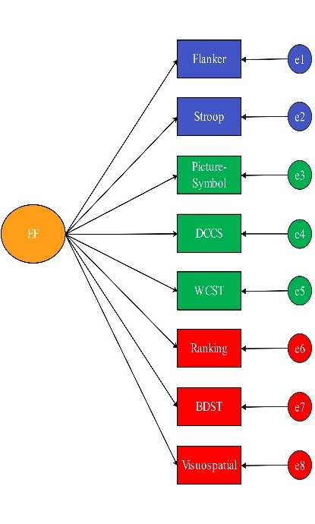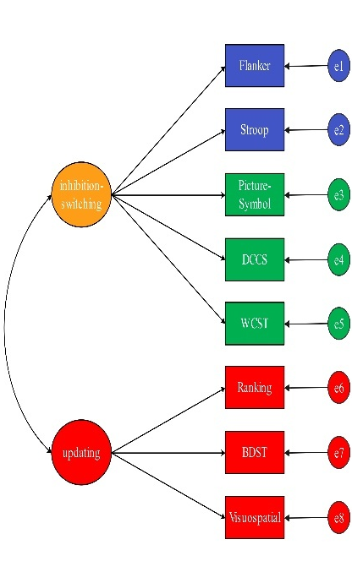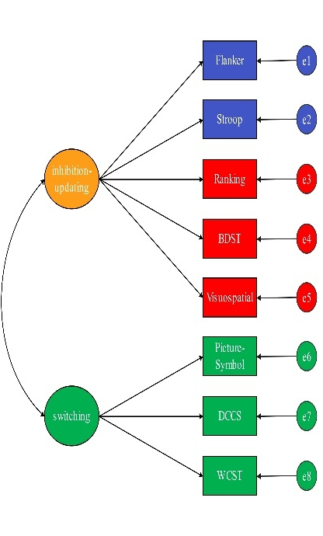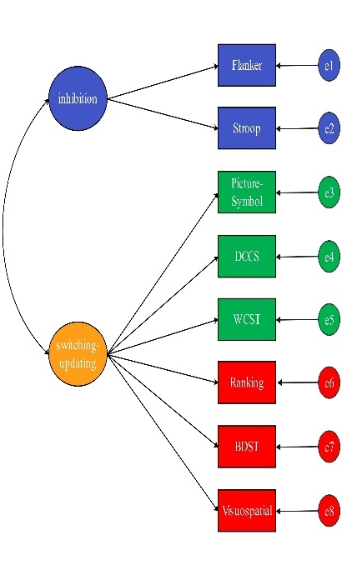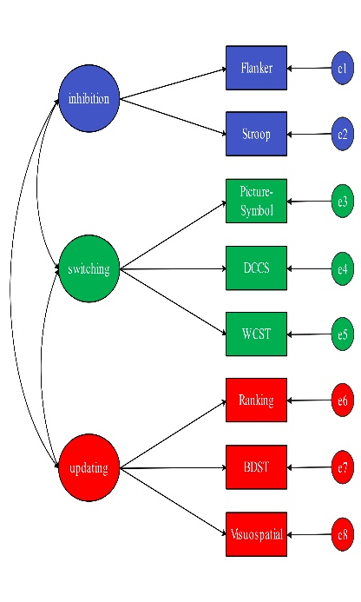

M1 M2a M2b M2c M3

Fig S2
Age-related differences in mean performance on the inhibition, switch, and updating tasks

Fig S3
EF component structure across cohorts and waves (multiple imputation)
 | T1 | T2 | T3 | T4 | T5
Cohort G5 | 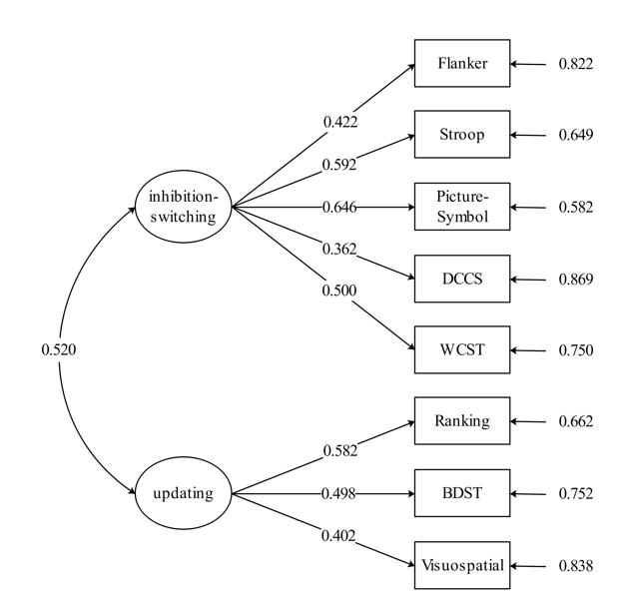 | 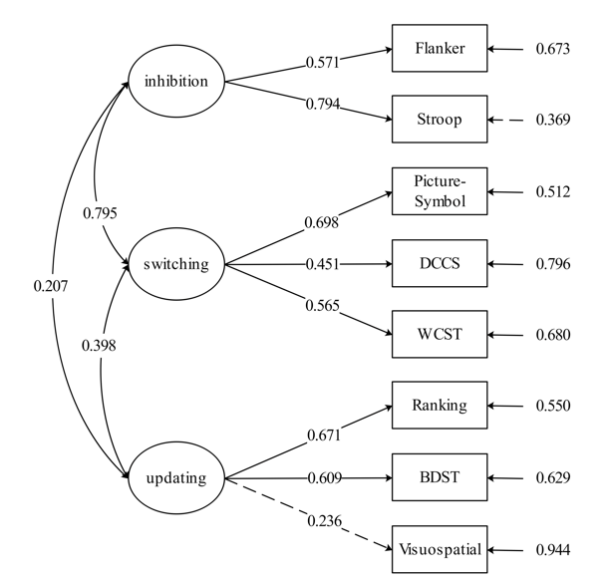 | 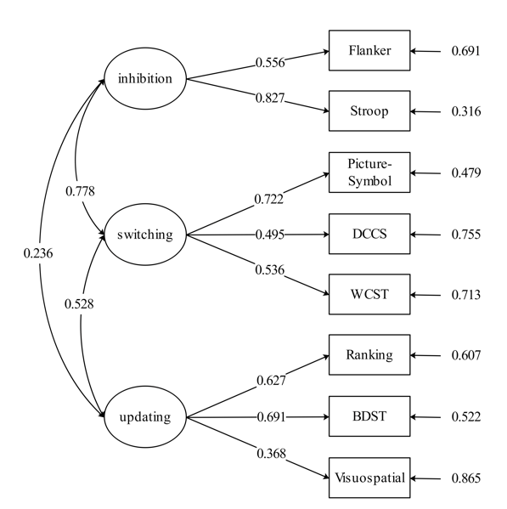 | 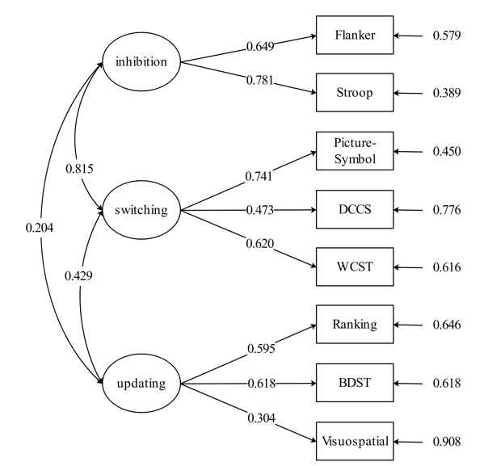 | 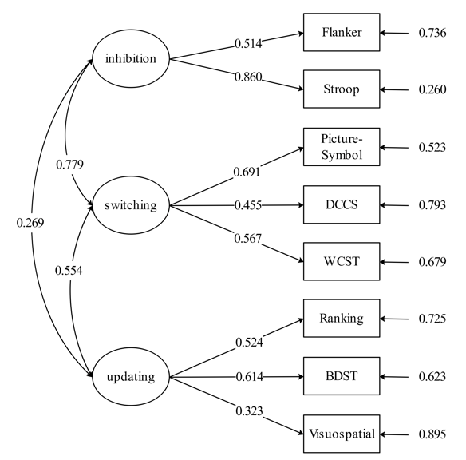
Cohort G7 | 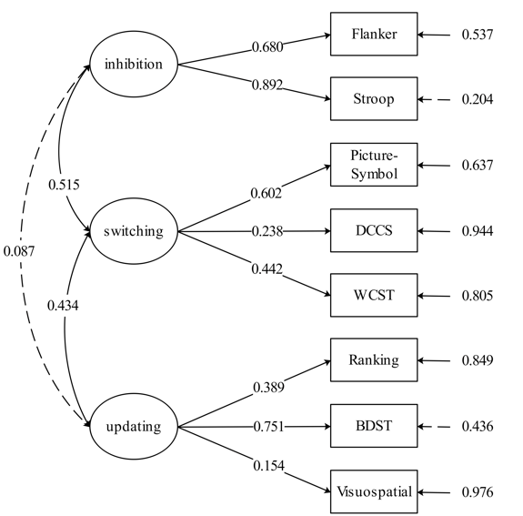 | 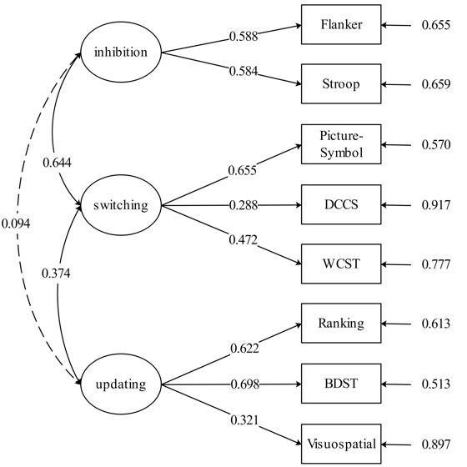 | 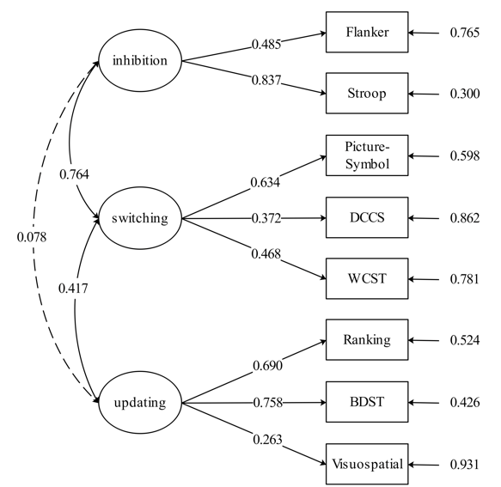 | 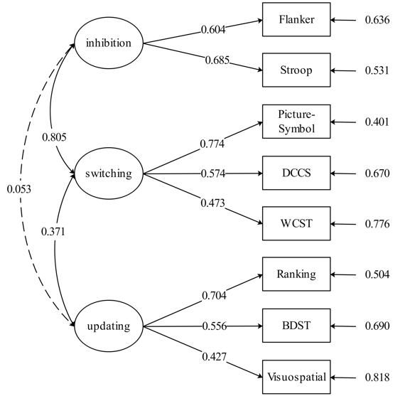 | 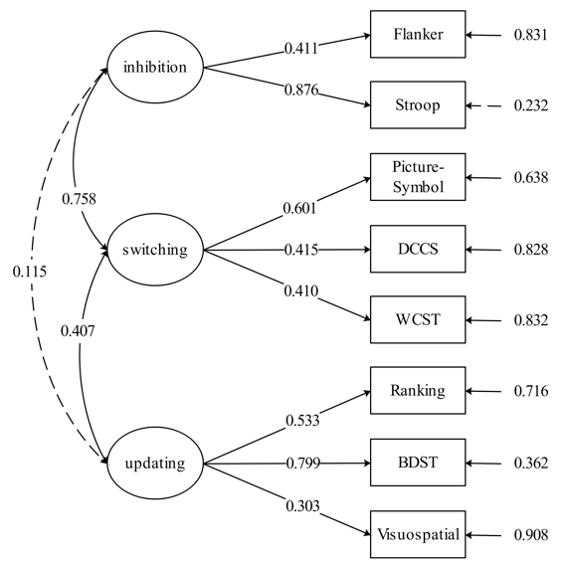
Cohort G9 | 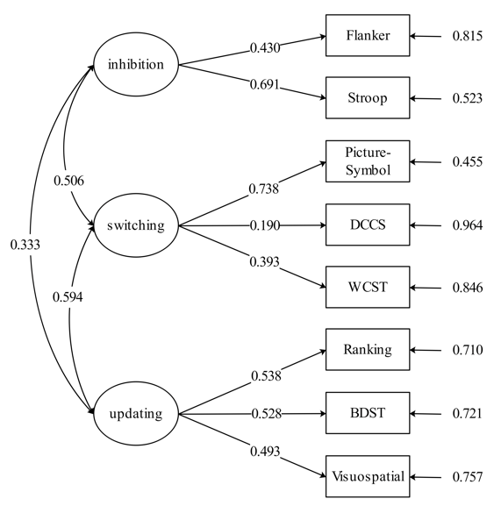 | 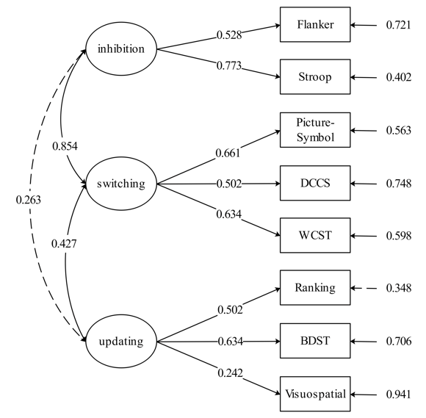 | 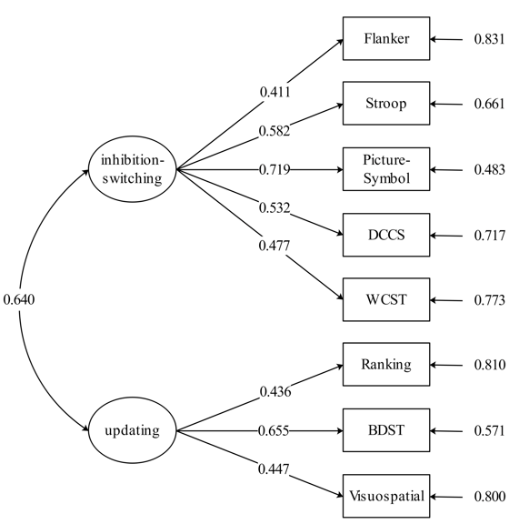 | 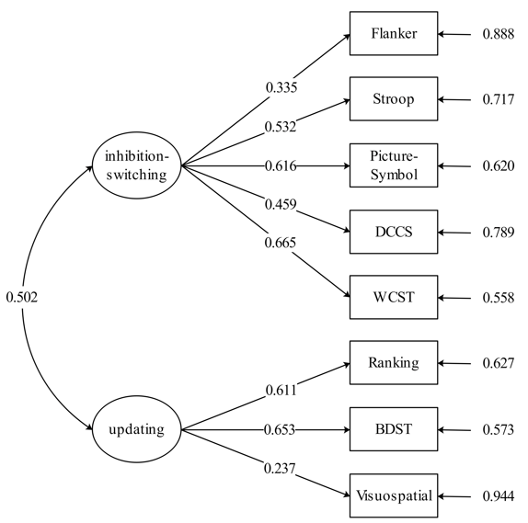 | 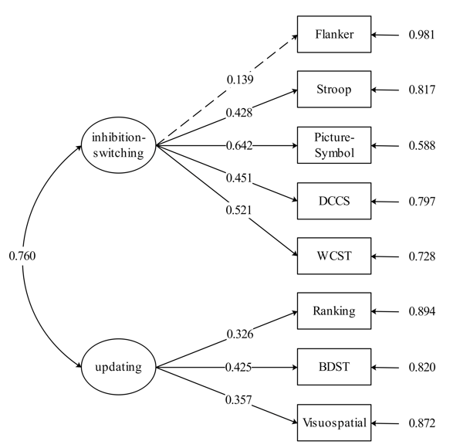
Fig S4
Participant-level distributions of task
