Online Supplement

Appendix A. Student-Level Variable Distributions before Imputation

Table A. Student-Level Variable Distributions before Imputation in the four Samples
 | England | Germany | Netherlands | Sweden
Mathematics grade
Missings | 27 % | 18 % | 29 % | 19 %
M(SD) | 3.02(0.72) | 4.11(0.98) | 6.63(1.34) | 2.54(0.80)
Language grade
Missings | 28 % | 19 % | 27 % | 19 %
M(SD) | 3.06(0.66) | 4.28(0.81) | 6.66(0.91) | 2.65(0.74)
Female gender
Percent | 51 % | 49 % | 49 % | 50 %
Resistance to schooling
Missings | 2 % | 1 % | 0 % | 3 %
M(SD) | 0.32(0.99) | -0.14(0.72) | 0.10(0.84) | -0.31(0.74)
Cognitive ability
Missings | 5 % | 0 % | 5 % | 5 %
M(SD) | 18.74(3.99) | 19.86(3.77) | 19.86(3.54) | 17.98(4.74)
Language ability
Missings | 4 % | 0 % | 4 % | 5 %
M(SD) | 16.73(3.40) | 12.91(4.31) | 17.26(4.17) | 19.00(4.94)
Tertiary parental education
Missings | 22 % | 7 % | 6 % | 18 %
Percent | 39 % | 24 % | 13 % | 53 %
Migration background
Missings | 2 % | 0 % | 0 % | 0 %
Percent | 15 % | 18 % | 8 % | 19 %
Note. Displayed are percent of missing values and means, standard deviations, and percentages, which reflect weighted distributions before multiple imputation. Note that cases with missing values on the gender variable were removed from the analyses (see data section).

Appendix B. Bivariate Associations
Correlations of variables on the student level can be found in Figure B1, showing that grades in mathematics and language correlated positively with each other as well as with the cognitive ability and language test scores in almost all cases. Resistance to schooling correlated negatively with both grade and both ability test variables. To what extent resistance behaviour can explain gender differences in school grades will be the focus of subsequent multilevel regression analyses. Furthermore, Figure B2 shows the bivariate correlations at the class level. Classes with higher average grade levels in mathematics also showed higher language grades. In some but not all cases, classes with a larger share of females had higher mathematics and language grades. In almost all cases, classes with higher levels of resistance to schooling had lower average mathematics and language grades. To what extent these findings on compositions are due to gender differences in grades and resistance behaviour will be investigated in the following multilevel regression analyses.

Figure B1. Bivariate Student-Level Correlations in the four Countries
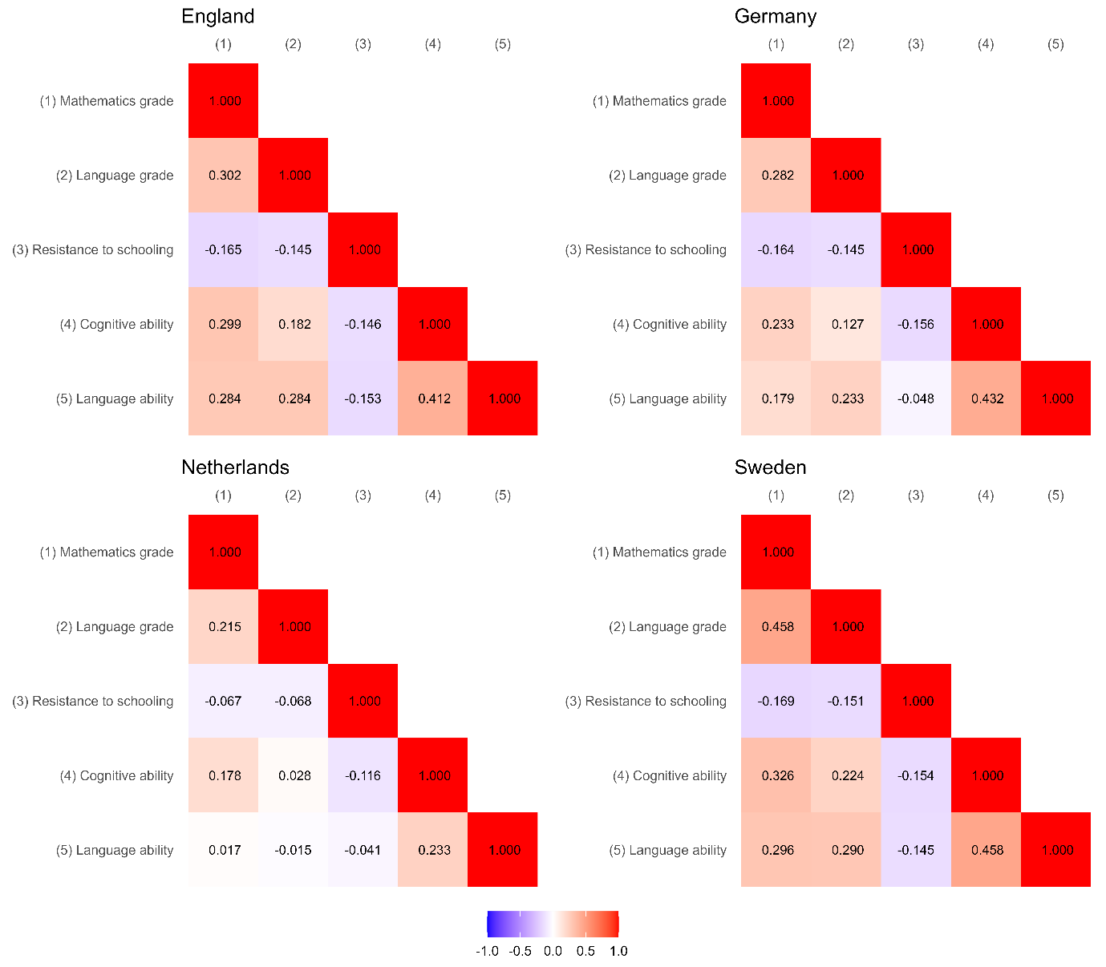
Note. Displayed are weighted bivariate correlations after multiple imputation. Binary student-level variables are not included.

Figure B2. Bivariate Class-Level Correlations in the four Countries
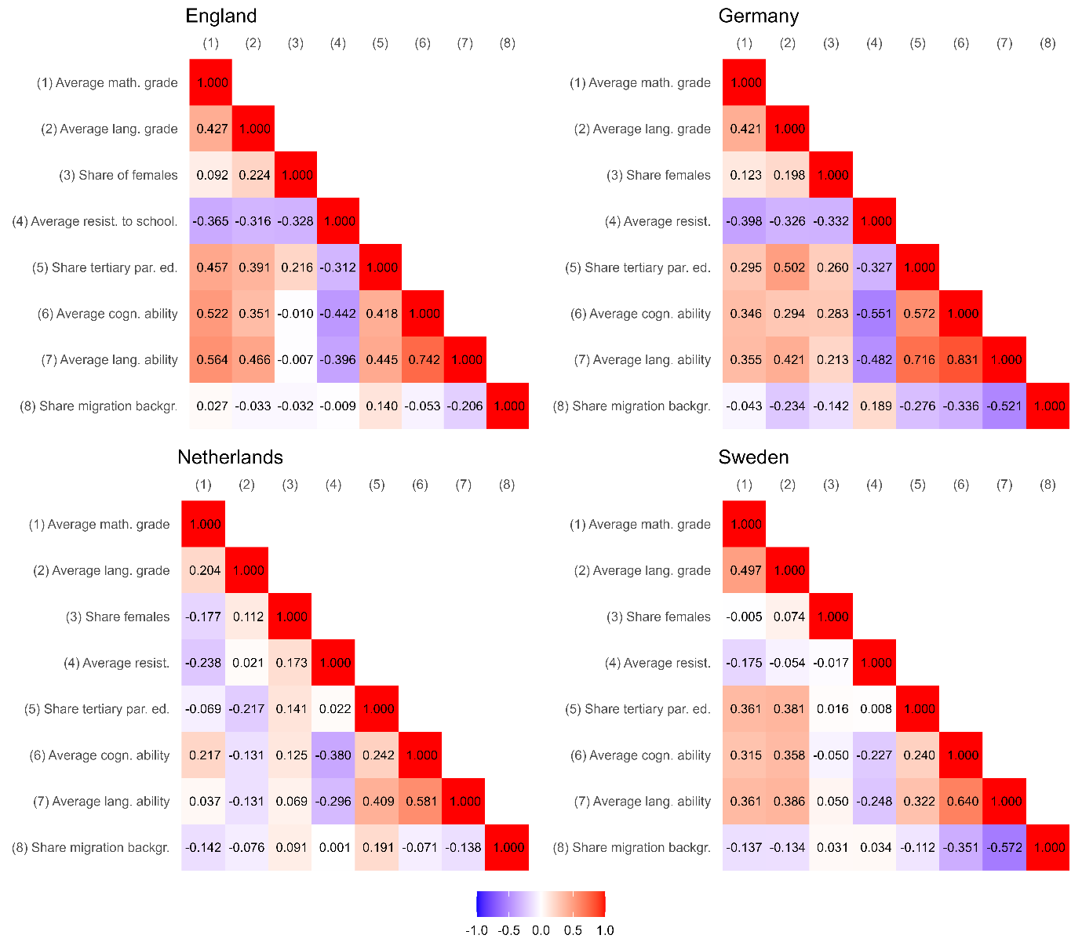
Note. Displayed are weighted bivariate correlations after multiple imputation. The class-level variables are aggregates of imputed student-level variables.

Appendix C. Details on factor analysis

The model specified a single latent factor, resistance behaviour, measured by four observed indicators. The CFA model demonstrated excellent fit to the data. The Comparative Fit Index (CFI) was 0.999, and the Tucker-Lewis Index (TLI) was 0.992, both of which exceed the threshold of 0.95 for excellent fit. The Root Mean Square Error of Approximation (RMSEA) was 0.032, which falls within the range of good fit (≤ 0.05), and the Standardized Root Mean Square Residual (SRMR) was 0.005, also indicating an excellent model fit. The chi-square test was statistically significant (χ² = 19.382, df = 1, p < 0.001), but given the large sample size, this result is expected and does not necessarily indicate poor model fit. All four items loaded significantly onto the latent construct, with standardized factor loadings ranging from 0.500 to 0.668, indicating moderate to strong associations with the resistance behaviour factor. The internal consistency of the scale was assessed using Cronbach’s alpha and composite reliability. Cronbach’s alpha was 0.71, which meets the threshold for acceptable reliability, and the composite reliability (ω) was 0.70, further supporting the internal consistency of the scale. These results provide strong evidence for the factorial validity and reliability of the resistance behaviour scale in the pooled data.
In addition to the pooled analysis, we estimated the same one-factor model separately for each country. Because the three-indicator model is just-identified in each country (df = 0), global fit indices and the χ² test are not informative and are therefore not reported. Instead, we summarise the standardised factor loadings, Cronbach’s alpha, and McDonald’s ω for England, Germany, the Netherlands, and Sweden in Table C below. The loadings were consistently moderate across countries, and omega coefficients ranged from 0.52 to 0.68, which is acceptable for a short behavioural scale composed of heterogeneous indicators. These results confirm that the resistance behaviour factor shows adequate measurement properties across all four national samples.

Table C. CFA-Results by country.
Country | Loading_Argue | Loading_Skip | Loading_Late | Cronbach_Alpha | Omega
England | 0.614 | 0.575 | 0.554 | 0.564 | 0.592
Germany | 0.449 | 0.546 | 0.578 | 0.514 | 0.522
Netherlands | 0.541 | 0.54 | 0.658 | 0.588 | 0.604
Sweden | 0.578 | 0.758 | 0.626 | 0.676 | 0.680

Appendix D. Intraclass Correlations (ICCs) and Design Effects of School Grades.

Table D. Intraclass Correlations (ICCs) and Design Effects of Mathematics and Language Grades in the four Samples. Cluster level: School classes.
 | Mathematics grades |  |  |  |  | Language grades
 | England | Germany | Netherlands | Sweden |  | England | Germany | Netherlands | Sweden
ICC | 0.237 | 0.076 | 0.065 | 0.098 |  | 0.222 | 0.134 | 0.158 | 0.077
Average cluster size | 21.37 | 19.79 | 20.90 | 20.47 |  | 21.37 | 19.79 | 20.90 | 20.47
Design effect | 5.83 | 2.43 | 2.29 | 2.91 |  | 5.52 | 3.52 | 4.14 | 2.50
Note. The design effect is computed as follows: $1+(average cluster size-1)*ICC$. If the design effect is larger than 2, the hierarchical data structure should be considered in the data analysis (Muthén and Satorra 1995).

Appendix E. Results of Models for First Research Question

Table E. Results of Models 1 (Research Question 1) in the four Countries
 | Mathematics grade as outcome |  |  |  |  | Language grade as outcome
 | England  est.(SE) | Germany  est.(SE) | Netherlandsest.(SE) | Sweden  est.(SE) |  | England  est.(SE) | Germany  est.(SE) | Netherlandsest.(SE) | Sweden  est.(SE)
Within
Female gender | -0.089*  (0.039) | -0.176*  (0.035) | -0.076*  (0.035) | -0.028  (0.036) |  | 0.217*  (0.040) | 0.348*  (0.030) | 0.219*  (0.044) | 0.329*  (0.037)
(Cogn. or lang.) ability | 0.254*  (0.021) | 0.208*  (0.019) | 0.121*  (0.021) | 0.310*  (0.019) |  | 0.236*  (0.024) | 0.242*  (0.023) | 0.053  (0.027) | 0.281*  (0.018)
Tertiary parental ed. | 0.166*  (0.032) | 0.153*  (0.046) | 0.027  (0.051) | 0.195*  (0.036) |  | 0.137*  (0.031) | 0.087*  (0.042) | 0.078  (0.057) | 0.155*  (0.031)
Migration backgr. | 0.053  (0.041) | -0.010  (0.033) | -0.031  (0.057) | -0.023  (0.037) |  | 0.015  (0.043) | -0.017  (0.034) | -0.010  (0.049) | 0.008  (0.040)
Residual variance | 0.696*  (0.031) | 0.885*  (0.026) | 0.902*  (0.051) | 0.815*  (0.026) |  | 0.765*  (0.032) | 0.811*  (0.025) | 0.880*  (0.074) | 0.824*  (0.021)
Between
Mean | -0.041  (0.044) | 0.063*  (0.031) | 0.045  (0.032) | -0.080*  (0.037) |  | -0.173*  (0.039) | -0.174*  (0.032) | -0.119*  (0.037) | -0.247*  (0.039)
Variance | 0.187*  (0.036) | 0.062*  (0.016) | 0.082*  (0.029) | 0.075*  (0.019) |  | 0.136*  (0.032) | 0.101*  (0.017) | 0.115*  (0.049) | 0.054*  (0.012)
Fit information
Log Likelihood | -5422 | -6688 | -5848 | -6648 |  | -5588 | -6522 | -5822 | -6650
AIC | 10859 | 13391 | 11710 | 13310 |  | 11189 | 13058 | 11658 | 13315
BIC | 10903 | 13436 | 11755 | 13356 |  | 11234 | 13104 | 11702 | 13360
Note. Displayed are weighted two-level regression results after multiple imputation. Note that continuous variables were standardized.

Appendix F. Results of Models for Second Research Question

Table F1. Results of Models 2a (Research Question 2) in the four Countries
 | Mathematics grade as outcome |  |  |  |  | Language grade as outcome
 | England  est.(SE) | Germany  est.(SE) | Netherlandsest.(SE) | Sweden  est.(SE) |  | England  est.(SE) | Germany  est.(SE) | Netherlandsest.(SE) | Sweden  est.(SE)
Within
Female gender | -0.120*  (0.040) | -0.230*  (0.036) | -0.093*  (0.035) | -0.053  (0.037) |  | 0.196*  (0.041) | 0.310*  (0.030) | 0.206*  (0.044) | 0.313*  (0.038)
Resistance to schooling | -0.108*  (0.023) | -0.117*  (0.019) | -0.068*  (0.020) | -0.125*  (0.022) |  | -0.071*  (0.020) | -0.083*  (0.017) | -0.051*  (0.019) | -0.088*  (0.023)
(Cogn. or lang.) ability | 0.242*  (0.020) | 0.200*  (0.019) | 0.116*  (0.021) | 0.292*  (0.019) |  | 0.227*  (0.023) | 0.241*  (0.022) | 0.053  (0.027) | 0.269*  (0.018)
Tertiary parental ed. | 0.158*  (0.031) | 0.154*  (0.045) | 0.033  (0.051) | 0.189*  (0.035) |  | 0.132*  (0.031) | 0.089*  (0.042) | 0.083  (0.057) | 0.152*  (0.030)
Migration backgr. | 0.040  (0.040) | -0.018  (0.033) | -0.035  (0.058) | -0.032  (0.036) |  | 0.003  (0.044) | -0.023  (0.034) | -0.011  (0.049) | -0.002  (0.040)
Residual variance | 0.686*  (0.031) | 0.873*  (0.026) | 0.898*  (0.052) | 0.800*  (0.027) |  | 0.760*  (0.032) | 0.805*  (0.025) | 0.878*  (0.075) | 0.816*  (0.022)
Between
Mean | -0.020  (0.043) | 0.093*  (0.032) | 0.055  (0.032) | -0.062  (0.037) |  | -0.158*  (0.040) | -0.152*  (0.033) | -0.112*  (0.037) | -0.233*  (0.039)
Variance | 0.182*  (0.037) | 0.062*  (0.016) | 0.081*  (0.029) | 0.075*  (0.018) |  | 0.134*  (0.033) | 0.101*  (0.018) | 0.114*  (0.049) | 0.055*  (0.012)
Fit information
Log Likelihood | -5391 | -6654 | -5838 | -6605 |  | -5575 | -6504 | -5816 | -6628
AIC | 10798 | 13325 | 11692 | 13225 |  | 11167 | 13024 | 11648 | 13273
BIC | 10849 | 13377 | 11743 | 13277 |  | 11217 | 13076 | 11699 | 13325
Note. Displayed are weighted two-level regression results after multiple imputation. Note that continuous variables were standardized.

Table F2. Results of Models 2b (Research Question 2) in the four Countries
 | Mathematics grade as outcome |  |  |  |  | Language grade as outcome
 | England  est.(SE) | Germany  est.(SE) | Netherlandsest.(SE) | Sweden  est.(SE) |  | England  est.(SE) | Germany  est.(SE) | Netherlandsest.(SE) | Sweden  est.(SE)
Within
Female gender | -0.120*  (0.040) | -0.237*  (0.036) | -0.093*  (0.035) | -0.054  (0.037) |  | 0.196*  (0.041) | 0.307*  (0.030) | 0.206*  (0.044) | 0.311*  (0.038)
Resistance to schooling | -0.104*  (0.024) | -0.068*  (0.021) | -0.052  (0.030) | -0.084*  (0.022) |  | -0.076*  (0.025) | -0.065*  (0.021) | -0.038  (0.028) | -0.051  (0.029)
Female * resistance | -0.008  (0.039) | -0.129*  (0.032) | -0.032  (0.041) | -0.094*  (0.034) |  | 0.011  (0.036) | -0.048  (0.037) | -0.027  (0.035) | -0.087*  (0.032)
(Cogn. or lang.) ability | 0.242*  (0.020) | 0.200*  (0.019) | 0.116*  (0.021) | 0.293*  (0.019) |  | 0.227*  (0.023) | 0.241*  (0.022) | 0.053  (0.027) | 0.270*  (0.018)
Tertiary parental ed. | 0.158*  (0.031) | 0.153*  (0.045) | 0.034  (0.051) | 0.188*  (0.035) |  | 0.132*  (0.031) | 0.088*  (0.042) | 0.083  (0.057) | 0.151*  (0.030)
Migration backgr. | 0.039  (0.040) | -0.020  (0.033) | -0.035  (0.058) | -0.033  (0.036) |  | 0.004  (0.044) | -0.024  (0.034) | -0.011  (0.048) | -0.002  (0.040)
Residual variance | 0.686*  (0.031) | 0.869*  (0.026) | 0.897*  (0.052) | 0.798*  (0.028) |  | 0.760*  (0.032) | 0.805*  (0.025) | 0.878*  (0.075) | 0.814*  (0.022)
Between
Mean | -0.020  (0.043) | 0.083*  (0.032) | 0.053  (0.031) | -0.065  (0.037) |  | -0.158*  (0.040) | -0.156*  (0.033) | -0.113*  (0.037) | -0.237*  (0.039)
Variance | 0.182*  (0.038) | 0.061*  (0.016) | 0.081*  (0.029) | 0.075*  (0.018) |  | 0.134*  (0.032) | 0.101*  (0.018) | 0.115*  (0.049) | 0.055*  (0.012)
Fit information
Log Likelihood | -5390 | -6644 | -5837 | -6598 |  | -5575 | -6502 | -5816 | -6623
AIC | 10799 | 13307 | 11692 | 13214 |  | 11168 | 13023 | 11649 | 13264
BIC | 10856 | 13365 | 11750 | 13273 |  | 11225 | 13081 | 11706 | 13323
Note. Displayed are weighted two-level regression results after multiple imputation. Note that continuous variables were standardized.

Appendix G. Results of Models for Third Research Question

Table G1. Results of Models 3a (Research Question 3) in the four Countries
 | Mathematics grade as outcome |  |  |  |  | Language grade as outcome
 | England  est.(SE) | Germany  est.(SE) | Netherlandsest.(SE) | Sweden  est.(SE) |  | England  est.(SE) | Germany  est.(SE) | Netherlandsest.(SE) | Sweden  est.(SE)
Within
Female gender | -0.135*  (0.042) | -0.236*  (0.035) | -0.088*  (0.038) | -0.054  (0.036) |  | 0.194*  (0.043) | 0.313*  (0.030) | 0.217*  (0.044) | 0.315*  (0.038)
Resistance to schooling | -0.104*  (0.023) | -0.118*  (0.019) | -0.066*  (0.020) | -0.127*  (0.021) |  | -0.069*  (0.019) | -0.084*  (0.018) | -0.051*  (0.020) | -0.092*  (0.021)
(Cogn. or lang.) ability | 0.227*  (0.019) | 0.212*  (0.021) | 0.120*  (0.022) | 0.296*  (0.019) |  | 0.212*  (0.021) | 0.247*  (0.023) | 0.065*  (0.026) | 0.269*  (0.019)
Tertiary parental ed. | 0.134*  (0.031) | 0.147*  (0.046) | 0.050  (0.054) | 0.175*  (0.033) |  | 0.113*  (0.031) | 0.078  (0.043) | 0.099  (0.058) | 0.136*  (0.031)
Migration backgr. | 0.048  (0.042) | -0.015  (0.036) | -0.030  (0.060) | -0.040  (0.040) |  | 0.006  (0.042) | -0.020  (0.035) | 0.008  (0.055) | -0.008  (0.044)
Residual variance | 0.686*  (0.030) | 0.872*  (0.026) | 0.898*  (0.052) | 0.800*  (0.027) |  | 0.760*  (0.032) | 0.805*  (0.025) | 0.878*  (0.075) | 0.816*  (0.022)
Between
Share of females | 0.032  (0.036) | 0.027  (0.028) | -0.011  (0.037) | 0.002  (0.024) |  | -0.008  (0.033) | -0.013  (0.027) | -0.034  (0.032) | -0.015  (0.022)
Average resist. to school. | -0.020  (0.068) | -0.009  (0.028) | -0.029  (0.030) | 0.004  (0.035) |  | -0.007  (0.043) | -0.005  (0.031) | -0.021  (0.027) | 0.018  (0.034)
Average (cogn. or lang.) ability | 0.107*  (0.052) | -0.084*  (0.038) | -0.016  (0.042) | -0.040  (0.027) |  | 0.086  (0.049) | -0.081  (0.048) | -0.073  (0.069) | -0.016  (0.043)
Share tertiary par. ed. | 0.113*  (0.052) | 0.040  (0.027) | -0.040  (0.030) | 0.074  (0.041) |  | 0.069  (0.041) | 0.065  (0.038) | -0.031  (0.032) | 0.065  (0.035)
Share migr. backgr. | -0.017  (0.035) | -0.023  (0.031) | -0.009  (0.035) | 0.012  (0.032) |  | 0.008  (0.044) | -0.036  (0.043) | -0.060  (0.058) | 0.010  (0.041)
Intercept | -0.001  (0.042) | 0.094*  (0.031) | 0.048  (0.033) | -0.051  (0.036) |  | -0.145*  (0.040) | -0.155*  (0.032) | -0.128*  (0.037) | -0.224*  (0.038)
Residual variance | 0.142*  (0.039) | 0.058*  (0.015) | 0.078*  (0.029) | 0.068*  (0.018) |  | 0.118*  (0.030) | 0.098*  (0.018) | 0.107*  (0.047) | 0.049*  (0.011)
Fit information
Log Likelihood | -5368 | -6649 | -5835 | -6597 |  | -5564 | -6501 | -5811 | -6621
AIC | 10762 | 13324 | 11696 | 13220 |  | 11154 | 13028 | 11648 | 13268
BIC | 10845 | 13408 | 11778 | 13304 |  | 11236 | 13112 | 11730 | 13353
Note. Displayed are weighted two-level regression results after multiple imputation. The class-level variables are aggregates of imputed student-level variables. Note that continuous variables were standardized.

Table G2. Results of Models 3b (Research Question 3) in the four Countries
 | Mathematics grade as outcome |  |  |  |  | Language grade as outcome
 | England  est.(SE) | Germany  est.(SE) | Netherlandsest.(SE) | Sweden  est.(SE) |  | England  est.(SE) | Germany  est.(SE) | Netherlandsest.(SE) | Sweden  est.(SE)
Within
Residual variance | 0.740*  (0.033) | 0.914*  (0.025) | 0.907*  (0.053) | 0.890*  (0.024) |  | 0.795*  (0.033) | 0.846*  (0.027) | 0.876*  (0.074) | 0.876*  (0.022)
Between
Gender gap on share females | 0.031  (0.068) | 0.066  (0.040) | -0.021  (0.052) | 0.060  (0.040) |  | 0.060  (0.083) | 0.021  (0.039) | 0.011  (0.054) | 0.038  (0.037)
Grade on share females | 0.052  (0.055) | 0.030  (0.037) | -0.005  (0.037) | -0.033  (0.035) |  | -0.019  (0.051) | 0.030  (0.033) | -0.037  (0.033) | -0.036  (0.029)
Grade with gender gap | -0.016  (0.021) | -0.021  (0.015) | -0.002  (0.019) | -0.026  (0.017) |  | -0.023  (0.025) | 0.002  (0.015) | -0.020  (0.036) | -0.039  (0.021)
Intercept grade | 0.031  (0.047) | 0.079*  (0.028) | 0.037  (0.033) | -0.014  (0.030) |  | -0.138*  (0.048) | -0.149*  (0.030) | -0.114*  (0.041) | -0.194*  (0.030)
Intercept gender gap | -0.111*  (0.042) | -0.191*  (0.034) | -0.068  (0.038) | 0.003  (0.038) |  | 0.216*  (0.044) | 0.286*  (0.030) | 0.215*  (0.047) | 0.373*  (0.040)
Res. variance grade | 0.254*  (0.038) | 0.079*  (0.022) | 0.079*  (0.027) | 0.091*  (0.018) |  | 0.186*  (0.036) | 0.118*  (0.024) | 0.123*  (0.037) | 0.092*  (0.020)
Res. variance gender gap | 0.042  (0.024) | 0.036  (0.021) | 0.029  (0.038) | 0.084*  (0.028) |  | 0.069  (0.036) | 0.017  (0.019) | 0.036  (0.043) | 0.076*  (0.027)
Fit information
Log Likelihood | -5588 | -6789 | -5874 | -6915 |  | -5715 | -6649 | -5826 | -6862
AIC | 11193 | 13593 | 11764 | 13847 |  | 11446 | 13314 | 11669 | 13741
BIC | 11244 | 13645 | 11815 | 13899 |  | 11497 | 13366 | 11719 | 13793
Note. Displayed are weighted two-level regression results after multiple imputation. The class-level variables are aggregates of imputed student-level variables. Note that continuous variables were standardized.

Appendix H. School Class Gender Compositions by Country

Figure H. Histograms of Shares of Girls per Classroom in the four Countries
