Exploring cocatalyst type effect on the Ziegler-Natta catalyzed ethylene polymerizations: experimental and DFT studies
Maryam Masoori¹, Mehdi Nekoomanesh¹, Sergio Posada-Pérez^{2*}, Reza Rashedi³, Naeimeh Bahri-Laleh^{1*}
- Department of Polymerization Engineering, Iran Polymer and Petrochemical Institute, Tehran, Iran.
- Institut de Química Computacional i Catàlisi and Departament de Química, Universitat de Girona, c/ Maria Aurèlia Capmany 69, 17003 Girona, Catalonia, Spain. Email:
- Bushehr, Asaluyeh, South Pars Special Economic Zone, Jam Petrochemical Company, Research and Development Department
Corresponding author: Naeimeh Bahri-Laleh (n.bahri@ippi.ac.ir), Sergio Posada-Pérez (sergio.posada@udg.edu)

Table S1. Coordinate date sets and absolute energy (a.u.) for DFT optimized systems.

(104) surface
I | I SCF Done: -18661.5335774 A.U.  Ti -6.206494 3.801686 -0.211304  C -7.684833 5.677610 -0.738101  C -7.332352 5.250479 0.680188  Cl -5.107520 2.411591 1.471970  H -6.756985 5.985956 1.260759  H -8.171824 4.845857 1.264681  H -8.747819 5.552280 -0.980212  H -7.355197 6.695669 -0.981990  H -7.169239 5.053743 -1.543484  Cl -7.251231 2.043073 -1.336888  Cl -4.187708 4.390958 -1.277670  Mg -6.048787 0.286465 0.054389  Cl -7.916473 -0.109778 1.533255  Mg -8.786993 -2.022914 0.305971  Cl -7.514964 -3.942138 1.126575  Mg -5.475148 -3.385074 0.028152  Mg -2.913911 2.731787 0.141934  Cl -10.836259 -2.108284 -0.575965  Cl -4.132581 -5.435085 0.423984  Mg -2.133282 -4.541407 -0.463152  Cl -1.270060 -2.949066 1.243558  Cl -0.042193 -4.675322 -1.525826  Cl -3.412414 -2.816225 -1.633282  Cl -4.548624 -1.453259 1.359273  Mg -2.514283 -1.041234 -0.044577  Cl -3.813978 0.748472 -1.240982  Mg 0.936535 -2.869578 -0.084519  Cl 2.336761 -4.540594 1.186869  Mg 4.333425 -3.841106 0.167243  Cl 3.106543 -2.340084 -1.390299  Cl 6.508364 -4.109362 -0.722233  Cl 5.168638 -1.971810 1.539012  Mg 7.300989 -1.845852 -0.045086  Cl 9.462410 -1.765951 -1.026282  Mg 10.196245 0.329842 0.018212  Cl 9.034876 2.128497 -1.159130  Mg 6.890256 1.841664 -0.151013  Cl 5.647638 3.787934 -0.935816  Mg 3.507529 3.311970 0.045728  Cl 2.183461 5.339614 -0.433277  Mg 0.159344 4.459008 0.443695  Cl 1.434754 2.758963 1.660779  Cl 12.152642 0.565011 1.064508  Cl -1.932014 4.625462 1.496439  Cl -0.693594 2.833759 -1.220811  Cl 2.596058 1.375284 -1.290214  Cl 5.932867 -0.170514 -1.376946  Mg 3.869180 -0.345235 0.095021  Cl 1.745522 -0.818211 1.370190  Mg 0.490140 0.948711 0.100188  Cl -0.345264 -0.901051 -1.357497  Cl -1.652589 0.839083 1.429295  Cl 4.752977 1.597802 1.446840  Cl -6.745050 -1.684909 -1.374864  Cl 7.992662 0.137684 1.444858  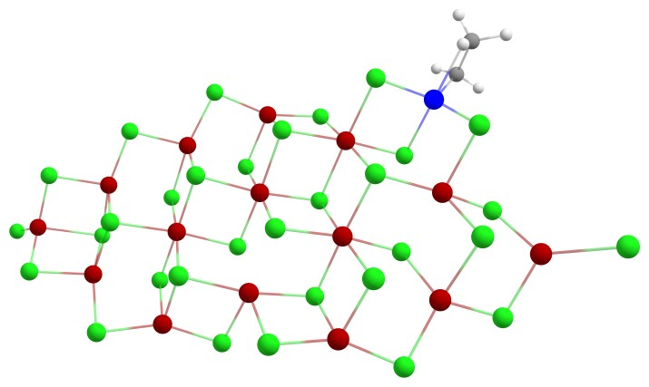
II | II SCF Done: -18740.1731479 A.U.  Ti -6.398464 3.713803 -0.561726  C -7.100283 4.751199 -2.725526  C -7.530865 5.237902 -1.348631  H -7.090469 6.203786 -1.054950  H -8.612741 5.236693 -1.167840  H -7.926441 4.311144 -3.297283  H -6.584452 5.524753 -3.309941  H -6.333214 3.921691 -2.699511  Cl -7.144134 1.641676 -1.361239  Cl -4.141811 4.234781 -1.062993  Mg -5.844210 0.070518 0.173785  Cl -7.737172 -0.401577 1.617692  Mg -8.542216 -2.310878 0.337652  Cl -7.250925 -4.227888 1.141057  Mg -5.215960 -3.615902 0.053705  Mg -2.868028 2.518457 0.313434  Cl -5.029040 2.111639 1.447173  Cl -10.598453 -2.379272 -0.536296  Cl -3.820940 -5.640206 0.409987  Mg -1.848561 -4.689648 -0.486394  Cl -1.004616 -3.102772 1.228052  Cl 0.235806 -4.753026 -1.574833  Cl -3.177962 -2.990454 -1.630801  Cl -4.315453 -1.695873 1.400141  Mg -2.317030 -1.205950 -0.034045  Cl -3.632680 0.560836 -1.212541  Mg 1.182104 -2.938497 -0.117870  Cl 2.657996 -4.592790 1.094692  Mg 4.617109 -3.802420 0.069868  Cl 3.325631 -2.307153 -1.435570  Cl 6.789926 -3.978240 -0.851741  Cl 5.411045 -1.943405 1.478050  Mg 7.513467 -1.706272 -0.128328  Cl 9.655468 -1.524361 -1.141102  Mg 10.333036 0.564915 -0.047089  Cl 9.093393 2.357658 -1.150740  Mg 6.974906 1.968096 -0.119631  Cl 5.661690 3.898357 -0.829135  Mg 3.550070 3.321544 0.163266  Cl 2.156098 5.320814 -0.232888  Mg 0.172999 4.337524 0.635376  Cl 1.527136 2.647857 1.780461  Cl 12.301522 0.836024 0.968673  Cl -1.907456 4.409050 1.712334  Cl -0.641493 2.750485 -1.074991  Cl 2.694595 1.397727 -1.226409  Cl 6.074435 -0.039939 -1.394911  Mg 4.034605 -0.323656 0.092498  Cl 1.948366 -0.898410 1.376796  Mg 0.613127 0.859697 0.166715  Cl -0.152626 -0.982218 -1.341751  Cl -1.499326 0.636695 1.507779  Cl 4.877639 1.606193 1.492817  Cl -6.519040 -1.915984 -1.307070  Cl 8.165157 0.256292 1.407715  C -7.954701 3.494476 1.307378  C -7.172321 4.578752 1.605282  H -8.906133 3.610061 0.780161  H -7.750984 2.499766 1.710092  H -6.298517 4.477679 2.253840  H -7.494026 5.593750 1.364079  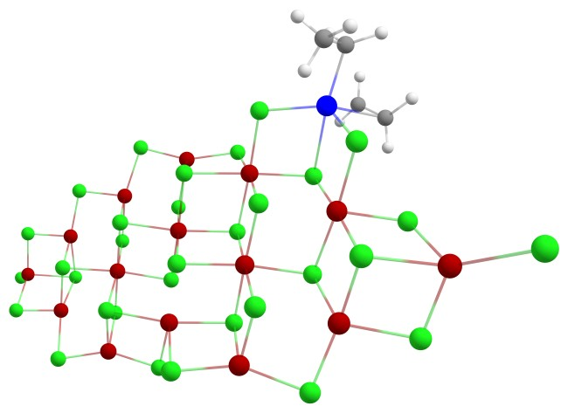
TS | et-TS SCF Done: -18740.1597992 A.U.  Ti -6.417927 3.592474 -0.237919  C -7.215622 5.023581 -2.135643  C -7.255926 5.582426 -0.718274  Cl -5.031432 2.087461 1.403923  H -6.315363 6.068037 -0.392288  H -8.055267 6.319736 -0.632520  H -8.226396 4.893893 -2.541500  H -6.616279 5.677195 -2.787238  H -6.711523 4.036150 -2.281619  Cl -7.093555 1.650667 -1.380278  Cl -4.209746 4.161204 -1.131394  C -8.310083 4.669842 0.866738  C -7.697239 3.566483 1.507981  H -8.267908 5.634242 1.375380  H -9.215668 4.509874 0.275097  H -8.122766 2.560415 1.396026  H -7.140509 3.733828 2.433778  Mg -5.835677 0.021949 0.084068  Cl -7.745814 -0.420036 1.522614  Mg -8.529300 -2.358939 0.279070  Cl -7.229457 -4.255244 1.117890  Mg -5.191661 -3.650934 0.032261  Mg -2.875521 2.527607 0.190562  Cl -10.581888 -2.468166 -0.600164  Cl -3.789939 -5.662706 0.434520  Mg -1.815302 -4.711081 -0.455204  Cl -0.993386 -3.094705 1.242498  Cl 0.277049 -4.781810 -1.526537  Cl -3.143935 -3.035680 -1.633857  Cl -4.316910 -1.707484 1.365428  Mg -2.302652 -1.220777 -0.053066  Cl -3.621552 0.512969 -1.266277  Mg 1.202682 -2.938722 -0.091917  Cl 2.674957 -4.568868 1.158772  Mg 4.637923 -3.788290 0.134355  Cl 3.352668 -2.323041 -1.405006  Cl 6.818014 -3.972258 -0.768591  Cl 5.415379 -1.903339 1.516916  Mg 7.527478 -1.685584 -0.078947  Cl 9.676278 -1.513988 -1.079717  Mg 10.338923 0.595810 -0.016719  Cl 9.101091 2.366031 -1.157973  Mg 6.976483 1.986095 -0.135190  Cl 5.661705 3.899576 -0.884897  Mg 3.545036 3.331295 0.103274  Cl 2.149509 5.321287 -0.329528  Mg 0.162307 4.343492 0.538462  Cl 1.516260 2.675539 1.716935  Cl 12.300942 0.890404 1.005375  Cl -1.918923 4.419345 1.607469  Cl -0.630189 2.730385 -1.158564  Cl 2.706894 1.381674 -1.260726  Cl 6.092386 -0.045798 -1.382799  Mg 4.041851 -0.311566 0.095687  Cl 1.948675 -0.873148 1.374700  Mg 0.613661 0.862438 0.126394  Cl -0.131619 -1.010611 -1.354639  Cl -1.509106 0.657463 1.452117  Cl 4.871350 1.643272 1.469580  Cl -6.497863 -1.979594 -1.365674  Cl 8.163599 0.304184 1.428892  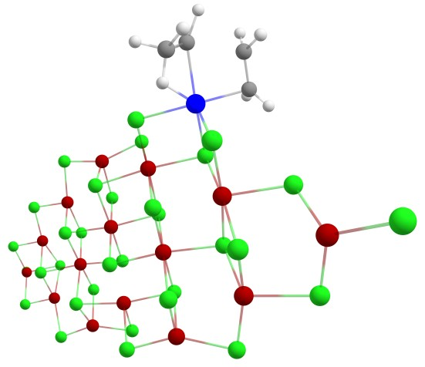
III | III SCF Done: -18740.1909436 A.U.  Ti -6.237480 3.328009 -0.144485  C -7.693073 5.221742 -0.660143  C -7.375042 4.760743 0.755553  Cl -5.067266 1.971317 1.527953  H -6.777521 5.473122 1.345968  H -8.226617 4.374375 1.333993  H -8.769623 5.133549 -0.875273  H -7.264897 4.494538 -1.440471  Cl -7.205318 1.523264 -1.271188  Cl -4.248274 4.029151 -1.199536  C -7.147122 6.606023 -1.048979  H -7.237884 6.736854 -2.139329  H -6.067697 6.634058 -0.821235  C -7.877403 7.740147 -0.322421  H -7.779662 7.647812 0.769934  H -7.470944 8.719129 -0.614805  H -8.952101 7.735643 -0.562953  Mg -5.905372 -0.178110 0.096890  Cl -7.741235 -0.694404 1.579255  Mg -8.511920 -2.634239 0.328949  Cl -7.136558 -4.494376 1.122441  Mg -5.136248 -3.817505 0.019752  Mg -2.899171 2.418207 0.201793  Cl -10.558236 -2.822916 -0.544263  Cl -3.686029 -5.800523 0.377115  Mg -1.741708 -4.791464 -0.508073  Cl -0.952438 -3.181249 1.216884  Cl 0.347956 -4.802171 -1.582493  Cl -3.114769 -3.120460 -1.648428  Cl -4.304661 -1.857484 1.369166  Mg -2.303631 -1.322734 -0.040658  Cl -3.699116 0.410988 -1.207203  Mg 1.239685 -2.970395 -0.117022  Cl 2.731926 -4.588123 1.119323  Mg 4.684788 -3.770712 0.103041  Cl 3.374850 -2.309294 -1.423874  Cl 6.866998 -3.910829 -0.800711  Cl 5.429395 -1.884203 1.501840  Mg 7.544273 -1.621720 -0.090095  Cl 9.691759 -1.408448 -1.083074  Mg 10.321270 0.701646 -0.000522  Cl 9.059302 2.460314 -1.133263  Mg 6.938871 2.041099 -0.119977  Cl 5.595243 3.935785 -0.867146  Mg 3.485658 3.331832 0.108990  Cl 2.056511 5.296040 -0.333148  Mg 0.083666 4.294580 0.530661  Cl 1.450124 2.645676 1.719670  Cl 12.270448 1.015009 1.038768  Cl -2.012739 4.342746 1.583819  Cl -0.686198 2.655023 -1.158482  Cl 2.672186 1.373944 -1.257112  Cl 6.083345 0.006031 -1.382648  Mg 4.039073 -0.302573 0.091929  Cl 1.948572 -0.904561 1.367009  Mg 0.594696 0.814568 0.131670  Cl -0.147012 -1.050205 -1.355500  Cl -1.535255 0.575130 1.461072  Cl 4.825434 1.659622 1.477093  Cl -6.501404 -2.169450 -1.354823  Cl 8.140707 0.366481 1.435064  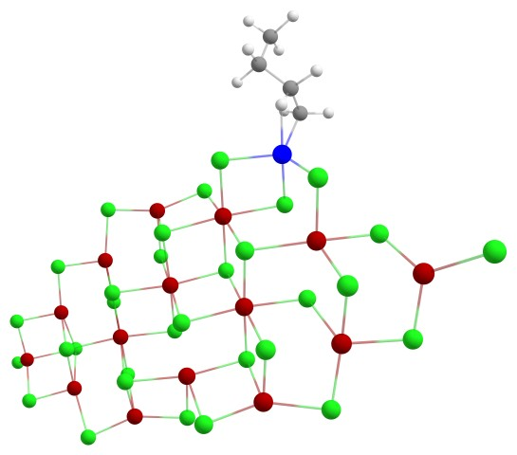
IV | IV SCF Done: -18741.3756238 A.U.  Ti -6.361749 3.254966 0.122542  C -7.640041 5.208488 -0.663891  C -7.093481 5.087079 0.748194  Cl -5.013785 1.852529 1.625977  H -6.206629 5.715934 0.939747  H -7.829270 5.200723 1.552840  H -8.740940 5.177301 -0.661697  H -7.388928 4.279964 -1.291061  Cl -7.084732 1.526617 -1.337605  Cl -4.385332 3.942618 -1.029967  C -7.115421 6.395530 -1.492092  H -7.434260 6.274875 -2.540162  H -6.013703 6.359665 -1.492830  C -7.607309 7.738167 -0.942230  H -7.276243 7.889030 0.096602  H -7.221565 8.573858 -1.544058  H -8.707276 7.794092 -0.954963  Mg -5.840710 -0.198488 0.023405  Cl -7.714357 -0.650254 1.499033  Mg -8.486229 -2.614784 0.269049  Cl -7.134822 -4.478324 1.091864  Mg -5.113156 -3.839330 -0.002330  Mg -2.907924 2.398406 0.254879  Cl -10.545817 -2.767918 -0.578492  Cl -3.670379 -5.823094 0.367960  Mg -1.714592 -4.813682 -0.500569  Cl -0.926345 -3.208701 1.229624  Cl 0.378661 -4.821882 -1.568564  Cl -3.078098 -3.140817 -1.646165  Cl -4.295451 -1.889112 1.355375  Mg -2.268346 -1.347545 -0.019632  Cl -3.639135 0.387708 -1.198770  Mg 1.269680 -2.983429 -0.107733  Cl 2.775604 -4.595479 1.119395  Mg 4.719727 -3.766614 0.094489  Cl 3.396136 -2.310311 -1.423669  Cl 6.897045 -3.895886 -0.823110  Cl 5.464085 -1.879219 1.490945  Mg 7.566172 -1.603164 -0.115934  Cl 9.704124 -1.376970 -1.127153  Mg 10.332196 0.733216 -0.044137  Cl 9.052114 2.489159 -1.159947  Mg 6.941863 2.056362 -0.130517  Cl 5.584884 3.948294 -0.859896  Mg 3.484953 3.331913 0.130219  Cl 2.046174 5.293352 -0.287593  Mg 0.082284 4.277934 0.583411  Cl 1.466187 2.626512 1.750026  Cl 12.289507 1.052299 0.978392  Cl -2.006343 4.314407 1.648444  Cl -0.694579 2.650879 -1.112518  Cl 2.673157 1.376120 -1.240856  Cl 6.088251 0.020793 -1.393400  Mg 4.054572 -0.301326 0.093424  Cl 1.976099 -0.918387 1.377921  Mg 0.605240 0.803194 0.154940  Cl -0.118547 -1.067064 -1.338408  Cl -1.508399 0.539636 1.493102  Cl 4.843992 1.659008 1.480269  Cl -6.466428 -2.191339 -1.400496  Cl 8.166095 0.382921 1.409492  H -8.162451 2.921471 1.169545  H -7.864116 2.218675 1.284128  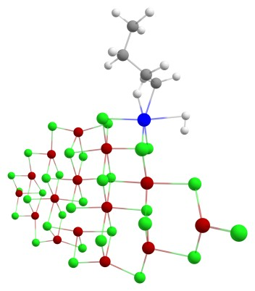
TS | H2-TS SCF Done: -18741.2985514 A.U.  Ti -5.927765 -3.786399 0.441316  C -4.924184 -2.892218 3.559958  C -5.730977 -4.006328 3.001997  Cl -5.177973 -2.468091 -1.756622  H -5.337826 -5.026764 3.003300  H -6.823287 -3.923708 3.032836  H -5.241535 -2.812522 4.628458  H -5.252214 -1.929609 3.126953  Cl -7.324273 -2.015711 0.911655  Cl -3.775181 -4.661162 0.491057  C -3.391708 -3.017913 3.517051  H -2.971261 -2.147091 4.043642  H -3.048316 -2.928176 2.477360  C -2.844817 -4.313972 4.120446  H -3.143959 -5.194725 3.531385  H -1.745525 -4.298323 4.139231  H -3.197522 -4.461076 5.153730  Mg -6.024707 -0.326491 -0.566502  Cl -7.899202 0.229773 -1.959643  Mg -8.784248 1.983835 -0.528374  Cl -7.526836 3.983705 -1.169970  Mg -5.495953 3.340860 -0.109888  Mg -2.843452 -2.671661 -0.864522  Cl -10.797753 1.975493 0.433746  Cl -4.172944 5.432826 -0.262927  Mg -2.186069 4.495412 0.603908  Cl -1.243967 3.088525 -1.217300  Cl -0.140041 4.536794 1.758018  Cl -3.464777 2.641229 1.561283  Cl -4.499150 1.547711 -1.594413  Mg -2.504095 1.050087 -0.161973  Cl -3.789993 -0.881706 0.820937  Mg 0.919907 2.907196 0.171570  Cl 2.348397 4.717778 -0.846961  Mg 4.310700 3.932847 0.180745  Cl 3.035782 2.257282 1.506695  Cl 6.438797 4.118706 1.195741  Cl 5.229497 2.234715 -1.347469  Mg 7.293439 1.949588 0.315612  Cl 9.401023 1.770211 1.395502  Mg 10.216765 -0.181156 0.150206  Cl 9.022945 -2.114224 1.049011  Mg 6.924461 -1.727989 -0.019639  Cl 5.673307 -3.759429 0.491210  Mg 3.573576 -3.194175 -0.526675  Cl 2.253583 -5.270190 -0.325972  Mg 0.261977 -4.316568 -1.197551  Cl 1.567904 -2.477623 -2.158350  Cl 12.221940 -0.274483 -0.822114  Cl -1.760005 -4.342367 -2.387625  Cl -0.669799 -2.886870 0.605876  Cl 2.584081 -1.425997 0.976697  Cl 5.885434 0.125460 1.381428  Mg 3.891663 0.446511 -0.155773  Cl 1.810382 1.038312 -1.459780  Mg 0.530855 -0.869656 -0.450112  Cl -0.379009 0.788858 1.185573  Cl -1.586385 -0.630316 -1.828296  Cl 4.860967 -1.324830 -1.673503  Cl -6.732513 1.494729 1.095900  Cl 8.080210 0.159597 -1.353436  H -6.867919 -5.114062 0.779872  H -6.693131 -4.652253 -0.745903  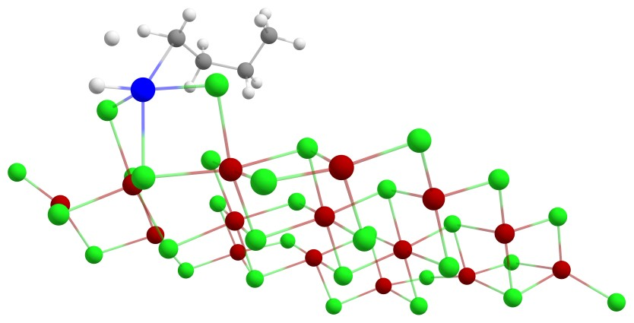
V | V SCF Done: -18582.8426456 A.U.  Ti -6.197177 4.166812 -0.162202  Cl -5.164237 2.772143 1.494474  H -7.015923 5.502463 0.515852  Cl -7.299828 2.511658 -1.330560  Cl -4.216818 4.639309 -1.297998  Mg -6.185903 0.617416 0.033657  Cl -8.073655 0.343498 1.496015  Mg -9.028434 -1.551886 0.292241  Cl -7.820734 -3.506273 1.119934  Mg -5.759905 -3.051398 0.017027  Mg -2.939941 2.964582 0.136992  Cl -11.065326 -1.566326 -0.613778  Cl -4.503844 -5.148543 0.425099  Mg -2.465203 -4.339052 -0.455124  Cl -1.545488 -2.775918 1.252884  Cl -0.381183 -4.546420 -1.516258  Cl -3.675923 -2.557674 -1.624687  Cl -4.767912 -1.149443 1.359155  Mg -2.704200 -0.827078 -0.030401  Cl -3.948061 1.022287 -1.224257  Mg 0.670352 -2.783341 -0.074667  Cl 1.996615 -4.501400 1.204336  Mg 4.023395 -3.885584 0.186299  Cl 2.854549 -2.343749 -1.380128  Cl 6.186280 -4.241135 -0.698942  Cl 4.925285 -2.042000 1.549637  Mg 7.068386 -2.007878 -0.032182  Cl 9.232834 -2.018335 -1.006685  Mg 10.047495 0.053028 0.028347  Cl 8.959930 1.886695 -1.165854  Mg 6.803944 1.691374 -0.163322  Cl 5.638286 3.677103 -0.965284  Mg 3.481988 3.296018 0.017482  Cl 2.238434 5.366818 -0.481810  Mg 0.181294 4.586131 0.407339  Cl 1.378189 2.838838 1.637167  Cl 12.003542 0.217597 1.086796  Cl -1.908008 4.836422 1.453919  Cl -0.745615 2.974172 -1.240893  Cl 2.488879 1.386651 -1.301953  Cl 5.766367 -0.288985 -1.376161  Mg 3.698232 -0.373243 0.095222  Cl 1.551815 -0.758342 1.371874  Mg 0.377024 1.052565 0.094171  Cl -0.543242 -0.766282 -1.351745  Cl -1.776379 1.033771 1.429750  Cl 4.648229 1.544526 1.434536  Cl -6.959277 -1.295442 -1.396767  Cl 7.828149 -0.043582 1.447337  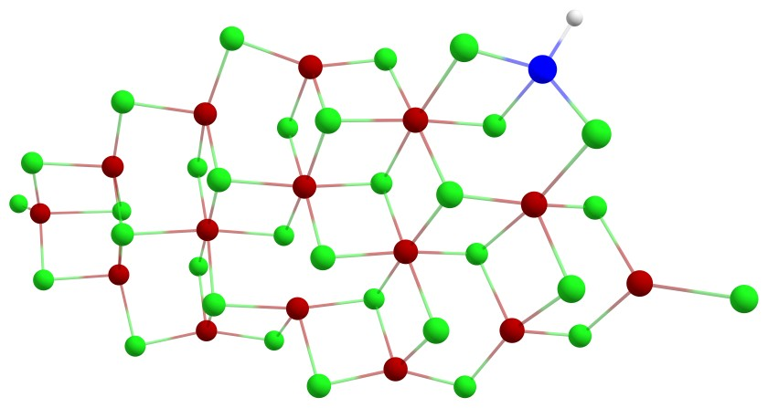
(110) surface
I | I SCF Done: -18661.5486894 A.U.  Mg -3.236389 3.479474 -0.215475  Cl -5.484639 3.698124 -1.005756  Mg -6.435717 1.639926 -0.097979  Cl -8.669567 1.713430 -0.922271  Mg -9.528103 -0.226608 0.294088  Cl -11.394732 -0.218450 1.516270  Ti -0.003354 5.346776 0.078101  Cl 2.098905 5.287272 1.400433  C 0.018165 7.414741 0.168746  H 0.564444 7.807509 1.034880  Cl 1.129968 3.540330 -1.326477  Cl -1.113757 3.540691 1.421765  C 0.817008 7.318307 -1.108962  H -0.979930 7.858152 0.065376  H 0.974438 6.236602 -1.455849  H 0.316442 7.762592 -1.978533  H 1.845685 7.688045 -1.013582  Cl -2.068183 5.342300 -1.244600  Mg 3.240305 3.447682 0.338772  Cl 5.496294 3.631644 1.116952  Mg 6.427400 1.586524 0.161860  Cl 8.664069 1.624254 0.981586  Mg 9.505437 -0.293135 -0.281216  Cl 8.629481 -2.271073 0.861016  Mg 6.392840 -2.140868 0.054191  Cl 5.424244 -4.225045 0.895401  Mg 3.195255 -3.983543 0.072918  Cl 2.107221 -6.090118 0.811595  Mg -0.031162 -5.542472 -0.043053  Cl 1.020377 -3.827100 -1.476343  Cl 11.368328 -0.269724 -1.509130  Cl -1.070250 -3.846877 1.423197  Cl -2.173624 -6.055926 -0.908588  Mg -3.244160 -3.954914 -0.129535  Cl -5.473699 -4.161174 -0.959976  Mg -6.427162 -2.088415 -0.074767  Cl -8.662298 -2.183556 -0.890874  Cl -2.140736 -2.081723 -1.389816  Cl 2.083140 1.542399 1.461061  Mg -0.000064 1.676778 0.027061  Cl -2.092815 1.599089 -1.397076  Cl 2.105556 -2.129762 1.371683  Mg -0.016793 -2.002730 -0.007675  Cl 1.049342 -0.174162 -1.369755  Cl -1.068777 -0.190348 1.389135  Mg 3.206690 -0.249110 -0.036583  Cl 4.201462 1.687658 -1.293092  Cl 5.272270 -0.304396 1.419490  Cl 4.177780 -2.122813 -1.414769  Mg -3.227048 -0.223769 0.058191  Cl -4.213879 -2.118403 1.395881  Cl -5.292441 -0.229420 -1.397992  Cl -4.208697 1.687876 1.363658  Cl -7.200265 -0.212330 1.525437  Cl 7.175552 -0.234322 -1.505621  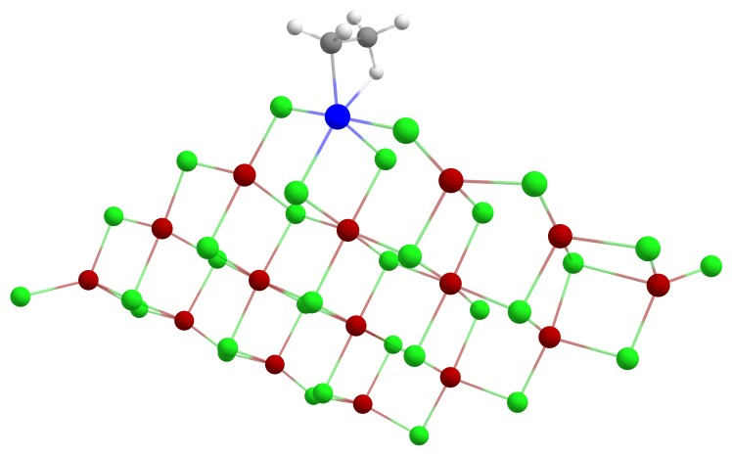
II | II SCF Done: -18740.1922768 A.U.  Mg -3.159265 3.292867 -0.318087  Cl -5.418767 3.525549 -1.084479  Mg -6.377687 1.464398 -0.170061  Cl -8.603991 1.535039 -1.016925  Mg -9.483135 -0.390679 0.210356  Cl -11.375383 -0.348409 1.393702  Ti -0.038758 5.452134 0.028574  Cl 2.162156 5.333340 1.128508  C 0.202886 7.444402 -0.546044  H 0.828753 8.021407 0.144641  C 0.926933 6.878829 -1.744418  H -0.730861 7.967092 -0.780182  H 0.933164 5.742984 -1.773553  H 0.439859 7.118860 -2.698078  H 1.995567 7.127041 -1.768240  Cl -2.057498 5.198583 -1.369556  Mg 3.182386 3.335064 0.169001  Cl 5.440730 3.566663 0.955991  Mg 6.400933 1.503600 0.072369  Cl 8.639059 1.597478 0.887850  Mg 9.503452 -0.350478 -0.312454  Cl 8.658581 -2.308712 0.886911  Mg 6.418854 -2.232229 0.079054  Cl 5.477753 -4.307534 0.979353  Mg 3.243396 -4.110080 0.156193  Cl 2.168511 -6.210374 0.938483  Mg 0.026385 -5.701224 0.063920  Cl 1.072630 -4.012079 -1.402484  Cl 1.060197 3.364025 -1.327523  Cl -1.130168 3.331624 1.315891  Cl 11.375214 -0.335894 -1.528367  Cl -1.032644 -3.987550 1.488646  Cl -2.110055 -6.249732 -0.801515  Mg -3.204226 -4.139083 -0.079693  Cl -5.429195 -4.367498 -0.923170  Mg -6.393182 -2.274503 -0.091937  Cl -8.620275 -2.374813 -0.932749  Cl -2.099353 -2.294244 -1.371314  Cl 2.109650 1.456387 1.428486  Mg 0.000084 1.515159 0.001926  Cl -2.077981 1.374456 -1.471440  Cl 2.138164 -2.240120 1.414617  Mg 0.015600 -2.166627 0.023973  Cl 1.067381 -0.356170 -1.363441  Cl -1.055157 -0.347028 1.381949  Mg 3.217354 -0.373951 -0.035021  Cl 4.179169 1.520701 -1.379582  Cl 5.293634 -0.369029 1.400116  Cl 4.205303 -2.275318 -1.375349  Mg -3.198940 -0.405684 0.029411  Cl -4.191821 -2.278072 1.399032  Cl -5.255708 -0.441083 -1.439683  Cl -4.192956 1.520219 1.297181  Cl -7.181896 -0.373721 1.471048  Cl 7.180580 -0.361563 -1.537934  C -0.554601 6.395192 2.314227  C -1.731947 6.502348 1.639990  H -0.338039 5.533847 2.949118  H 0.151845 7.225049 2.363468  H -2.021116 7.414421 1.118408  H -2.499908 5.732100 1.727638  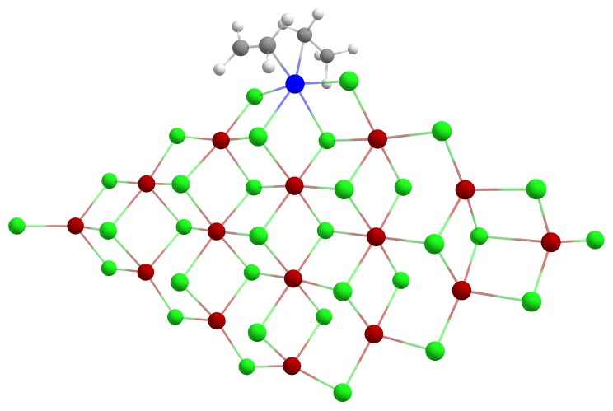
TS | et-TS SCF Done: -18740.1773492 A.U.  Mg -3.157943 3.299478 -0.257954  Cl -5.414054 3.529678 -1.049711  Mg -6.383696 1.475964 -0.139633  Cl -8.614147 1.561755 -0.976202  Mg -9.495343 -0.369848 0.239858  Cl -11.386199 -0.330229 1.426009  Ti -0.031359 5.429902 0.043713  Cl 2.264647 5.419216 1.002274  C 0.155722 7.575822 -0.716197  H 0.743132 8.433132 -0.382428  C 0.941351 6.791789 -1.753763  H -0.825317 7.895095 -1.084352  H 0.785326 5.680353 -1.810247  H 0.600007 7.070385 -2.762347  H 2.024225 6.926501 -1.653665  Cl -2.113342 5.299805 -1.222270  C -0.344150 7.493424 1.414336  C -0.808933 6.277843 1.932764  H 0.633816 7.856951 1.732115  H -1.061206 8.262144 1.126911  H -1.884191 6.080819 1.953472  H -0.206679 5.737730 2.668142  Mg 3.191837 3.318252 0.215134  Cl 5.449396 3.504909 1.028099  Mg 6.400455 1.457778 0.110586  Cl 8.642008 1.529201 0.921037  Mg 9.491901 -0.409963 -0.302480  Cl 8.636937 -2.374968 0.878542  Mg 6.396593 -2.275937 0.073568  Cl 5.446371 -4.355289 0.953425  Mg 3.212487 -4.134378 0.135647  Cl 2.130187 -6.236870 0.903929  Mg -0.009192 -5.713722 0.031610  Cl 1.044379 -4.019071 -1.422999  Cl 1.061027 3.327698 -1.317598  Cl -1.101977 3.326185 1.311611  Cl 11.362504 -0.395009 -1.520739  Cl -1.060121 -4.005987 1.468596  Cl -2.147891 -6.246846 -0.837606  Mg -3.232370 -4.136437 -0.098728  Cl -5.460707 -4.353734 -0.936677  Mg -6.414051 -2.262933 -0.086784  Cl -8.644461 -2.349033 -0.921271  Cl -2.121466 -2.287698 -1.380269  Cl 2.102855 1.436278 1.447432  Mg -0.008589 1.499536 0.011632  Cl -2.096776 1.389276 -1.458069  Cl 2.115993 -2.268829 1.407862  Mg -0.005160 -2.178889 0.016498  Cl 1.056999 -0.366323 -1.358518  Cl -1.068339 -0.363499 1.383130  Mg 3.205155 -0.392367 -0.025086  Cl 4.183108 1.509393 -1.349191  Cl 5.279795 -0.421954 1.413600  Cl 4.183680 -2.291462 -1.380364  Mg -3.213414 -0.402309 0.032225  Cl -4.208620 -2.282849 1.394090  Cl -5.276198 -0.425417 -1.426947  Cl -4.195127 1.510345 1.327910  Cl -7.191604 -0.370839 1.492204  Cl 7.168956 -0.393418 -1.523982  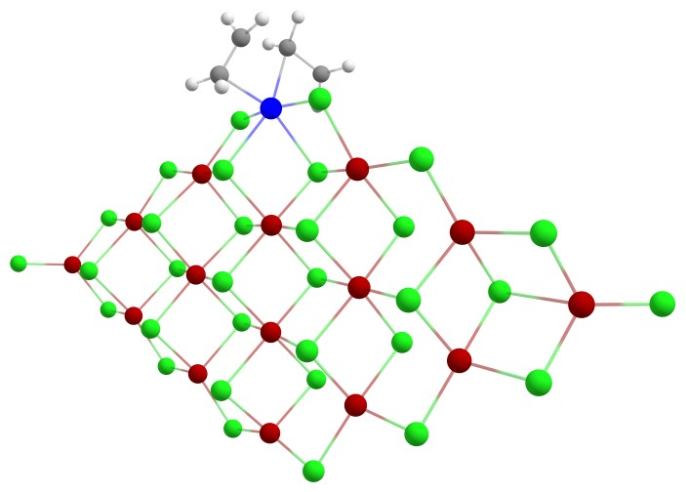
III | III SCF Done: -18740.2066420 A.U.  Mg -3.226710 3.314403 -0.031710  Cl -5.475745 3.576323 -0.808570  Mg -6.435147 1.485261 0.012684  Cl -8.669822 1.602539 -0.804864  Mg -9.534604 -0.385596 0.327459  Cl -11.402791 -0.422015 1.547036  Ti 0.017738 5.161884 0.329565  Cl 2.106529 5.027445 1.664969  C 0.066849 7.225968 0.485399  H 0.582962 7.589693 1.382114  Cl 1.140371 3.393451 -1.136401  Cl -1.110530 3.302896 1.602090  C 0.896389 7.163855 -0.774431  H -0.927918 7.676166 0.361542  H 1.018536 6.071567 -1.127732  H 1.944236 7.439976 -0.578332  Cl -2.050861 5.210314 -0.992574  C 0.326913 7.898537 -2.000560  H 0.896171 7.605005 -2.897450  H -0.709771 7.560571 -2.160667  C 0.372997 9.419733 -1.823332  H 1.407040 9.772376 -1.683888  H -0.040639 9.929485 -2.705457  H -0.210029 9.736223 -0.945154  Mg 3.239560 3.231871 0.522991  Cl 5.496849 3.376984 1.308503  Mg 6.421608 1.368544 0.272970  Cl 8.657619 1.366060 1.096180  Mg 9.495419 -0.500227 -0.242978  Cl 8.613774 -2.522348 0.814680  Mg 6.377703 -2.350739 0.013608  Cl 5.400107 -4.464564 0.766172  Mg 3.172898 -4.179798 -0.048310  Cl 2.074867 -6.311164 0.599780  Mg -0.060110 -5.720085 -0.234984  Cl 0.999690 -3.949875 -1.592688  Cl 11.360729 -0.429690 -1.465695  Cl -1.095898 -4.084865 1.300886  Cl -2.203450 -6.188722 -1.123396  Mg -3.266383 -4.117465 -0.256623  Cl -5.496132 -4.278604 -1.096691  Mg -6.441519 -2.241762 -0.122381  Cl -8.677565 -2.294037 -0.940142  Cl -2.155294 -2.197580 -1.436479  Cl 2.079326 1.284407 1.569436  Mg -0.003015 1.489580 0.141657  Cl -2.093527 1.477484 -1.289568  Cl 2.086926 -2.379812 1.325981  Mg -0.032624 -2.185286 -0.048920  Cl 1.041804 -0.306828 -1.331700  Cl -1.080325 -0.430535 1.422133  Mg 3.196704 -0.445426 -0.001353  Cl 4.202012 1.534751 -1.178159  Cl 5.261125 -0.569701 1.452461  Cl 4.163571 -2.264173 -1.455923  Mg -3.235853 -0.397890 0.087753  Cl -4.231386 -2.343389 1.344914  Cl -5.301484 -0.333038 -1.366835  Cl -4.209381 1.461157 1.472272  Cl -7.207921 -0.432602 1.556596  Cl 7.168293 -0.385312 -1.466772  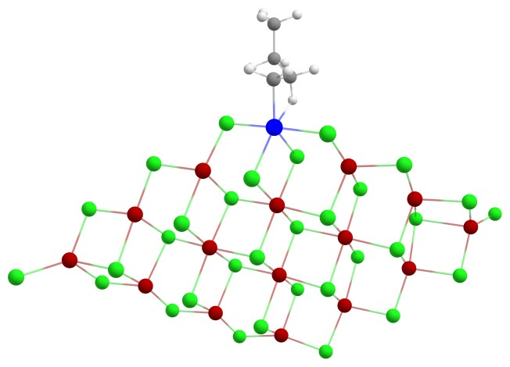
IV | IV SCF Done: -18741.3948360 A.U.  Mg -3.187184 3.313580 0.026713  Cl -5.438141 3.594711 -0.749388  Mg -6.414914 1.500416 0.044133  Cl -8.649890 1.646331 -0.769437  Mg -9.528543 -0.354109 0.331117  Cl -11.403620 -0.391821 1.540866  Ti 0.046392 5.246398 0.403577  Cl 2.145143 5.078472 1.678974  C 0.263207 7.353717 0.210402  H 0.864413 7.844905 0.983790  Cl 1.111725 3.359329 -1.037524  Cl -1.085868 3.231351 1.633035  C 1.007299 6.977665 -1.044419  H -0.683059 7.881909 0.031296  H 0.995175 5.844798 -1.224219  H 2.087452 7.164872 -0.936903  Cl -2.057486 5.269917 -0.873504  C 0.447974 7.558761 -2.357805  H 0.932741 7.057055 -3.210678  H -0.624839 7.313889 -2.416853  C 0.659434 9.073249 -2.447014  H 1.729912 9.329096 -2.403545  H 0.257388 9.469009 -3.390918  H 0.156199 9.597388 -1.620259  Mg 3.213653 3.209554 0.561758  Cl 5.471504 3.339408 1.359926  Mg 6.400737 1.341915 0.306252  Cl 8.638007 1.334658 1.127017  Mg 9.476302 -0.520356 -0.228513  Cl 8.599641 -2.555794 0.808949  Mg 6.363242 -2.379295 0.008965  Cl 5.384719 -4.502621 0.737379  Mg 3.156662 -4.206080 -0.073231  Cl 2.050351 -6.343663 0.543978  Mg -0.082648 -5.739014 -0.290328  Cl 0.987107 -3.954838 -1.620666  Cl 11.346798 -0.435388 -1.443026  Cl -1.118621 -4.124451 1.266280  Cl -2.226588 -6.185789 -1.191395  Mg -3.286655 -4.122731 -0.297654  Cl -5.518080 -4.262374 -1.139660  Mg -6.452634 -2.230135 -0.141681  Cl -8.688152 -2.252844 -0.963213  Cl -2.164056 -2.195606 -1.450454  Cl 2.084888 1.247106 1.619554  Mg -0.008213 1.451903 0.190702  Cl -2.095368 1.476380 -1.263900  Cl 2.071980 -2.424019 1.323544  Mg -0.045443 -2.211489 -0.055016  Cl 1.036832 -0.320477 -1.307110  Cl -1.092397 -0.478942 1.437325  Mg 3.186383 -0.469630 0.024855  Cl 4.188489 1.518003 -1.144740  Cl 5.252807 -0.613448 1.469928  Cl 4.150515 -2.273918 -1.455294  Mg -3.240917 -0.405171 0.092262  Cl -4.246236 -2.364105 1.324660  Cl -5.304252 -0.313118 -1.361513  Cl -4.201090 1.440303 1.504614  Cl -7.208796 -0.437827 1.561241  Cl 7.154001 -0.397309 -1.451324  H -0.728386 6.404009 1.821532  H -0.862761 5.710273 2.159994  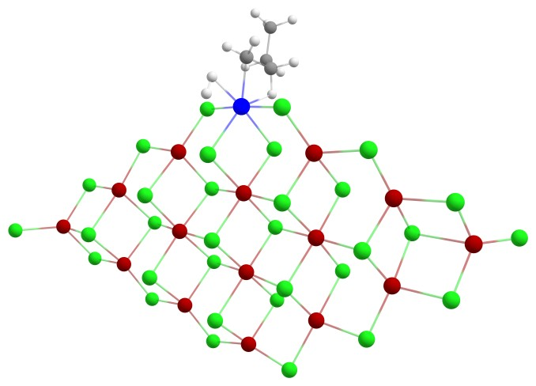
TS | H2-TS SCF Done: -18741.3862655 A.U.  Mg 3.181743 3.294756 -0.022983  Cl 5.433913 3.567889 0.756828  Mg 6.406267 1.474309 -0.041531  Cl 8.641584 1.612569 0.773557  Mg 9.515433 -0.387113 -0.331901  Cl 11.392165 -0.426758 -1.539178  Ti 0.002992 5.202038 -0.451372  Cl -2.170950 5.184459 -1.541668  C -0.099658 7.467510 -0.301831  H -0.739127 8.033649 -0.989166  Cl -1.092234 3.342858 1.056111  Cl 1.066426 3.197940 -1.633953  C -0.813424 7.056318 0.969974  H 0.836994 8.003735 -0.098806  H -0.789553 5.932806 1.194274  H -1.896432 7.228100 0.877220  Cl 2.105308 5.306682 0.822969  C -0.246765 7.673814 2.265312  H -0.712470 7.177398 3.131445  H 0.830800 7.450174 2.313825  C -0.488954 9.185031 2.331805  H -1.564552 9.418833 2.295315  H -0.086318 9.601100 3.266484  H -0.002575 9.709195 1.495146  Mg -3.191999 3.215555 -0.511177  Cl -5.449416 3.364980 -1.315738  Mg -6.392530 1.361098 -0.284566  Cl -8.627819 1.373248 -1.111525  Mg -9.480611 -0.489605 0.224405  Cl -8.613437 -2.523098 -0.825072  Mg -6.378462 -2.364767 -0.016359  Cl -5.408284 -4.489039 -0.754828  Mg -3.179864 -4.206016 0.060758  Cl -2.079127 -6.345199 -0.561863  Mg 0.055870 -5.751710 0.276844  Cl -1.008931 -3.969931 1.613174  Cl -11.356905 -0.402296 1.430225  Cl 1.097776 -4.135215 -1.272998  Cl 2.198553 -6.206931 1.178153  Mg 3.265750 -4.143811 0.291796  Cl 5.497397 -4.290844 1.132213  Mg 6.435810 -2.258046 0.137469  Cl 8.671854 -2.288039 0.957340  Cl 2.149816 -2.217313 1.451274  Cl -2.093500 1.259020 -1.605319  Mg 0.003699 1.440846 -0.171636  Cl 2.096368 1.462875 1.275316  Cl -2.087461 -2.421541 -1.326399  Mg 0.030096 -2.224807 0.055728  Cl -1.045307 -0.337015 1.314978  Cl 1.080402 -0.490973 -1.428515  Mg -3.194074 -0.468766 -0.018575  Cl -4.187565 1.508715 1.172440  Cl -5.260143 -0.594087 -1.464071  Cl -4.166974 -2.278576 1.451393  Mg 3.229428 -0.424038 -0.087507  Cl 4.229220 -2.382988 -1.326261  Cl 5.294788 -0.340489 1.362655  Cl 4.190332 1.421156 -1.500545  Cl 7.195757 -0.462716 -1.561963  Cl -7.163959 -0.390572 1.456630  H 0.791949 5.887331 -1.905316  H 0.475606 6.653116 -1.372105  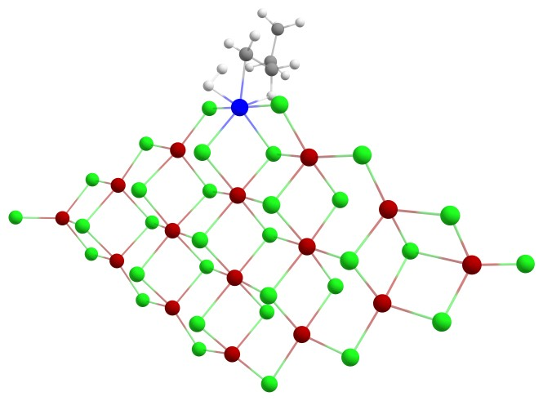
V | V SCF Done: -18582.8580734 A.U.  Mg 3.290901 3.639483 0.271826  Cl 5.522767 3.806517 1.099368  Mg 6.464622 1.767042 0.146146  Cl 8.698784 1.806842 0.964405  Mg 9.537004 -0.116801 -0.291409  Cl 11.386681 -0.112177 -1.536609  Ti 0.000065 5.365777 -0.000037  Cl -2.117488 5.555983 -1.176631  H -0.000150 7.066835 -0.000370  Cl -1.091246 3.675854 1.418906  Cl 1.091398 3.675528 -1.418763  Cl 2.117506 5.556177 1.176541  Mg -3.290852 3.639165 -0.272557  Cl -5.522712 3.806089 -1.100240  Mg -6.464768 1.767076 -0.146267  Cl -8.698998 1.807016 -0.964380  Mg -9.537133 -0.116751 0.291291  Cl -8.650862 -2.079740 -0.868373  Mg -6.416078 -1.955689 -0.060882  Cl -5.447433 -4.028527 -0.925163  Mg -3.219406 -3.802295 -0.101350  Cl -2.140356 -5.903358 -0.865108  Mg 0.000002 -5.383463 -0.000241  Cl -1.044923 -3.673289 1.449314  Cl -11.386759 -0.112118 1.536572  Cl 1.044912 -3.673101 -1.449442  Cl 2.140342 -5.903470 0.864663  Mg 3.219461 -3.802256 0.101385  Cl 5.447465 -4.028537 0.925253  Mg 6.416065 -1.955680 0.060900  Cl 8.650875 -2.079838 0.868283  Cl 2.124525 -1.929818 1.377112  Cl -2.095737 1.762580 -1.412247  Mg -0.000012 1.805697 0.000818  Cl 2.096141 1.762939 1.412547  Cl -2.124574 -1.929703 -1.376865  Mg 0.000029 -1.846935 -0.000044  Cl -1.061511 -0.022437 1.382918  Cl 1.061423 -0.022224 -1.382291  Mg -3.229343 -0.066647 0.053140  Cl -4.218072 1.868803 1.327858  Cl -5.286394 -0.104860 -1.407770  Cl -4.197531 -1.952096 1.408546  Mg 3.229286 -0.066661 -0.052717  Cl 4.197468 -1.952074 -1.408322  Cl 5.286494 -0.104874 1.407884  Cl 4.218046 1.868484 -1.327832  Cl 7.193795 -0.057891 -1.510943  Cl -7.193948 -0.057817 1.510851  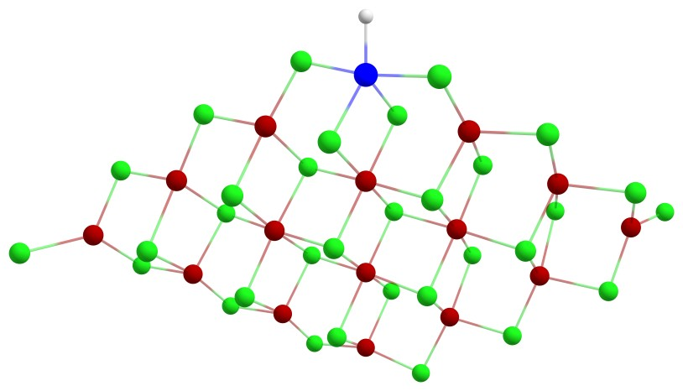
Al complexes (110) surface
MgCl₂ (110) + Ti cluster + TEA
II | II SCF Done: -19220.4450264 A.U.  Mg 3.199990 -3.373381 -0.262835  Cl 5.377471 -3.909558 -1.122951  Mg 6.641916 -2.000100 -0.263310  Cl 8.811213 -2.371488 -1.178704  Mg 9.978863 -0.584338 0.016236  Cl 11.885924 -0.882389 1.138246  Ti -0.154052 -5.061189 0.334867  Cl -2.151923 -4.405882 1.577240  C -0.710685 -7.032799 -0.060732  H -1.453903 -7.399174 0.659359  C -1.289364 -6.479929 -1.339932  H 0.110383 -7.745046 -0.193128  H -1.237136 -5.346457 -1.404481  H -0.740660 -6.792699 -2.236664  H -2.367004 -6.654205 -1.449894  Cl 1.827488 -5.183360 -1.145697  Mg -3.080646 -2.592941 0.200434  Cl -5.400654 -2.387884 0.992331  Mg -6.068599 -0.226398 -0.162195  Cl -8.218620 -0.044620 0.861193  Mg -8.839321 2.067975 -0.198104  Cl -7.749517 3.803231 1.130487  Mg -5.544012 3.467349 0.263323  Cl -4.284872 5.348421 1.160649  Mg -2.116435 4.843060 0.271282  Cl -0.749189 6.766164 1.053678  Mg 1.289372 5.969712 0.145339  Cl 0.004219 4.461713 -1.322001  Cl -0.996082 -2.936416 -1.215430  Cl 1.241412 -3.051573 1.428295  Cl -10.684499 2.260457 -1.440662  Cl 2.121089 4.111698 1.535296  Cl 3.466271 6.231453 -0.750609  Mg 4.261833 3.975314 -0.074674  Cl 6.476003 3.907675 -0.978399  Mg 7.161928 1.695538 -0.190768  Cl 9.353041 1.494355 -1.109577  Cl 2.890333 2.308377 -1.355502  Cl -1.799474 -0.806860 1.458163  Mg 0.290446 -1.176117 0.059754  Cl 2.354418 -1.350192 -1.437470  Cl -1.275002 2.821772 1.493125  Mg 0.798539 2.470184 0.071470  Cl -0.501330 0.827039 -1.315235  Cl 1.631872 0.525489 1.411033  Mg -2.629415 1.147610 0.020192  Cl -3.811935 -0.610719 -1.364113  Cl -4.718091 1.362440 1.399976  Cl -3.329656 3.206525 -1.265070  Mg 3.738177 0.278920 0.023318  Cl 5.022929 1.988614 1.367098  Cl 5.742349 0.038422 -1.500707  Cl 4.521437 -1.747156 1.282990  Cl 7.740854 -0.293282 1.350283  Cl -6.563695 1.941051 -1.498073  C 0.358607 -5.958650 2.659734  C 1.483120 -6.230266 1.944374  H 0.273545 -5.051770 3.261359  H -0.438289 -6.695026 2.772968  H 1.640685 -7.187972 1.449101  H 2.337320 -5.551738 1.967905  Al -6.299234 -3.980154 -0.812790  C -7.987827 -4.448461 0.114484  H -8.640084 -3.556996 0.051210  H -8.506604 -5.218536 -0.487863  C -4.687474 -5.184558 -0.832903  H -4.694413 -5.685791 -1.820051  H -3.713718 -4.638389 -0.869170  C -6.415005 -2.834545 -2.445281  H -5.423151 -2.650448 -2.891430  H -6.913677 -3.524178 -3.155232  C -7.893228 -4.909533 1.583538  H -7.307792 -5.836661 1.683977  H -7.404183 -4.150399 2.214047  H -8.886035 -5.102828 2.022756  C -7.216440 -1.520310 -2.398328  H -6.542595 -0.654556 -2.228114  H -7.680041 -1.241776 -3.358365  H -8.031062 -1.515828 -1.654974  C -4.656162 -6.225811 0.299583  H -4.715723 -5.753641 1.291126  H -5.518575 -6.904995 0.215439  H -3.747320 -6.851965 0.300525  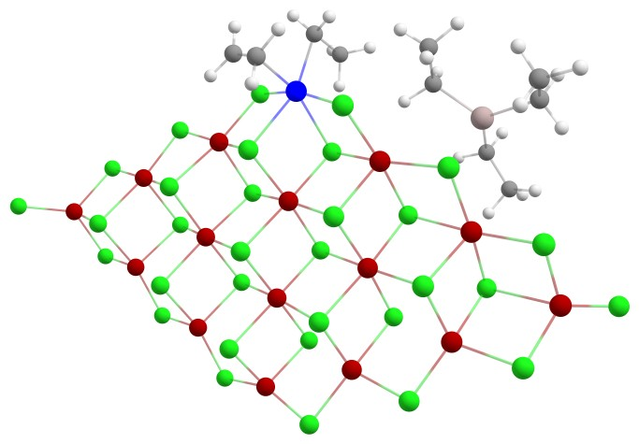
III | III SCF Done: -19220.4654441 A.U.  Mg -3.296400 3.452328 -0.060482  Cl -5.488161 4.015010 -0.845554  Mg -6.733687 2.088410 -0.002398  Cl -8.930857 2.515501 -0.820079  Mg -10.069151 0.681923 0.330622  Cl -11.927690 0.924880 1.542581  Ti 0.182846 4.806690 0.318216  Cl 2.228107 4.357100 1.608634  C 0.521662 6.843525 0.508857  H 1.044993 7.124181 1.430923  Cl 0.962715 2.908593 -1.207338  Cl -1.222604 3.147285 1.568526  C 1.388879 6.678995 -0.713928  H -0.396005 7.426762 0.351055  H 1.361322 5.589983 -1.086032  H 2.461990 6.785406 -0.462285  Cl -1.859492 5.172813 -1.007610  C 0.991744 7.511750 -1.944633  H 1.556209 7.158918 -2.823373  H -0.073943 7.327076 -2.159693  C 1.244670 9.006084 -1.719628  H 2.309486 9.202421 -1.518122  H 0.955722 9.591264 -2.604606  H 0.666889 9.382905 -0.861943  Mg 3.076130 2.513988 0.292790  Cl 5.230836 2.136296 1.454789  Mg 5.986994 0.140502 0.143372  Cl 8.034730 -0.255365 1.320529  Mg 8.750926 -2.015116 -0.208008  Cl 7.665051 -4.023289 0.702456  Mg 5.446525 -3.524246 -0.027364  Cl 4.176923 -5.462243 0.766746  Mg 2.007428 -4.872680 -0.027830  Cl 0.617645 -6.811684 0.672675  Mg -1.421316 -5.942867 -0.152767  Cl -0.139815 -4.366360 -1.549999  Cl 10.646429 -1.870570 -1.380855  Cl -2.220986 -4.162872 1.364451  Cl -3.616974 -6.127543 -1.025881  Mg -4.389974 -3.915282 -0.191451  Cl -6.627928 -3.774894 -1.026280  Mg -7.275601 -1.604033 -0.096757  Cl -9.493785 -1.336965 -0.925987  Cl -3.028939 -2.187564 -1.402859  Cl 1.687214 0.741331 1.496419  Mg -0.370554 1.178941 0.120384  Cl -2.453134 1.457460 -1.299977  Cl 1.171788 -2.933057 1.337720  Mg -0.917379 -2.455783 -0.025648  Cl 0.388134 -0.771922 -1.341129  Cl -1.702178 -0.553924 1.428210  Mg 2.512241 -1.192614 -0.006936  Cl 3.757934 0.584182 -1.249596  Cl 4.573538 -1.610595 1.387792  Cl 3.236119 -3.135710 -1.475081  Mg -3.836645 -0.227259 0.099709  Cl -5.096928 -1.997954 1.378878  Cl -5.872684 0.107847 -1.359149  Cl -4.543844 1.766667 1.461072  Cl -7.779041 0.312600 1.562274  Cl 6.536082 -1.702427 -1.533992  Al 6.875104 3.370825 0.121634  C 7.251658 1.999084 -1.335162  H 6.648543 1.081850 -1.502160  H 6.908490 2.567835 -2.225957  C 8.288549 3.784931 1.440550  H 8.697184 2.822330 1.787387  H 9.139972 4.297343 0.950603  C 5.461203 4.721130 -0.357763  H 4.946015 4.997023 0.579340  H 5.903984 5.666135 -0.718416  C 7.769645 4.615612 2.631551  H 6.946010 4.099022 3.152758  H 8.549035 4.812194 3.385289  H 7.378495 5.594285 2.307238  C 4.427653 4.223040 -1.386309  H 4.750009 4.446481 -2.414193  H 4.331214 3.111446 -1.454428  H 3.417242 4.673473 -1.287362  C 8.749228 1.652096 -1.501774  H 9.338971 2.563683 -1.685176  H 9.180400 1.188604 -0.600310  H 8.935527 0.964804 -2.340534  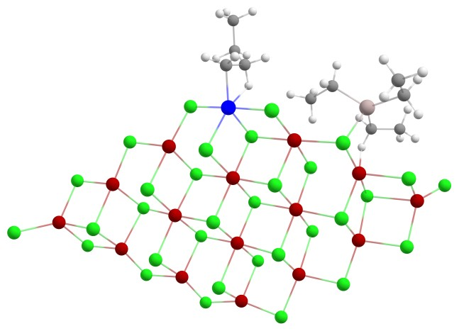
IV | IV SCF Done: -19221.6630312 A.U.  Mg 3.263827 3.436733 -0.071979  Cl 5.439207 4.018281 0.754900  Mg 6.706310 2.069081 -0.005243  Cl 8.886156 2.526045 0.843626  Mg 10.050078 0.656999 -0.222579  Cl 11.942846 0.872593 -1.386755  Ti -0.188327 4.885497 -0.606605  Cl -2.151314 4.307831 -1.952331  C -0.733403 6.939312 -0.506430  H -1.331328 7.319647 -1.342338  Cl -0.944209 2.938861 0.948910  Cl 1.261227 3.020852 -1.724102  C -1.522611 6.480514 0.691368  H 0.107090 7.605026 -0.268560  H -1.413369 5.353230 0.870219  H -2.604970 6.541375 0.497448  Cl 1.850958 5.257760 0.726935  C -1.141743 7.113451 2.041690  H -1.615476 6.541314 2.856041  H -0.053230 7.010765 2.180278  C -1.560705 8.584514 2.119171  H -2.650748 8.692157 2.002237  H -1.280718 9.021945 3.088336  H -1.078979 9.179521 1.328457  Mg -3.025956 2.510426 -0.539256  Cl -5.216962 2.122278 -1.665569  Mg -6.088135 0.290983 -0.036441  Cl -8.006546 -0.268689 -1.383891  Mg -8.743714 -2.063930 0.078024  Cl -7.651227 -4.058514 -0.780790  Mg -5.441415 -3.470728 -0.056467  Cl -4.182529 -5.449171 -0.778803  Mg -2.019886 -4.858804 0.047006  Cl -0.630339 -6.834544 -0.566648  Mg 1.401993 -5.947548 0.264350  Cl 0.105883 -4.324511 1.591751  Cl -10.622864 -1.803679 1.265362  Cl 2.233300 -4.215761 -1.287122  Cl 3.582367 -6.113312 1.179184  Mg 4.367426 -3.922420 0.302705  Cl 6.586135 -3.763042 1.185561  Mg 7.256991 -1.621593 0.208465  Cl 9.455934 -1.327514 1.079804  Cl 2.983044 -2.161989 1.433042  Cl -1.675075 0.685724 -1.659049  Mg 0.374914 1.143681 -0.259349  Cl 2.424866 1.475854 1.219998  Cl -1.169579 -2.963800 -1.364358  Mg 0.894658 -2.465297 0.019893  Cl -0.427854 -0.733903 1.251834  Cl 1.730787 -0.621845 -1.476422  Mg -2.557436 -1.172626 -0.094085  Cl -3.736003 0.670140 1.116130  Cl -4.613071 -1.551038 -1.428841  Cl -3.252262 -3.084025 1.428174  Mg 3.828013 -0.247962 -0.104190  Cl 5.115983 -2.055882 -1.306374  Cl 5.830891 0.123756 1.390488  Cl 4.572397 1.701099 -1.509395  Cl 7.797468 0.244551 -1.494197  Cl -6.550580 -1.703371 1.475789  H 0.490851 6.099061 -2.033350  H 0.723873 5.420116 -2.345349  Al -6.308199 3.299771 0.170140  C -4.630805 4.198281 0.852044  H -3.895777 3.482780 1.287139  H -4.145379 4.747848 0.021624  C -7.784047 4.286693 -0.680893  H -8.442252 4.695274 0.107901  H -7.372195 5.167970 -1.204274  C -6.946581 1.879273 1.531153  H -6.385422 1.075232 2.049806  H -6.683712 2.695648 2.244149  C -4.915548 5.215903 1.983937  H -4.004217 5.729892 2.331719  H -5.621942 5.990276 1.647498  H -5.359599 4.725644 2.864434  C -8.465524 1.619443 1.654477  H -9.049708 2.465297 1.265736  H -8.792109 0.738157 1.085897  H -8.765899 1.451232 2.698932  C -8.607188 3.421422 -1.662300  H -9.456273 3.978403 -2.090242  H -7.989914 3.069027 -2.503294  H -9.015534 2.520806 -1.178853  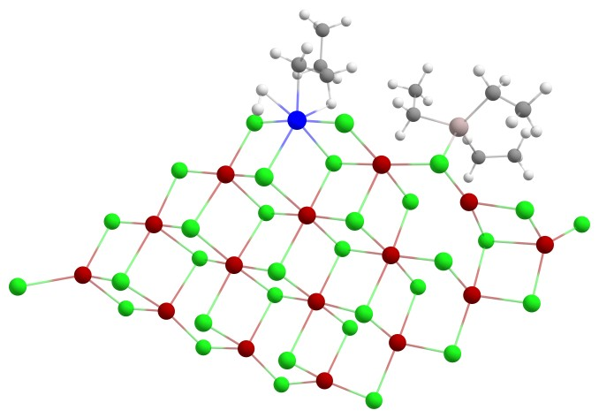
MgCl₂ (110) + Ti cluster + DEAC
II | II SCF Done: -19601.5179528 A.U.  Mg -3.197460 3.376375 -0.204877  Cl -5.373224 3.935749 -1.052608  Mg -6.643087 2.017166 -0.224466  Cl -8.812320 2.412485 -1.128307  Mg -9.983449 0.607348 0.035693  Cl -11.882696 0.887088 1.174487  Ti 0.169116 5.051169 0.387058  Cl 2.188232 4.392378 1.605155  C 0.712911 7.026752 0.001639  H 1.472349 7.380770 0.711375  C 1.263707 6.492171 -1.297606  H -0.108374 7.743124 -0.102847  H 1.232322 5.358209 -1.366785  H 0.683447 6.801701 -2.175234  H 2.333944 6.688747 -1.437187  Cl -1.823271 5.189231 -1.074343  Mg 3.074216 2.554724 0.251565  Cl 5.460627 2.470307 0.941670  Mg 6.100604 0.192559 -0.018635  Cl 8.182457 -0.087702 1.109954  Mg 8.838680 -2.130648 -0.054327  Cl 7.705117 -3.912119 1.168308  Mg 5.521618 -3.498678 0.287838  Cl 4.238179 -5.382324 1.147197  Mg 2.090252 -4.864405 0.225692  Cl 0.710386 -6.798048 0.953301  Mg -1.315111 -5.976720 0.040303  Cl -0.006822 -4.443732 -1.384645  Cl 1.009271 2.932077 -1.177896  Cl -1.223980 3.031695 1.472011  Cl 10.684052 -2.272449 -1.301138  Cl -2.145084 -4.140780 1.461052  Cl -3.486336 -6.208782 -0.875276  Mg -4.278873 -3.966720 -0.153016  Cl -6.490878 -3.872589 -1.058062  Mg -7.173547 -1.676356 -0.224608  Cl -9.364801 -1.449336 -1.134439  Cl -2.893664 -2.280406 -1.397170  Cl 1.796064 0.779595 1.490273  Mg -0.294088 1.168646 0.079037  Cl -2.352243 1.372219 -1.414928  Cl 1.249288 -2.853193 1.465959  Mg -0.811531 -2.476419 0.035469  Cl 0.511585 -0.813631 -1.315029  Cl -1.637771 -0.548772 1.402718  Mg 2.624445 -1.169236 0.029812  Cl 3.849945 0.605403 -1.301629  Cl 4.678901 -1.401765 1.455503  Cl 3.341591 -3.206980 -1.269910  Mg -3.744584 -0.276212 0.016896  Cl -5.032733 -2.006177 1.326730  Cl -5.746062 0.000639 -1.501552  Cl -4.514562 1.731081 1.314072  Cl -7.739583 0.283257 1.357097  Cl 6.588819 -1.924876 -1.408005  C -0.318168 5.924809 2.724649  C -1.452309 6.203566 2.027511  H -0.224793 5.011322 3.315075  H 0.479021 6.661145 2.836865  H -1.617235 7.166731 1.545452  H -2.305409 5.523814 2.054135  Al 6.257398 4.061305 -0.876708  C 4.652062 5.239322 -0.879453  H 4.643795 5.751838 -1.859888  H 3.690347 4.677482 -0.894374  C 6.663148 2.882765 -2.414831  H 5.765921 2.718037 -3.035103  H 7.332799 3.512815 -3.029485  C 7.361448 1.541088 -2.142460  H 6.597037 0.748453 -2.001292  H 7.929040 1.147578 -3.000294  H 8.070011 1.572979 -1.297708  C 4.649885 6.264790 0.268880  H 4.711802 5.777194 1.252591  H 5.522823 6.929191 0.189769  H 3.747279 6.898620 0.280941  Cl 7.983518 4.873335 0.108121  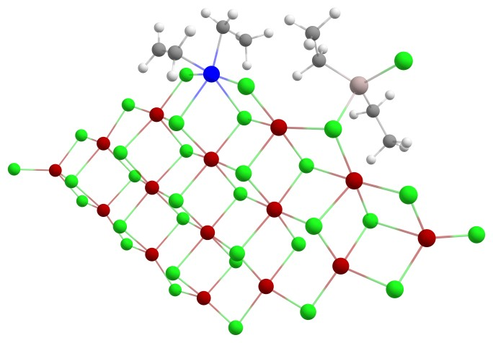
III | III SCF Done: -19601.5550320 A.U.  Mg 3.341269 3.429480 -0.022443  Cl 5.532653 3.987745 0.766934  Mg 6.760389 2.034636 -0.035250  Cl 8.958995 2.451858 0.782586  Mg 10.077598 0.584882 -0.332871  Cl 11.940642 0.785089 -1.544824  Ti -0.117552 4.810667 -0.426729  Cl -2.123651 4.326811 -1.787248  C -0.469274 6.846983 -0.602794  H -1.003224 7.125833 -1.519224  Cl -0.942681 2.946112 1.118089  Cl 1.264507 3.108703 -1.660015  C -1.322019 6.662367 0.627654  H 0.440165 7.443142 -0.448051  H -1.289452 5.565710 0.985293  H -2.393056 6.772530 0.395331  Cl 1.924330 5.183083 0.890169  C -0.915033 7.472512 1.870125  H -1.466376 7.094508 2.746709  H 0.154104 7.292419 2.068851  C -1.182069 8.969899 1.686482  H -2.250894 9.163480 1.503755  H -0.886020 9.533857 2.582786  H -0.618004 9.372978 0.831801  Mg -3.041452 2.540007 -0.392178  Cl -5.297590 2.419119 -1.407239  Mg -6.146847 0.244786 0.050223  Cl -8.043019 -0.307603 -1.319336  Mg -8.806079 -2.148677 0.075568  Cl -7.627360 -4.074326 -0.834462  Mg -5.463637 -3.460655 -0.037323  Cl -4.178825 -5.409842 -0.777742  Mg -2.030642 -4.826003 0.070971  Cl -0.660033 -6.804410 -0.569331  Mg 1.377523 -5.931367 0.250196  Cl 0.100499 -4.309162 1.603639  Cl -10.757345 -2.169184 1.160004  Cl 2.188393 -4.183332 -1.297022  Cl 3.566190 -6.114452 1.133507  Mg 4.343727 -3.924735 0.255904  Cl 6.576596 -3.793179 1.101997  Mg 7.254900 -1.655874 0.128046  Cl 9.473659 -1.402761 0.957903  Cl 2.989108 -2.159056 1.424206  Cl -1.704709 0.746684 -1.545043  Mg 0.378757 1.181380 -0.180636  Cl 2.456249 1.472307 1.249572  Cl -1.199790 -2.904033 -1.320137  Mg 0.875827 -2.436182 0.045388  Cl -0.432812 -0.707439 1.317664  Cl 1.694405 -0.575169 -1.445262  Mg -2.579118 -1.137503 0.000593  Cl -3.820395 0.709453 1.194816  Cl -4.627779 -1.479606 -1.361146  Cl -3.268944 -3.068319 1.472101  Mg 3.831142 -0.248346 -0.110557  Cl 5.078606 -2.050503 -1.351822  Cl 5.865170 0.093452 1.351640  Cl 4.569471 1.709879 -1.506094  Cl 7.784963 0.221659 -1.565026  Cl -6.597799 -1.758913 1.520005  Al -6.738478 3.790253 -0.001386  C -8.261853 4.256773 -1.145647  H -8.967445 4.841728 -0.526806  H -7.893640 4.960867 -1.914480  C -5.530169 4.999282 1.005648  H -5.390698 5.946353 0.457520  H -6.104670 5.262449 1.912670  C -4.168998 4.431943 1.430514  H -4.247533 3.418216 1.859628  H -3.470738 4.455606 0.568350  H -3.645747 5.037825 2.188741  C -8.991294 3.070379 -1.807290  H -8.319796 2.489921 -2.458056  H -9.388601 2.368075 -1.060255  H -9.837136 3.408252 -2.427278  Cl -7.168225 2.058010 1.428273  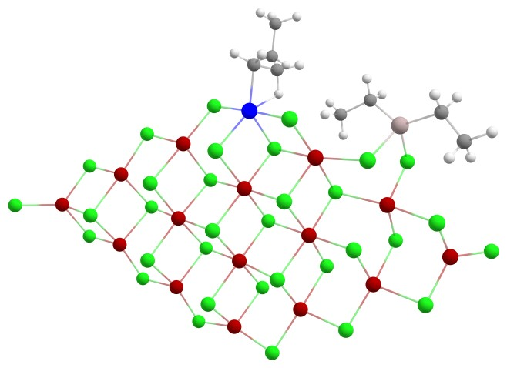
IV | IV SCF Done: -19602.7467129 A.U.  Mg 3.285843 3.440329 -0.031124  Cl 5.473423 3.994525 0.786847  Mg 6.720971 2.048230 -0.003693  Cl 8.912359 2.482936 0.828710  Mg 10.055420 0.616353 -0.262400  Cl 11.940553 0.827127 -1.440137  Ti -0.153319 4.912000 -0.540379  Cl -2.113644 4.328377 -1.872477  C -0.702849 6.963230 -0.436687  H -1.314253 7.336718 -1.265760  Cl -0.890487 2.960583 1.046294  Cl 1.276374 3.039680 -1.673021  C -1.471810 6.502797 0.773566  H 0.137860 7.633745 -0.212413  H -1.333645 5.380640 0.966230  H -2.557935 6.535624 0.594511  Cl 1.903723 5.274950 0.775170  C -1.081293 7.155649 2.112308  H -1.549948 6.594927 2.936803  H 0.008741 7.057088 2.243286  C -1.499966 8.627994 2.171629  H -2.590242 8.734514 2.057300  H -1.216130 9.077724 3.134149  H -1.020804 9.212820 1.371663  Mg -3.023754 2.640554 -0.347158  Cl -5.253084 2.126029 -1.619817  Mg -6.027327 0.215048 -0.057960  Cl -8.015268 -0.207158 -1.343898  Mg -8.762390 -2.028391 0.093346  Cl -7.668635 -4.009811 -0.802801  Mg -5.452310 -3.485141 -0.041224  Cl -4.197349 -5.448309 -0.776261  Mg -2.029787 -4.840382 0.038582  Cl -0.655150 -6.814992 -0.604124  Mg 1.381237 -5.940599 0.229581  Cl 0.090164 -4.328521 1.579839  Cl -10.649163 -1.757402 1.263138  Cl 2.201185 -4.194553 -1.307942  Cl 3.563934 -6.122352 1.130384  Mg 4.350296 -3.925698 0.266830  Cl 6.577424 -3.792538 1.129626  Mg 7.250851 -1.643900 0.170742  Cl 9.458626 -1.374723 1.028588  Cl 2.980796 -2.173451 1.427888  Cl -1.719872 0.757020 -1.561717  Mg 0.370659 1.174016 -0.212970  Cl 2.446086 1.468399 1.250468  Cl -1.191942 -2.926587 -1.353273  Mg 0.883623 -2.448268 0.029169  Cl -0.430173 -0.729277 1.290524  Cl 1.705007 -0.595838 -1.454920  Mg -2.552904 -1.135941 -0.056038  Cl -3.786853 0.666687 1.169989  Cl -4.618698 -1.547833 -1.412823  Cl -3.271461 -3.079030 1.432340  Mg 3.823035 -0.243889 -0.099923  Cl 5.089066 -2.050307 -1.329419  Cl 5.844948 0.094820 1.381210  Cl 4.575804 1.705928 -1.494860  Cl 7.790346 0.228830 -1.519428  Cl -6.568262 -1.716140 1.492858  H 0.508096 6.126536 -1.970585  H 0.745436 5.449088 -2.283257  Al -6.429294 3.256127 0.098108  C -7.742762 4.431177 -0.746299  H -8.344509 4.923571 0.037687  H -7.221698 5.240830 -1.283855  C -7.023544 1.931352 1.507566  H -6.509015 1.033709 1.906207  H -6.692693 2.637590 2.300210  C -8.554360 1.741661 1.614014  H -9.092493 2.672312 1.380444  H -8.929559 0.979223 0.918899  H -8.849210 1.431111 2.626737  C -8.655262 3.633494 -1.708777  H -9.425744 4.277687 -2.161353  H -8.080196 3.182979 -2.532496  H -9.176544 2.807921 -1.199466  Cl -4.531080 4.209874 0.949221  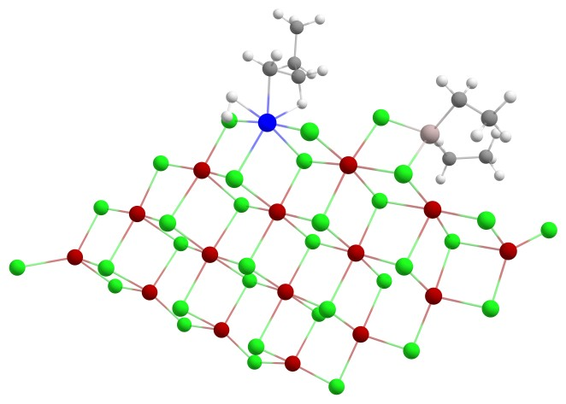
MgCl₂ (110) + Ti cluster + EADC
II | II SCF Done: -19982.6092795 A.U.  Mg 3.185027 3.385134 0.231446  Cl 5.384088 3.918556 1.033156  Mg 6.627545 1.998296 0.163614  Cl 8.818297 2.385854 1.019267  Mg 9.960661 0.572103 -0.159809  Cl 11.846441 0.841369 -1.324378  Ti -0.192014 5.065777 -0.273743  Cl -2.270288 4.453098 -1.400223  C -0.774718 7.021416 0.161492  H -1.443726 7.461180 -0.586963  C -1.465410 6.406327 1.352789  H 0.059442 7.689037 0.405888  H -1.281127 5.288343 1.454376  H -1.088377 6.773944 2.315738  H -2.559932 6.454874 1.302951  Cl 1.831084 5.197136 1.146309  Mg -3.065614 2.648433 0.059509  Cl -5.444529 2.417306 -1.145589  Mg -6.080368 0.174637 -0.089427  Cl -8.106962 -0.137982 -1.348496  Mg -8.868207 -2.039064 -0.009585  Cl -7.744767 -3.952295 -1.012696  Mg -5.546802 -3.482275 -0.187216  Cl -4.290123 -5.395536 -1.030825  Mg -2.131372 -4.851868 -0.152758  Cl -0.766377 -6.796083 -0.885749  Mg 1.267871 -5.973767 0.005048  Cl -0.030911 -4.430166 1.432672  Cl -0.891449 2.897042 1.309602  Cl 1.211241 3.067857 -1.428806  Cl -10.757901 -1.910653 1.171837  Cl 2.087984 -4.151607 -1.437309  Cl 3.447145 -6.208334 0.898314  Mg 4.245341 -3.976171 0.143601  Cl 6.474966 -3.894995 1.004043  Mg 7.154092 -1.700921 0.156880  Cl 9.362353 -1.482061 1.027278  Cl 2.882726 -2.284063 1.399860  Cl -1.849613 0.862724 -1.381876  Mg 0.292884 1.178909 -0.057831  Cl 2.377974 1.350854 1.421352  Cl -1.288365 -2.855578 -1.419903  Mg 0.785059 -2.469786 -0.003000  Cl -0.531464 -0.811783 1.347637  Cl 1.596365 -0.549669 -1.391861  Mg -2.634459 -1.143154 -0.015396  Cl -3.949873 0.564127 1.306450  Cl -4.672775 -1.462855 -1.464040  Cl -3.395380 -3.164665 1.328201  Mg 3.730493 -0.280017 -0.033833  Cl 4.981679 -2.025436 -1.356719  Cl 5.758519 -0.022081 1.456911  Cl 4.486753 1.727663 -1.333099  Cl 7.697358 0.250260 -1.438059  Cl -6.672313 -1.761499 1.406797  C 0.212505 5.946871 -2.610915  C 1.338916 6.276387 -1.921307  H 0.152975 5.029542 -3.199636  H -0.616956 6.647237 -2.718445  H 1.465470 7.249437 -1.447077  H 2.222120 5.636167 -1.953049  Al -6.264700 4.083334 0.338896  C -7.710664 3.288004 1.397883  H -7.790730 3.924574 2.296957  H -8.672367 3.390419 0.871067  C -7.491003 1.825843 1.826005  H -6.470248 1.633320 2.199913  H -8.174214 1.502071 2.625856  H -7.753315 1.147762 0.989205  Cl -6.376741 5.865577 -0.805971  Cl -4.387917 4.119486 1.614109  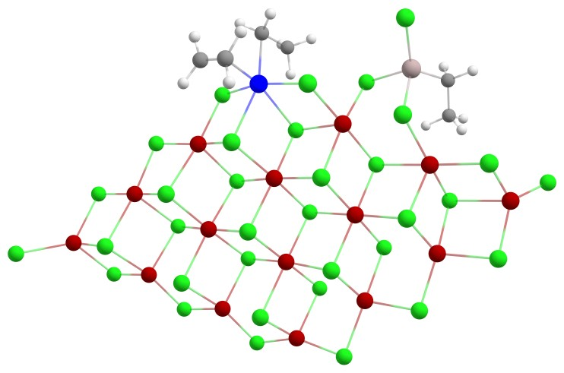
III | III SCF Done: -19982.6304581 A.U.  Mg -3.326779 3.429018 0.002308  Cl -5.522071 3.968811 -0.792345  Mg -6.742367 2.017001 0.021486  Cl -8.944437 2.424725 -0.793594  Mg -10.057283 0.557494 0.326240  Cl -11.922000 0.753019 1.536923  Ti 0.125137 4.819224 0.428379  Cl 2.099098 4.297162 1.804975  C 0.497319 6.849982 0.598442  H 1.019465 7.122731 1.523563  Cl 0.928493 2.959659 -1.152200  Cl -1.266397 3.104264 1.645810  C 1.368381 6.644752 -0.616120  H -0.400688 7.458618 0.426092  H 1.344203 5.541830 -0.954712  H 2.436873 6.750194 -0.371888  Cl -1.920053 5.197098 -0.890919  C 0.979030 7.435778 -1.876155  H 1.538953 7.040778 -2.739148  H -0.088901 7.258439 -2.084345  C 1.251382 8.934873 -1.713936  H 2.319108 9.125317 -1.521781  H 0.969109 9.485508 -2.622974  H 0.679562 9.355466 -0.872804  Mg 3.041801 2.634428 0.284826  Cl 5.325450 2.267543 1.523346  Mg 6.132496 0.164194 -0.039671  Cl 8.111962 -0.225358 1.269900  Mg 8.851250 -2.147881 -0.036118  Cl 7.643199 -4.030179 0.920562  Mg 5.486949 -3.490426 0.043638  Cl 4.208292 -5.439117 0.767519  Mg 2.055294 -4.825301 -0.061269  Cl 0.691650 -6.803199 0.593894  Mg -1.344976 -5.934631 -0.232216  Cl -0.063783 -4.317616 -1.592056  Cl 10.797572 -2.226184 -1.124959  Cl -2.152426 -4.181024 1.306850  Cl -3.531445 -6.124631 -1.115498  Mg -4.312652 -3.931826 -0.246195  Cl -6.546772 -3.815336 -1.089609  Mg -7.229515 -1.673863 -0.127809  Cl -9.448870 -1.431799 -0.960286  Cl -2.960233 -2.171846 -1.423223  Cl 1.745726 0.778650 1.502610  Mg -0.357202 1.190428 0.170160  Cl -2.440715 1.463446 -1.261320  Cl 1.233748 -2.896884 1.326328  Mg -0.847797 -2.433683 -0.043482  Cl 0.457693 -0.713502 -1.324790  Cl -1.665665 -0.571746 1.439532  Mg 2.597208 -1.120095 0.006371  Cl 3.865129 0.693509 -1.199437  Cl 4.664777 -1.500389 1.370641  Cl 3.307295 -3.067110 -1.454554  Mg -3.806961 -0.252139 0.104882  Cl -5.047609 -2.056221 1.353202  Cl -5.844669 0.071167 -1.358892  Cl -4.557909 1.703994 1.492529  Cl -7.765221 0.203308 1.558825  Cl 6.648192 -1.792338 -1.512926  Al 6.329288 3.659219 -0.042527  C 7.597285 4.898522 0.759196  H 8.044834 5.510560 -0.042514  H 7.049221 5.598426 1.412146  C 8.692528 4.145017 1.549595  H 9.420900 4.846721 1.985267  H 8.268793 3.557904 2.379001  H 9.252975 3.445537 0.910837  Cl 4.435597 4.359873 -1.012740  Cl 7.149502 2.098430 -1.388345  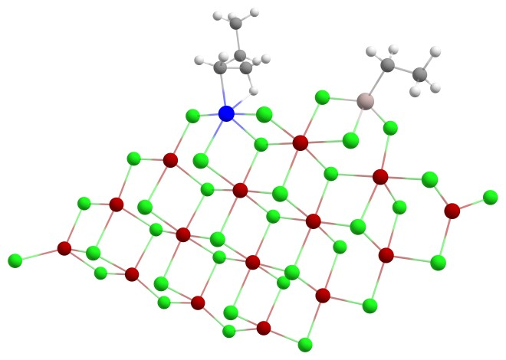
IV | IV SCF Done: -19983.8185886 A.U.  Mg 3.290818 3.413999 -0.044066  Cl 5.485135 3.967068 0.755056  Mg 6.719970 2.015066 -0.037904  Cl 8.919257 2.442699 0.775690  Mg 10.045042 0.569844 -0.322591  Cl 11.915830 0.769530 -1.524107  Ti -0.146538 4.905019 -0.518208  Cl -2.134967 4.332813 -1.818358  C -0.668327 6.963325 -0.415274  H -1.296703 7.335360 -1.232348  Cl -0.884602 2.955666 1.081029  Cl 1.251769 3.021124 -1.663573  C -1.410915 6.522242 0.818341  H 0.184461 7.627397 -0.219120  H -1.286171 5.398340 1.013493  H -2.500476 6.572522 0.668082  Cl 1.926249 5.256184 0.770808  C -0.977087 7.178586 2.141891  H -1.429196 6.628230 2.982426  H 0.114824 7.069685 2.244418  C -1.378861 8.655623 2.202253  H -2.470775 8.772909 2.118001  H -1.063540 9.108763 3.153246  H -0.916156 9.229832 1.385091  Mg -3.017197 2.625118 -0.290775  Cl -5.316374 2.263171 -1.523662  Mg -6.119273 0.148489 0.028257  Cl -8.097167 -0.241443 -1.285275  Mg -8.840242 -2.160961 0.022766  Cl -7.634546 -4.048481 -0.927454  Mg -5.478783 -3.509124 -0.048445  Cl -4.199786 -5.461720 -0.763856  Mg -2.048497 -4.844451 0.068340  Cl -0.679579 -6.825788 -0.567319  Mg 1.354431 -5.952030 0.262995  Cl 0.064475 -4.328617 1.606842  Cl -10.791115 -2.235655 1.104328  Cl 2.165122 -4.210198 -1.285094  Cl 3.538656 -6.131253 1.156453  Mg 4.321742 -3.942682 0.274785  Cl 6.555024 -3.813569 1.120890  Mg 7.232659 -1.675701 0.143943  Cl 9.449462 -1.414319 0.978875  Cl 2.961145 -2.181007 1.436386  Cl -1.753842 0.761462 -1.527910  Mg 0.359657 1.162150 -0.191846  Cl 2.445359 1.454586 1.253318  Cl -1.224273 -2.923690 -1.326735  Mg 0.853996 -2.456114 0.050294  Cl -0.458789 -0.727451 1.312479  Cl 1.673292 -0.609841 -1.442041  Mg -2.591933 -1.136671 -0.022718  Cl -3.853336 0.677649 1.187303  Cl -4.659355 -1.522247 -1.381993  Cl -3.304316 -3.079699 1.448652  Mg 3.806853 -0.265909 -0.102891  Cl 5.055098 -2.078091 -1.336437  Cl 5.841924 0.072431 1.359712  Cl 4.552683 1.676840 -1.511997  Cl 7.763309 0.189681 -1.557576  Cl -6.642186 -1.806272 1.502877  H 0.503116 6.106200 -1.963737  H 0.726672 5.424748 -2.278097  Al -6.316682 3.640854 0.053651  C -7.571961 4.902229 -0.734375  H -8.016933 5.505923 0.075121  H -7.014741 5.607321 -1.373980  C -8.671174 4.172481 -1.540966  H -9.389986 4.888195 -1.969726  H -8.249454 3.593159 -2.376850  H -9.242201 3.469794 -0.915211  Cl -4.423146 4.322914 1.038061  Cl -7.148350 2.073224 1.382825  