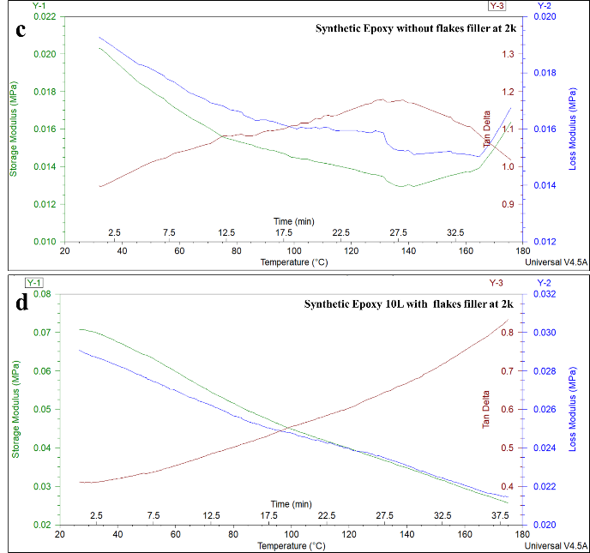
DMA Results for Bio-Epoxy and synthetic epoxy (2K)
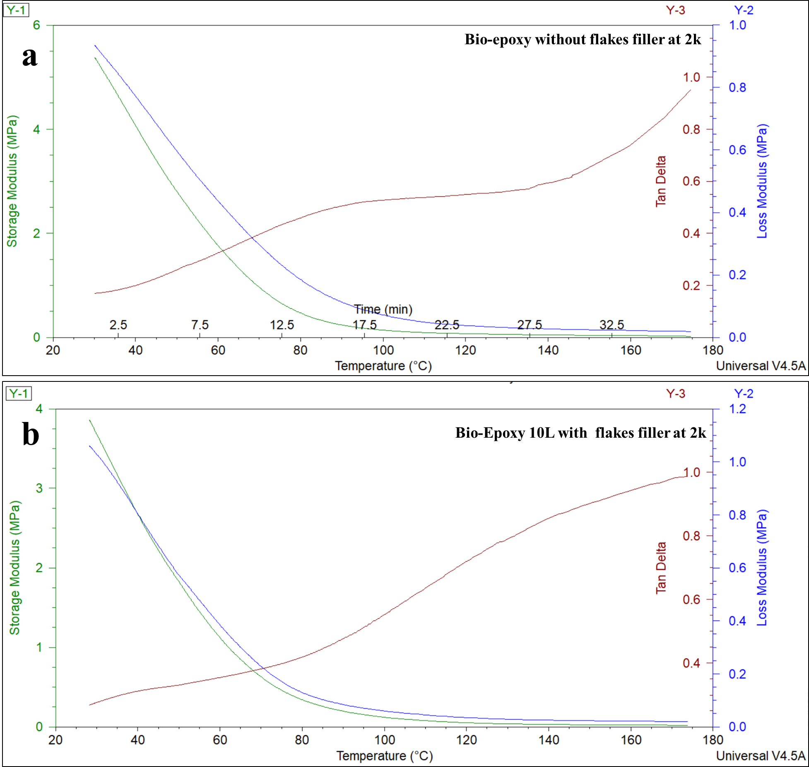
The comparison between bio-epoxy and synthetic epoxy composites with and without flakes filler demonstrates distinct thermal and mechanical behaviors. Bio-epoxy composites exhibit higher initial storage modulus (E'), with unfilled samples starting at ~6 MPa and decreasing below 0.5 MPa beyond 120°C, whereas synthetic epoxy starts significantly lower at ~0.020 MPa and declines to ~0.012 MPa at 120°C. The addition of flakes filler improves stiffness retention in both materials, with filled bio-epoxy maintaining ~0.6 MPa at 120°C and filled synthetic epoxy retaining ~0.07 MPa at 25°C, showing better reinforcement effects in the synthetic matrix. Loss modulus (E'') peaks at ~0.4 MPa around 90°C for unfilled bio-epoxy and ~0.016 MPa around 100–120°C for unfilled synthetic epoxy, shifting to ~0.5 MPa at ~100°C for filled bio-epoxy and ~0.03 MPa for filled synthetic epoxy, confirming improved resistance to molecular relaxation in both cases. Tan delta (tan δ) analysis reveals a Tg increase in both materials upon filler incorporation, with bio-epoxy shifting from ~90°C to ~100°C and synthetic epoxy shifting from ~120°C to ~130°C, indicating reduced damping and enhanced rigidity. However, synthetic epoxy shows a larger reduction in tan δ (~1.2 to ~0.8) compared to bio-epoxy (~1.0 to ~0.9), suggesting a more pronounced stiffening effect with flakes filler. These results confirm that while both materials benefit from filler addition in terms of thermal and mechanical stability, synthetic epoxy exhibits a greater degree of stiffness enhancement and Tg improvement, making it more suitable for applications requiring high-temperature resistance and structural durability.

DMA Results for Bio-Epoxy and synthetic epoxy (4K)
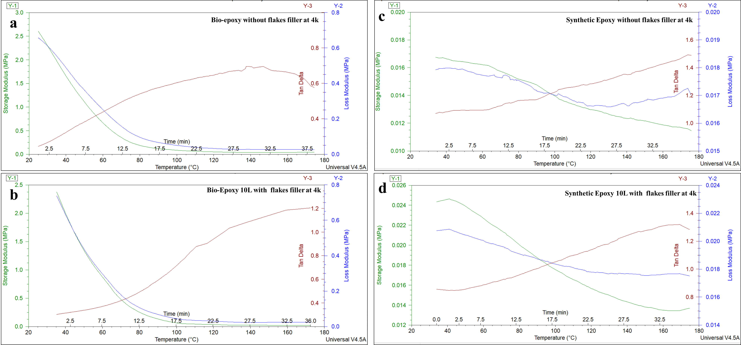
Comparative analysis of the Dynamic Mechanical Analysis (DMA) results for unfilled and filled bio-epoxy and synthetic epoxy materials at 4k reveals significant differences in their thermo-mechanical properties: for unfilled bio-epoxy, the storage modulus (E') starts at approximately 2.5 MPa at 20°C and decreases to near 0 MPa at 180°C, with a loss modulus (E'') peak at ~60°C (0.2 MPa) and a tan delta peak of 0.8 at ~120°C, indicating a glass transition temperature (Tg) of ~120°C, while filled bio-epoxy also starts with E' of 2.5 MPa at 20°C but shows a higher loss modulus peak at ~70°C (0.2 MPa) and a tan delta peak of 1.2 at ~130°C, indicating an elevated Tg of ~130°C. In contrast, unfilled synthetic epoxy's E' decreases from ~0.017 MPa at 20°C to 0.012 MPa at 180°C, with a loss modulus peak from 0.015 MPa to 0.017 MPa, and tan delta rising from 1.0 to 1.6 peaking at 100°C, indicating Tg ~100°C, while filled synthetic epoxy's E' decreases from 0.024 MPa to 0.014 MPa, with a loss modulus rise from 0.018 MPa to 0.022 MPa, and tan delta rising from 0.8 to 1.4 peaking at 110°C, indicating Tg ~110°C. These results demonstrate that the flakes filler significantly enhances the thermal stability, stiffness, and damping behavior of both bio-epoxy and synthetic epoxy, leading to improved mechanical performance at higher temperatures.

DMA Results for Bio-Epoxy and synthetic epoxy (6K)
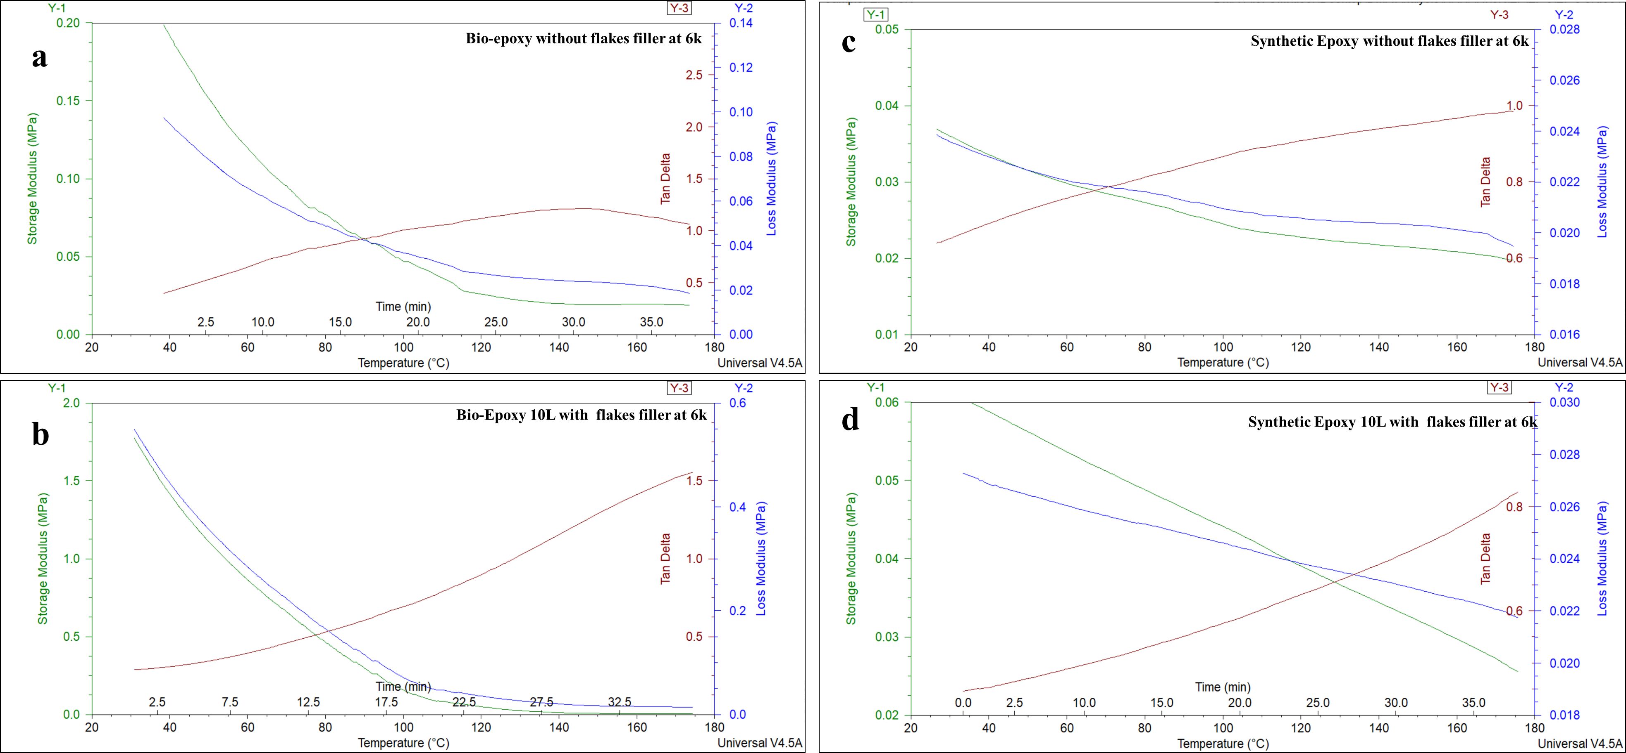
The Dynamic Mechanical Analysis (DMA) graphs for bio-epoxy and synthetic epoxy with and without flakes filler at 6k reveals significant differences in their thermo-mechanical properties. For unfilled bio-epoxy, the storage modulus (E') decreases from approximately 0.18 MPa at 20°C to about 0.02 MPa at 160°C, whereas filled bio-epoxy shows a higher E' starting at 1.8 MPa and decreasing to 0.1 MPa at 160°C, indicating enhanced stiffness due to the filler. The loss modulus (E'') of unfilled bio-epoxy peaks at around 60°C (0.06 MPa), while the filled bio-epoxy peaks higher at approximately 0.4 MPa around 100°C, indicating improved energy dissipation. Tan delta for both materials peaks around 100°C, with unfilled bio-epoxy reaching 1.5 and filled bio-epoxy also at 1.5, indicating the glass transition temperature (Tg). For unfilled synthetic epoxy, E' decreases from approximately 0.04 MPa at 20°C to 0.02 MPa at 180°C, while filled epoxy starts at about 0.055 MPa and decreases to 0.02 MPa, showing higher initial stiffness. The loss modulus (E'') for unfilled epoxy peaks around 100°C, whereas filled epoxy shows a higher peak at the same temperature. Tan delta for unfilled epoxy increases from 0.6 to 1.0, peaking around 100°C (Tg), while filled epoxy's tan delta increases from 0.6 to 0.8, peaking around 110°C, indicating an elevated Tg of about 110°C. These results demonstrate that flakes filler significantly enhances the thermal stability, stiffness, and damping behavior of both bio-epoxy and synthetic epoxy, improving mechanical performance at higher temperatures.

