Supplementary information

Use of WetSEM® capsules for convenient multimodal scanning electron microscopy, energy dispersive X-ray analysis, and micro Raman spectroscopy characterisation of technetium oxides.
D. J. Bailey,^{1*} M. C. Stennett,¹ J. Heo,^{2,3} N. C. Hyatt^{1*}
*Corresponding author: d.j.bailey@sheffield.ac.uk, n.c.hyatt@sheffield.ac.uk

¹Department of Materials Science and Engineering, University of Sheffield, Mappin Street, Sheffield, S1 3JD, United Kingdom
²Department of Materials Science and Engineering, Pohang University of Science and Technology (POSTECH), Pohang, Gyeongbuk 790-784, South Korea
³Division of Advanced Nuclear Engineering, Pohang University of Science and Technology (POSTECH), Pohang, Gyeongbuk 790-784, South Korea

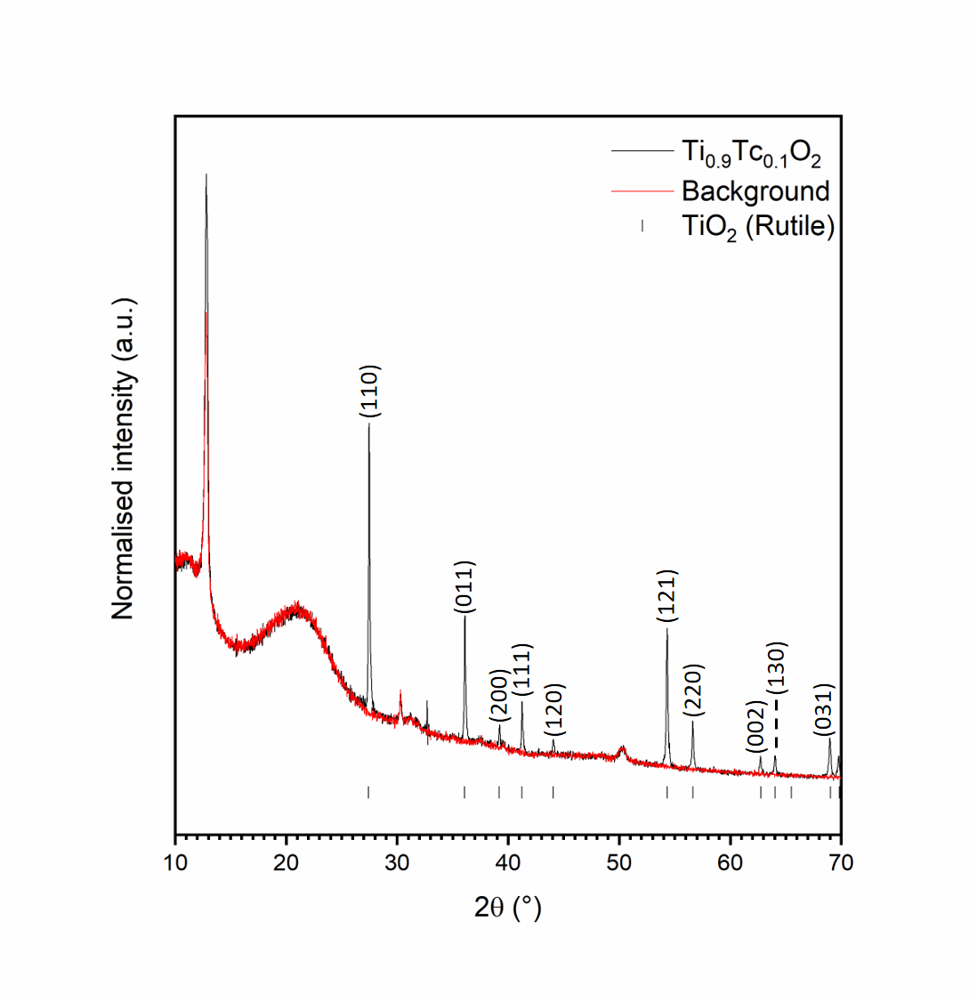
Fig. S1: X-ray diffraction pattern of synthesised Ti_{0.9}Tc_{0.1}O₂. Tick marks show allowed reflections for TiO₂ (rutile).

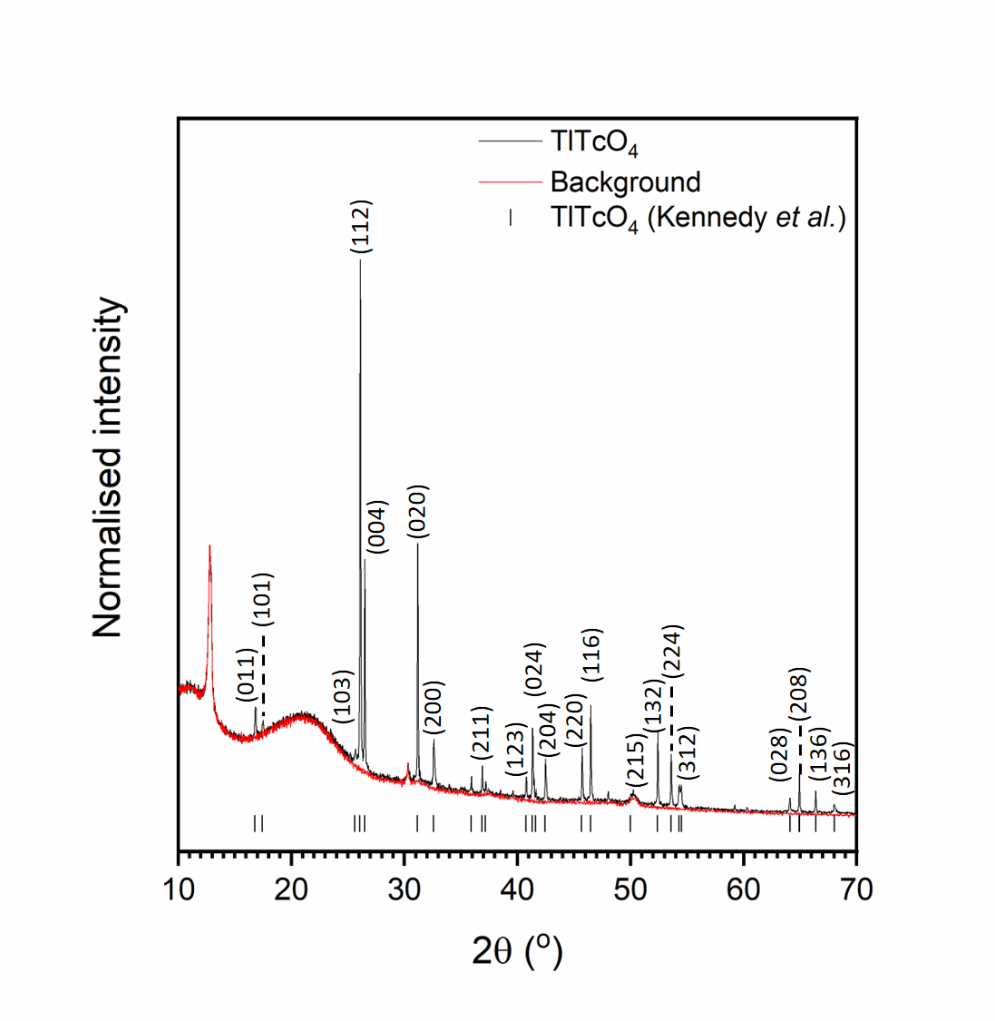
Fig. S2: X-ray diffraction pattern of synthesised TlTcO₄. Tick marks show allowed reflections for TlTcO₄, minimum 1 % of maximum intensity.

Table S1: Raman shifts and tentative mode/symmetry assignments for TlTcO₄, assignments based on TlReO₄. Rot. = rotation, Sci. = scissoring, Wagg. = wagging, Rock. = rocking, Twist. = twisting, Asym. Str. = Asymmetric stretching and Sym. Str = symmetric stretching [1].

Raman shift (cm⁻¹) | Symmetry | Assignment
67.34 | E_{g} | Rot. of TcO₄
95.04 | B_{g} | Rot. of TcO₄
316.76 | A_{g} | Sci. in TcO₄
334.27 | E_{g} | Wagg., Rock. in TcO₄
344.82 | B_{g} | Sci., Twist. in TcO₄
864.88 | E_{g} | Asym. Str. of Tc-O bonds
886.28 | B_{g} | Asym. Str. of Tc-O bonds
900.05 | A_{g} | Sym. Str of all bonds in TcO₄

References
- Mondal S, Vaitheeswaran G, Kennedy BJ, et al (2020) Crystal structure and phase transition of TlReO₄: a combined experimental and theoretical study. J Phys Condens Matter 33:. https://doi.org/10.1088/1361-648X/abb651

