Supplementary information
Dose Rate

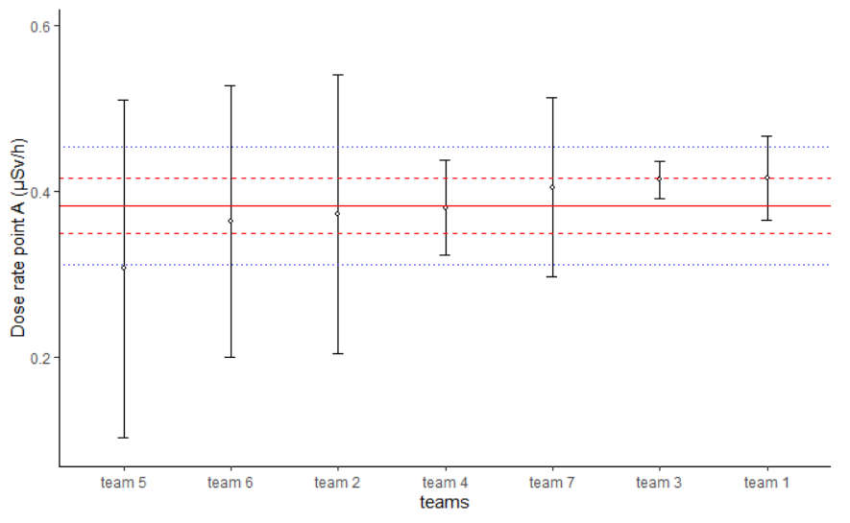
Figure 14 Plot of dose rate results at point A with their expanded uncertainties (in black), $x_{pt}$ (plain red line), $x_{pt}±2u_{pt}$ (dashed red lines), $x_{pt}±2σ_{pt}$ (dotted blue lines)

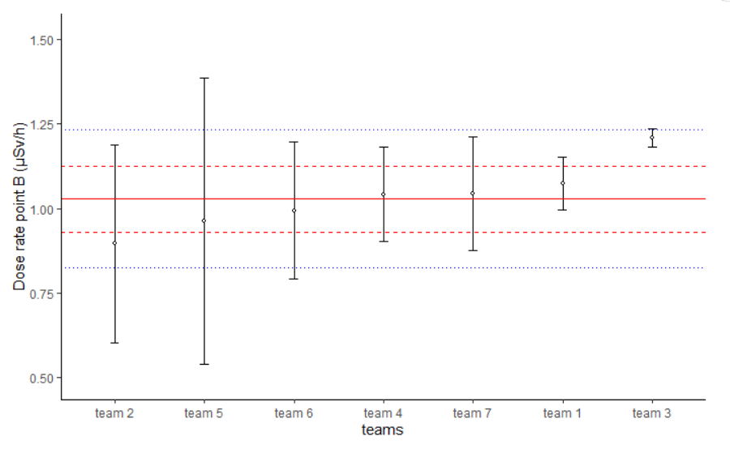
Figure 15 Plot of dose rate results at point B with their expanded uncertainties (in black), $x_{pt}$ (plain red line), $x_{pt}±2u_{pt}$ (dashed red lines), $x_{pt}±2σ_{pt}$ (dotted blue lines)

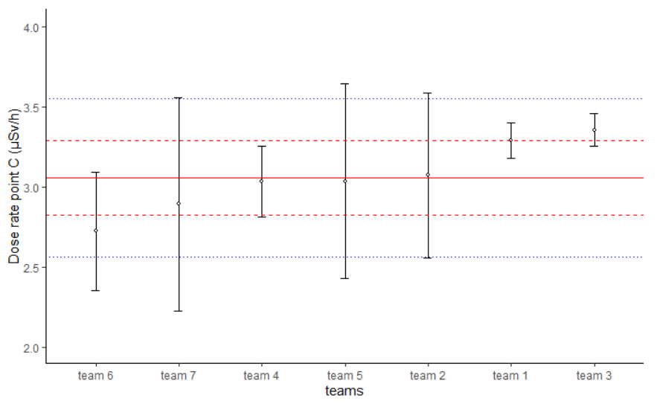
Figure 16 Plot of dose rate results at point C with their expanded uncertainties (in black), $x_{pt}$ (plain red line), $x_{pt}±2u_{pt}$ (dashed red lines), $x_{pt}±2σ_{pt}$ (dotted blue lines)
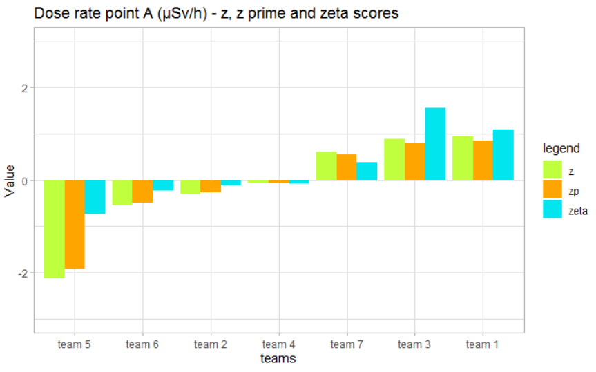
Figure 17 Value of performance statistics at point A for dose rate measurements

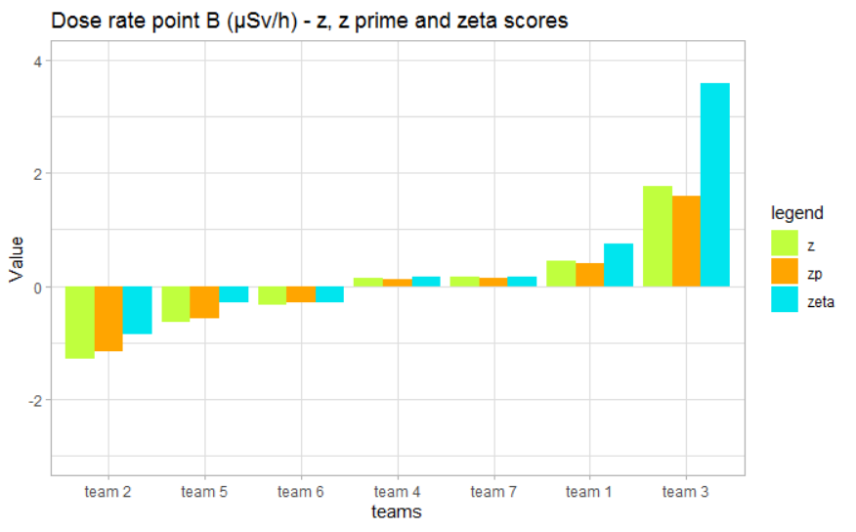
Figure 18 Value of performance statistics at point B for dose rate measurements

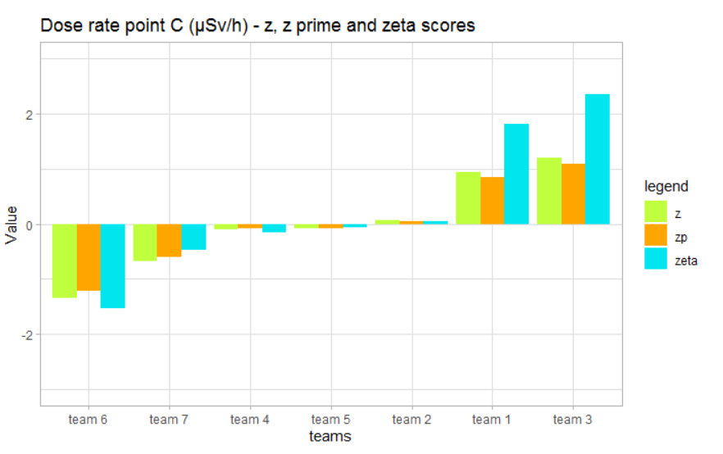
Figure 19 Value of performance statistics at point C for dose rate measurements

Total gamma
Table 11 Performance statistics values for depth Ba-133 measurement
Team | 1 | 2 | 3 | 4 | 5&6 | 7
$$x_{i}$$ | 50.49 | 57.00 | 55.000 | 45.80 | 56.900 | 50.300000
$$u(x_{i})$$ | 0.39 | 0.57 | 0.030 | 0.96 | 0.050 | 0.000010
$$D_{i}$$ | -4.0 | 8.4 | 4.6 | -13 | 8.2 | -4.3
$$z_{i}$$ | -0.41 | 0.87 | 0.48 | -1.3 | 0.85 | -0.45
$$z_{i}^{'}$$ | -0.37 | 0.78 | 0.43 | -1.2 | 0.76 | -0.40
$P_{A,i}$(%) | -14 | 29 | 16 | -45 | 28 | -15

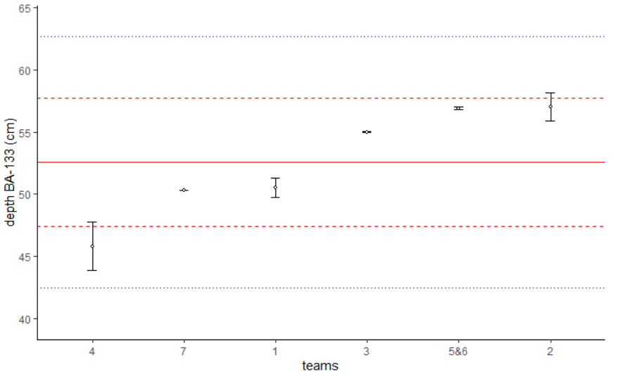
Figure 20 Plot of depth Ba-133 results with their expanded uncertainties (in black), $x_{pt}$ (plain red line), $x_{pt}±2u_{pt}$ (dashed red lines), $x_{pt}±2σ_{pt}$ (dotted blue lines)
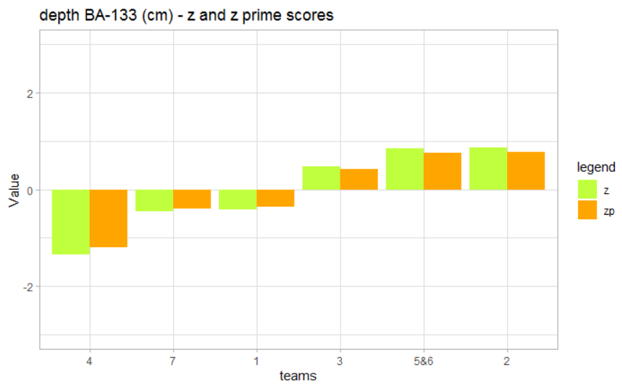
Figure 21 Value of performance statistics for depth Ba-133 measurement
Table 12 Performance statistics values for depth Eu-152 measurement
Team | 1 | 2 | 3 | 4 | 5&6 | 7
$$x_{i}$$ | 36.86 | 45.0 | 38.00 | 39.70 | 37.00 | 34.5
$$u(x_{i})$$ | 0.44 | 0.9 | 0.07 | 0.95 | 0.20 | 0.1
$$D_{i}$$ | -3.6 | 18 | -0.66 | 3.8 | -3.3 | -9.8
$$z_{i}$$ | -0.40 | 2.0 | -0.073 | 0.42 | -0.36 | -1.1
$$z_{i}^{'}$$ | -0.36 | 1.340 | -0.065 | 0.37 | -0.32 | -0.96
$P_{A,i}$(%) | -13 | 65 | -2.4 | 14 | -12 | -36

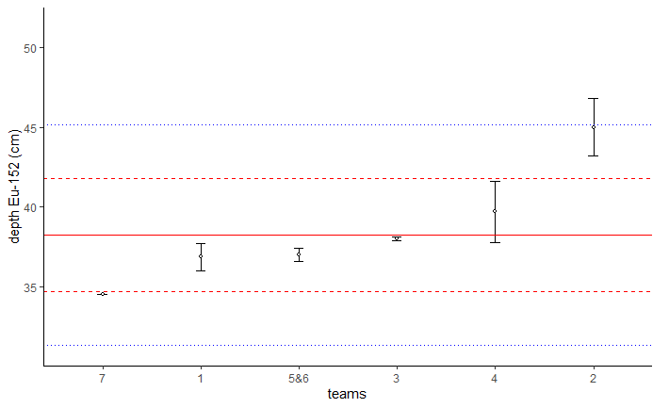
Figure 22 Plot of depth Eu-152 results with their expanded uncertainties (in black), $x_{pt}$ (plain red line), $x_{pt}±2u_{pt}$ (dashed red lines), $x_{pt}±2σ_{pt}$ (dotted blue lines)
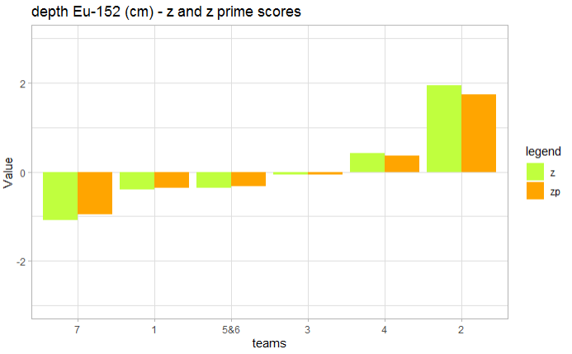
Figure 23 Value of performance statistics for depth Eu-152 measurement

Table 13 Performance statistics values for SUM (Ba-133&Eu-152) measurement
Team | 1 | 2 | 3 | 4 | 5&6 | 7
$$x_{i}$$ | 52.33 | 59.00 | 57.00 | 65.00 | 58.00 | 51.80
$$u(x_{i})$$ | 0.59 | 0.10 | 0.08 | 0.10 | 0.10 | 0.10
$$D_{i}$$ | -8.5 | 3.17 | -0.33 | 14 | 1.4 | -9.4
$$z_{i}$$ | -0.89 | 0.33 | -0.034 | 1.4 | 0.15 | -0.98
$$z_{i}^{'}$$ | -0.79 | 0.29 | -0.030 | 1.3 | 0.13 | -0.87
$P_{A,i}$(%) | -29 | 11 | -1.1 | 47 | 4.9 | -33

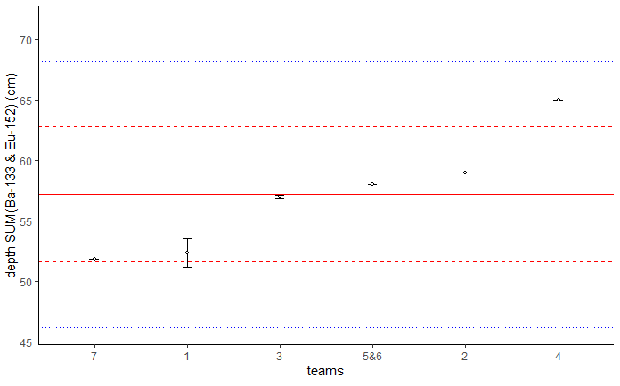
Figure 24 Plot of SUM (Ba-133&Eu-152) results with their expanded uncertainties (in black), $x_{pt}$ (plain red line), $x_{pt}±2u_{pt}$ (dashed red lines), $x_{pt}±2σ_{pt}$ (dotted blue lines)

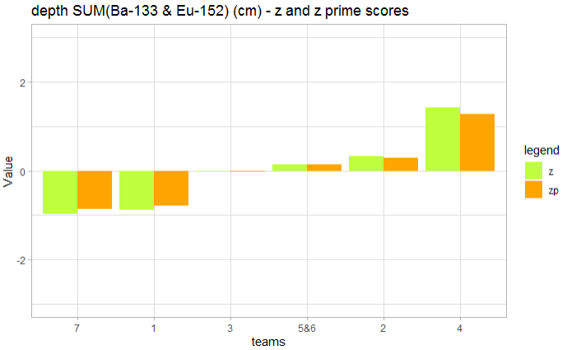
Figure 25 Value of performance statistics for SUM (Ba-133&Eu-152) measurement
Table 14 Performance statistics values for Eu-152/Eu-154 measurement
Team | 1 | 2 | 3 | 4 | 5&6 | 7
$$x_{i}$$ | 1.83 | 13.0 | 18.00 | 30.0 | 17.20 | 15.62
$$u(x_{i})$$ | 0.53 | 1.3 | 0.20 | 8.0 | 0.89 | 0.12
$$D_{i}$$ | -89 | -18 | 13 | 88 | 7.9 | -2.0
$$z_{i}$$ | -1.4 | -0.29 | 0.20 | 1.4 | 0.12 | -0.031
$$z_{i}^{'}$$ | -1.2 | -0.26 | 0.18 | 1.2 | 0.11 | -0.028
$P_{A,i}$(%) | -46 | -9.5 | 6.7 | 46 | 4.1 | -1.0

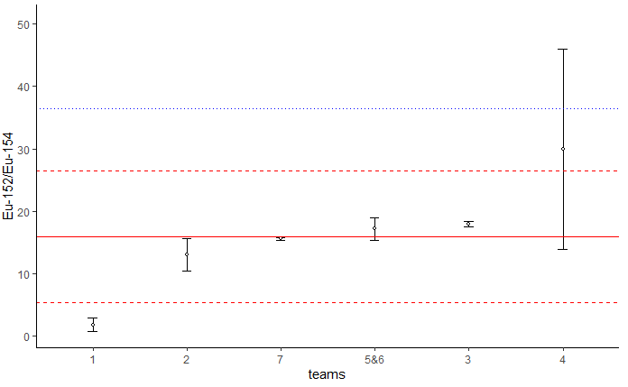
Figure 26 Plot of Eu-152/Eu-154 results with their expanded uncertainties (in black), $x_{pt}$ (plain red line), $x_{pt}±2u_{pt}$ (dashed red lines), $x_{pt}±2σ_{pt}$ (dotted blue lines)
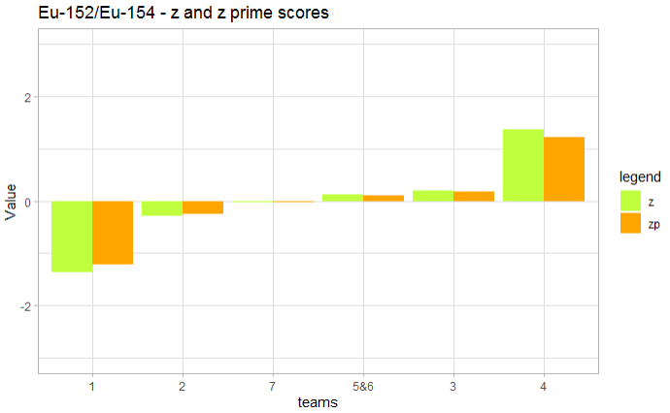
Figure 27 Value of performance statistics for Eu-152/Eu-154 measurement

Table 15 Performance statistics values for Cs-137 measurement
Team | 1 | 2 | 3 | 4 | 5&6 | 7
$$x_{i}$$ | 8830 | 7385 | 3950.0 | 3680 | 3437.0 | 20400
$$u(x_{i})$$ | 2217 | 2215 | 5.0 | 3257 | 1.3 | 32
$$D_{i}$$ | 29.50 | 8.3 | -42 | -46 | -50 | 199
$$z_{i}$$ | 0.44 | 0.12 | -0.63 | -0.69 | -0.74 | 3.0
$$z_{i}^{'}$$ | 0.39 | 0.11 | -0.56 | -0.62 | -0.66 | 2.7
$P_{A,i}$(%) | 15 | 4.2 | -21 | -23 | -25 | 100

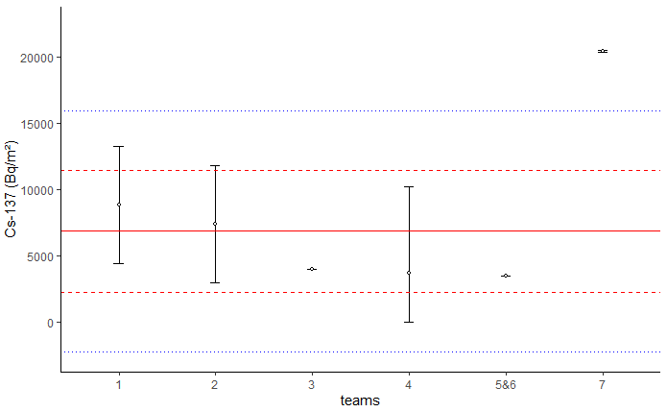
Figure 28 Plot of Cs-137 results with their expanded uncertainties (in black), $x_{pt}$ (plain red line), $x_{pt}±2u_{pt}$ (dashed red lines), $x_{pt}±2σ_{pt}$ (dotted blue lines)

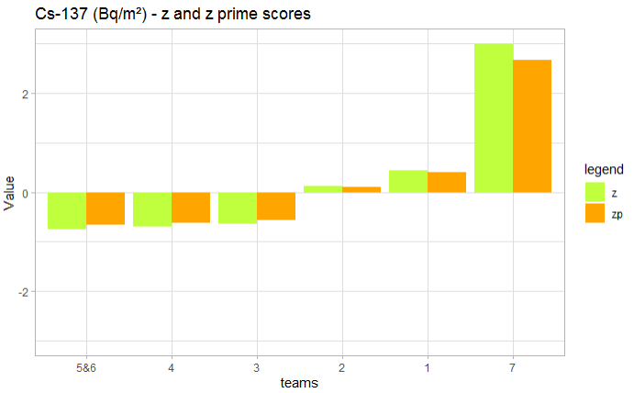
Figure 29 Value of performance statistics for Cs-137 measurement

