Supplementary information
Microfluidic system
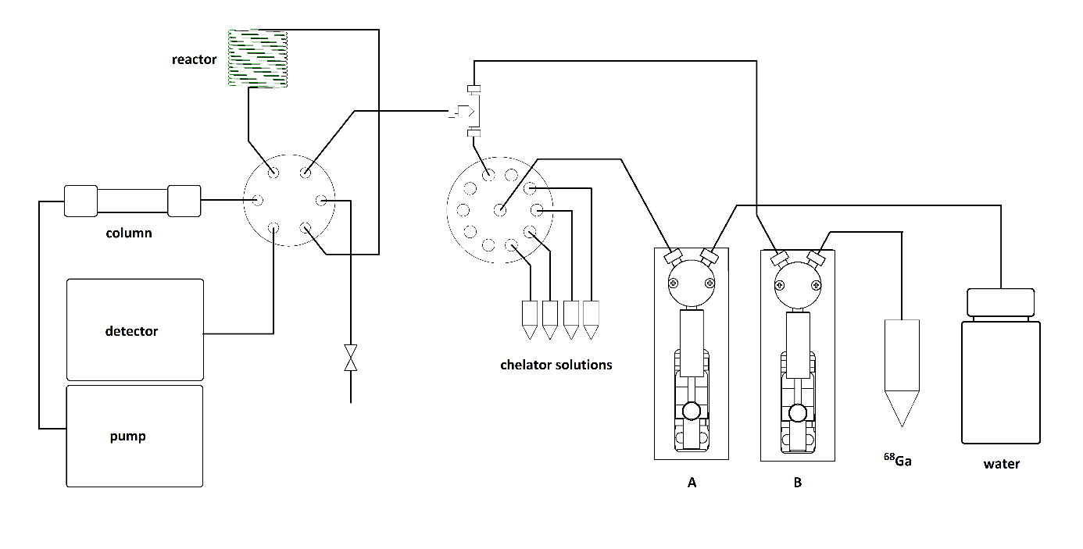
Figure 8. Layout of the microfluidic system.
The microfluidic system (Figure 8.) was built for the co-injection of small volume samples of buffered chelator solutions and a ⁶⁸Ga stock solution into a heated capillary reactor. After the reaction time, the contents of the capillary were immediately injected onto the HPLC column for separation. The system consisted of a Titan HP HPLC injector valve (IDEX) a 10 position Cheminert selection valve (Valco) two Tecan XP3000 syringe pumps (Cavro) and a home-built temperature controlled heating block equipped with PEEK capillary reactor (0.25 mm i.d., 2 m length). The system was controlled by a PC, running a LabView code. The units of the system were connected to an Arduino Mega card, receiving the commands from the PC. The Arduino Mega card controlled the units via I2C bus.
Labeling experiments were performed according to the following steps. Syringe pump „B” was filled with 1 mL ⁶⁸Ga solution before starting the experiments. Syringe pump “A” pulled a 100 µL chelator solution sample from a vial, selected by the 10-way valve. The chelator solution remained in the connection tubing (0.8 mm i.d. Tefzel) between the syringe pump and the 10-way valve, separated from the liquid in the syringe pump by a small air bubble. The buffered chelator solution and the ⁶⁸Ga solution were co-injected into the heated capillary reactor and the outlet valve closed for the duration of the reaction to prevent liquid loss from the reactor. After the elapse of the reaction time the injector valve switched, and the eluent flow flushed the contents of the reactor to the HPLC column.

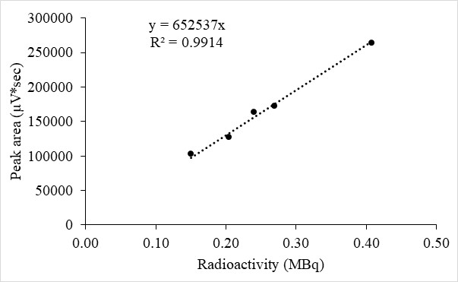
Figure 9. Linearity of the radioactivity detector measured by the new chromatographic method with [Ga⁶⁸]Ga-DOTA.
Effect of different buffers on radiolabeling
In addition to the widely used ammonium acetate (AmAc), the labeling reaction of [⁶⁸Ga]Ga-NOTA and [⁶⁸Ga]Ga-DOTA were also studied in the presence of non-coordinating buffers [27]. The applied buffers were used in the same concentration and adjusted to the same pH. The concentration dependence of complex formation was investigated with NOTA chelator in the case of seven buffers (Table 3.). Samples buffered with ascorbate and citrate were examined only once, as the radiochemical yield achieved with them was very low. The recovery of the formed complexes from the column was also investigated at flow rates of 1.0 and 0.6 mL/min. The decay corrected peak areas of the samples, injected to the HPLC with- and without column were compared.

Table 3. Optimization of the labeling reaction using different buffers by iTLC and recovery% of the formed complexes by liquid chromatography.
Buffers | AmAc | MOPS | PIPES | MES | HEPES | Ascorbate | Citrate
pH | 4 | 4 | 5.1 | 4 | 4 | 4 | 4
c (M) | 1 | 1 | 0.0033* | 1 | 1 | 1 | 1
NOTA c (µM) | RCY % by iTLC
3 | 97.01 | 98.48 | 93.19 | 95.78 | 98.92 | 11.72 | 73.50
1 | 3.17 | 93.92 | 91.94 | 93.36 | 96.91 | 0.00 | 74.60
0.3 | 0.00 | 85.17 | 80.28 | 59.21 | 81.02 | 0.00 | 71.89
 | Recovery % by HPLC
1.0 mL/min | 91.7 | 92.2 | 93.2 | 88.8 | 96.5 | - | -
0.6 mL/min | 99.6 | 99.9 | 99.4 | 92.5 | 98.5 | - | 87.4
*Piperazine-1,4-bis(2-ethanesulfonic acid) (PIPES) has limited solubility in water (1 g/L = 0.003307 M).
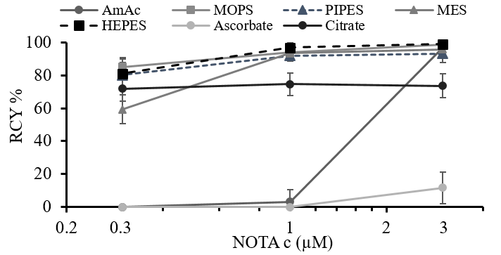
Figure 10. Effect of different buffers on radiochemical yields.

The best labeling yields were achieved with 3-(N-morpholino)propanesulfonic acid (MOPS) and 4-(2-hydroxyethyl)piperazine-1-ethanesulfonic acid (HEPES) buffers (Figure 10.). Gallium recovery was poor in the case of HEPES and 4-morpholineethanesulfonic acid (MES) buffers. Labeling yield was higher in non-coordinating buffers, it was the best in HEPES. In our previous work with HEPES buffered [⁶⁸Ga]Ga³⁺, we observed pH dependent adsorption of activity on the walls of the PEEK capillary reactor, which complicated the experimental work. We aimed to avoid cross contamination problems, related to the use of HEPES, so we chose to use ammonium acetate buffer for further experiments. The effect with the MOPS buffer is the opposite of that experienced with NOTA and DOTA using the microfluidic system (Figure 11.). We tested the MOPS buffer at pH 4 and pH 6.7, but the radiochemical yield was low in both cases, below 10%. With HEPES (similarly to the manual labeling), even at low chelator concentrations, the degree of complex formation could be easily measured, but due to its high tendency for adsorption its application in this system was not suitable either. The use of ammonium acetate buffer was well proven for both DOTA and NOTA, so we used it throughout the subsequent experiments for pH adjustment.
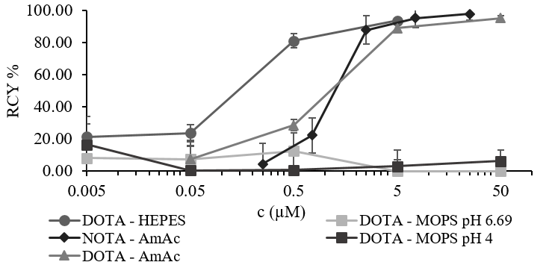
Figure 11. Comparison of the effect of buffers in a microfluidic system. (25 μL of AmAc, MOPS or HEPES buffer (2 M; pH 4.0) and 25 μL of DOTA or NOTA, 50 μL of ⁶⁸Ga, 100°C, 5 min.)

Figure 12. Structures of the tested chelators.

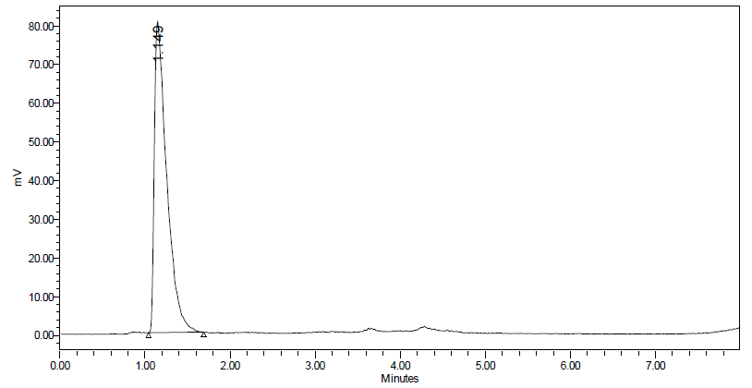
Figure 13. ⁶⁸Ga and [⁶⁸Ga]Ga-NO₂BzDOTA (1.149 min) radiochromatographic separation.
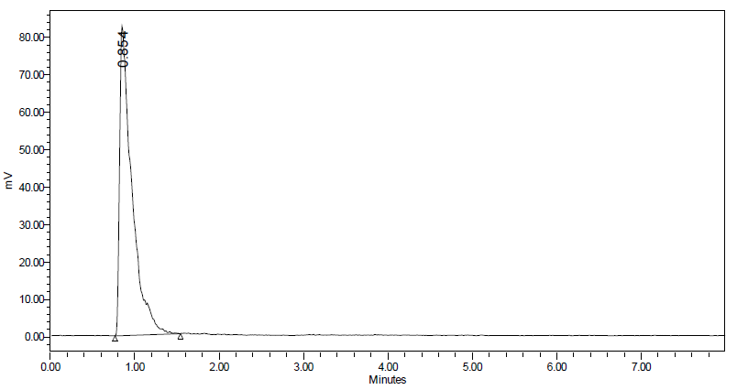
Figure 14. ⁶⁸Ga and [⁶⁸Ga]Ga-AAZTA-C4 (0.854 min) radiochromatographic separation.
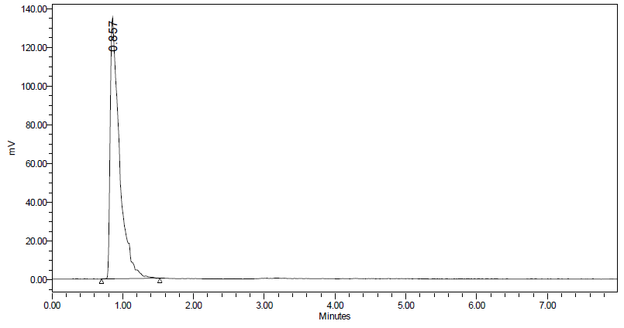
Figure 15. ⁶⁸Ga and [⁶⁸Ga]Ga-AAZTA (0.857 min) radiochromatographic separation.
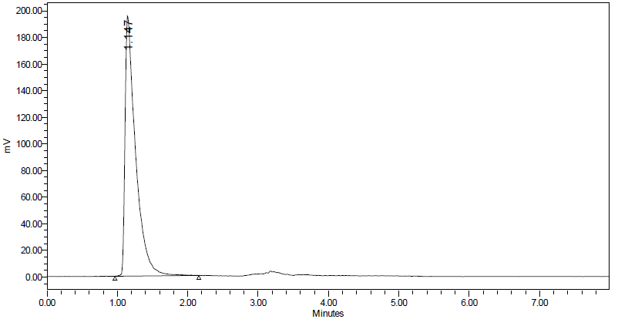
Figure 16. ⁶⁸Ga and [⁶⁸Ga]Ga-HXTA (1.147 min) radiochromatographic separation.
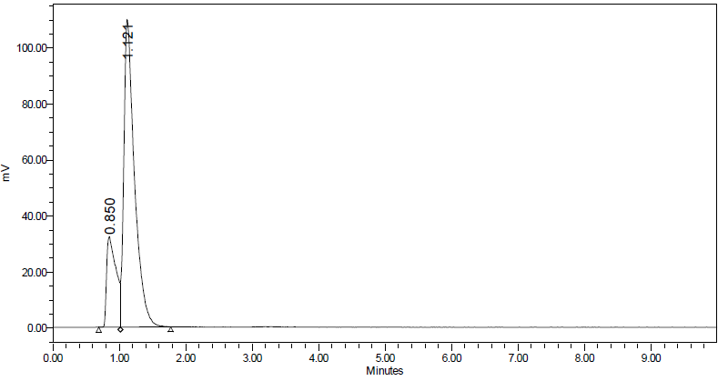
Figure 17. ⁶⁸Ga and [⁶⁸Ga]Ga-NOPO (0.850 and 1.121 min) radiochromatographic separation.
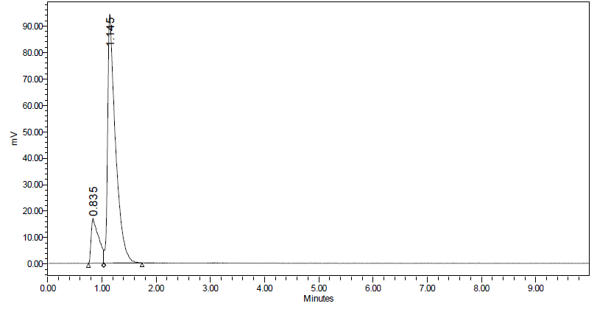
Figure 18. ⁶⁸Ga and [⁶⁸Ga]Ga-TRAP (0.835 and 1.145 min) radiochromatographic separation.
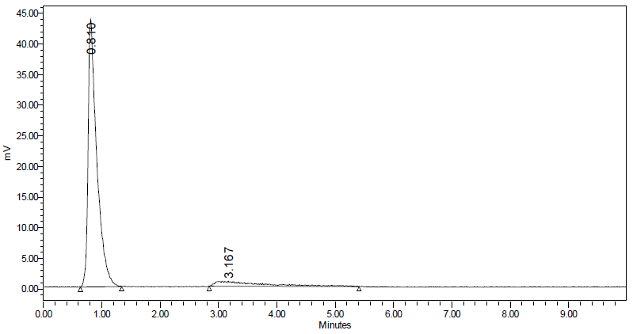
Figure 19. ⁶⁸Ga (3.167 min) and [⁶⁸Ga]Ga-DTPA (0.810 min) radiochromatographic separation.
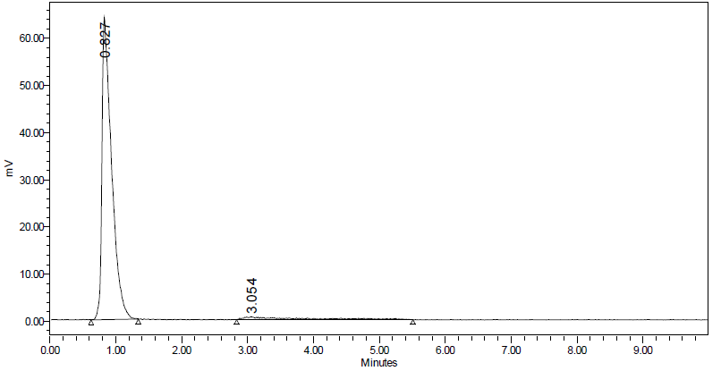
Figure 20. ⁶⁸Ga (3.054 min) and [⁶⁸Ga]Ga-EDTA (0.827 min) radiochromatographic separation.
The negatively charged complexes ( [⁶⁸Ga]Ga-NO₂BzDOTA, [⁶⁸Ga]Ga-AAZTA-C4, [⁶⁸Ga]Ga-AAZTA, [⁶⁸Ga]Ga-DTPA, [⁶⁸Ga]Ga-EDTA) elute at 0.85 min, the neutrals ([⁶⁸Ga]Ga-HXTA) at 1.15 min. The low retention of negatively charged forms can be explained by the ion exclusion effect. NOPO and TRAP elute as double peaks, corresponding to their neutral and negatively charged forms at the eluent pH due to protonation equilibrium [28].

