Supplementary information
Materials and Methods
- Chemicals and Materials:
All chemicals were used without further purification. Hydrochloric acid (analytical grade) was purchased from TH.GEYER (Renningen, Germany). Type 1 ultra-pure water (≥18 MΩ cm) was prepared onsite with a Purelab classic water purification system from ELGA Labwater (Celle, Germany). Chromabond® empty columns, 1 mL, propylene, with PE filter elements was provided from VWR International (Wien, Austria). Zirconium “ZR” resin (containing hydroxamate functional groups) was provided by Triskem Intl. (Bruz, France). Dry dimethylformamide (DMF), N,N-diisopropylethylamine (DIPEA) (99.5%), 1,2-cyclohexanedinitrilotetraacetic acid (CDTA) (98%), citric acid, tartaric acid, oxalic acid and phosphate salts for buffering were purchased from Sigma-Aldrich (Darmstadt, Germany). The scandium disks (Sc purity TREM > 99.99%) for irradiations were purchased from Smart Elements GmbH (Vienna, Austria). and were supplied as a scandium ingots, which were rolled to plates (thickness: 0.65±0.05 mm, diameter: 13 mm, mass: 330±30 mg). Chlorine gas (5.0) was obtained from Linde Gas (Germany).
Mass flow controllers were supplied from Bronkhorst Deutschland Nord GmbH (Germany) (EL FLOW Select 300 mL/min for inert gases, LOW-ΔP-FLOW 60 mL/min for chlorine gas). Mass flow conversions were done using the Fluidat database (Bronkhorst Nord GmbH, Kamen, Germany). Glassware for the separation system was manufactured by the Central Institute of Engineering, Electronics and Analytics (ZEA-1) at Forschungszentrum Jülich. For thin layer chromatography (TLC), RP silica coated aluminum TLC plates from Sigma-Aldrich (Darmstadt, Germany) were used. The analysis of the radio-TLCs was performed with a PerkinElmer Cyclone Plus Storage Phosphor System (Waltham, MA, USA). Measurement of radioactivity were performed with a DOSE Calibrator TALETE HC (COMECER S.p.A., Castel Bolognese (RA), Italy).
Gamma-ray spectroscopy was performed with ORTEC HPGe spectrometers (AMETEK GmbH, Germany), which were energy and efficiency calibrated with certified radiation point sources (Co-60, Ba-133, Eu-152, Ra-226) from the Physikalisch-Technische Bundesanstalt (Germany).
Radio-HPLC was performed on a HPLC system consisting of an Azura P 4.1 s pump with an Azura UVD 2.1 s UV/VIS detector (Knauer Wissenschaftliche Geräte GmbH, Germany) and an EG & G Ortec ACE NaI(Tl) radioactivity detector with photomultiplier (EG & G Ortec, USA). The radioactivity detection limit was determined by serial dilution and amounted to 0.3 kBq. Co-elution experiments of radioactive and non-radioactive complexes were performed at a flow rate of 0.7 mL/min using H₂O/PBS/CH₃COOH (96.4/3.1/0.5, v/v/v) as the mobile phase and Synergi Polar-RP 4 μ RP 80 Å, 250 × 4.6 mm (Phenomenex Inc., Germany) as the RP stationary phase. The UV detection wavelength for all measurements was 210 nm.
NMR spectra were measured on a Varian Inova 400 spectrometer (Agilent Technologies, Germany) with 400.1 MHz (¹H-NMR) and 100.62 MHz (¹³C-NMR).
The electrospray ionization (ESI) source was operated in the positive mode. Low-resolution mass spectrometry was performed using a Finnigan Automass Multi spectrometer (Thermoquest, Germany).

- Target dissolution:
The irradiated target was placed in a 20 mL screw lid jar and cooled in an ice bath. 10 m hydrochloric acid (5 mL) was then added, the jar was closed after 1 min, and the solution was stirred for 5-10 min until the color turned from black to slightly yellow. The resulting solution, which contained around 250 MBq ⁴⁵Ti, was directly used for the batch experiments or diluted to 20 mL with 10 m hydrochloric acid for further evaluation experiments.

- Separation experiments
All statistical calculations are in the form MEAN±SD. Decay corrected (d.c.) values are reffered to the start of the separation.
  - Preparation and conditioning of resin:
For the separation experiments, Chromabond® columns (1 mL, equipped with two frits) were filled with ZR Resin™ (66±6 mg, 130±6 mg or 280±6 mg as indicated) which was slurred in water. The columns were conditioned with 10 m HCl (5 mL) and directly used for the separation experiments.

  - Preparation of stock solutions:
Table 2: Buffer solutions.
No. | pH | c [mol/L] | Buffer
I | 8.0 | 0.100 | NaH₂PO₄ / Na₂HPO₄
II | 8.0 | 1.000 | NaH₂PO₄ / Na₂HPO₄
III | 8.0 | 0.067 | NaH₂PO₄ / Na₂HPO₄
IV | 5.5 | 0.100 | NaH₂PO₄ / Na₂HPO₄
V | 5.5 | 0.500 | NaH₂PO₄ / Na₂HPO₄
VI | 5.5 | 1.000 | NaH₂PO₄ / Na₂HPO₄
VII | 3.3 | 0.100 | HCOOH / NH₃

Table 3: Elution media with respective concentration, pH value and ⁴⁵Ti recovery d.c.
No. | Media | c [mol/L] | Buffer | pH | ⁴⁵Ti recovery d.c.[%]
1 | 30% MeOH / H₂O / H₂O₂ | 0.065 | ─ | ─ | 12.5±2.6
2 | 30% MeCN / H₂O / H₂O₂ | 0.065 | ─ | ─ | 17.8±2.2
3 | Tartaric acid | 0.10 | ─ | ─ | 28.5±5.0
4 | 1 m HCl / H₂O₂ | 0.065 | ─ | ─ | 30.8±3.3
5 | Citric acid | 0.10 | ─ | ─ | 35.3±5.3
6 | 0.65 m H₂O₂ | 0.65 | ─ | ─ | 35.0±13.3
7 | Oxalic acid | 0.50 | ─ | ─ | 59.1±24.0
8 | MeCN | ─ | ─ | ─ | 72.3±10.3
9 | MeCN / H₂O₂ | 0.65 | ─ | ─ | 82.3±7.4
10 | Oxalic acid | 0.10 | ─ | 1.3 | 28.9±6.0
11 | Oxalic acid | 0.05 | ─ | 1.5 | 13.9
12 | Oxalic acid | 0.05 | IV | 2.6 | 36.2±4.6
13 | Oxalic acid | 0.05 | VII | 2.8 | 33.4±14.7
14 | Oxalic acid | 0.01 | VII | 3.2 | 5.3
15 | Oxalic acid | 0.10 | V | 3.8 | 16.9
16 | Oxalic acid | 0.05 | I | 5.1 | 8.6
17 | Oxalic acid | 0.10 | VI | 5.3 | 9.9
18 | Oxalic acid | 0.10 | II | 7.0 | 8.1
19 | Oxalic acid | 0.01 | II | 7.9 | 1.9
20 | Oxalic acid | 0.10 | III | 2.8 | 65.2±1.2
21 | Oxalic acid | 0.20 | III | 2.8, adjusted with NaOH | 66.6±6.1
22 | 20% MeOH / Oxalic acid | 0.1 | III | 2.8 | 60.8±5.9

  - Eluent screening:
Aliquots (1 mL) of the ⁴⁵Ti target solution were applied to a series of columns filled with 130±6 mg ZR Resin™ and each column was washed with 10 m HCl (5 mL) and H₂O (5 mL). Afterwards, 2.5 mL of the eluents No. 1-9 (Table 2) were used to elute the ⁴⁵Ti and the percentage of ⁴⁵Ti in the resulting solutions was determined. The ⁴⁵Ti recoveries observed with the different eluents (n=3 per eluent) are summarized in Table 2.

  - pH screening
Aliquots (1 mL) of the ⁴⁵Ti target solution were applied to a series of columns filled with 130±6 mg ZR Resin™ and each column was washed with 10 m HCl (5 mL) and H₂O (5 mL). Afterwards, 2.5 mL of the eluents No. 10-19 (Table 2) were used to elute the ⁴⁵Ti and the percentage of ⁴⁵Ti in the resulting solutions was determined. The ⁴⁵Ti recoveries observed with the different eluents (n=1-3 per eluent, as indicated) are summarized in Table 2.

  - Further oxalic acid eluents
Aliquots (1 mL) of the ⁴⁵Ti target solution were applied to a series of columns filled with 130±6 mg ZR Resin™ and each column was washed with 10 m HCl (5 mL) and H₂O (5 mL). Afterwards, 2.5 mL of the eluents No. 20-22 (Table 2) were used to elute the ⁴⁵Ti and the percentage of ⁴⁵Ti in the resulting solutions was determined (n=3 per eluent).

  - Minimization of Sc content
For this experiment, the Sc target was irradiated without degrader foil to enable use of the co-produced ⁴⁴Sc as a radiotracer for determination of the Sc content. Aliquots (1 mL) of the ⁴⁵Ti/⁴⁴Sc target solution were applied to a series of columns filled with 130±6 mg ZR Resin™ and the columns were
- not washed,
- washed with 5 mL of H₂O,
- washed with 5 mL of 10 m HCl and an equal volume of H₂O,
- washed with 10 mL of 10 m HCl and an equal volume of H₂O,
- washed with 15 mL of 10 m HCl and an equal volume of H₂O.
Afterwards, 2.5 mL of 0.1 m oxalic acid (pH 2.8) was used to elute the ⁴⁵Ti and ⁴⁴Sc and the resulting solutions were analyzed by γ-ray spectroscopy. The activity of ⁴⁵Ti (E_{γ}=719.6 keV, I_{γ}=0.154% and E_{γ}=511 keV) and ⁴⁴Sc (E_{γ}=1157.02 keV, I_{γ}=94.3%) from each solution was calculated and the ⁴⁵Ti:⁴⁴Sc ratio were calculated. The ⁴⁵Ti:⁴⁴Sc ratios observed with the different wash volumes (n=3 per volume) are summarized in Table 4.

Table 4: ⁴⁵Ti/⁴⁴Sc-ratio obtained with different volumes of the wash solutions.
 | ⁴⁵Ti/⁴⁴Sc
Target solution | 20±11
No washing step | 36±2
5 mL H₂O | 380±80
5 mL HCl / 5 mL H₂O | 4000±300
10 mL HCl / 10 mL H₂O | 3600±200
15 mL HCl / 15 mL H₂O | 130±40

  - Batch experiment
- Determination of Sc-contamination
Columns filled with 130±6 mg ZR Resin™ were prepared, a non-irradiated target solution (350 mg in 4 mL 10 m HCl) was transferred to the column, and the column was washed with 10 m HCl (5 mL) and H₂O (5 mL). Afterwards, 0.1 m oxalic acid (pH = 2.8) was used for elution. For the first experiment a total of 2.5 mL of 0.1 m oxalic acid was used and 0.5 mL fractions were collected. Each fraction was analyzed by ICP-MS. This resulted in the elution profile for Sc. Then two further experiments were done with the same conditions and 2.5 mL 0.1 m oxalic acid was used for elution. The solutions were analyzed by ICP-MS. The results of the conducted experiments are given in Table 5. The average Sc-contamination was determined from the sum of the elution profile and the two experiments (3.0±1.8 mg/mL).
Table 5: Results of the ICP-MS analysis of Sc in the final solution.
 | V [mL] | ρ(Sc) [µg/mL]
1 | 0.5 | 0.113±0.012
2 | 0.5 | 0.797±0.017
3 | 0.5 | 0.182±0.009
4 | 0.5 | 0.182±0.009
5 | 0.5 | 0.021±0.009
1-5 | 2.5 | 1.27
7 | 2.5 | 4.84±0.09
8 | 2.5 | 2.86±0.04
- Batch experiments with aliquots
Columns filled with 130±6 mg ZR Resin™ were prepared, aliquots (1 mL) of the target solution (6-35 MBq) were transferred to the columns, and the columns were washed with 10 m HCl (5 mL) and H₂O (5 mL). Afterwards, 2.5 mL 0.1 m oxalic acid (pH = 2.8) was used to elute the ⁴⁵Ti. The results are summarized in Table 5.

Table 6: ⁴⁵Ti recovery with optimized conditions.
A₀ [MBq] | ⁴⁵Ti Recovery [MBq] | ⁴⁵Ti Recovery d.c. [%] | A₀ [MBq] | ⁴⁵Ti Recovery [MBq] | ⁴⁵Ti Recovery d.c. [%]
10.22 | 7.55 | 88.46 | 9.58 | 4.82 | 61.61
7.1 | 3.86 | 59.06 | 5.68 | 3.04 | 73.69
5.96 | 3.28 | 61.38 | 7.44 | 3.6 | 64.26
18.25 | 14.11 | 86.04 | 12.24 | 3.96 | 62.32
13.69 | 8.4 | 66.9 | 6.54 | 4.03 | 70.09
16.7 | 10.7 | 71.43 | 5.67 | 2.35 | 67.77
35.24 | 22.9 | 71.48 | 5.39 | 2.6 | 54.19
10.1 | 5.99 | 78.6 | 11.45 | 7.63 | 72.82
10.2 | 4.89 | 53.83 | 10.63 | 7.14 | 74.24
7.99 | 5.6 | 76.1 | 8.69 | 5.66 | 80.15
7.14 | 4.64 | 77.6 | 7.27 | 5.13 | 78.3
11.15 | 4.97 | 52.09 | 6.37 | 2.9 | 51.42
- Scaled up experiments with whole target
Columns filled with 130±6 mg ZR Resin™ were prepared, a complete target solution (Sc: 330±30 mg, ⁴⁵Ti: 107-180 MBq, V=5 mL) was transferred to the columns, and the columns were washed with 10 m HCl (5 mL) and H₂O (5 mL). Afterwards, 2.5 mL 0.1 m oxalic acid (pH = 2.8) was used to elute the ⁴⁵Ti. The results are summarized in Table 6.

Table 7: Scaled-up experiment. ⁴⁵Ti recovery and separation time.
A₀ [MBq] | ⁴⁵Ti Recovery [MBq] | ⁴⁵Ti Recovery d.c. [%] | t [min]
176 | 120 | 69.21 | 4
120 | 84 | 71.05 | 5
160 | 75 | 47.76 | 5
178 | 102 | 58.16 | 4
124 | 85 | 69.84 | 4
137 | 84 | 62.23 | 9
114 | 63 | 56.72 | 11
107 | 64 | 61.85 | 8
140 | 83 | 61.54 | 10
146 | 75 | 53.12 | 9

  - Determination of elution profile
Columns filled with 130±6 mg ZR Resin™ were prepared, aliquots (1 mL) of the target solution (21-29 MBq) were transferred to the columns, and the columns were washed with 10 m HCl (5 mL) and H₂O (5 mL). Afterwards, 0.1 m oxalic acid (pH 2.8) (n=3) were used to elute the ⁴⁵Ti and the respective eluate was collected in 0.5 mL fractions.

- Ti(cdta)
  - Synthesis of Ti(cdta)(H₂O)
Under an argon atmosphere, 1,2-cyclohexanedinitrilotetraacetic acid (CDTA) (730 g, 2.1 mmol, 1.00 eq.) was dissolved in dry DMF (5 mL) and TiCl₄(thf)₂ (700 mg, 2,1 mmol, 1.00 eq.) was added to the solution. After stirring for 45 min at 70 °C, the organic solvent was removed under reduced pressure and the crude product was recrystallized from water. The product was obtained as colorless crystals (165 mg, yield: 20%). A single crystal was analyzed by x-ray diffraction and the results were in accordance with those from Liu et al. [1].
¹H-NMR (400 MHz, DMSO) δ 4.21 (d, J = 17.3 Hz, 2H), 3.90 – 3.74 (m, 4H), 3.65 – 3.58 (m, 2H), 3.19 (d, J = 8.0 Hz, 2H), 1.93 (d, J = 12.1 Hz, 2H), 1.67 (d, J = 8.0 Hz, 2H), 1.42 (d, J = 3.7 Hz, 2H), 1.17 (t, J = 9.6 Hz, 2H).
¹³C-NMR (101 MHz, DMSO) δ 174.36 (s), 173.32 (s), 67.21 (s), 65.24 (s), 58.22 (s), 53.40 (s), 41.67 (s), 25.08 (s), 23.35 (s), 18.04 (s), 16.75 (s), 12.29 (s).

  - Complexation of ⁴⁵Ti using CDTA
[⁴⁵Ti]TiCl₄ (thermochromatography):
[⁴⁵Ti]TiCl₄ was obtained by thermochromatography using a previously reported method [5] and dissolved in dry THF (81 MBq in 2 mL). For radiolabeling, CDTA (1 mg) and DIPEA (20 µL) in anhydrous DMF (2mL) were added to a reaction vessel containing the isolated [⁴⁵Ti]TiCl₄ in THF and the mixture was allowed to react for 45 min at room temperature. The reaction mixture was then quenched by addition of H₂O (0.5 mL) and analyzed by HPLC (Hydro-RP: H₂O/PBS/EtOH 96.4/3.1/0.5, 0.7 mL/min) and radio-TLC (RP: 90% H₂O / 10% MeCN, R_{f}=0.85).
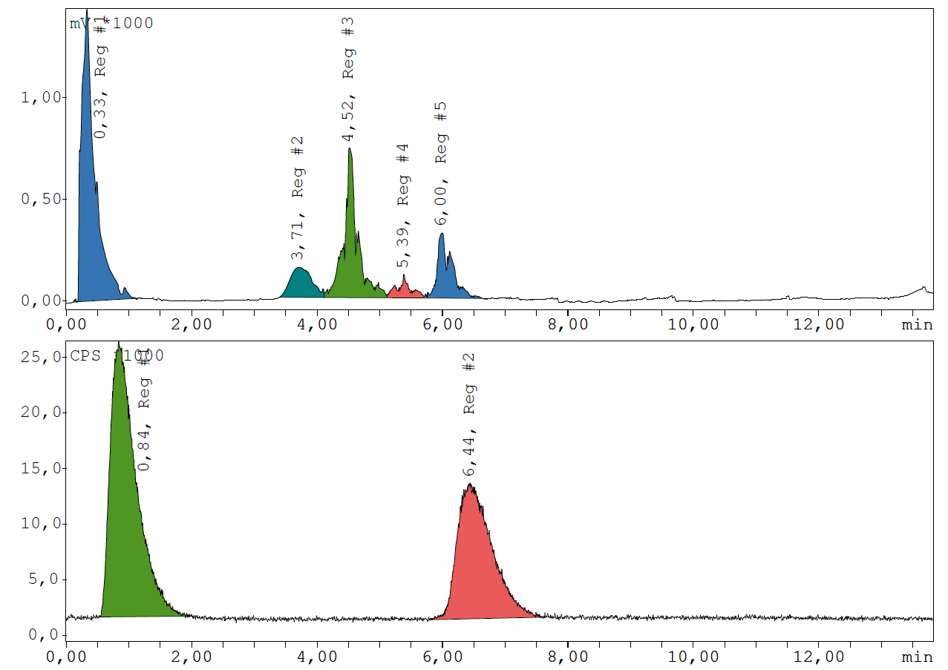
SI-Fig. 1: Chromatogram of [⁴⁵Ti]Ti(cdta) co-injected with the non-radioactive reference compound Ti(cdta). Top UV-channel: Post column injection (0.33 min), solvents DMF/THF (3.71/4.52 min), CDTA (5.39 min), Ti(cdta) 6.00 min. Bottom radioactivity channel: Post column injection (0.84 min), [⁴⁵Ti]Ti(cdta) (6.44 min).

⁴⁵Ti-containing 0.65 mM H₂O₂ in MeCN solution (column chromatography):
Columns filled with 130±6 mg ZR Resin™ were prepared, aliquots (1 mL) of the target solution (6-35 MBq) were transferred to the columns, and the columns were washed with 10 m HCl (5 mL) and H₂O (5 mL). Afterwards, 0.65 mM H₂O₂ in MeCN (n=3) were used to elute the ⁴⁵Ti. CDTA (1 mg) was dissolved in sodium phosphate buffer (pH = 8.0, 300 µL), the solution was added to a reaction vessel containing the isolated ⁴⁵Ti. The mixture was allowed to react for 45 min at room temperature, after which it was analyzed by radio-TLC.

⁴⁵Ti-oxalate solution (column chromatography):
CDTA (1 mg) was dissolved in sodium phosphate buffer (pH = 8.0, 300 µL), the solution was added to a reaction vessel containing the isolated [⁴⁵Ti]Ti-oxalate complex, and the mixture was allowed to react for 45 min at room temperature, after which it was analyzed by radio-TLC.
References
1. Liu Q-X, Zhou Z-H (2012) Monomeric peroxo titanate coordinated with cyclohexanediaminetetraacetate: Towards the active oxygen species of the Ti(IV) site hosted in the titanium silicalite catalyst TS-1. Polyhedron 35:1–6. https://doi.org/10.1016/j.poly.2011.12.037

