Supporting Information

Projections of future ambient dose rates at the mountainous area in the Fukushima evacuation zone, Japan.

Katsumi Shozugawa ^{1*}, Mayumi Hori ^{1*}, Thomas E. Johnson ², Yo Ishigaki ³, Yoshinori Matsumoto ⁴

¹ Graduate School of Arts and Sciences, University of Tokyo, 3-8-1 Komaba, Meguro, Tokyo 153-8902, Japan
cshozu@mail.ecc.u-tokyo.ac.jp, cmayumi@mail.ecc.u-tokyo.ac.jp

² Department of Environmental and Radiological Health Sciences, Colorado State University, Fort Collins, CO 80523, United States

³ Research Center for Realizing Sustainable Societies, The University of Electro-Communications, 1-5-1 Chofugaoka, Chofu, Tokyo 182-8585

⁴ Department of Applied Physics and Physico-Informatics, Faculty of Science and Technology, Keio University, 3-14-1 Hiyoshi, Kohoku-ku, Yokohama, Kanagawa 223-8522, Japan

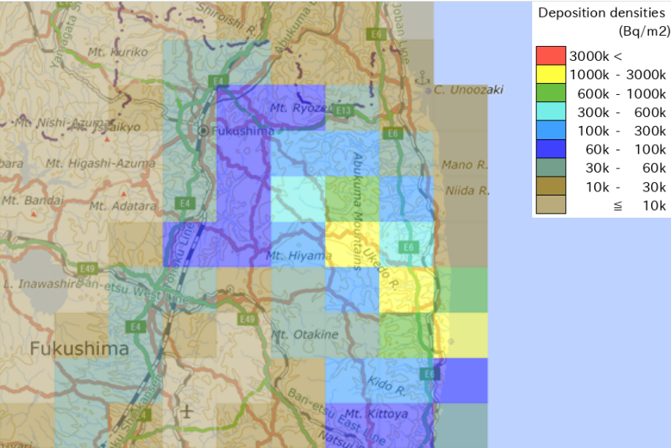
Fig.S1 The deposition of ¹³⁷Cs in the Omaru district (dot on the map) during the study period was estimated at 1000 – 3000 kBqm⁻² according to aircraft monitoring by JAEA.

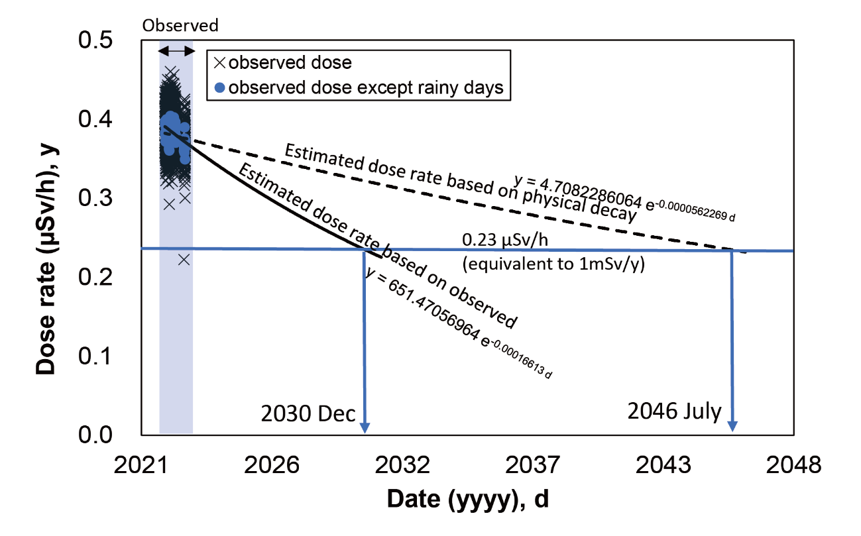
Fig.S2
Figure 2 in the text simplifies the coefficients of the two approximate curves. For more detailed values, the significant figures need to be expanded to five digits. To enable the calculations to be checked, a diagram with more detailed figures is given here.

