Reactivity and Volatility of Astatine in a quartz column
Supplementary Material
D. Dietzel^{1,2,3}*, A. Yakushev², Ch. E. Düllmann^{1,2,3}, K. Hermainski^{1,2}, J. Ballof², P. Bartl⁴, R. Cantemir², J. John⁴, J. Krier², P. Mošat², M. Němec⁴, J. P. Omtvedt⁵, J. Štursa⁶

¹Department of Chemistry, Johannes Gutenberg University Mainz, Mainz, Germany
²GSI Helmholtzzentrum für Schwerionenforschung, Darmstadt, Germany
³Helmholtz Institute Mainz, Mainz, Germany
⁴Czech Technical University, Prague, Czech Republic
⁵University of Oslo, Oslo, Norway
⁶Nuclear Physics Institute CAS, Řež, Czech Republic
*E-mail: dietzel@uni-mainz.de

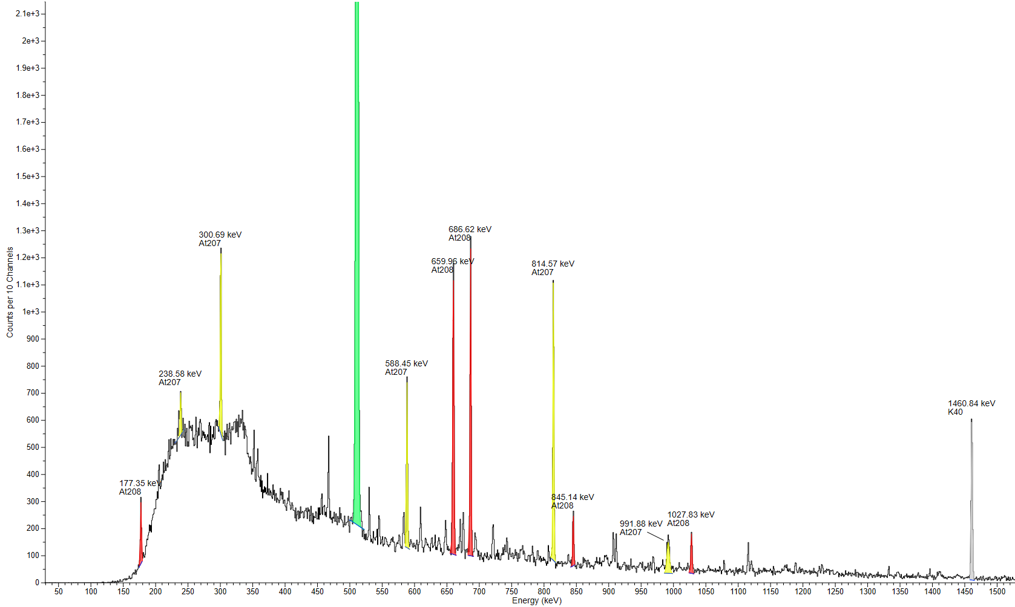
Fig. 1: Representative gamma spectrum of isotopes from the Recoil Chamber transported through a 10m-long PTFE capillary directly to a charcoal filter using He gas flow. The green peak represents the annihilation peak at 511 keV.

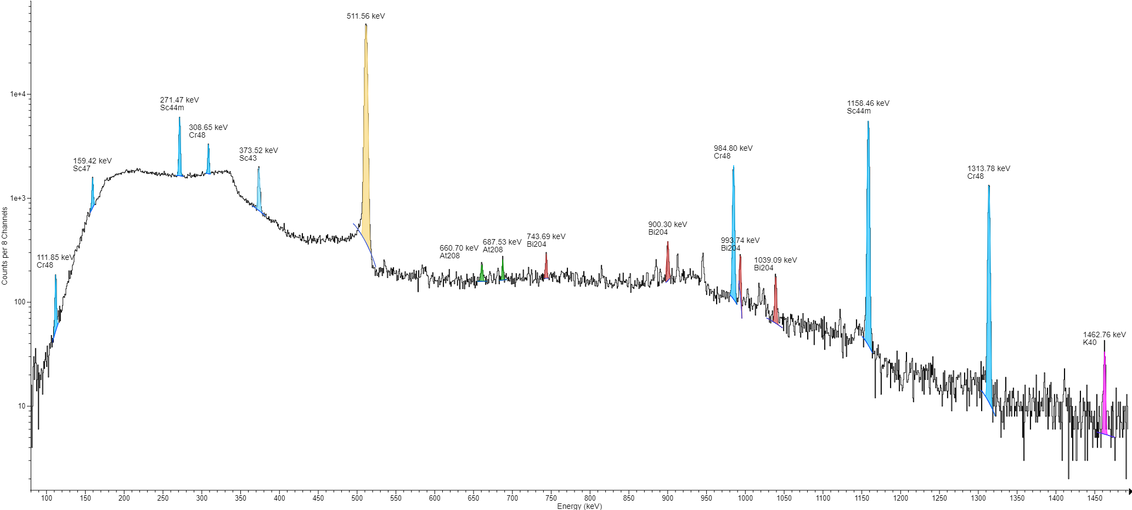
Fig. 2: Representative gamma spectrum of a titanium catcher foil after successfully heating out of astatine at 400 °C for ~1 h. A small amount of astatine remains deposited inside the catcher.

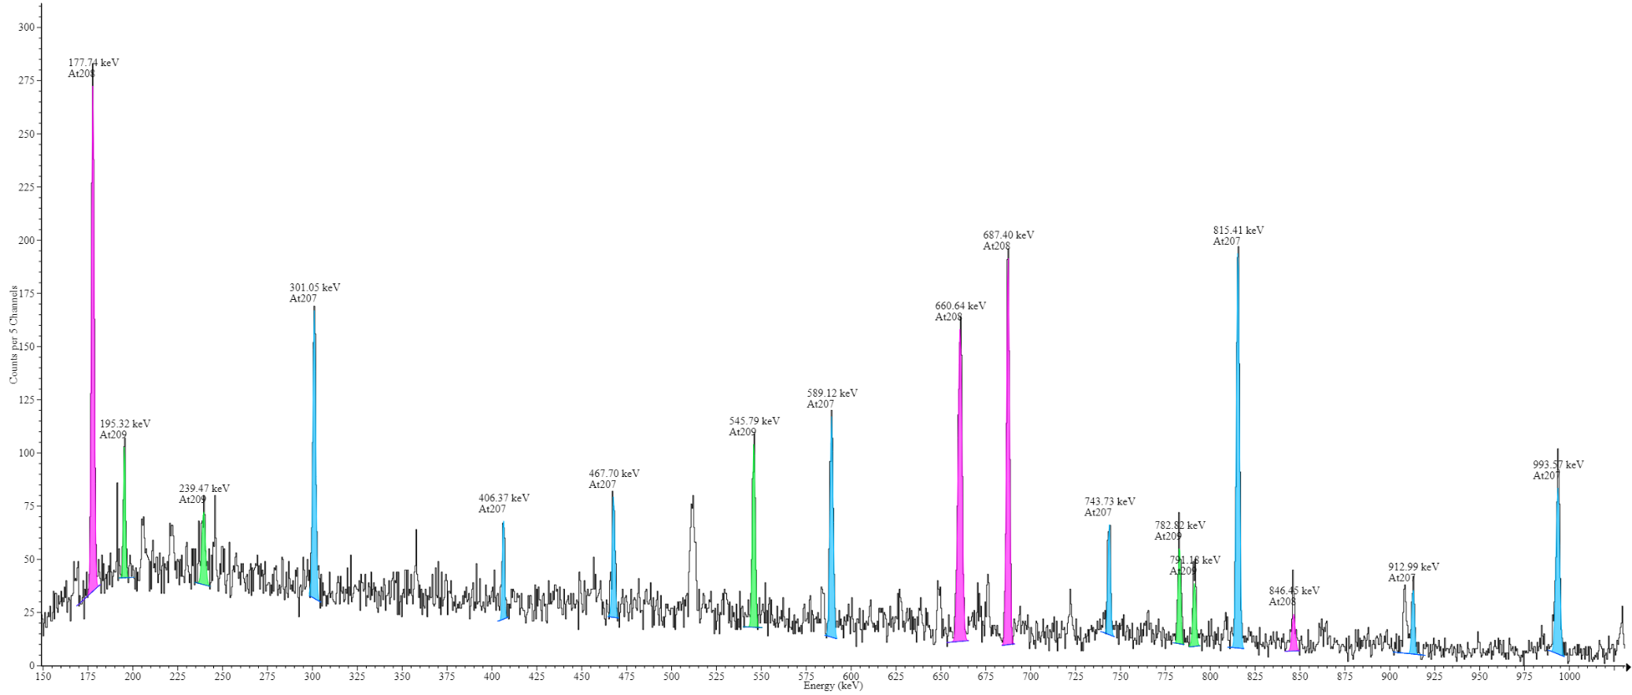
Fig. 3: Representative gamma spectrum of astatine trapped inside the charcoal filter after evaporating from the catcher foil and passing the quartz column.

