Supplementary data
Table S1 SEM-EDX analysis of Ag content (relative values normalized to Si) for pristine zeolite samples and after heat treatment under various atmospheres
Sample | Pristine | Inert | Reducing | Oxidizing
GemVax | 11 | 13 | 13 | 17
AgX | 214 | 106 | 130 | 72
AgR | 27 | 10 | 29 | 17
Note: Ag contents are expressed as relative values normalized to Si. Due to the rough surface morphology and low Ag content in some samples, an uncertainty of at least 15% should be considered.
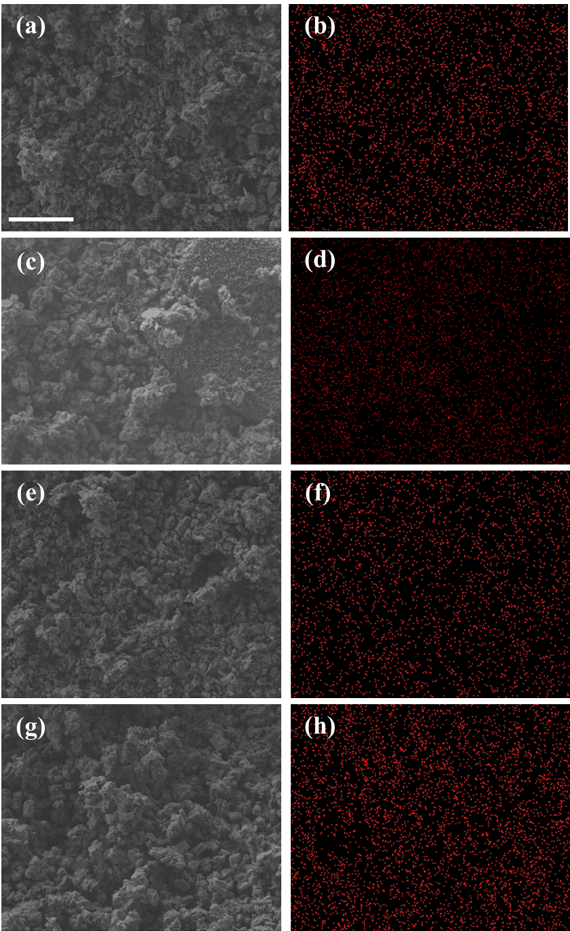
Fig. S1 SEM images and Ag distribution on GemVax samples: (a) & (b) pristine sample, (c) & (d) heated in inert condition, (e) & (f) heated in reducing condition, (g) & (h) heated in oxidizing condition. The bar visible in (a) indicates a scale of 10 μm valid for all the SEM/EDX image
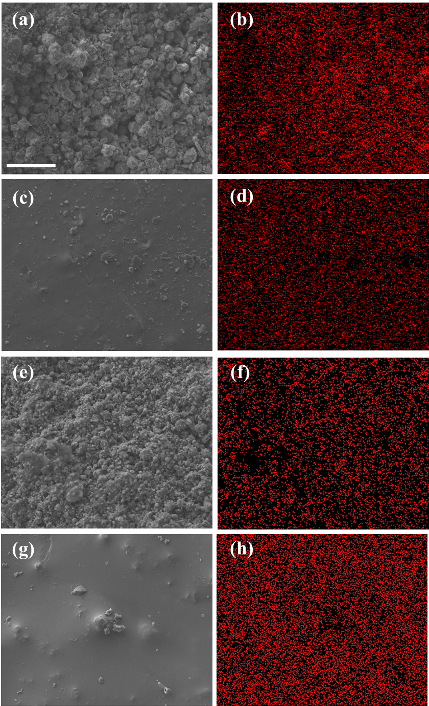
Fig. S2 SEM images and Ag distribution on AgX samples: (a) & (b) pristine sample, (c) & (d) heated in inert condition, (e) & (f) heated in reducing condition, (g) & (h) heated in oxidizing condition. The bar visible in (a) indicates a scale of 10 μm valid for all the SEM image
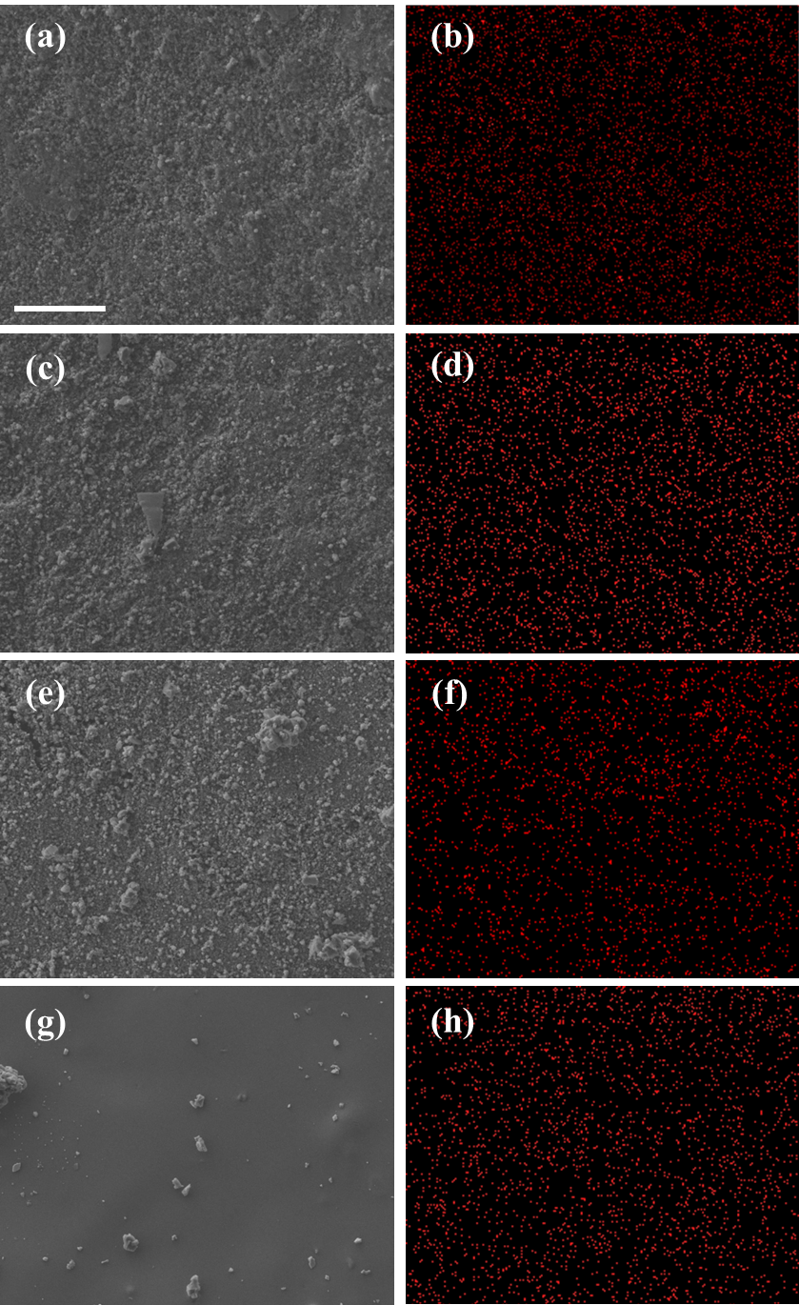
Fig. S3 SEM images and Ag distribution on AgR samples: (a) & (b) pristine sample, (c) & (d) heated in inert condition, (e) & (f) heated in reducing condition, (g) & (h) heated in oxidizing condition. The bar visible in (a) indicates a scale of 10 μm valid for all the SEM image

