Supplementary information

“Mechanisms for texture in BaTiO₃ thin films from aqueous chemical solution deposition”
Kristine Bakken¹, Anders Bank Blichfeld¹, Dmitry Chernyshov², Tor Grande¹, Julia Glaum¹, Mari-Ann Einarsrud¹
1 Department of Materials Science and Engineering, NTNU Norwegian University of Science and Technology, Trondheim, Norway
2 Swiss-Norwegian Beamlines, European Synchrotron Radiation Facility, Grenoble, France
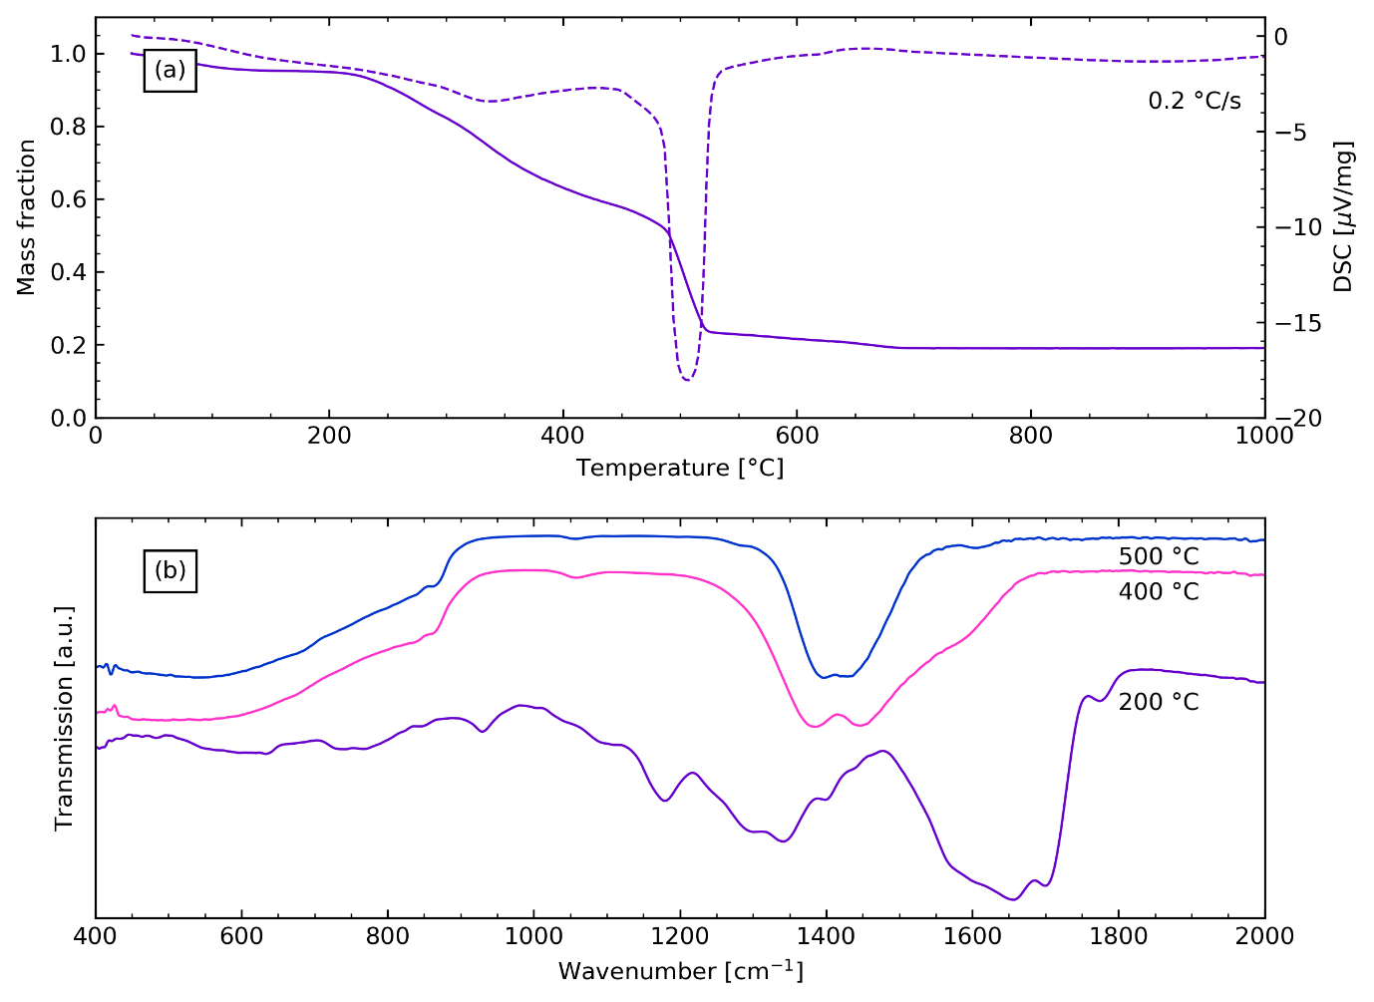
Fig. S1: (a) Thermogravimetric profile of amorphous precursor BaTiO₃ powder from the same precursor solution as used for thin film fabrication (0.26M), showing the main mass loss occurring around 500 °C. (b) Infrared spectra of the amorphous BaTiO₃ precursor powder, from the same precursor solution as used for thin film fabrication, dried (200 °C) and annealed at 400 °C and 500 °C. The IR spectra show that no carbonate phases are present in the dried powder, but form during decomposition of the precursors, and that no significant changes in the IR spectra occur in the temperature range 400-500 °C.

