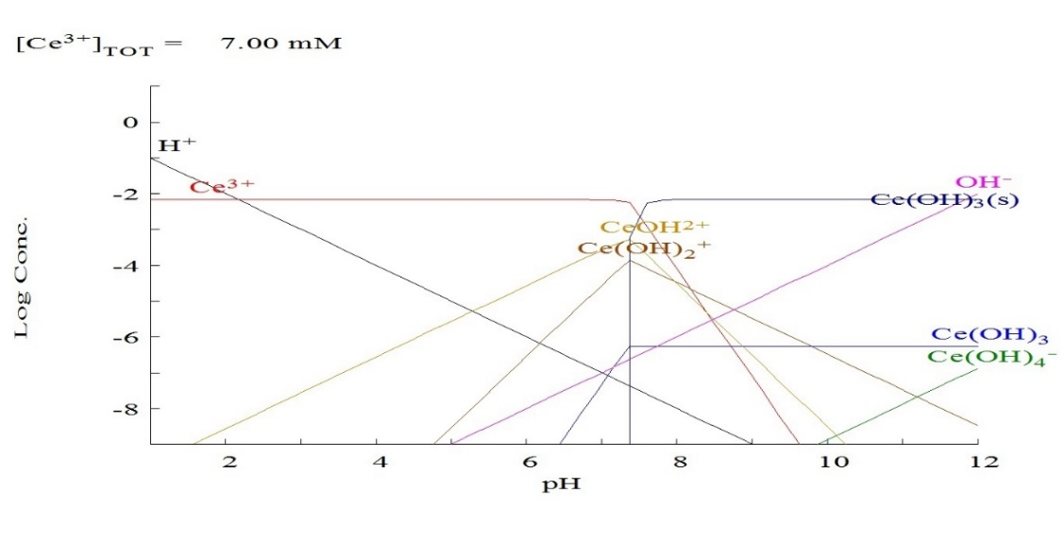

Figure S1: Distribution of REEs (represented as Ce³⁺) species at pH 1 to 12. According to the Hydra and Medusa software, 1000 mg/L Ce³⁺.

Figure S2: Graphical determination of point of zero care (pHzpc) for the magnesium fluoride surface.

Figure S3: Nonlinear pseudo-first-order model (PFOM) (red curve) and pseudo-second-order model (PFSOM) (blue curve) for REEs adsorption onto magnesium fluoride.
Figure S4: Nonlinear Langmuir model (blue curve) and Freundlich model (red curve) for REEs adsorption onto magnesium fluoride.

Table S1: Chemical compositions of total rare earth elements sourced from NMA.
REEs Elements | Concentration mg/L
La | 182625
Ce | 222109.6
Pr | 67414.4
Nd | 55430.6
Sm | 7285.2
Eu | 327.8
Gd | 2267.4
Tb | 497.6
Dy | 1119
Ho | 26
Er | 172.8
Tm | --
Yb | 48.6
Lu | 3.6
Sc | 11.2
Y | 2783.4

Table S2: Mediterranean Sea sample analysis (major constituents).
Element | Concentration mg/l
Mg | 1500
Ca | 492
K | 920
Na | 1022

Table S3: Interference findings of REEs separation over MgF₂ at pH 1 (ion exchange mechanism) and at pH 4 (adsorption mechanisms).
Interfering ion | pH 1 (Exchange) |  |  | pH 4 (Exchange)
Interfering ion | REEs uptake |  | REEs % | REEs uptake |  | REEs %
Interfering ion | Uptake decline | Uptake decline % | REEs % | Uptake decline | Uptake decline % | REEs %
Na | 301 | 0. 46 | 75.25 | 301 | 0.46 | 75.25
K | 300.5 | 0.79 | 75.15 | 302 | 0.13 | 75.5
Ba | 299.5 | 0.96 | 74.8 | 300 | 0.8 | 75
Al | 300.9 | 0.49 | 75.2 | 261 | 13.7 | 65.2
Fe | 300.4 | 0.78 | 75.1 | 254 | 14.7 | 63.5
Zn | 301.2 | 0.39 | 75.3 | 295 | 2.45 | 73.7
Cu | 302 | 0.13 | 75.5 | 301 | 0.48 | 75.25
Sn | 301.6 | 0.26 | 75.4 | 298 | 1.45 | 75.4
All finding were calculated relative to optimum REEs saturation capacity of 302.4 mgg⁻¹ and optimum REEs % is 75.6%.

Table S4: Nonlinear constants and parameters for PFOM and PSOM of REEs adsorption onto magnesium fluoride.
Kinetic model | q_{max} mg.g⁻¹ | R² | Order constant
Pseudo First order | 387.7 | 0.96 | K₁ =0.0009
Pseudo second order | 314.9 | 0.979 | K₂ =0.0667

Table S5: Nonlinear constants and parameters for the Langmuir and Freundlich model of REEs adsorption onto magnesium fluoride.
Isotherm model | q_{max} | R² | Model constant
Langmuir model | 397 | 0.73 | K_{L} =0.0114
Freundlich model |  | 0.888 | K_{F} =41.8, n⁻¹=0.35

Table S6. Several second-group fluoride saturation capacities for REEs at pH 4.
q_{e} | REE% | Second group
302.4 | 75.6 | MgF₂
285.5 | 71.4 | CaF₂
229.1 | 57.5 | BaF₂
190.8 | 47.7 | SrF₂

Table S7: Comparison of MgF₂ with different materials for REEs separation.
Materials | REEs uptake mgg⁻¹
intercalated cellulose nanocomposite | 300
barite-gypsum composite | 168.05
activated talc | 68
Phosphogypsum | 357
composite hybrid nanomaterials | 139.09
two-dimensional titanium carbide nanosheets | 229.85 and 175.83
Poly(acrylic acid–co-acrylamide/16, 16-dimethylheptadecan-1-amine) Composite | 182.1

