ONLINE RESOURCES
Synthesis of MgAl₂O₄ by Sol-Gel Method and Investigation of Catalytic Performances in CO₂ Methanation
Duygu Yeşiltepe-Özçelik^{1,2}*, Utku Burgun^{3,4}, Faruk Kaya¹, Emircan Uysal¹, Bora Derin¹, Andreas Schaefer^{5,6}, Per-Anders Carlsson^{5,6}, Gamze Gümüşlü-Gür^{3,4}, Alper Sarıoğlan^{3,4}, Sebahattin Gürmen¹

¹ Department of Metallurgical and Materials Engineering, Istanbul Technical University, 34469, Istanbul, Turkey
² Department of Mechanical Engineering, Osmaniye Korkut Ata University, 80000, Osmaniye, Turkey
³ Department of Chemical Engineering, Istanbul Technical University, 34469, Istanbul, Turkey
⁴ ITU Synthetic Fuels and Chemicals Technology Center, ITU-SENTEK, Istanbul Technical University, 34469, Istanbul, Turkey
⁵ Department of Chemistry and Chemical Engineering, Chalmers University of Technology, Kemigården 4, 41296, Gothenburg, Sweden
⁶ Competence Centre for Catalysis, Chalmers University of Technology, Kemigården 4, 41296, Gothenburg, Sweden
*Corresponding author: yesiltepe15@itu.edu.tr

Fig. S1 TGA-DTG curves of the uncalcined MA support under air atmosphere.
Fig. S2 XRD analysis results between 2theta=30-90º of the spent NiCo-MA catalysts plus SiO₂ mixture. NiCo700spent (black curve), NiCo800spent (red curve), and NiCo900spent (blue curve).

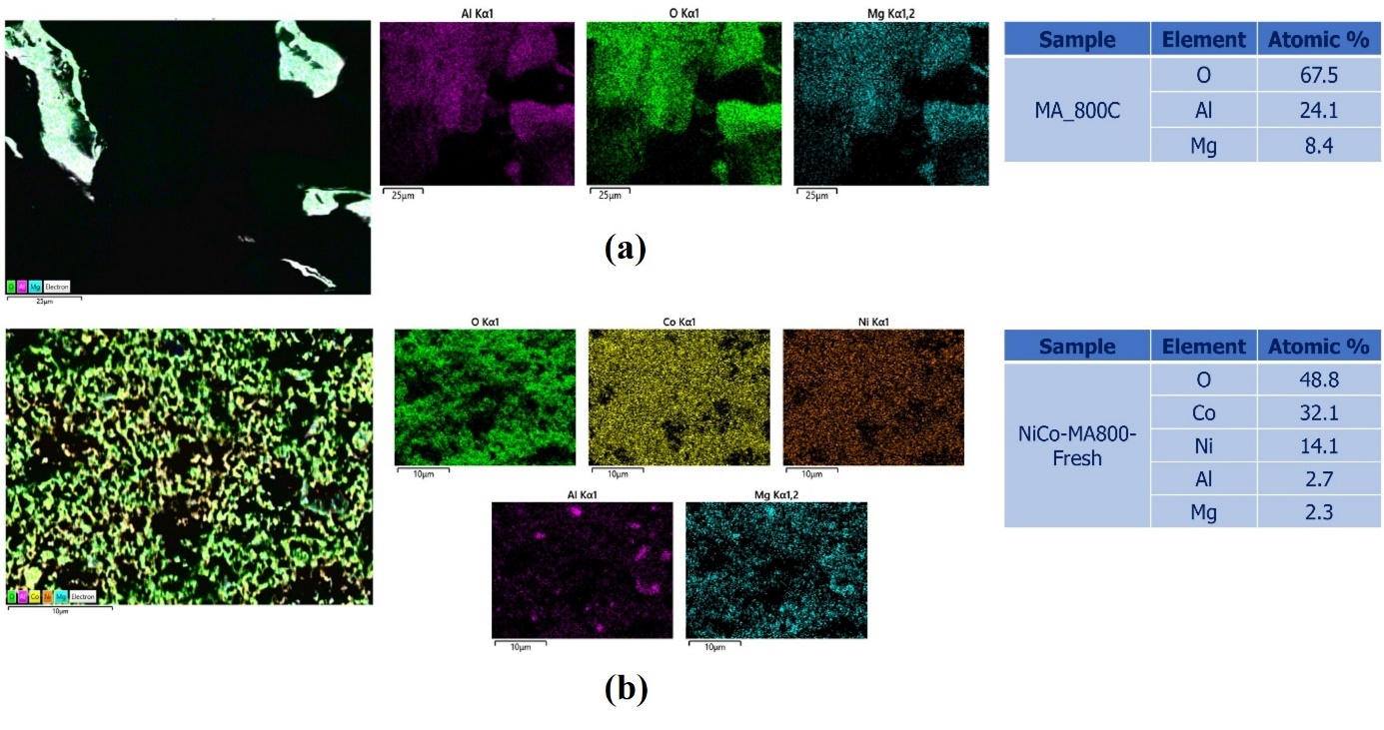
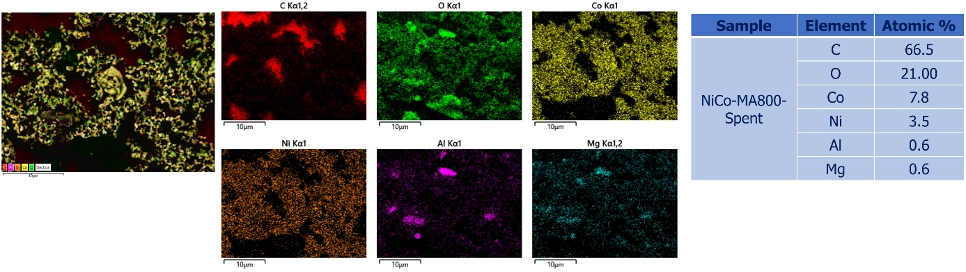
(c)
Fig. S3 EDS analysis results and X-ray mapping (a) MA calcined at 800 °C, (b) NiCo-MA-800 fresh catalyst, (c) NiCo-MA-800 spent catalyst.

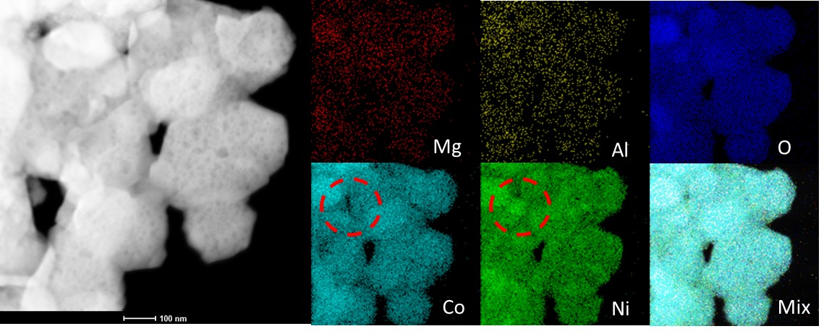
Fig. S4 TEM-EDS mapping results of the NiCo-MA-800 fresh catalyst. The red circles indicate a region where Co and Ni signals exhibit locally increased intensity, suggesting potential metal segregation or particle aggregation in that specific area.

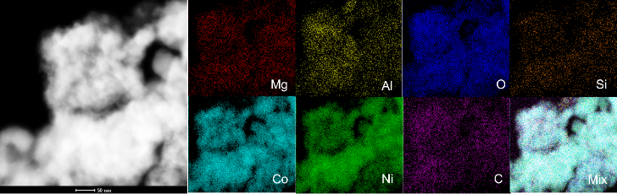
Fig. S5 TEM-EDS mapping results of the NiCo-MA-800 spent catalyst.

