Supplementary Information

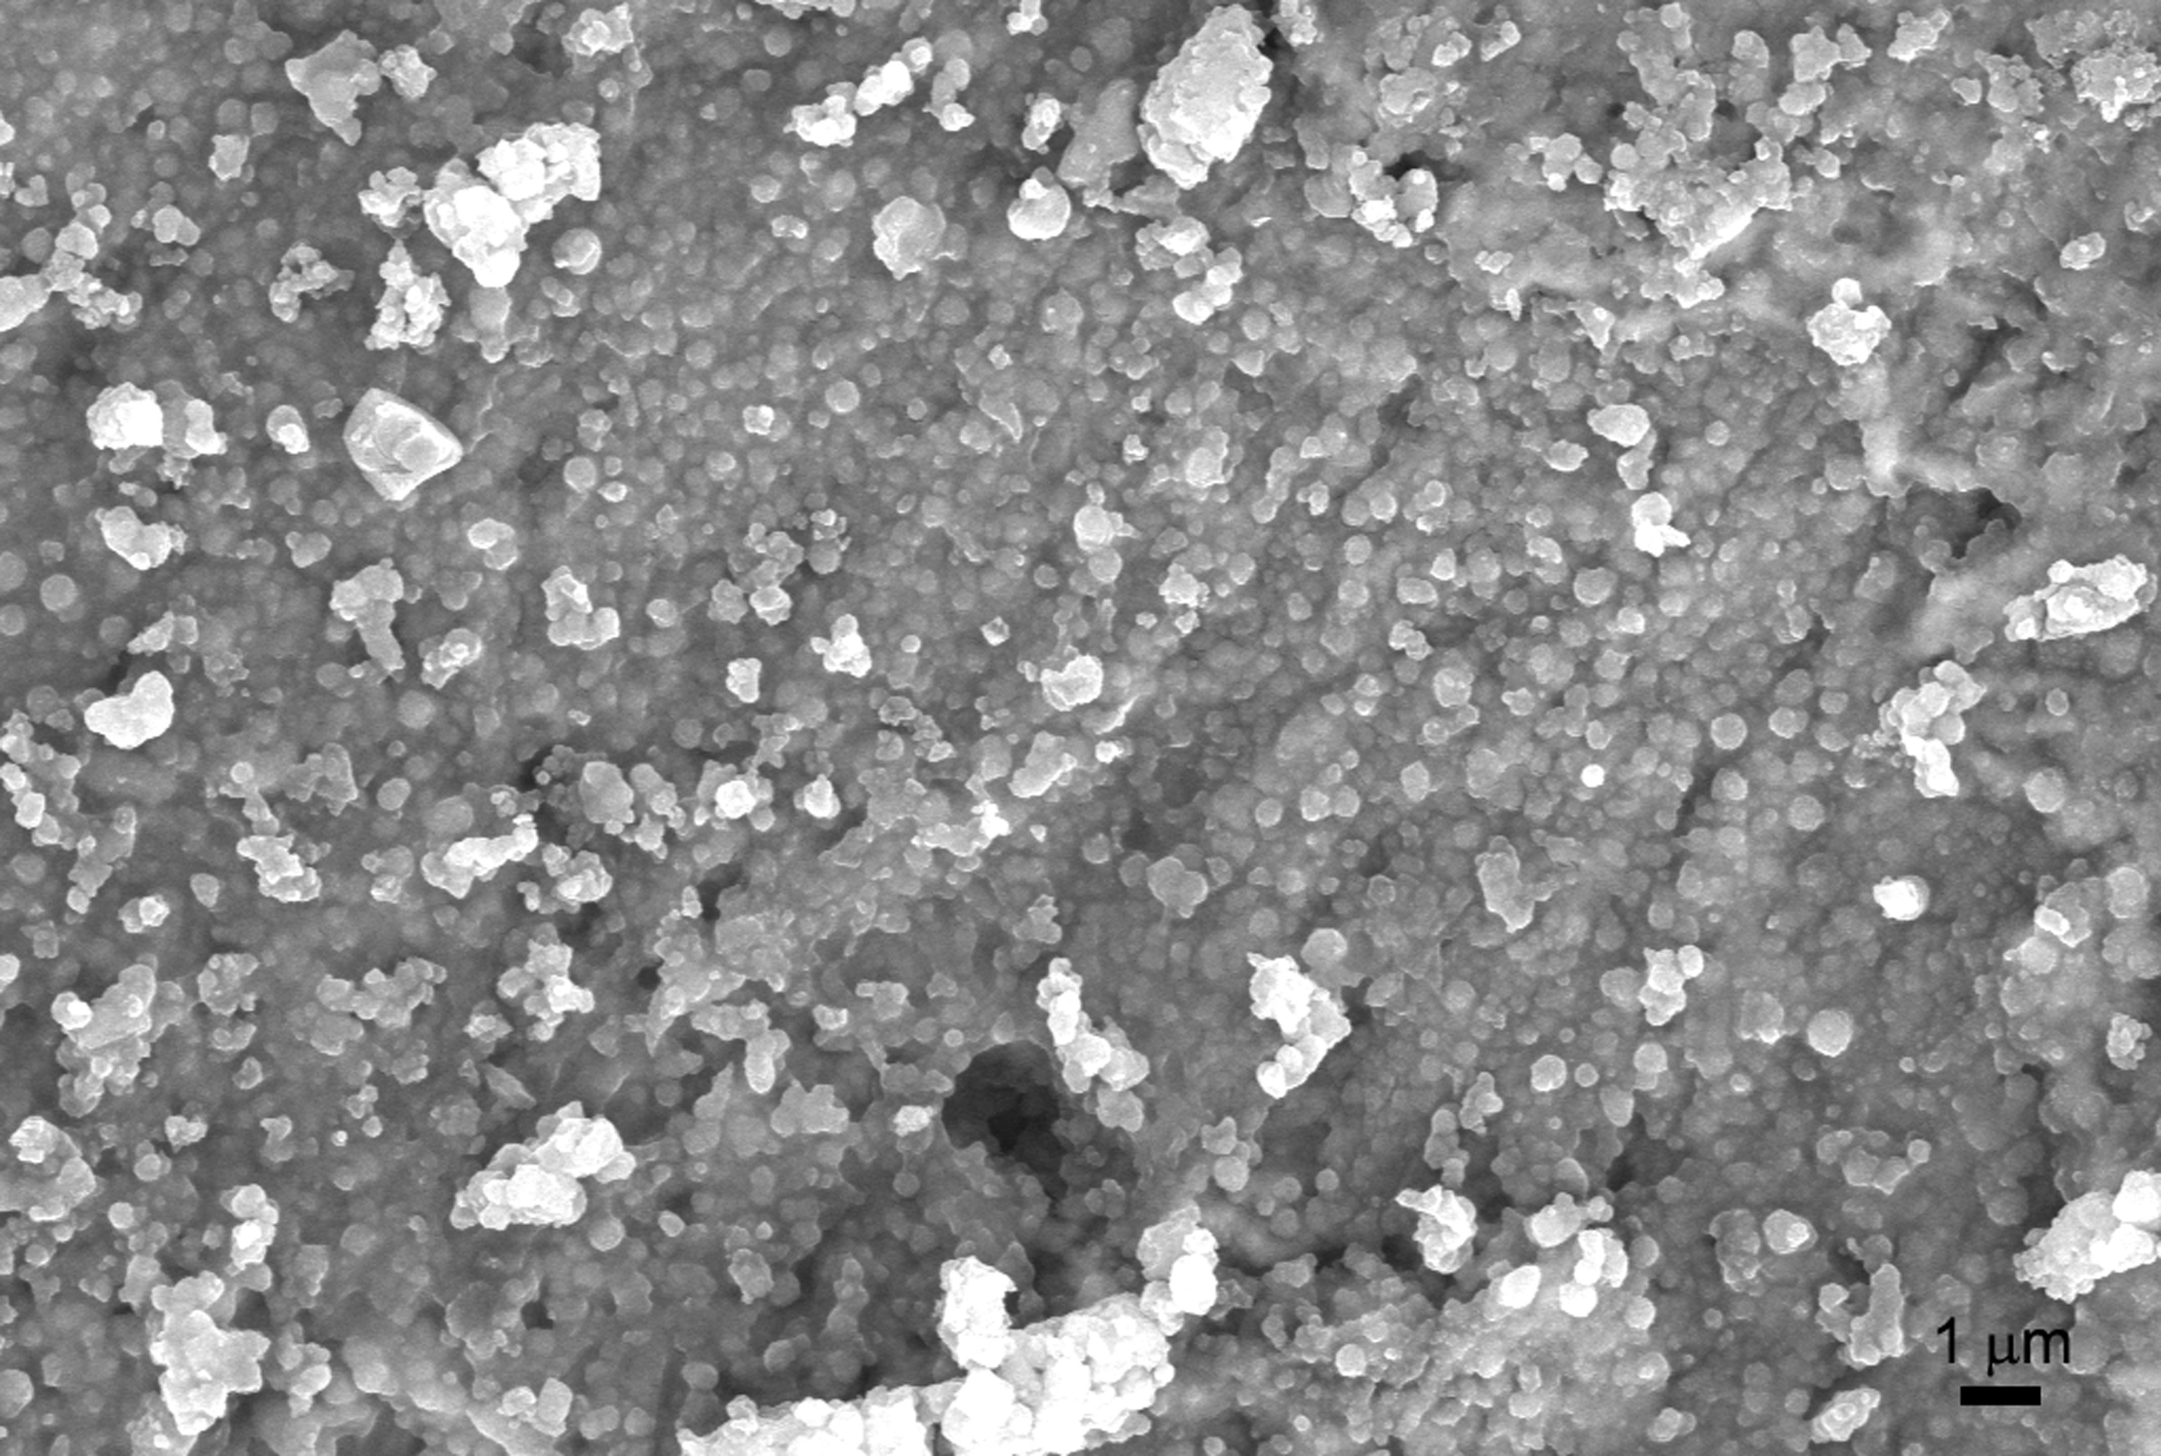
(a)
(b)
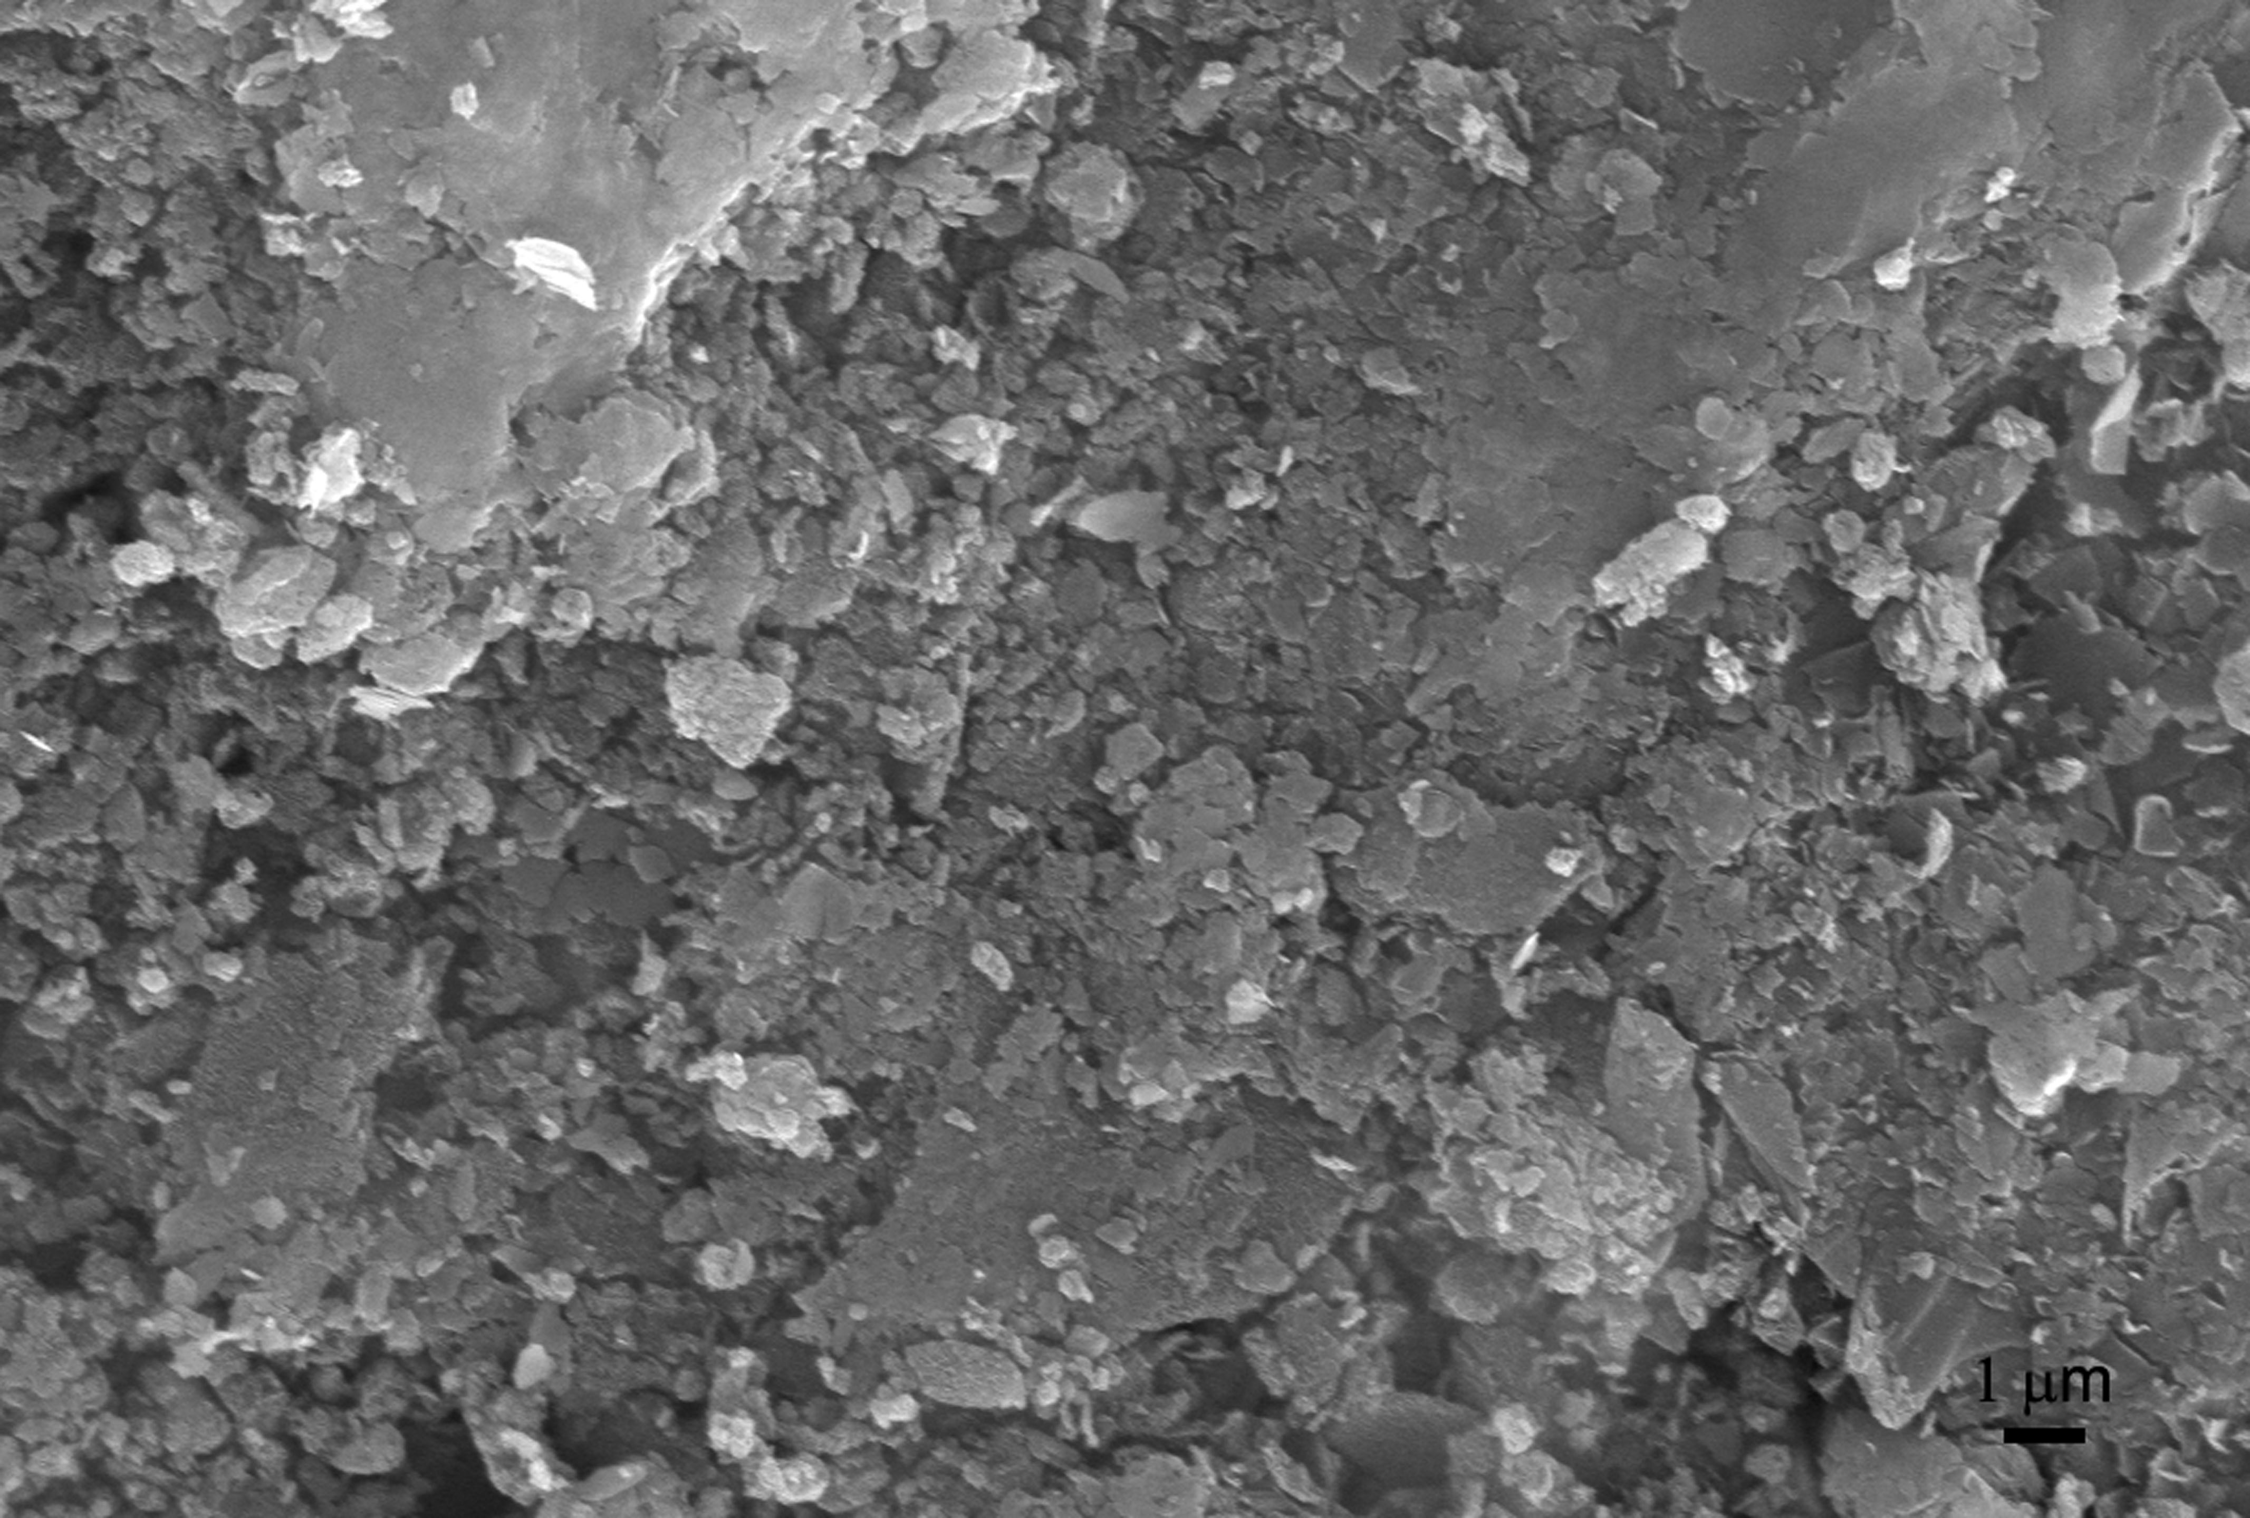
Fig. S1 FESEM images of (a) GO and silane (GS) coated and (b) GO, zirconia and silane (GZS) coated carbon steel samples.

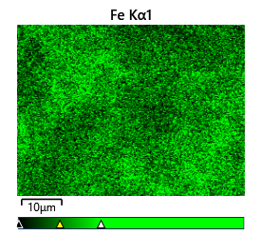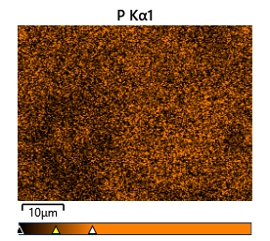

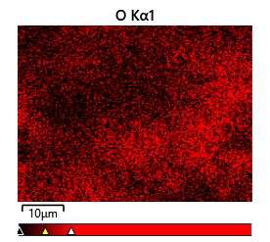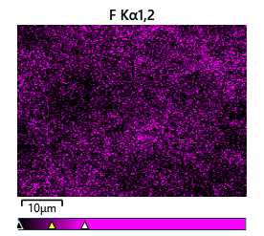

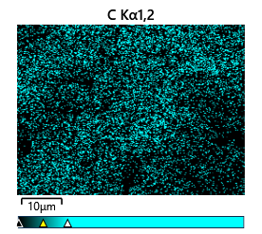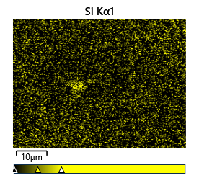

Fig. S2 EDS mapping of GS coated sample indicating different elements present on the surface.

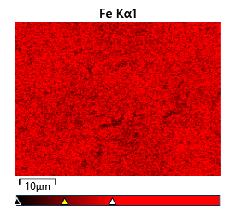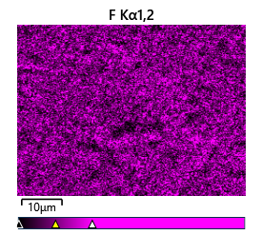

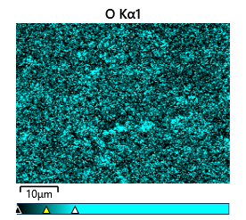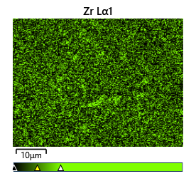

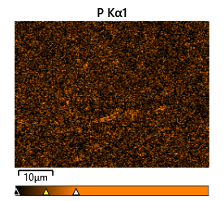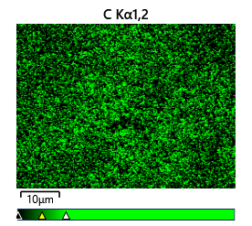

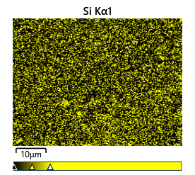

Fig. S3 EDS mapping of GZS coated sample indicating different elements present on the surface.

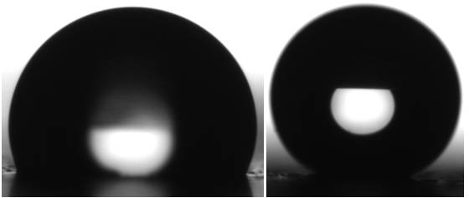
(b)
(a)

Fig. S4 Water contact angle images recorded on (a) bare and (b) GZS coated SHP carbon steel samples.
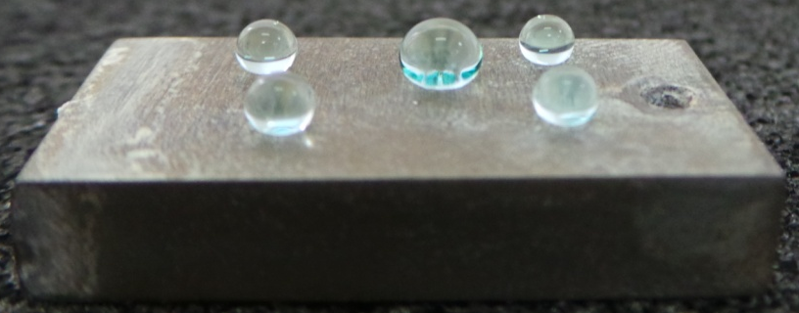
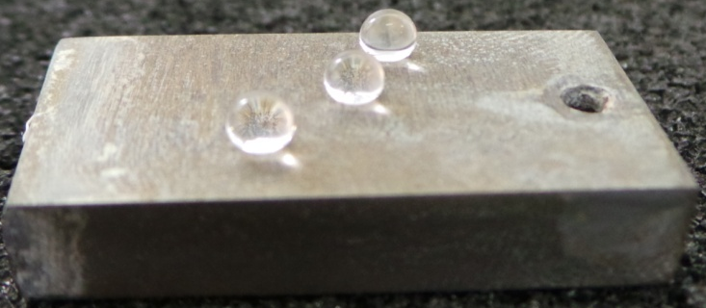
(b)
(a)
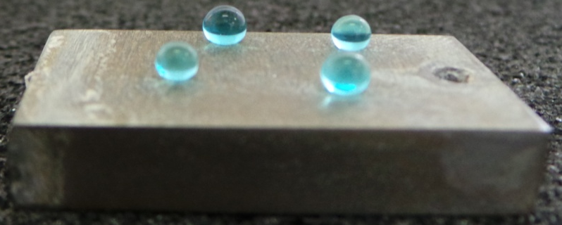
(c)

Fig. S5 Photographs showing the colored water droplets forming beads on the GZS coated SHP carbon steel samples.
Video 1 Self-cleaning property of the GZS SHP coated carbon steel sample with myristic acid as dirt particles.

Video 2 Self-cleaning property of the GZS SHP coated carbon steel sample with graphite flakes as dirt particles.

Table S1. Comparison of the GZS superhydrophobic coating on carbon steel surface with other similar coatings reported in the literature

S. No. | Substrate | Coating | Water Contact Angle | Corrosion Studies | Biofouling Studies | References
1 | Carbon Steel | GO, ZrO₂ and silane | 169±1° | 3.5 % NaCl | Pseudomonas sp. and Bacillus sp. | Present study
2 | Mild Steel | GO functionalized with APTES and GPTMS – epoxy composite | - | 3.5 % NaCl | - | 1
3 | AZ31B Mg alloy | GO, silane (a mixture of BTESPT and OTMS) | 140° | 3.5 % NaCl | - | 2
4 | Steel | PDMS-GO-epoxy | 127.8±1° | NaCl solution | Pseudomonas sp. | 3
5 | Al alloy | LDH-GO/DTMS composite coating by electrophoretic deposition | 155 ± 2.0° | 3.5 % NaCl | Anti-biofouling studies in BSA | 4
6 | AZ91 Mg alloy | GPTMS/GO/FAS | 110.4° | 3.5 % NaCl | - | 5
7 | Al alloy | silane/graphene oxide (GO) composite coating | 151° | 1 M NaCl solution | - | 6

References:

1. Pourhashem, S., Vaezia, M.R., Rashidi, A., Bagherzadeh, M.R. (2017) Distinctive roles of silane coupling agents on the corrosion inhibition performance of graphene oxide in epoxy coatings. Prog Org Coat 111:47-56.
2. Wang, Y., Yin, M., Bao, H., Zhao, X., Cheng, G., Yuan, N., Ding, J. (2024) Superior corrosion and wear-resistance of graphene oxide with the aid of composite silanes. Mater Today Commun 39:108635.
3. Zhou, Z., Seif, A., Pourhashem, S., Duan, J., Rashidi, A., Silvestrelli, P.L., Ji, X., Mirzaee, M., Hou, B. (2023) Multi-treatments based on polydimethylsiloxane and metal-organic framework wrapped with graphene oxide for achieving long-term corrosion and fouling protection: experimental and density functional theory aspects. Constr Build Mater 384:131229.
4. He, Z., Cao, H., Zhou, M., Jia, W., Shen, X., Min, Y., Xu, Q. (2022) Superior corrosion resistance and anti-biofouling performance via electrodeposited graphene oxide/silane composite coating with special wettability. Surf Coat Technol 449:128952.
5. Tabish, M., Malik, M.U., Abubaker Khan, M., Anjum, M.J., Muhammad, N., Ahmad, A., Ibraheem, S., Kumar, A., Nguyen, T.A., Yasin, G. (2022) Boosting the hydrophobicity and mechanical properties of fluoroalkylsilane hydrolyzed 3-glycidyloxypropyl/graphene oxide-based nanocomposite coating for enhanced corrosion resistance. Thin Solid Films 756:139373.
6. Du, X.Q., Liu, Y.W., Chen, Y. (2021) Enhancing the corrosion resistance of aluminum by superhydrophobic silane/graphene oxide coating. Appl Phys A 127:580.

