Supporting Information
Sol-gel engineered diffusion-type nickel cobaltite hollow fibrous electrode for high-capacity hybrid supercapacitors
Mohammed Kuku^{a,c}, and Mohammad Arishi^{b,c}*
ªDepartment of Mechanical Engineering, College of Engineering and Computer Sciences, Jazan University, Jazan 45142, Saudi Arabia
^{b} Department of Chemical Engineering, College of Engineering and Computer Sciences, Jazan University, Jazan 45142, Saudi Arabia
^{c}Engineering and Technology Research Center, Jazan University, P.O.Box 114, Jazan 82817, Saudi Arabia

Corresponding author: maarishi@jazanu.edu.sa

Physical Characterization: Scanning electron microscopy (SEM, ZEISS Sigma 500, field emission scanning electron microscope) equipped with Energy -dispersive X-ray spectroscopy (EDX) mapping was used to examine the morphology and elemental composition of the microstructure. X-ray diffraction (XRD, Malvern Panalytical Aeris X-ray diffractometer) analysis was performed to assess the crystalline properties of the prepared material. The surface area analysis of H-NiCo₂O₄ was investigated by Brunauer-Emmett-Teller (BET) analyzer (Micromeritics Instrument corporation, ASAP 2020)
Electrochemical measurements:
The electrochemical properties of the as-prepared hybrid electrodes were studied on a Biologic electrochemical analyzer using a beaker-based three-electrode cell system with an electrolyte solution of 1M KOH. The Ni foam coated with H-NiCo₂O₄ electrode was used as the working electrode, a platinum mesh and an Ag/AgCl electrode were used as the counter and reference electrode, orderly. The cyclic voltammetry tests were conducted in the voltage window of 0 to 0.6 V at different scan rates. The galvanostatic charge-discharge tests were carried out at different current densities within a potential range of 0 to 0.5 V. Electrochemical impedance spectroscopy was recorded at open-circuit voltage with 20 mV amplitude in a frequency range from 0.01 Hz to 100 kHz in a 1 M KOH. The specific capacitance of the electrode in three-electrode mode was calculated from the GCD curves according to the following equation.
C = $\frac{I×Δt}{m×ΔV}$
where C is the specific capacitance (F/g or F/cm²), I is the discharge current (A), ∆t is the discharge time (s), ΔV is the potential window (V), and m is the mass of the active material (g). The specific energy (E) and specific power (P) of the electrodes were calculated from the following equations:
E = $\frac{1×CV^{2}}{2×3.6}$;
P = $\frac{E}{Δt}$,
where E is the specific energy (Wh/kg), C is the specific capacitance (F/g), ΔV is the potential range (V), P is the specific power (W/kg) and Δt is the discharge time (s).
Coin-cell type asymmetric supercapacitor (ASC)
The device was assembled in a coin-cell using H-NiCo₂O₄ and commercial activated carbon composite was used as negative electrode. The negative electrode was prepared by casting a slurry of the electroactive material: activated carbon, carbon black and PVdF binder with a weight ratio of 8:1:1 in N-methyl-2-pyrrolidine (NMP) onto a nickel foam current collector and then the electrode was pressed and dried at 60 °C overnight. To assemble the cell, the negative electrode and positive electrode were placed face to face with a filter paper that was coated with PVA-KOH gel electrolyte.

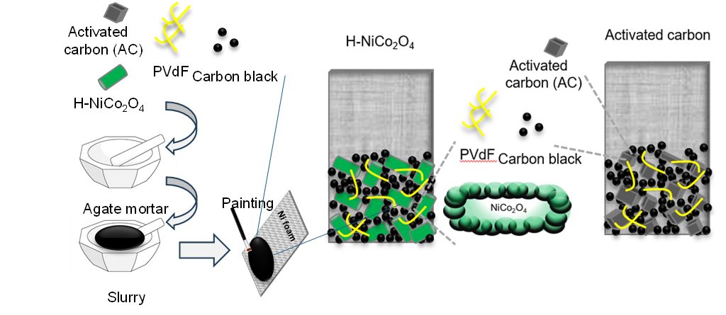
Figure S1. Preparation process of H-NiCo₂O₄ and AC electrodes using PVdF binder and carbon black as conductive additive. The mixture of these blends was made into slurry using few drops of N-methyl pyrrolidone and casted on Ni foam current collector.

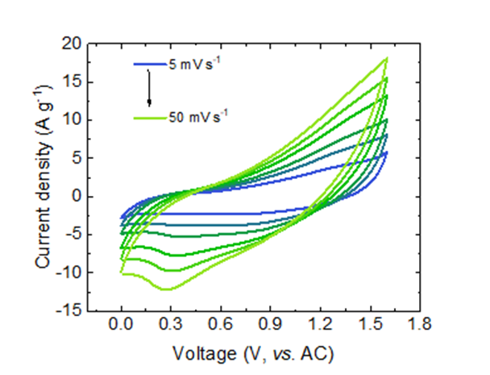
Figure S2. CV curves of HySC device at different scan rates of 5-50 mV s⁻¹.

Table S1. Specific energy storage performance and cycling stability of various mixed metal oxides (CuCo₂O₄, NiCo₂O₄ and ZnCo₂O₄) redox type electrodes with our hybrid nanoarchitecture.
Synthesis process | Nanostructured shape | Specific capacitance or capacity | Cycling stability | SI Ref.
Co-precipitation | Nanosheets | 291 F/g  (40.4 mAh/g) | No decay | [1]
Hydrothermal | Microsphere | 284 F/g  (∼37 mAh/g) | 75.6% (1000 cycles) | [2]
Dry synthesis | Nanoparticles with rhombohedral | 306.1 F/g | 96.1% (10000 cycles) | [3]
Hydrothermal | Nanoplates | 132 F/g | 86% (2000 cycles) | [4]
Room-temperature (RT) and heating process | Nanoflowers | 225 F/g  (31.2 mAh/g) | 88% (1000 cycles) | [5]
Sol-gel process | Nanoparticles | 243 F/g | 100% (5000 cycles) | [6]
Wet-chemical and annealing process | Hexagonal nanoplates | 105.8 mAh/g | No fading | [7]
Electrochemical deposition | Nanosheets | 290 and 250 F/g | 95% (1000 cycles) | [8]
Combustion method | Cauliflower-shaped nanostructures | 338 F/g (46.9 mAh/g) | 77% (1000 cycles) | [9]
Solvothermal | Nanorods | 188 F/g | 93% (1000 cycles) | [10]
Sol-gel process | Porous crystals | 217 F/g | 96.3% (600 cycles) | [11]
Wet-chemical process | Hybrid nanostructures | 313.3 F/g (34.8 mAh/g) | 93.6% (8000 cycles) | [12]
Sol-gel process | Hollow fibers | 648.5 F g⁻¹ (383.9 C g⁻¹) | 85.6% after 7000 cycles | This work

SI Reference

[1] P. Liang, F. Wang, Z.-A. Hu, Controlled synthesis of ordered sandwich CuCo2O4/reduced graphene oxide composites via layer-by-layer heteroassembly for high-performance supercapacitors, Chemical Engineering Journal 350 (2018) 627-636.
[2] S.K. Hussain, J.S. Yu, HMTA-assisted uniform cobalt ions activated copper oxide microspheres with enhanced electrochemical performance for pseudocapacitors, Electrochimica Acta 258 (2017) 388-395.
[3] M. Al-Aqeel, Liquid-free simple synthesis of nickel cobaltite nanostructures for high-performance supercapacitors and electrocatalyst applications, Journal of Solid State Electrochemistry (2025).
[4] T. Kim, A. Ramadoss, B. Saravanakumar, G.K. Veerasubramani, S.J. Kim, Synthesis and characterization of NiCo2O4 nanoplates as efficient electrode materials for electrochemical supercapacitors, Applied Surface Science 370 (2016) 452-458.
[5] A. Fathi, M. Eskandari, P.T. Antelo, E. Saievar-Iranizad, ZIF-derived Cu doped Co3O4/RGO composites for asymmetric supercapacitors, Solid State Sciences 132 (2022) 106967.
[6] M. Zhang, S. Guo, L. Zheng, G. Zhang, Z. Hao, L. Kang, Z.-H. Liu, Preparation of NiMn2O4 with large specific surface area from an epoxide-driven sol−gel process and its capacitance, Electrochimica Acta 87 (2013) 546-553.
[7] F. Semerci, H. Eşgin, Step-wise synthesis of mesoporous CuCo2O4@reduced graphene oxide composites for supercapacitor applications, Journal of Electroanalytical Chemistry 970 (2024) 118550.
[8] S. Sahoo, K.K. Naik, C.S. Rout, Electrodeposition of spinel MnCo2O4 nanosheets for supercapacitor applications, Nanotechnology 26(45) (2015) 455401.
[9] A. Pendashteh, M.S. Rahmanifar, R.B. Kaner, M.F. Mousavi, Facile synthesis of nanostructured CuCo2O4 as a novel electrode material for high-rate supercapacitors, Chemical Communications 50(16) (2014) 1972-1975.
[10] L. Ren, J. Chen, X. Wang, M. Zhi, J. Wu, X. Zhang, Facile synthesis of flower-like CoMn2O4 microspheres for electrochemical supercapacitors, RSC Advances 5(39) (2015) 30963-30969.
[11] Y.Q. Wu, X.Y. Chen, P.T. Ji, Q.Q. Zhou, Sol–gel approach for controllable synthesis and electrochemical properties of NiCo2O4 crystals as electrode materials for application in supercapacitors, Electrochimica Acta 56(22) (2011) 7517-7522.
[12] Al-Aqeel, M. Formation of hybrid nanoarchitectured CuCo₂O₄ as a binder-free redox-type electrode for high-rate performance supercapacitors. J Porous Mater 32, (2025), 2151–2162

