Supporting Information (SI):
Similarities and differences between tannin- and resorcinol-based carbon aerogels: nitrogen-doping, electrical conductivity, and performance in a Zn-based electrochemical cell
Jessica Kröner¹, Daniela Söllinger², Ann-Kathrin Koopmann², Christoph Thurner³, Simon Penner³, Michael S. Elsaesser², and Marina Schwan¹*
¹ Institute for Frontier Materials on Earth and in Space, German Aerospace Center, 51147 Cologne, Germany
² Chemistry and Physics of Materials, University of Salzburg, 5020 Salzburg, Austria
³ Institute of Physical Chemistry, University of Innsbruck, Innsbruck, Austria
* Corresponding author: Marina.Schwan@dlr.de

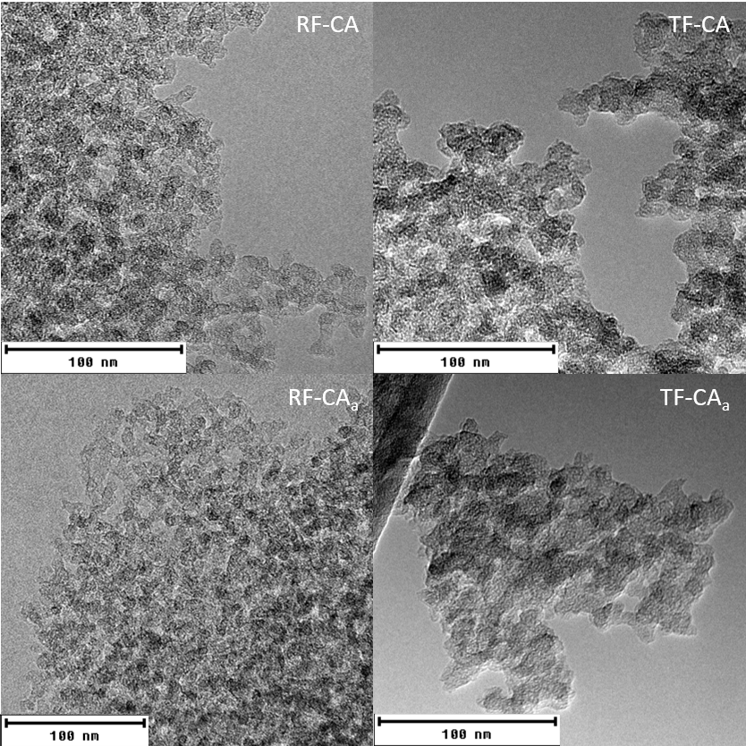
Figure S1: TEM images of RF-CA, RF-CA_{a}, TF-CA and TF-CA_{a}. The figure shows that RF-based carbon aerogels have much smaller particles than TF-based carbon aerogels. Furthermore, activation leads to a denser structure.
a)  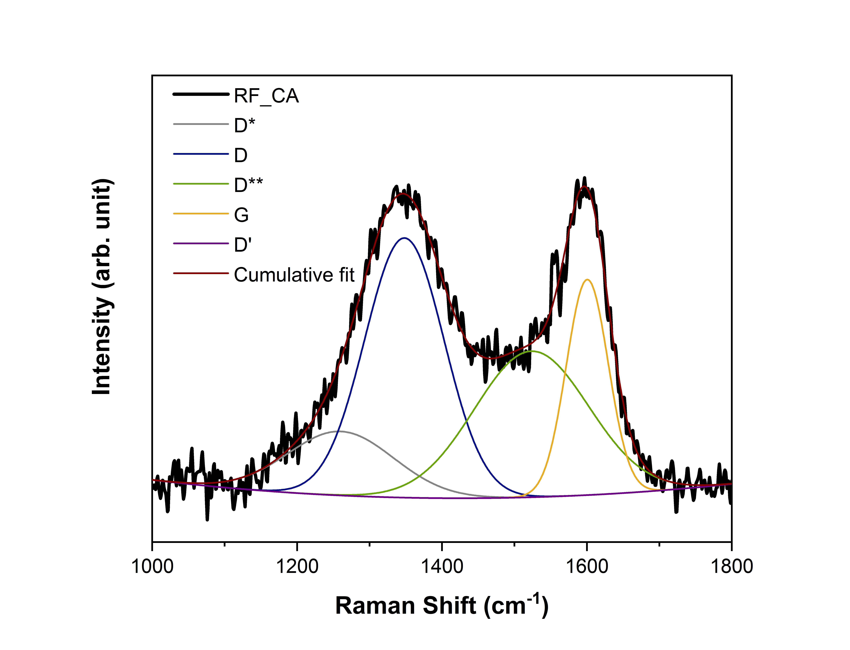 | b)  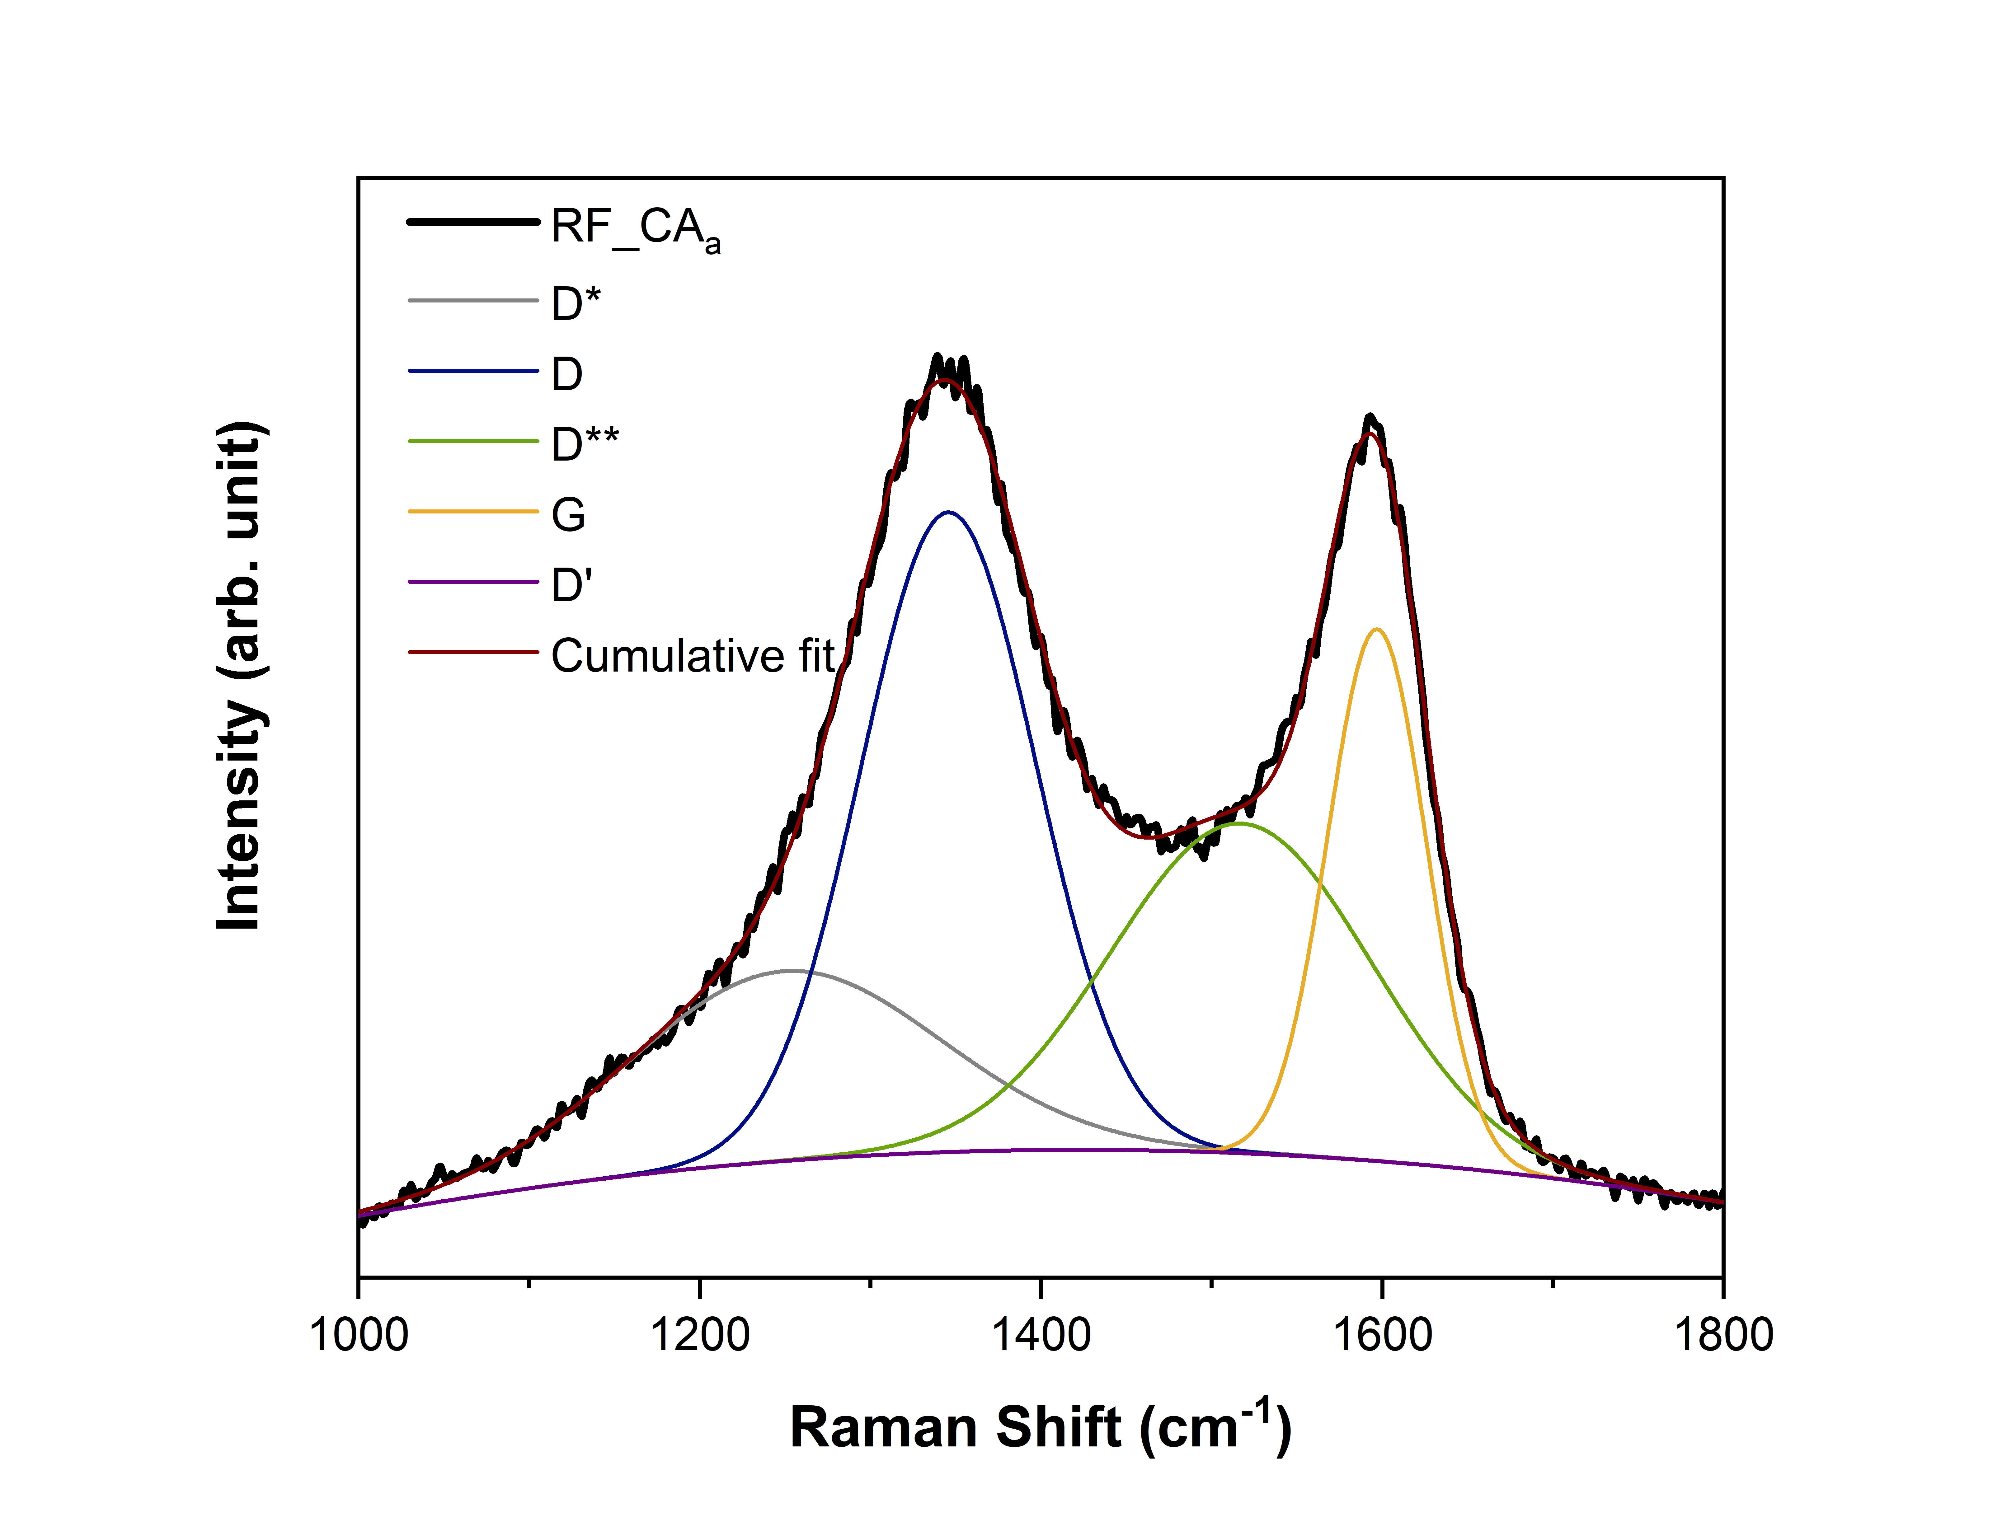
c)  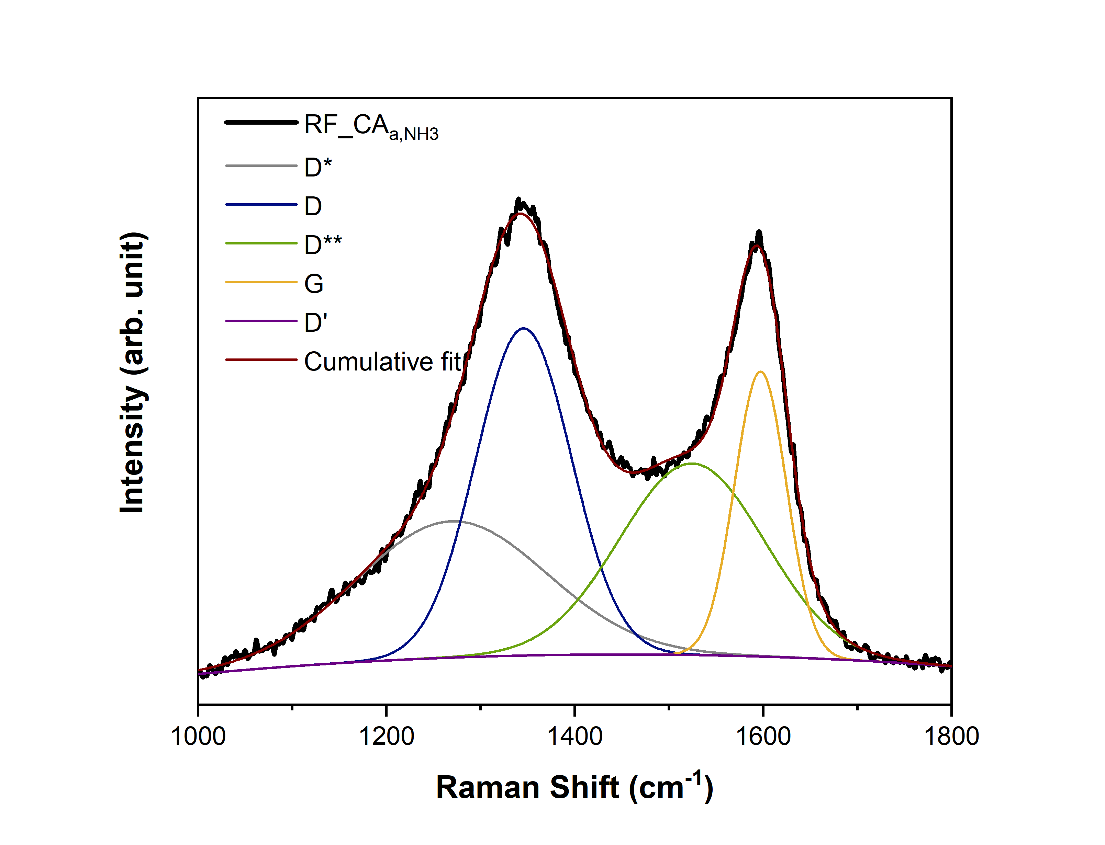 | d)  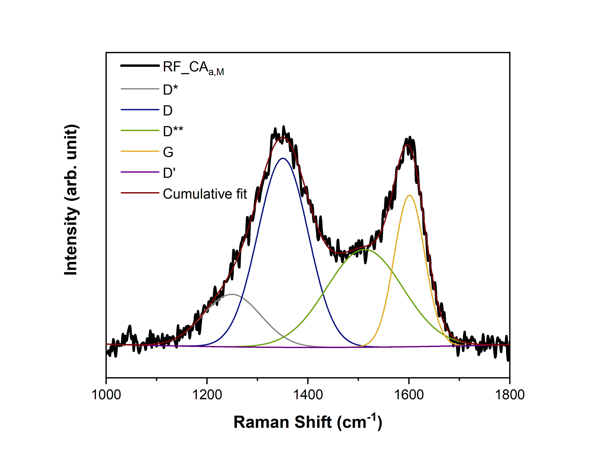
e)  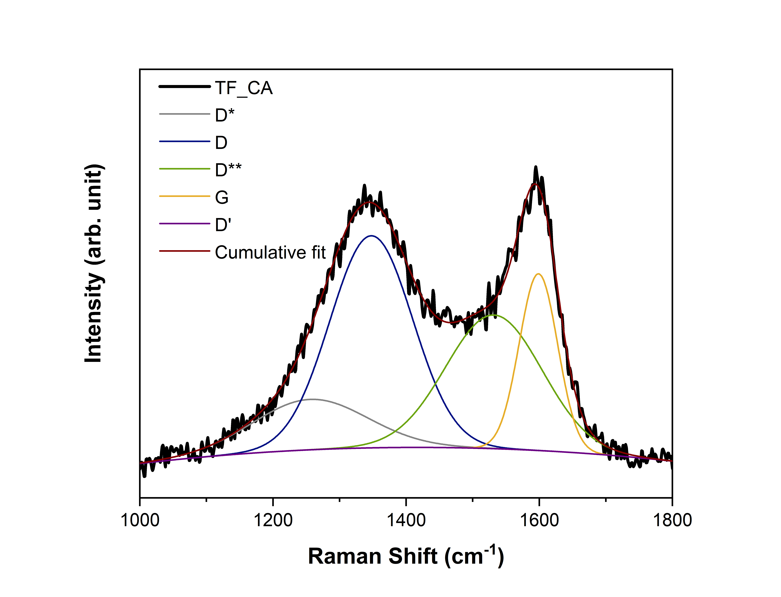 | f)  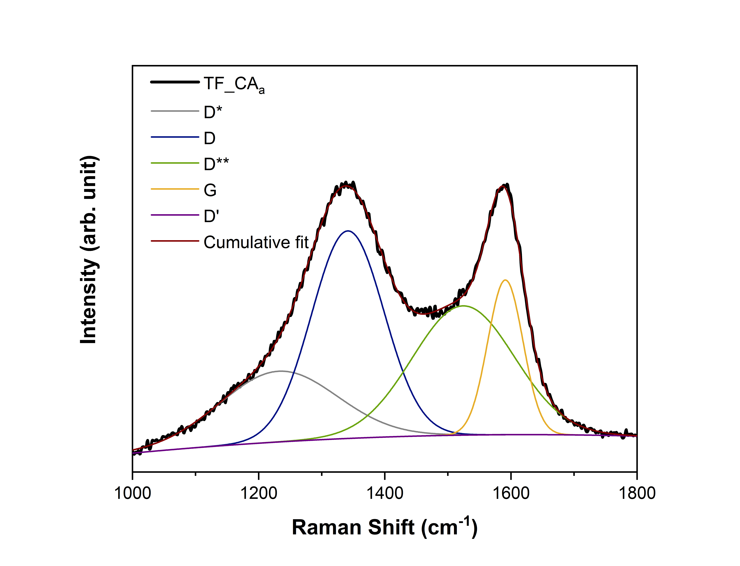
g)  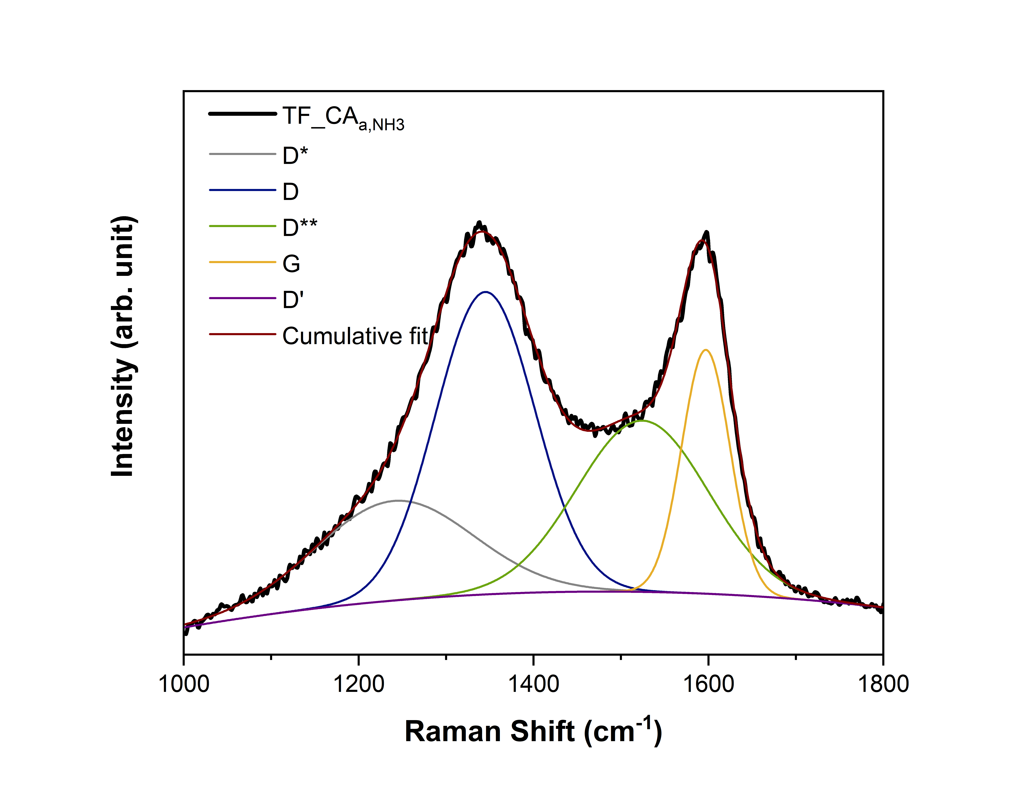 | h)  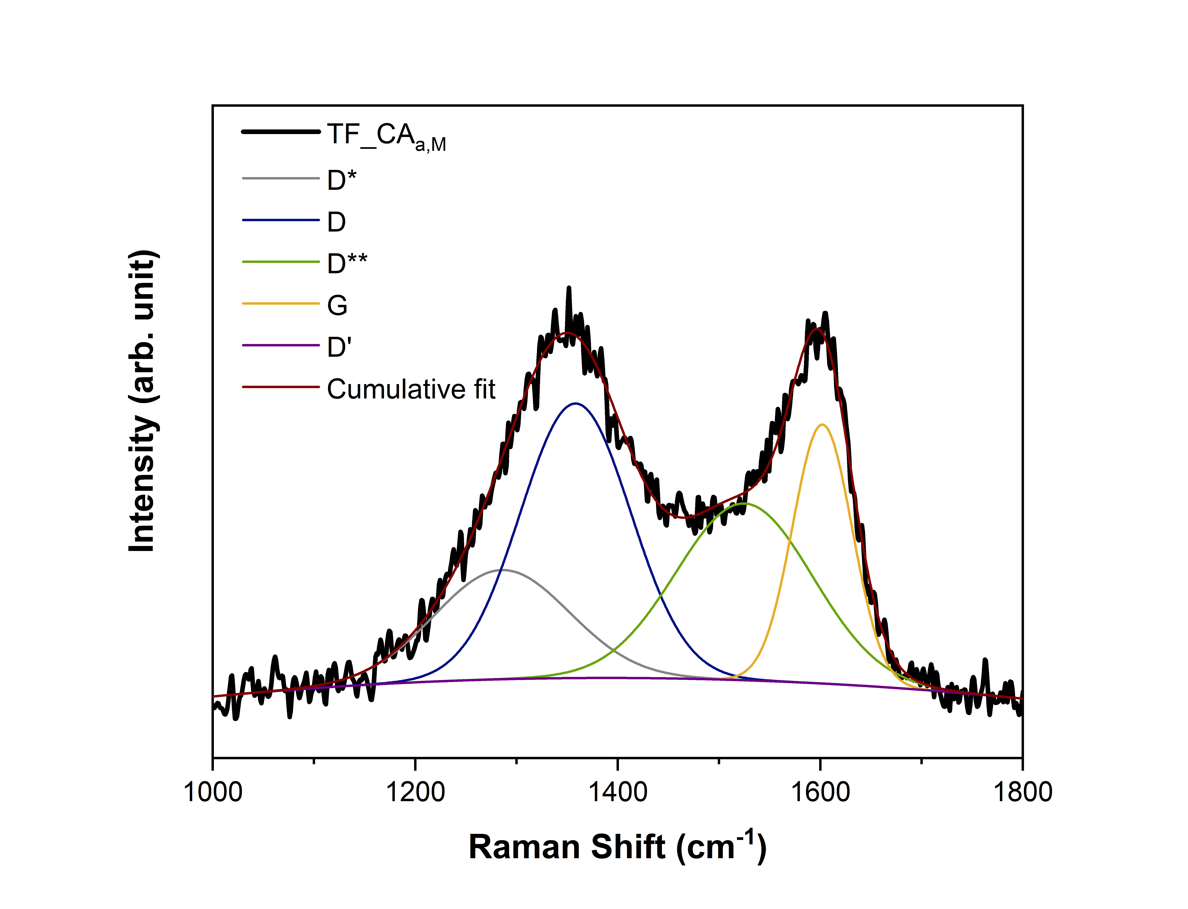

Figure S2: a) RF-CA, b) RF-CA_{a}, c) RF-CA_{a,NH3}, d) RF-CA_{a,M}, e) TF-CA, f) TF-CA_{a}, g) TF-CA_{a,NH3} and h) TF-CA_{a,M} cumulatively fitted by deconvolution into the bands D*, D, D**, G and D’ in accordance to Kaniyoor and Ramaprabhu [45]

Table S3: Elemental ratios of the samples obtained from XPS

Sample | C  [at.-%] | N  [at.-%] | O  [at.-%]
RF-CA_{a} | 98 | 0 | 2
RF-CA_{a,NH3} | 96 | 2 | 2
RF-CA_{a,M} | 94 | 5 | 1
TF-CA_{a} | 97 | 0 | 3
TF-CA_{a, NH3} | 96 | 2 | 2
TF-CA_{a,M} | 94 | 4 | 2

Table S4: Energy densities of RF-CA_{a}, RF-CA_{a,M}, RF-CA_{a,NH3}, TF-CA_{a}, TF-CA_{a,M} and
TF-CA_{a,NH3} calculated by the integration of the potential versus capacity curve after the initial cycle at 0.0 to 1.9 V vs. Zn/Zn²⁺ at a current density of 500 mA‧g⁻¹.
Sample | Energy density [Wh‧kg⁻¹]
RF-CA_{a} | 72.239
RF-CA_{a,M} | 48.704
RF-CA_{a,NH3} | 48.343
TF-CA_{a} | 45.511
TF-CA_{a,M} | 42.254
TF-CA_{a,NH3} | 44.699

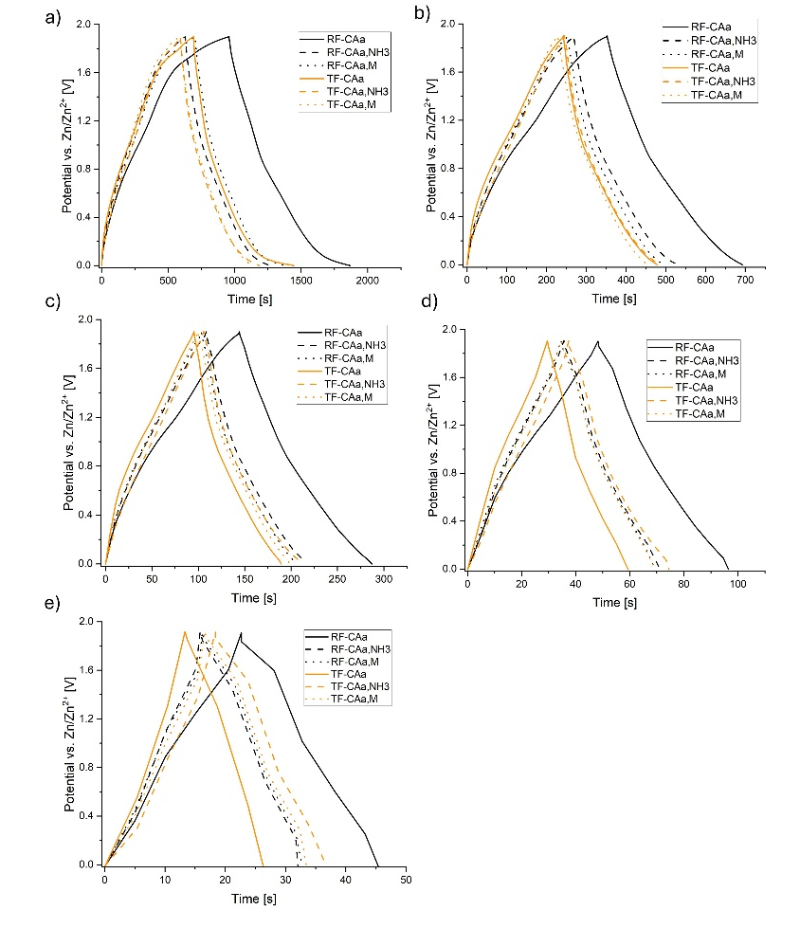
Figure S5: GCD curves of RF- and TF-based carbon aerogels vs. Zn/Zn²⁺ in the potential range 0.0-1.9 V measured at a) 0.5 A·g⁻¹, b) 1 A·g⁻¹, c) 2 A·g⁻¹, d) 5 A·g⁻¹ and 10 A·g⁻¹

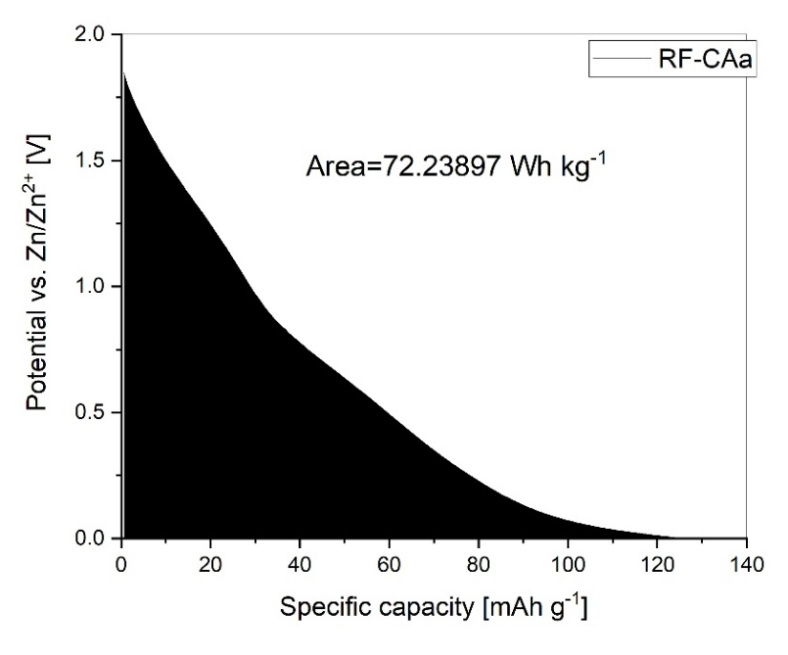
Figure S6: The figure shows the galvanostatic discharge of RF-CA_{a} and the area which was used for the calculation of the energy density as an example.
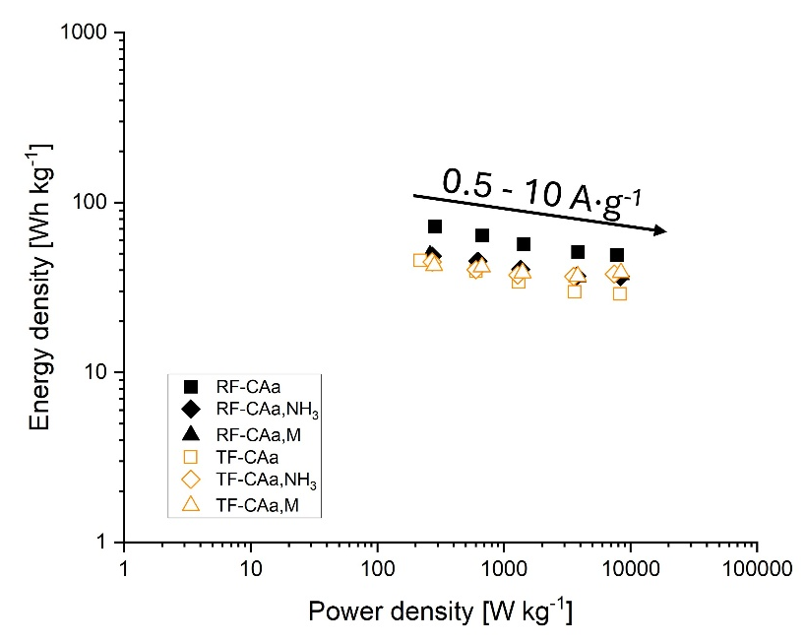
Figure S7: Ragone plot of RF- and TF-based carbon aerogels vs. Zn/Zn2+ in the potential range 0.0-1.9 V measured at 0.5, 1, 2, 5 and 10 A·g⁻¹.

