Supporting Information
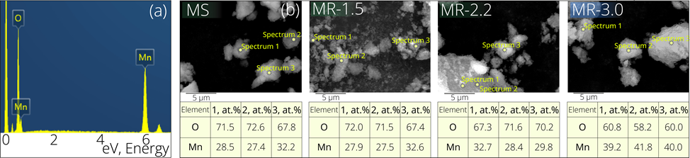
Figure S1. Figure S1. Representative EDX spectrum of manganese (hydro)oxide samples (a) and SEM-EDX elemental analysis results with atomic percentages for MS, MR-1.5, MR-2.2 and MR-3.0 electrodes (b).

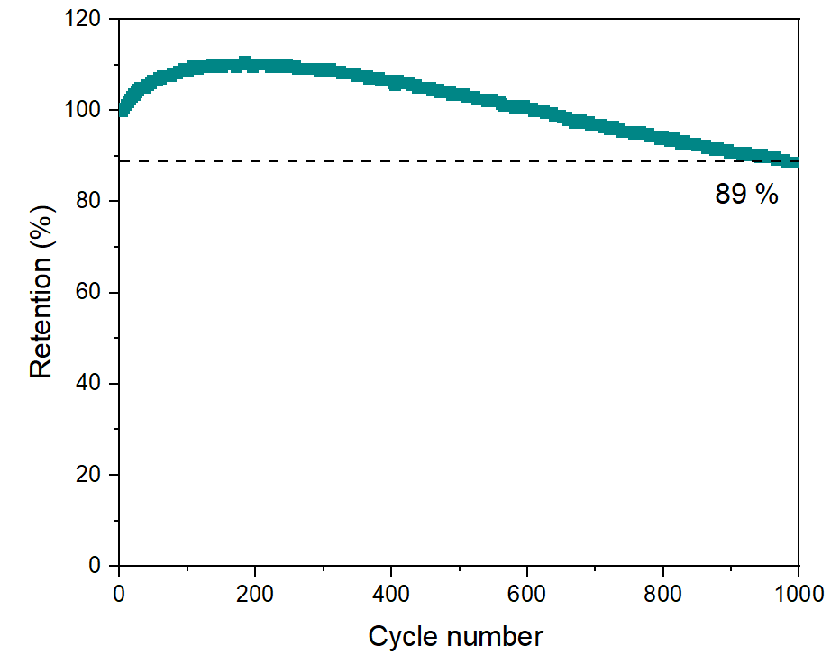
Figure S2. Cycling stability of the MR-3.0 electrode measured by galvanostatic charge–discharge in a three-electrode configuration in 1 M Na₂SO₄ electrolyte.
The initial increase in the specific capacitance observed during the first ~200 cycles can be associated with gradual wetting of the mesoporous structure, improved electrolyte penetration, and progressive formation of electrochemically active hydroxide/oxyhydroxide surface species. This behavior is consistent with the mixed pseudocapacitive-diffusion-controlled mechanism (b = 0.74), indicating progressive activation of electrochemically accessible surface sites during the initial cycling stage. The subsequent decrease in capacitance is attributed to partial structural fatigue of the manganese oxide/hydroxide framework and the accumulation of resistive interfacial layers [57]. All experimental parameters of the cycling stability measurements are described in Section 2.2.5 of the main manuscript. A detailed mechanistic interpretation of this two-stage behavior is provided in Section 3.3.1 of the main manuscript.
Table S1. Comparison of specific capacitance values of Mn-based electrodes reported in the literature in neutral sulfate electrolytes.
Material | Electrolyte | Current density  (A/g) | Specific capacitance  (F/g) | Ref
Mn₃O₄ MR-3.0 | 1 M Na₂SO₄ | 5 | 200 | This work
MnO₂-rGO composite | 0.1 M Na₂SO₄ | 5 | 223.1 | 58
Porous MnO₂ | 1 M Na₂SO₄ | 5 | 190 | 59
Mn₃O₄ hydrothermal synthesis | 1 M Na₂SO₄ | 5 | 196 | 60
α-MnO₂ nanoflowers | 1 M Na₂SO₄ | 5 | < 130 | 61
MnO₂ nanoparticles on graphene | 1 M Na₂SO₄ | 5 | < 296 | 62
α-MnO₂ nanoflowers in Zn BDC MOF | 1 M Na₂SO₄ | 5 | 880.58 | 63
MnO₂-Ti₃C₂T_{x}-CNFs | 1 M Na₂SO₄ | 5 | 196 | 64
Al-MnO₂ nanoparticles | 1 M Na₂SO₄ | 1 | 301.8 | 65
Cu-MnO₂ | 1 M K₂SO₄ | 1 | 92.3 | 66
MnO₂ on carbon cloth | 1 M Na₂SO₄ | 1 | 408.1 | 67
MnO₂ on graphene G10 | 1 M Na₂SO₄ | 1 | 500 | 68

A kinetic analysis was carried out to gain further insight into the charge-storage mechanism of the MnO₂ electrode. The progressive shift of anodic and cathodic peaks with increasing scan rate (Figure S3a) reflects the presence of kinetic limitations associated with ion diffusion and surface redox transitions rather than ideal capacitive behavior.
In general, the total capacitance of an electrode can be divided into two contributions: surface-controlled pseudocapacitance and diffusion-controlled charge storage [69]. The relationship between peak current (i) and scan rate (v) can be expressed as:
$$\begin{aligned}i=a*v^{b} \#\left(3\right)\end{aligned}$$
where a and b are adjustable parameters. The b value can be obtained from the slope of the log(i) versus log(v) plot. A b value of 0.5 corresponds to a diffusion-controlled process, while b = 1.0 indicates a surface-dominated capacitive process. As shown in Figure S3 (b), the fitted b value for the redox peak is 0.74, suggesting that Na⁺ storage in MnO₂ is primarily governed by surface-induced pseudocapacitive behavior. The intermediate b value (0.74) quantitatively confirms the mixed surface- and diffusion-controlled charge storage mechanism, which explains the non-ideal quasi-rectangular shape of the CV curves observed in Figure 5a.
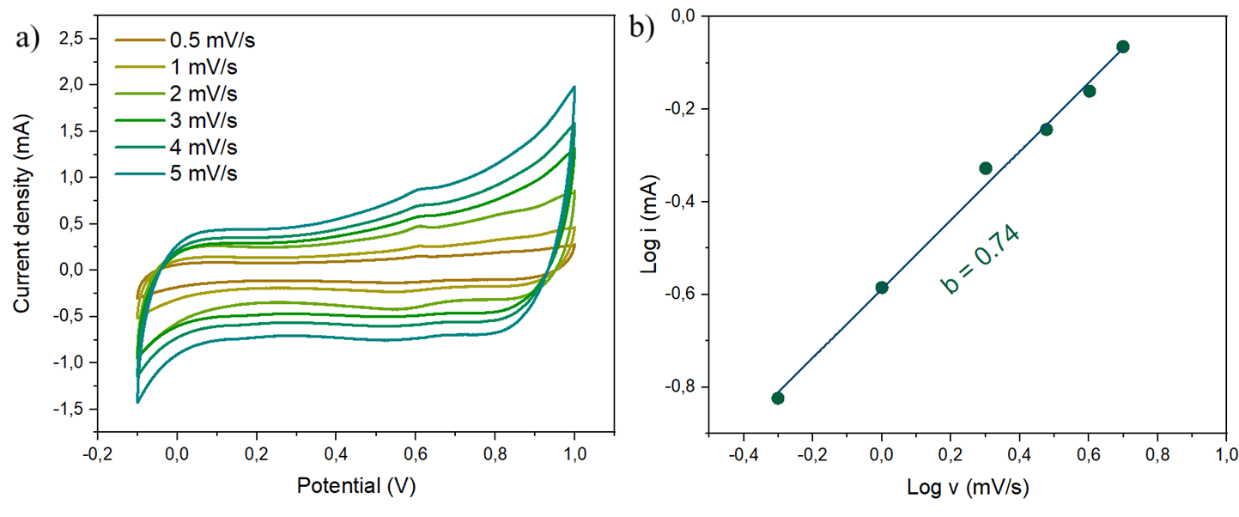
Figure S3. Cyclic voltammograms of the MR-3.0 electrode recorded at different scan rates (a) and corresponding log(i) versus log(v) plot used for determination of the b value (b).

Table S2. Mn 3s multiplet splitting (ΔE) values and binding energies of Mn 2p and O 1s core-level components derived from XPS spectra.
Sample | Mn 3s ΔE  (eV) | Mn 2p spin-orbit splitting  (eV) | O 1s Mn-O-Mn BE  (eV) | O 1s Mn-OH BE  (eV) | O 1s H-O-H BE  (eV)
MR-3.0 | 5.38 | 10.2 | 529.8 | 531.2 | 532.9
MR-2.2 | 5.29 | 10.2 | 529.8 | 531.2 | 532.9
MR-1.5 | 5.33 | 10.2 | 529.8 | 531.2 | 532.9
MS | 5.54 | 10.2 | 529.8 | 531.2 | 532.9

Table S3. Fitted solution resistance (R_{s}) and charge-transfer resistance (R_{ct}) values obtained from electrochemical impedance spectroscopy (EIS) measurements.
 | MS | MR-1.5 | MR-2.2 | MR-3.0
R_{s} (Ω) | 1.17 | 1.03 | 0.77 | 0.72
R_{ct} (Ω) | 8.13 | 6.19 | 5.99 | 4.78

References
[57] Wu, Q., He, T., Zhang, Y., Zhang, J., Wang, Z., Liu, Y., Zhao, L., Wu, Y., & Ran, F. (2021). Cyclic stability of supercapacitors: materials, energy storage mechanism, test methods, and device. Journal of Materials Chemistry A, 9(43), 24094–24147.
https://doi.org/10.1039/D1TA06815F

[58] Zhou, Y, Guo, L, Shi, W, Zou, X, Xiang, B, & Xing, S (2018). Rapid Production of Mn₃O₄/rGO as an Efficient Electrode Material for Supercapacitor by Flame Plasma. Materials, 11(6), 881. https://doi.org/10.3390/ma11060881
[59] Yang, F, Zhao, M, Sun, Q, & Qiao, Y (2015). A novel hydrothermal synthesis and characterisation of porous Mn₃O₄ for supercapacitors with high rate capability. RSC Advances, 5(13), 9843–9847. https://doi.org/10.1039/C4RA10175H
[60] Yang, L, Cheng, S, Ji, X, Jiang, Y, Zhou, J, & Liu, M (2015). Investigation into the origin of pseudocapacitive behavior of Mn3O4 electrodes using operando Raman spectroscopy. Journal of Materials Chemistry A: Materials for Energy and Sustainability, 3. https://doi.org/10.1039/C5TA00223K
[61] Zhang, D, Dai, J, Zhang, J, Zhang, Y, Liu, H, Xu, Y, Wu, J, & Li, P (2024). Preparation of Spherical δ-MnO₂ Nanoflowers by One-Step Coprecipitation Method as Electrode Material for Supercapacitor. ACS Omega, 9(16), 18032–18045. https://doi.org/10.1021/acsomega.3c09725
[62] Kang, D (2020). Synthesis of MnO2 Nanoparticle Decorated Graphene-Based Porous Composite Electrodes for High-Performance Supercapacitors. International Journal of Electrochemical Science, 15, 6091–6108. https://doi.org/10.20964/2020.07.13
[63] Chettiannan, B, Srinivasan, AK, Arumugam, G, Shajahan, S, Haija, MA, & Rajendran, R (2023). Incorporation of α-MnO2 Nanoflowers into Zinc-Terephthalate Metal-Organic Frameworks for High-Performance Asymmetric Supercapacitors. ACS Omega, 8(7), 6982–6993. https://doi.org/10.1021/acsomega.2c07808
[64] Wang, Z, Zhang, D, Guo, Y, Jiang, H, Wang, D, Cheng, J, Chu, PK, Yan, H, & Luo, Y (2023). Ti₃C₂T_{x} MXene-embedded MnO2-based hydrophilic electrospun carbon nanofibers as a freestanding electrode for supercapacitors. Chemical Communications, 59(96), 14309–14312. https://doi.org/10.1039/D3CC03925K
[65] Yan, J, Liu, C, Yang, J, Wang, Z, Yao, W, Huang, L, Cui, J, Liu, J, Hu, X, & Wu, Y (2023). A 2.6 V Flexible Supercapacitor Based on Al-MnO₂-Na₂SO₄//AC-KOH with High Specific Energy. ACS Energy Letters, 8(4), 2033–2041. https://doi.org/10.1021/acsenergylett.3c00439
[66] Barclay, M, Firestein, K, Jadhav, SD, Motta, N, & Ostrikov, K (2024). Development of novel plasma process for modification of solid and liquid interfaces for high-energy-density Cu-MnOx supercapacitor electrodes. Electrochimica Acta, 506, 144985. https://doi.org/10.1016/j.electacta.2024.144985
[67] Dang, S, Wen, Y, Qin, T, Hao, J, Li, H, Huang, J, Yan, D, Cao, G, & Peng, S (2020). Nanostructured manganese dioxide with adjustable Mn³⁺/Mn⁴⁺ ratio for flexible high-energy quasi-solid supercapacitors. Chemical Engineering Journal, 396, 125342. https://doi.org/10.1016/j.cej.2020.125342
[68] Liu, X, Liang, B, Hong, X, & Long, J (2022). Electrochemical Performance of MnO2/Graphene Flower-like Microspheres Prepared by Thermally-Exfoliated Graphite. Frontiers in Chemistry, 10, 870541. https://doi.org/10.3389/fchem.2022.870541
[69] Zhao, Y, Wang, B, Shi, M, An, S, Zhao, L, & Yan, C (2022). Mg-intercalation engineering of MnO₂ electrode for high-performance aqueous magnesium-ion batteries. International Journal of Minerals, Metallurgy and Materials, 29(11), 1954–1962. https://doi.org/10.1007/s12613-021-2346-7

