Exploring the Role of Rare Earth Elements Doped TiO₂ Based Photoanodes on the Performance of Dye-Sensitized Solar Cells

Berrak CALISKAN^{1*}, Enes SAYAN¹, Erdal IGMAN²

¹ Atatürk University, Faculty of Engineering, Department of Chemical Engineering, (esayan@atauni.edu.tr), 25240, Erzurum, TURKEY
² Bayburt University, Department of Material Science and Nanotechnology Engineering, (eigman@bayburt.edu.tr), 69100, Bayburt, TURKEY

* Corresponding author:
Dr. Berrak CALISKAN
Atatürk University, Faculty of Engineering,
Department of Chemical Engineering,
25240, Erzurum, TURKEY
e-mail: berrak.c@atauni.edu.tr

Supplementary Information

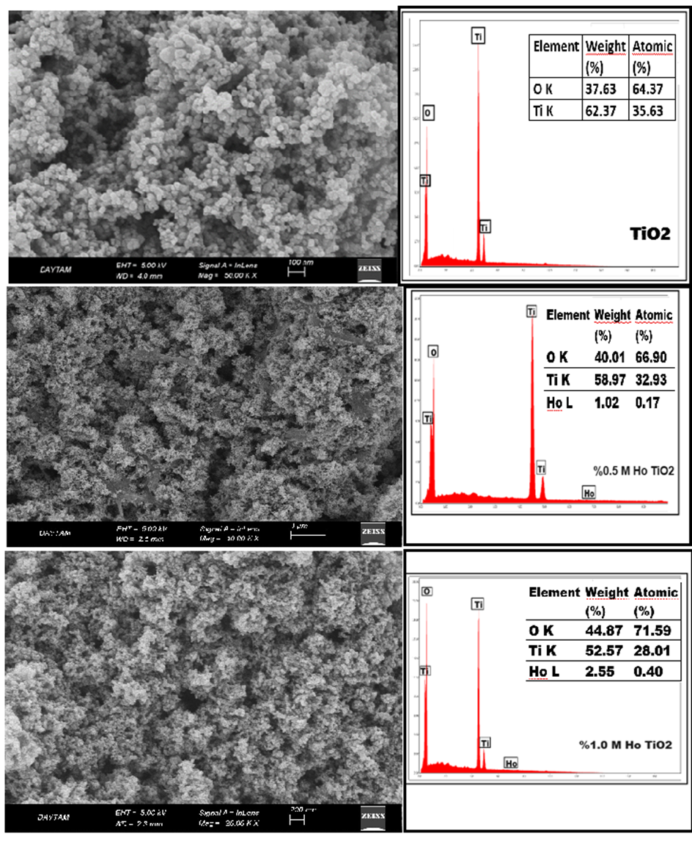
Figure S3: SEM images of pure and TiO₂ working electrodes doped with different percentages (%0,5, %1,0 and %1,5) of REEs (Ho⁺³, La⁺³, Er⁺³, Yb⁺²) and the weight percentages and atomic weight percentages of the elements proven by EDS.

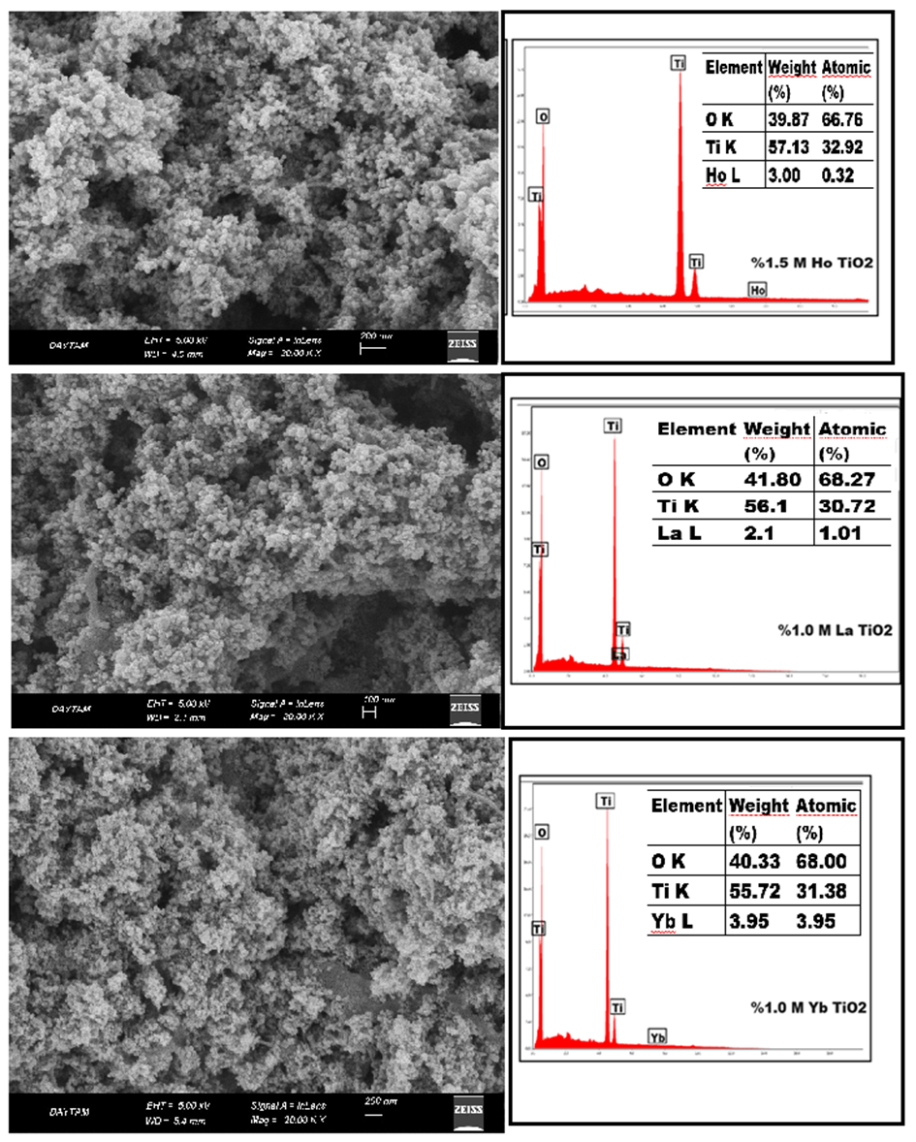
Figure S3 continued
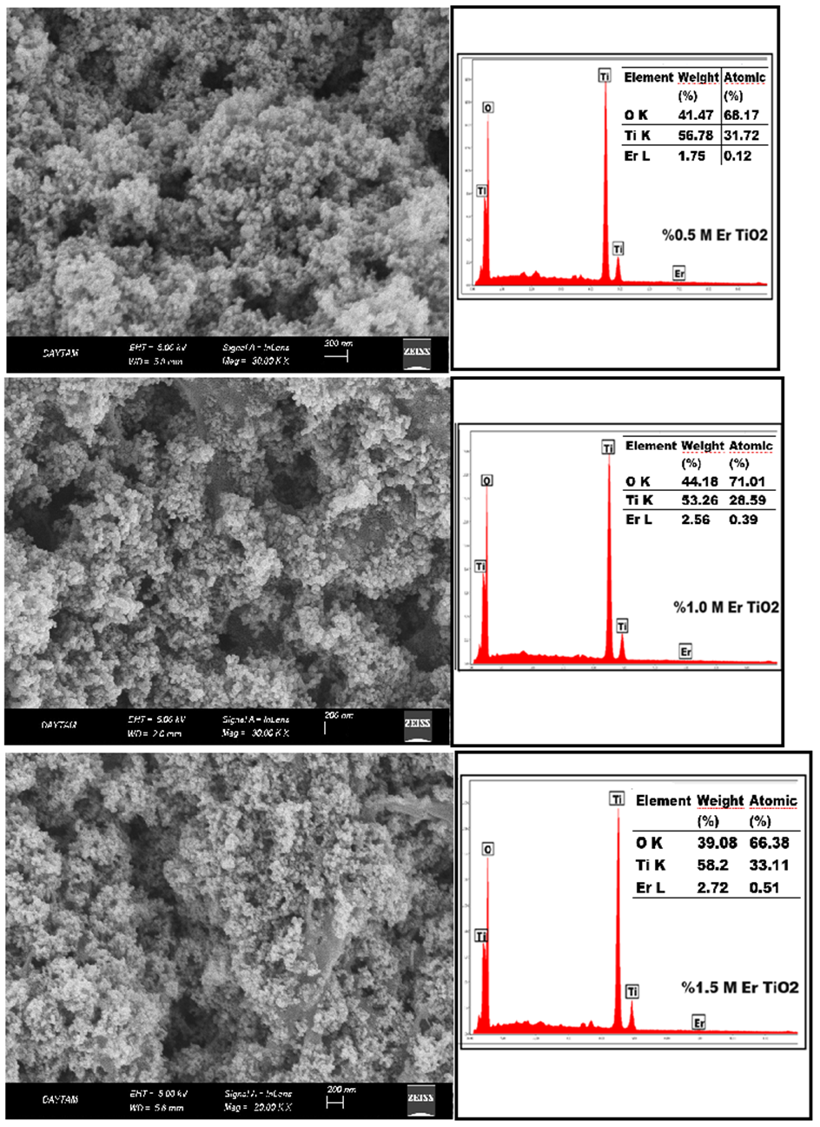
Figure S3 continued
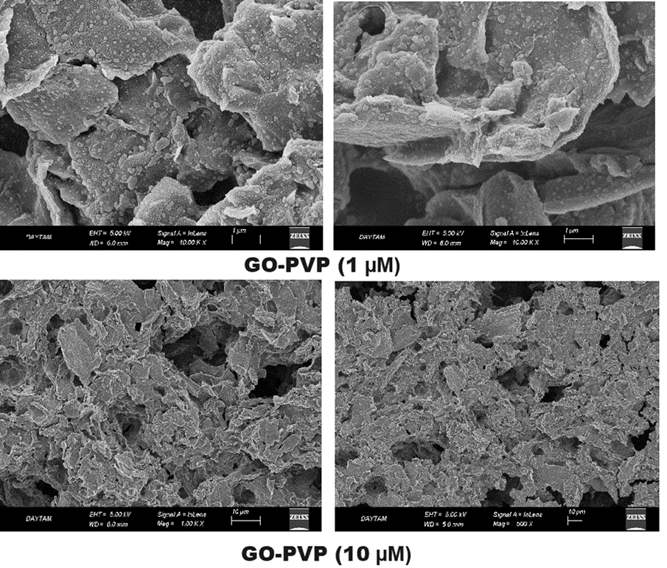
Figure S4: SEM image of the GO-PVP structure applied to the FTO base material with the ‘Doctor Blade’ technique.
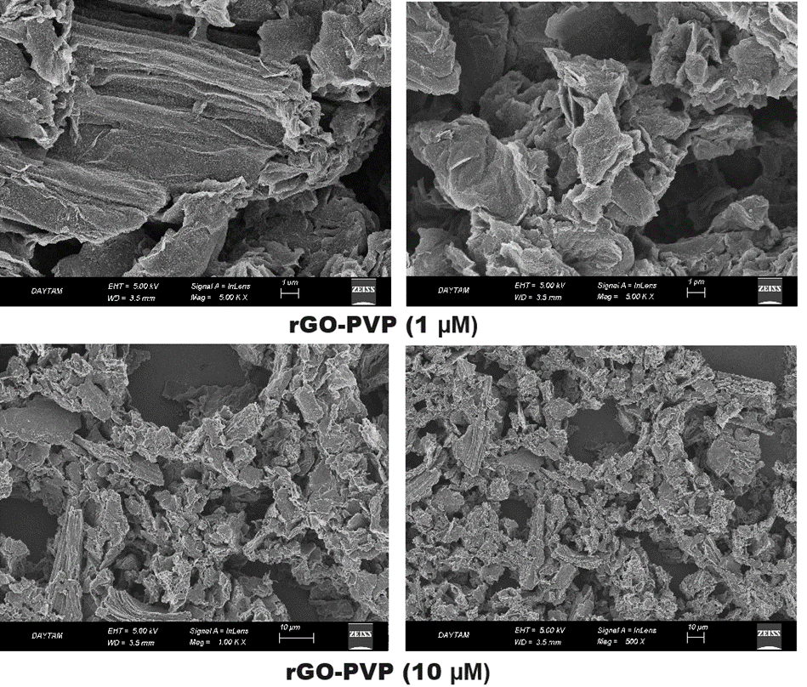
Figure S5: SEM image of the rGO-PVP structure applied to the FTO base material with the ‘Doctor Blade’ technique.

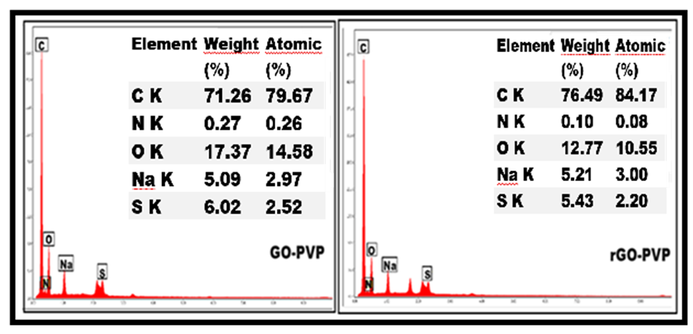
Figure S6: Weight percentages and atomic weight percentages of elements proven by EDS of GO-PVP and rGO-PVP photocathode electrodes.
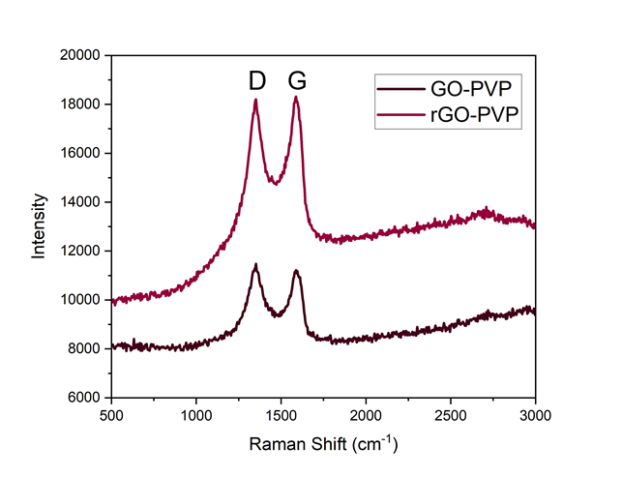
Figure S15: Raman spectra of GO-PVP and rGO-PVP CE used in DSSCs

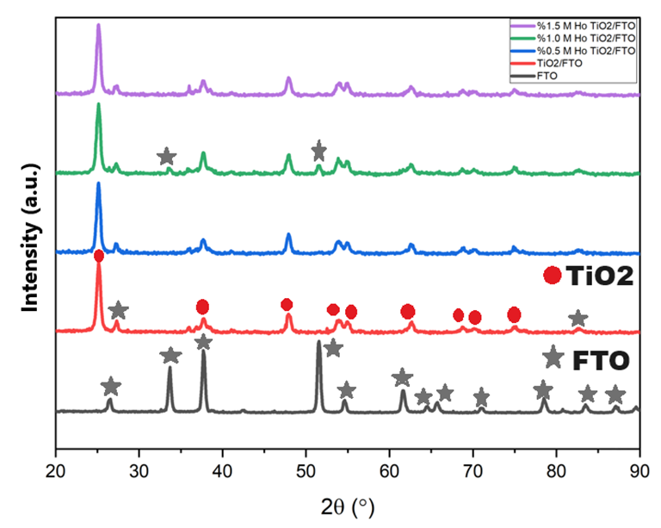
Figure S16: XRD patterns of TiO₂ and (0.5%, 1.0% and 1.5% M Ho⁺³) doped TiO₂ films synthesized by the Sol-Gel method.
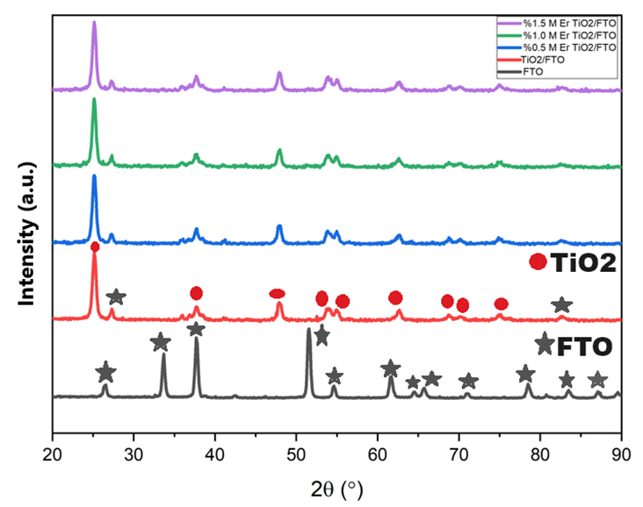
Figure S17: XRD patterns of TiO₂ and TiO₂ films (0.5%, 1.0% and 1.5% M Er⁺³) doped synthesized by the Sol-Gel method.

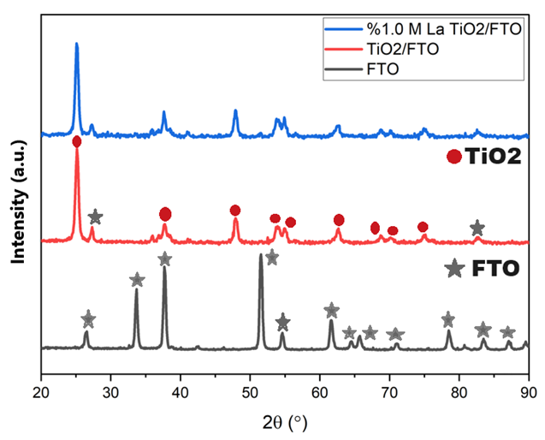
Figure S18: XRD patterns of TiO₂ and 1.0 M La⁺³ doped TiO₂ films synthesized by the Sol-Gel method.
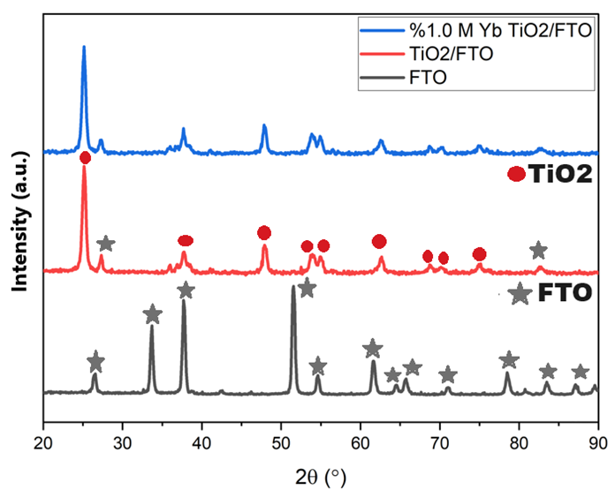
Figure S19: XRD patterns of TiO₂ and 1.0 M Yb⁺² doped TiO₂ films synthesized by the Sol-Gel method.
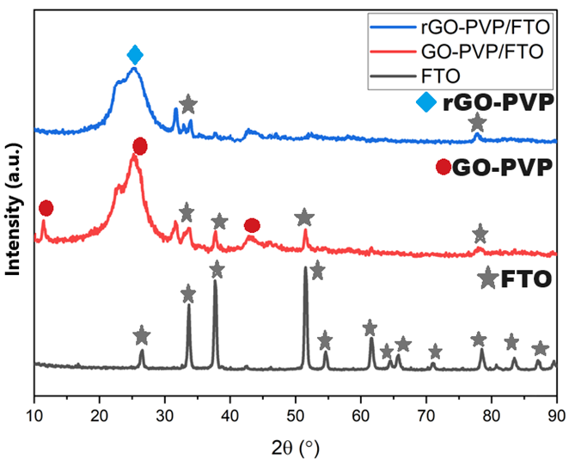
Figure S20: XRD patterns of FTO, GO-PVP/FTO and rGO-PVP/FTO films

Table S2: Determination of β, 2θ and Crystal Size Values ​​of Photo-Anode Electrodes
Photo-anode electrodes | Β (Half Height Width (FWHM) (radians) | 2θ (Derece) | Crystal size (D) (nm)
TiO₂ | 0.55 | 25.10 | 16.59
%0,5 M Ho TiO₂ | 0.58 | 25.04 | 15.57
%1,0 M Ho TiO₂ | 0.61 | 25.04 | 14.87
%1,5 M Ho TiO₂ | 0.67 | 25.05 | 13.62
%1,0 M La TiO₂ | 0.6 | 25.03 | 15.10
%0,5 M Er TiO₂ | 0.58 | 25.04 | 15.52
%1,0 M Er TiO₂ | 0.60 | 25.04 | 14.71
%1,5 M Er TiO₂ | 0.62 | 25.04 | 14.69
%1,0 M Yb TiO₂ | 0.6 | 25.06 | 15.14

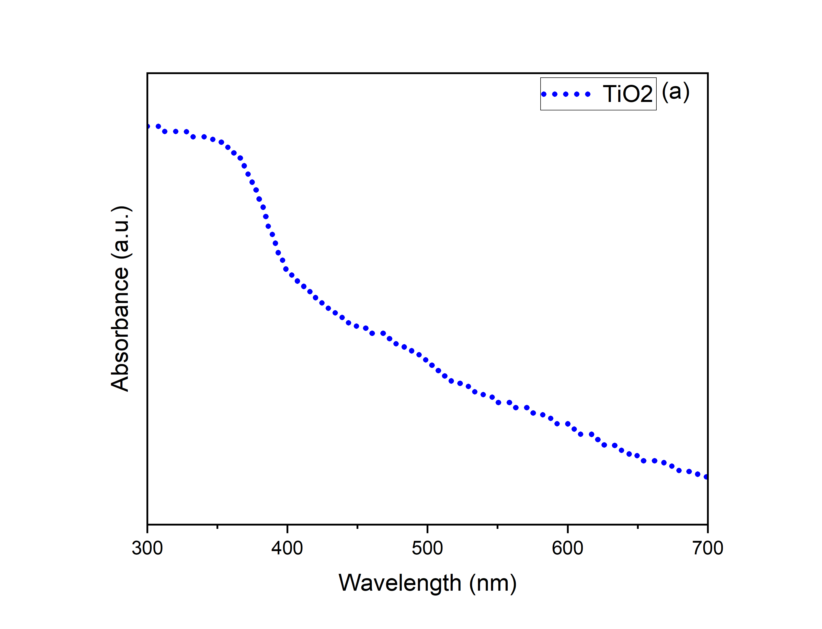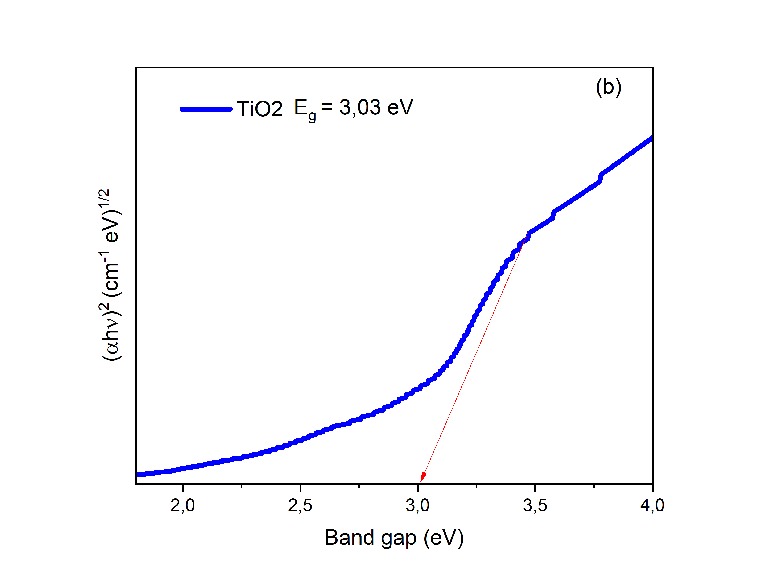
Figure S26: Absorption (a) and optical band gap (b) graph of pure TiO₂ photoanode film synthesized by sol-gel method.

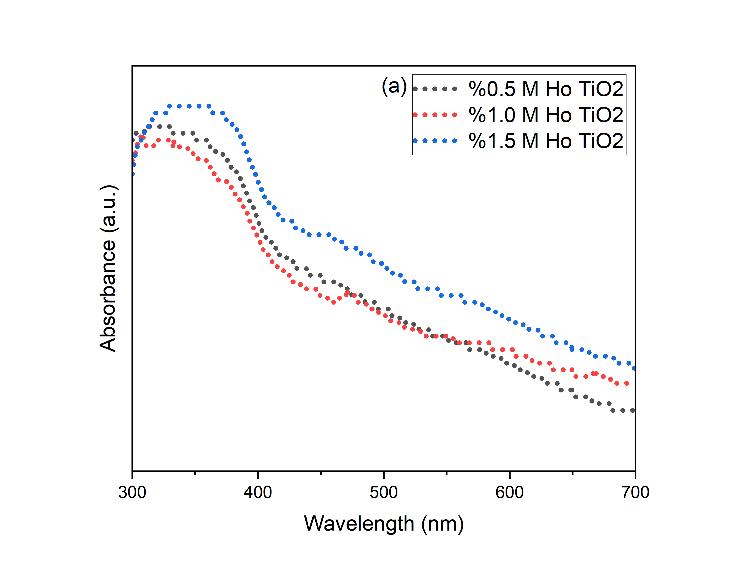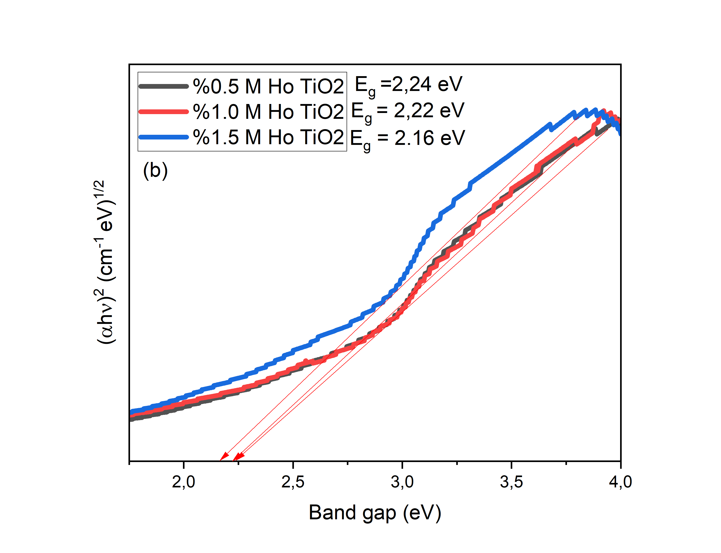
Figure S27: Absorption (a) and optical band gap (b) graph of TiO₂ photoanode film doped with (0.5%, 1.0% and 1.5% M Ho⁺³) synthesized by sol-gel method.

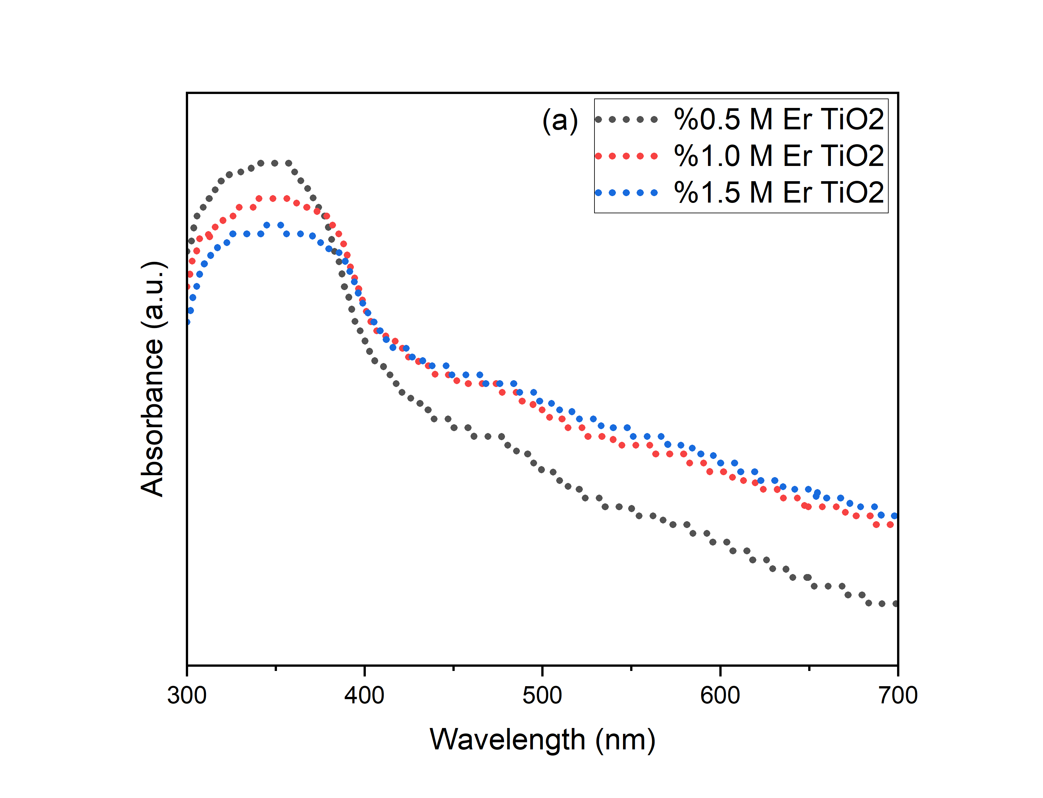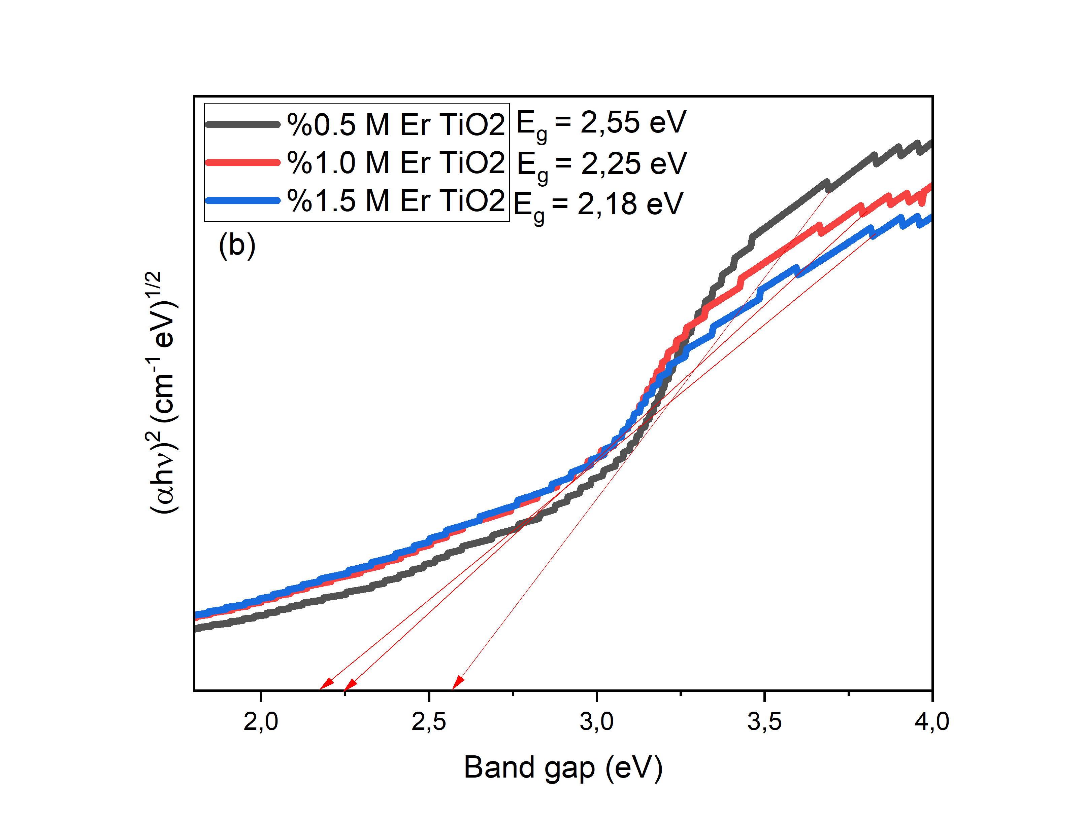
Figure S28: Absorption (a) and optical band gap (b) graph of TiO₂ photoanode film doped with (0.5%, 1.0% and 1.5% M Er⁺³) synthesized by sol-gel method.
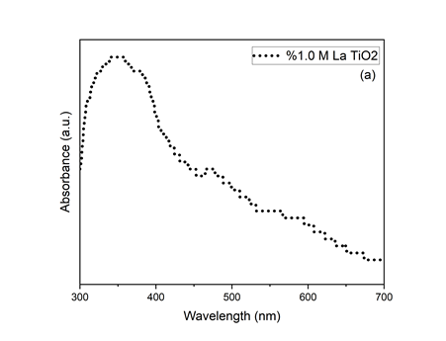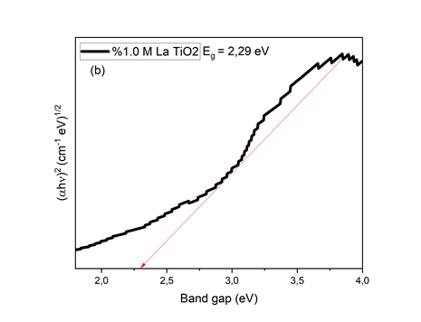
Figure S29: Absorption (a) and optical band gap (b) graph of 1.0 M La⁺³ doped TiO₂ photoanode film synthesized by sol-gel method.

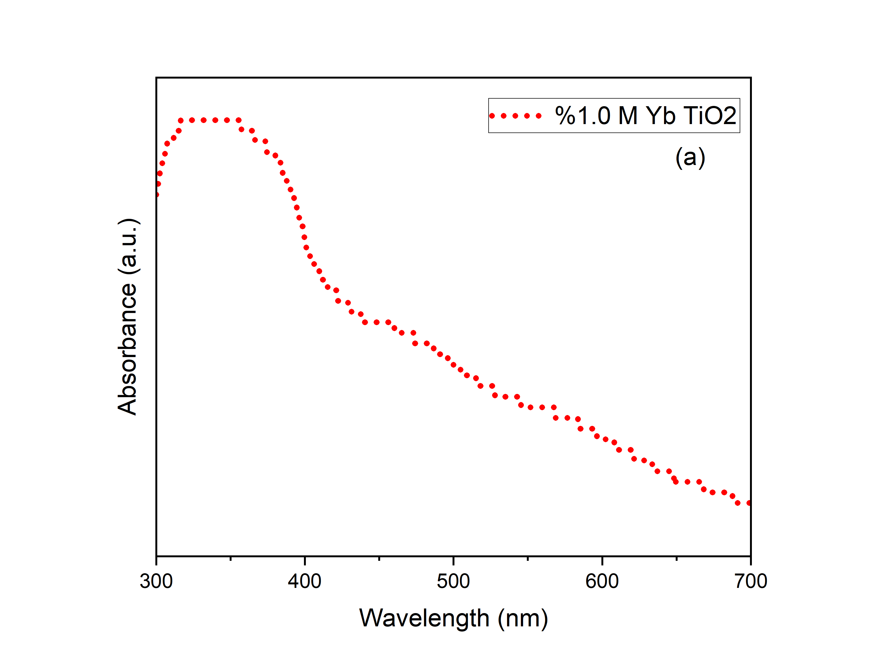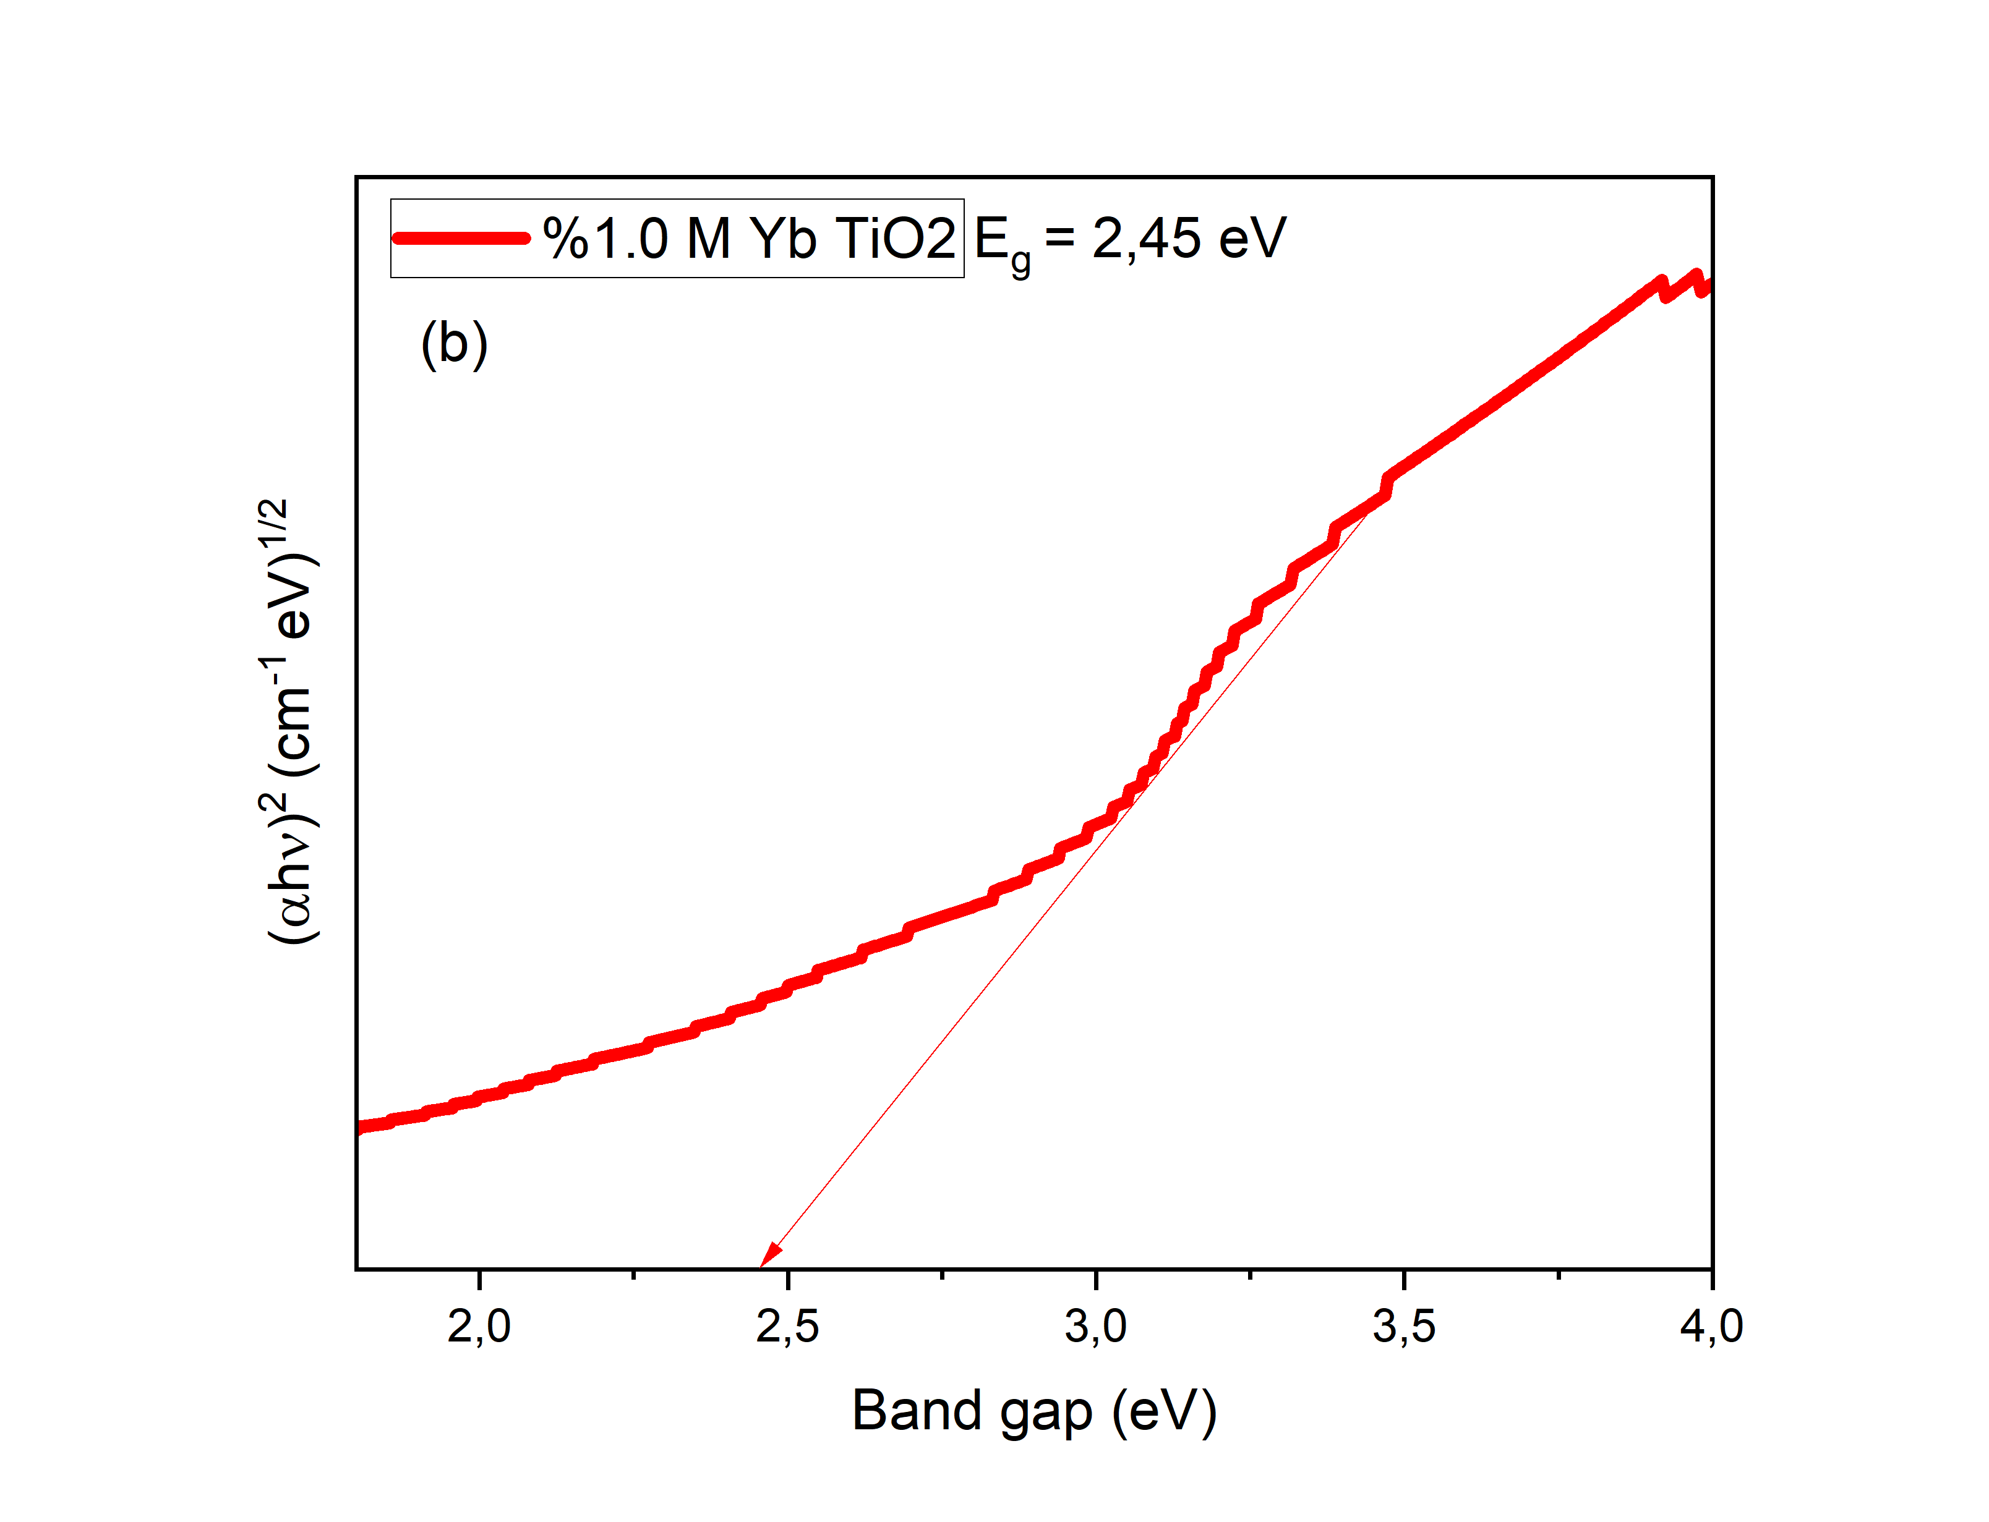
Figure S30: Absorption (a) and optical band gap (b) graph of 1.0% M Yb⁺² doped TiO₂ photoanode film synthesized by sol-gel method.

Table S4: Determination of Band Gap Values ​​of WEs
Working Electrodes | Band Gap (eV)
TiO₂ | 3.03
%0,5 M Ho⁺³ TiO₂ | 2.24
%1,0 M Ho⁺³ TiO₂ | 2.22
%1,5 M Ho⁺³ TiO₂ | 2.16
%0,5 M Er⁺³ TiO₂ | 2.55
%1,0 M Er⁺³ TiO₂ | 2.25
%1,5 M Er⁺³ TiO₂ | 2.18
%1,0 M La⁺³ TiO₂ | 2.29
%1,0 M Yb⁺² TiO₂ | 2.45

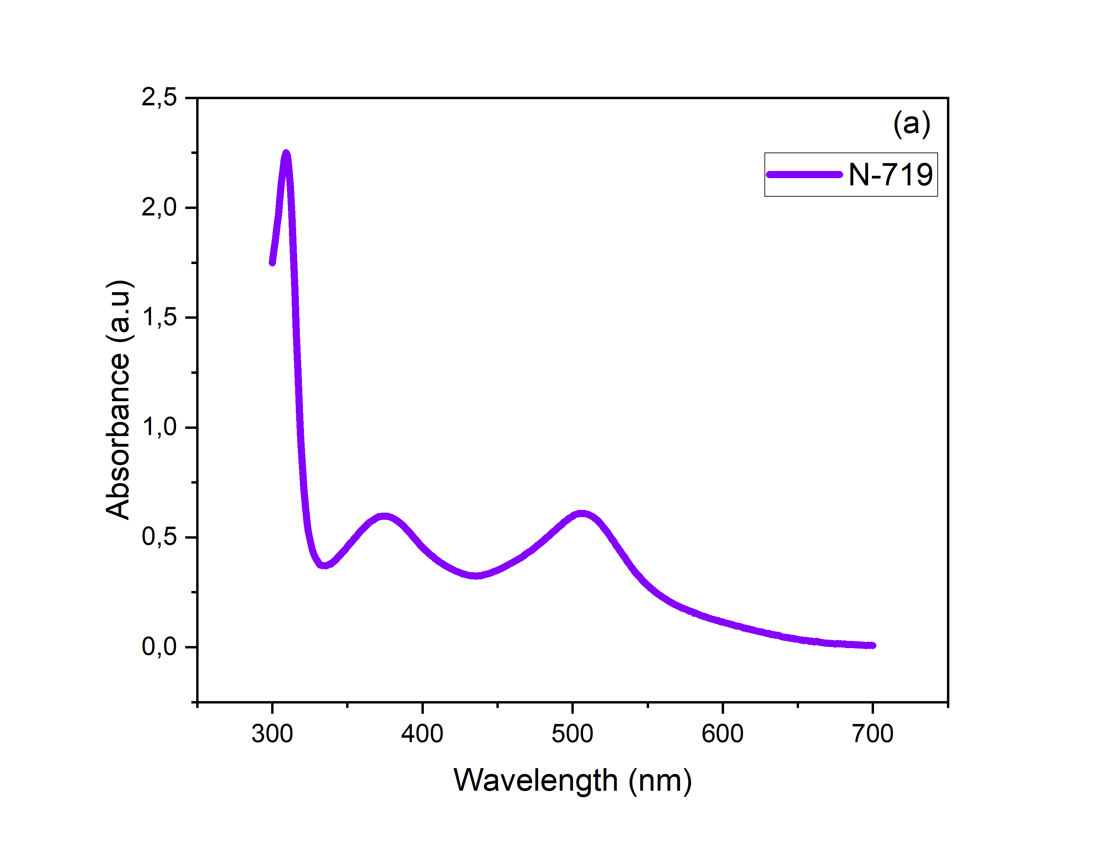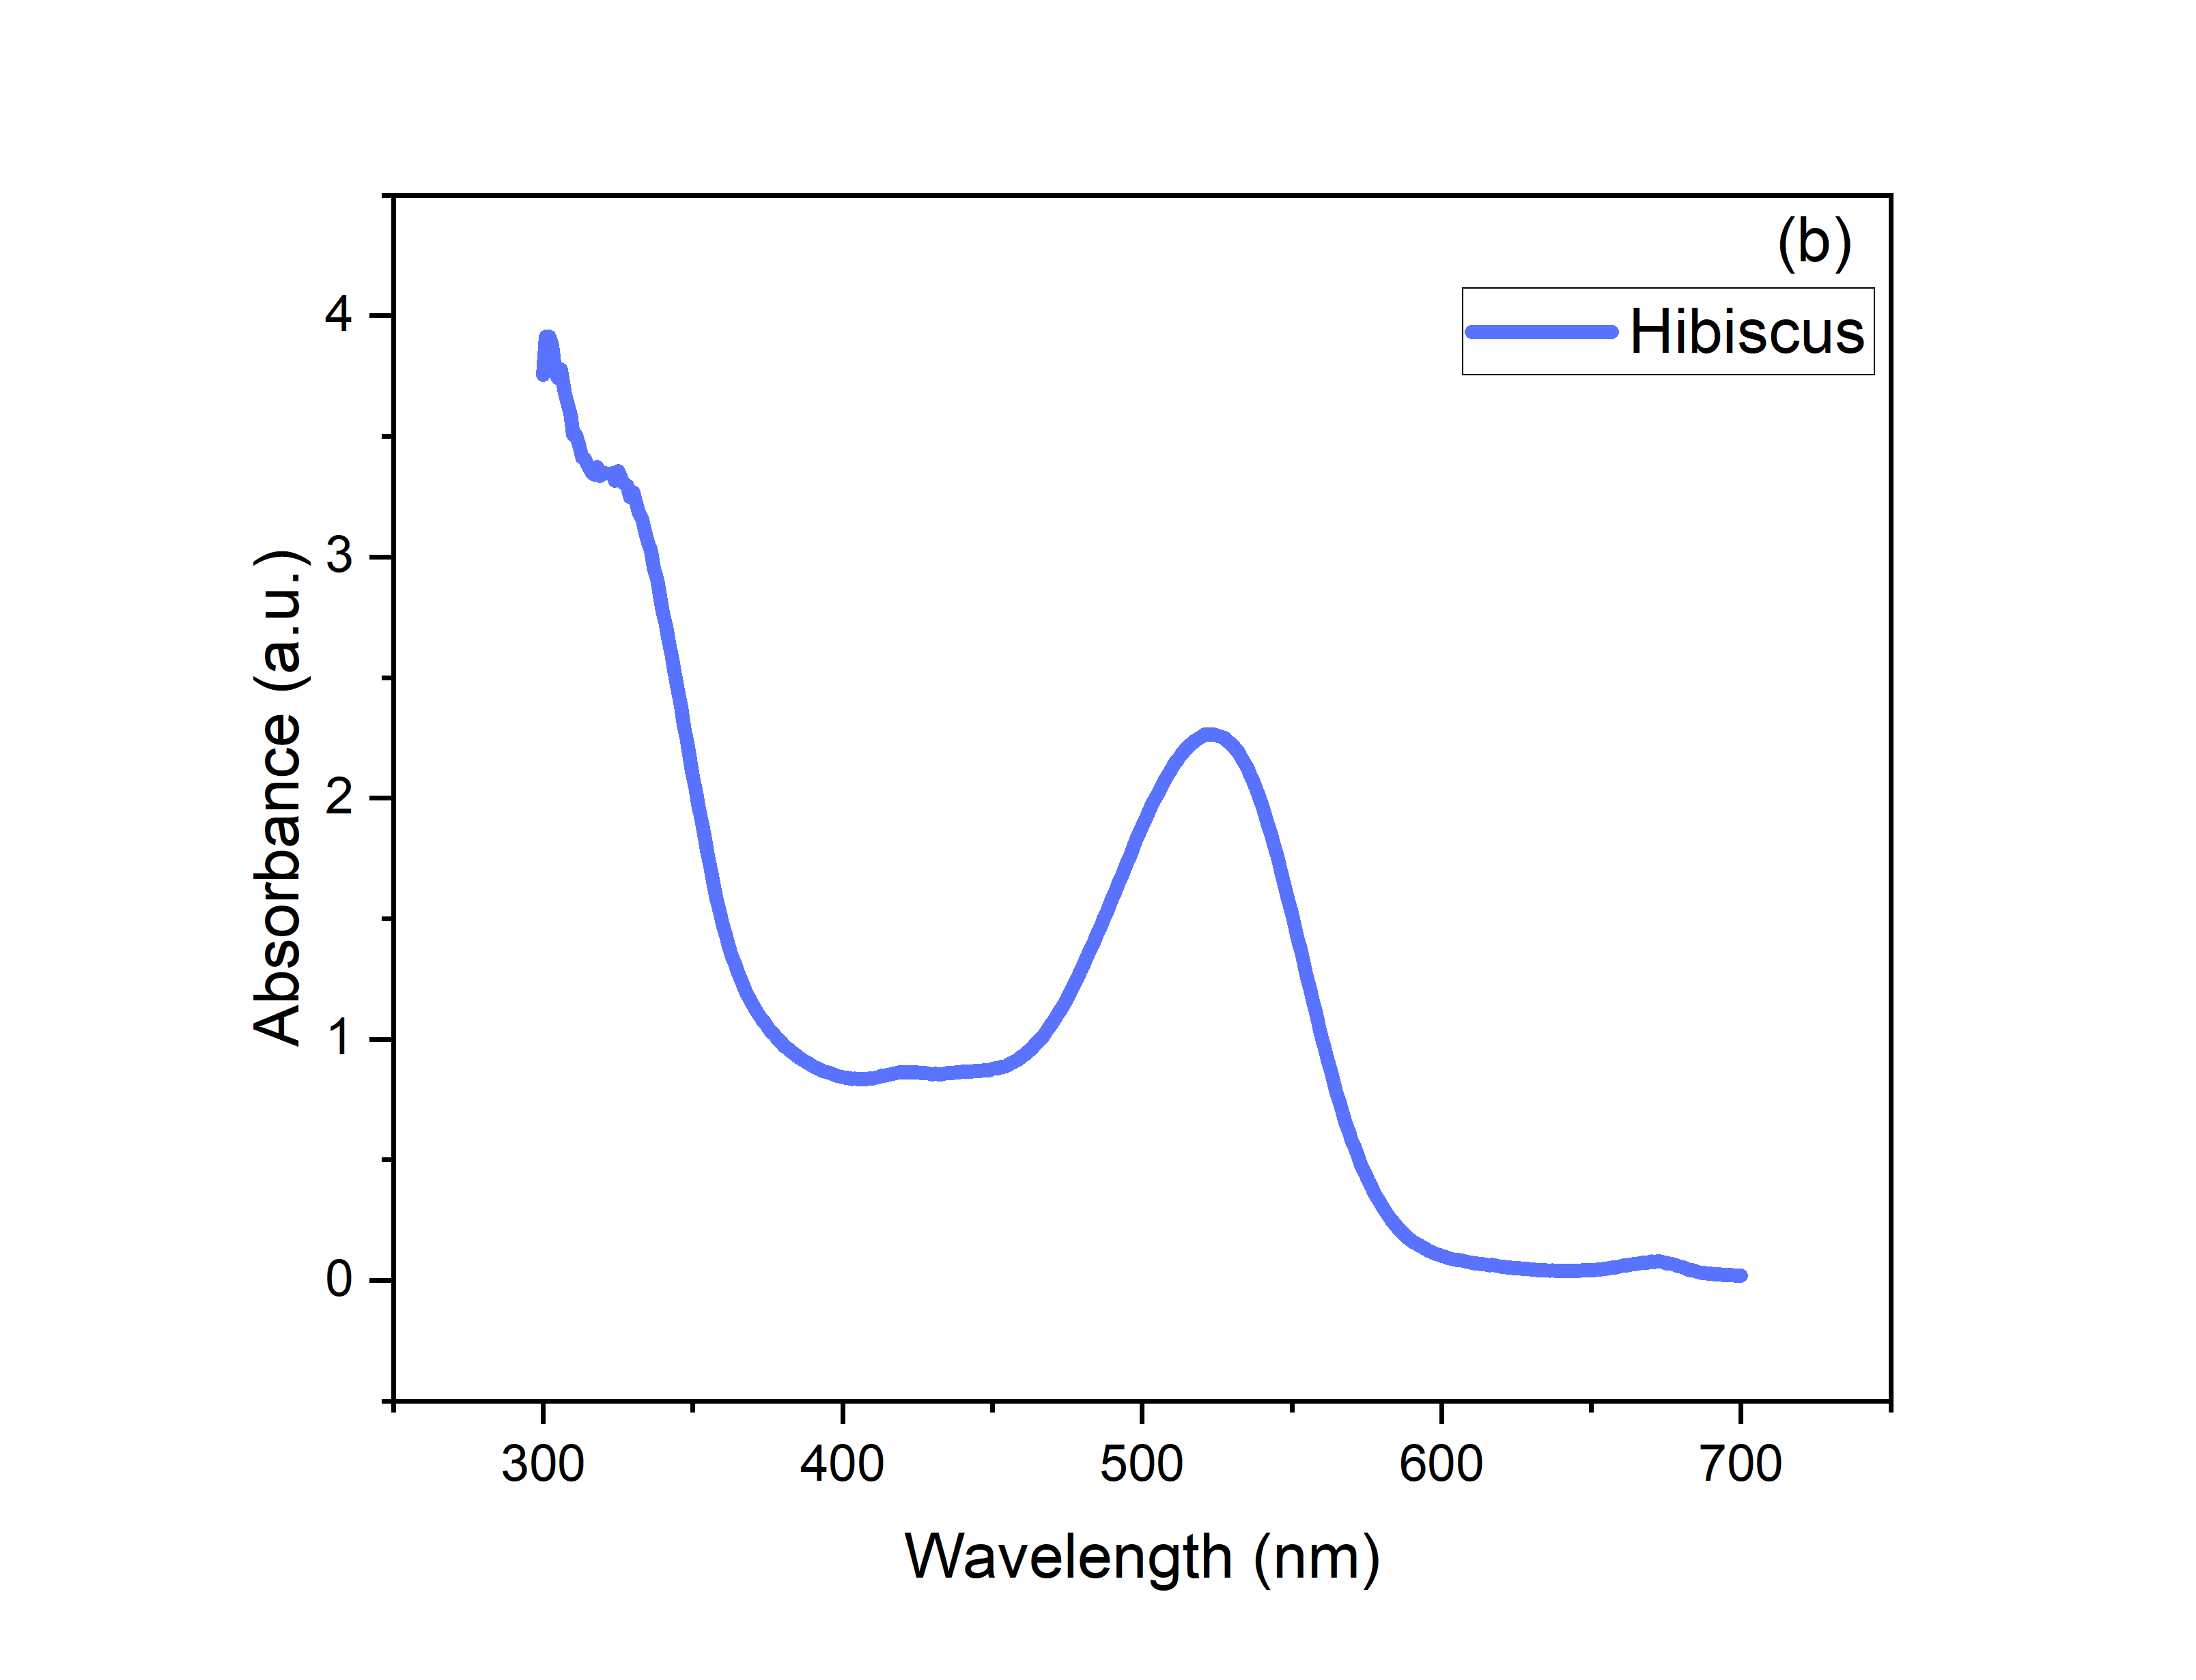
Figure S31: Absorbance spectrum of dyes obtained from (a) N-719 and (b) hibiscus plant.

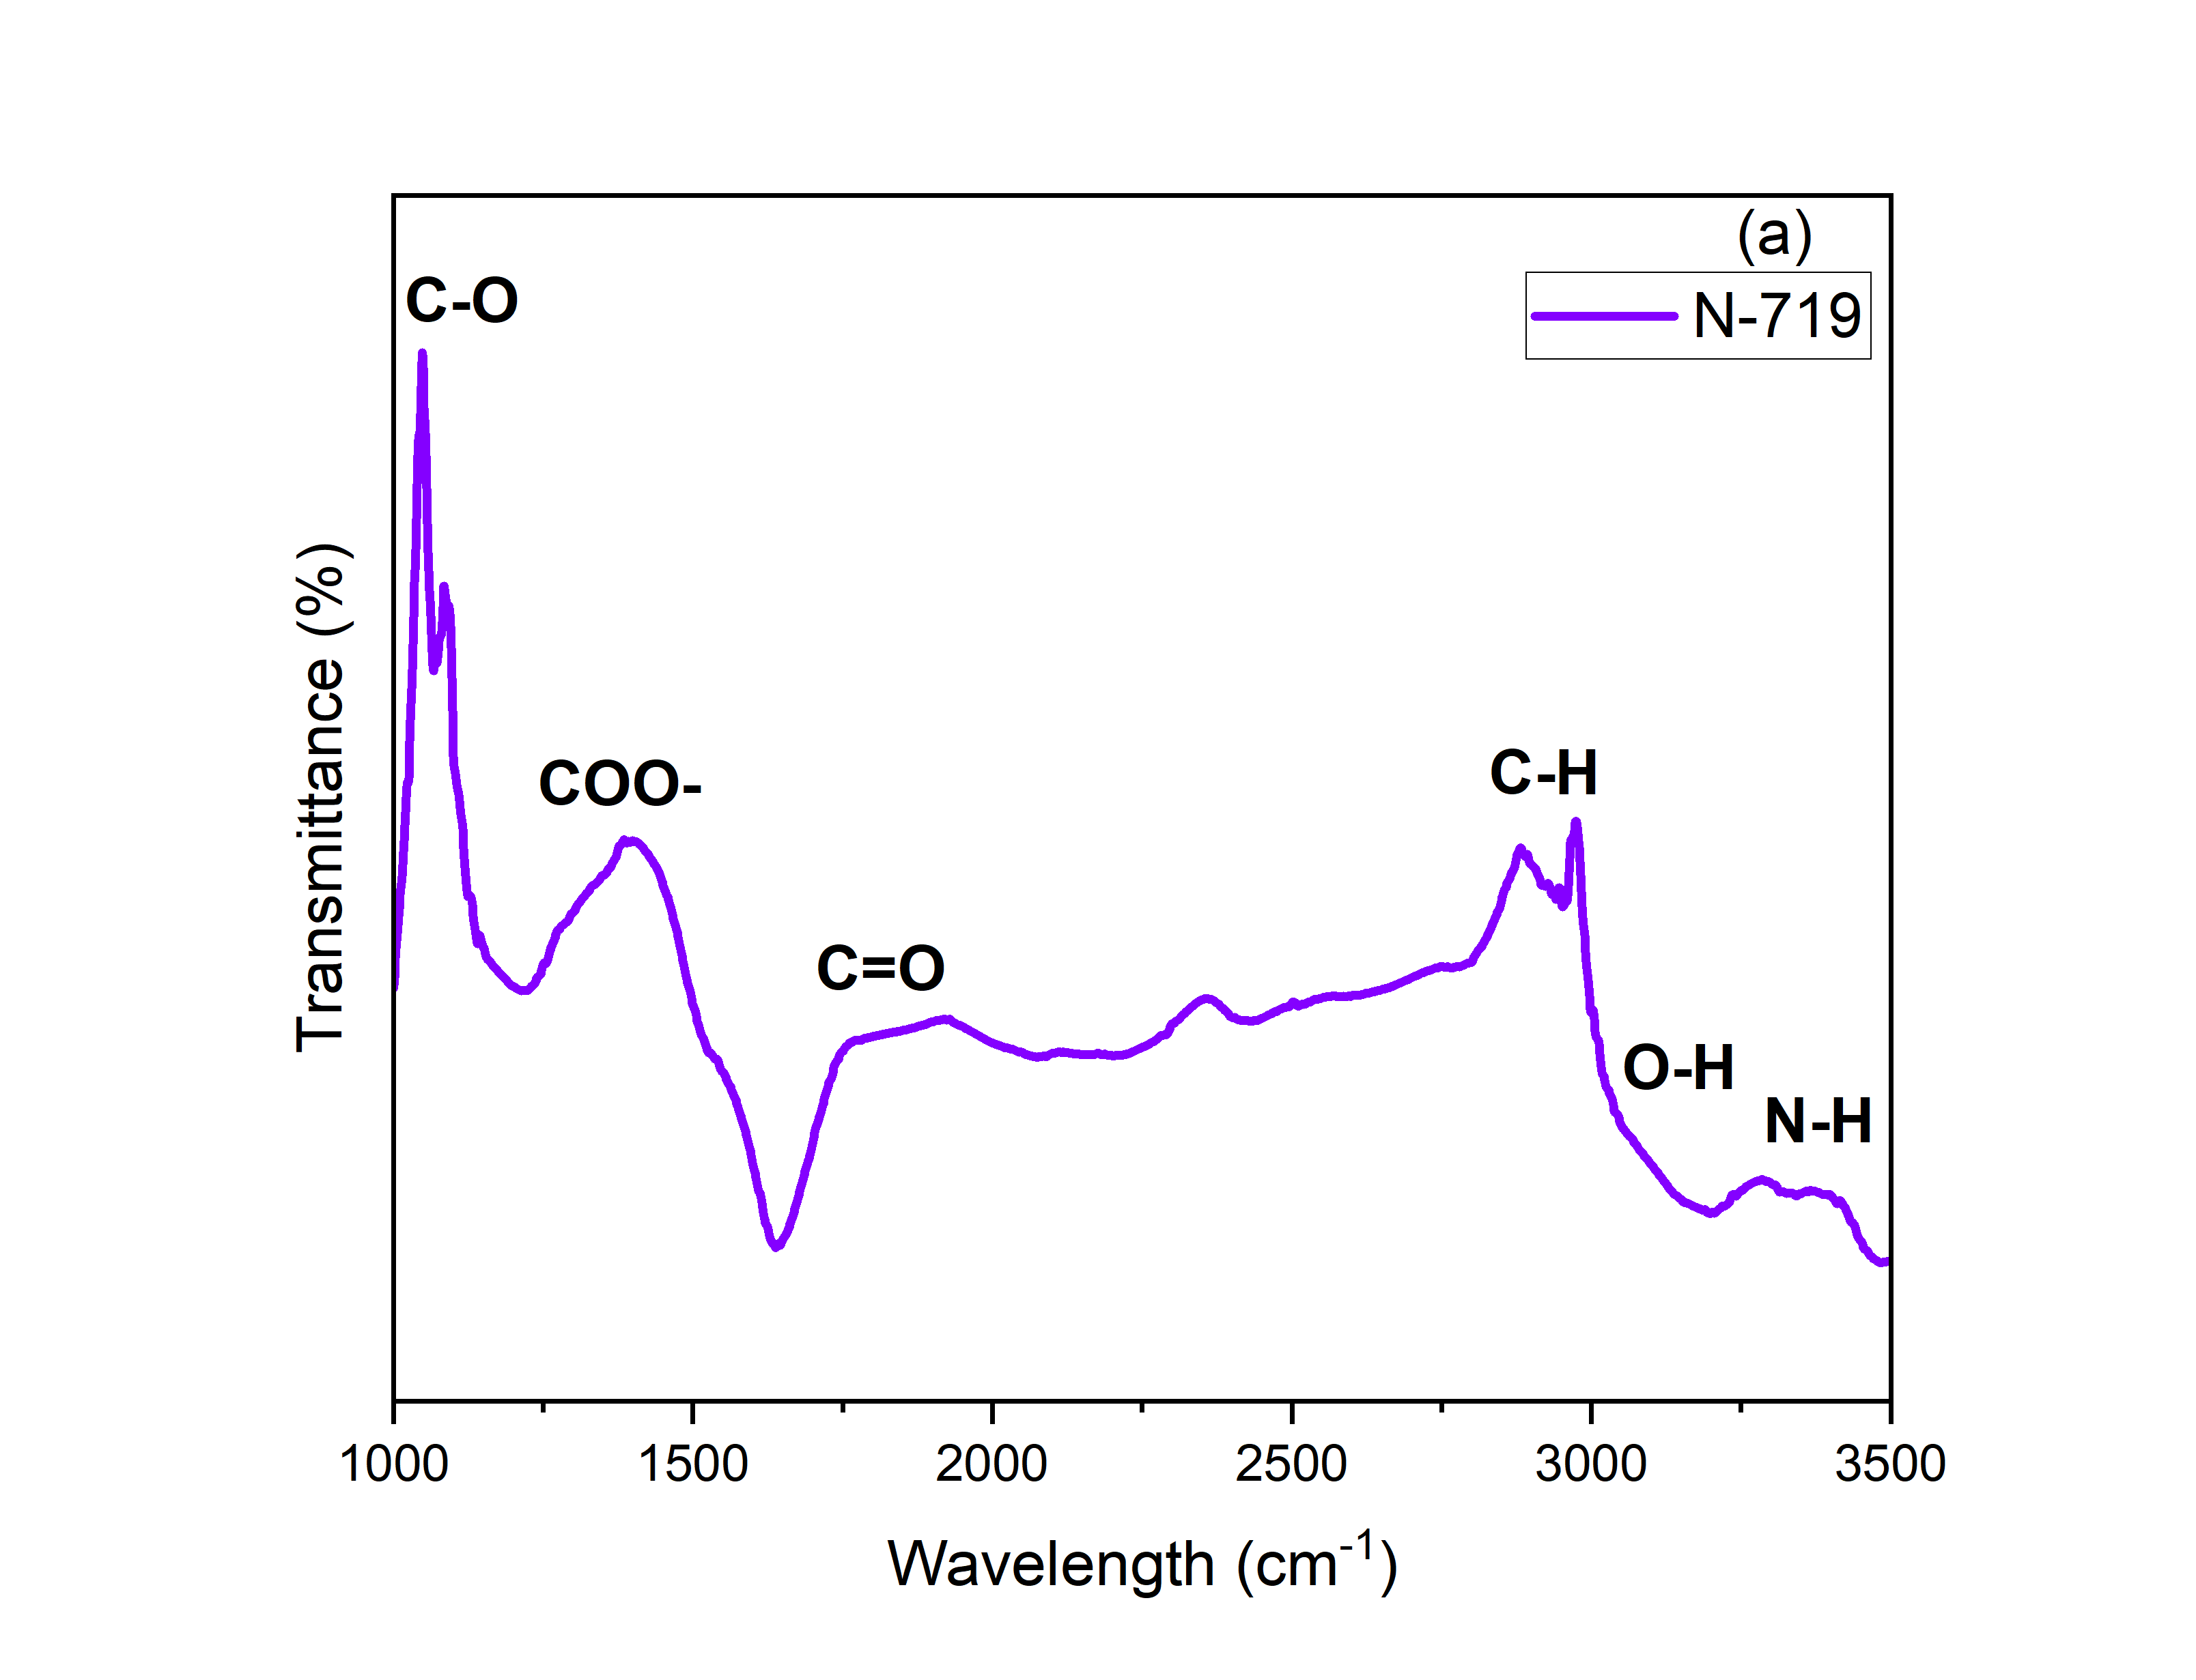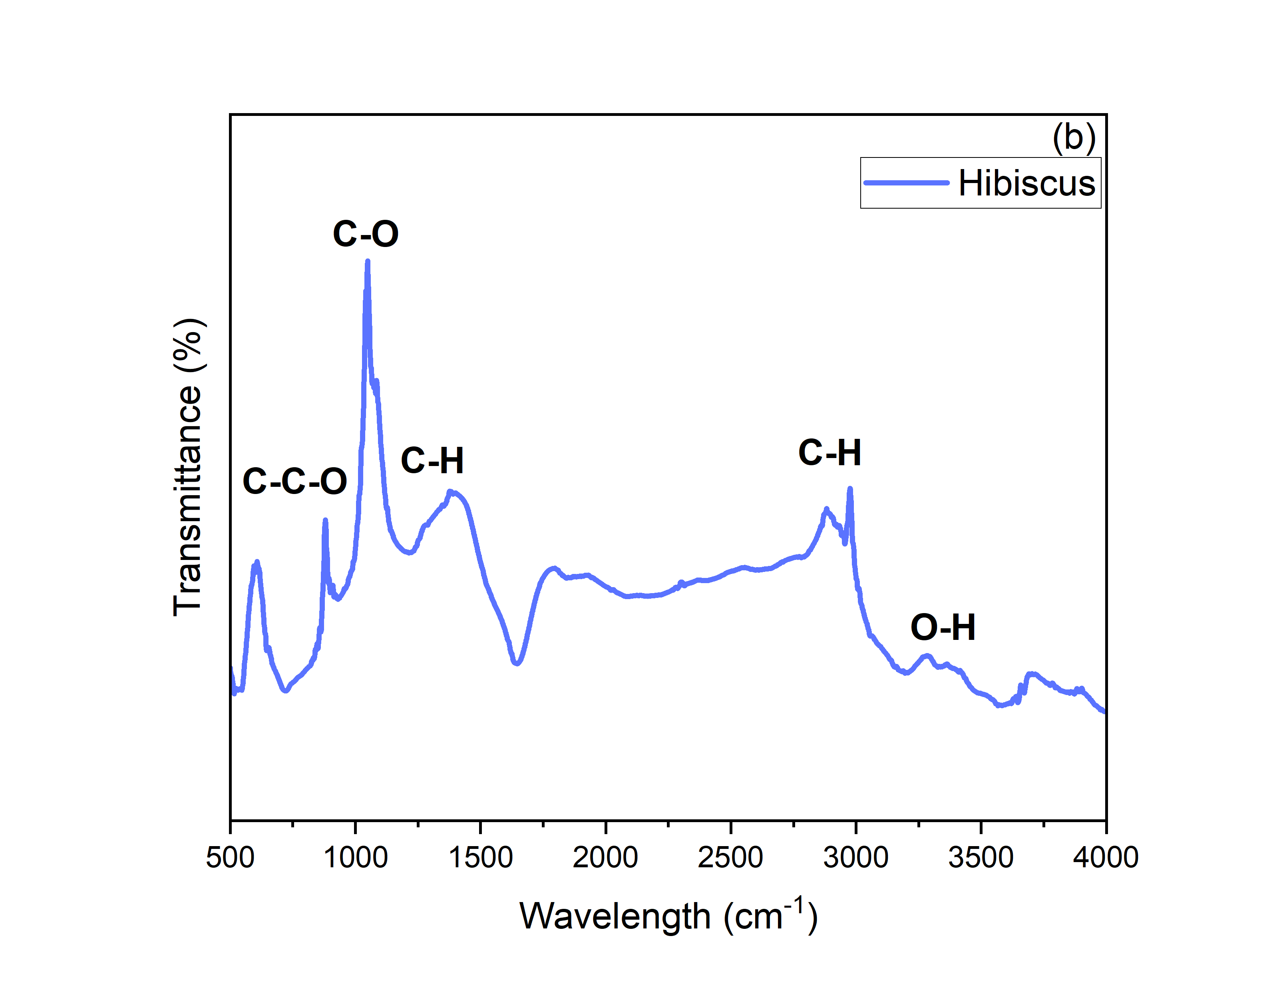
Figure S32: FTIR spectrum of dyes obtained from (a) N-719 (b) hibiscus plant

