Supporting Materials

Al-Mediated Doping Boosts Photocatalysis and Room-Temperature Ferromagnetism in Sol–Gel ZnS Thin Films

Sultan Göktaş^{1,2*}

¹Ministry of National Education, Ziyaeddin Middle School, Sanliurfa 63300, Turkey
²Harran University, Faculty of Science and Arts, Department of Chemistry, Sanliurfa 63290, Turkey

*Corresponding Author: Tel: +090 5 63161975 (Mobile); Fax: +90 414 318 30 00
Email: sultangoktas@harran.edu.tr

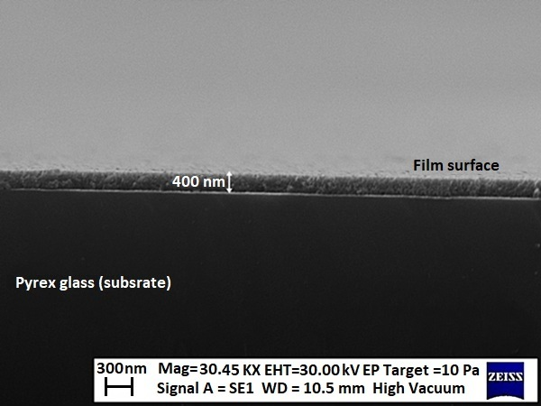
Fig. S1. Cross-sectional SEM image of the ZAS-3 film sample.

