Supporting information
Additive Manufacturing of Zirconia‑Stabilized Silica-Phosphate Glasses from Sol-Gel-based Photocurable Inks

Daria Savraeva^{a1}, May Yam Moshkovitz-Douvdevany^{a2}, Vitaly Gutkin^{b}, Shlomo Magdassi^{a, b}*
ORCID: 0000-0002-5551-4792, 0000-0002-2570-3656, 0000-0002-6794-0553
ªCasali Center for Applied Chemistry, Institute of Chemistry, The Hebrew University of Jerusalem, Jerusalem, Israel
^{b}Center for Nanoscience and Nanotechnology, The Hebrew University of Jerusalem, Jerusalem, Israel
*Corresponding author: magdassi@mail.huji.ac.il

- Glass structure characterization
To analyse structural features, FTIR spectroscopy was performed for three samples: pure SiO₂, 96SiO₂-4P₂O₅, and 92SiO₂-4ZrO₂-4P₂O₅ glasses. The spectra are shown in Fig. S1.
In pure silica glass, prominent characteristic peaks were observed at 798 and 960 cm⁻¹, corresponding to the symmetric stretching of Si-O-Si [1] and Si-OH [1] or Si-O⁻ NBOs [2], respectively. The peak at 1060 cm⁻¹ corresponds to the asymmetric Si-O-Si stretching vibration [3, 4].
For silica-phosphate glass (red line), a shift of the main peak, from 1060 cm⁻¹ to 1030 cm⁻¹, which is attributed to a difference in compositions and surrounding bands, is observed. According to the results of Lindner et al., the peak at 1027 cm⁻¹ is the Si-O-Si band [5]. The peak shapes of silica and silica-phosphate glass are similar, but the latter is more intense, possibly due to signal overlap. Building on Lindner et al.’s research, the peak at 970 cm⁻¹ may correspond to the P-O-P bond [5]. There is no resolved peak at 1100 cm⁻¹ corresponding to P-O-Si [5]; however, the altered shape of the primary signal (1030 cm⁻¹) compared to pure silica may indicate the presence of this band.
The blue line represents the FTIR data of silica-zirconia-phosphate glass. The shape of the main peak (1086 cm⁻¹) differs from that of pure silica and silica-phosphate glasses, and its position has changed, but it probably still corresponds to asymmetric stretching of Si-O-Si [6]. The signal at 957 cm⁻¹ may be attributed to the Si-O-Zr band according to studies on silica-zirconia systems of Alhooshani et al. and He et al. [7, 8]. These spectral features indicate Zr incorporation into the glass network; however, the precise coordination environments require further analysis.
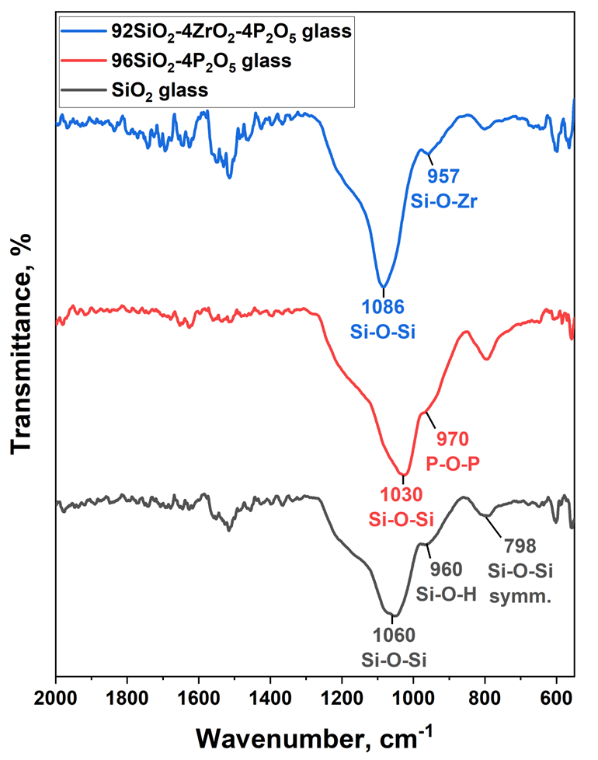
Figure S1 - FTIR spectra of grey - pure SiO₂, red - 96SiO₂-4P₂O₅, and blue - 92SiO₂-4ZrO₂-4P₂O₅ glasses.

X‑ray photoelectron spectroscopy (XPS) was used to probe the surface chemical environments in 96SiO₂-4P₂O₅ and 92SiO₂-4P₂O₅-4ZrO₂ glasses. Finely ground powders of both compositions were analyzed, and high‑resolution spectra were acquired for the Si 2p, P 2p and Zr 3d regions. Fig. S2 presents the high-resolution XPS spectra, peak deconvolutions, backgrounds, and fitted envelopes for the following regions: (a) Si 2p and (b) P 2p of 96SiO₂-4P₂O₅ glass, (c) Si 2p, (d) P 2p and (e) Zr 3d of the 92SiO₂-4P₂O₅-4ZrO₂ glass, and (f) a comparison of the normalized P 2p spectra of 96SiO₂-4P₂O₅ and 92SiO₂-4P₂O₅-4ZrO₂ glasses. For each chemical state, the 2 p 3/2 and 2 p 1/2 components were fitted as a spin-orbit doublet with a fixed area ratio of 2:1, fixed spin-orbit splitting 0.60 ± 0.05 eV for Si 2p and 0.90 ± 0.05 eV for P 2p), and identical full width at half maximum.
In both 96SiO₂-4P₂O₅ (Fig. S2a) and 92SiO₂-4P₂O₅-4ZrO₂ (Fig. S2c) Si 2p envelope consisted of contributions from at least two chemically distinct environments. The main doublet, with Si 2p 3/2 at ≈102.7 eV and Si 2p 1/2 ≈103.3 eV was assigned to fully polymerized Si-O-Si (green line for Si 2p 3/2 and purple line for Si 2p 1/2) units characteristic of tetrahedral Si⁴⁺ [9–11] in silica‑rich networks. A second doublet at slightly lower binding energy (Si 2 p 3/2 ≈ 102.1 eV and Si 2 p 1/2 ≈ 102.7 eV) is attributed to silicon in non‑bridging environments such as Si-OH [12] (red line for Si 2p 3/2 and blue line for Si 2p 1/2) or Si-O-P, which are commonly formed in sol-gel-derived silicate and silicate-phosphate glasses [13]. The coexistence of these components, together with the overall peak broadening, indicates a mixture of bridging and non-bridging oxygens, consistent with partial condensation and residual hydroxyl groups in the sol-gel glasses.
Similarly, P 2p spectra for both 96SiO₂-4P₂O₅ (Fig. S2b) and 92SiO₂-4P₂O₅-4ZrO₂ (Fig. S2d) were fitted with two chemically distinct doublets.
For 96SiO₂-4P₂O₅, the dominant contribution, with P 2 p 3/2 ≈135.1 eV and P 2 p1/2 at ≈136.0 eV corresponds to P⁵⁺ in phosphate groups [14–16], P-O-P/P-O-Si (green line for P 2p 3/2 and purple line for P 2p 1/2), within a cross‑linked phosphate-silicate network[17]. A second component at slightly lower binding energy, with P 2p 3/2 at 134.3 eV and P 2p 1/2 at 135.2 eV was assigned to P-OH-containing species [18] (red line for P 2p 3/2 and blue line for P 2p 1/2) arising from incomplete condensation and residual -OH groups. The asymmetric line shape and width of the P 2p envelope, therefore, reflect a distribution of phosphate environments ranging from fully condensed P-O-P [19] linkages to partially protonated P-O-H groups [18]. For 92SiO₂-4P₂O₅-4ZrO_{2,} the main phosphate contribution is located at P 2p 3/2 = 135.2 eV and P 2p 1/2 = 136.1 eV, while the lower binding energy component appears at P 2p 3/2 = 134.5 eV and P 2p 1/2 = 135.4 eV. Compared to 96SiO₂-4P₂O₅ glass, the main phosphate peak shows a positive shift of approximately 0.1 eV, indicating a possible modification of the local phosphate environment due to zirconium incorporation.
The Zr 3d spectrum (Fig. S2e, magenta solid line) forms a well-defined doublet of 3d 5/2 at 183.90 eV (Fig. S2e, green dots) and 3d 3/2 at 186.24 eV (Fig. S2e, yellow dots). These binding energies correspond to Zr⁴⁺ in zirconium-oxygen species [20–22], indicating that zirconium is in the network as a fully oxidized cation.
Overall, the XPS analysis demonstrates the presence of Si-O-Si and Si-OH/Si-O-P environments for silicon, P-O-P and P-O-H/P-O-Si units for phosphorus, and fully oxidized Zr-O species for zirconium, all embedded in a mixed silicate-phosphate-zirconia glass network. The coexistence of bridging and non‑bridging oxygens and of hydroxyl‑containing species is consistent with sol-gel synthesis [23].
Additionally, the normalized P 2p peaks of 96SiO₂-4P₂O₅ and 92SiO₂-4P₂O₅-4ZrO₂ glasses were compared (Fig.S2d, red and blue curves, respectively). The P 2p signal is significantly stronger for the 92SiO₂-4P₂O₅-4ZrO₂ glass compared to the 94SiO₂-4P₂O₅-4ZrO₂ sample. This funding, in addition to EDS, demonstrates the role of zirconia in maintaining phosphate within the glass structure.
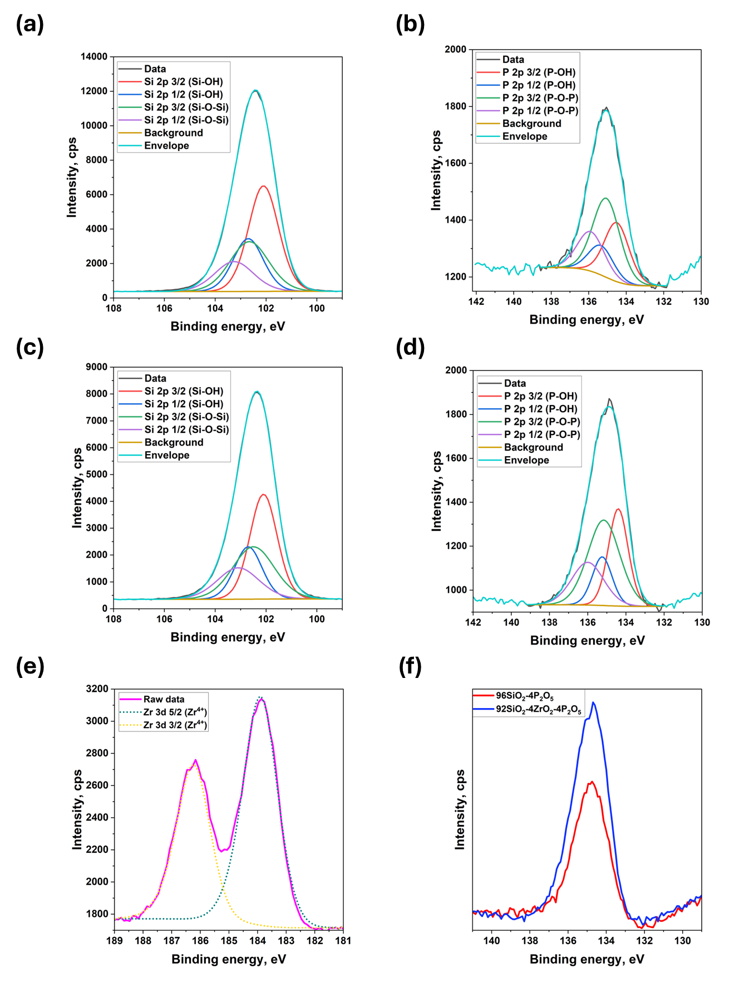
Figure S2. XPS spectra of 96SiO₂-4P₂O₅ glass: a - Si 2p, b - P 2p, and of 92SiO₂-4P₂O₅-4ZrO₂ glass: c - Si 2p, d - P 2p, e - Zr 3d; f - comparison of the XPS spectra P 2p peaks of 96SiO₂-4P₂O₅ and 92SiO₂-4P₂O₅-4ZrO₂ glasses
- Detection of voids and defects in sintered glass
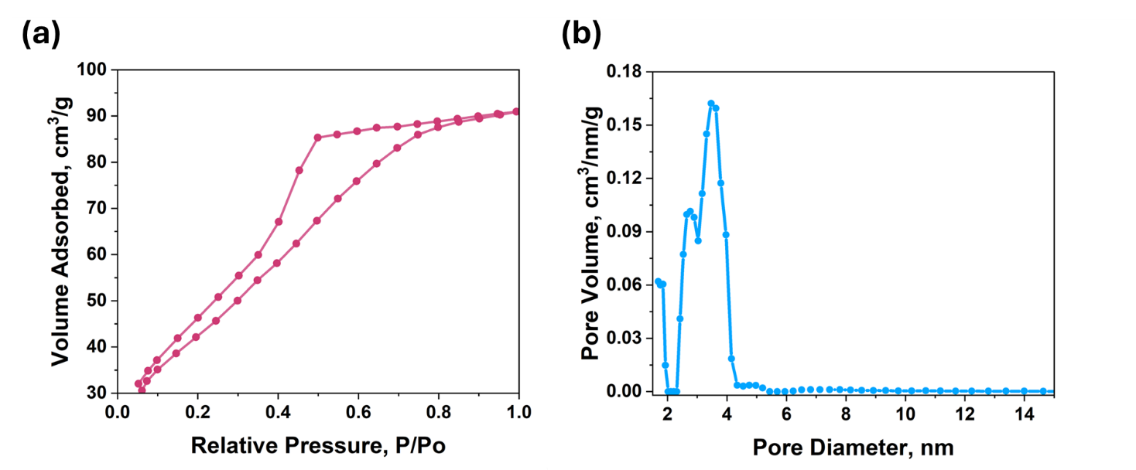
Figure S3 – Porosity of 98SiO₂-2P₂O₅ samples studied with N₂ adsorption-desorption measurements using the Brunauer-Emmett-Teller (BET). (a) - Adsorption-desorption isotherm, (b) - pore size distribution using the DFT model.
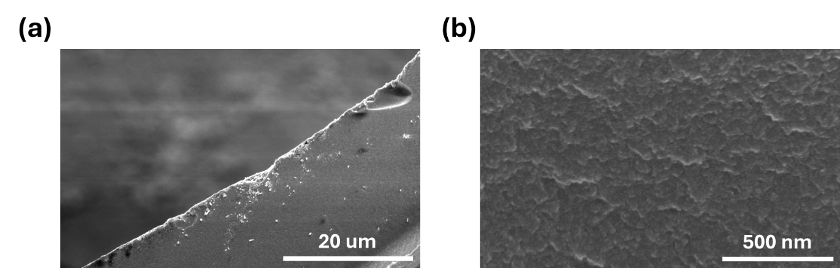
Figure S4 – Cross-sectional SEM images of the 98SiO₂-2P₂O₅ sample showing (a) the surface and (b) the internal morphology.

- Photoluminescence measurements of Nd³⁺-doped samples
In our work, we initially used an excitation wavelength of 680 nm, which corresponds to one of the absorption bands of Nd³⁺ observed in the absorbance spectra (Fig. 7d). These spectra display several distinct absorption maxima at approximately 511, 523, 581, 680, 745, 800, and 870 nm. Under excitation at 680 nm using a Xe lamp equipped with a monochromator (narrow-band selection of the excitation wavelength), we observed a broad emission band centered around 850 nm (Fig. 7e, f).
To examine if the broad PL band is not an artifact of the excitation conditions, and to strengthen the assignment of this emission to Nd³⁺, we performed additional PL measurements for a 94SiO₂-2P₂O₅-4ZrO₂ glass sample doped with 0.7 mol% of Nd₂O₃ using a different excitation wavelength, 745 nm, which corresponds to another Nd³⁺ absorption maximum. As shown in the new Fig. S5, excitation at 745 nm produced an emission band with the same spectral shape and peak position around 850 nm. This consistency across two distinct excitation wavelengths within Nd³⁺ absorption bands confirms that the observed PL originates from Nd³⁺ ions and is not an artifact of the chosen excitation wavelength.
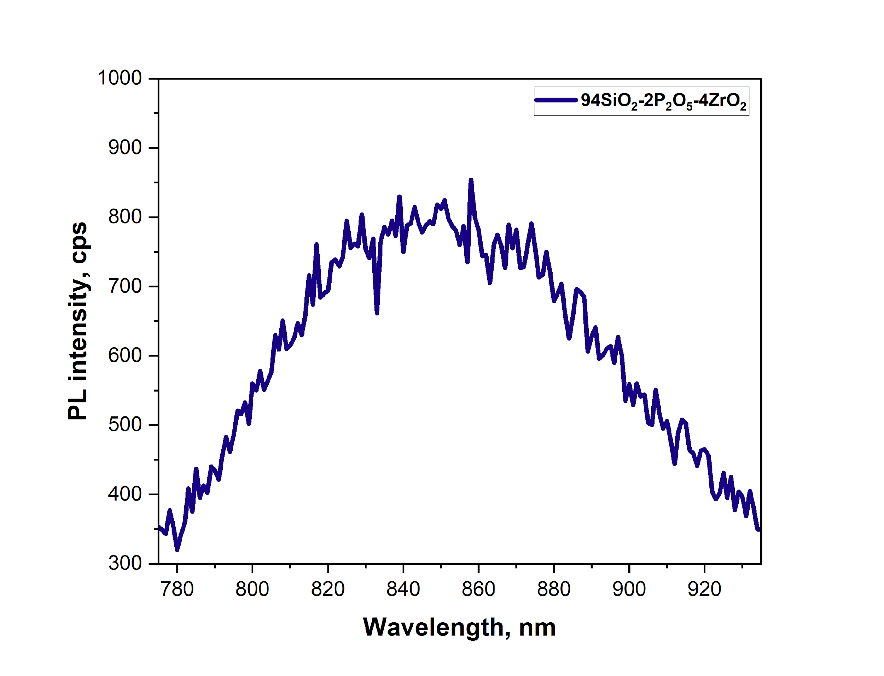
Figure S5 - PL intensity for glass casted sample with the composition 94SiO₂-2P₂O₅-4ZrO₂ doped with 0.7 mol% of Nd₂O₃ under excitation at 745 nm using a Xe lamp equipped with a monochromator.

- Phosphorus loss
In sol-gel synthesis of phosphate glasses, TEOS hydrolyses rapidly to form a silica backbone, while TEP hydrolyses slowly and remains largely unhydrolyzed. TEP molecules get expelled to particle surfaces and interstices during silica gel formation, concentrating there in the xerogel. Thermogravimetric data published by Bueno et al. [24] confirm significant mass loss around 215 °C due to TEP vaporization, followed by P₂O₅ compositional loss before 700 °C. Moreover, the findings of Anastasescu et al. [9] revealed the evaporation of phosphorous alkoxides, such as triethyl phosphate, used as phosphorous precursors, during the thermal treatment of sol-gel-derived films at 200-500 °C. To experimentally confirm its evaporation, we heated a 3D-printed, aged 94SiO₂-4ZrO₂-2P₂O₅ glass sample at 400 °C, a temperature much lower than that used for sintering in the current research (700 °C). According to the EDS results of this sample, the phosphorus content was 1.5 ± 0.1 at. %, which is significantly lower than the expected 2.5 at.%. This confirms that phosphorus already leaves the glass structure at temperatures below the sintering temperature used in this study.
References
1. Panwar K, Jassal M, Agrawal AK (2014) In situ synthesis of Ag–SiO2 Janus particles with epoxy functionality for textile applications. Particuology. https://doi.org/10.1016/j.partic.2014.06.007
2. Serra J, González P, Liste S, et al (2002) Influence of the non-bridging oxygen groups on the bioactivity of silicate glasses. J Mater Sci Mater Med 13:1221–1225. https://doi.org/10.1023/A:1021174912802
3. Grill A, Neumayer DA (2008) Structure of low dielectric constant to extreme low dielectric constant SiCOH films: Fourier transform infrared spectroscopy characterization. https://doi.org/10.1063/1.1618358
4. Cassetta M, Soraru GD, Callone E, et al (2025) From SiO1.5CH3 to vitreous SiO2: A structural evolution study. 648:. https://doi.org/10.1016/j.jnoncrysol.2024.123327
5. Lindner FL, Aichele CA, Kriltz AK, et al (2022) FTIR multispectral imaging of P / Al-doped silica glass preforms prepared by MCVD in combination with the high temperature evaporation of AlCl 3. 12:184–195
6. Liu H, Kim SH, Lin Y, Ogrinc A (2022) Vibrational spectroscopy analysis of silica and silicate glass networks. 2355–2384. https://doi.org/10.1111/jace.18206
7. Alhooshani K, Kim T, Kabir A, Malik A (2005) Sol – gel approach to in situ creation of high pH-resistant surface-bonded organic – inorganic hybrid zirconia coating for capillary microextraction. 1062:1–14. https://doi.org/10.1016/j.chroma.2004.10.103
8. He W, Ding N, Hou B, Zhang Z Bonding effect of a Zr / Si coating prepared on zirconia using a sol-gel method. J Prosthet Dent 129:787.e1-787.e9. https://doi.org/10.1016/j.prosdent.2023.03.013
9. Sawyer R, Nesbitt HW, Secco RA (2012) High resolution X-ray Photoelectron Spectroscopy (XPS) study of K 2O-SiO2 glasses: Evidence for three types of O and at least two types of Si. J Non Cryst Solids 358:290–302. https://doi.org/10.1016/j.jnoncrysol.2011.09.027
10. Li Z, Jia Y, Duan K, et al (2024) One-photon three-dimensional printed fused silica glass with sub-micron features. Nat Commun 15:. https://doi.org/10.1038/s41467-024-46929-x
11. Simonsen ME, Sønderby C, Li Z, Søgaard EG (2009) XPS and FT-IR investigation of silicate polymers. J Mater Sci 44:2079–2088. https://doi.org/10.1007/s10853-009-3270-9
12. Huang R, Tang M, Kan W, et al (2024) Single-crystalline LiNbO3 integrated onto Si-based substrates via Ar plasma-activated low-temperature direct bonding. J Phys D Appl Phys 57:. https://doi.org/10.1088/1361-6463/acff05
13. Logrado M, Eckert H, Ikeda H, et al (2022) Silica incorporation into sodium aluminum phosphate glasses: Structural characterization by Raman spectroscopy and multinuclear solid-state NMR. J Non Cryst Solids 579:. https://doi.org/10.1016/j.jnoncrysol.2021.121366
14. Moulder JF, Stickle WF, Sobol PE, Bomben KD (1993) Handbook of X-ray photoelectron spectroscopy (XPS)
15. Rotole JA, Sherwood PMA (1998) Aluminum Phosphate by XPS. Surf Sci Spectra 5:60–66. https://doi.org/10.1116/1.1247858
16. Zaharescu M, Vasilescu A, Badescu V, Radu M Hydrolysis-Polycondensation in Binary Phosphorus Alkoxides-TEOS System Studied by GC-MS. Kluwer Academic Publishers
17. Massiot P, Centeno MA, Carrizosa I, Odriozola JA Thermal evolution of sol±gel-obtained phosphosilicate solids (SiPO)
18. Sherwood PMA (2002) Introduction to Studies of Phosphorus-Oxygen Compounds by XPS. Surf Sci Spectra 9:62–66. https://doi.org/10.1116/11.20030101
19. Shih PY, Yung SW, Chin TS (1999) FTIR and XPS studies of P2O5-Na2O-CuO glasses. J Non Cryst Solids 244:211–222. https://doi.org/10.1016/S0022-3093(99)00011-3
20. Morant C, Sanz JM, Galán L, et al (1989) An XPS study of the interaction of oxygen with zirconium. Surf Sci 218:331–345. https://doi.org/10.1016/0039-6028(89)90156-8
21. Gondal MA, Fasasi TA, Baig U, Mekki A (2017) Effects of Oxidizing Media on the Composition, Morphology and Optical Properties of Colloidal Zirconium Oxide Nanoparticles Synthesized via Pulsed Laser Ablation in Liquid Technique. J Nanosci Nanotechnol 18:4030–4039. https://doi.org/10.1166/jnn.2018.15244
22. Lackner P, Zou Z, Mayr S, et al (2019) Using photoelectron spectroscopy to observe oxygen spillover to zirconia. Phys Chem Chem Phys 21:17613–17620. https://doi.org/10.1039/c9cp03322j
23. Palomeque Chávez JC, Mohammed AA, Aghajanpour S, et al (2025) One-pot sol–gel synthesis of Sr/Ca-doped silica nanoparticles for osteogenic therapy in osteoporosis. Front Nanotechnol 7:1–17. https://doi.org/10.3389/fnano.2025.1634210
24. Bueno OMVM, Herrera CL, Bertran CA, et al (2021) An experimental and theoretical approach on stability towards hydrolysis of triethyl phosphate and its effects on the microstructure of sol-gel-derived bioactive silicate glass. Mater Sci Eng C 120:. https://doi.org/10.1016/j.msec.2020.111759

