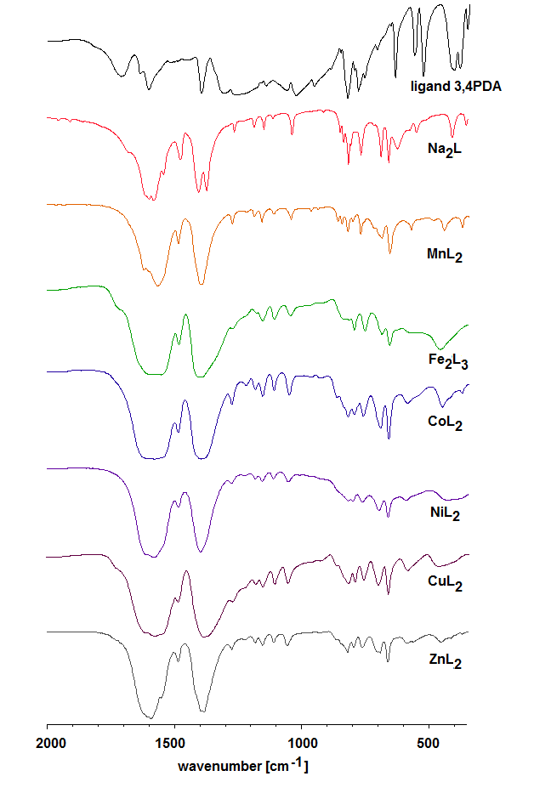

Fig S1. IR spectra of 3,4-pyridinedicarboxylates in the range 2000-400 cm⁻¹
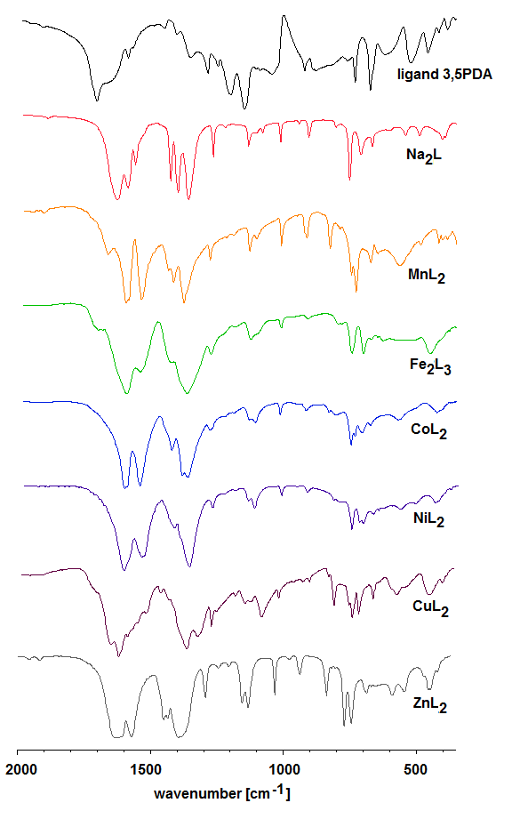

Fig S2. IR spectra of 3,5-pyridinedicarboxylates in the range 2000-400 cm⁻¹

