SUPPLEMENTARY MATERIAL
Thermal diffusity in copper benzene-1,3,5-tricarboxylate – reduced graphite oxide mechanical composites
Márton Gálª, Samantha K. Samaniego Andradeª, Anna Fehér^{b}, Attila Farkas^{c}, János Madarász^{d}, Lili Horváthª, Péter Gordon^{e}, Róbert Kovács^{b,f}, Krisztina László^{a*}

ªDepartment of Physical Chemistry and Materials Science, Faculty of Chemical Technology and Biotechnology, Budapest University of Technology and Economics,
Műegyetem rkp. 3., H-1111 Budapest, Hungary
^{b}Department of Energy Engineering, Faculty of Mechanical Engineering, Budapest University of Technology and Economics,
Műegyetem rkp. 3., H-1111 Budapest, Hungary
^{c}Department of Organic Chemistry and Technology, Faculty of Chemical Technology and Biotechnology, Budapest University of Technology and Economics,
Műegyetem rkp. 3., H-1111 Budapest, Hungary
^{d}Department of Inorganic and Analytical Chemistry, Faculty of Chemical Technology and Biotechnology, Budapest University of Technology and Economics,
Műegyetem rkp. 3., H-1111 Budapest, Hungary
^{e}Department of Electronics Technology, Faculty of Electrical Engineering and Informatics, Budapest University of Technology and Economics,
Műegyetem rkp. 3., H-1111 Budapest, Hungary
^{f}Department of Theoretical Physics, HUN-REN Wigner Research Centre for Physics, 1121 Budapest, Hungary
* corresponding author, email: laszlo.krisztina@vbk.bme.hu

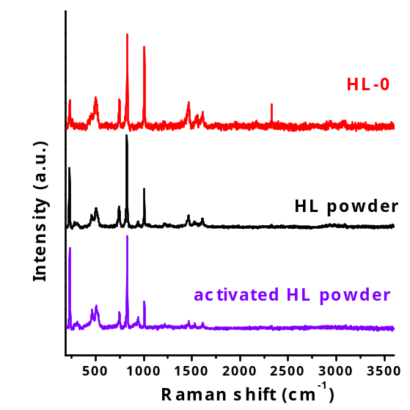 | 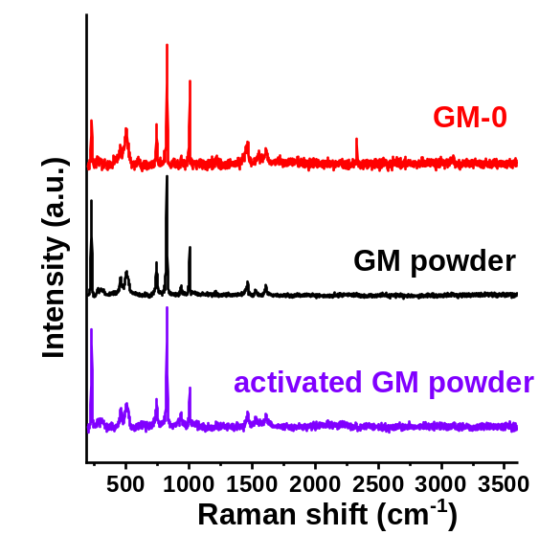
HL synthesis | GM synthesis
Figure S1 Normalized Raman spectra of as received, activated (vacuum, 110 °C) and compressed (25 bar) HKUST-1. The spectra are vertically shifted for clarity.

