Supplementary material

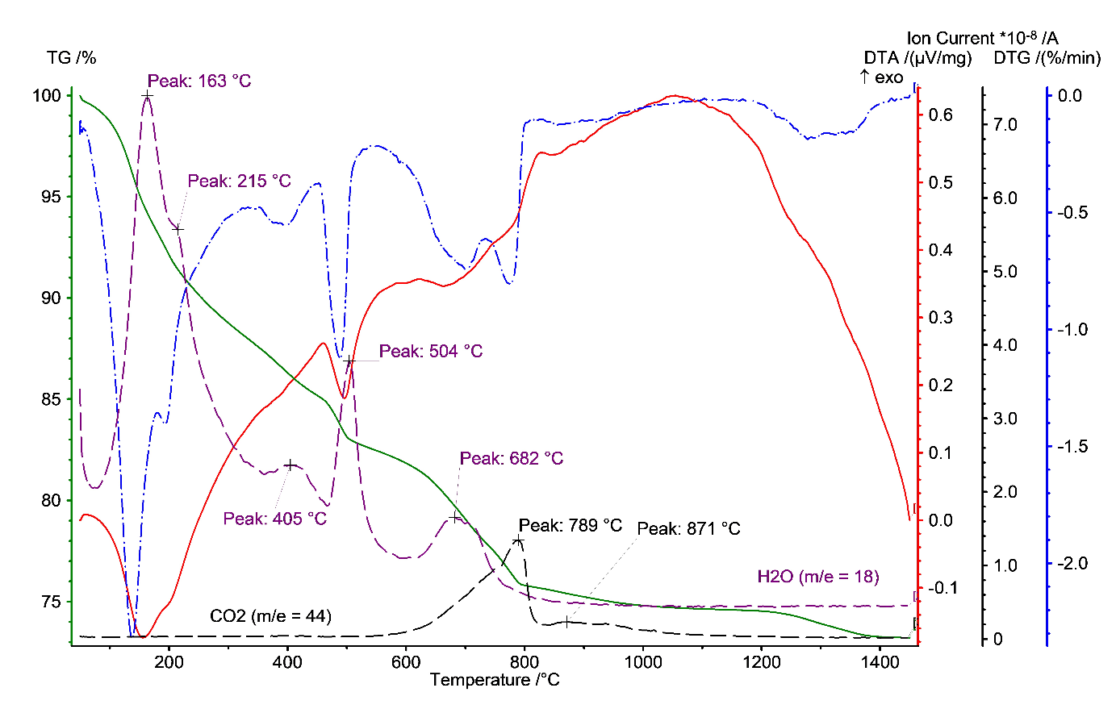
TG/DTG-EGA results of cement-asbestos sample

