Supplementary Information

Thermal behavior and determination of physicochemical properties of novel candidates for antipsychotic drugs

Piotr Stępnicki ^{1#}, Radosław Ł. Gwarda ², Agata Bartyzel ³, Tadeusz Karcz ⁴, Katarzyna Szczepańska ⁴, Tomasz M. Wróbel ¹ and Agnieszka A. Kaczor ^{1, 5,} *

¹ Department of Synthesis and Chemical Technology of Pharmaceutical Substances with Computer Modeling Laboratory, Faculty of Pharmacy, Medical University of Lublin, 4A Chodźki St., PL-20093 Lublin, Poland;
² Department of Physical Chemistry, Faculty of Pharmacy, Medical University of Lublin, 4A Chodźki St., PL-20093 Lublin, Poland;
³ Department of General and Coordination Chemistry and Crystallography, Institute of Chemical Sciences, Faculty of Chemistry, Maria Curie-Skłodowska University in Lublin, Maria Curie-Skłodowska Sq. 2, PL-20-031 Lublin, Poland;
⁴ Department of Technology and Biotechnology of Drugs, Faculty of Pharmacy, Jagiellonian University, Medical College, Medyczna 9, PL-30-688 Kraków, Poland;
⁵ School of Pharmacy, University of Eastern Finland, P.O. Box 1627, FI-70211 Kuopio, Finland;
* Correspondence: agnieszka.kaczor@umlub.pl (A.A.K.)
# current address: Independent Radiopharmacy Unit, Faculty of Pharmacy, Medical University of Lublin, 4A Chodźki St., PL-20093 Lublin, Poland

Content: Representative chromatograms for compounds 1-8.
Compound 1
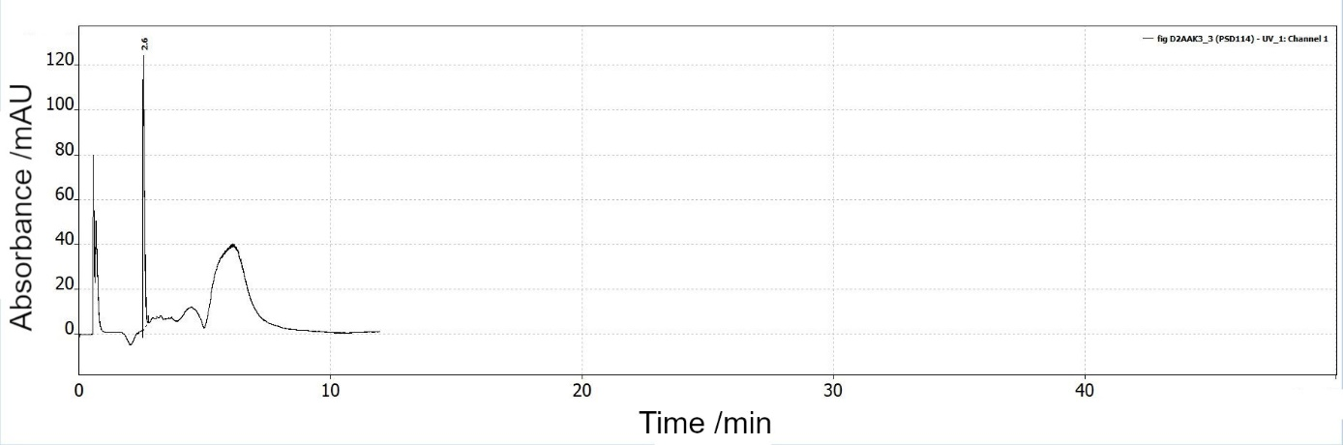
Compound 2
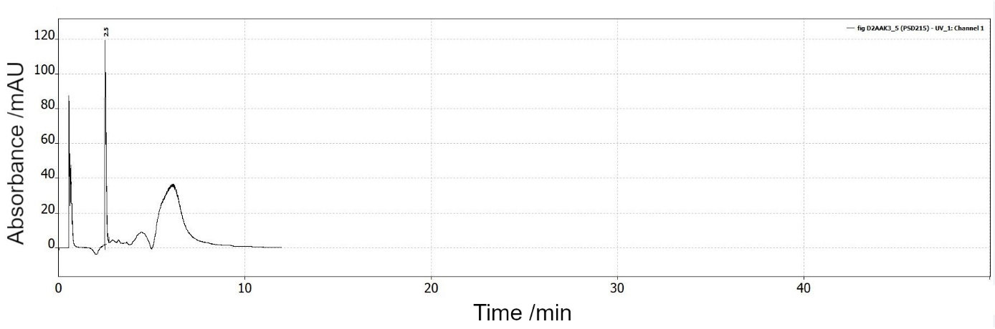
Compound 3
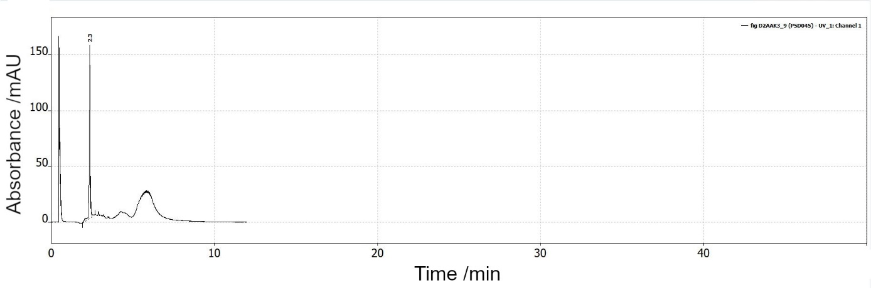

Compound 4
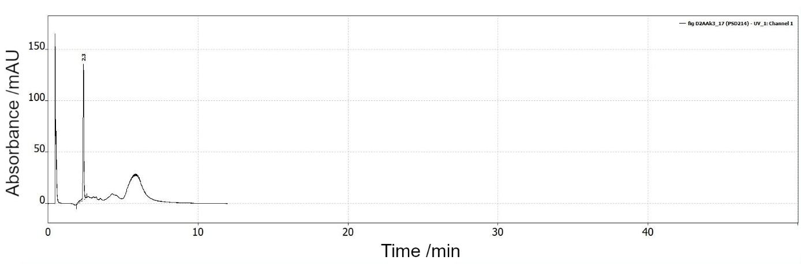
Compound 5
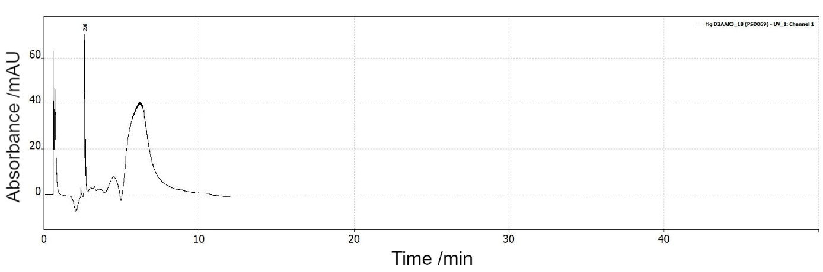
Compound 6
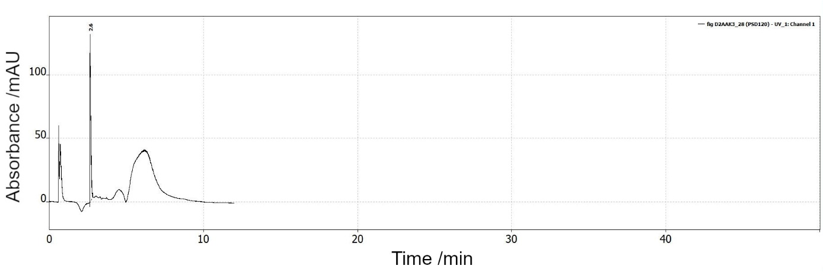

Compound 7
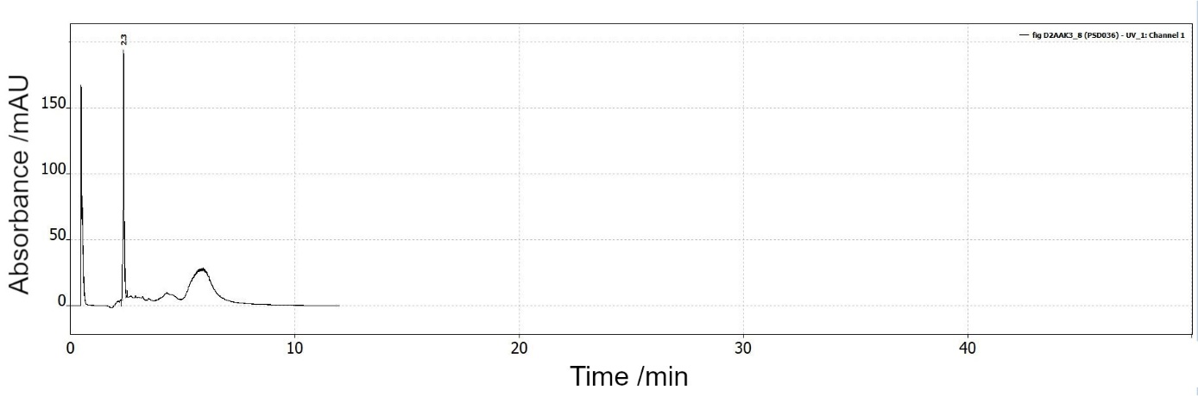
Compound 8
