Article
Evaluation of the stabilizing effect and aging time indicator properties of poly(flavonoids) in a cyclic olefin copolymer (COC)

Malgorzata Latos-Brozio ^{1,*}, Anna Masek ^{1*} Katarzyna Milczarek¹,
¹Institute of Polymer and Dye Technology, Faculty of Chemistry, Lodz University of Technology, Stefanowskiego 16, 90-537 Lodz, Poland
*Correspondence: malgorzata.latos@p.lodz.pl, ORCID: 0000-0001-6730-5464; anna.masek@p.lodz.pl, ORCID: 0000-0003-3785-1995

Supplementary material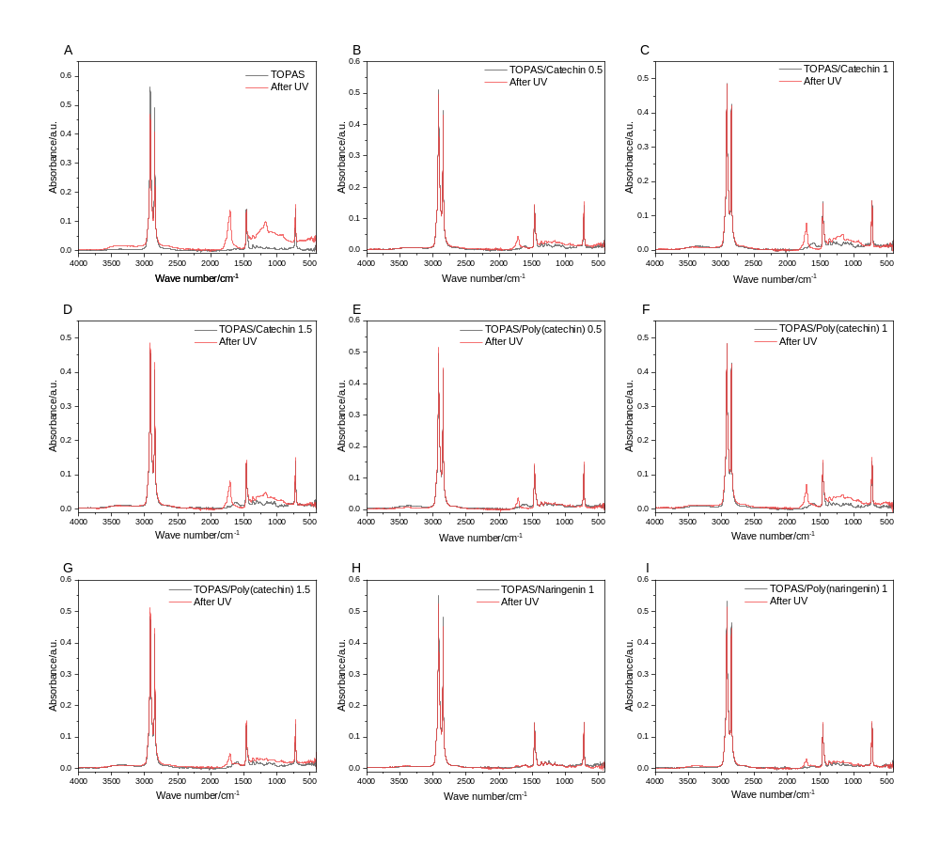
Fig. S.1. FTIR spectra of Topas (A), Topas with catechin (B, C, D), poly(catechin) (E, F, G), Topas with naringenin (H) and poly(naringenin) (I) before and after UV aging.

