SYNTHESIS, THERMAL, AND MECHANICAL CHARACTERISATION OF METAKAOLIN-BASED GEOPOLYMERS COLOURED WITH GRAPE MARC EXTRACT
Chiara Pelosi,¹ Elena Pulidori,¹ Antonio D’Angelo,*^{,2} Maria Rosaria Tiné, ¹ Michela Catauro. ²

1: Department of Chemistry and Industrial Chemistry, University of Pisa, via G. Moruzzi 13, 56124 Pisa, Italy.
2: Department of Engineering, University of Campania ‘‘Luigi Vanvitelli’’, Via Roma 29, 81031 Aversa, Italy.
*Corresponding author. E-mail: antonio.dangelo@unicampania.it

ABSTRACT
Over the years, several materials have been used for restoration purposes, with different types of dyes and colour hues. Recently, some researchers have proposed geopolymers (GPs) or amorphous aluminosilicate polymers for these purposes. In this work, an alcohol-based grape marc extract (GME, obtained via dark maceration assisted with ultrasound) was used as a natural dyeing agent for metakaolin (MK)-based GPs. The geopolymerisation occurrence was assessed by Fourier-Transform InfraRed (FT-IR) spectroscopy and X-ray diffraction analysis (XRD), while the colour of the resulting material was determined through the colourimetric analysis in the L*a*b* colour space. Additionally, the thermal stability of GME and GPs was investigated by thermogravimetry coupled with FT-IR spectroscopy. The microstructure, the reticulation stability, and the antimicrobial activity of GPs were examined through scanning electron microscopy (SEM), pH and ionic conductivity measurements, integrity, and mass loss tests. Overall, a coloured geopolymer with suitable thermal, antimicrobial, and mechanical properties was obtained, justifying its potential use in restoration or, more generally, in the construction field.

KEYWORDS. Coloured geopolymer, FT-IR, CIELab measurement, antimicrobial assessment, thermal stability, grape-marc extract.

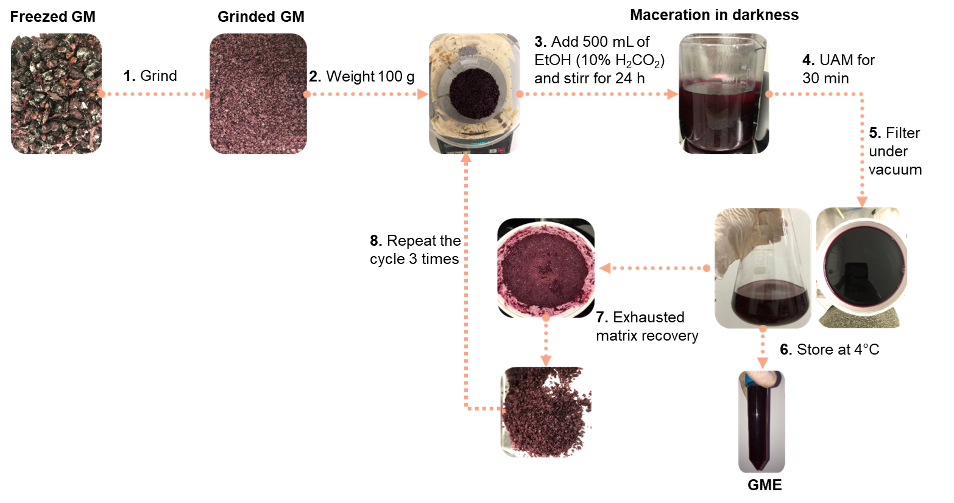
Figure S1. The flow-chart procedure of GM extraction.
Figure S2. FT-IR spectrum of the gases evolved during the thermal degradation of GME at 375°C. The spectrum was recorded in the range of 4000-600 cm⁻¹, with a zoom in the range of 3100-2700 cm⁻¹.

Figure S3. XRD diffraction patterns of a) MK and b) GP and GP-GME after 56 days of ageing time.

Figure S4: Thermograms obtained by TGA of GP and GP-GME. The analysis of the (a) GP and (b) GP-GME gases evolved during thermal degradation by FT-IR spectroscopy.

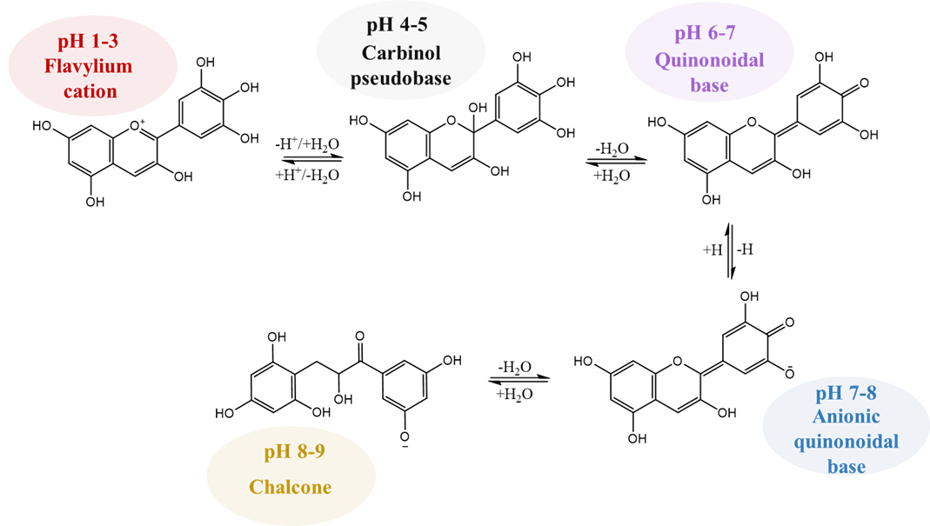
Figure S5: Molecular structures of anthocyanins as a function of pH.

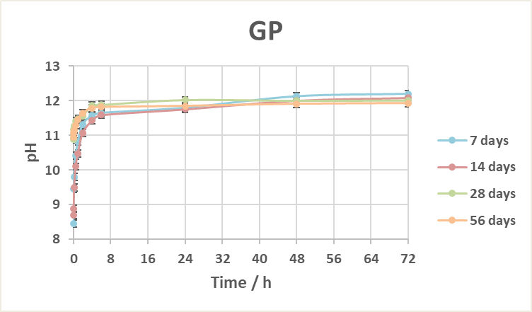
(a)
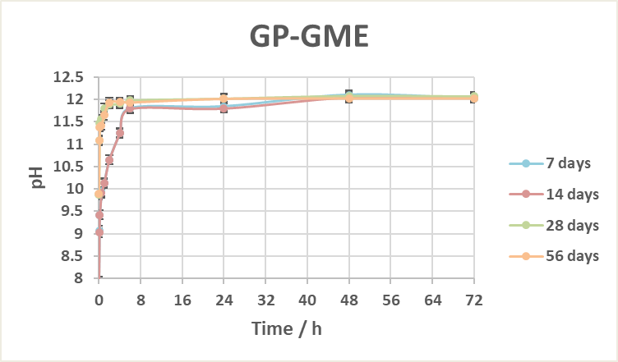
(b)
Figure S6. pH measurements of (a) GP and (b) GP-GME at different ageing times.

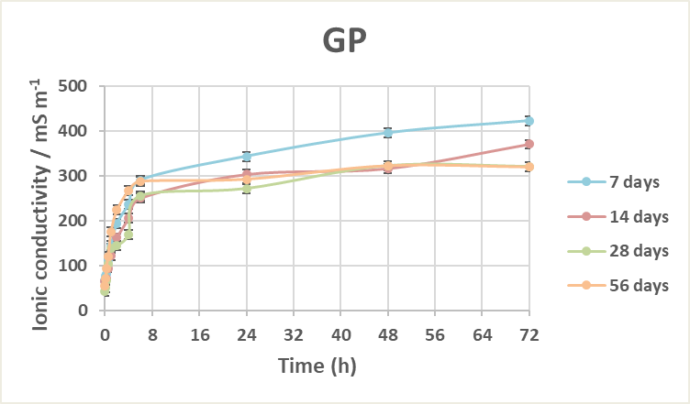
(a)
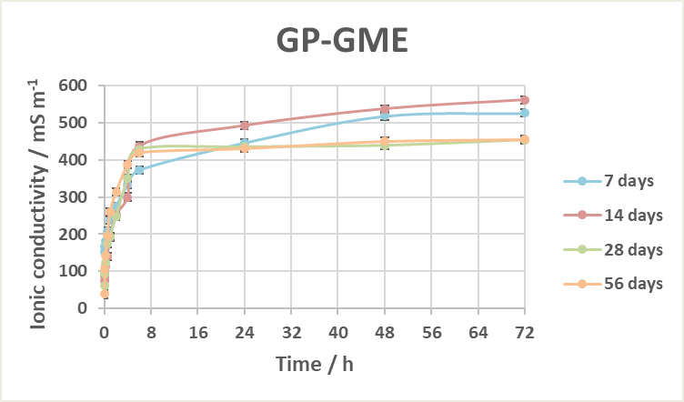
(b)

Figure S7. Ionic conductivity measurements of (a) GP and (b) GP-GME at different ageing times.

Table S1. Measured IHD and BV (%) after the incubation time of GP and GP-GME with microbial strains.
 | Escherichia coli |  | Staphylococcus aureus
 | IHD / cm | BV / % | IHD / cm | BV / %
MK | 1.41±0.04 | 76.6±0.6 | 1.36±0.02 | 77.3±0.3
GP | 1.37±0.01 | 77.21±0.08 | 1.34±0.02 | 77.7±0.3
GP-GME | 1.66±0.07 | 72±1 | 1.30±0.04 | 78.3±0.7

