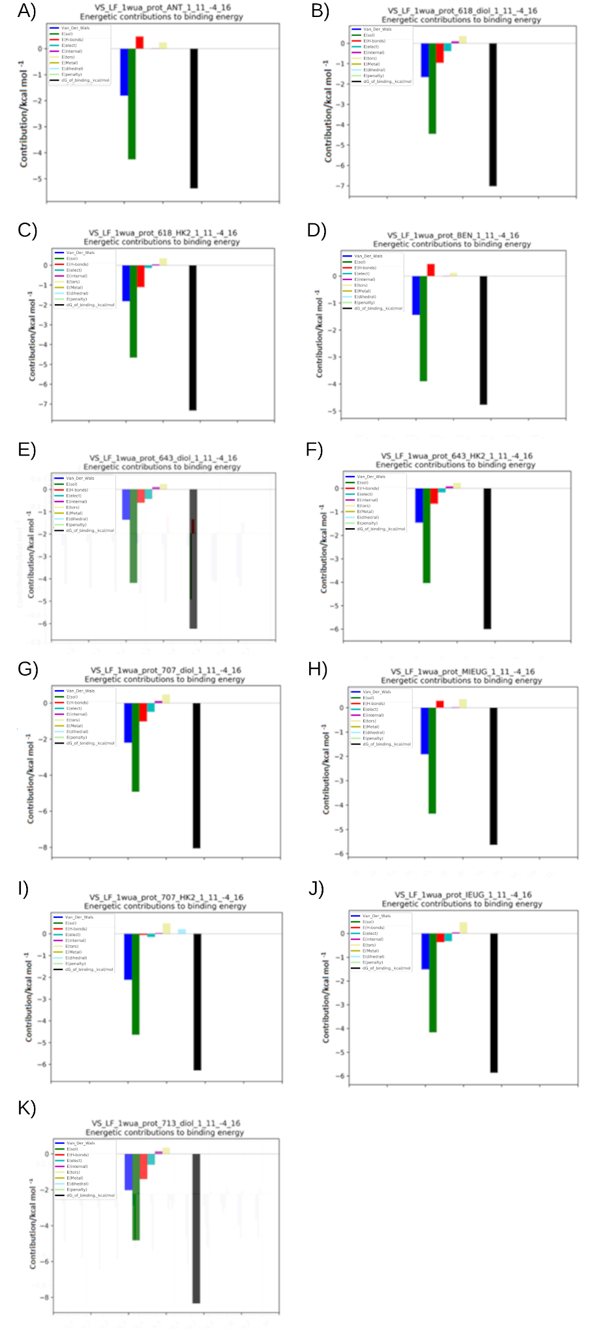

Fig Sx: Overview of the Leadfinder Molecular Docking results for Actin. The energy values of the interactions that make up the total binding energy of the propenylbenzene derivatives with actin. (a) – 3a, (b) – 3b, (c) – 3c, (d) – 2a, (e) – 2b, (f) – 2c, (g) – 4a, (h) – 4b, (i) – 4c, (j) – 5a, (k) – 5b.

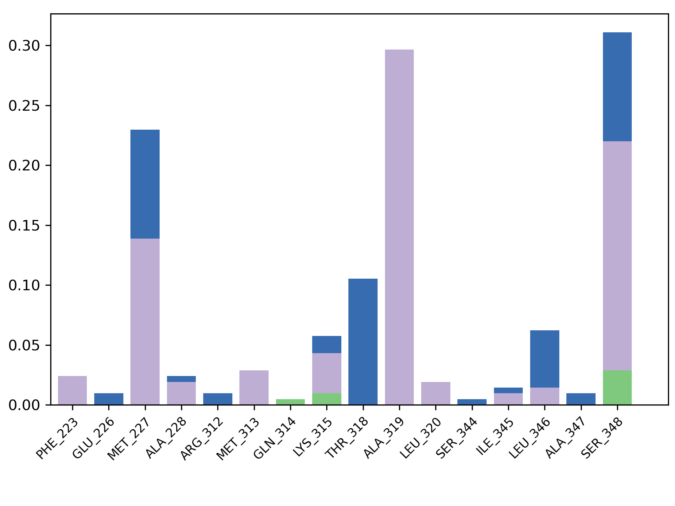
A
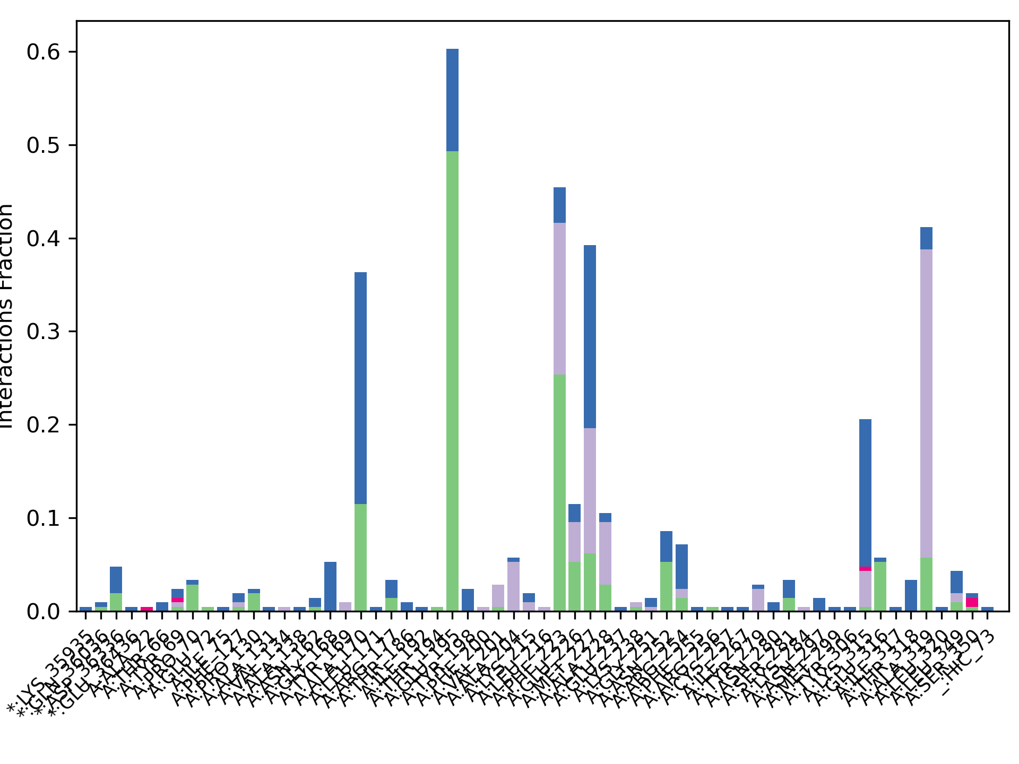
B
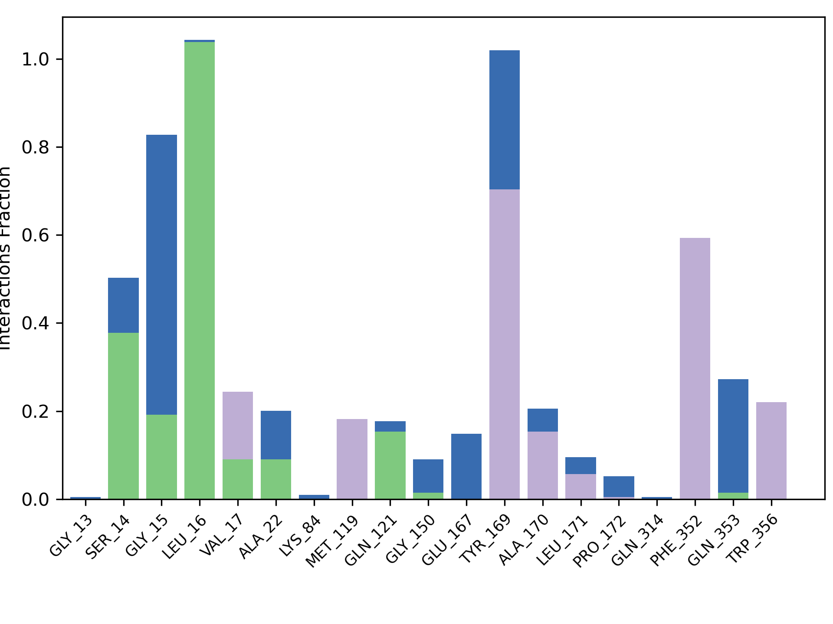
C
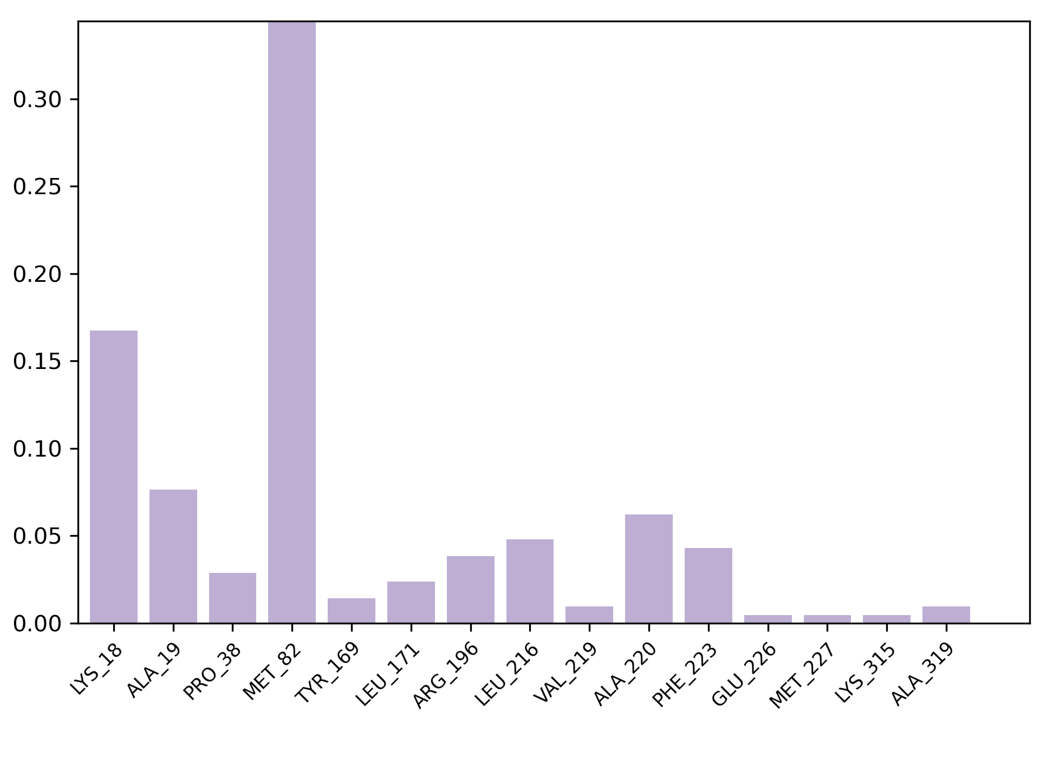
D
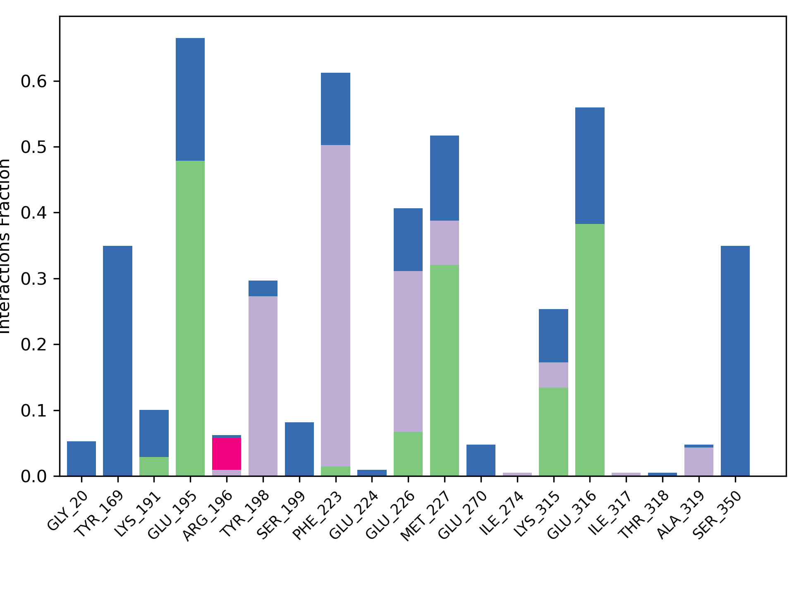
E
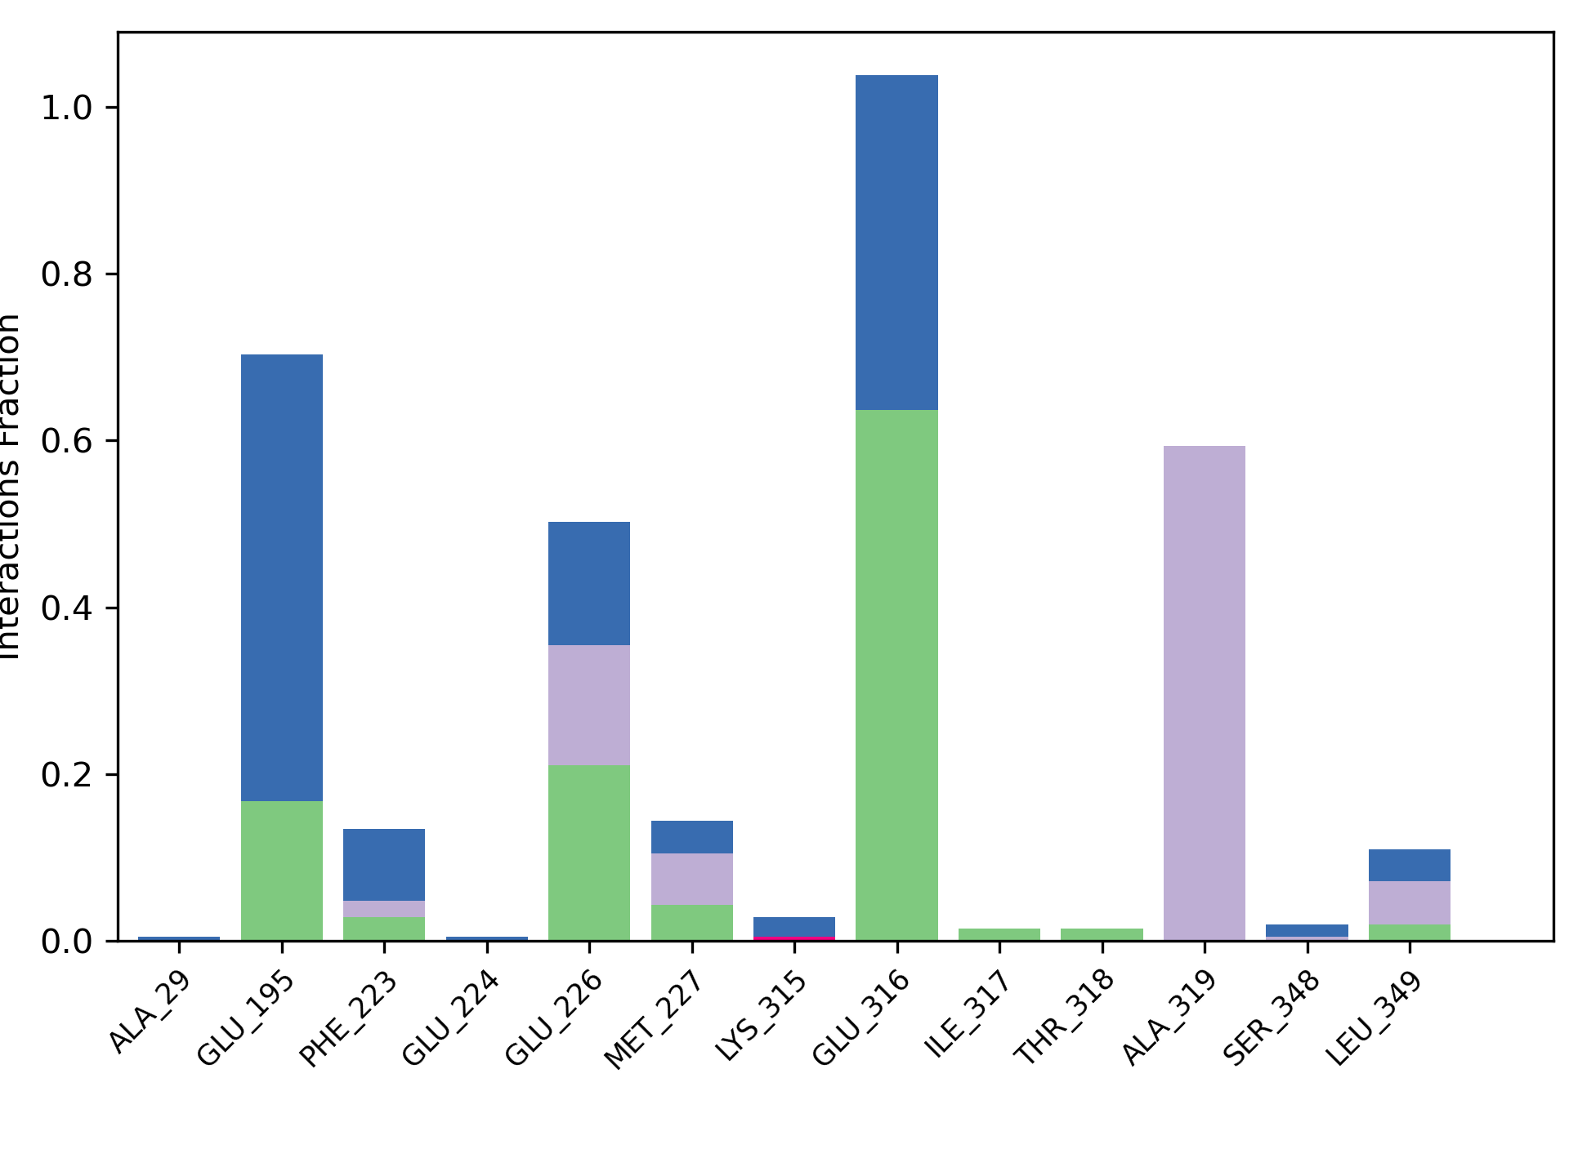
F

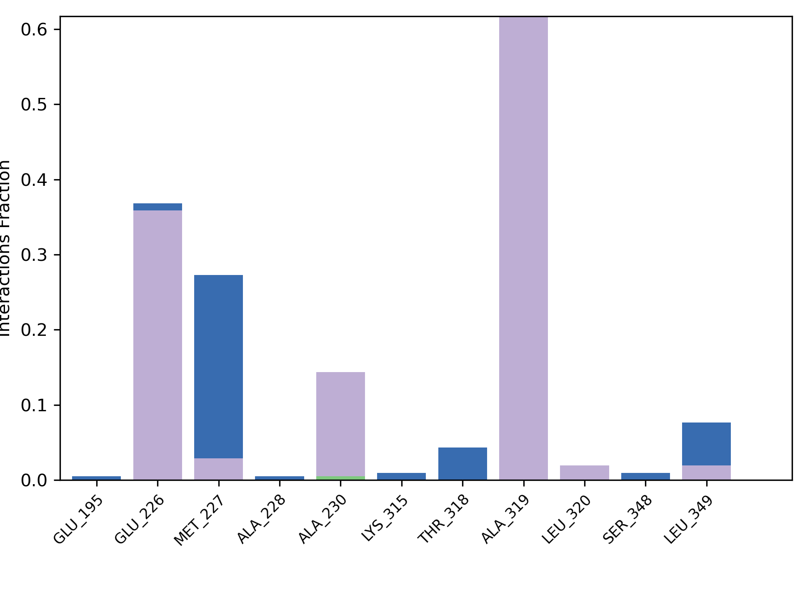
G
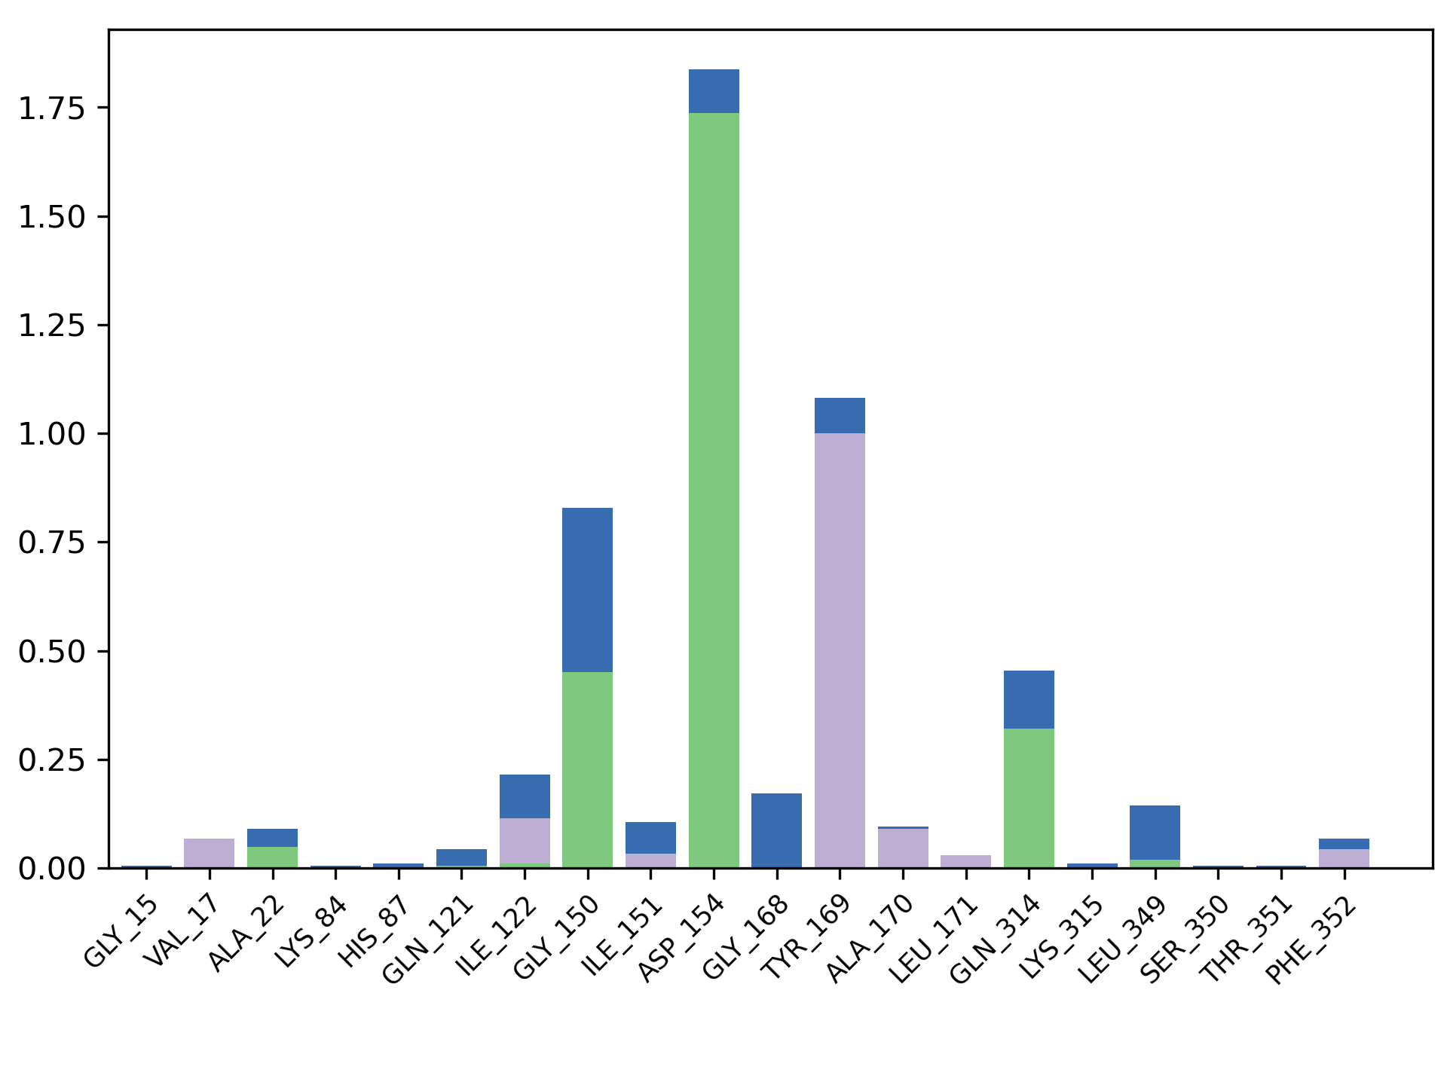
H
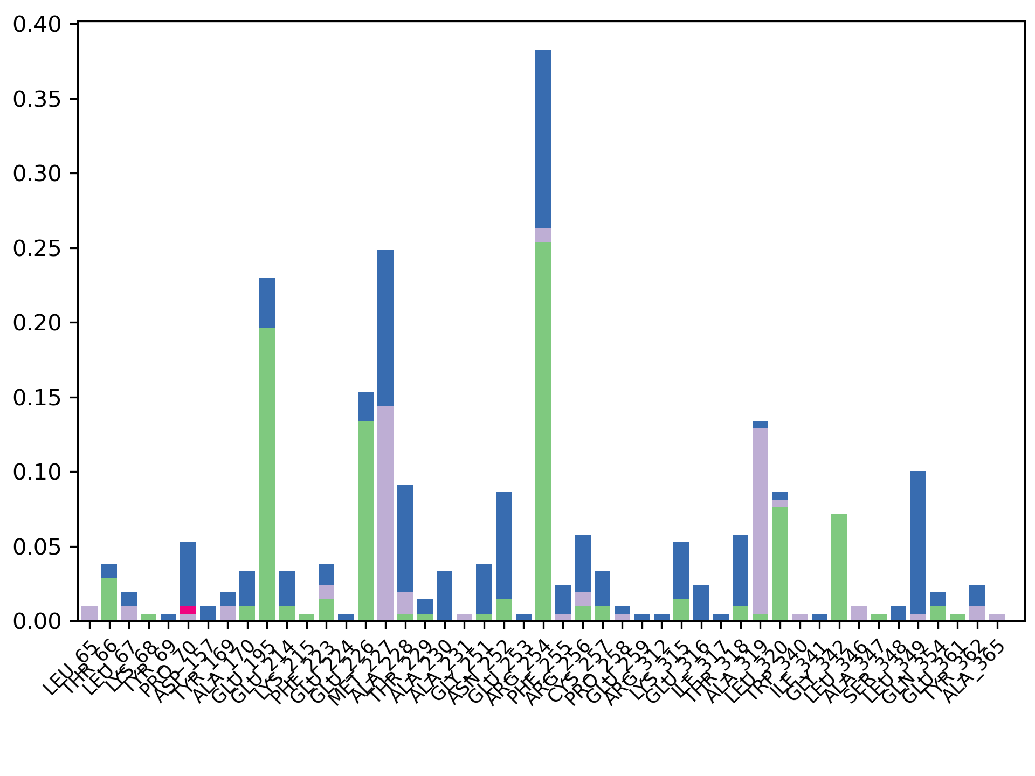
I
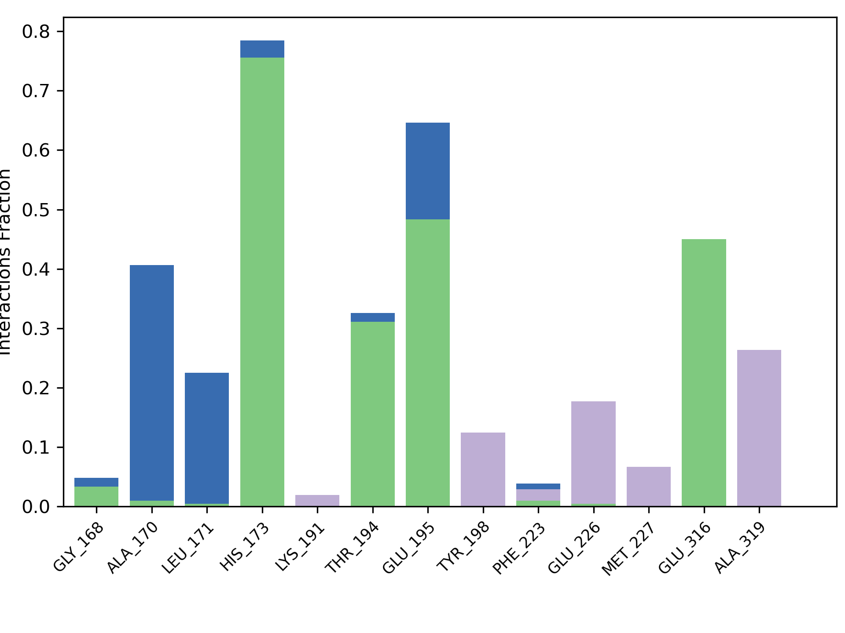
J
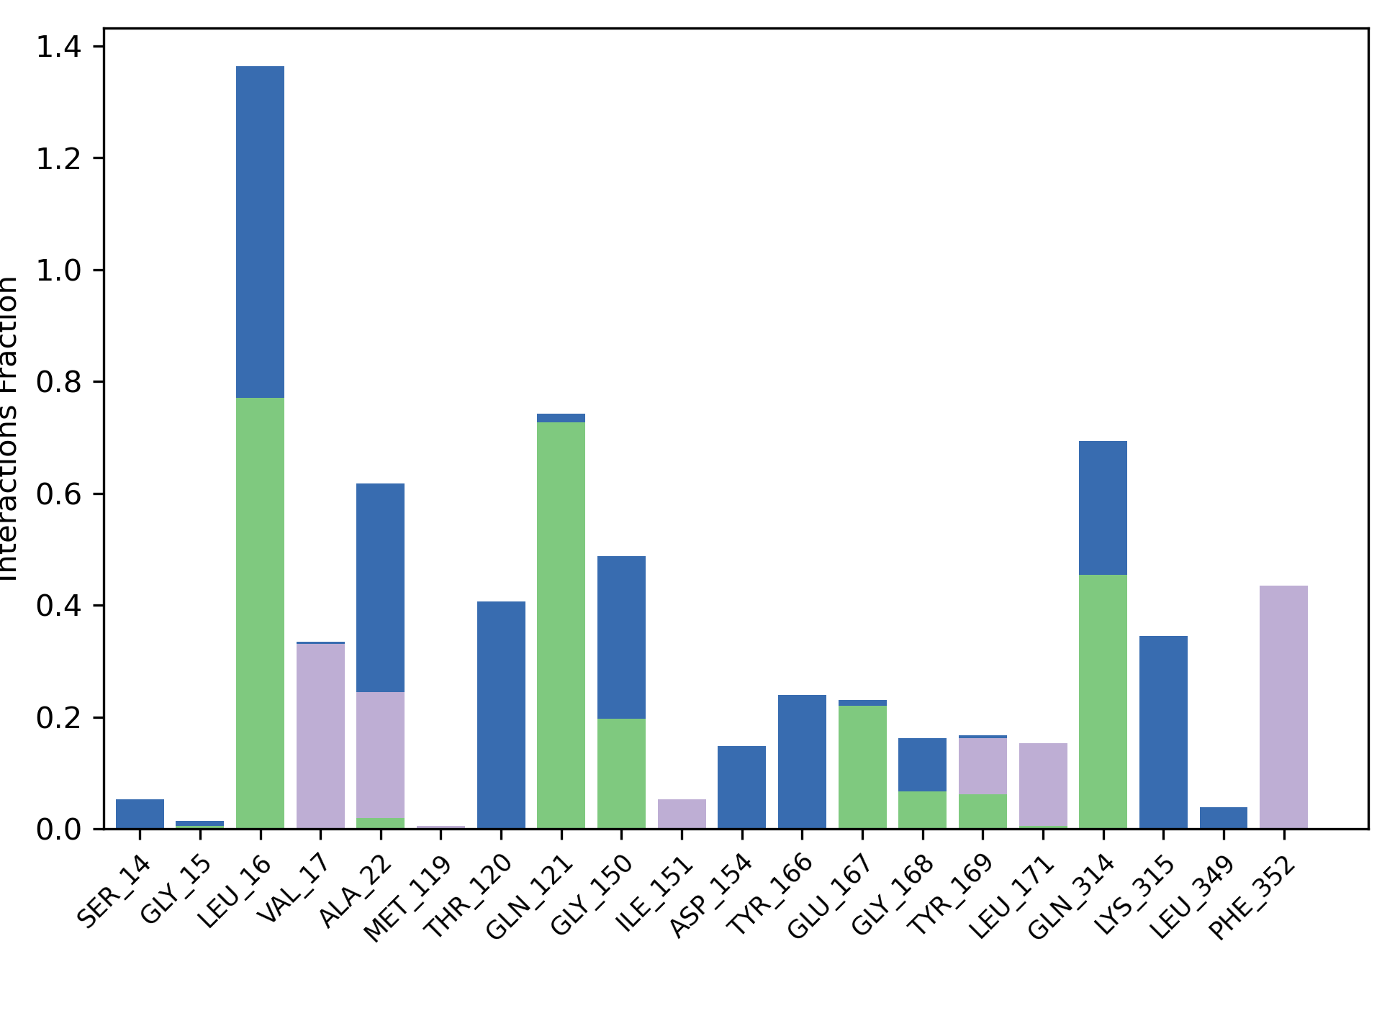
K
Figure SX+1. Protein-Ligand histograms for Actin. (A) – 3a, (B) – 3b, (C) – 3c, (D) – 2a, (E) – 2b, (F) – 2c, (G) – 4a, (H) – 4b, (I) – 4c, (J) – 5a, (K) – 5b. There are interaction types each indicated by a different color: hydrogen bonds as green, hydrophobic interactions as lavender, ionic interaction as pink and water bridges as blue colors.

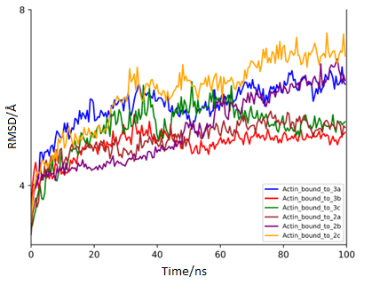

Figure SX+2. RMSD plot of the actin bound to 3a (blue), 3b (red), 3c (green), 2a (brown), 2b (purple), and 2c (orange) after 100 ns of MD simulation. Å

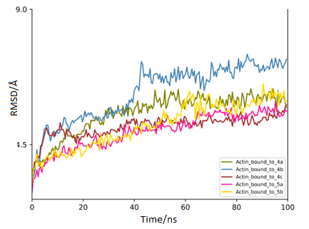
Figure SX+3. RMSD plot of the actin bound to 4a (green), 4b (blue), 4c (brown), 5a (pink), and 5b (yellow) after 100 ns of MD simulation.
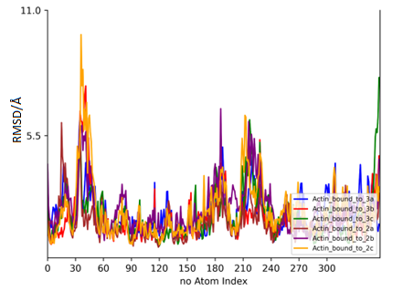

Figure SX+4. RMSF plot of the actin bound to 3a (blue), 3b (red), 3c (green), 2a (brown),2b (purple), and 2c (orange) after 100 ns of MD simulation.

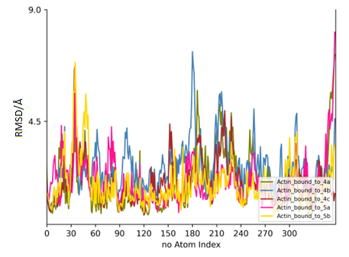

Figure SX+5. RMSF plot of the actin bound to 4a (green), 4b (blue), 4c (brown), 5a (pink), and 5b (yellow) after 100 ns of MD simulation.

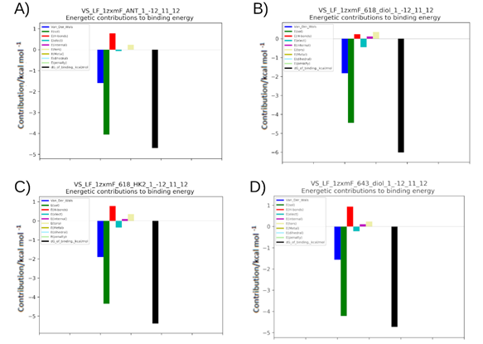

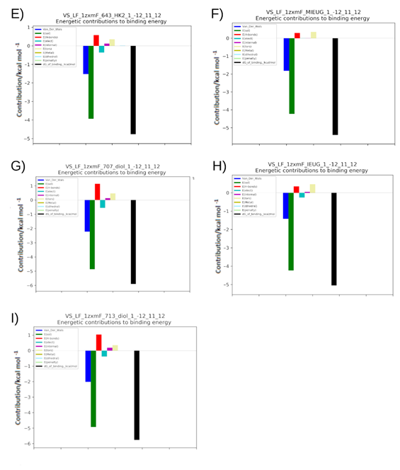

Figure SX+6. Overview of the Leadfinder Molecular Docking results for TOPIIα. The energy values of the interactions that make up the total binding energy of the propenylbenzene derivatives with actin. (a) – 3a, (b) – 3b, (c) – 3c, (d) – 2b, (e) – 2c, (f) – 4a, (g) – 4b, (h) – 5a, (i) – 5b.

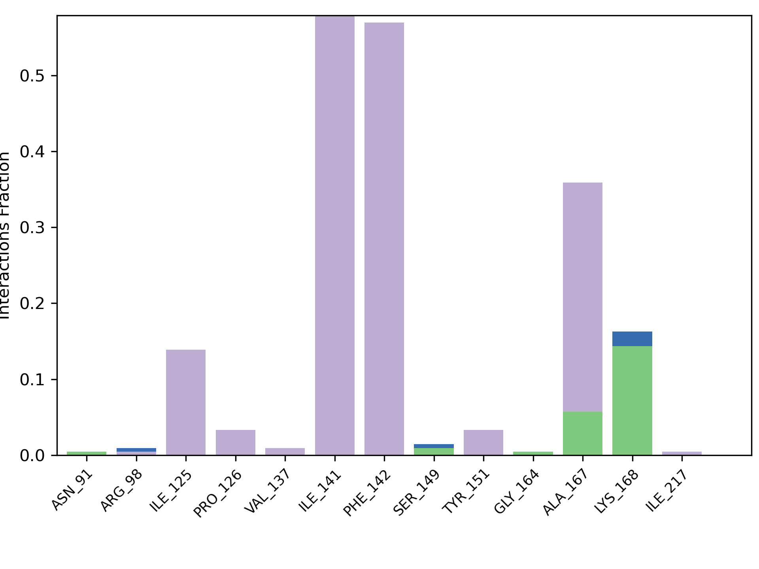
A
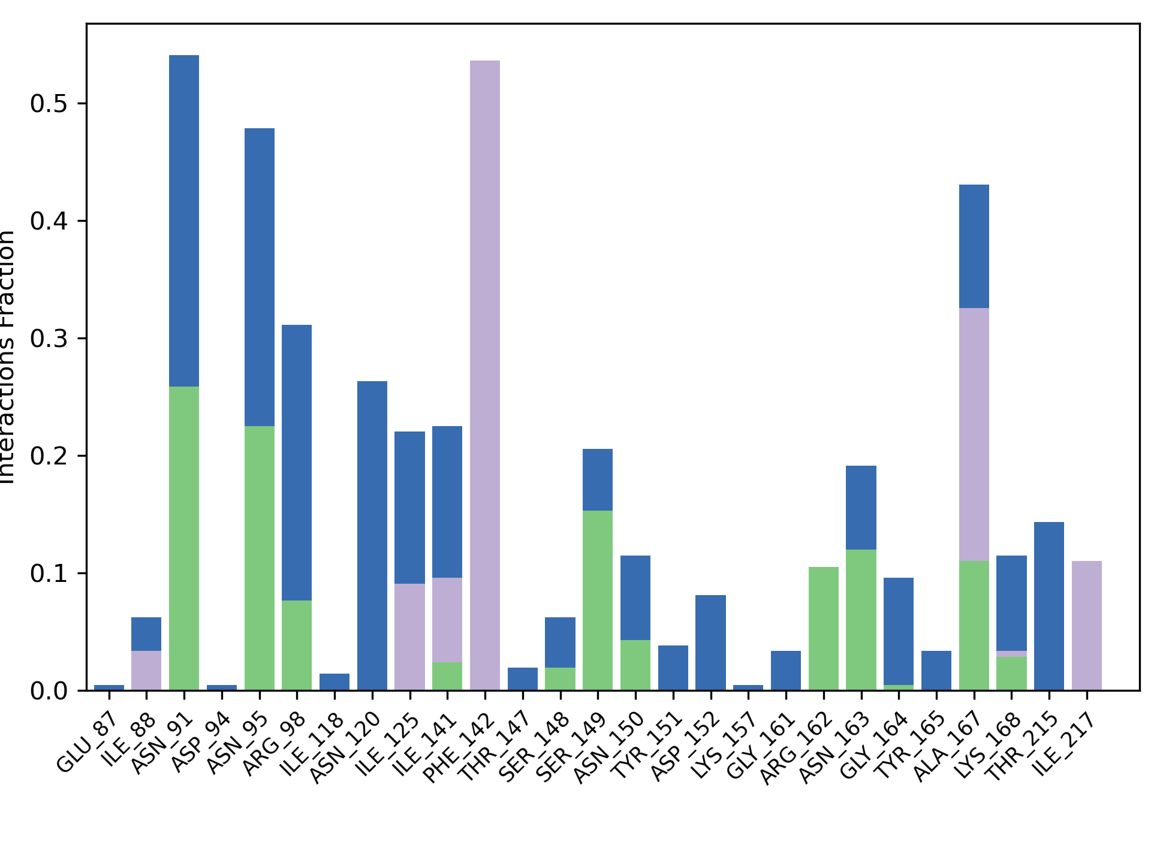
B
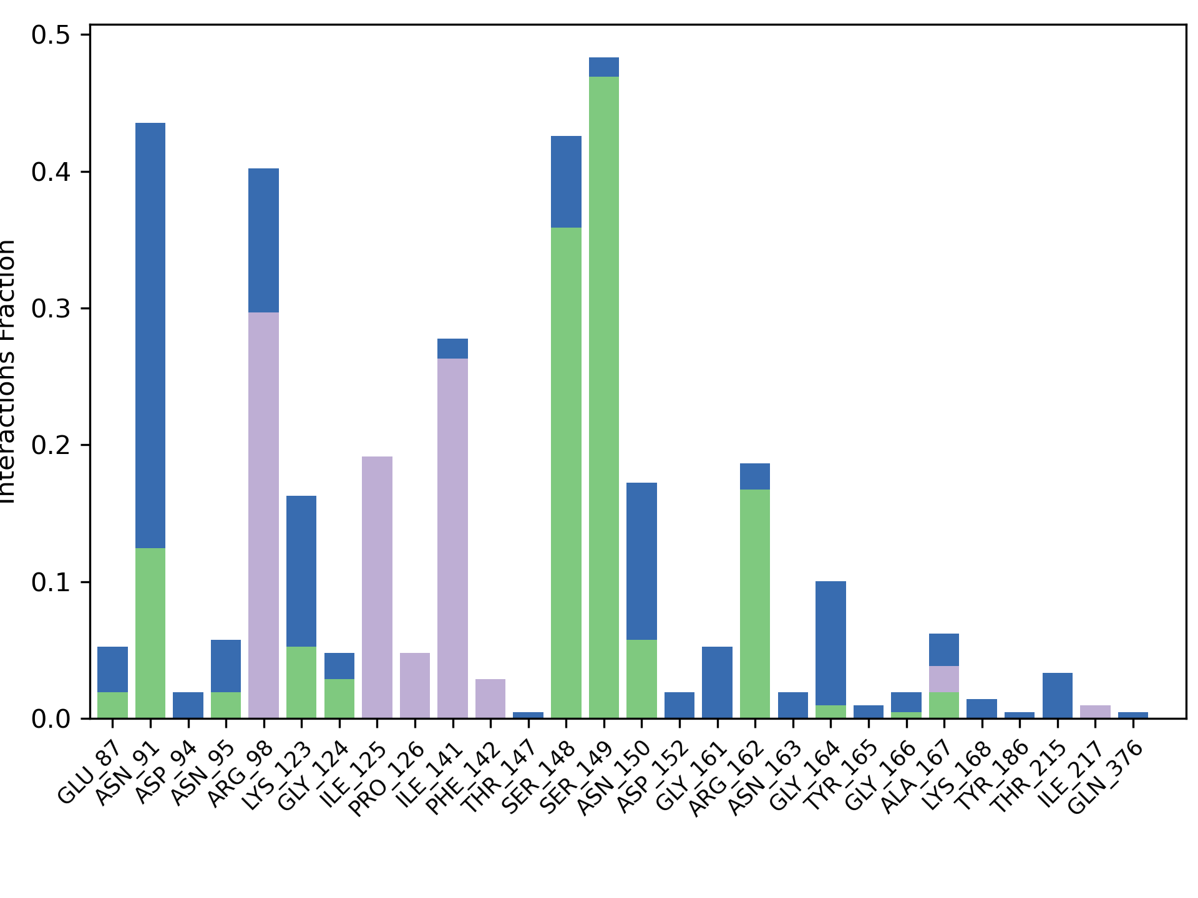
C
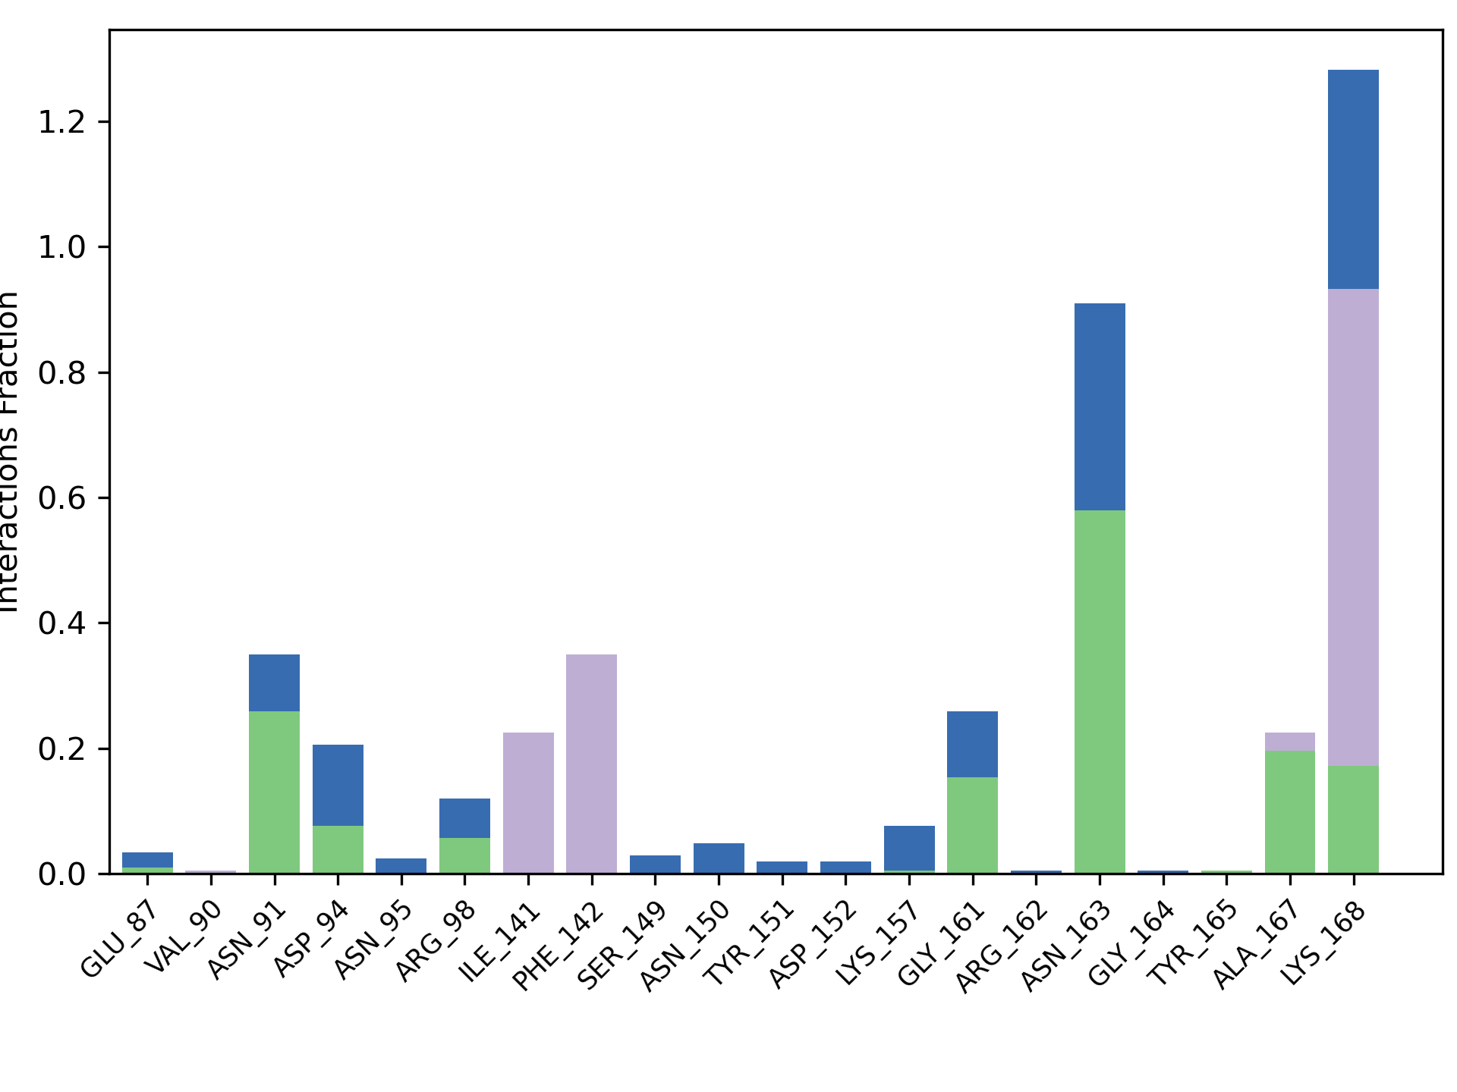
D
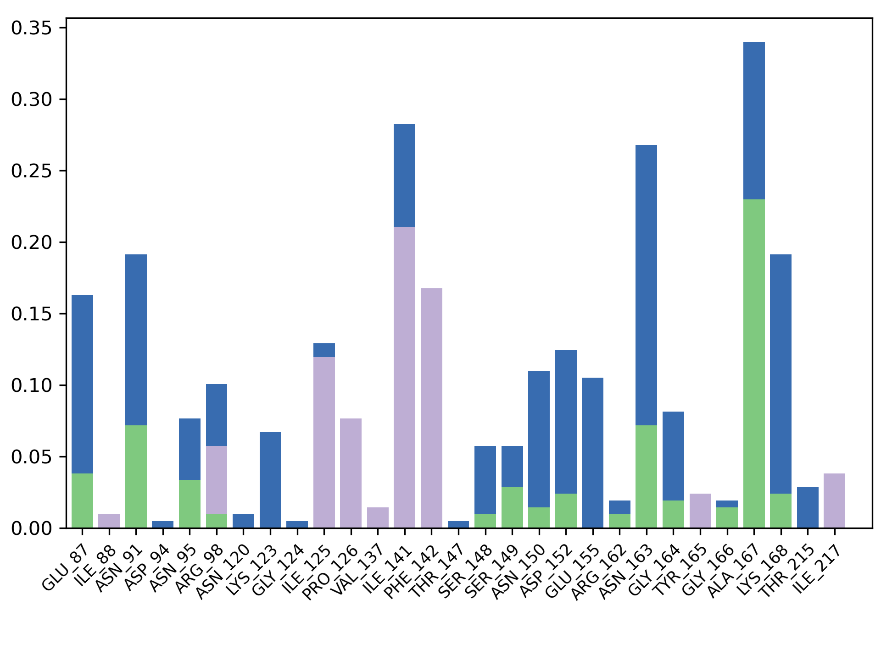
E
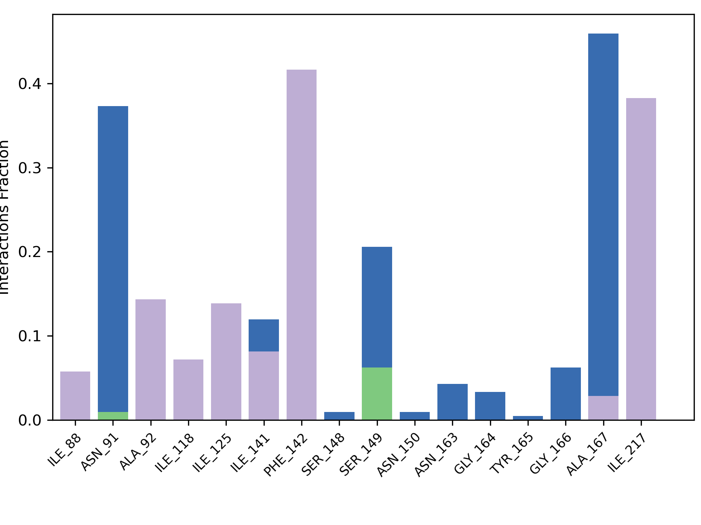
F
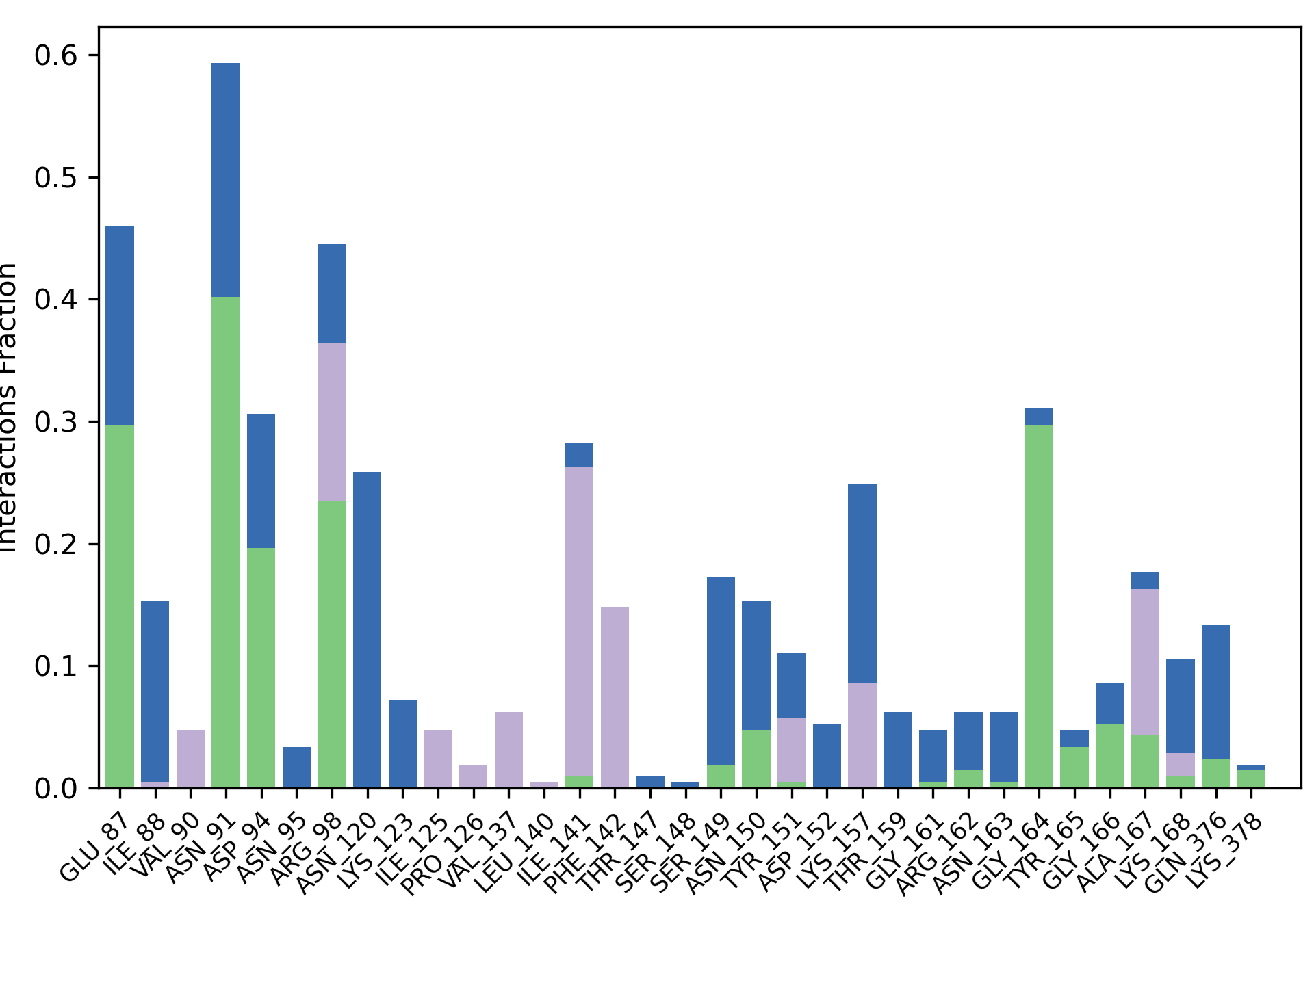
G
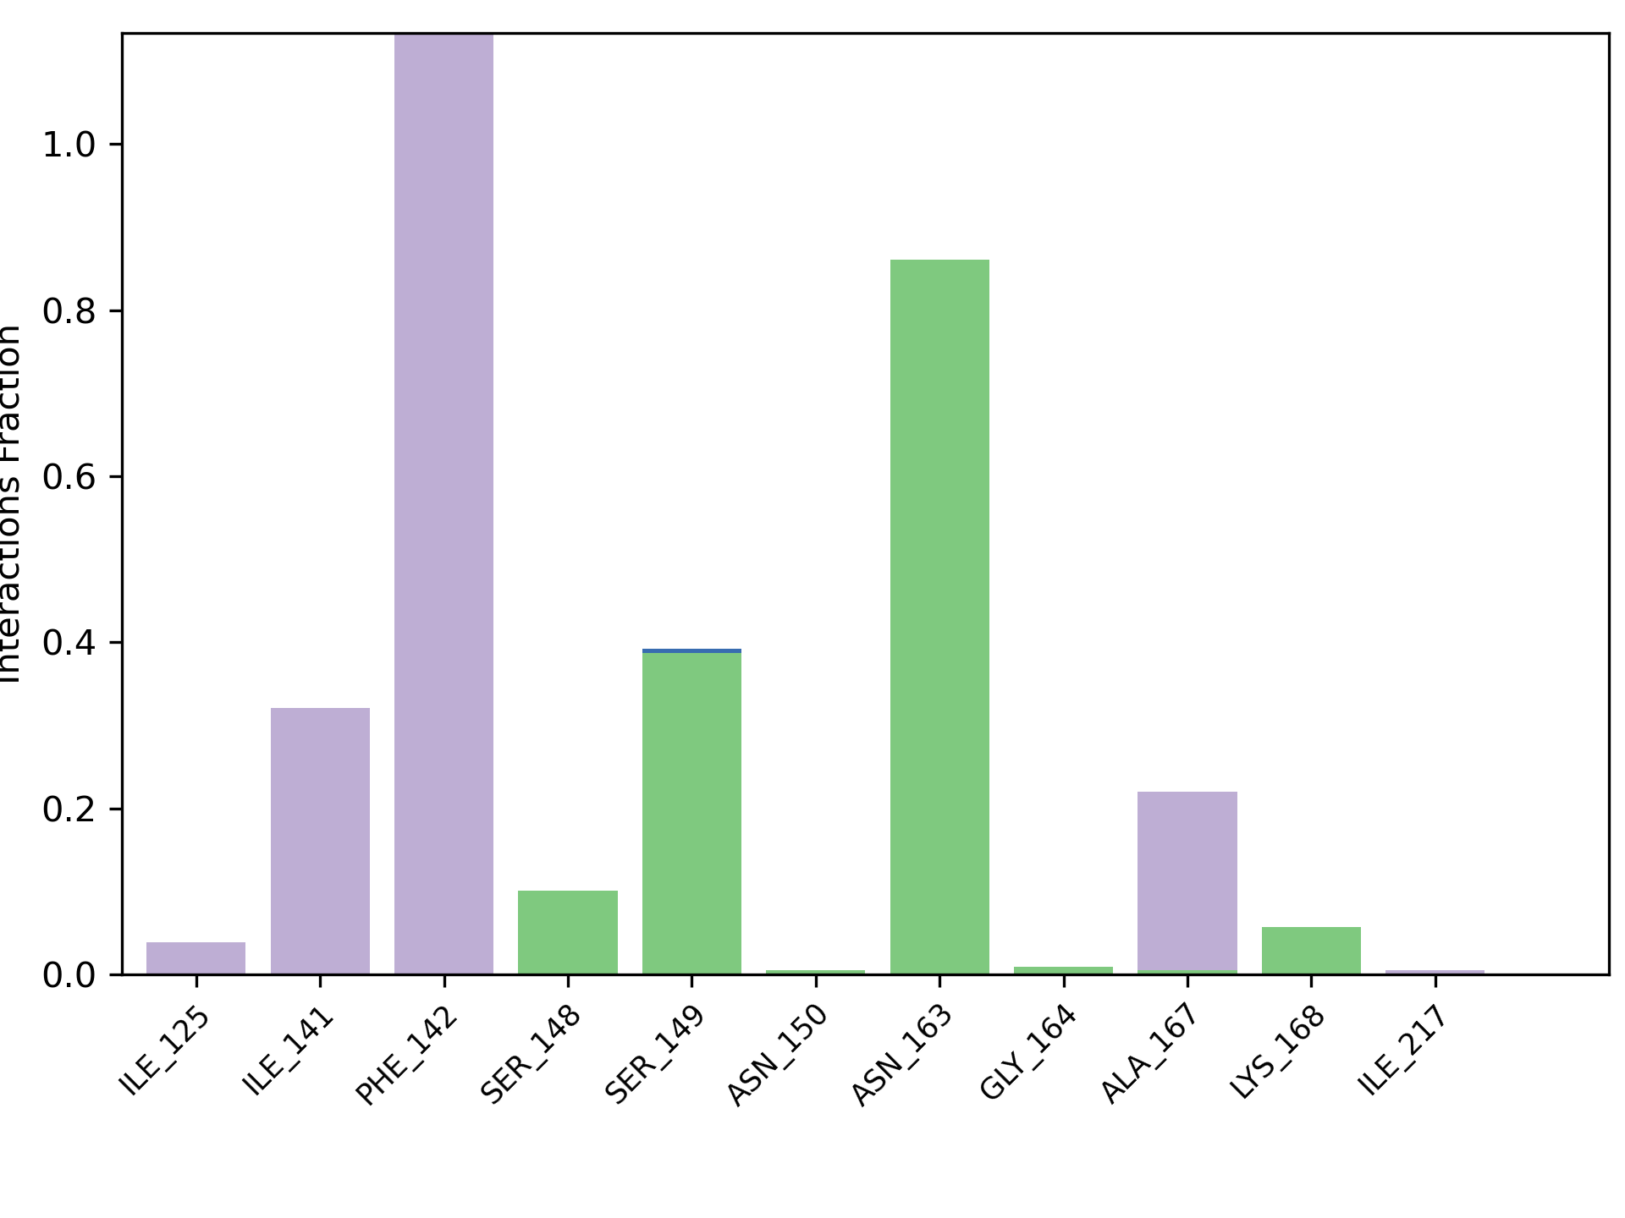
H
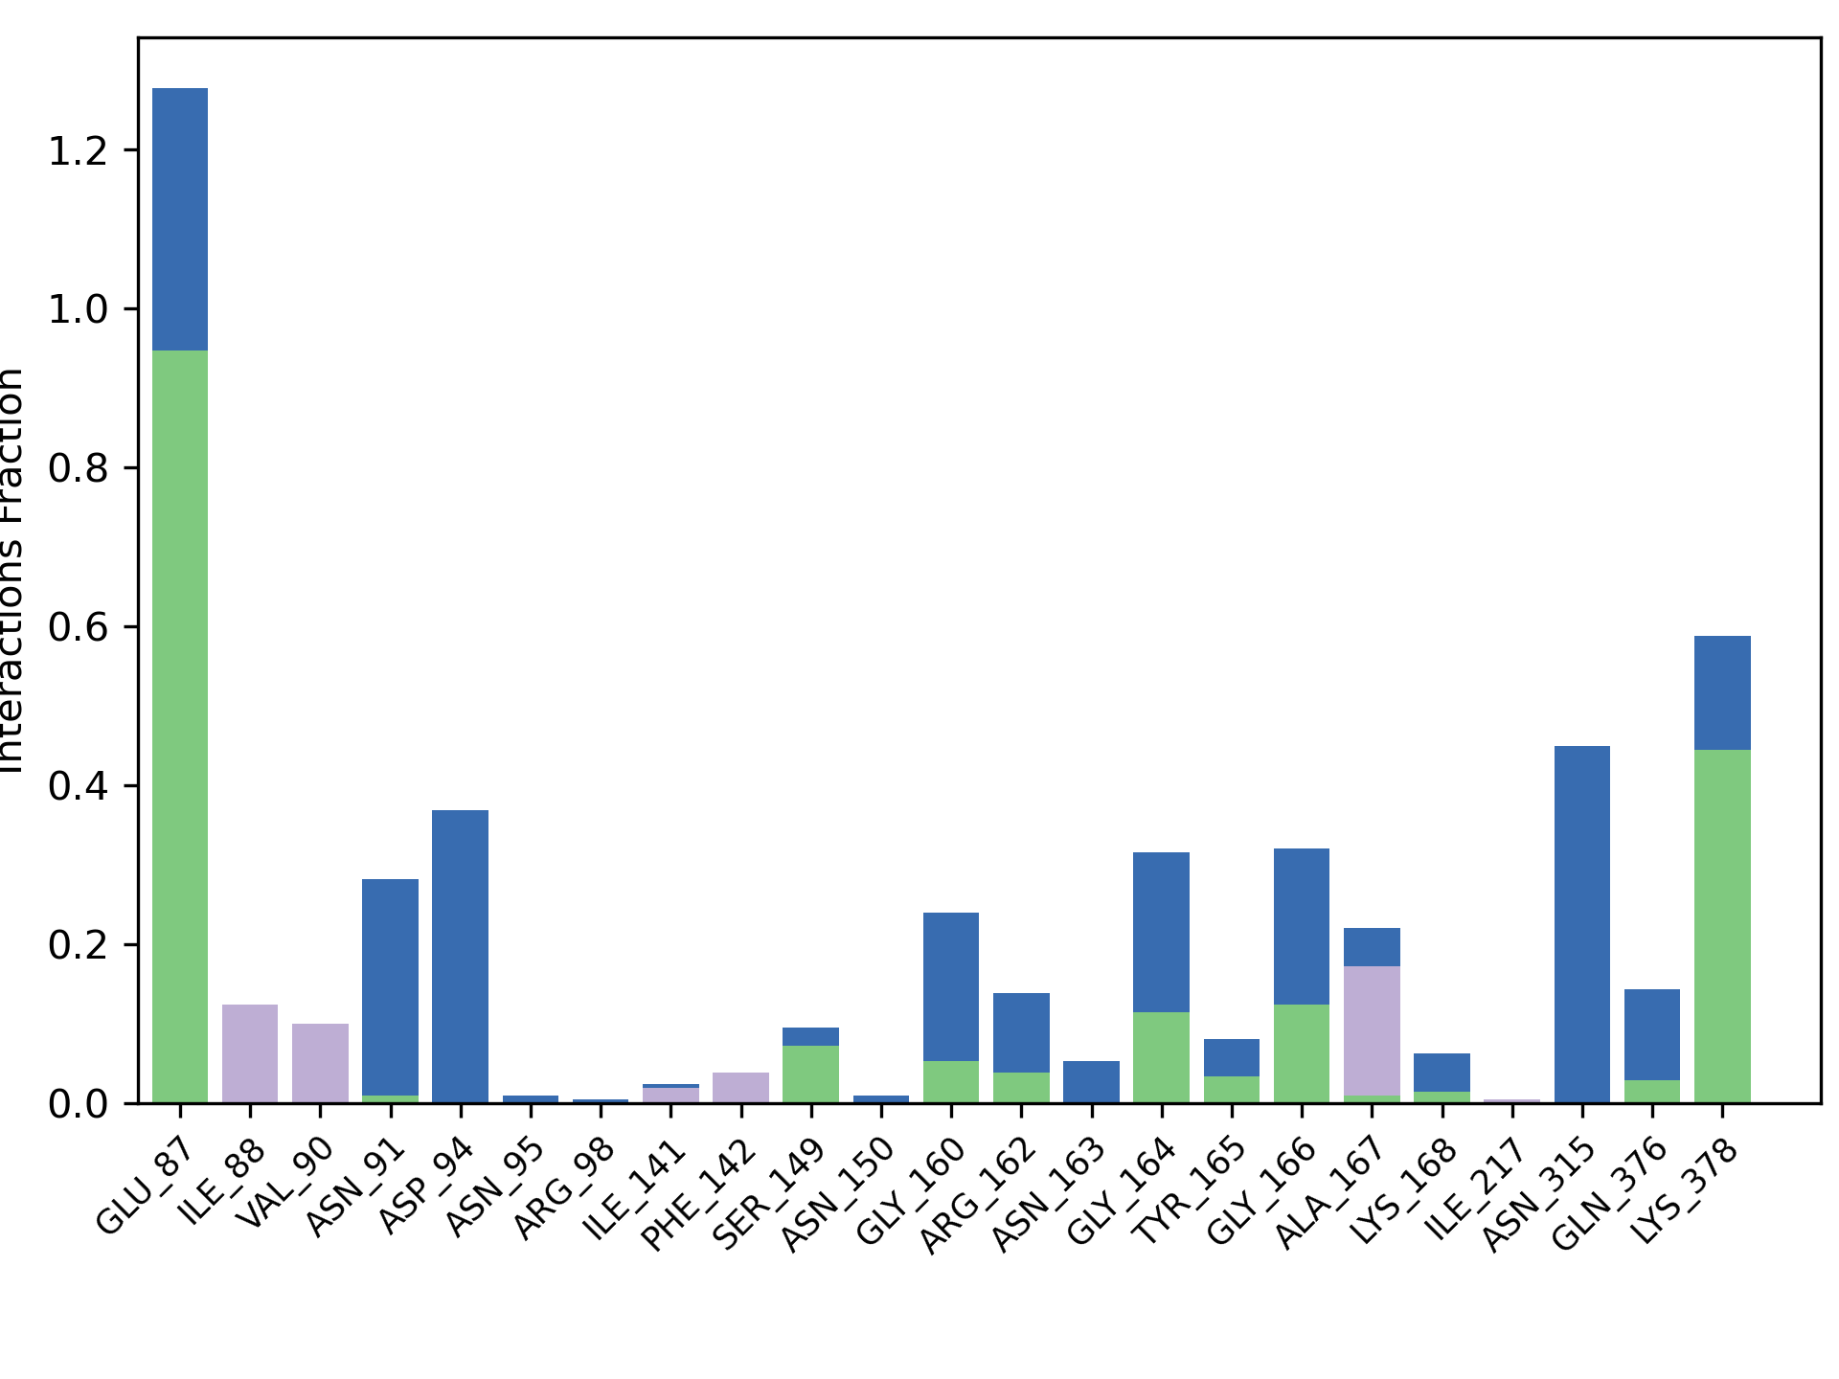
I
Figure SX+7. Protein-Ligand histograms for Actin. (A) – 3a, (B) – 3b, (C) – 3c, (D) – 2b, (E) – 2c, (F) – 4a, (G) – 4b, (H) – 5a, (I) – 5b. There are interaction types each indicated by a different color: hydrogen bonds as green, hydrophobic interactions as lavender, ionic interaction as pink and water bridges as blue colors.

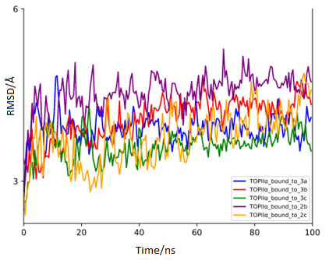

Figure SX+8. RMSD plot of the TOPIIα bound to 3a (blue), 3b (red), 3c (green), 2b (purple), and 2c (orange) after 100 ns of MD simulation.

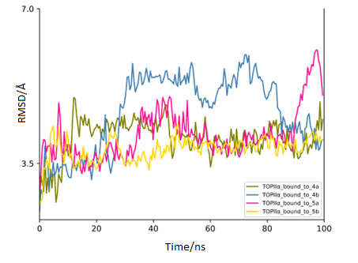
Figure SX+9. RMSD plot of the TOPIIα bound to 4a (green), 3b(blue), 5a (pink), and 5b (yellow) after 100 ns of MD simulation.

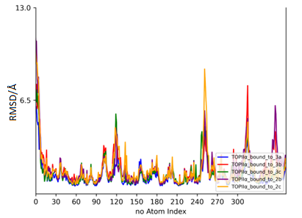
Figure SX+10. RMSF plot of the TOPIIα bound to 3a (blue), 3b (red), 3c (green), 2b (purple), and 2c (orange) after 100 ns of MD simulation.

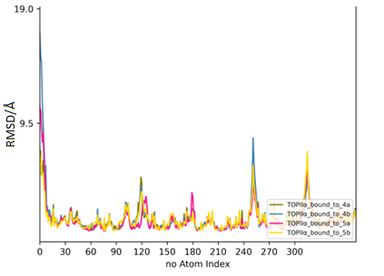
Figure SX+11. RMSF plot of the TOPIIα bound to 4a (green), 3b(blue), 5a (pink), and 5b (yellow) after 100 ns of MD simulation.

