Thermo-mechanical properties of bionanocomposites based on polycaprolactone and halloysite clay nanotubes
Maria Rosalia Carotenuto^{a,b}, Giuseppe Cavallaro^{a,*}, Ileana Chinnici^{b}, Giuseppe Lazzaraª, Stefana Miliotoª
ªDipartimento di Fisica e Chimica “E. Segrè”, Università degli Studi di Palermo, Viale delle Scienze, pad. 17, 90128 Palermo, Italy. giuseppe.cavallaro@unipa.it
^{b}INAF – Astronomical Observatory “G. S. Vaiana”, Piazza del Parlamento, 1, Palermo, Italy

Supporting Information
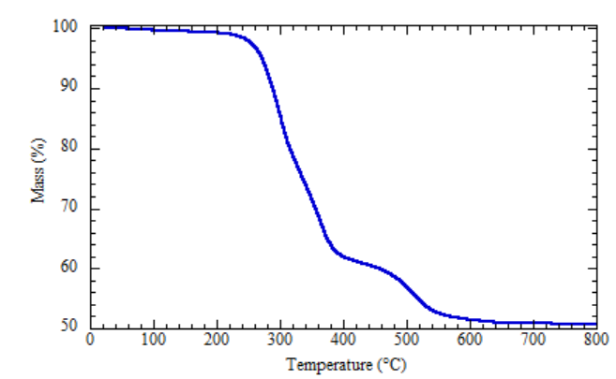
Figure 1S. Thermogravimetric curve of PCL/HNTs 60 wt%.

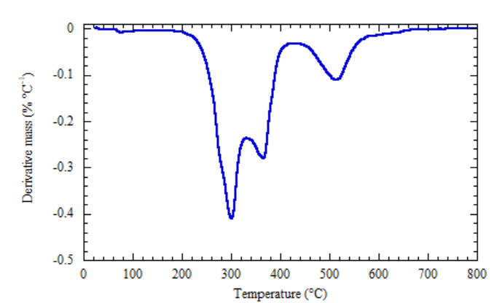
Figure 2S. Differential thermogravimetric curve of PCL/HNTs 60 wt%.

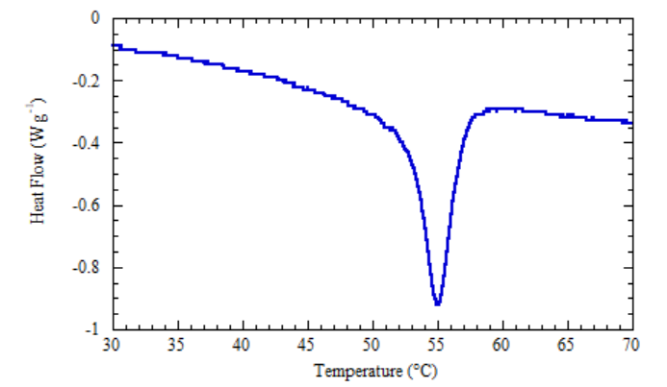
Figure 3S. μ-DSC curve of PCL/HNTs 60 wt% obtained by heating ramp at 1 °C min⁻¹.

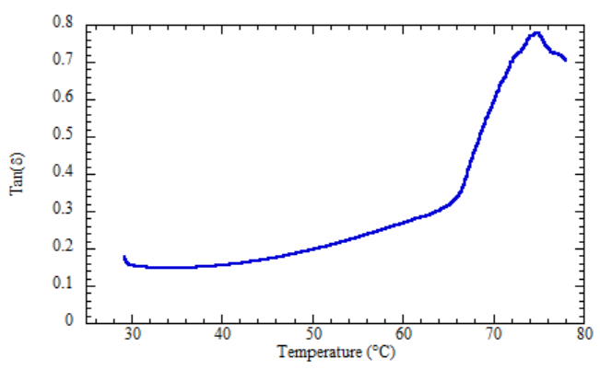
Figure 4S. Tan(δ) as a function of the temperature for PCL/HNTs 60 wt%.

Table 1S. Accuracy data for the thermal analysis instruments
 | Temperature | Mass | Heat capacity
TGA Q5000 IR (TA Instruments) | ± 0.01 °C | ± 0.1 μg
Micro-DSC III 106 (Setaram) | ± 0.0001 °C |  | ± 1 μW
DSC 250 instrument (TA Instruments) | ± 0.05 °C |  | ± 10 μW

