SUPPLEMENTARY MATERIAL
Evaluation of the structure and thermal stability of composite materials containing special additives
Karolina Młynarczyk*¹, Beata Podkościelna¹
¹ Department of Polymer Chemistry, Maria Curie-Sklodowska University in Lublin, Gliniana 33, Pl-20614 Lublin, Poland
*Correspondence: karolina.mlynarczyk@mail.umcs.pl, Gliniana St. 33, PL-20614, tel. +48815242251 w. 137
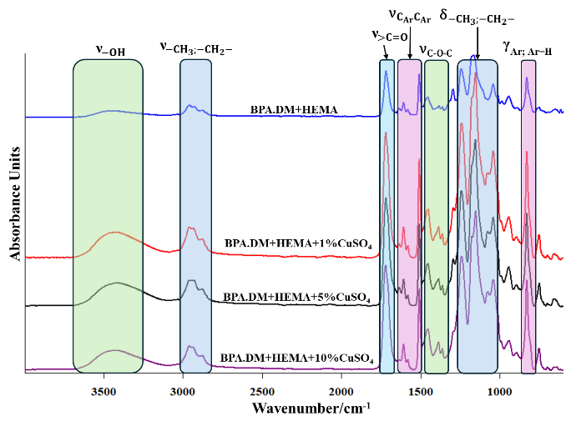 | 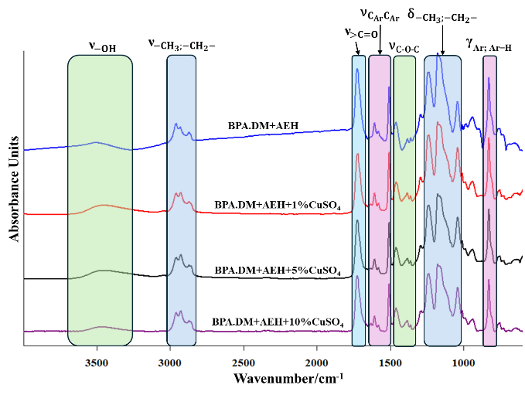
Fig. S1 ATR/FT-IR spectra of HEMA-CuSO₄ composites | Fig. S2 ATR/FT-IR spectra of AEH- CuSO₄ composites
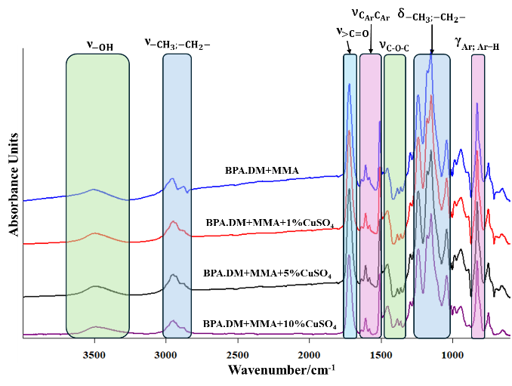 | 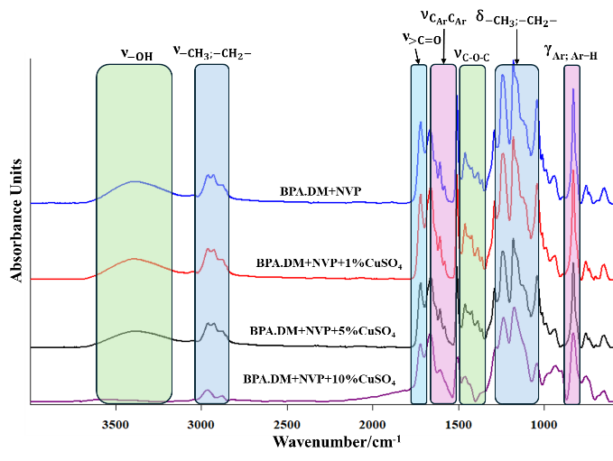
Fig. S3 ATR/FT-IR spectra of MMA- CuSO₄ composites | Fig. S4 ATR/FT-IR spectra of NVP- CuSO₄ composites
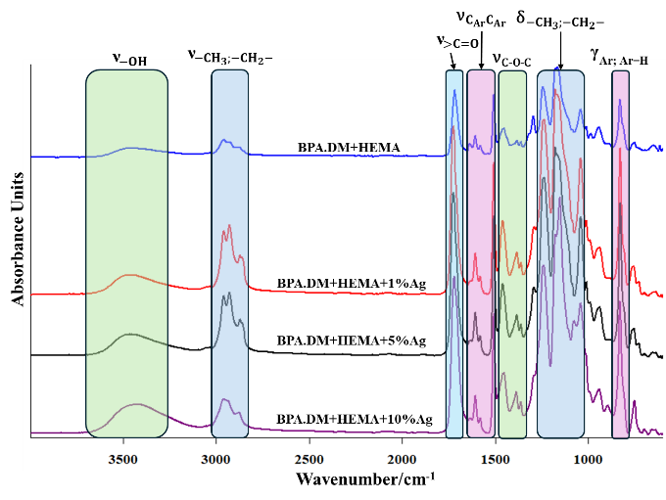 | 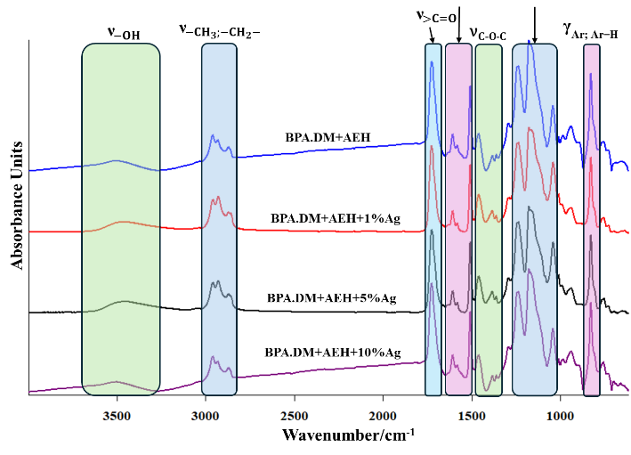
Fig. S5 ATR/FT-IR spectra of HEMA-Ag composites | Fig. S6 ATR/FT-IR spectra of AEH-Ag composites
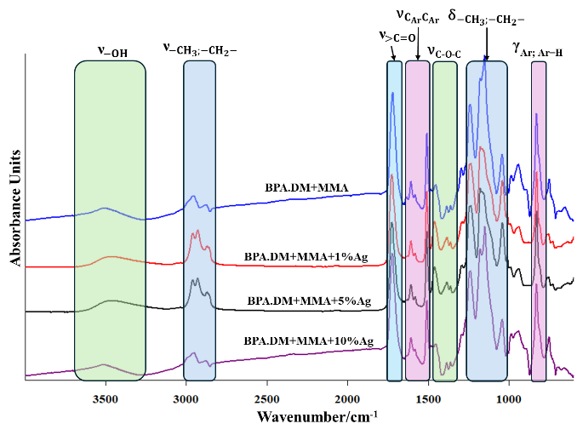 | 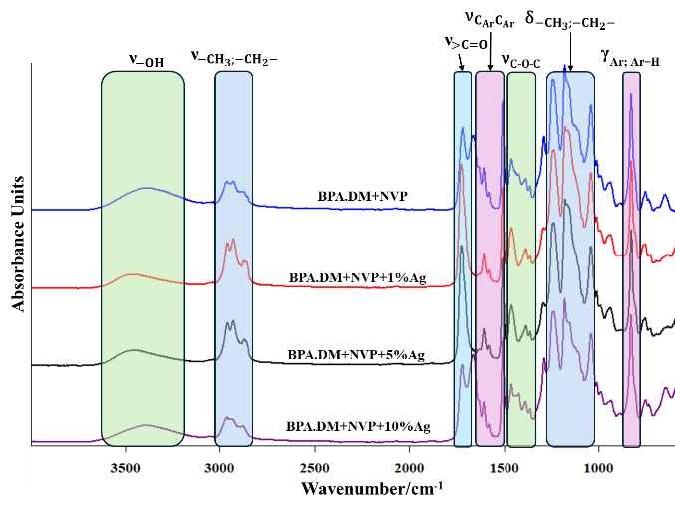
Fig. S7 ATR/FT-IR spectra of MMA-Ag composites | Fig. S8 ATR/FT-IR spectra of NVP-Ag composites
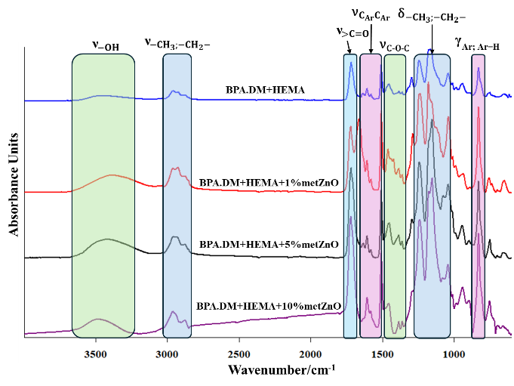 | 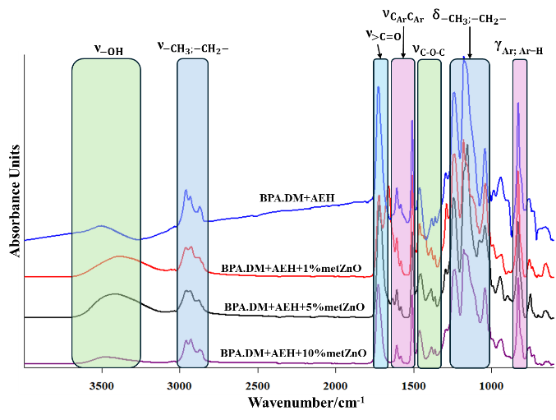
Fig. S9 ATR/FT-IR spectra of HEMA-metZnO composites | Fig. S10 ATR/FT-IR spectra of AEH-metZnO composites
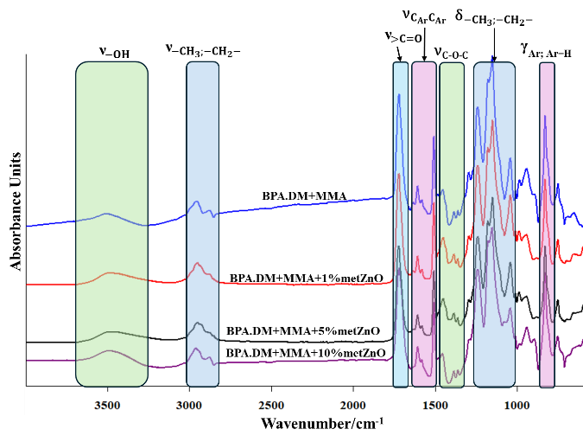 | 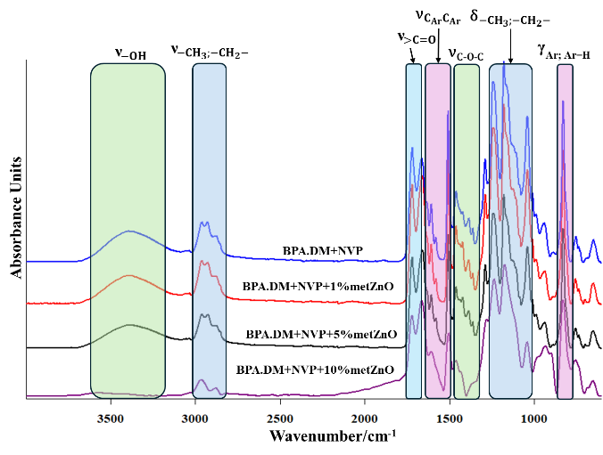
Fig. S11 ATR/FT-IR spectra of MMA-metZnO composites | Fig. S12 ATR/FT-IR spectra of NVP-metZnO composites

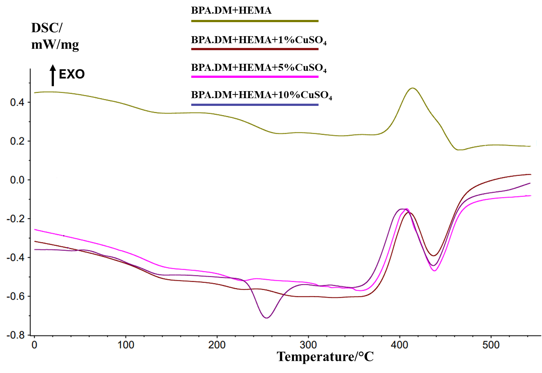 | 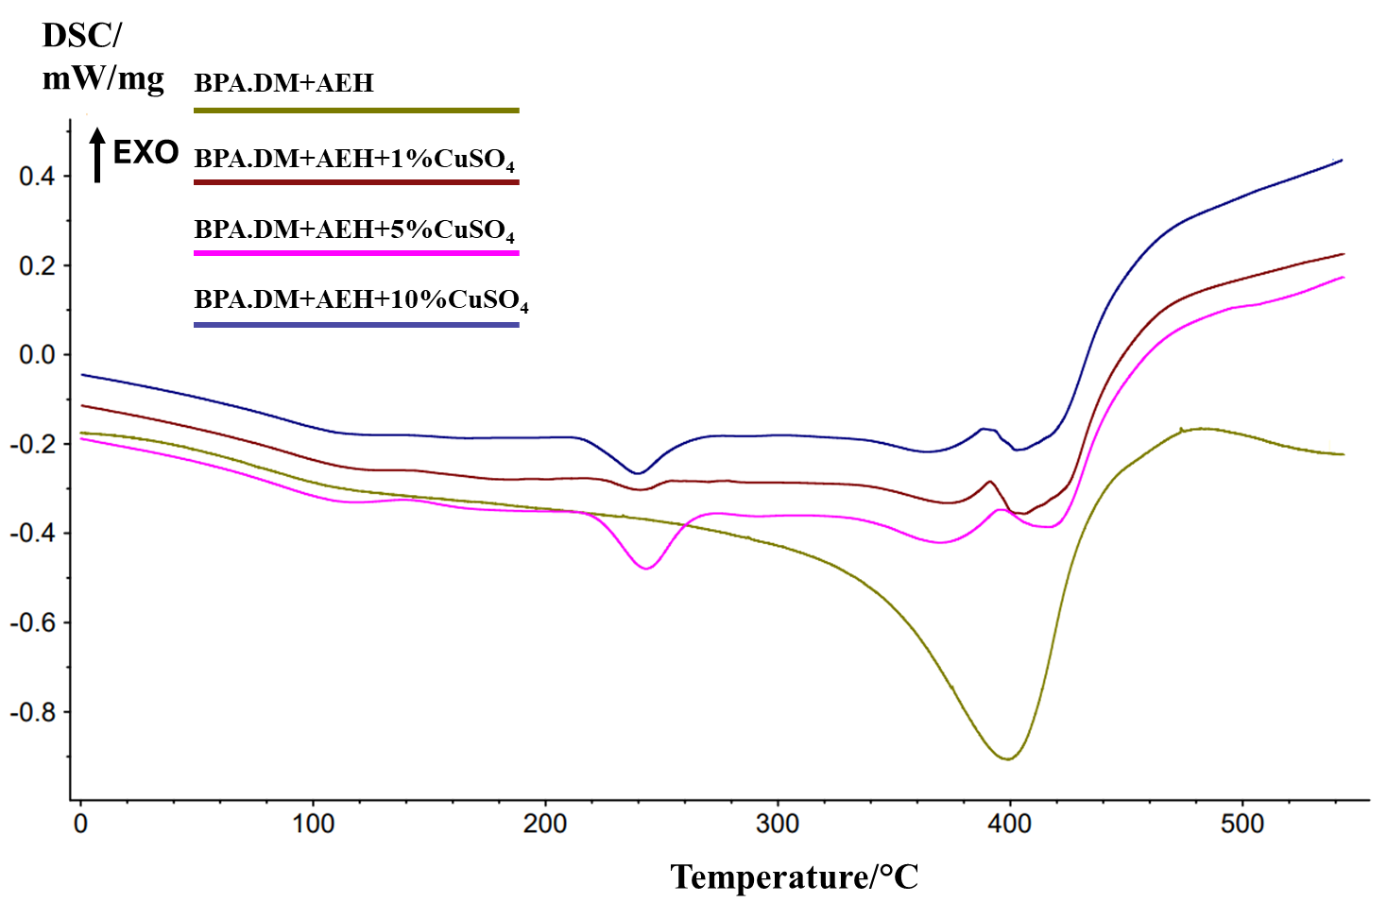
Fig. S13 DSC curves of HEMA-CuSO₄ composites | Fig. S14 DSC curves of AEH-CuSO₄ composites
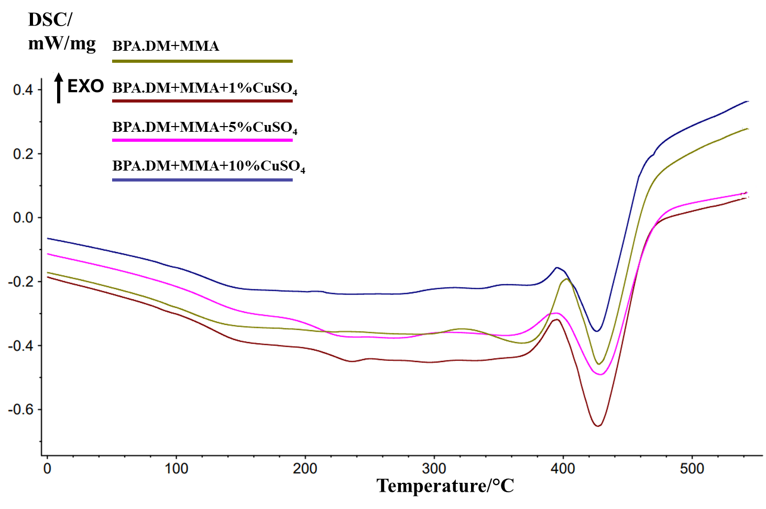 | 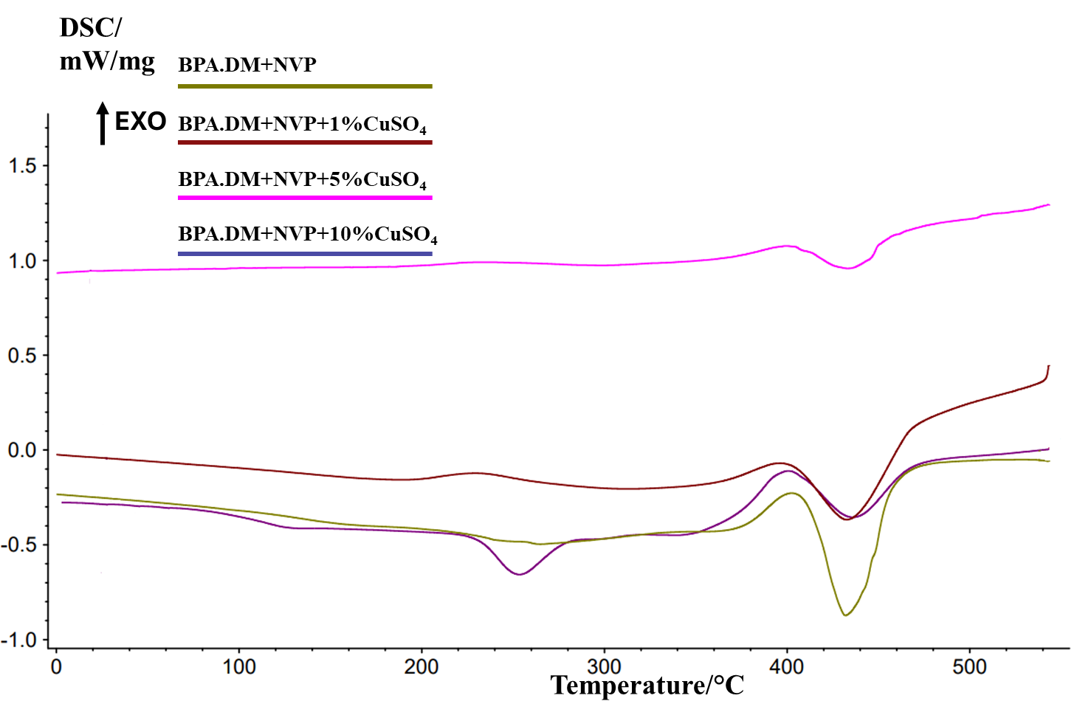
Fig. S15 DSC curves of MMA-CuSO₄ composites | Fig. S16 DSC curves of NVP-CuSO₄ composites
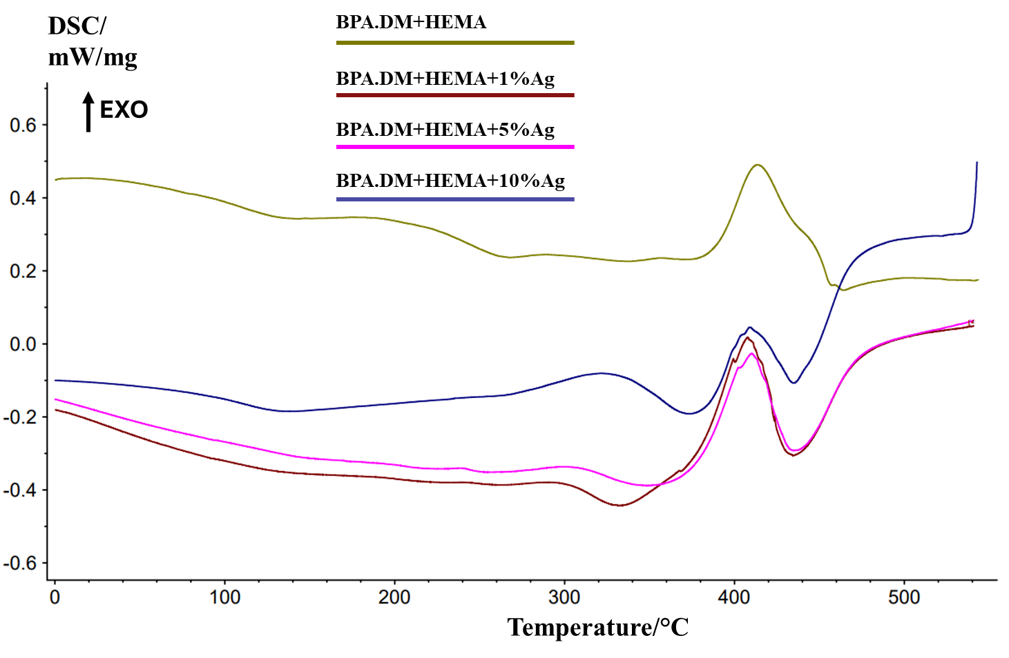 | 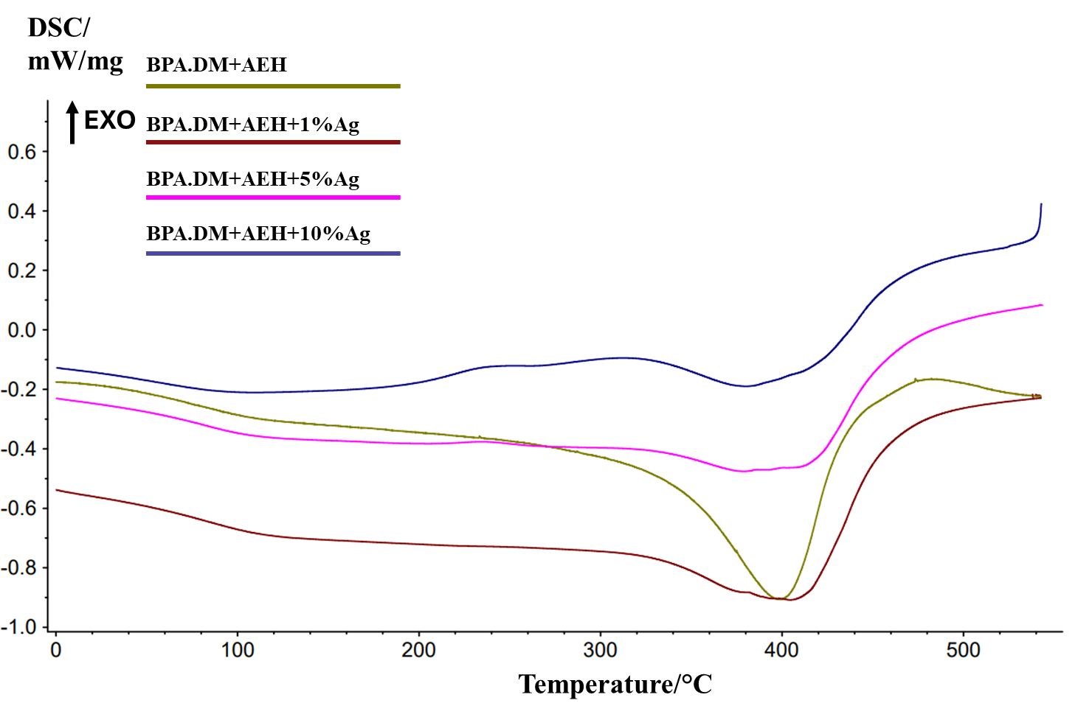
Fig. S17 DSC curves of HEMA-Ag composites | Fig. S18 DSC curves of AEH-Ag composites
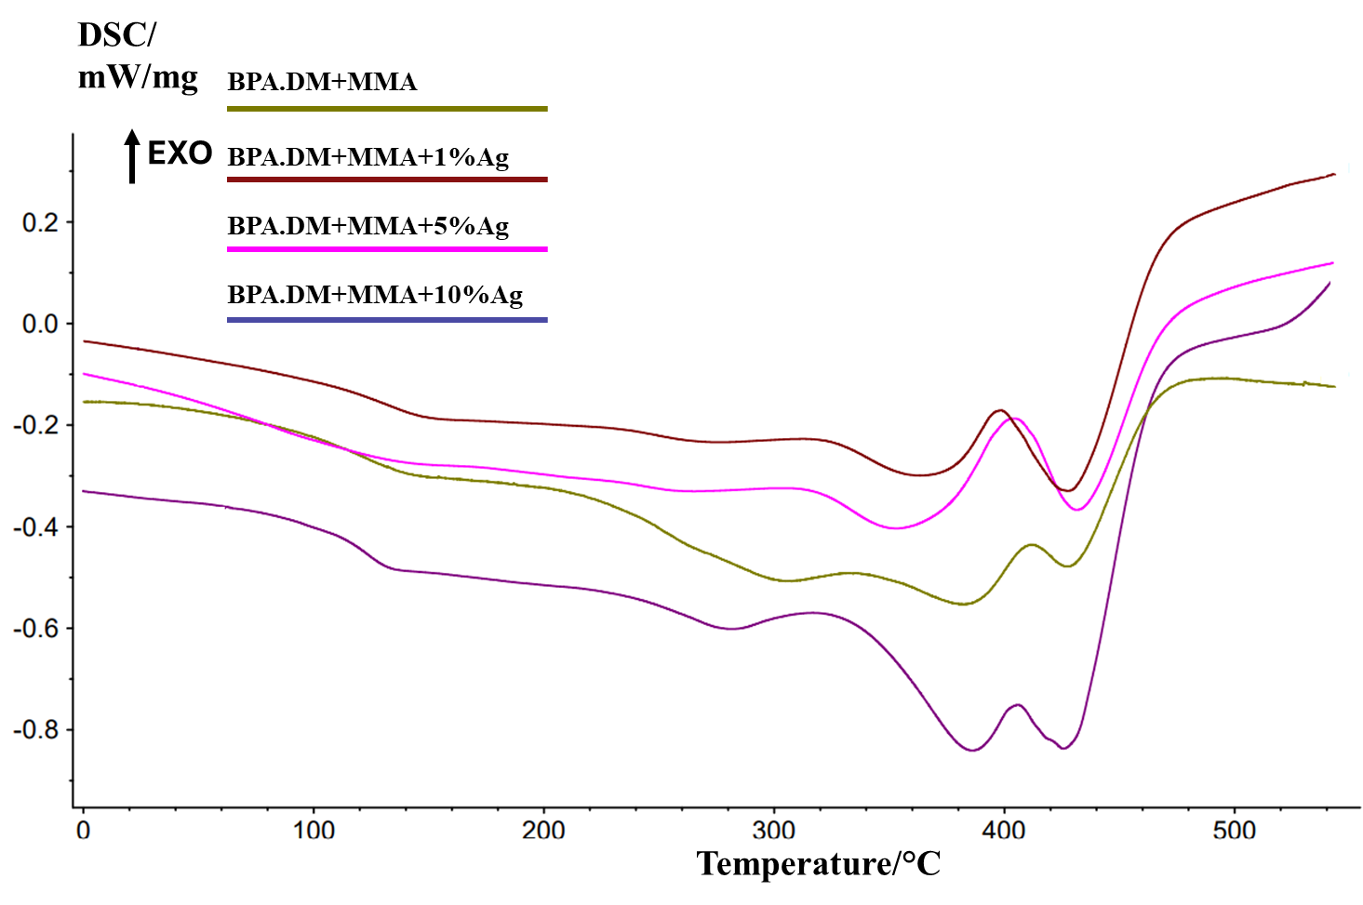 | 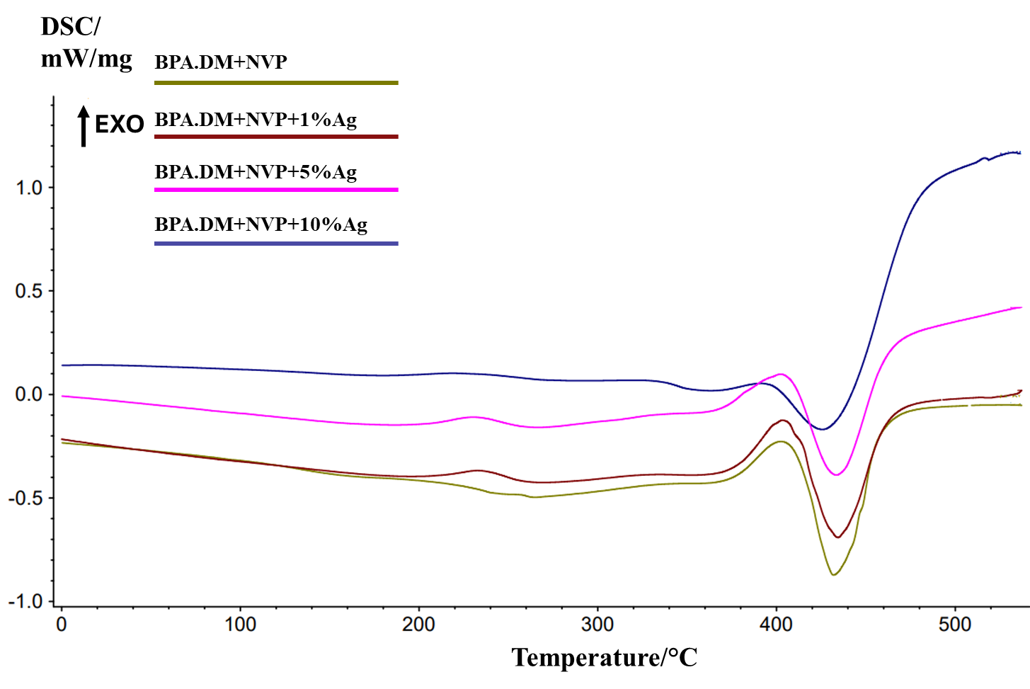
Fig. S19 DSC curves of MMA-Ag composites | Fig. S20 DSC curves of NVP-Ag composites
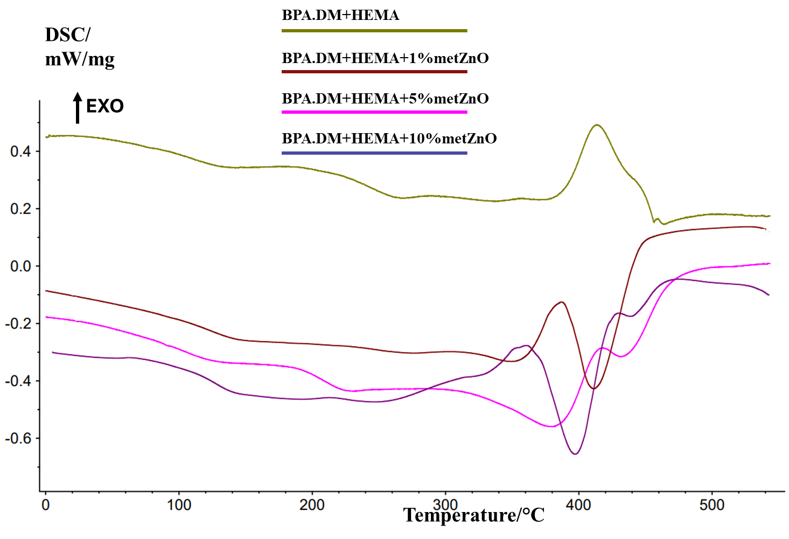 | 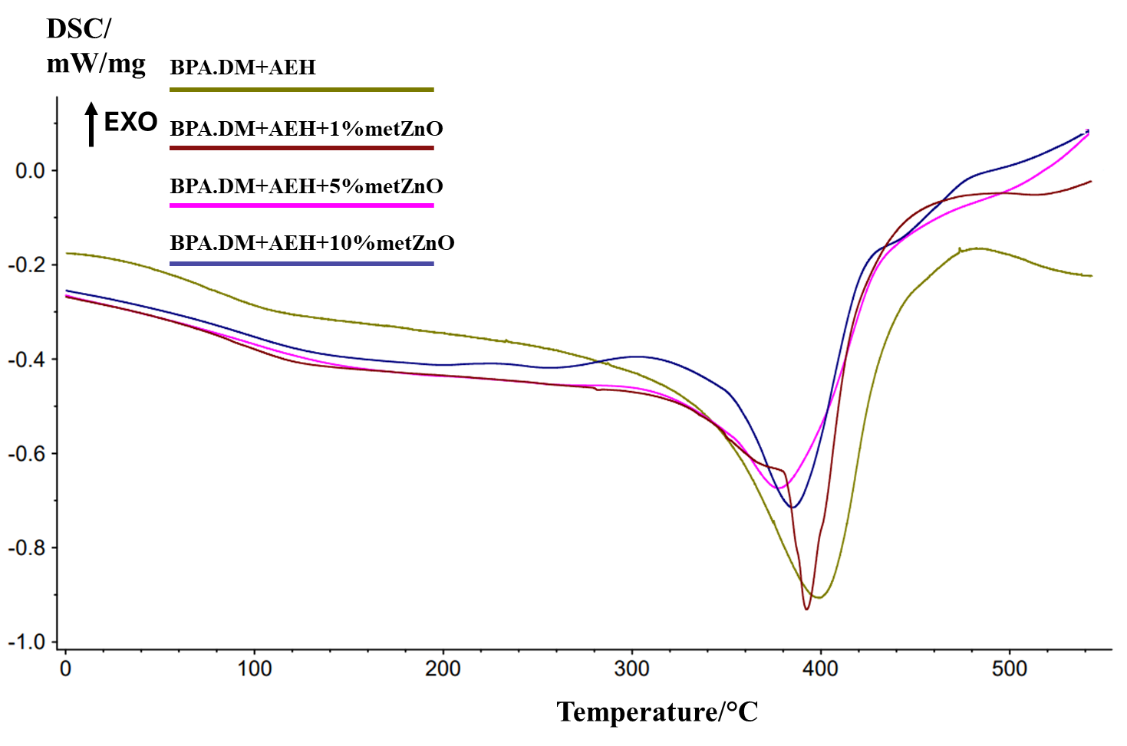
Fig. S21 DSC curves of HEMA-metZnO composites | Fig. S22 DSC curves of AEH-metZnO composites
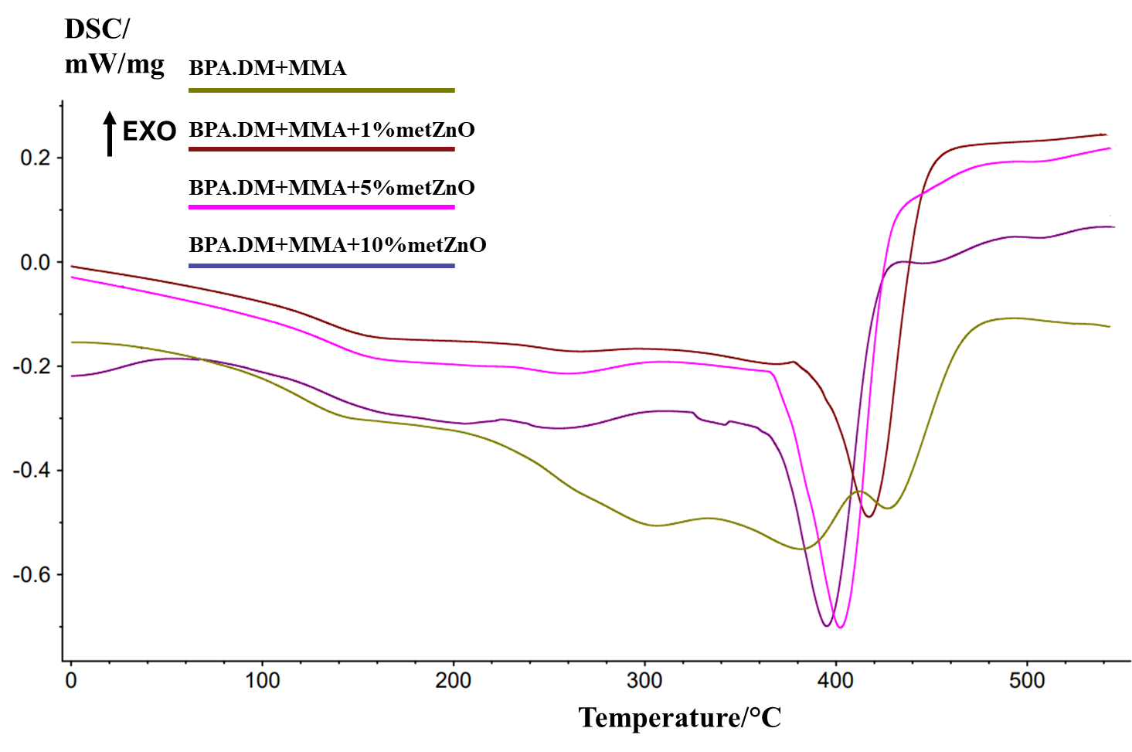 | 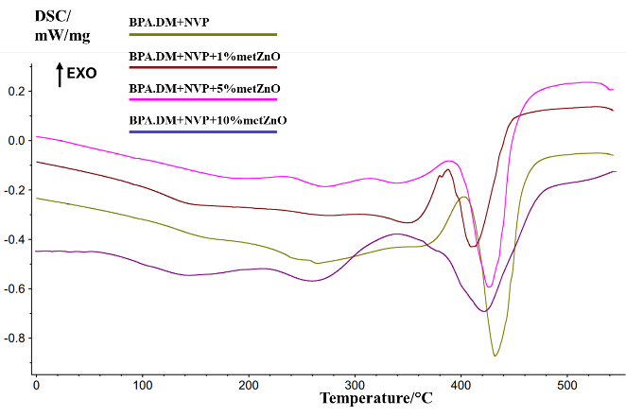
Fig. S23 DSC curves of MMA-metZnO composites | Fig. S24 DSC curves of NVP-metZnO composites

Table S1 DSC data of HEMA-containing composites
Composite | T_{d1} [°C] | DSC [uV/mg] | T_{d2} [°C] | DSC [uV/mg] | T_{d3} [°C] | DSC [uV/mg]
BPA.DM  +HEMA | - | - | 371.4 | 0.2813 | 465.2 | 0.1496
BPA.DM  +HEMA+1%CuSO₄ | - | - | - | - | 436.9 | -0.3912
BPA.DM  +HEMA+5%CuSO₄ | - | - | - | - | 438.0 | -0.4688
BPA.DM  +HEMA+10%CuSO₄ | 254.1 | -0.7120 | - | - | 436.7 | -0.4417
BPA.DM  +HEMA+1%Ag | - | - | 332.1 | -0.4428 | 434.3 | -0.3063
BPA.DM  +HEMA+5%Ag | - | - | 348.4 | -0.3881 | 434.6 | -0.2922
BPA.DM  +HEMA+10%Ag | - | - | 373.4 | -0.1916 | 443.9 | -0.1071
BPA.DM  +HEMA+1%metZnO | - | - | 349.5 | -0.3324 | 411.3 | -0.4274
BPA.DM  +HEMA+5%metZnO | - | - | 380.2 | -0.5594 | 431.3 | -0.3156
BPA.DM  +HEMA+10%metZnO | - | - | 379.3 | -0.6554 | 438.7 | -0.1752

Table S2 DSC data of AEH-containing composites
Composite | T_{d1} [°C] | DSC [uV/mg] | T_{d2} [°C] | DSC [uV/mg] | T_{d3} [°C] | DSC [uV/mg]
BPA.DM  +AEH | - | - | - | - | 398.9 | -0.9066
BPA.DM  +AEH+1%CuSO₄ | 240.8 | -0.3028 | 373.0 | -0.3323 | 406.0 | -0.3564
BPA.DM  +AEH+5%CuSO₄ | 243.3 | -0.4793 | 369.8 | -0.4208 | 416.6 | -0.3860
BPA.DM  +AEH+10%CuSO₄ | 246.5 | -0.2445 | 364.2 | -0.2175 | 402.7 | -0.2140
BPA.DM  +AEH+1%Ag | - | - | - | - | 404.4 | -0.9082
BPA.DM  +AEH+5%Ag | - | - | - | - | 380.0 | -0.4787
BPA.DM  +AEH+10%Ag | - | - | - | - | 377.1 | -0.1801
BPA.DM  +AEH+1%metZnO | - | - | - | - | 392.5 | -0.9310
BPA.DM  +AEH+5%metZnO | - | - | - | - | 377.5 | -0.6739
BPA.DM  +AEH+10%metZnO | - | - | - | - | 384.9 | -0.7148

Table S3 DSC data of MMA-containing composites
Composite | T_{d1} [°C] | DSC [uV/mg] | T_{d2} [°C] | DSC [uV/mg]
BPA.DM  +MMA | - | - | 427.7 | -0.4587
BPA.DM  +MMA+1%CuSO₄ | - | - | 426.9 | -0.6524
BPA.DM  +MMA+5% CuSO₄ | - | - | 428.9 | -0.4908
BPA.DM  +MMA+10%CuSO₄ | - | - | 425.9 | -0.3556
BPA.DM  +MMA+1%Ag | 363.2 | -0.2992 | 427.7 | -0.3293
BPA.DM  +MMA+5%Ag | 353.2 | -0.4032 | 431.4 | -0.3668
BPA.DM  +MMA+10%Ag | 386.1 | -0.8406 | 425.7 | -0.8368
BPA.DM  +MMA+1%metZnO | - | - | 417.2 | -0.4893
BPA.DM  +MMA+5%metZnO | - | - | 402.2 | -0.7017
BPA.DM  +MMA+10%metZnO | - | - | 395.1 | -0.6989

Table S4 DSC data of NVP-containing composites
Composite | T_{d1} [°C] | DSC [uV/mg] | T_{d2} [°C] | DSC [uV/mg]
BPA.DM  +NVP | - | - | 431.9 | -0.8725
BPA.DM  +NVP+1%CuSO₄ | - | - | 432.6 | -0.3675
BPA.DM  +NVP+5%CuSO₄ | - | - | 433.1 | 0.9574
BPA.DM  +NVP+10%CuSO₄ | 253.5 | -0.6568 | 435.9 | -0.3551
BPA.DM  +NVP+1%Ag | - | - | 434.4 | -0.6911
BPA.DM  +NVP+5%Ag | - | - | 433.6 | -0.3891
BPA.DM  +NVP+10%Ag | - | - | 425.7 | -0.1694
BPA.DM  +NVP+1%metZnO | - | - | 409.5 | -0.4301
BPA.DM  +NVP+5%metZnO | - | - | 426.2 | -0.5932
BPA.DM  +NVP+10%metZnO | - | - | 421.7 | -0.6920

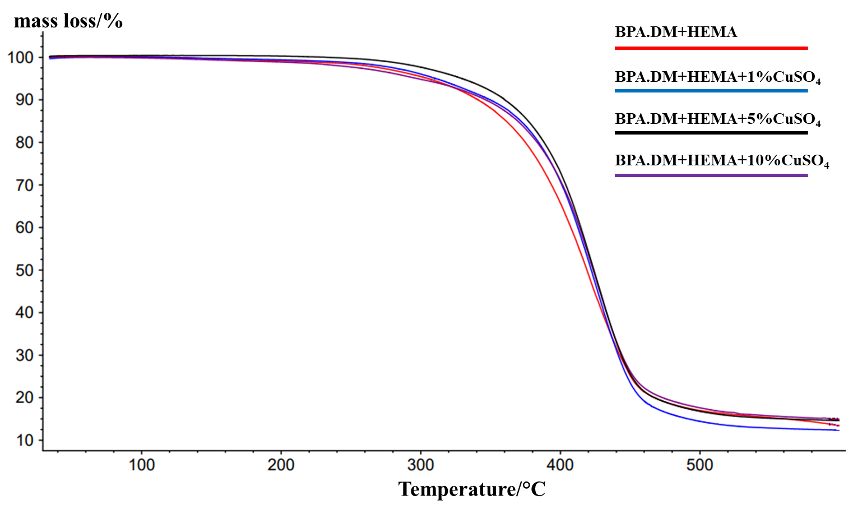 | 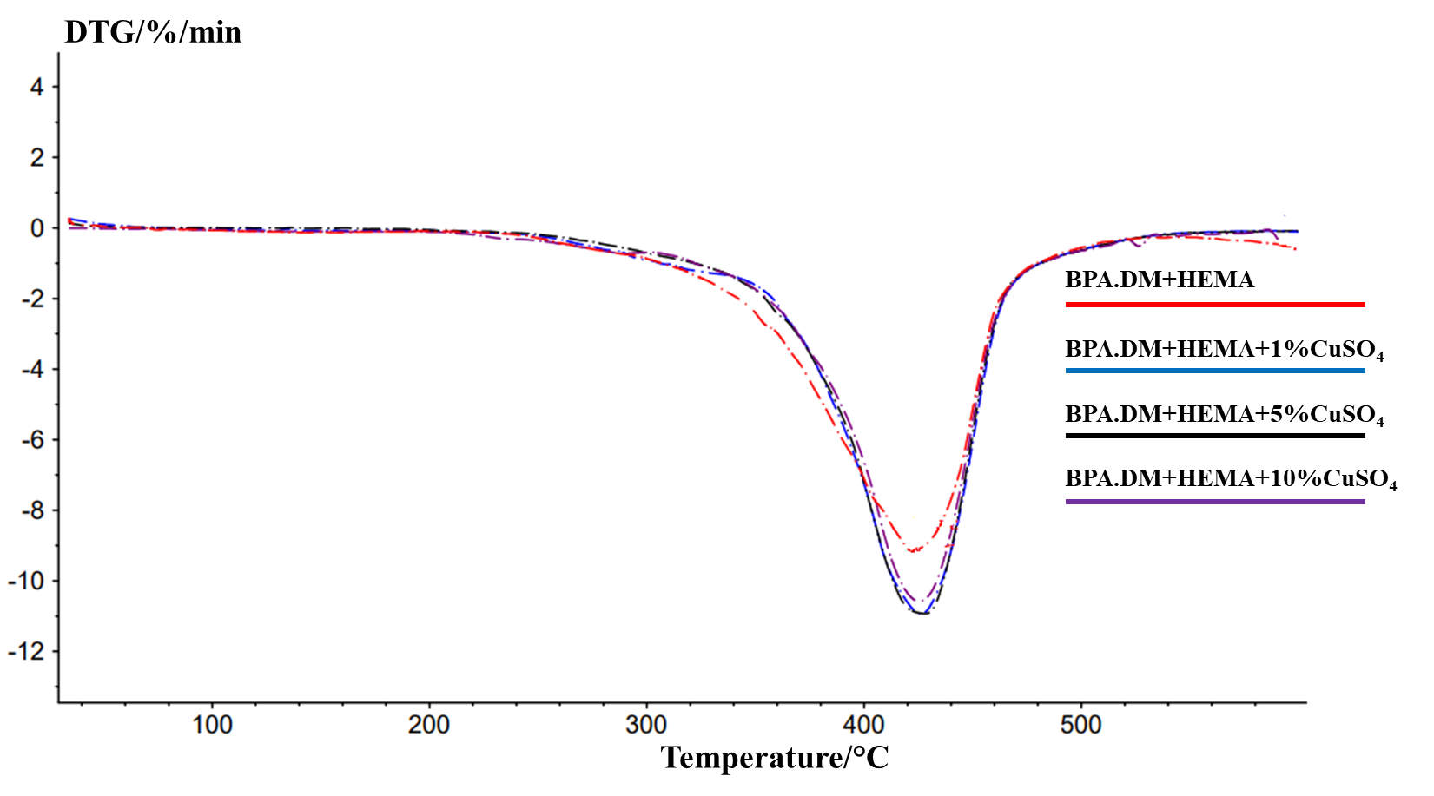
Fig. S25 TG and DTG curves of HEMA-CuSO₄ composites
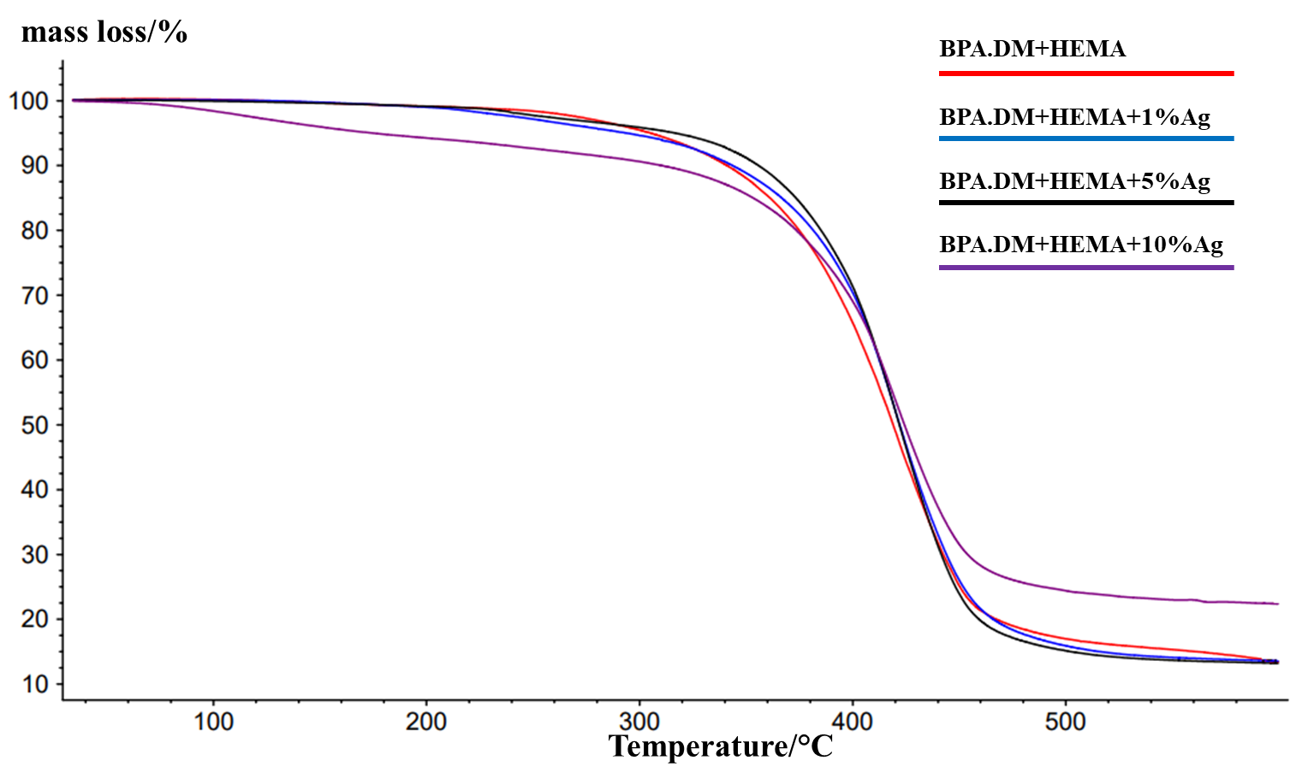 | 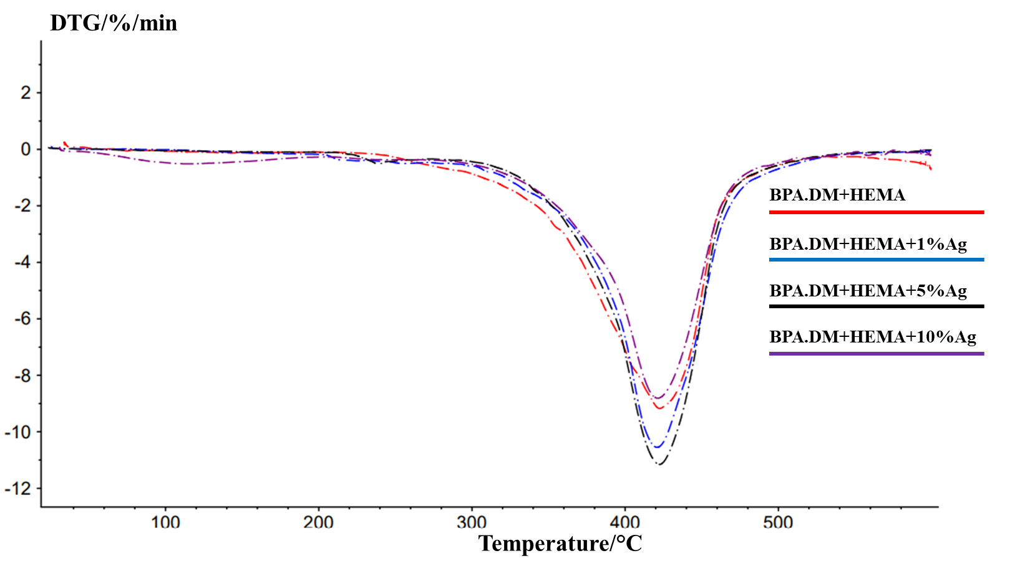
Fig. S26 TG and DTG curves of HEMA-Ag composites
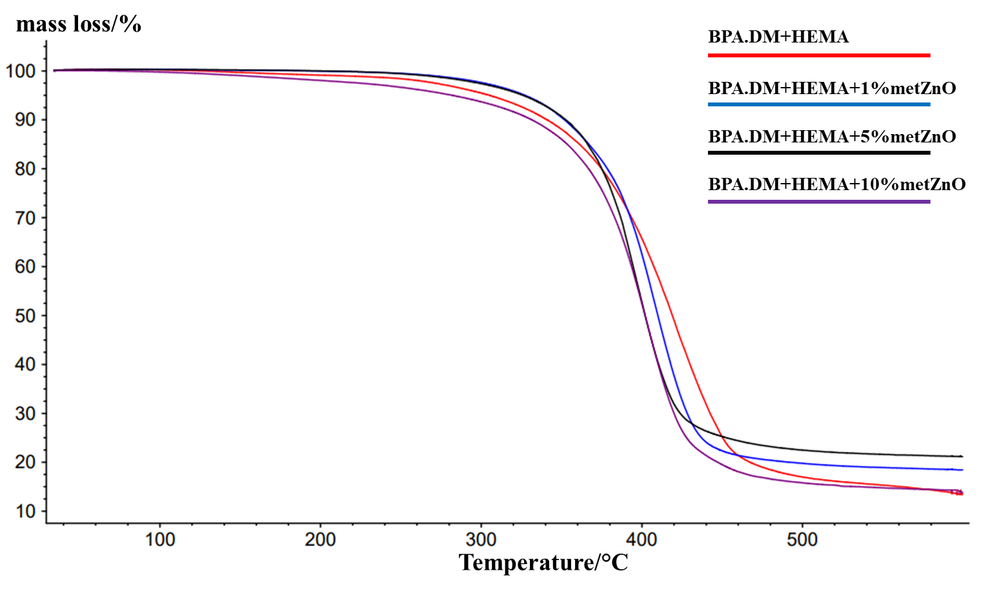 | 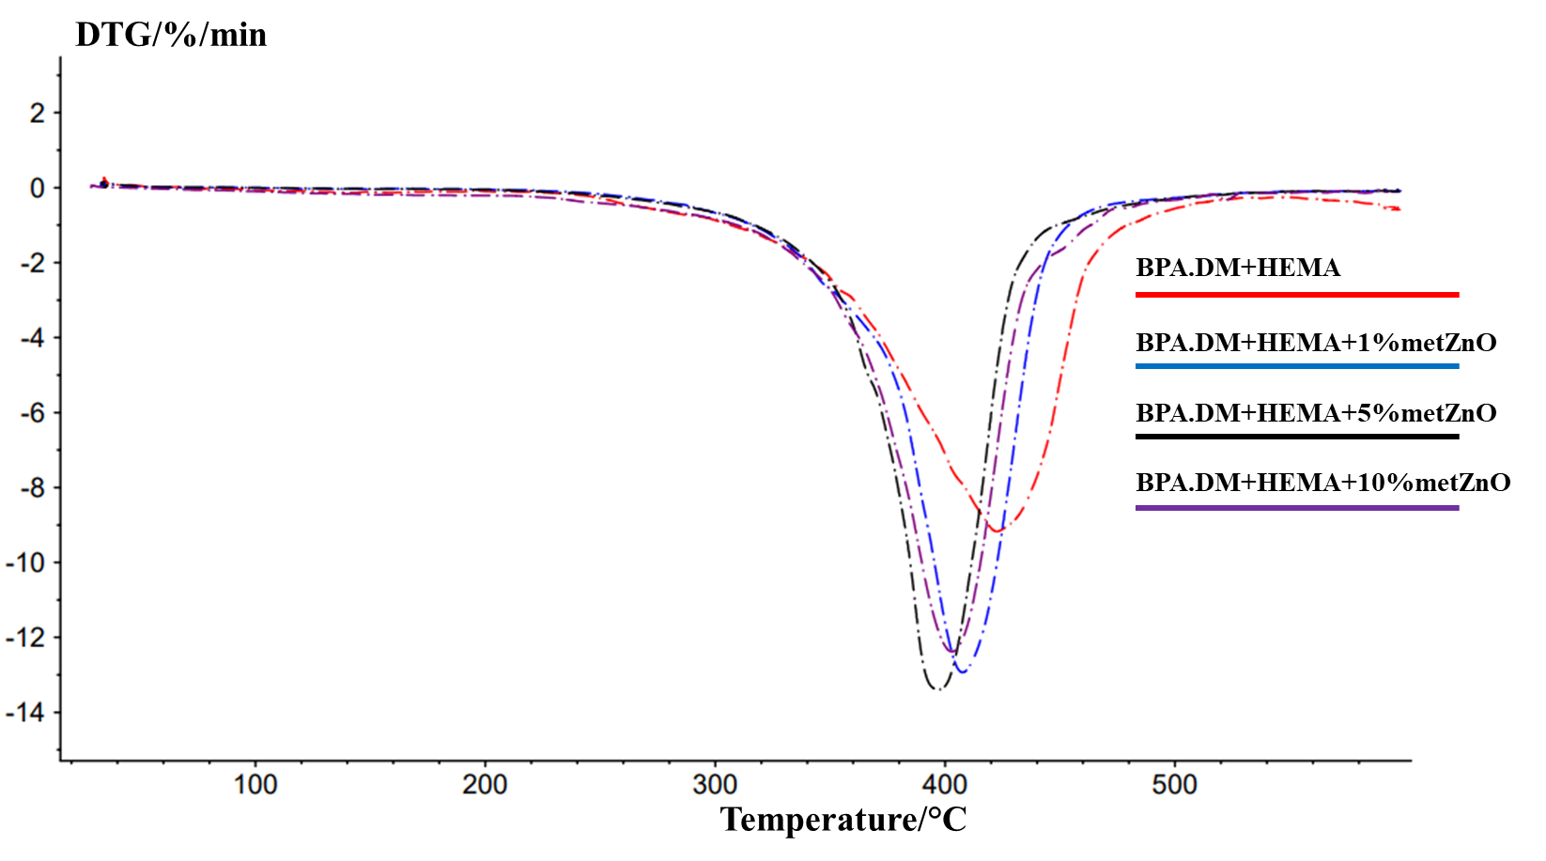
Fig. S27 TG and DTG curves of HEMA-metZnO composites
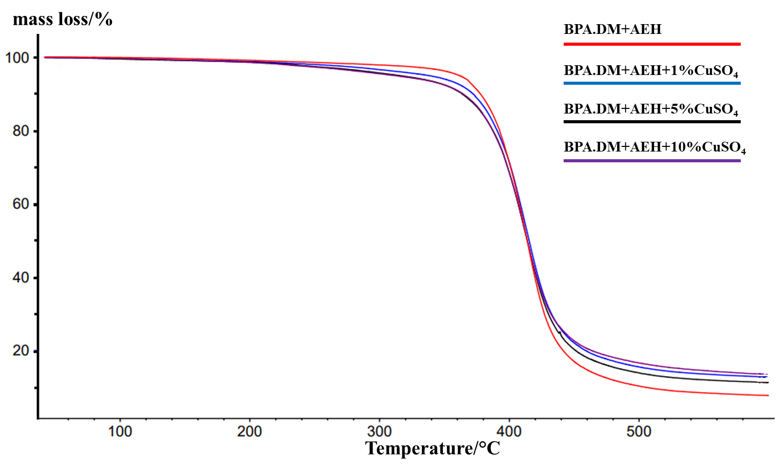 | 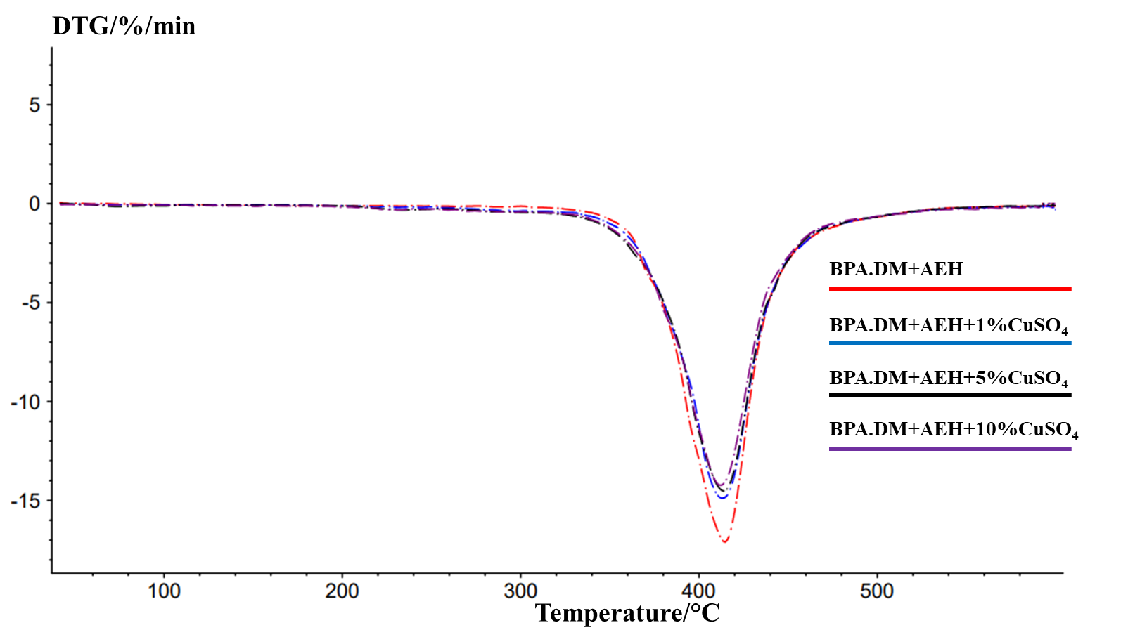
Fig. S28 TG and DTG curves of AEH-CuSO₄ composites
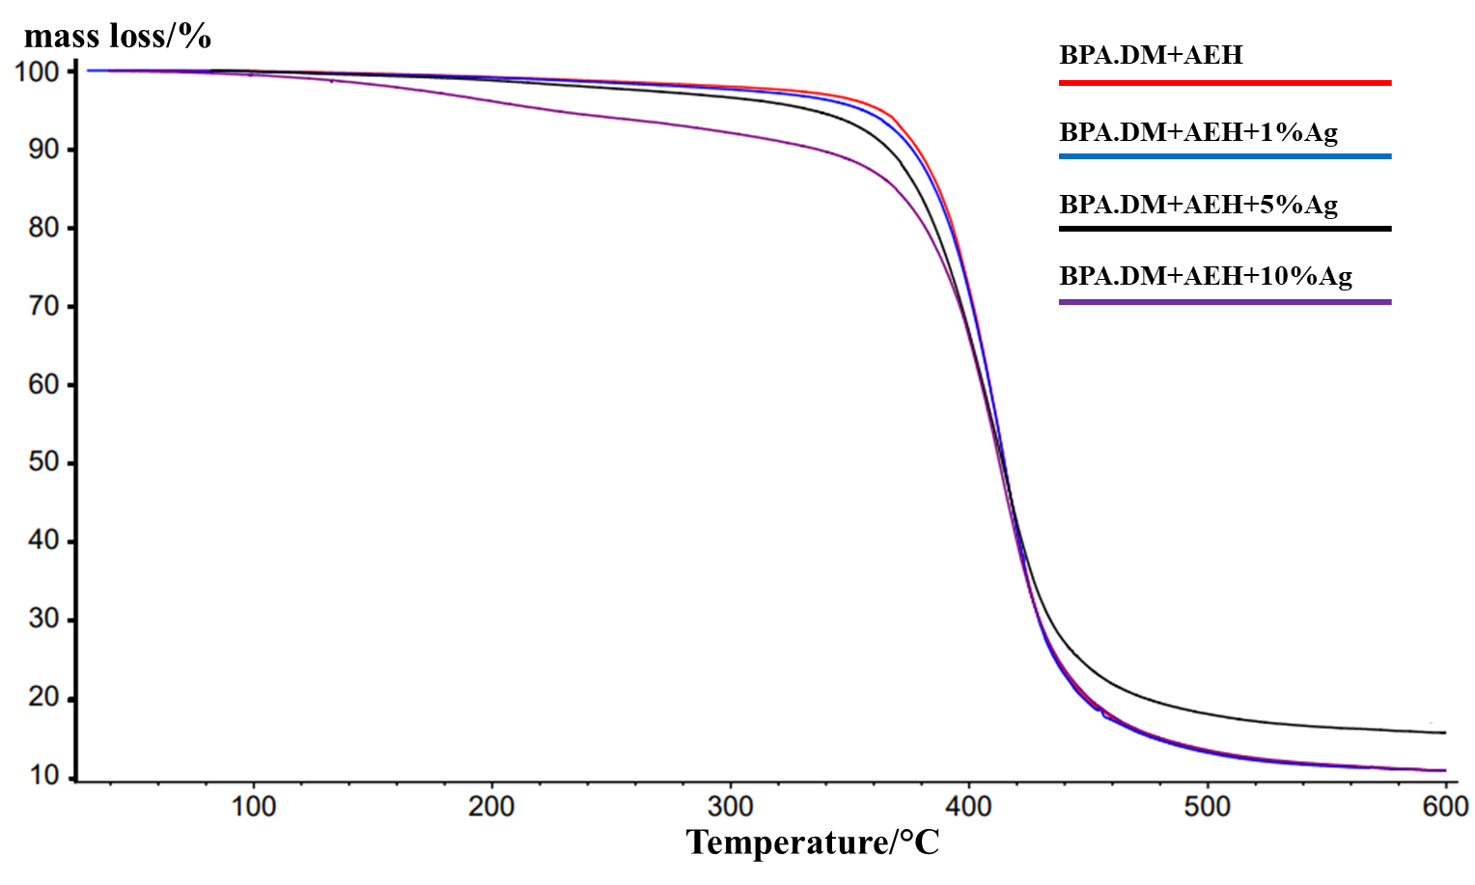 | 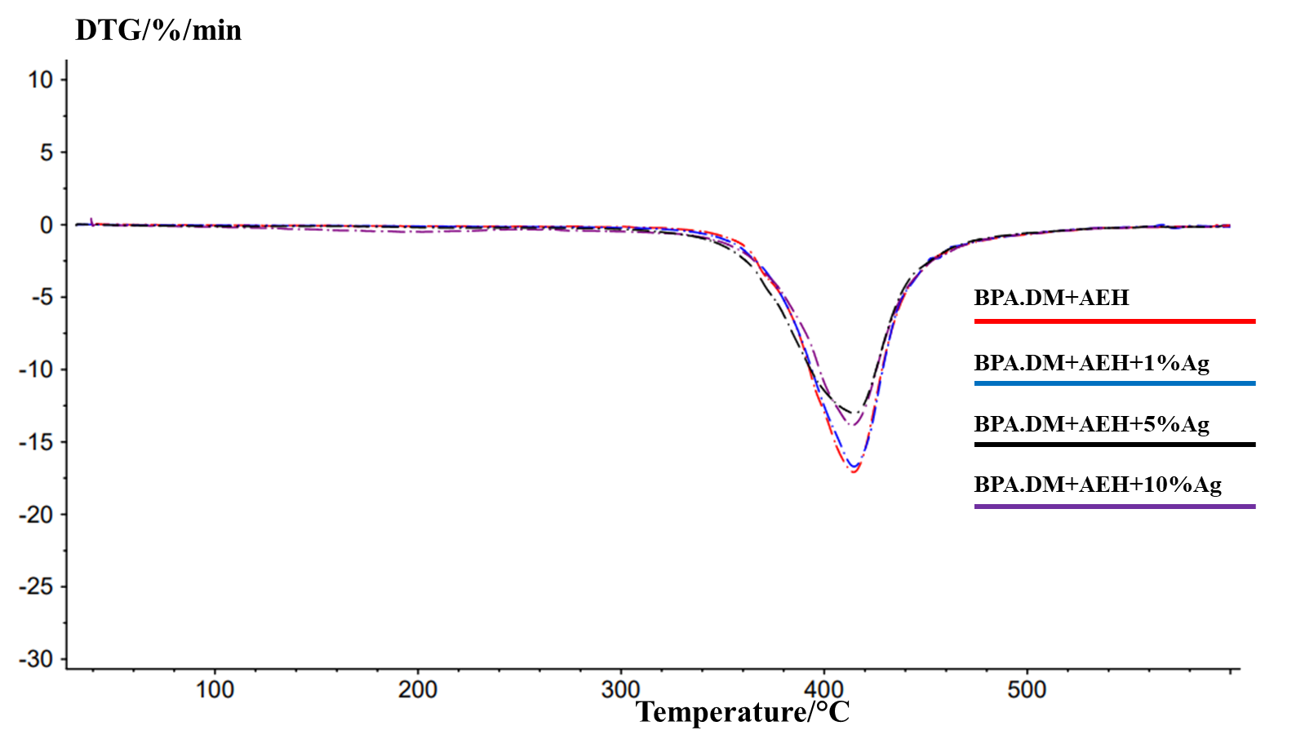
Fig. S29 TG and DTG curves of AEH-Ag composites
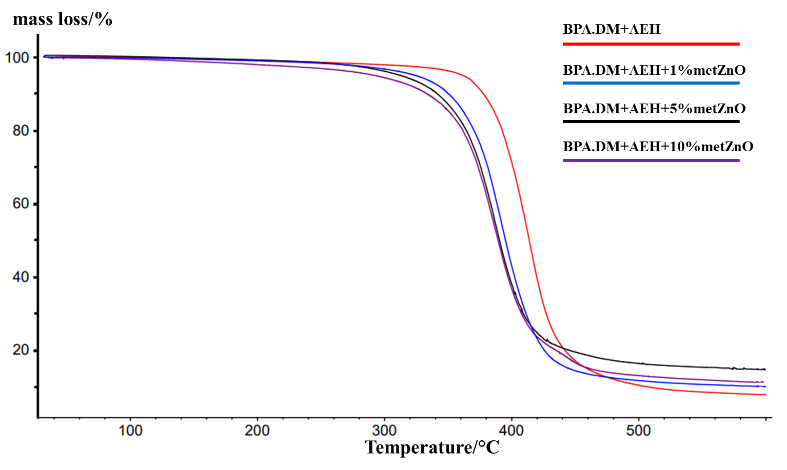 | 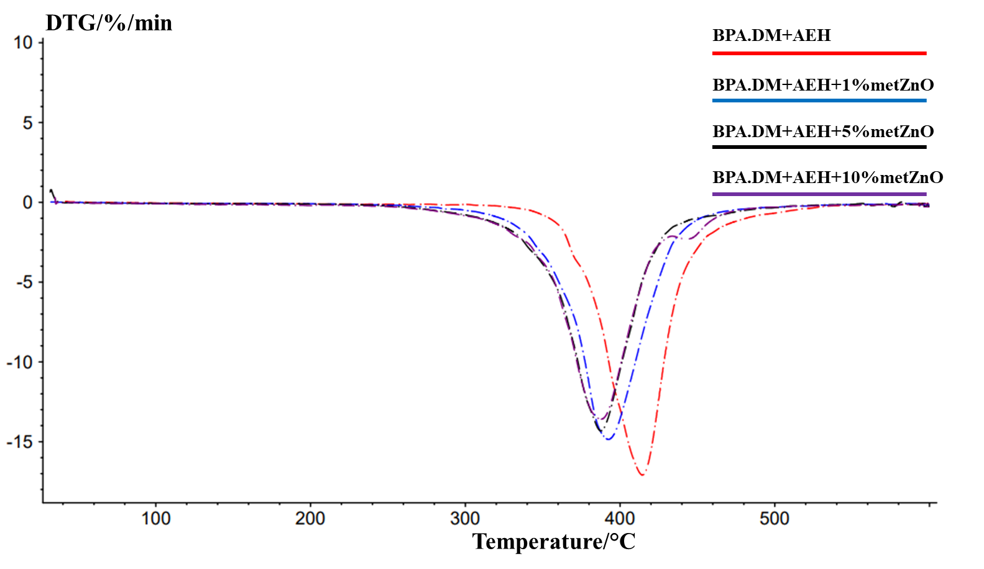
Fig. S30 TG and DTG curves of AEH-metZnO composites
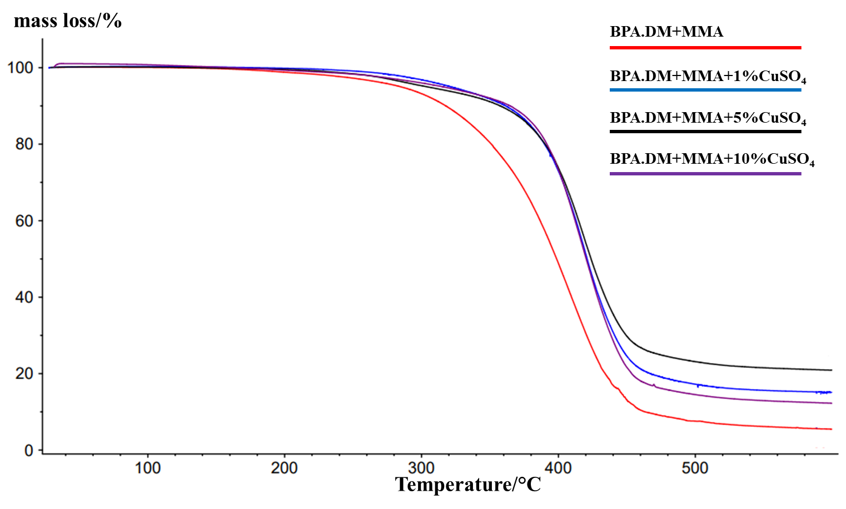 | 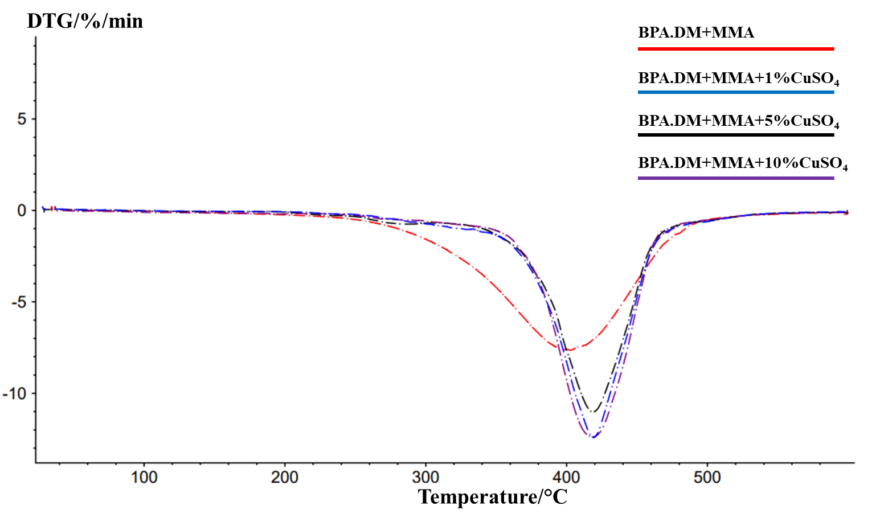
Fig. S31 TG and DTG curves of MMA-CuSO₄ composites
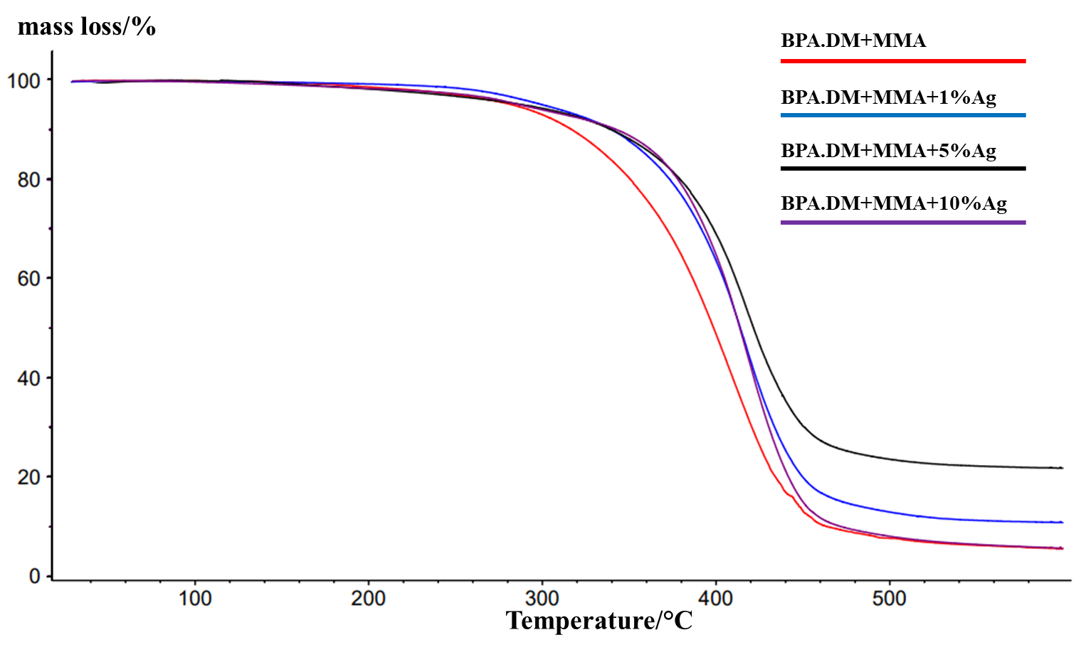 | 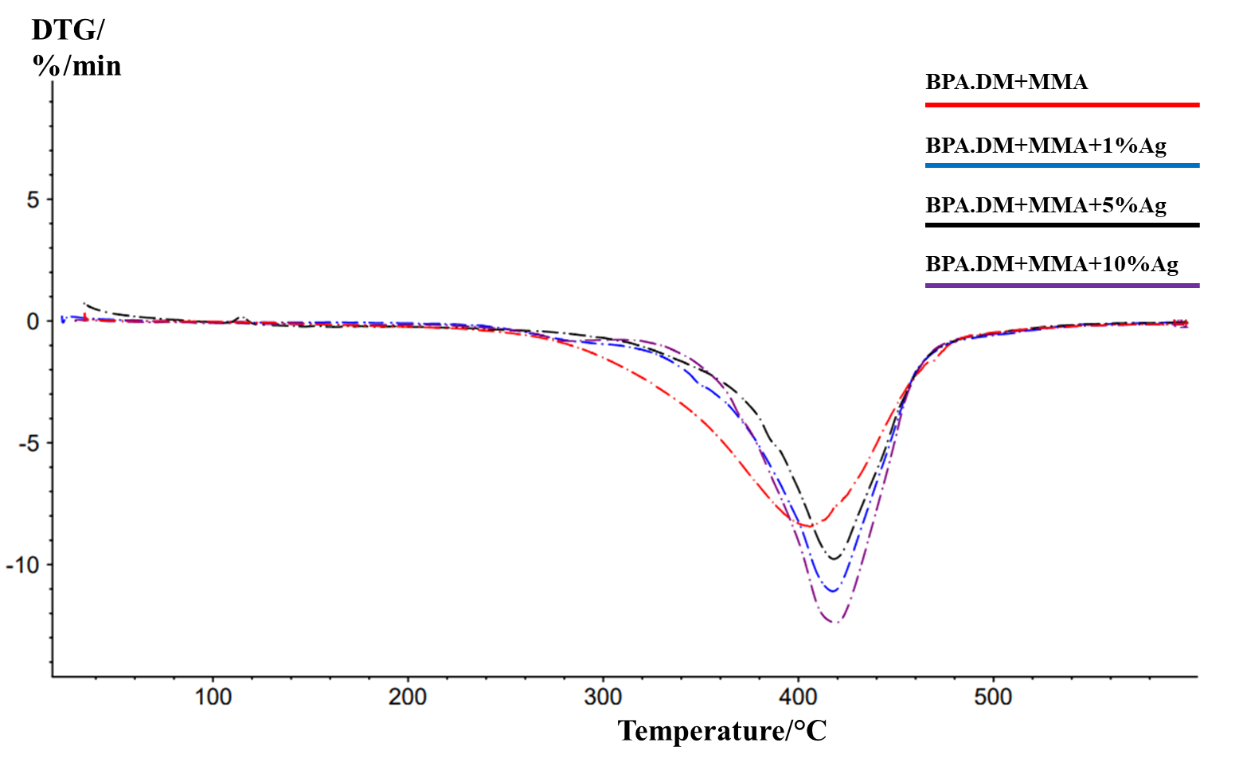
Fig. S32 TG and DTG curves of MMA-Ag composites
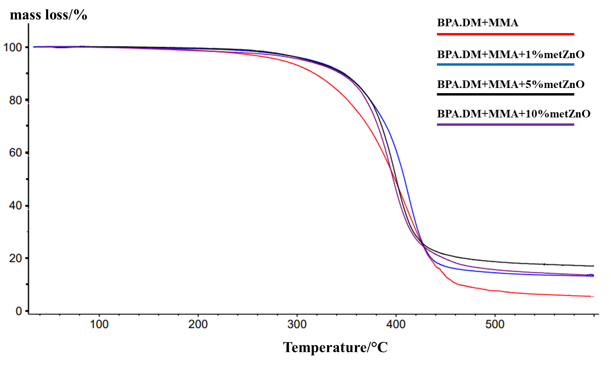 | 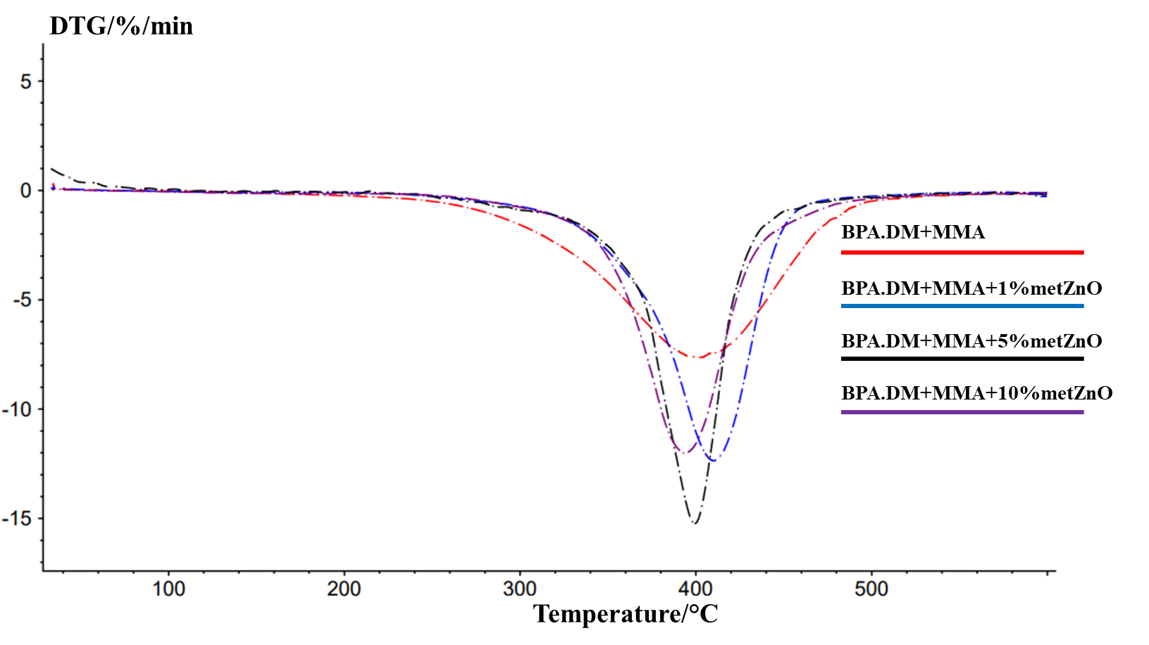
Fig. S33 TG and DTG curves of MMA-metZnO composites
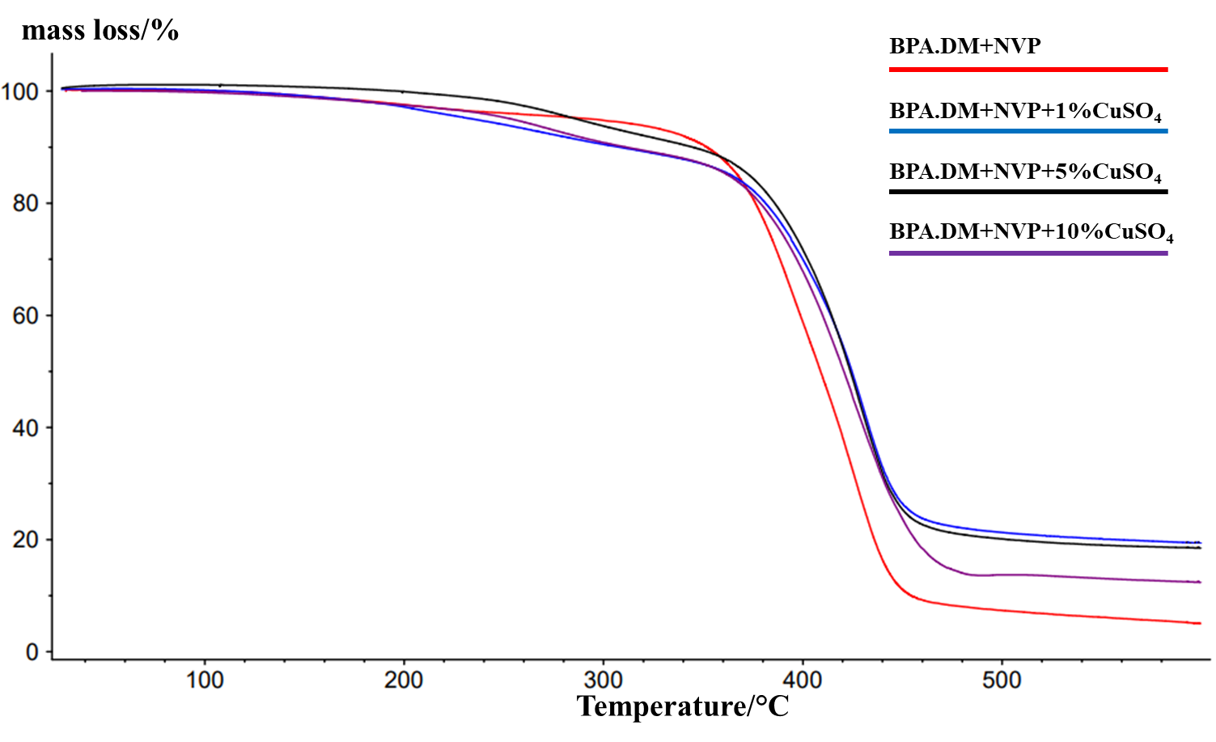 | 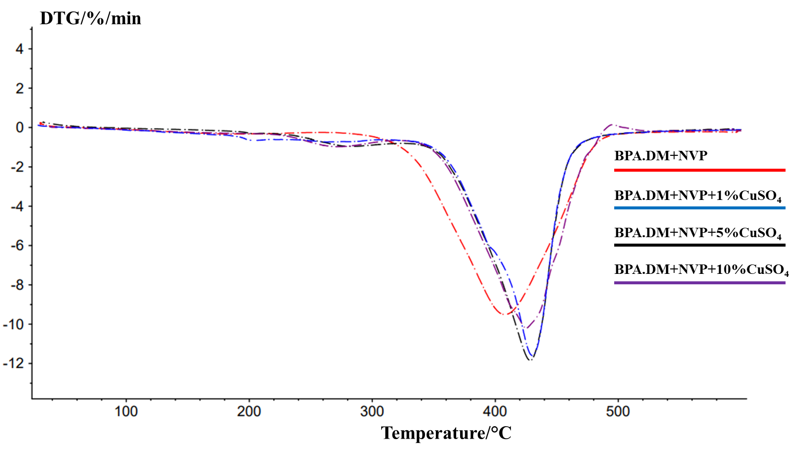
Fig. S34 TG and DTG curves of NVP-CuSO₄ composites
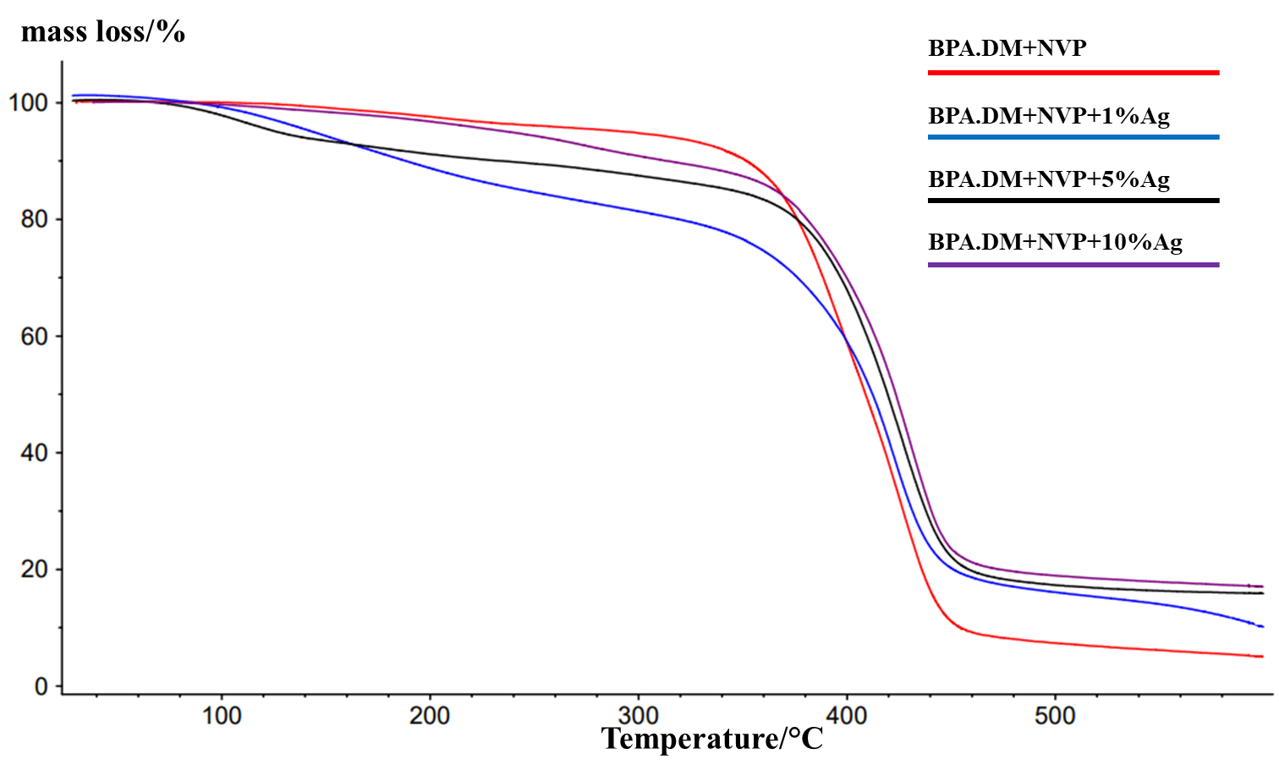 | 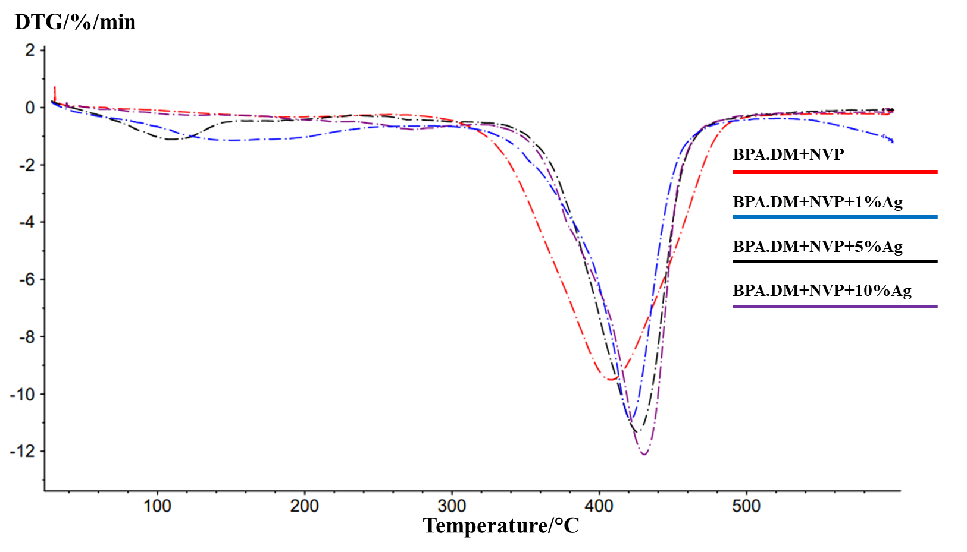
Fig. S35 TG and DTG curves of NVP-Ag composites
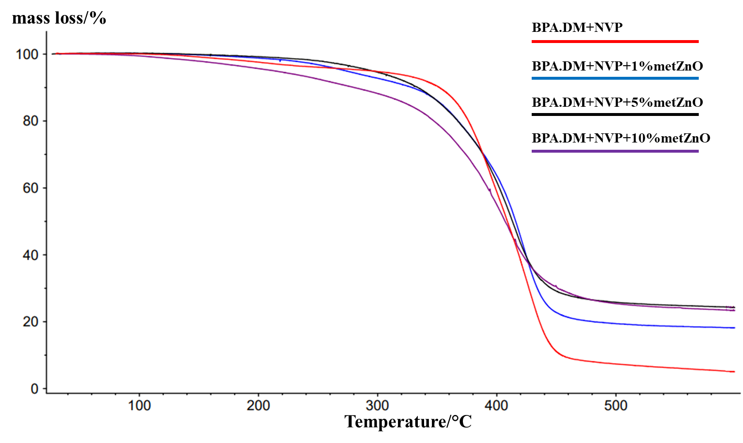 | 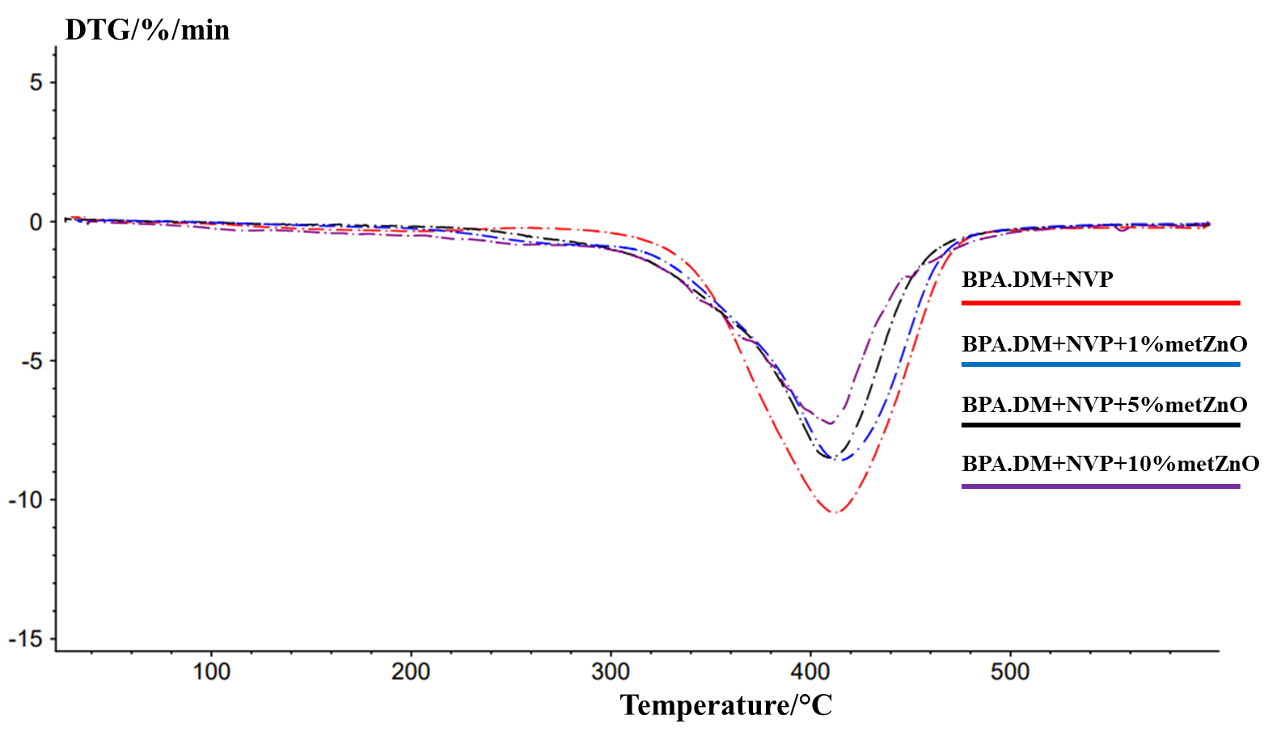
Fig. S36 TG and DTG curves of NVP-metZnO composites

Tab. S5 TG and DTG data of HEMA-containing composites
Composite | T_{2%}  (°C) | T_{5%}  (°C) | T_{50%}  (°C) | T_{max1}  (°C) | Δm₂  [%] | T_{max1}  (°C) | Δm₂  [%] | RM  (%)
BPA.DM  +HEMA | 261.1 | 305.2 | 419.0 | - | - | 422.5 | 86.57 | 13.43
BPA.DM  +HEMA+1%CuSO₄ | 259.7 | 307.5 | 425.6 | - | - | 426.2 | 86.42 | 13.58
BPA.DM  +HEMA+5%CuSO₄ | 295.2 | 329.6 | 424.0 | - | - | 428.1 | 85.39 | 14.61
BPA.DM  +HEMA+10%CuSO₄ | 241.7 | 297.6 | 423.5 | - | - | 425.4 | 85.06 | 14.94
BPA.DM  +HEMA+1%Ag | 228.3 | 294.0 | 422.1 | - | - | 420.8 | 86.37 | 13.63
BPA.DM  +HEMA+5%Ag | 244.4 | 316.8 | 421.9 | - | - | 422.5 | 86.74 | 13.26
BPA.DM  +HEMA+10%Ag | 108.6 | 175.0 | 424.2 | 119.3 | 5.60 | 423.3 | 71.99 | 22.41
BPA.DM  +HEMA+1%metZnO | 294.0 | 327.3 | 409.9 | - | - | 407.6 | 81.55 | 18.45
BPA.DM  +HEMA+5%metZnO | 289.8 | 326.0 | 402.1 | - | - | 397.0 | 78.85 | 21.15
BPA.DM  +HEMA+10%metZnO | 202.3 | 282.2 | 401.9 | - | - | 403.0 | 86.16 | 13.84

Tab. S6 TG and DTG data of AEH-containing composites
Composite | T_{2%}  (°C) | T_{5%}  (°C) | T_{50%}  (°C) | T_{max1}  (°C) | Δm₁  [%] | T_{max2}  (°C) | Δm₂  [%] | RM  (%)
BPA.DM  +AEH | 272.0 | 330.9 | 402.0 | 405.1 | 97.24 | - | - | 2.76
BPA.DM  +AEH+1%CuSO₄ | 233.3 | 316.3 | 413.8 | 413.2 | 88.72 | - | - | 11.28
BPA.DM  +AEH+5%CuSO₄ | 229.0 | 311.0 | 415.0 | 414.0 | 85.64 | - | - | 14.36
BPA.DM  +AEH+10%CuSO₄ | 227.0 | 306.4 | 414.5 | 412.0 | 84.43 | - | - | 15.57
BPA.DM  +AEH+1%Ag | 276.7 | 354.1 | 413.9 | 414.7 | 91.66 | - | - | 8.34
BPA.DM  +AEH+5%Ag | 246.0 | 344.0 | 410.0 | 414.9 | 84.74 | - | - | 15.26
BPA.DM  +AEH+10%Ag | 157.1 | 223.5 | 412.5 | 413.7 | 89.56 | - | - | 10.44
BPA.DM  +AEH+1%metZnO | 267.1 | 324.7 | 395.1 | 392.4 | 90.06 | - | - | 9.94
BPA.DM  +AEH+5%metZnO | 265.8 | 303.2 | 392.6 | 387.6 | 82.76 | - | - | 17.24
BPA.DM  +AEH+10%metZnO | 199.8 | 292.7 | 389.2 | 386.6 | 79.35 | 446.0 | 9.65 | 11.00

Tab. S7 TG and DTG data of MMA-containing composites
Composite | T_{2%}  (°C) | T_{5%}  (°C) | T_{50%}  (°C) | T_{max1}  (°C) | Δm₁  [%] | RM  (%)
BPA.DM  +MMA | 231.2 | 284.8 | 398.7 | 417.1 | 94.52 | 5.48
BPA.DM  +MMA+1%CuSO₄ | 281.4 | 321.5 | 421.0 | 419.2 | 84.88 | 15.12
BPA.DM  +MMA+5%CuSO₄ | 260.2 | 304.1 | 423.8 | 418.6 | 79.1 | 20.90
BPA.DM  +MMA+10%CuSO₄ | 259.9 | 315.5 | 420.3 | 418.4 | 87.73 | 12.27
BPA.DM  +MMA+1%Ag | 264.7 | 302.3 | 414.1 | 417.6 | 89.25 | 10.75
BPA.DM  +MMA+5%Ag | 233.1 | 299.7 | 421.1 | 418.1 | 75.77 | 24.23
BPA.DM  +MMA+10%Ag | 229.8 | 289.7 | 413.8 | 415.1 | 94.43 | 5.57
BPA.DM  +MMA+1%metZnO | 268.9 | 315.2 | 408.5 | 410.2 | 94.52 | 5.48
BPA.DM  +MMA+5%metZnO | 268.0 | 310.0 | 405.0 | 399.3 | 76.6 | 23.40
BPA.DM  +MMA+10%metZnO | 241.8 | 307.6 | 397.0 | 393.8 | 86.48 | 13.52

Tab. S8 TG and DTG data of NVP-containing composites
Composite | T_{2%}  (°C) | T_{5%}  (°C) | T_{50%}  (°C) | T_{max1}  (°C) | Δm₁  [%] | T_{max2}  (°C) | Δm₂  [%] | RM  (%)
BPA.DM  +NVP | 185.9 | 215.9 | 421.8 | - | - | 430.9 | 86.34 | 13.66
BPA.DM  +NVP+1%CuSO₄ | 183.5 | 234.9 | 424.7 | 263.2 | 12.08 | 430.1 | 68.53 | 19.39
BPA.DM  +NVP+5%CuSO₄ | 251.1 | 286.8 | 423.9 | 285.4 | 9.82 | 428.4 | 71.68 | 18.50
BPA.DM  +NVP+10%CuSO₄ | 183.4 | 254.1 | 420.6 | 272.6 | 11.61 | 425.1 | 75.99 | 12.40
BPA.DM  +NVP+1%Ag | 115.4 | 143.9 | 412.3 | 150.8 | 7.59 | 421.3 | 82.26 | 10.15
BPA.DM  +NVP+5%Ag | 98.4 | 126.6 | 419.5 | 108.9 | 18.70 | 426.1 | 65.43 | 15.87
BPA.DM  +NVP+10%Ag | 165.6 | 237.7 | 423.4 | - | - | 430.5 | 82.95 | 17.05
BPA.DM  +NVP+1%metZnO | 218.0 | 273.3 | 415.9 | - | - | 414.4 | 81.81 | 18.19
BPA.DM  +NVP+5%metZnO | 250.3 | 295.4 | 413.2 | - | - | 409.5 | 75.72 | 24.28
BPA.DM  +NVP+10%metZnO | 147.2 | 213.2 | 407.0 | - | - | 409.9 | 76.62 | 23.38

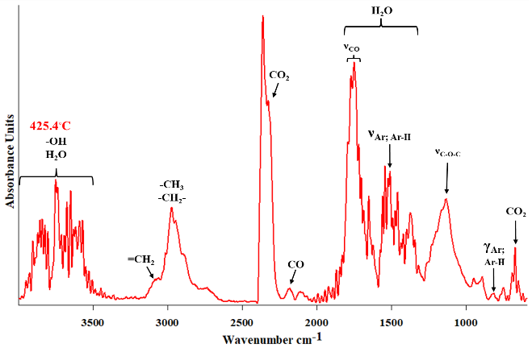 | 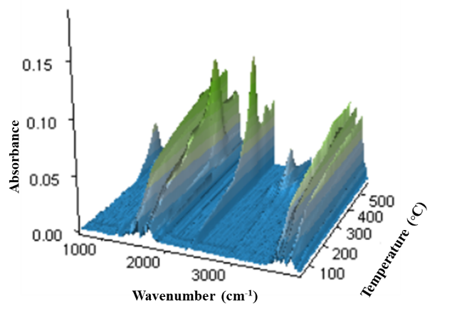
Fig. S37 ATR/FT-IR spectra and 3D diagram of FT-IR absorption of evolved gases for HEMA-CuSO₄ composites at the maxima of decomposition
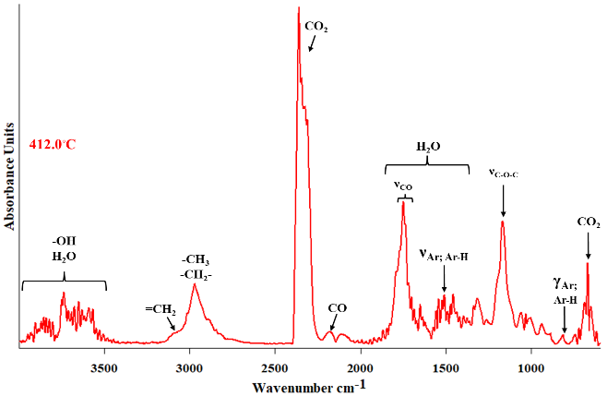 | 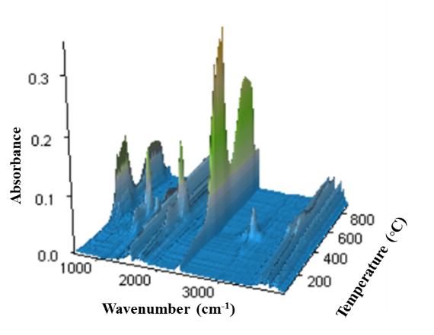
Fig. S38 ATR/FT-IR spectra and 3D diagram of FT-IR absorption of evolved gases for AEH-CuSO₄ composites at the maxima of decomposition
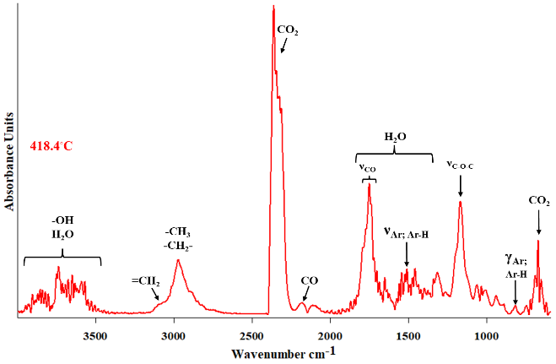
Fig. S39 ATR/FT-IR spectra and 3D diagram of FT-IR absorption of evolved gases for MMA-CuSO₄ composites at the maxima of decomposition
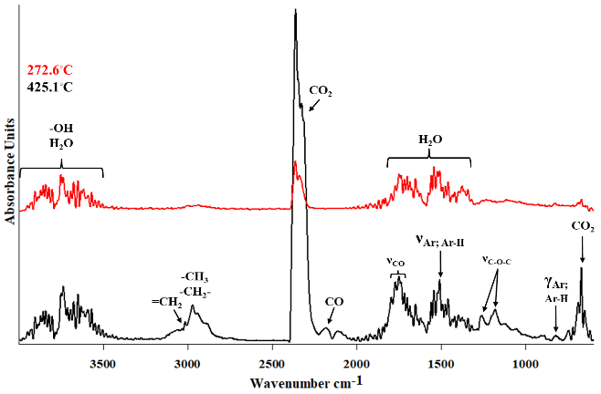 | 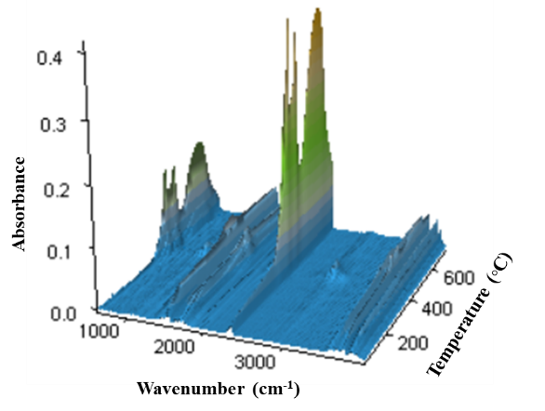
Fig. S40 ATR/FT-IR spectra and 3D diagram of FT-IR absorption of evolved gases for NVP-CuSO₄ composites at the maxima of decomposition
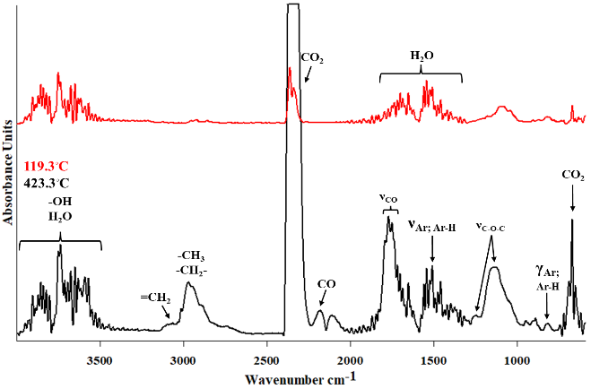 | 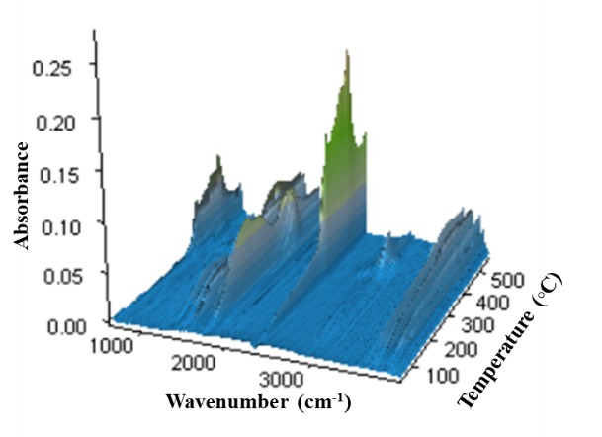
Fig. S41 ATR/FT-IR spectra and 3D diagram of FT-IR absorption of evolved gases for HEMA-Ag composites at the maxima of decomposition
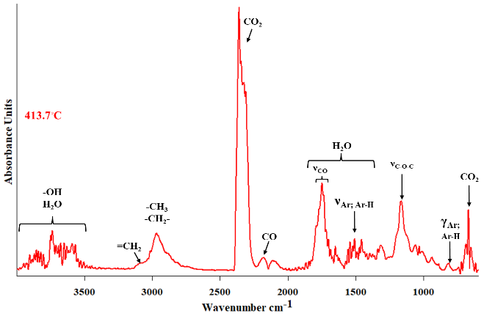 | 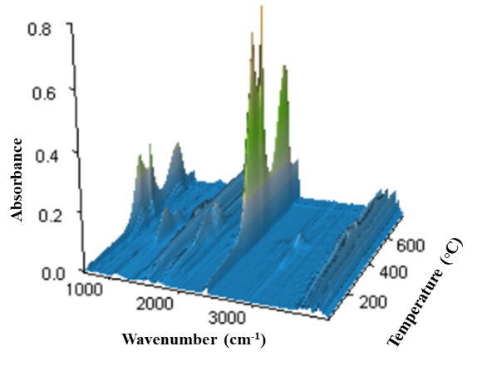
Fig. S42 ATR/FT-IR spectra and 3D diagram of FT-IR absorption of evolved gases for AEH-Ag composites at the maxima of decomposition
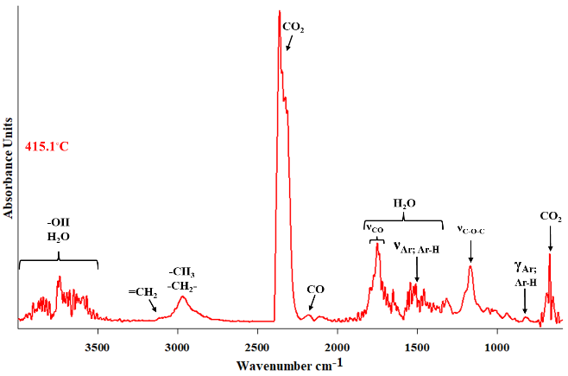 | 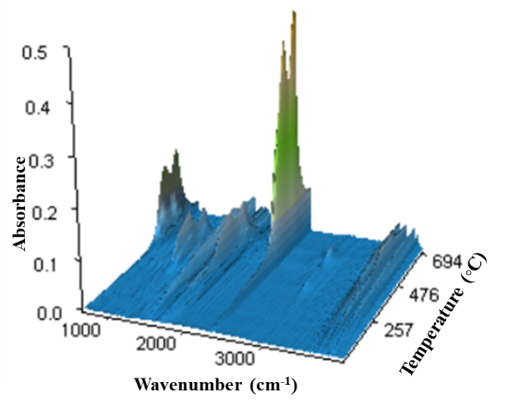
Fig. S43 ATR/FT-IR spectra and 3D diagram of FT-IR absorption of evolved gases for MMA-Ag composites at the maxima of decomposition
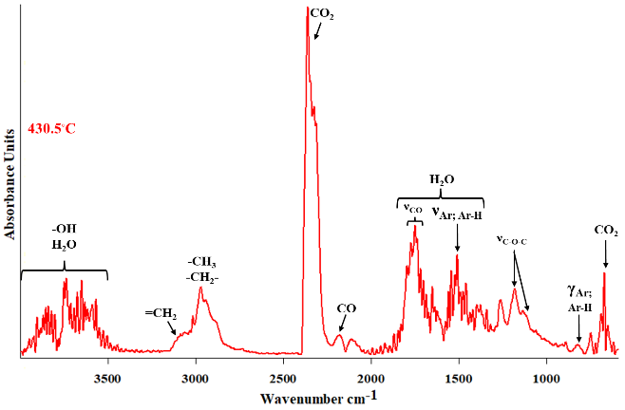
Fig. S44. ATR/FT-IR spectra and 3D diagram of FT-IR absorption of evolved gases for NVP-Ag composites at the maxima of decomposition
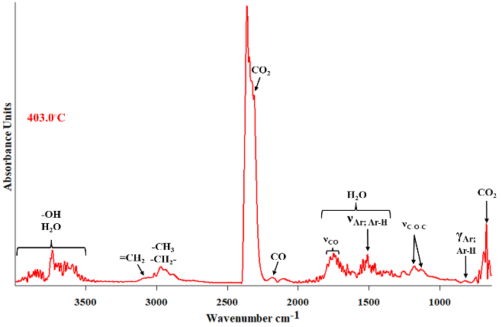 | 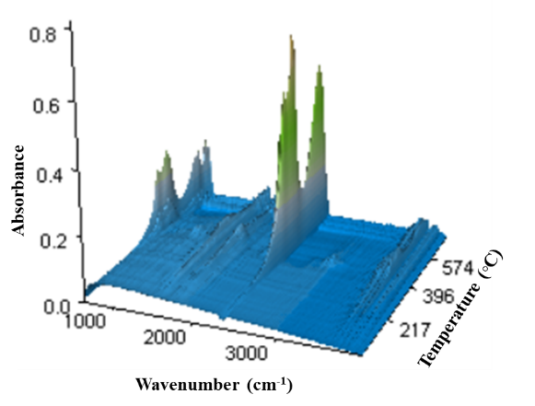
Fig. S45. ATR/FT-IR spectra and 3D diagram of FT-IR absorption of evolved gases for HEMA-metZnO composites at the maxima of decomposition
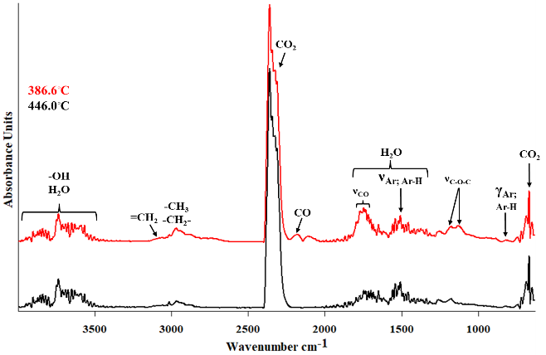
Fig. S46. ATR/FT-IR spectra and 3D diagram of FT-IR absorption of evolved gases for AEH-metZnO composites at the maxima of decomposition
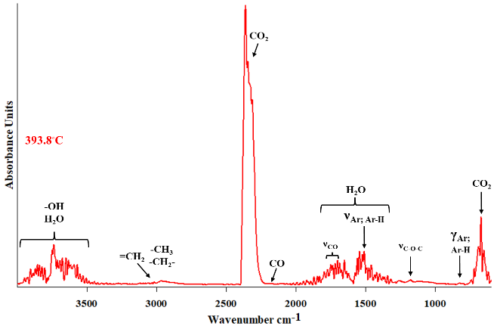 | 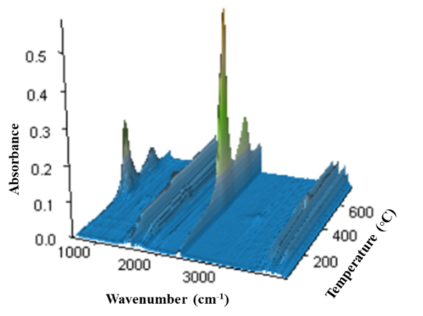
Fig. S47. ATR/FT-IR spectra and 3D diagram of FT-IR absorption of evolved gases for MMA-metZnO composites at the maxima of decomposition
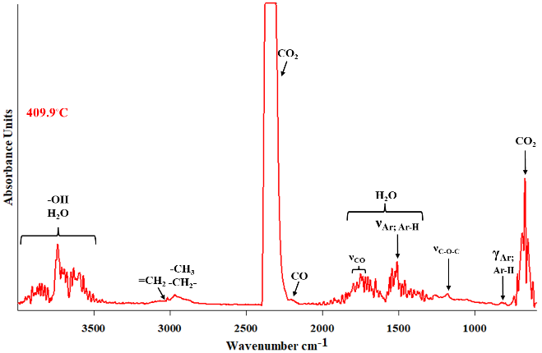 | 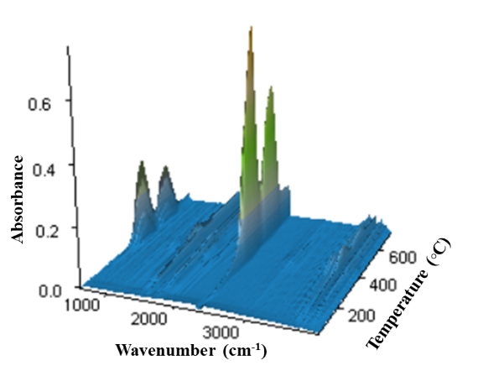
Fig. S48. ATR/FT-IR spectra and 3D diagram of FT-IR absorption of evolved gases for NVP-metZnO composites at the maxima of decomposition

