Thermal behaviour, crystal structure, spectroscopic and biological studies of novel Co(II), Ni(II) and Cu(II) complexes with indomethacin
Journal of Thermal Analysis and Calorimetry
Karolina Kafarska¹ ∙ Patrycja Schab¹ ∙ Michał Gacki¹ ∙ Anna Pietrzak¹ ∙ Izabela Korona-Głowniak² ∙ Wojciech M. Wolf¹
¹Institute of General and Ecological Chemistry, Faculty of Chemistry, Łódź University of Technology, Żeromskiego 116, 90-924 Łódź, Poland
²Department of Pharmaceutical Microbiology, Medical University of Lublin, Chodźki 1, 20-093 Lublin, Poland
E-mail address of corresponding author: karolina.kafarska@p.lodz.pl
Table S1 Crystallographic data and structure refinement parameters for 2 and 3
 | 2 | 3
Empirical formula | C₃₈H₄₀NiCl₂N₂O₁₃ | C₈₀H₇₂Cu₂Cl₄N₄O₁₈
Formula mass | 862.33 | 1646.35
T/°C | -173 | -173
Crystal system | monoclinic | triclinic
Space group | P2₁/n | P$\overline{1}$
a/Å | 21.3086(11) | 11.7941(5)
b/Å | 5.1918(2) | 12.0669(6)
c/Å | 15.6733(7) | 16.0164(7)
α/° | 90 | 68.505(4)
β/° | 103.742(5) | 83.818(4)
γ/° | 90 | 62.035(5)
V/Å³ | 1842.40(15) | 1867.53(17)
Z | 2 | 1
ρ_{calc}/g cm⁻³ | 1.587 | 1.464
F(000) | 916 | 850
Radiation | Cu–Kα (λ = 1.54178) | Cu–Kα (λ = 1.54178)
Reflections collected | 5427 | 6657
Independent reflections | 4892 | 5132
Goodness–of–fit(GOF) | 1.106 | 1.071
R1 [I>=2σ (I)] | 0.0887 | 0.0622
wR2 [I>=2σ (I)] | 0.2497 | 0.1528
wR2 (all refl.) | 0.2545 | 0.1686

Table S2 Hydrogen bond geometry in 2 (Å,°)
D-H…A | D-H | H…A | D…A | D-H…A
O1W-H1WA…O3ª | 0.89 | 1.75 | 2.544(7) | 147
O1W-H1WB…O1W^{b} | 0.89 | 2.41 | 3.064(7) | 131
O1W-H1WB…O4A^{b} | 0.89 | 2.08 | 2.86(2) | 146
O2W-H2WA…O2^{c} | 0.89 | 1.88 | 2.771(9) | 175
O2W-H2WB…O1W^{d} | 0.89 | 2.37 | 3.123(10) | 142
O2W-H2WB…O3W^{d} | 0.89 | 2.02 | 2.496(17) | 112
O3W-H3WB…O4A* | 0.85 | 2.54 | 2.89(2) | 106
C2-H2…O1e | 0.95 | 2.43 | 3.339(9) | 161
C12-H12…O1 | 0.95 | 2.43 | 2.914(9) | 111
C16-H16A…O3^{f} | 0.99 | 2.44 | 3.429(9) | 175
C18-H18A…O3^{f} | 0.98 | 2.36 | 3.336(9) | 174

Symmetry codes: (ª) 1-x, -y, 1-z; (^{b}) 1-x, 1-y, 1-z; (^{c}) 1-x, ½+y, 3/2-z; (^{d}) x, 1+y, z; (^{e}) x, ½-y, - ½ +z; (^{f}) x, 1+y, z.

Table S3 Hydrogen bond geometry in 3 (Å,°)
D-H…A | D-H | H…A | D…A | D-H…A
C39-H39A…O4 | 0.99(3) | 2.51 | 3.182(7) | 125(3)
O9-H9…O6ª | 0.88(7) | 1.95(7) | 2.814(5) | 167(7)
C32-H32…O3^{b} | 0.95 | 2.43 | 3.127(7) | 131
C35-H35…O9^{c} | 0.95 | 2.39 | 3.324(7) | 168
Symmetry codes: (ª) 1+x, -1+y, z; (^{b}) 1-x, 1-y, 1-z; (^{c}) 2-x, 1-y, 1-z.
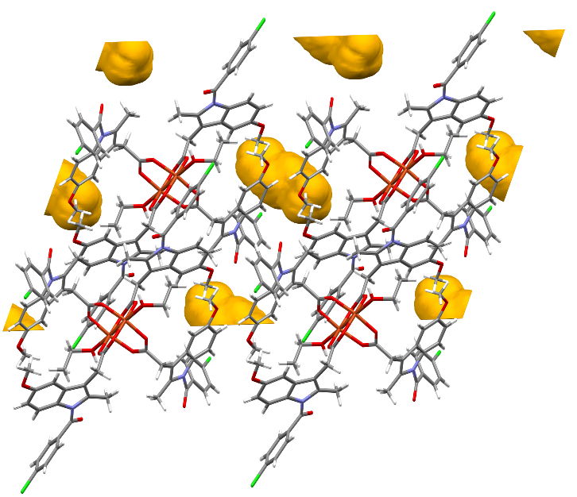
Fig. S1 The crystal voids in 3

Table S4 Type of coordination according to Nakamoto criteria [67]
Compound | ν_{as(OCO)}/cm⁻¹ | ν_{s(OCO)}/cm⁻¹ | ∆ν | Coordination mode
1 | 1560  (1556) | 1327 | 233 (229) | monodentate
2 | 1558 | 1328 | 230 | monodentate
3 | 1631  (1587) | 1365  (1361) | 266 (226) | monodentate/ bridging

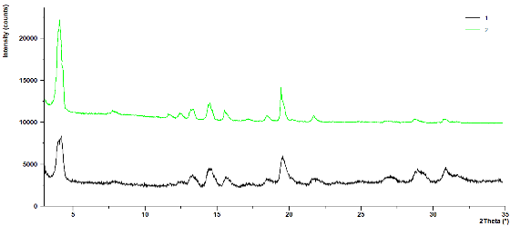
Fig. S2 The X-ray powder diffraction patterns of 1-2

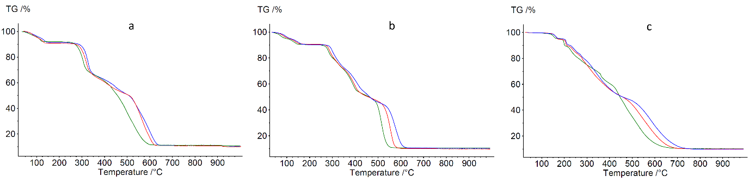
Fig. S3 Thermoanalytical curves with different heating rate of a) 1; b) 2; c) 3. 5°C min⁻¹ plotted in green, 10°C min⁻¹ is in red and 20°C min⁻¹ is in blue

