Supplemental Information

Table S1. Mincing Solution – Ph 6.8
Contents | Concentration
NaCl | 0.1M
MgAc | 5mM
EGTA | 2mM
Phosphate Buffer | 7mM
Protease Inhibitor Cocktail  -AEBSF  -Aprotinin  -Bestatin  -E-64  -Leupeptin  -Pepstatin A | 520 µM  0.4 µM  20 µM  7 µM  10 µM  7.5 µM

Table S2. Relaxing Solution – Ph 6.8
Contents | Concentration
NaCl | 0.1M
MgAc | 5mM
EGTA | 2mM
Phosphate Buffer | 7mM
Protease Inhibitor Cocktail  -AEBSF  -Aprotinin  -Bestatin  -E-64  -Leupeptin  -Pepstatin A | 520 µM  0.4 µM  20 µM  7 µM  10 µM  7.5 µM
ATP | 2.5mM
Creatine Phosphate | 10mM

Table S3. Microscope Collection and Reconstruction Details
Collection | Collection 1 (TF1) | Collection 2 (TF2)
No. micrographs | 3,105 | 2,517
Magnification | 81,000x | 81,000x
Pixel size (Å/p) | 1.048 | 1.048
Microscope | Titan Krios | Titan Krios
Detector | K2 (Counted Mode) | K2 (Counted Mode)
Voltage, kV | 300 | 300
Defocus range (µm) | 0.4 – 1.0 | 0.4 – 1.1
No. of frames | 40 | 40
Dose per frame | 1.11 | 1.11
 | Thin Filament Reconstruction (TF1 & TF2)
Box Size (p) | 500
Particles | 9,821
Resolution (Å) | 15.3
 | Actin Reconstruction (TF1)
Box Size (p) | 500
Particles | 420,108
Resolution (Å) | 3.85
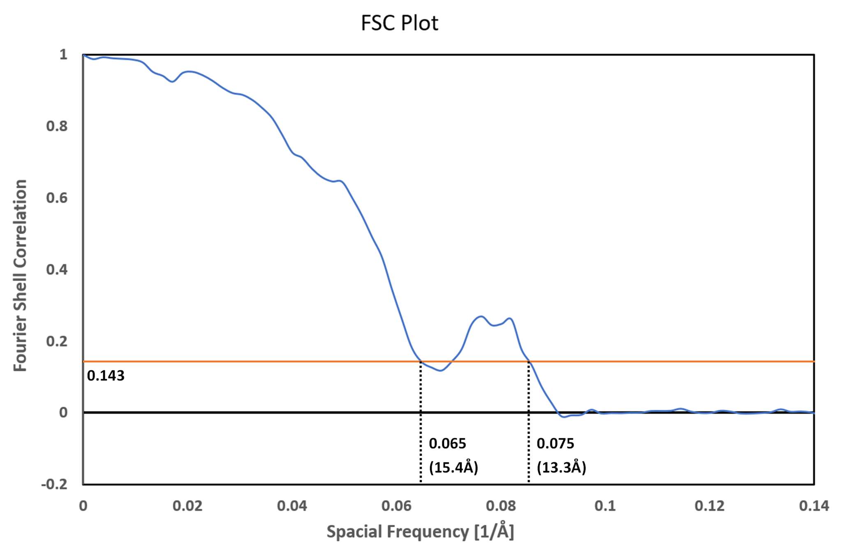

Fig S1. Resolution estimation by Fourier shell correlation calculated using independent half maps from zebrafish thin filament structure. A cut-off is shown at 0.143 with the first intersection occurring at spatial frequency 0.065, suggesting a resolution of 15.3Å. The FSC curve only briefly dips below this threshold and later recrosses at 0.075 suggesting a resolution of 13.3Å. This may represent distinct local resolutions within the zebrafish map.

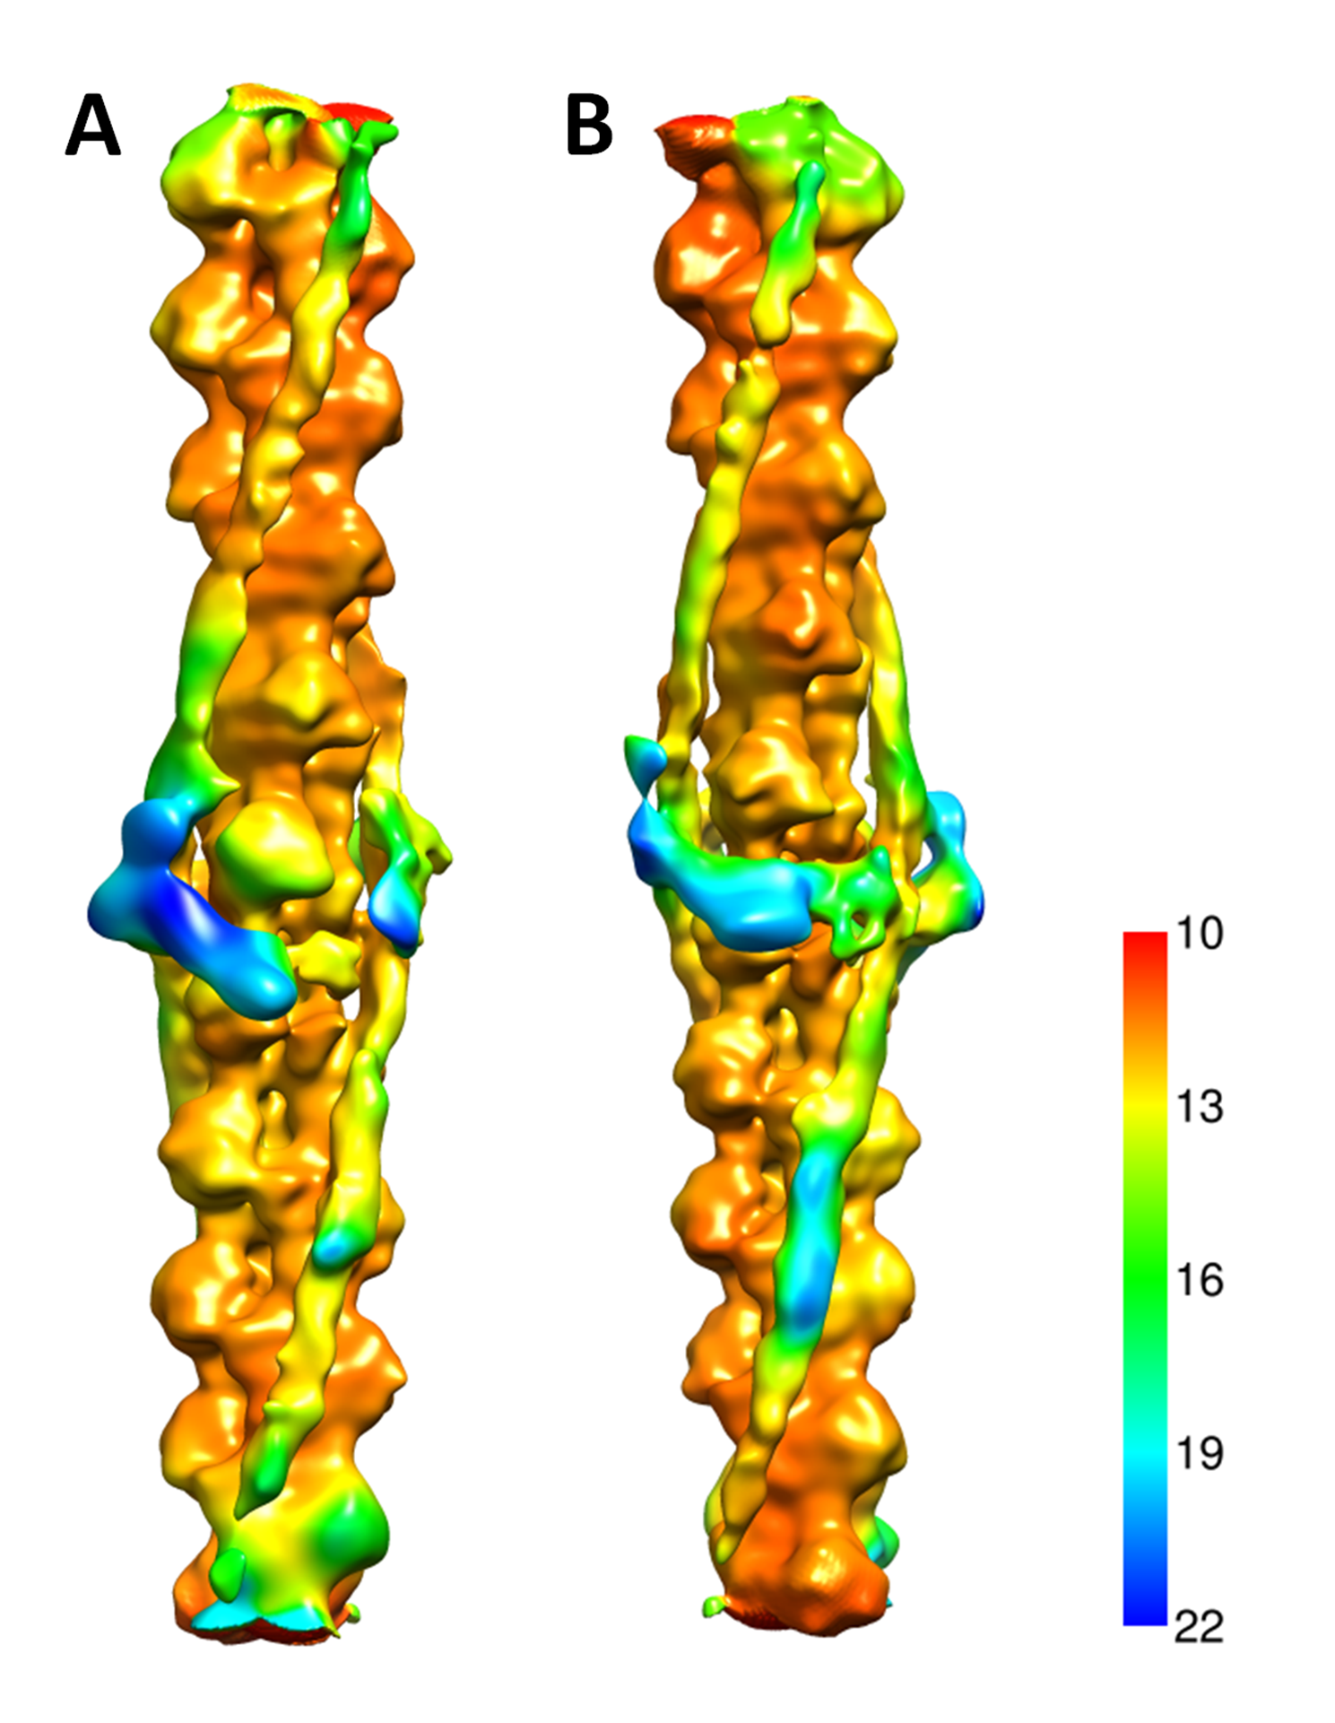

Fig S2 Local resolution 3D map reconstruction obtained using Relion’s Local Resolution function. A & B show the reconstruction from opposing angles to include both troponin complexes. The Map shows local resolution between actin (higher resolution) and accessory proteins (lower resolutions). Performed by inputting half-maps, each generated using subsets of half the particles used in the final Zebrafish reconstruction.
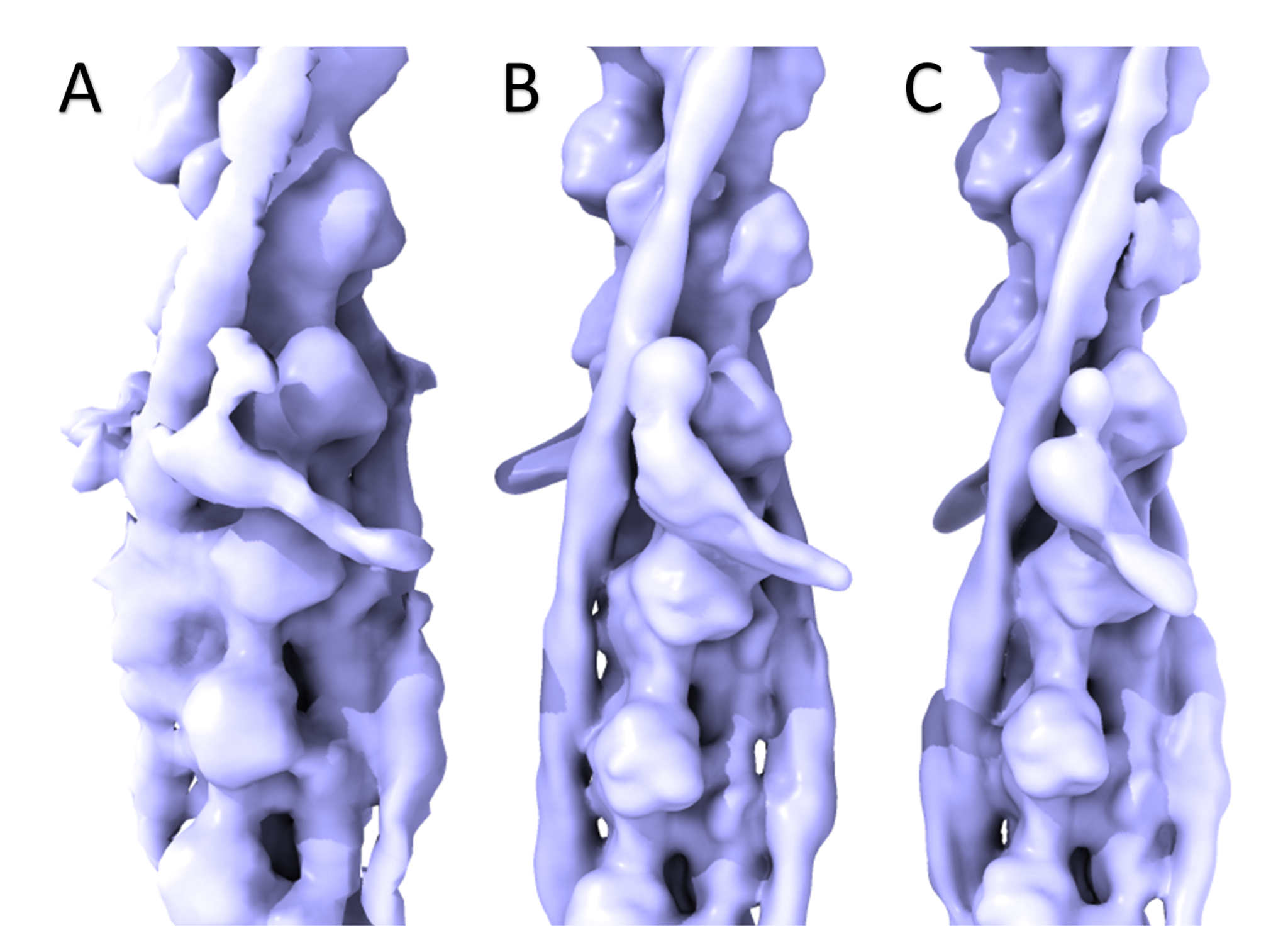

Fig. S3 Cryo EM reconstructions of the thin filament filtered to a resolution of 15Å. A: The native zebrafish map EMD-15901. B & C: The high and low Ca²⁺ human reconstituted thin filament maps EMD-0279 and EMD-0278. The orientation of the troponin core domain in the zebrafish map (A) closely resembles that seen at high Ca²⁺ (B).

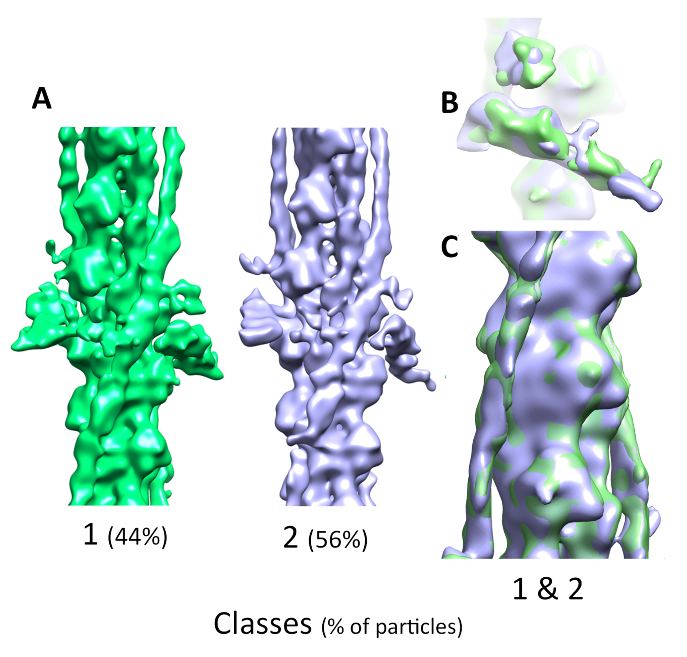
Fig S5 Evaluating the activation state of the data using 3D classification. A: Particle set used for the final zebrafish cryo-EM map used to generate 2 classes in cisTEM. B: Both classes aligned using Chimera’s fit in map function shown superimposed, alignment shows very similar IT arm angle. C: Both classes aligned as in B. with the same tropomyosin position, highlighting a high degree of similarity between the two, suggesting both classes occupy the same activation state.

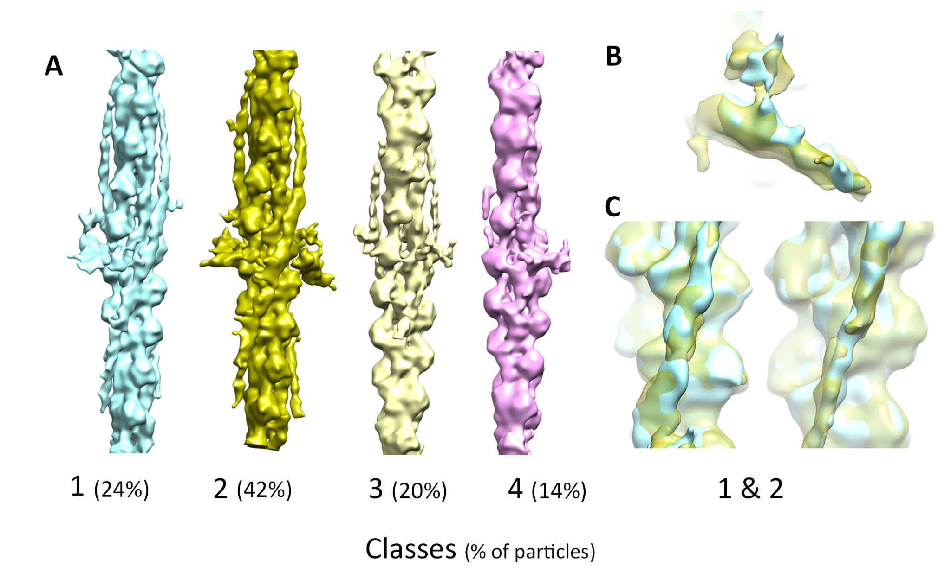
Fig S6 Evaluating the activation state of the data using 3D classification. A: Four 3D classes generated in cisTEM from the particles used for the final Zebrafish Cryo-EM map including a subpopulation of thin filaments with single sided troponin decoration (1 & 4) B: Classes 1 & 2 aligned using Chimera’s fit in map function superimposed, alignment shows very similar IT arm angle. C: Classes 1 & 2 aligned as in B. with tropomyosin shown, highlighting a high degree of similarity between the two. Class 3 also showed alignment in the troponin core and tropomyosin with classes 1 & 2, class 4 was lacking sufficient density of either feature to compare. Overall, this suggests classes 1,2 & 3 occupy the same activation state.

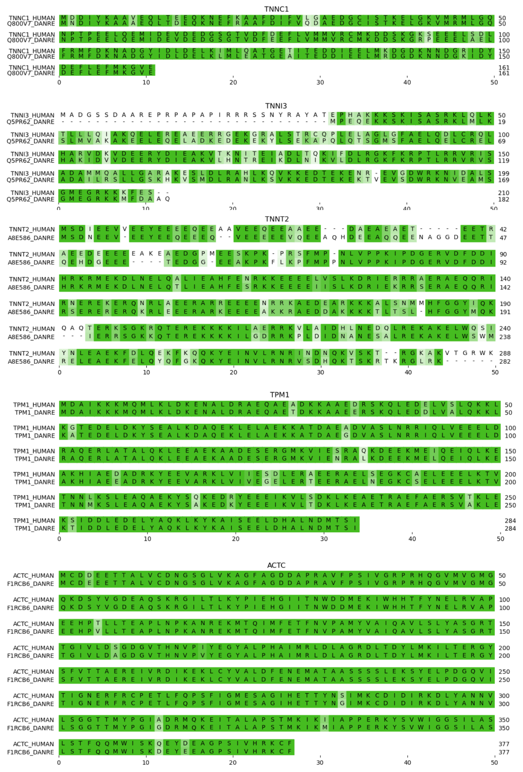
Fig S7. A pairwise sequence alignment of the human and zebrafish thin filament genes. Uniprot identifiers TnC: TNNC1_HUMAN & Q800V7_DANRE, TnI: TNNI3_HUMAN & Q5PR62_DANRE, TnT: TNNT2_HUMAN & A8E586_DANRE, Tropomyosin: TPM1_HUMAN & TPM1_DANRE, Actin: ACTC_HUMAN & F1RCB6_DANRE.
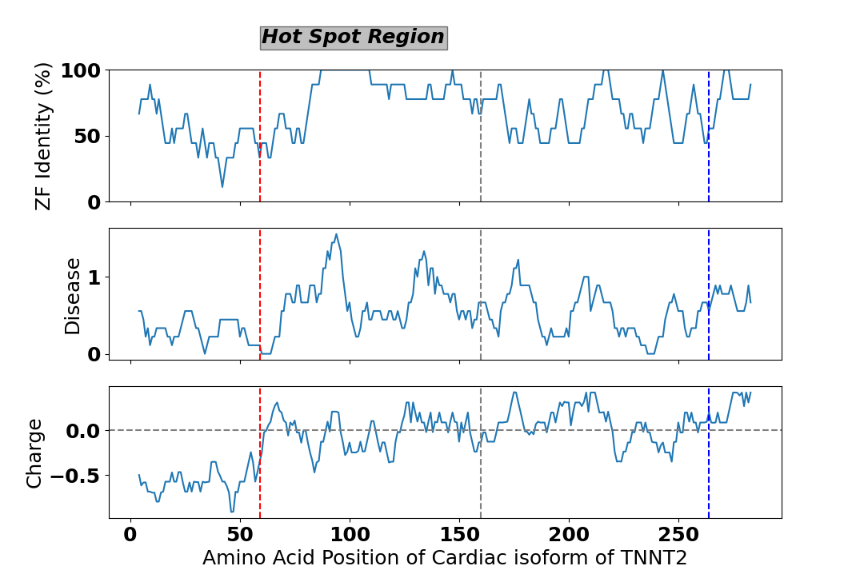

Fig. S8 Analysis of sequence properties for sub-regions of TNT2_HUMAN. A sliding window of 11 amino acids was moved across the sequence and in that window average properties were calculated for: (Top) Protein sequence identity between human and zebrafish; (Middle) Number of distinct disease-causing mutations per residue (distinct based on position and mutant AA); (Bottom) Net Charge at pH7.

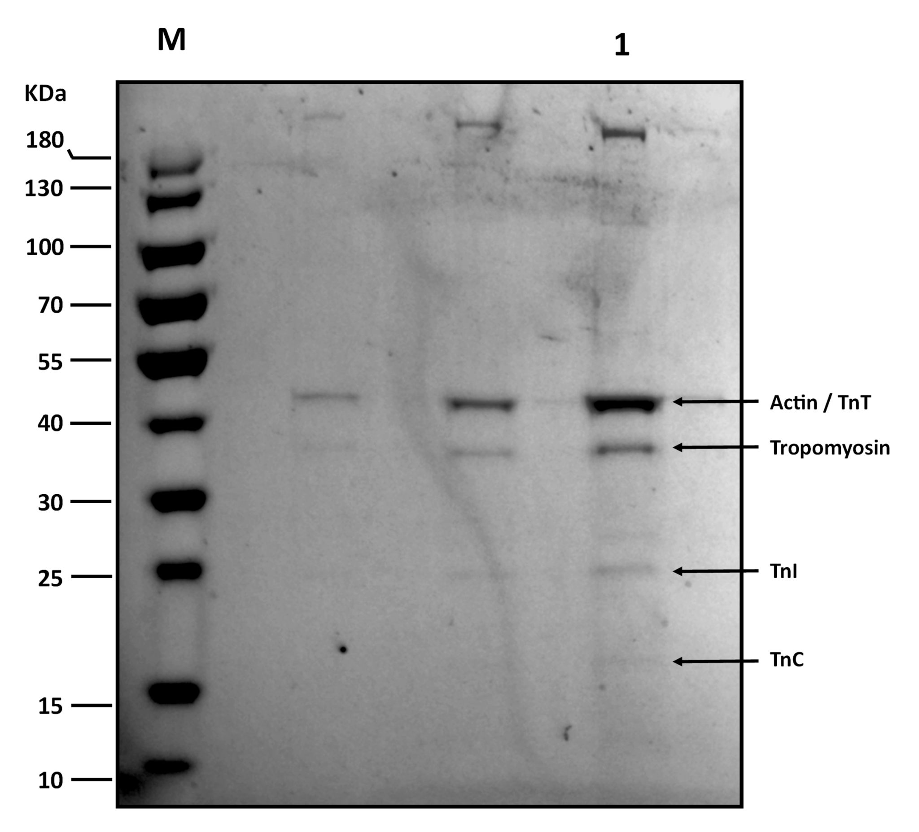
Fig S9. SDS-PAGE for zebrafish heart isolation prior to cryo plunge freezing. Lane 1 shows the highest concentration of thin filament isolate providing the clearest bands (compared to middle 2 lanes). Lane M shows the molecular weight markers. Overlapping Actin/TnT band and weaker TnI and TnC bands are consistent with mammalian thin filament gels. (Yamada et al., 2020. Risi et al., 2021)
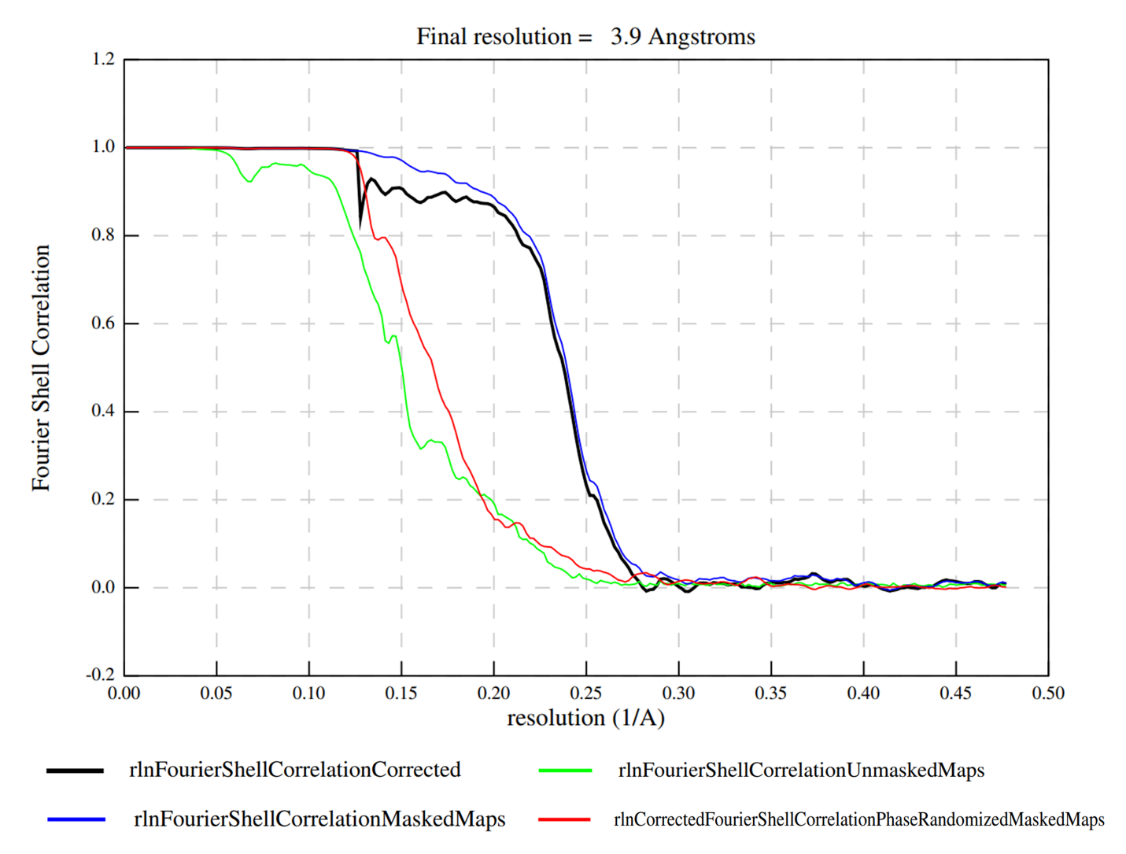
Fig S10 Resolution estimation by Fourier shell correlation calculated using independent half-maps from zebrafish cardiac actin structure. A cut-off is shown at 0.143 with the first intersection occurring at spatial frequency 0.26 giving a resolution of 3.85Å.

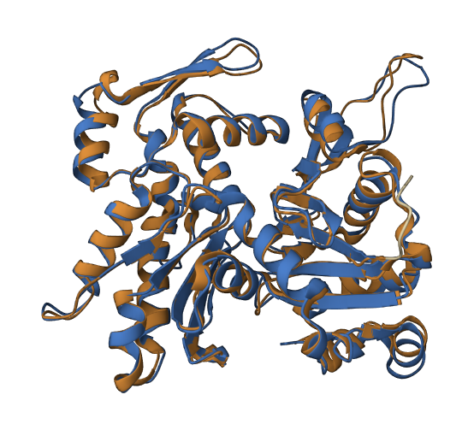
Fig S11. Structural similarity between zebrafish actin PDB 8ORD (F1RCB6_DANRE-blue) and human cardiac actin PDB 6KN8 (ACTA_HUMAN-brown) TM score 0.97, RMSD 1.19.

