SUPPLEMENTARY MATERIAL

TABLES

Table S1: Global Moran’s I for Landsat bands across different scenes. Positive values indicate positive spatial autocorrelation, values range from −1 (indicating perfect dispersion) to +1 (perfect correlation) and the zero value indicating a random spatial pattern (Hijmans 2015).

Year |  Season | band1 | band2 | band3 | band4 | band5 | band7
1984 | Winter | 0.84 | 0.85 | 0.88 | 0.89 | 0.91 | 0.91
1987 | Summer | 0.89 | 0.87 | 0.89 | 0.91 | 0.91 | 0.91
1991 | Winter | 0.83 | 0.85 | 0.87 | 0.91 | 0.90 | 0.90
1993 | Summer | 0.84 | 0.84 | 0.87 | 0.93 | 0.89 | 0.88
1998 | Winter | 0.83 | 0.87 | 0.90 | 0.94 | 0.94 | 0.92
2000 | Summer | 0.77 | 0.86 | 0.85 | 0.92 | 0.84 | 0.80

Table S2: Eigenvalues (or loadings) from a Principle Component (PC) Analysis of Landsat bands 1-5 and 7, indicating the proportion of variance accounted for by each PC across the different years and seasons (GRASS 2014).

 | PCA 1991 | PCA 1993 | PCA 1984 | PCA 1987 | PCA 1998 | PCA 2000
rain | low |  | average |  | high
season | winter | summer | winter | summer | winter | summer
PC1 | 0.81 | 0.75 | 0.81 | 0.75 | 0.84 | 0.68
PC2 | 0.09 | 0.18 | 0.11 | 0.17 | 0.06 | 0.19
PC3 | 0.05 | 0.04 | 0.04 | 0.05 | 0.05 | 0.09
PC4 | 0.03 | 0.02 | 0.02 | 0.01 | 0.03 | 0.02
PC5 | 0.02 | 0.01 | 0.01 | 0.01 | 0.01 | 0.01
PC6 | 0.01 | 0.01 | 0.01 | 0.01 | 0.01 | 0.01

Table S3: Geographically Weighted Regression results illustrating local differences between relationships of physical landscape elements with Landsat spectral variation across different years. The first (1stQu), second (Median) and third (3rdQu) order quartiles show the local variability of resulting coefficient estimates. The inter-quartile range (IQR) summarise the range where 50% of all coefficient estimate values fall. Leung et al.’s (2000) F statistic (F3) tests the spatial non-stationarity of each in dependent variable’s coefficient using numerator degrees of freedom (nDF) and denominator degrees of freedom (dDF).

 |  | 1stQu | Median | 3rdQu | IQR | F3 | nDF | dDF | P
1991 | X.Intercept. | 865.30 | 875.60 | 880.20 | 14.90 | 6.87 | 550 | 2380 | < 0.0001 | ***
1991 | aspect | -3.99 | -1.21 | -0.72 | -3.27 | 0.98 | 1449 | 2380 | 0.6962
1991 | dem | -12.92 | -1.88 | 1.24 | -11.68 | 4.57 | 1254 | 2380 | < 0.0001 | ***
1991 | slope | -4.73 | -1.40 | -0.45 | -4.28 | 1.26 | 360 | 2380 | 0.0013 | **
1991 | tci | -6.64 | -3.26 | -1.99 | -4.66 | 2.99 | 344 | 2380 | < 0.0001 | ***
1991 | soil.form | -5.58 | -0.80 | 0.42 | -5.16 | 1.36 | 206 | 2380 | 0.0007 | ***
1991 | soil.depth | -3.44 | -0.64 | 0.30 | -3.13 | 1.34 | 41 | 2380 | 0.0730 | .
1991 | Number nearest neighbours: 199 |  |  |  |  | Adjusted R²: 0.392
1991 | Quasi-global R²: 0.456 |  |  |  |  | AICc: 18944.54
1984 | X.Intercept. | 863.40 | 908.40 | 918.80 | 55.40 | 7.89 | 485 | 2329 | < 0.0001 | ***
1984 | aspect | -0.06 | -0.01 | -0.01 | -0.06 | 1.00 | 1432 | 2329 | 0.5250
1984 | dem | -0.44 | -0.06 | 0.04 | -0.40 | 3.92 | 1236 | 2329 | < 0.0001 | ***
1984 | slope | -0.43 | -0.06 | 0.02 | -0.40 | 1.11 | 368 | 2329 | 0.0843 | .
1984 | tci | -0.26 | -0.09 | -0.04 | -0.22 | 2.85 | 363 | 2329 | < 0.0001 | ***
1984 | soil.form | -0.19 | -0.04 | 0.00 | -0.19 | 2.53 | 138 | 2329 | < 0.0001 | ***
1984 | soil.depth | -0.14 | -0.04 | -0.01 | -0.13 | 2.10 | 30 | 2329 | 0.0004 | ***
1984 | Number nearest neighbours: 157 |  |  |  |  | Adjusted R²: 0.439
1984 | Quasi-global R²: 0.494 |  |  |  |  | AICc: 20560.98
1998 | X.Intercept. | 655.50 | 723.20 | 737.60 | 82.10 | 7.72 | 475 | 2316 | < 0.0001 | ***
1998 | aspect | -0.13 | -0.03 | -0.02 | -0.11 | 1.75 | 1427 | 2316 | < 0.0001 | ***
1998 | dem | -0.89 | -0.32 | -0.12 | -0.77 | 5.82 | 1230 | 2316 | < 0.0001 | ***
1998 | slope | -0.67 | -0.17 | -0.07 | -0.60 | 1.15 | 371 | 2316 | 0.0319 | *
1998 | tci | -0.31 | -0.14 | -0.08 | -0.23 | 2.19 | 368 | 2316 | < 0.0001 | ***
1998 | soil.form | -0.23 | -0.04 | 0.00 | -0.23 | 1.71 | 127 | 2316 | < 0.0001 | ***
1998 | soil.depth | -0.17 | -0.04 | -0.01 | -0.16 | 1.47 | 31 | 2316 | 0.0479 | *
1998 | Number nearest neighbours: 149 |  |  |  |  | Adjusted R²: 0.315
1998 | Quasi-global R²: 0.409 |  |  |  |  | AICc: 21810.65
1993 | X.Intercept. | 601.40 | 656.50 | 671.00 | 69.60 | 11.67 | 475 | 2316 | < 0.0001 | ***
1993 | aspect | -0.06 | -0.02 | -0.01 | -0.05 | 1.25 | 1427 | 2316 | < 0.0001 | ***
1993 | dem | -0.97 | -0.39 | -0.23 | -0.74 | 4.74 | 1230 | 2316 | < 0.0001 | ***
1993 | slope | -1.23 | -0.16 | -0.05 | -1.18 | 1.50 | 371 | 2316 | < 0.0001 | ***
1993 | tci | -0.30 | -0.06 | -0.03 | -0.27 | 1.60 | 368 | 2316 | < 0.0001 | ***
1993 | soil.form | -0.28 | -0.03 | 0.01 | -0.26 | 1.84 | 127 | 2316 | < 0.0001 | ***
1993 | soil.depth | -0.23 | -0.04 | -0.01 | -0.22 | 1.27 | 31 | 2316 | 0.1467
1993 | Number nearest neighbours: 149 |  |  |  |  | Adjusted R²: 0.565
1993 | Quasi-global R²: 0.635 |  |  |  |  | AICc: 21298.95
1987 | X.Intercept. | 802.80 | 917.90 | 940.10 | 137.30 | 13.58 | 475 | 2316 | < 0.0001 | ***
1987 | aspect | -0.07 | -0.01 | 0.00 | -0.07 | 1.32 | 1427 | 2316 | < 0.0001 | ***
1987 | dem | -1.30 | -0.28 | -0.05 | -1.25 | 10.88 | 1230 | 2316 | < 0.0001 | ***
1987 | slope | -1.13 | -0.14 | -0.04 | -1.09 | 2.02 | 371 | 2316 | < 0.0001 | ***
1987 | tci | -0.31 | -0.07 | -0.03 | -0.29 | 2.58 | 368 | 2316 | < 0.0001 | ***
1987 | soil.form | -0.35 | -0.02 | 0.03 | -0.33 | 2.37 | 127 | 2316 | < 0.0001 | ***
1987 | soil.depth | -0.34 | -0.04 | 0.00 | -0.34 | 2.01 | 31 | 2316 | 0.0008 | ***
1987 | Number nearest neighbours: 149 |  |  |  |  | Adjusted R²: 0.567
1987 | Quasi-global R²: 0.720 |  |  |  |  | AICc: 19696.98
2000 | X.Intercept. | 439.60 | 450.70 | 457.40 | 17.80 | 4.74 | 529 | 2363 | < 0.0001 | ***
2000 | aspect | -0.03 | -0.01 | 0.00 | -0.03 | 1.58 | 1444 | 2363 | < 0.0001 | ***
2000 | dem | -0.24 | -0.05 | 0.01 | -0.23 | 3.44 | 1250 | 2363 | < 0.0001 | ***
2000 | slope | -0.23 | -0.03 | 0.02 | -0.20 | 1.20 | 363 | 2363 | 0.0105 | *
2000 | tci | -0.01 | 0.02 | 0.05 | 0.04 | 3.77 | 349 | 2363 | < 0.0001 | ***
2000 | soil.form | -0.02 | 0.01 | 0.02 | 0.00 | 1.32 | 185 | 2363 | 0.0032 | **
2000 | soil.depth | -0.10 | -0.02 | -0.01 | -0.09 | 2.54 | 35 | 2363 | < 0.0001 | ***
2000 | Number nearest neighbours: 183 |  |  |  |  | Adjusted R²: 0.255
2000 | Quasi-global R²: 0.234 |  |  |  |  | AICc: 19061.62
Model settings: gwr.basic (Kernel function = bisquare; adaptive bandwidth = no of nearest neighbours; regression points = same locations as observations; distance metric = Euclidean distance metric) (Gollini et al. 2015)

Table S4: Comparatively, only 57% and 62% of the variability in plant species richness was captured by raw surface reflectance PC values and raw physical landscape properties respectively. The first (1stQu), second (Median) and third (3rdQu) order quartiles show the local variability of resulting coefficient estimates. The inter-quartile range (IQR) summarise the range where 50% of all coefficient estimate values fall. Leung et al.’s (2000) F statistic (F3) tests the spatial non-stationarity of each in dependent variable’s coefficient using numerator degrees of freedom (nDF) and denominator degrees of freedom (dDF).

 | Q1 |  | Med |  | Q3 |  | IQR |  | F3 |  | nDF | dDF |  | P
Intercept | -2504.00 |  | 34.69 |  | 122.90 |  | -2381.10 |  | 2.89 |  | 231.07 | 566.54 |  | < 0.0001 |  | ***
PC 1991 | -0.38 |  | 0.04 |  | 0.19 |  | -0.19 |  | 1.43 |  | 213.69 | 566.54 |  | 0.0006 |  | ***
PC 1993 | -1.82 |  | -0.07 |  | 0.02 |  | -1.80 |  | 4.20 |  | 264.86 | 566.54 |  | < 0.0001 |  | ***
PC 1984 | -0.71 |  | -0.01 |  | 0.07 |  | -0.65 |  | 3.30 |  | 218.93 | 566.54 |  | < 0.0001 |  | ***
PC 1987 | -1.03 |  | 0.04 |  | 0.13 |  | -0.90 |  | 1.72 |  | 250.75 | 566.54 |  | < 0.0001 |  | ***
PC 1998 | -0.82 |  | -0.01 |  | 0.08 |  | -0.74 |  | 1.42 |  | 217.50 | 566.54 |  | 0.0008 |  | ***
PC 2000 | -0.73 |  | 0.05 |  | 0.15 |  | -0.58 |  | 3.00 |  | 201.00 | 566.54 |  | < 0.0001 |  | ***
Number of nearest neighbours: 76
Adjusted R²: 0.566
AICc: 5766.01
Intercept | 71.14 |  | 127.00 |  | 448.60 |  | 377.46 |  | 5.39 |  | 226.44 | 553.46 |  | < 0.0001 |  | ***
aspect | 0.00 |  | 0.01 |  | 0.06 |  | 0.06 |  | 1.18 |  | 341.25 | 553.46 |  | 0.0443 |  | *
dem | -0.06 |  | 0.02 |  | 0.41 |  | 0.35 |  | 6.02 |  | 354.78 | 553.46 |  | < 0.0001 |  | ***
sink | 0.00 |  | 0.00 |  | 0.03 |  | 0.02 |  | 8.36 |  | 223.11 | 553.46 |  | < 0.0001 |  | ***
slope | -0.82 |  | 0.79 |  | 9.89 |  | 9.06 |  | 7.60 |  | 161.91 | 553.46 |  | < 0.0001 |  | ***
tci | -0.48 |  | 0.13 |  | 7.15 |  | 6.67 |  | 1.71 |  | 132.88 | 553.46 |  | < 0.0001 |  | ***
soil.form | -0.05 |  | 0.94 |  | 5.23 |  | 5.18 |  | 0.78 |  | 103.15 | 553.46 |  | 0.9411
soil.depth | -0.32 |  | 0.78 |  | 8.43 |  | 8.12 |  | 0.94 |  | 98.69 | 553.46 |  | 0.6340
Number of nearest neighbours: 85
Adjusted R²: 0.621
AICc: 5694.72
Model settings: gwr.basic (Kernel function = bisquare; adaptive bandwidth = no of nearest neighbours; regression points = same locations as observations; distance metric = Euclidean distance metric) (Gollini et al. 2015).

Fig. S1: Annual rainfall (dotted line) and three-year rolling mean (solid blue line) of Skukuza rainfall records from 1982 - 2013. Solid grey line indicates long-term annual mean and arrows indicates winter (red) and summer (green) Landsat scenes selected.

 | WINTER | SUMMER
LOW RAINFALL | 1991  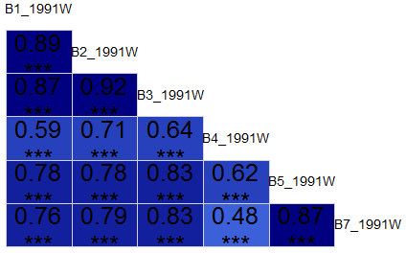 | 1993  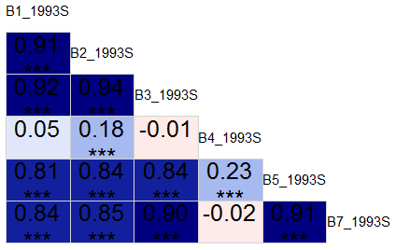
AVERAGE RAINFALL | 1984  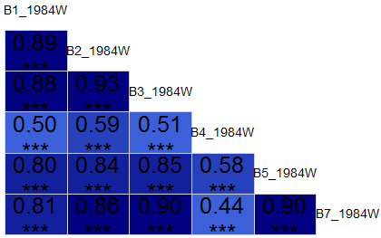 | 1987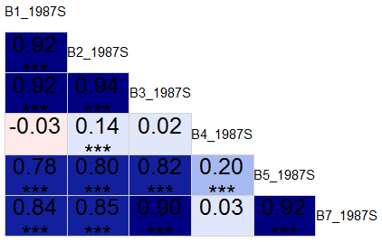
HIGH RAINFALL | 1998  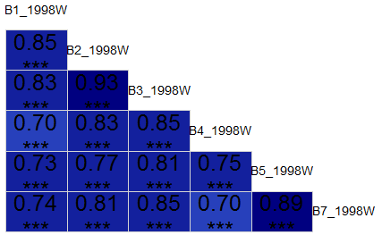 | 2000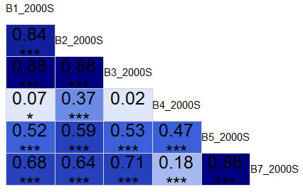

Fig. S2: Correlogram (graphical display of a correlation matrix) of bands values for each Landsat scene. Cells shaded blue are positively correlated, those shaded red are negatively correlated and the intensity of the shades indicate the level of the correlation value. The actual values with significance levels (* p<0.01; ** p<0.001; *** p<0.0001) are also illustrated (Wright 2015).

WINTER
SUMMER
LOW
AVG
HIGH
LOW
AVG
HIGH

Fig. S3: Difference in the percentage variance accounted for in PC1, PC2, PC3 and PCs 4, 5 and 6 across different image dates sorted by a three-year rolling mean of rainfall (low-average-high) and season (winter-summer). In general, the proportion of variance accounted for by PC1, for example, decreases from winter to summer. In summer months, this decreases from low to high rainfall. While patterns are less clear within winter months and average rainfall conditions, possibly because of the relatively large variation in rainfall between individual years.

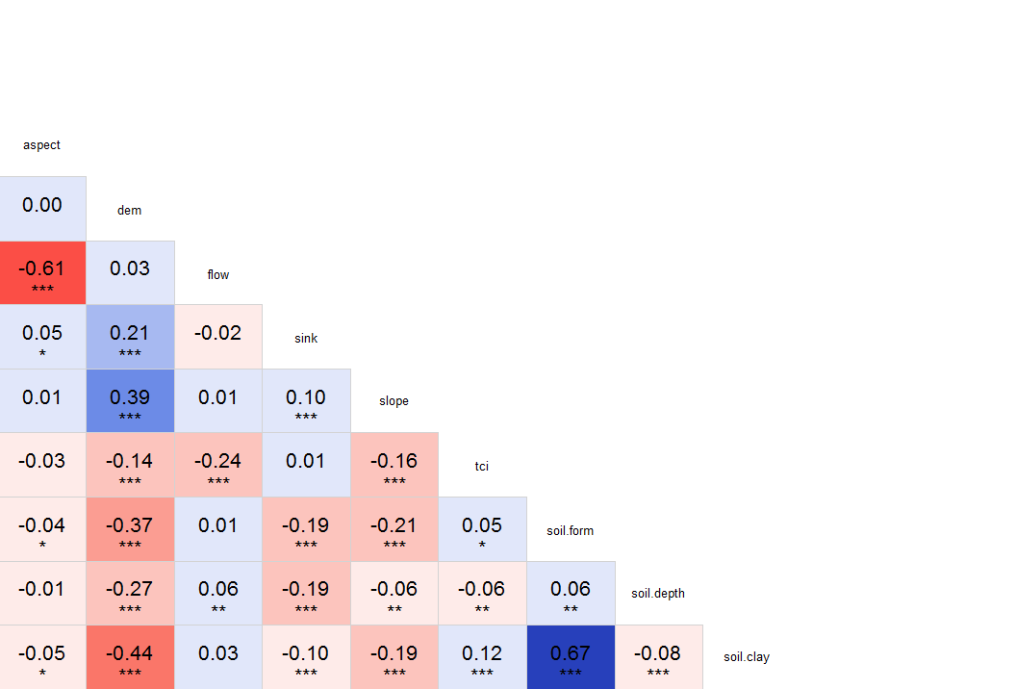
Soil Depth [VIF: 1.152 1.093]
Soil Form [VIF: 2.086 1.213]
TCI [VIF: 1.193 1.038]
Slope [VIF: 1.284 1.237]
Flow [VIF: 1.844]
Elevation [VIF: 1.637 1.486]
Aspect [VIF: 1.743 1.002]
Sink [VIF: 3.088]
Soil Clay [VIF: 2.139]

Fig. S4: Correlogram (graphical display of a correlation matrix) of physical landscape covariates (Wright 2015). Cells shaded blue are positively correlated, those shaded red are negatively correlated and the intensity of the shades indicate the level of the correlation value. The actual values with significance levels (* p<0.01; ** p<0.001; *** p<0.0001) are also illustrated. Variance Inflation Factors (VIF) are calculated for these physical landscape covariates by excluding highly correlated variables and repeating VIF calculations until all values were below 1.5 (Naimi 2015). Flow and aspect are significantly negatively correlated (-0.63) while soil form and soil clay content are significantly positively correlated (0.67). Flow and soil clay as well as watershed area (sink) have higher VIF values and are therefore removed from further analyses.

Fig. S5: Difference in AIC scores for local GWR models of raw PC values, different diversity indices (Shannon, simpson, renyi, pielou) and textural variance measures (uniformity, entropy and variance) of the spectral response and physical landscape properties by season and rainfall condition. Unilaterally, models with raw PC values representing spectral variation were better able to balance model fit and complexity, as indicated by the notably lower AIC scores.

REFERENCES

Gollini I, Lu B, Charlton M et al. (2015). GWmodel: An R Package for Exploring Spatial Heterogeneity Using Geographically Weighted Models. Journal of Statistical Software 63: 1-50
GRASS (2014) GRASS Development Team. GRASS GIS 7.1.svn Reference Manual. Available from http://grass.osgeo.org/grass71/manuals/index.html (accessed November 2014)
Hijmans RJ (2015). raster: Geographic Data Analysis and Modeling. R package version 2.3-40. Available from http://CRAN.R-project.org/package=raster (accessed June 2015)
Leung Y, Mei C-L, Zhang W-X (2000) Statistical tests for spatial nonstationarity based on the geographically weighted regression model. Environment and Planning 32: 9-32
Naimi B (2015) usdm: Uncertainty analysis for species distribution models. R package version 1.1-12. Available from http://CRAN.R-project.org/package=usdm (accessed June 2015)
Wright K (2015) corrgram: Plot a Correlogram. R package version 1.7. Available from http://CRAN.R-project.org/package=corrgram (accessed June 2015)

