Supplemental Tables:
Supplemental table 1. Futures submodels, parameters, and data sources used.
Supplemental table 2. Results of generalized linear mixed model: Fixed effects include the interactions between development pressure, slope, distance to interchanges, road density, distance to protected lands, and distance to water services followed by random effects for intercept and development pressure which varies by county.
Supplemental table 3. Results of the logistic regression model for the potential of organic camping.
Supplemental table 4. Results of the logistic regression used to model the camping site suitability of Western North Carolina.
Supplemental table 1.
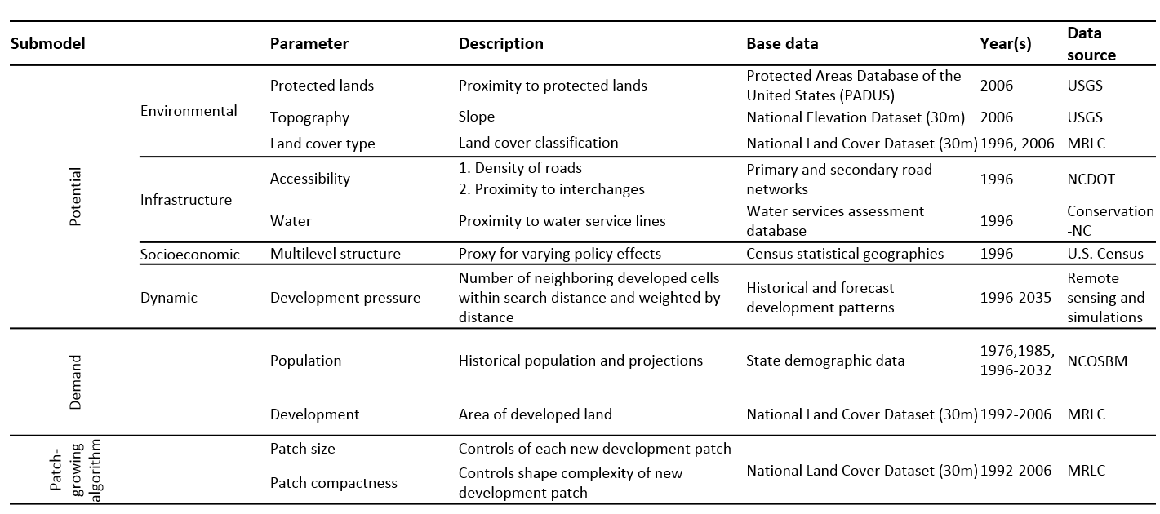

Supplemental table 2.
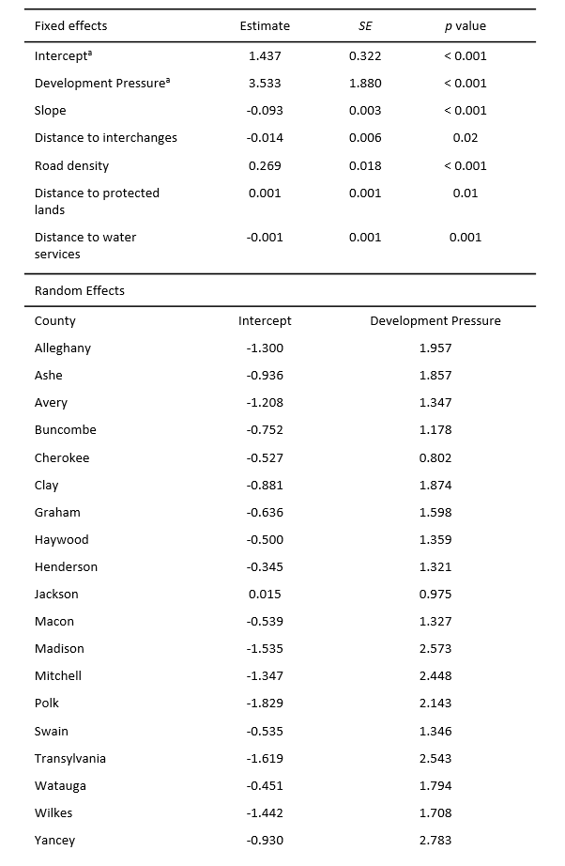

Supplemental table 3.
 | Estimate | Std. Est.
Intercept | 6.45(0.53)***
Distance to potable water wells (km) | -0.13(0.01)*** | -1.009
Ground water abstraction rates (gallon/min) | 0.0(0.0)*** | -0.424
Enhanced Vegetation Index (1-0) | 2.11(0.28)*** | 0.791
Cost/distance to urban (hours) | -0.72(0.12)*** | -0.627
Population/mile (100*) | -0.09(0.06) | -0.085
Average annual minimum temperature | -0.13(0.01)*** | -1.067
Percent forested land | -2.41(0.09)*** | -2.076
Agricultural suitability | 0.16(0.08) . | 0.122

Supplemental table 4.
 | Estimate | Std. Est.
Intercept | 3.61(0.94)***
Distance to lakes and rivers (km) | -1.02(0.16)*** | -1.47
Distance to potable water wells (km) | -0.26(0.03)*** | -1.63
Travel time to large urban centers (hour) | 1.00(0.22)*** | 0.75
Forest 250m (%) | -2.31(0.22)*** | -1.91
Farm suitability (SSURGO) | -0.5(0.26) . | -0.34
Average minimum temperature | -0.04(0.02) . | -0.30
Distance to protected areas (km) | -0.13(0.02)*** | -1.49
Distance to attractions (km) | -0.02(0.01)** | -0.55

Supplemental Figures:
Supplemental Figure 1. A sample sub-region depicting carbon sequestration for (clockwise from top left) (a) initial conditions (2006), and three simulations of urban growth with different spatial configurations of (b) maintaining status quo growth, (c) infill, and (d) sprawl. Note that all three scenarios (b-d) have approximately the same amount of land converted but in very different visual configurations that are less obvious from landscape perspectives.
Supplemental Figure 2. A sample sub-region depicting surface water runoff for (clockwise from top left) (a) initial conditions (2006), and three simulations of urban growth with different spatial configurations of (b) maintaining status quo growth, (c) infill, and (d) sprawl. Note that all three scenarios (b-d) have approximately the same amount of land converted but in very different visual configurations that are less obvious from landscape perspectives.
Supplemental Figure 3. A sample sub-region depicting nitrogen export for (clockwise from top left) (a) initial conditions (2006), and three simulations of urban growth with different spatial configurations of (b) maintaining status quo growth, (c) infill, and (d) sprawl. Note that all three scenarios (b-d) have approximately the same amount of land converted but in very different visual configurations that are less obvious from landscape perspectives.
Supplemental Figure 4. A sample sub-region depicting phosphorus export for (clockwise from top left) (a) initial conditions (2006), and three simulations of urban growth with different spatial configurations of (b) maintaining status quo growth, (c) infill, and (d) sprawl. Note that all three scenarios (b-d) have approximately the same amount of land converted but in very different visual configurations that are less obvious from landscape perspectives.
Supplemental Figure 5. A sample sub-region depicting site suitability of organic farming for (clockwise from top left) (a) initial conditions (2006), and three simulations of urban growth with different spatial configurations of (b) maintaining status quo growth, (c) infill, and (d) sprawl. Note that all three scenarios (b-d) have approximately the same amount of land converted but in very different visual configurations that are less obvious from landscape perspectives.
Supplemental Figure 6. A sample sub-region depicting site suitability of camping for (clockwise from top left) (a) initial conditions (2006), and three simulations of urban growth with different spatial configurations of (b) maintaining status quo growth, (c) infill, and (d) sprawl. Note that all three scenarios (b-d) have approximately the same amount of land converted but in very different visual configurations that are less obvious from landscape perspectives.

Supplemental Figure 1.
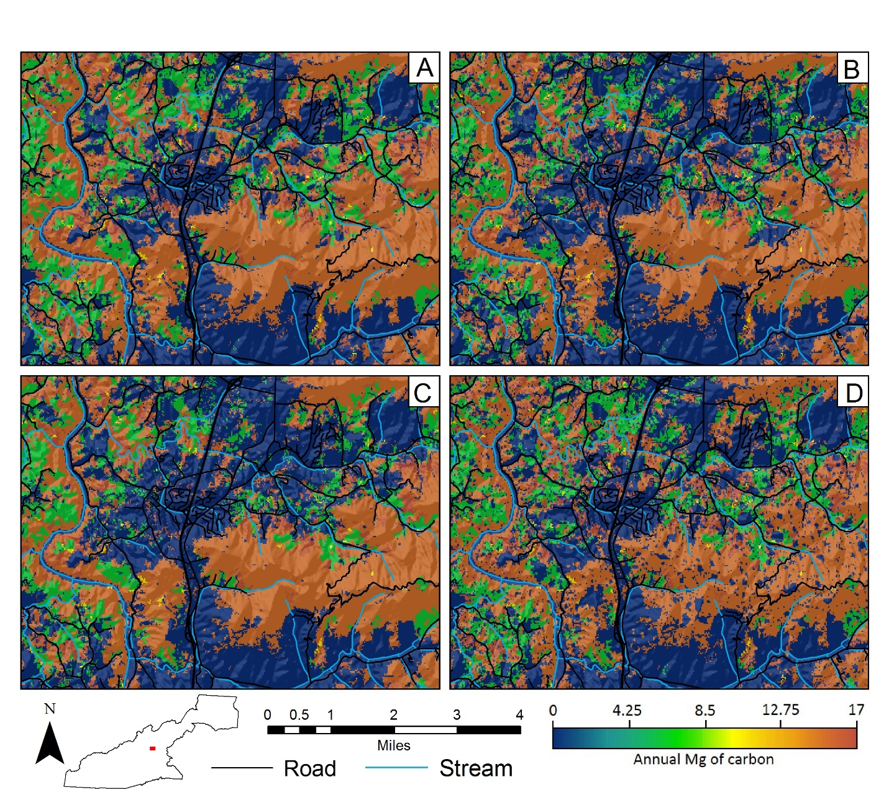

Supplemental Figure 2.
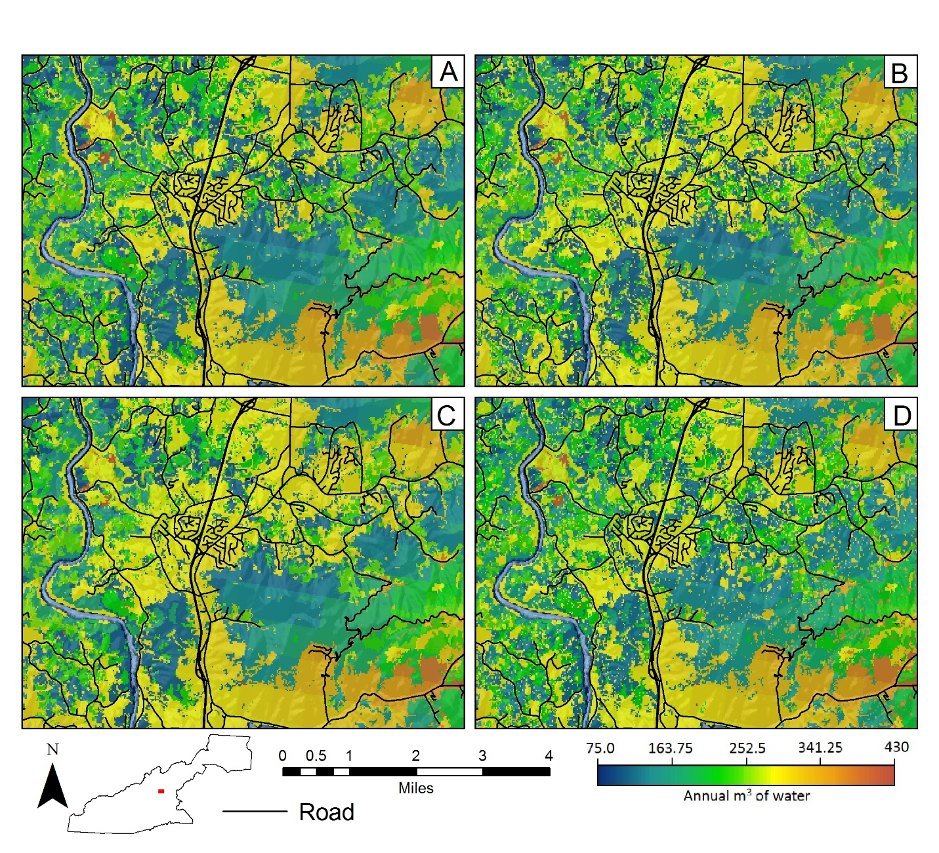

Supplemental Figure 3.
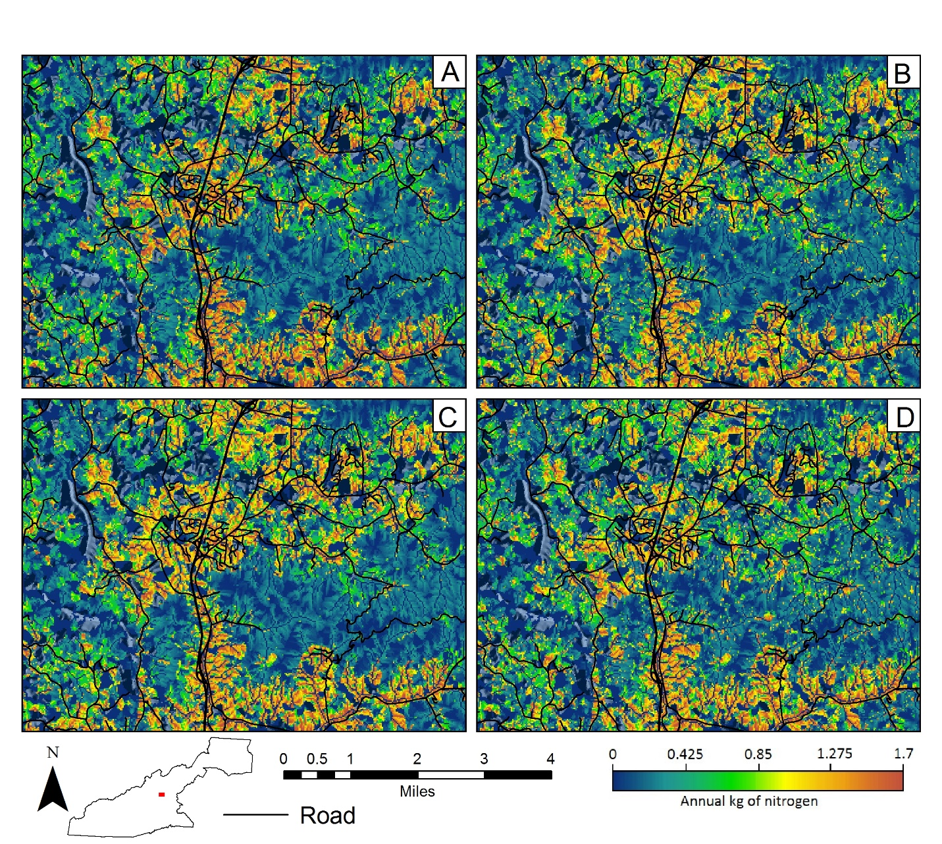

Supplemental Figure 4.
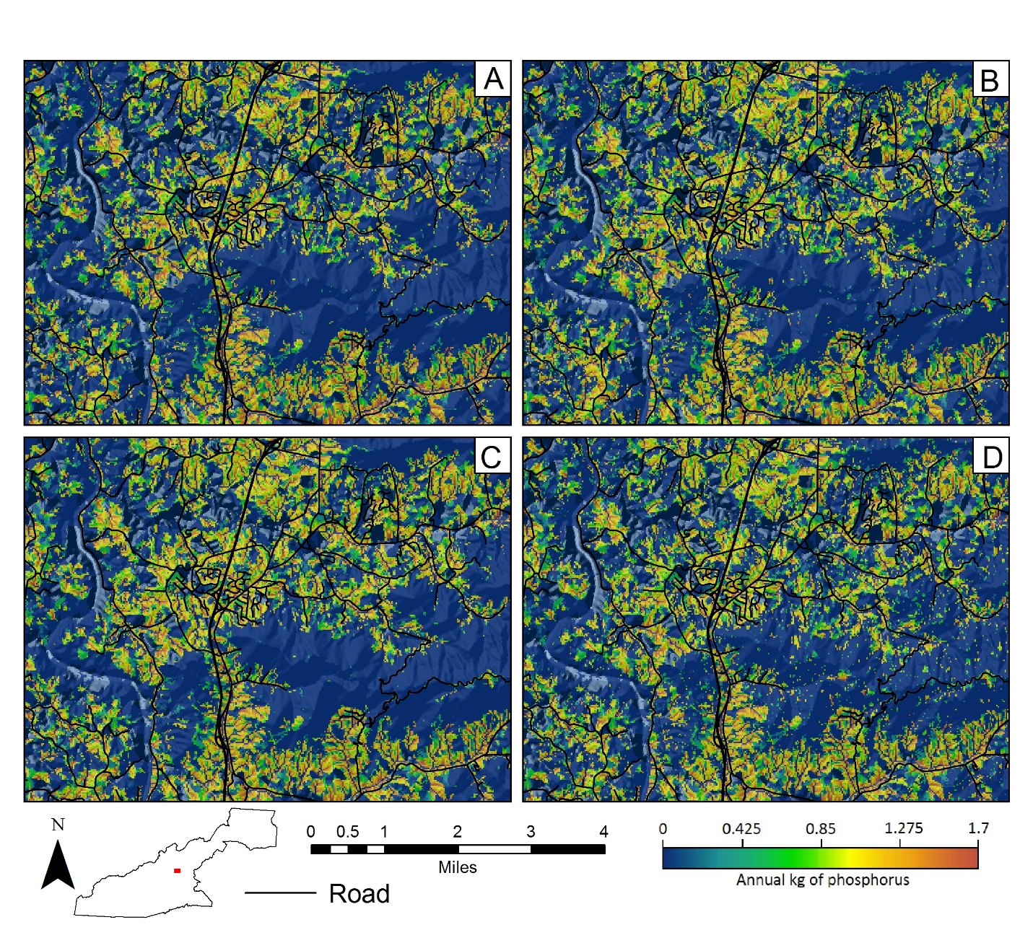

Supplemental Figure 5.
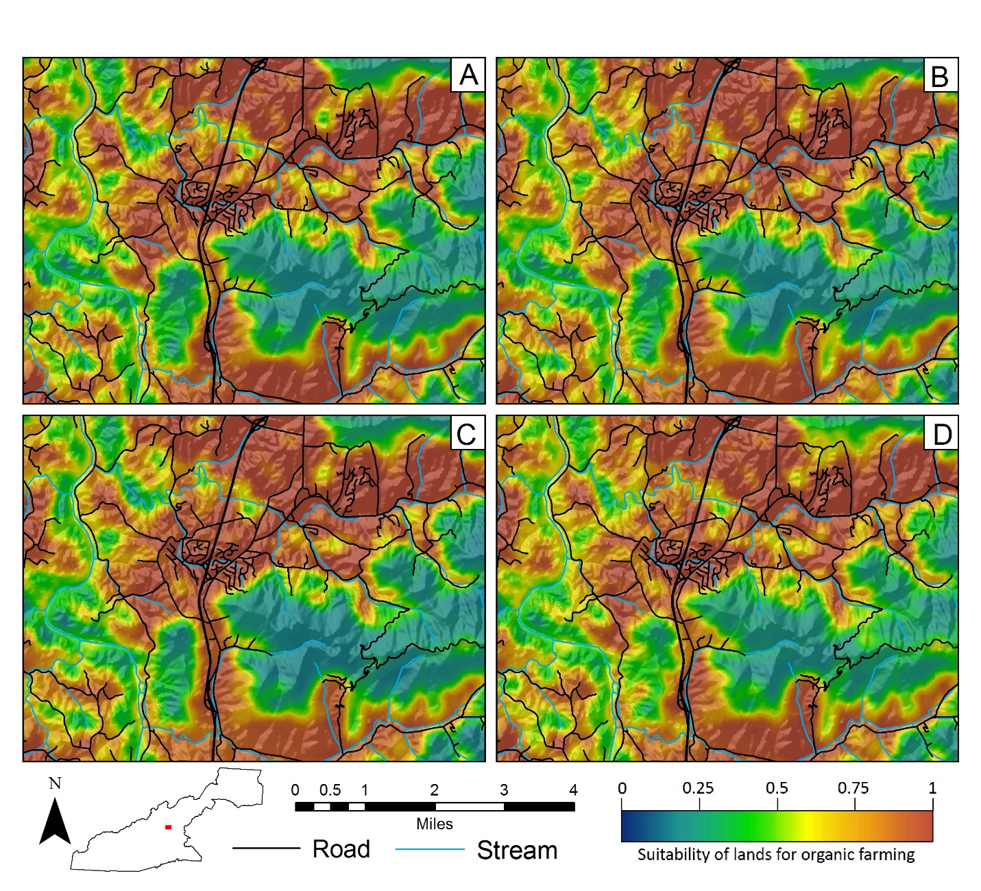

Supplemental Figure 6.
